Marketing strategy of Lenovo laptops

Final project “Principles of marketing” Section C

Authors:

Ayesha Majid

Khunsha Sadiq

Saqib Raza

Iza Haider

Farhan Safdar

Table of Contents

Origin of Lenovo group 3

The top executives 3

Mission and Vision Statement 6

Mission Statement 6

Vision Statement 6

Organization Culture 7

**Lenovo laptops in Pakistan** 8

**The Laptop Market** 9

Background of market 9

Challenge 9

Findings 10

Insights 12

Lenovo’s consumer market 13

Consumer Profile 15

Age 15

Family Size: 15

Family life cycle: 15

Income and Expenditure patterns: 15

Occupation: 16

Education: 16

Basis of Differentiation 17

Product Positioning 18

Market Segmentation and Positioning 19

Targeting 19

Target Marketing Choice of Lenovo At present, Lenovo considers the following factors when choosing target market: 20

Segmentation 21

Demographic Segmentation (Consumer Profile) 21

Geographic Segmentation 22

Psychographic Segmentation 23

Behavioral Segmentation 24

Product segmentation 25

Marketing Strategies 26

Product 26

Product Differentiation: Wider Quality Spectrum 27

Complements to Compete with Apple and HP 28

Brand positioning 29

Pricing Strategy 30

Lenovo Pricing in India 32

Differentiation Strategy 33

Focus Strategy 33

Placement 34

Promotion 34

The main goals for us are: 35

Community Engagement 35

Media Engagement 35

Product Profile 36

Conclusion: Lenovo Should Split and Diversify 38

# Origin of Lenovo group

The Lenovo Company was founded by eleven engineers in china and it is formerly known as the legend that makes a variety of electronic products for the consumers. The company is privately owned as well as partially owned by the government of Chinese. The Lenovo provides the suitable management tools to use and simplify the management of think server system. The value chain models for the company include operations like inbound logistics marketing and sales. Lenovo also supports the other business activities like technology procurement and the development of human resource management with the firm structure. The company deserves the technical management especially in the research of the product and development. Lenovo holds the largest customer share in china. Europe has the opportunity of the global market share. The objective of the company is developing the overall experience of pc ownership driving to the total cost.

### http://www.laptopmag.com/images/wp/purch-api/incontent/2011/11/David-Hill_sh.jpgThe top executives

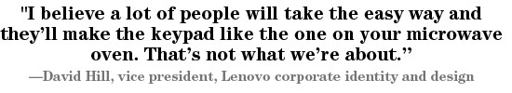David Hill, vice president, Lenovo corporate identity and design. Hill spent more than 20 years at IBM, helping to create the company’s overall design identity. He joined Lenovo in 2005, overseeing the design of everything from servers to the ThinkPad line of notebooks. He has received 12 IDEA awards for his work, and the Design of the Decade honour for ThinkPad.

#### Emergence strategy

First came a string of **aggressive acquisitions,** which helped the company acquire new technology, assembling a scale and scope advantage in the process. In 2005, for instance, Lenovo acquired the PC division of IBM for $1.75 billion. In 2012, the company acquired Digi bras Industrial, a leading Brazilian PC and gadget maker. Many more acquisitions followed, some taking place as frequently as every 2-3 weeks. Most recently, Lenovo acquired IBM’s low-end server division in China for $2.3 billion – and the handset division of Google for close to $3 billion**.**

Second came the **gradual elimination of the shi, shi, shi, (yes, yes, yes)** business culture – a ‘yes man’ environment unattractive to the high-tech industry. This helped Lenovo improve its ability to recruit and retain talent in overseas markets – where technology companies typically favor more of a heretic culture.

Third came **innovation.** Recruitment and retention of foreign talent has helped Lenovo make the transition from being an imitator, competing on costs, to being an innovator competing on state-of-the art products like the ThinkPad laptop and Yoga four-position Ultrabook.

Fourth is the **strengthening of the company brand**. Innovation and global expansion have helped Lenovo’s product gain recognition in overseas markets. Lenovo’s Window Yoga Tablet with Any Pen Technology, for instance, was included in PC Magazine’s “The Best of CES 2015 list,” as was the company’s Vibe Band and LaVie H750 convertible and HZ550 clamshell laptop.

Fifth came the company’s **listing in the HK exchange**, which added transparency to Lenovo’s corporate image, something other large Chinese companies are missing.

And Six is **dual headquarters—Beijing and North Carolina**. This highly decentralized corporate structure has facilitated the company’s efforts to recruit and retain global technology and marketing talent, while getting closer to the end customer.

|  |  |
| --- | --- |
| Name | Lenovo Group Limited |
| Logo | Lenovo Group logo |
| Industries served | Computer hardware and Electronics |
| Geographic areas served | Worldwide |
| Headquarters | China and U.S. |
| Current CEO | Yang Yuanqing |
| Revenue | $ 29.57 billion (2012) |
| Profit | $ 472 million (2012) |
| Employees | 27,000 (2012) |
| Main Competitors | Apple Inc., Samsung Electronics Co., Microsoft Corporation, Dell Inc., Hewlett-Packard Company, Sony Corporation, Fujitsu Limited and many other companies. |

# Mission and Vision Statement

## [http://word.emerson.edu/emersonimc/files/2012/02/lenovo-300x244.png](http://word.emerson.edu/emersonimc/files/2012/02/lenovo.png)Mission Statement

**“Our mission is** to become one of the world’s great personal technology companies. We aspire to achieve this objective by leading in three key areas:

**Personal Computers:** Lead in PCs and be respected for our product innovation and quality.

**Convergence:** Lead the industry with an ecosystem of devices, services, applications and content for people to seamlessly connect to people and web content.

**Culture:** Become recognized as one of the best, most trusted and most well-respected companies to work for and do business with.**”**

## Vision Statement

At Lenovo, our vision is that Lenovo will create personal devices more people are inspired to own, a culture more people aspire to join and an enduring, trusted business that is well respected around the world. This vision guides us in pursuit of our mission to become one of the world's great personal technology companies.

We will accomplish this through:

* **Personal Computers:** Lead in PCs and be respected for our product innovation and quality.
* **Convergence:** Lead the industry with an ecosystem of devices, services, applications and content for people to seamlessly connect to people and web content.
* **Culture:** Become recognized as one of the best, most trusted and most well-respected companies to work for and do business with.

## Organization Culture

The Lenovo Way and it's the values we share and the business practices we deploy. It's how we address our day-to-day commitments. The Lenovo Way is embodied in the statement**: We do what we say and we own what we do.**

That culture also drives how we work every day, utilizing what we call the 5 P's:

* We **PLAN** before we pledge.
* We **PERFORM** as we promise.
* We **PRIORITIZE** the company first.
* We **PRACTICE** improving every day.
* We **PIONEER** new ideas.

Our culture is what has enabled us to consistently raise the bar on delivering break-through innovations, award-winning designs and strong financial performance.

# Lenovo laptops in Pakistan

Laptops in Pakistan have a common trend of being in competitiveness. Not only in Pakistan but all around the world. It is quite important to keep in view the essential possibilities for all those laptops with high configuration and competitive prices. **Lenovo laptops** in Pakistan are still not in pace but its campaigns are run by them are working super efficiently. This allows the company to win most of the customers in Pakistan but still due to high competition in laptop industry, **Lenovo laptops** in Pakistan is trying hard to have its share as much as the market leaders have now. It is continuously innovating and coming up with new technology to show up the importance so that they are made more comfortable according to the requirements. The main phase of going under innovation circles, it is quite important to view the desired presentations up to the mark in order to show the magnitude of the **Lenovo laptops** in Pakistan to the audience. It also brings to formulate the cultural impacts to have the ways of image building. The **Lenovo laptops** in Pakistan have their own way to success catering only a niche market segment as per their priorities. This indulges the main stream work of the laptops companies all round the world. **Lenovo laptops** in Pakistan is making its place in the market with a very high range of interest. In laptop industry, the most important factor to be considered is the ability to categorize within those elements which really mean to have their own way. This not only includes the laptops which are based on a high-tech configuration, but also enhances the features which are thought to be more essential while selling a laptop. Again the dealership is thought to be more important in order to consider the significance of the **Lenovo laptops** in Pakistan.

# The Laptop Market

## Background of market

The laptop market targets a variety of groups: students, who are especially concerned with prices; gadget-geeks and techies, who are looking for the most advanced systems; design aficionados, who are primarily seeking a sophisticated computer that looks good; and also the people who don’t get emotionally involved in this category and only view the computer as a work and entertainment tool. However, what all these groups have in common is the tendency to share information and opinions online. The conversation about laptops is mainly dominated by requests for advice and brand comparisons, and many people consult expert forums for recommendations.

## Challenge

In order to better understand the laptop market and identify consumer perceptions of leading brands, Bugzilla conducted a research study based on its T/Brand methodology, which assesses the brand and its environment, including its Talk ability Index. This model examined the volume of conversation about each brand during the second quarter of 2010, together with the opinions expressed. The combination of these parameters brought to light the perceived strength of HP, while also identifying the relative benefits of its competitors. In addition, analysis of the conversations and their participants contributed important information about each brand's target audience.

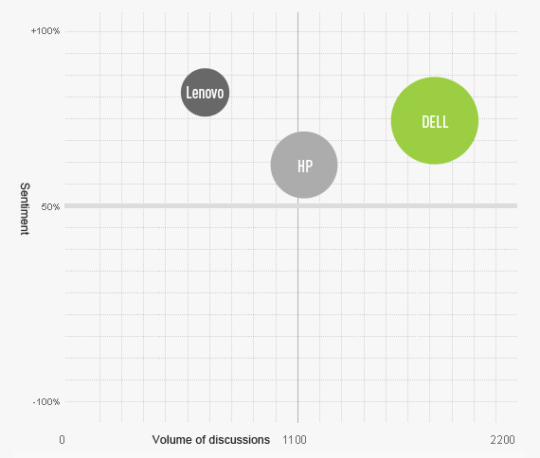

## 

## Findings

Analysis of the data revealed a relatively complex picture. During the three-month investigation period, the volume of conversations about HP totaled approximately 1,100, with approximately 68% positive sentiment. The conversation index of the HP brand, however, was lower than that of Dell, which topped it in both conversation volume and the rate of positive sentiment.   
The situation of a newer brand, Lenovo, was interesting: although it suffered from significantly lower conversation volume in comparison to its two competitors, the positive sentiment about it ranked higher.

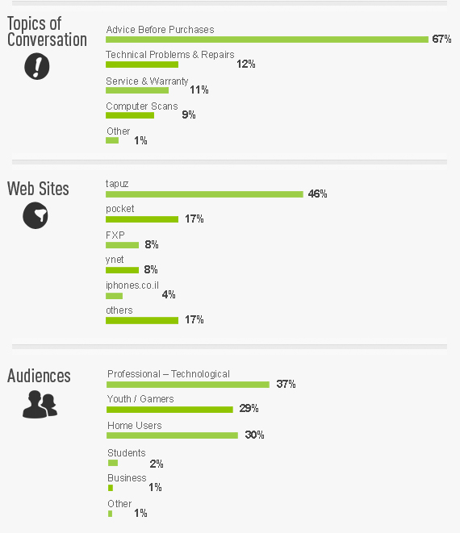

## Insights

David Hill, vice president, Lenovo corporate identity and design Hill spent more than 20 years at IBM, helping to create the company’s overall design identity. He joined Lenovo in 2005, overseeing the design of everything from servers to the ThinkPad line of notebooks. He has received 12 IDEA awards for his work, and the Design of the Decade honor for ThinkPad.

Analysis revealed that those talking about the brand fell into three groups: typical households, advanced online gamers (primarily young people), and users with a deeper technological understanding who were mainly focused on technical performance.

Among the positive factors revealed were the advanced and progressive features of most computers. Analysis revealed that the brand was highly regarded among both home and business users seeking reliable, lightweight models with maximum portability and ease of use in different environments. A challenge as well as an opportunity: improvement in these areas would likely contribute to more positive perceptions and enable the company to lure a market segment away from its competitor.

Regarding the relative positioning of competitors in this category, it appeared that the main source of Lenovo's strength came from the business sector, influenced by the reputation of IBM (which sold its laptop computer division to Lenovo). Dell, in contrast, was supported by uniform strength across a varied audience, due to its wide variety of models and its perceived image as a reliable, quality name brand.

# Lenovo’s consumer market

Lenovo has chosen a skillful mix of segmentation and Integrated Marketing and Communications (IMC).  Let’s look at some of the decisions made by Lenovo that lead to as successful Market Development strategy:

***“The consumer market is a new market for us in many places, and when we look at the consumer space and who determines the brand there, it is the youth market”.***

It is a bit shocking that the consumer market is new to Lenovo in many locations given the company’s size and success, yet the segmentation and attractiveness was based on the Revenue Generation.   Lenovo, as represented by David Roman, has decided that the youth market is underserved by Lenovo and revenue can be generated in this market.  Mr. Roman said further;

***“They (the youth market) decide whose hip and who’s not, whose cool and who’s not from the brand perspective.  That is different from the product perspective, where we (Lenovo) do well with different demographics. A college student in Beijing has more in common with a college student in New York than he does with his parents in Beijing”.***

[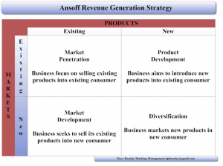](http://word.emerson.edu/emersonimc/files/2012/02/Anoff.png)Mr. Roman quote here has made a very clear decision on segmentation and total market attractiveness of the youth segment of 18-35 as his statement demonstrates.   The decision made, presumably on research data that the targeted consumer would be well suited by: Lenovo’s corporate strengths and the products they are already selling

With the market segment decided upon, Lenovo used IMC to connect with these consumers and generate more revenue; the “[Those that do](http://www.youtube.com/watch?v=TJJJaDMpCn0)” campaign.  “Those that do” is the tag line for Lenovo’s Market Development efforts.  These connections are designed to build credibility among the market segment, connecting with the segment where they are in their environments.  The company has developed key relationships with Google, MTV, YouTube, and Southwest Airlines to engage this segment.  Lenovo believes “partnerships are a jump start to gain recognition—their brand Halo extends to us.” 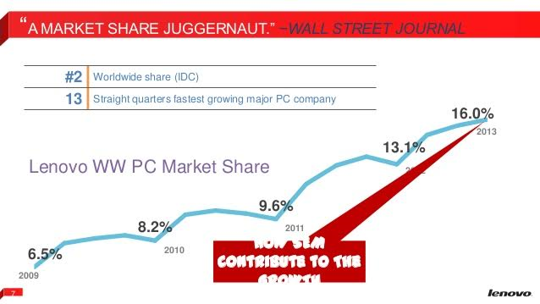

Sponsoring the annual Hopscotch Music fest, being a technical partner in Transformers 3, and Lenovo Lounge during New York fashion week are just some IMC programs Lenovo enacted.  Lenovo is even the technology partner on the International Space Station sponsoring High School science experiments.  Lenovo has made the right choices and H. Igor Ansoff would be proud.

According to Lenovo, they are now the largest computer maker in the world and the sales have gone up six hundred million in just the last quarter.

The growth of the revenue leads to other opportunities in the Ansoff matrix including product development and diversification.  A last piece of information from Lenovo demonstrates, Ansoff was right on. ***“For future growth, Lenovo is banking on its relatively new line of tablets, its ultra-books and smart phones”. Ansoff has three more quadrants for Lenovo to work with.***

# Consumer Profile

In the consumer Profile the company can approach such as age income education level and occupation. It is more chance to sell the product by analysing the techniques. College students they use the laptop for the education purpose and referring online articles and books. The business class people can focus on the market situation and checking mail. They can also store the valuable information in the storage devices.

Age: tweens and teens usually use their computer for study and online game, while Generation X use their computer for work and social contact. Lenovo's two main PC products ThinkPad and Idea Pad are different. Specifically, The Idea Pad design marked a deviation from the business-oriented ThinkPad laptops, towards a more consumer-focused look and feel (Jackson, 2008).

Gender: the purchasing habit of women cannot be overlooked in PC market, because most woman buyers focus the stylish appearance and lightweight portable design rather than the computer performance, such as software and hardware.

Family Size: Target all family sizes

Family life cycle: Lenovo laptops can be described as being affordable but still yet luxury, sophisticated and intelligent thereby not reserved not only for the middle age group but encompassing and catering to a whole range of individuals. So either someone is married, single, with children or couples or older Lenovo laptops do not limit its services to a specific group.

Income and Expenditure patterns: because the income directly determines the purchasing power of consumer, Lenovo PC products are distributed across low end market, mid-range market and high end market. Lenovo has been very aggressive in setting their prices they follow IBMs pricing policies which is price skimming and the range of Lenovo laptops are from $24500 to $54000, they are several high models also which are cost more than $100,000. Lenovo also use alternate pricing strategies to protect and attack market share and increase profits or grow the company. Lenovo offers customers with blend of affordable prices.

Occupation: As it includes all types of occupation but it mainly targets the professional, managers, and people in IT department or students.

Education: As it targets all the literate individuals with high level of education but specifically targeting professionals or executive suites. Executive Suites consists of upper-middle-class singles and couples who typically own a management career position. Located within suburban and exurban communities, these are consumers who hunger for the latest technology, financial products, aerobic exercises, and travel vacations

The key factor for Lenovo is to balance the price as well as the brand value. Lenovo offers customers with blend of affordable prices. Customers‟ focus has changed from product quality and price gradually to control energy consumption, frequency and quiet technology (Jack, Telaote, Lise, 2006). So Lenovo's market position should be made promptly converted to meet consumer demand. It is the origin of Lenovo to create the famous Chinese brand, and this existing connotation can continue exist and support Lenovo’s strategy choice. As for the supermarket channel, Lenovo has designed relatively low prices of mid-level products, while high-end products on the electrical chain and retail sales channels. For the rural market, Lenovo designs and develops products that have relatively simple functions, relatively low prices to meet the needs of the students market. A differentiation strategy is based upon persuading customers that a product is superior to that offered by competitors. Lenovo is seeking to differentiate itself which will organize its value chain activities to help create differentiated products and to create a perception among customers that these offering are worth a higher price.

Lenovo has since become the second-largest PC maker globally and introduced a 1.36 kg carbon-fibre ultrathin ThinkPad notebook

Even as sleek, slim and bendable laptops become ubiquitous, Lenovo still finds ways to stand out among its competitors. The company's new LaVie Z is the world's lightest laptop at just 1.72 pounds, and comes as either a standard clamshell or a Yoga-style convertible design. The new Yoga 3 improves on the notebook's ultra-flexible hinge while adding a taste of luxury watch-inspired style. The company brought a touch-enabled, rotating display to the Chromebook with the N20p, though the notebook suffers from poor viewing angles.

Besides all these recommendable features Lenovo needs to improve its brand image and create awareness as there are too many cheap products appearing in the world so it needs lower down its prices. The problem faced by the marketing team was clear; Lenovo has excellent products, they needed to sell more of these existing products to new customers. Selling in new markets with existing products is defined a Market Development by H. Igor Ansoff.

# Basis of Differentiation

A differentiation strategy is based upon persuading customers that a product is superior to that offered by competitors. Lenovo aims to differentiate its laptops through a number of strategies. It includes societal concept such as introduction to energy 4.0 star. More energy efficient and less carbon dioxide are the prime differentiating elements which Lenovo uses a pro environment technological producer. Thus energy star 4.0 saves as much as 15% manual electricity costs, allowing less thermal stress and longer lasting.

Furthermore Lenovo differentiates it’s Laptops through Product and cost innovation. Establishing ThinkPad allowed Lenovo to gain a strong foothold in international PC market. The company also focuses on differentiating through offering a reliable product to consumer by offering High Tech, Low cost approach. Moreover differentiation strategy is also aimed at managing the key market holders individually, For example when buying a medium priced laptop while evaluating pros cons it is believed that Dell has acute heating problems whereas it’s processor doesn’t allow long usage as it gets heated, similarly HP has also numerous hardware problems reported by its users. Lenovo offers best solution in similar or lesser price to its consumer allowing a better perception and basis of differentiation.

Thus Lenovo has been in business for more than 25 years and has been market leader in China before Internationalization. In terms of resources as well Lenovo differentiates itself from its competitors. Buying IBM PC division not only allowed it to go Global but also allowed to create a synergy of both the cultures and a closer study of western Market which is a huge market for Lenovo Products.

#### The major benefits to Lenovo of a successful differentiation strategy are:

(1) Its products will command a premium price.

(2) Demand or its product will be less price elastic than that for competitors‟ products.

(3) Above average profits can be earned.

(4) It creates an additional barrier to entry new business wishing to enter the industry.

Lenovo is seeking to differentiate itself which will organize its value chain activities to help create differentiated products and to create a perception among customers that these offering are worth a higher price

# Product Positioning

Lenovo laptops are an independent cognitive value in the eyes of consumers. It’s perceived as cost & product innovator of tech products unlike its competitors. It offers cheap prices due to low transaction cost yet high quality. Convenience and reliability is also an added future to perceived image of Lenovo laptops. Currently Lenovo is successfully able to capture value from households and domestic PC users through its product and brand awareness programmes, however it’s developing planes to capture the attention of High end users and compete with Apple which encompasses the image of luxury and long usages.

Thus innovation accompanied by quality is the prime objective of Lenovo which allow it to capture positive image in the minds of consumers.

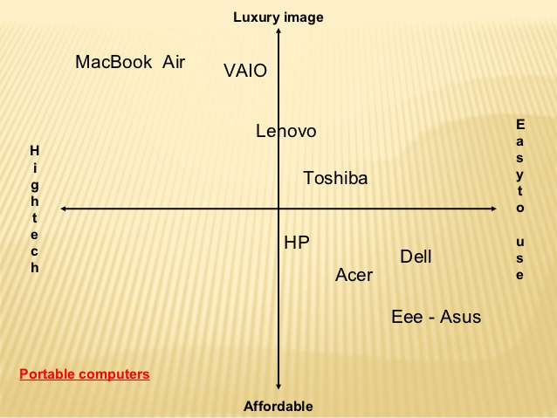

Through this perceptual mapping tool it can be analysed that for PC Lenovo is able to capture more value and create a luxurious image as well as a high tech one. Focused on providing high end quality design, speed performance and price.

# Market Segmentation and Positioning

Lenovo design different computers for variety need. The basic segmentation is commercial use and home use. This segmentation can be divided into many small categories.

### Targeting

Lenovo’s business strategy has witnessed a massive transformation over the past seven years. Surpassing rivals Dell and Acer, Lenovo became the world’s second largest pc vendor behind Hewlett Packard in its fiscal year of 2011. Recently, new target market segmentations have been established to endure this rapid trend of accomplishments. Lenovo’s current target markets include city customers, rural customers with strong brand awareness, customers with advanced concepts and a high level education. Amongst city consumers according to Claritas, the “Executive Suites” segment fits Lenovo’s targeted audience. Executive Suites consists of upper-middle-class singles and couples who typically own a management career position. Located within suburban and exurban communities, these are consumers who hunger for the latest technology, financial products, aerobic exercises, and travel vacations. They are consumers of IKEA commodities, who happens to play racquetball and are constantly active people with good physical health. The age ranges amongst this collection of citizens between thirty and fifty-five respectively. Usually, this segment of civilians is Asian and or Caucasian decent with four year college degrees. Stereotypically, the executive suite segment usually does not have more than one child per household. Categorized socially as affluentials, they tend to be big fans of healthy foods, effective computer equipment, consumer electronics, and the full range of big-box retailers. Being that Lenovo is on a brand escalation path in the industry, they target regions on this rise of technology such as rural consumers. According to the PRIZM Claritas reference, the market segment most suitable is referred as “Old Milltowns”. These consumers’ financial incomes statuses reside at a downscale rate due to the fact that majority are retired. Therefore, ages range between 65 years and older. Most of these citizens are homeowners with self-regulating employed children.

Lenovo computers are the second largest selling computer brand in the world after having bypassed Dell and Acer. They have a luxury problem in some ways, the brand is not well known, yet Lenovo’s sales grew 35% ending September 2011. Lenovo has had great success in enterprise and business to business (B2B) market segments. The company enjoys large market shares, dominating both business and industrial segments in China and India. In particular the ThinkPad, which this post is being typed on, enjoys a loyal following.

The in-house marketing team at Lenovo is led by David Roman, a former top executive at Apple and Hewlett Packard. David has assembled a team to focus on “brand experience integrating social media, design branded content, retail experience, event and strategic engagement and partnerships” The problem faced by the marketing team was clear; Lenovo has excellent products, they needed to sell more of these existing products to new customers. Selling in new markets with existing products is defined a Market Development by H. Igor Ansoff.

### Target Marketing Choice of Lenovo At present, Lenovo considers the following factors when choosing target market:

1) Strong brand awareness, city customers who have advanced concepts. In the personal computer market, the impact of Lenovo brand is comparative advantage, so choosing such target customers can cater to the needs of such customers.

2) Cities customers who have the high level of education, higher on admission, and are aged below 45. Lenovo called this crowd high-end crowd, the crowd is conducive to high-end products sales.

3) Developed rural market, those customers have strong brand awareness. This crowd has formed part of purchasing power, Moreover, Lenovo early did the act of the "free movies for countryside" to develop the rural market, the activities have brought the brand impact, so choosing this part of the crowd as the target customer group, apparently can quickly enter the rural market.

### Segmentation

The business strategy of Lenovo has the massive changes over the past years. The Lenovo has become the second world largest personal computer vendor in the year. The company took the innovation segmentation and that helps to establish to endure new trend of the accomplishment. The new market segmentation includes the city customers especially the rural customers with the great brand awareness. The Lenovo also focused on the customers with new concepts and high level educations. There are four market segmentation have been used in the market for the computer industry to push the product to the people.

•The geographic segmentations

•Demographic segmentation

•Psychographic segmentations

•Benefits segmentations

In these segments the focusing upon the consumer buys the product and they want to require in terms of service. The consumer buying process should also be considered in the market segmentations. The understanding of the customer needs helps to design the clears strategy to explore a good business. Since Lenovo’s top executives are from diverse areas of the world its target customer base and actual customer base is enormous as well.

### Demographic Segmentation (Consumer Profile)

In the demographic segmentation the company can approach such as age income education level and occupation. It is more chance to sell the product by analyzing the techniques. College students they use the laptop for the education purpose and referring online articles and books. The business class people can focus on the market situation and checking mail. They can also store the valuable information in the storage devices.

Gender: the purchasing habit of women cannot be overlooked in PC market, because most woman buyers focus the stylish appearance and lightweight portable design rather than the computer performance, such as software and hardware.

Age: tweens and teens usually use their computer for study and online game, while Generation X use their computer for work and social contact. Lenovo's two main PC products ThinkPad and Idea Pad are different. Specifically, The Idea Pad design marked a deviation from the business-oriented ThinkPad laptops, towards a more consumer-focused look and feel (Jackson, 2008).

Income and Expenditure patterns: because the income directly determine the purchasing power of consumer, Lenovo PC products are distributed across low end market, mid-range market and high end market.

### Geographic Segmentation

From 2009 to 2012, Lenovo divided the overall market based on mature market and emerging market. However, from January 2012 onward, Lenovo gave up this method of market segmentation, while Lenovo divided the global market into four parts: Chinese market, North American market, EMEA market (Europe, Middle East and Africa market) and Asia Pacific - Latin American market. In this four parts, Chinese market has a large number of population, which means great potential for profit growth. In contrast, North American market is relatively difficult to enter, because it is a mature market and consumers are loyal to former brands, such as Dell and HP. Overall, Lenovo combine its marketing efforts for countries and regions that share similar population and product-use patterns instead of treating each country or region as an independent segment.

The company can push their product in geographic segmentations with various groups in the locations. Since the laptop has been used all over the world for simple in structure. It could also focus on the different countries and continents. The approach is wide open for the product in all the countries.

Lenovo sells its laptops to almost every country in the world but has major consumers in China and India. Lenovo computers are the second largest selling computer brand in the world after having bypassed Dell and Acer. They have a luxury problem in some ways, the brand is not well known, yet Lenovo’s sales grew 35% ending September 2011.Lenovo has had great success in enterprise and B2B market segments. The company enjoys large market shares, dominating both business and industrial segments in China and India. In particular the ThinkPad, which this post is being typed on, enjoys a loyal following.

#### Employee profile

* Executive headquarters: New York
* Principle Operations: Beijing, Singapore
* Sales Headquarters: Beijing, Singapore, New York, Paris
* Manufacturing Centre’s: China, India
* Lenovo operates 46 world-class labs, including research centers in Yokohama, Japan; Beijing, Shanghai, Wuhan and Shenzhen, China; and Morrisville, North Carolina, U.S.

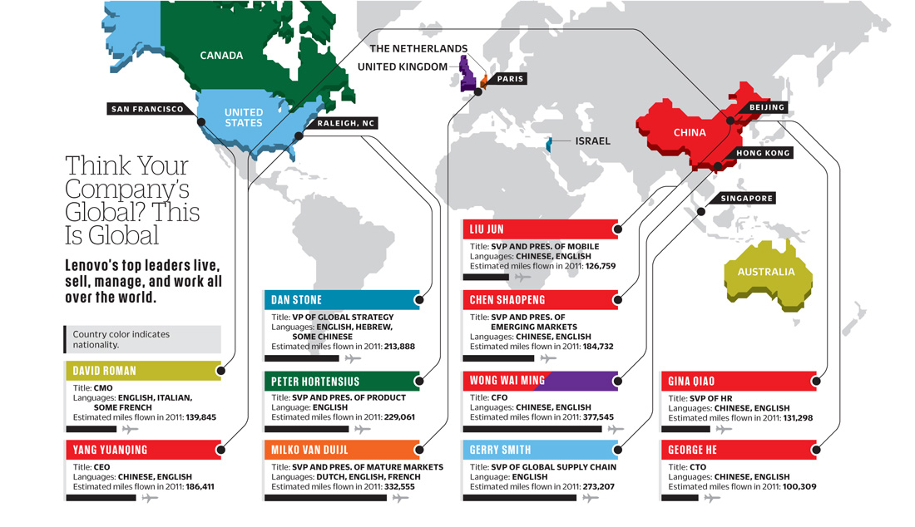

### Psychographic Segmentation

Lenovo's marketers quantify aspects of consumers' personalities and lifestyles to create goods and services for a target market. For example, Lenovo products advertisements are different in Mainland China and America. Because consumers in China focus on the performance of the product while American consumers focus on the spirit that the product convey. Furthermore, most Chinese PC consumers like comparing goods before taking money from their wallet, while European consumers prefer to pursue high-quality product and to make decision quickly.  
In the psychographic segmentation emphasize is on the lifestyle and interest of Lenovo’s customers. Some children have more interest in playing the videos games on the laptop and some people prefer to watch the movies on the laptop.

### Behavioural Segmentation

The benefit segmentation is related with the design and delivers the product to the consumer by offering the relevant service to the consumers.

#### *Customer segmentation*

##### General business purpose

Lenovo Company for business design the idea pad S, idea pad U and Think pad R

##### College students

For student group Lenovo mainly makes idea pad Y series.

##### Advanced Gamers

For advance games Lenovo offers 3000 series and Lenovo yoga

#### Segmenting shoppers

The primary focus of Lenovo’s effort to create a more personalized experience for shoppers involves segmentation work melding its own data with that of Neuter. Lenovo can use the data it now has on 25 million households to create differentiated online experiences based on trends and shopping histories.  As a result, the company has created eight different homepage “experiences” based on which segment it believes shoppers belong to, based in part of the type of product consumers are shopping for.  The campaign has driven an increase in pages per visit and other positive metrics. It also led to a 9 percent increase in intent to purchase a product from the company’s Yoga line, in one example that was tested against shoppers who were only exposed to the previous version of the Web site. Lenovo has also recently been experimenting with responsive design to optimize the experience on mobile, and has been active in other mobile marketing efforts as well.

For example, the company also has experimented with local search, creating pages targeting consumers in specific cities with a Google Map integration and partnering with retailers including Staples, Office Depot, Best Buy and Office Max. In addition to segmenting customers to customize experiences on Lenovo’s home page, the company also wants to take the experience deeper into the site and use segmentation to continually present appropriate web pages to shoppers as they dig deeper on the site.

In addition, Lenovo wants to use its data capabilities retarget customers with appropriate messaging.

### Product segmentation

Lenovo is popular with multiple product market segments:

1. As a study instrument assisted learning
2. As amusement (watching movies, videos and so on)
3. As a sport sponsor recognized by the fandom
4. As a friendly environment company accepted by public

#### Segment marketing

Lenovo for home: Y-Series

Lenovo innovation: 3000 Series, Lenovo yoga

Lenovo Business tools: Think Pad

#### Local marketing

Provides customer call and chat services in 15 different languages.

There are many methods to segment the overall market. After that, the company will choose the appropriate market as their target market. As to Lenovo, from 2009 to 2012, Lenovo divided the overall market based on mature market and emerging market. However, from January 2012 onward, Lenovo divided the global market into four parts: Chinese market, North American market, EMEA market (Europe, Middle East and Africa market) and Asia Pacific - Latin American market. Specifically, in mature market like North America, Lenovo covers low level, medium level, and high-level products, targeting various users ranging from individuals to large enterprises. Additionally, Lenovo is a market follower after Dell and HP and this pricing strategy can allow them to ensure values as well as the optimal price of the products in North American market. In contrast, Lenovo attack emerging market, such as Kenyan market, with cheap PCs, and the product range is fewer than American market. Furthermore, The Group's PC business across the mature markets are facing challenges in the retail channel due to significant slowdown in consumer demand. On the other hand, Lenovo begin to set up more specialty shops in Africa and Latin America, because people there don't adapt to online shopping and the demand from enterprise and government is low. Overall, Lenovo’s target market will be considered when making decision about the four marketing mix variables.

# Marketing Strategies

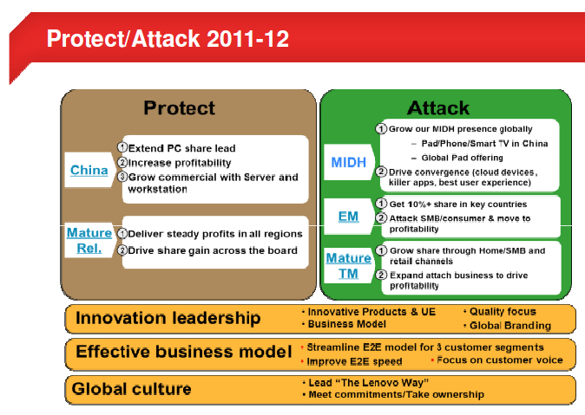

## Product

The Product Strategy of Lenovo Lenovo’s product strategy is the same as target market and positioning, mainly embodied as follows: Middle and High End Market Positioning Take Lenovo’s personal computer as example, the market survey shows that its refrigerators mainly focus on middle and high end, Lenovo owns 70% market share in high end products, while the middle end count for 40-50% market share, the market share of low end product is lower than 10%. Different Competition of Product Development Through segmenting the market, tapping users‟ unmet demand, thereby pre-empt competitors to develop completely different products from the market, exclusive share the cake of segment market. Seen from the introduction of Lenovo’s products in the past three years, we can see this development idea. In light of this situation, in 2001 Lenovo introduced the "ThinkPad" machines, which reaches not only to meet the needs of the users but also share the piece of cake alone. According to the Channels and the Difference of Segment Markets, Develop and Design Targeted Products As for the supermarket channel, Lenovo has designed relatively low prices of mid-level products, while high-end products on the electrical chain and retail sales channels. For the rural market, Lenovo designs and develops products that have relatively simple functions, relatively low prices to meet the needs of the students market. 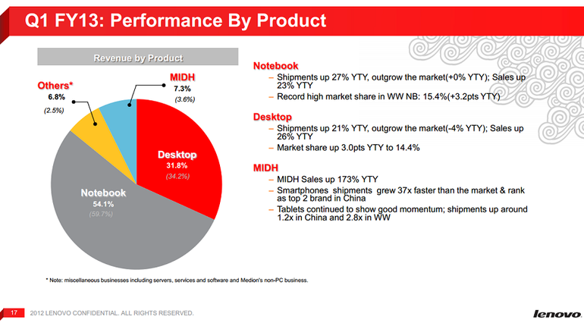

The product which has been chosen for the targeted segment is Lenovo Idea pad S-10 which is a line of consumer-oriented Netbook computers. The Lenovo Idea pad S -10 is ultra-portable product mainly for Internet applications with colorful fashion body, lightweight design and provides a variety of Internet experience. It can combine different Internet applications to meet user demands. Providing freedom is the products idea. It is designed for email, browsing the Web, and other computing activities on the go.

### Product Differentiation: Wider Quality Spectrum

Lenovo has the opportunity to provide a broad spectrum of services to the corporate market. With a reasonably high-quality, low cost series of computers in the Lenovo 3000 line, Lenovo can attack the same niche in the corporate market that allows Dell more than 50% of the market share: providing not only high-end notebooks and computers for executives, but also mid-spectrum machines for non-executives; people who don’t need to use the top of the line ThinkPad. In doing so, Lenovo has the potential to become a “one-stop shop” in the corporate market. At the same time, however, Lenovo needs to continue to focus on providing the most features in their high-end machines, ensuring that they maintain the reputation that the high-end ThinkPad series has built. An executive purchasing a computer is less likely to worry about a hundred dollar difference in prices than about the number of features a computer provides.

Apple’s response to Lenovo’s top-end products seems to have been to provide a lower cost product on purpose (undercutting) but only by skimping on quality. The MacBook Air, for instance, is intentionally priced at $100 less than the similarly lightweight, but more feature-intensive ThinkPad X300. Since Lenovo’ target is the corporate, rather than individual consumers this should be to our benefit. A worst case scenario in response to this suggested attack of the mid-spectrum market results in a price war for this market. This is difficult to avoid – by minimizing marginal costs, Lenovo can hope to “win” the price war and hurt its competitors in the process. Lenovo’s in-house manufacturing expertise will serve to give them the upper hand against a company like Dell in providing to the less-than-high-end corporate need. It is this advantage in marginal costs and the existence of Lenovo’s lower end 3000 line computers that makes this attack a wise choice.

### Complements to Compete with Apple and HP

HP and Apple have begun to demonstrate success in the marketing of complements in server interfacing technology and efficiency equipment, respectively, in the corporate market. It is likely, however, that if Lenovo were to partner with IBM to produce a complement with IBM server technology, both companies would stand to gain: while it is not in IBM’s interest to make their servers solely compatible with Lenovo products, cooperation to optimize interfacing makes both products more desirable for customers.

HP demonstrated that the software interfacing they introduced for their server systems increased productivity and popularity of their product in the corporate market. This same model, if applied to an IBM-Lenovo cooperation, might result in both continued positive brand identification for Lenovo, and an increase in popularity for both products – IBM already has a significant brand name for its server technology, on which Lenovo would likely be riding. While it is a much vaguer suggestion, Lenovo should also attempt to use their significant base as an electronics manufacturer and retailer to develop complements to their products that appeal to executives, modeling efforts after the ease with which Apple’s iPhone interfaces with Apple computers.

In both these instances, we must hope that Lenovo’s complement is more attractive or cheaper to executives than competing products – otherwise, such attempts are likely to fail to a similar extent that HP and Dell attempts at products like PDAs have failed. An improper method of complementing the device that makes the device is most likely to cause the synergy to fail. The device might be too dependent on purchase of a Lenovo notebook, resulting in an inability to generate widespread demand for the product making it an ineffective draw for Lenovo products, or not dependent enough on such a purchase, resulting in an ineffective pairing.

## Brand positioning

The development of China’s smartphone industry has allowed a production chain to form and mature. Assembling modules and parts into smartphones has become a profitable business. This leads to the burst of budget smartphone brands. While many domestic brands still depend on low price to boost sales without properly managing brand equity, some have stepped up the game and are establishing solid brand image through differentiating brand positioning.

Diagram 1: Baidu’s Top Searched Smartphone Brands 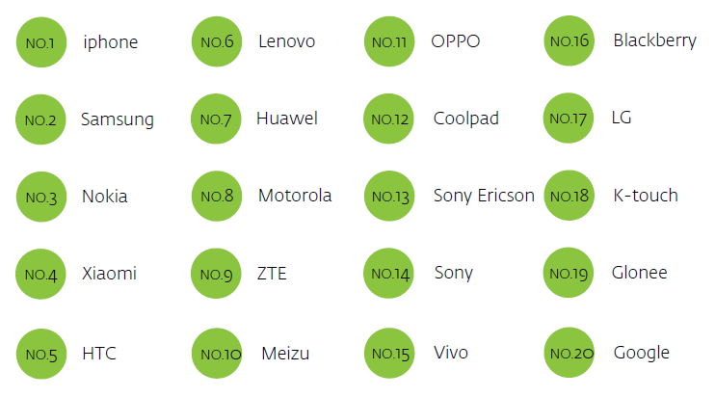

Lenovo has seized the opportunity to boost its smartphone division. Thanks to its strong foothold in the PC territory, Lenovo is able to leverage its high brand esteem and knowledge while establishing a successful distribution network all over the country. By focusing on medium-low end markets, Lenovo has increased its market share from 5 percent in 2011 to 10.4 percent in 2012, while Apple’s and Samsung’s dropped by 2.1 and 5.8 percent.  Since 2012, Lenovo has become the No.2 smartphone brand in China and No.5 in the world.

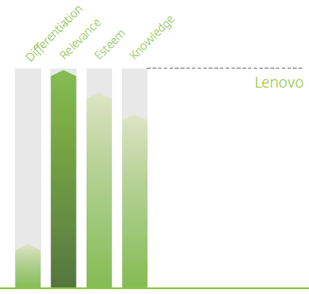As one of China’s biggest technology brands, Lenovo enjoys long-established brand stature in the domestic market. Moreover, Lenovo smartphones have a strong relevance among the mass consumers due to the high cost-efficacy. The downside is that differentiation is greatly lacking for the brand.

## Pricing Strategy

There are many companies in the market, which have a better reputation than Lenovo in the computer world. Hard work of the company and a strong commitment to providing the best for the people helped with the harvest of a global customer base. This is the main reason why Lenovo has become the world’s fourth largest provider of PCs worldwide in a very short time.

Lenovo is priced competitively when compared to other top brands. In fact, in some areas like accessories it also uses penetrative pricing. The key factor for Lenovo is to balance the price as well as the brand value. If priced too low, then Lenovo risks the drop of brand image and positioning in the mind of customers. However, if priced too high, Lenovo will lose customers to competitors like Dell and Hewlett Packard. Laptops are one of the leading products for Lenovo where it is strongly placed on the pricing front having high value for the demanded price of the product. Lenovo is subject to the price war as large computer manufacturer however Lenovo did not reduce price while the corporate image enhanced, sales grew and market share expanded.

Lenovo developed different prices by creating differential products to meet different consumer groups. Lenovo cannot set high prices than that of their competitors because there production costs are not that high and they assemble their laptops in china so they cannot charge high prices as compared to their competitors so they use going rate pricing or penetration pricing. Lenovo has been very aggressive in setting their prices they follow IBMs pricing policies which is price skimming and the range of Lenovo laptops are from $24500 to $54000, they are several high models also which are cost more than $100,000. Lenovo also use alternate pricing strategies to protect and attack market share and increase profits or grow the company. Lenovo offers customers with blend of affordable prices. 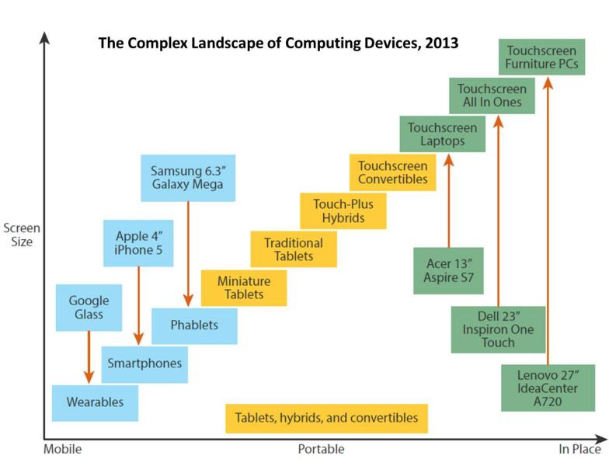

If a person decides to buy a computer system, Lenovo India is the name of a very respectable place in the priority list. The company also tightened its grip on the PC market through the acquisition of IBM’s PC division in 2005. Lenovo is not a name that is restricted for a certain Product, but that there is a long list of products that are sold under the same brand needs. Some of them are as follows:

* Lenovo Think Centre
* Think Station Lenovo
* Idea Centre desktop
* Lenovo Think Server
* Consumer-oriented Idea Pad notebooks
* Lenovo 3000 J Series desktops
* Lenovo 3000 C, N and V series notebooks and LCD monitors

CRT projectors and Think Vision monitors Lenovo signed an agreement allowing them to sell under the brand name of IBM laptops and desktops by 2010. Lenovo notebooks and business machines are available with Linux pre-installed.

### Lenovo Pricing in India

Pricing strategy of this company is one that takes note of the key considerations of the customer, which is nothing more than the price of the product. Probably for this reason, almost every product that comes from the production of the parent company is reasonably priced. Lenovo has been very aggressive in its pricing strategy with its different series of laptops and respective models. Lenovo initially followed IBM’s pricing policy.

This can be considered skimming done by a company which wants to earn as much as possible. Lenovo Laptops prices are in the range of Rs.24500 to Rs.54000.There are several high end models also which cost more than Rs. One Lakhs. Dell is the market leader which offers an AMD Athlon processor in its lowest costing desktop worth 16000Rs.In the same category, Lenovo introduced the 3000Hseries-a P4 processor for Rs 18000/-.Lenovo has always maintained a product mix such as bread and butter products like 3000H series and high end products like ThinkPad and Think centre

Price strategy of Lenovo In recent years, the production capacity of IT enterprises seriously exceeds, and this causes to expand market share and the price war has become worse. As a large computer manufacturer, of course, Lenovo is subject to the impact of the price war. However, Lenovo was demonstrated most vividly in this price war, Lenovo did not reduce price, while the corporate image enhanced, sales grew and market share expanded, the effective price strategy has enabled Lenovo to exceed in the economy of excessive capacity. Based on different levels of consumers, Lenovo developed different prices, by creating differentiated products to meet different consumer groups, formulating differential price discrimination. Lenovo domestic market sales operator, Yang (2006) said, Lenovo's production line is continuity, so prices of their products are also of continuity, from more than 10,000 Yuan to more than 2000 Yuan. Almost every 500 Yuan there are two products to serve the different needs and purchasing power of consumers. Lenovo now has 19 species, 200 various models of products; Lenovo's exports and diversified product enable it to avoid involvement in domestic plague of the price war impact of its competitors. We can see that Lenovo's price strategy can according to products in accordance with the best performance of the physical value, brand value, the value of service and other form of value make Lenovo establish an independent retailer.

Cognitive value in the eyes of consumers, which can be the base of the price of Lenovo products and achieve the relatively independent cognitive value system. This awareness of the value system is not set up like the prices can be as simple imitation. Such an independent value and the price of Lenovo model are built on years of accumulated brand and the concept of service. This created a core competitiveness of Lenovo brand and Lenovo is still invincible in the fierce competition.

Differentiation Strategy

A differentiation strategy is based upon persuading customers that a product is superior to that offered by competitors. The major benefits to Lenovo of a successful differentiation strategy are:

(1) Its products will command a premium price.

(2) Demand or its product will be less price elastic than that for competitors‟ products.

(3) Above average profits can be earned.

(4) It creates an additional barrier to entry new business wishing to enter the industry.

Lenovo is seeking to differentiate itself which will organize its value chain activities to help create differentiated products and to create a perception among customers that these offering are worth a higher price.

Focus Strategy

A focus strategy is aimed at a segment of the market for a product rather than at the whole market or many markets. The major benefits of Lenovo‟ focus strategies are:

(1) It requires a lower investment in resources compared to a strategy aimed at an entire market or many markets.

(2). It allows specialization and greater knowledge of the segment being served.

(3). It makes enter to a new market less costly and much simpler.

Since Lenovo is regarded to adopt cost leadership as its development strategy which share some features of differentiation in the current by the author, the Lenovo’s competent advantage is developed from differentiation and cost saving through value chain.

Its core competence is illustrated:

* Improved supply chain;
* A cheaper price through lower transaction costs;
* Convenience and twenty-four-hour access;
* Good reputation among customers;
* Quick and efficient search capability;
* The personality of the service;
* Wide selection and one-stop shopping;
* First mover in the market stronger than average and well-known.

Lenovo famous brand names makes Lenovo stay well in the fierce market competition, Lenovo’s lot of advertising budgets provided a strong guarantee for the material in order to maintain the competitiveness of Lenovo brand. Over the years, Lenovo brand and Lenovo advertising leave a deep impression in people’s minds, enhancement of brand recognition, is actually the acceptance of Lenovo cultural diffusion.

## Placement

Lenovo has exclusive showrooms as well as multi brand showrooms. It markets itself through modern retail, E commerce chains, and majorly through the vast numbers of IT and peripheral shops present across the country. Typically, Lenovo operates through channel sales wherein distributors are associated with the company. These distributors in turn give to individual retailers and channel dealers. At the same time, Lenovo sells the products directly through modern retail and through online channels. Because of channel marketing concept, Lenovo has been able to spread far and wide for its products. Today, Lenovo has 60000 employees and is present in 160 countries across the globe. The business line that is focused is laptops so the places where you can buy Lenovo laptops in USA are as follow:

## Promotion

Even strong brands require promotional support for successful brand extension. The Lenovo is a strong brand, and the Idea pad can be considered either a new brand (in addition to the other Lenovo products such as ThinkPad), or a brand extension (of the Lenovo). Lenovo has always showcased its products as the right fit for their customers which will get the work done. The concept that they have is that there products are machines which "do the work" for the customers. It uses many ATL as well as BTL mediums to get its products across to end customers. The Idea pad can be considered either a new brand (in addition to the other Lenovo products such as ThinkPad), or a brand extension. The main goal is to Build and enforce brand awareness and help establish credibility among target customers by community engagement and media engagement. They can achieve these by using tools such as print media, web site, TV, radio, direct mail, and outdoor billboards etc. Idea pad get involved in public activities such as charity shows and fundraising events. It also connect with local organizations like Universities and High school through education fares. Students can use net books for free. People use Facebook, twitter and blogs as information platform to connect with young people and encourage their happy customers to make Tweets and posts on Facebook and blogs. Lenovo also advertise its products on radios and television throughout the world to spread the awareness about their products and latest additions to people. Lenovo also use various search engines and official sites to advertise its latest laptops. Lenovo made ThinkPad as the bridge to increase the brand value in international market. Very strong strategy used by Lenovo was in 2008 for Olympics.

### The main goals for us are:

1. Build and enforce brand awareness;

2. Help establish credibility among target customers.

The main promotions strategies will therefore include community engagement and media engagement. We can achieve these by using tools such as print media, web site, TV, radio, direct mail, and outdoor billboards etc.

### Community Engagement

Idea pad S-10 to get involved in public activities such as charity shows and fundraising events.

Connect with local organizations like Universities and High school through education. Let these students use netbooks for free.

Use Facebook, Twitter and blogs as information platform to connect with young people and encourage their happy customers to make Tweets and posts on Facebook and blogs.

### Media Engagement

Television: Advertisement will be released on free-to-air channel like ABC, Channel 7, Channel 9, Channel 10 and SBS, and subscription broadcasting, such as Foxtel.

Radio: Radio is a nearly ubiquitous medium in Australia and has strong potential as an advertising medium. Advertisement will be released on some music channel like b105 in Brisbane.

Lenovo should build various communication mixes so that it can connect to its key group.

# Product Profile

Computer and IT based market is highly volatile and has numerous challenges that follow it, and to overcome it a participant has to offer variety and technologically advanced products in order to stay abreast and sustain the market. Lenovo is a brand that has widely differentiated and has not depended upon a solitary class of items or administrations for its extension. The key for Lenovo has been to furnish the business sector with a wide mixed bag of technology driven products to satisfy their separate aspirations. This development has been focused around a broad research and investigation of approaching needs of its clients and distinguishing a need even before it exists, which makes an unedifying dependability and dependence among clients and customers. It has offered machines, and continually enhanced them at consistent interims, and wandered into working frameworks, and giving changes on them consistently keeping the pace alongside the business sector.

The products of Lenovo are known to be dependable and reliable. As we are focusing on the Lenovo laptops the range it includes or the laptops it offers are as follow:

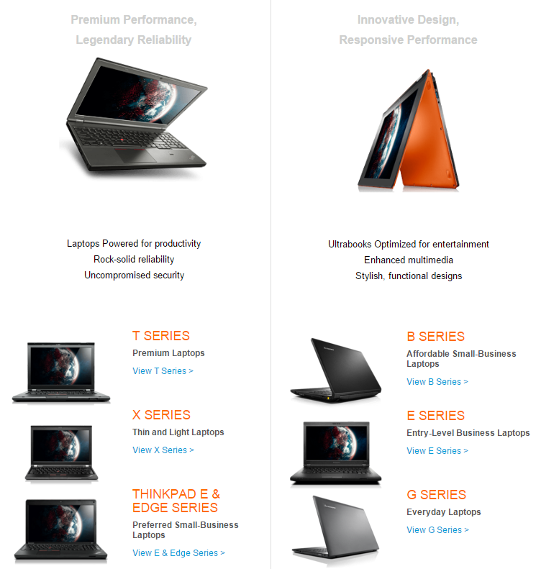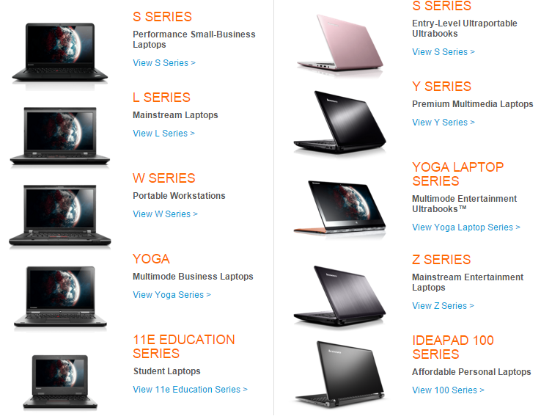

Lenovo is priced competitively when compared to other top brands. In fact, in some areas like accessories it also uses penetrative pricing. The key factor for Lenovo is to balance the price as well as the brand value. If priced too low, then Lenovo risks the drop of brand image and positioning in the mind of customers. However, if priced too high, Lenovo will lose customers to competitors like Dell and Hewlett Packard. On the mobile front, Lenovo has too less models to be actually competitive and hence it uses a cost plus pricing method where a fixed mark-up is added to the product. In the end, laptops are one of the leading products for Lenovo where it is strongly placed on the pricing front – having high value for the demanded price of the product.

Lenovo has exclusive showrooms as well as multi brand showrooms. It markets itself through modern retail, E commerce chains, and majorly through the vast numbers of IT and peripheral shops present across the country. Typically, Lenovo operates through channel sales wherein distributors are associated with the company. These distributors in turn give to individual retailers and channel dealers. At the same time, Lenovo sells the products directly through modern retail and through online channels. Because of channel marketing concept, Lenovo has been able to spread far and wide for its products. Today, Lenovo has 60000 employees and is present in 160 countries across the globe. The business line that is focused is laptops so the places where you can buy Lenovo laptops in USA are as follow:

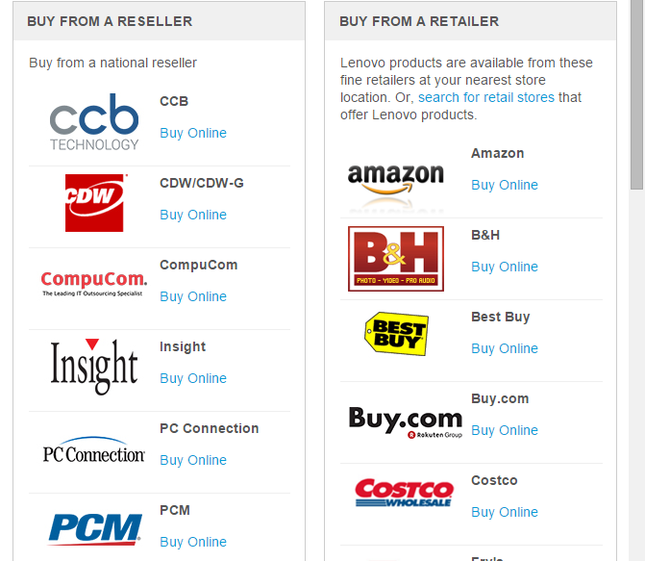

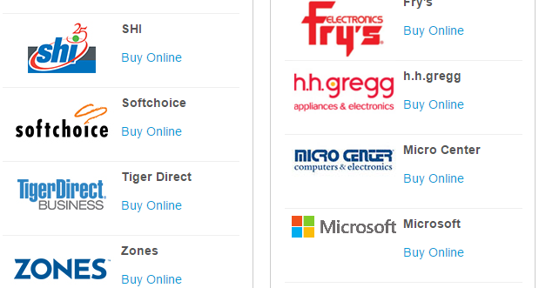

Due to its products, Lenovo has a certain measure of headway when it concerns the promotions department. The technology segment and especially the IT market is filled with competitors like HP, Dell and Microsoft to make the competition very high in the segment. However, by using the right marketing communications and by targeting geeky customers who like a bit of zing in the products that they use, Lenovo has hit the right promotions mix. It has always showcased its products as the right fit for their customers – which will get the work done. The concept is that Lenovo makes machines which “Do the work” for the customers. The company uses various ATL as well as BTL mediums to get its product across to end customers

# Conclusion: Lenovo Should Split and Diversify

In order to help maintain the positive brand identity of Lenovo’s, we therefore suggest that Lenovo not only begin to provide a wide spectrum of qualities of product but also that they form two separate companies for the marketing of these different products. The main focus of this diversification will be to attack the mid-spectrum corporate market and provide a wider spectrum of solutions for corporate customers, making a direct play for the products that have made Dell dominant in the market. It is likely, however, that an association of lower-quality Lenovo products with ThinkPad’s will diminish the ThinkPad reputation and lose customers in the long run. In order to attack the Dell market safely, without diminishing existing profits in the high-end corporate market, the ThinkPad

should be marketed through a spin-off company centred in Silicon Valley – the reputation of such a company centred on marketing the ThinkPad would hold up much better than the current apparent strategy of marketing both Lenovo and ThinkPad products under the same brand after the loss of the IBM brand name.