FACTORY-TO-CUSTOMER SHIPPING ROUTE EFFICIENCY ANALYSIS
FOR NASSAU CANDY DISTRIBUTOR

RESEARCH PAPPER

Submitted By
Sonu Kumar
Internship Organization
Unified Mentor

Internship Domain
Data Analytics

Project Dataset
Nassau Candy Distributor Sales Dataset

Technologies Used
Python | Pandas | NumPy | Matplotlib | Streamlit | Git & GitHub

Abstract
Efficient logistics and shipping management are essential components of modern supply chain operations. Organizations that distribute products across multiple regions generate a large amount of shipment and sales data every day. Analyzing this data helps businesses improve delivery performance, reduce operational delays, increase customer satisfaction, and maximize profitability. However, extracting meaningful insights from large datasets through manual analysis is difficult and time-consuming.
This research presents a comprehensive shipping route efficiency analysis for the Nassau Candy Distributor dataset using data analytics and business intelligence techniques. The dataset consists of 10,194 shipment records and 18 attributes, including order details, shipping information, customer locations, product information, sales, units sold, gross profit, and shipping cost. Data preprocessing techniques such as cleaning, data type conversion, duplicate removal, and feature engineering were applied to improve data quality. A new feature, Shipping Lead Time, was created to evaluate delivery efficiency by calculating the time difference between the order date and ship date.
Exploratory Data Analysis (EDA) was performed to identify sales trends, regional performance, product demand, and shipping patterns. Key Performance Indicators (KPIs) including Total Sales, Total Profit, Total Orders, Total Units Sold, and Average Shipping Lead Time were developed to support business decision-making. Interactive dashboards were implemented using Streamlit and Microsoft Power BI to provide visual insights into shipping performance, regional sales distribution, product analysis, and delivery efficiency.
The proposed analytics solution enables business managers to monitor logistics performance, identify profitable business areas, evaluate shipping efficiency, and make data-driven strategic decisions. The study demonstrates how modern analytics tools can enhance supply chain visibility and improve overall business performance.

Keywords
Supply Chain Analytics, Shipping Route Analysis, Business Intelligence, Data Analytics, Python, Streamlit, Power BI, Logistics, Sales Analysis, Dashboard.

1. Introduction
1.1 Background
In today's highly competitive business environment, efficient logistics and supply chain management have become critical factors for organizational success. Companies that distribute products across multiple cities and regions process thousands of customer orders every day. Managing these shipments efficiently is essential for reducing operational costs, improving delivery performance, increasing customer satisfaction, and maximizing business profitability.
With the rapid growth of e-commerce and large-scale distribution networks, organizations generate a significant amount of operational data related to customer orders, shipping methods, sales transactions, product distribution, and regional performance. However, without proper data analysis techniques, this information remains underutilized and does not contribute effectively to strategic decision-making.
Data Analytics and Business Intelligence (BI) provide organizations with powerful techniques to transform raw business data into meaningful insights. Through data preprocessing, visualization, and dashboard development, companies can monitor key performance indicators (KPIs), identify operational bottlenecks, evaluate shipping efficiency, and optimize business performance.
This research focuses on analyzing the shipping performance of the Nassau Candy Distributor dataset by applying modern data analytics techniques. The study uses Python, Streamlit, and Microsoft Power BI to develop an interactive analytics solution that enables business managers to evaluate shipping efficiency, regional sales performance, product demand, and overall logistics operations.

1.2 Motivation
The motivation behind this research is to demonstrate how business data can be transformed into actionable insights through modern analytics tools. Many organizations possess large volumes of shipment and sales data but struggle to extract meaningful information for strategic planning.
The Nassau Candy Distributor dataset contains valuable information about customer orders, shipping modes, products, sales, and profitability. By analyzing this dataset, it becomes possible to identify business trends, compare regional performance, evaluate delivery efficiency, and support data-driven decision-making.
The project also aims to strengthen practical knowledge in data preprocessing, exploratory data analysis (EDA), business intelligence, and dashboard development using industry-standard tools.

1.3 Scope of the Study
The scope of this research is limited to analyzing the shipment and sales data available in the Nassau Candy Distributor dataset. The study includes data cleaning, preprocessing, feature engineering, exploratory data analysis, KPI generation, and interactive dashboard development.
The analysis focuses on identifying business insights related to sales performance, profitability, shipping efficiency, regional distribution, and product performance. Interactive dashboards developed using Streamlit and Microsoft Power BI provide visual representations of these insights, enabling users to monitor business performance efficiently.
This research does not include predictive modeling, machine learning algorithms, or real-time logistics tracking. Instead, it emphasizes descriptive analytics and business intelligence techniques for improving supply chain visibility and supporting strategic business decisions.

2. Literature Review
Several researchers have explored the application of data analytics, business intelligence, and supply chain management to improve logistics performance and organizational decision-making. The following studies provide the theoretical foundation for this research.
Song (2021) presented a comprehensive review of container shipping supply chain planning and highlighted that digital technologies such as data analytics, artificial intelligence, and Internet of Things (IoT) can significantly improve logistics efficiency. The study also emphasized that fragmented logistics operations reduce overall supply chain performance and that integrated analytics platforms are essential for better decision-making.
Lodemann et al. (2022) investigated supply chain analytics from both academic and industry perspectives. Their review showed that descriptive, predictive, and prescriptive analytics help organizations improve planning, optimize operations, and enhance business performance. However, they also identified a gap between research and real-world implementation of analytics solutions.
Darbanian et al. (2024) conducted a systematic literature review covering more than 350 research papers related to data analytics in supply chain management. Their findings indicate that data analytics is increasingly being used for demand forecasting, inventory optimization, logistics management, and transportation planning. The authors also highlighted the growing use of hybrid analytics models in modern supply chain systems.
Wairimu (2024) reviewed the definitions, characteristics, and applications of supply chain analytics. The study concluded that big data analytics improves procurement, inventory management, logistics, and order processing by enabling organizations to make more accurate and timely business decisions.
Previous research has also emphasized the importance of supply chain visibility. Studies show that providing accurate, timely, and accessible logistics information improves operational efficiency, customer satisfaction, and strategic planning. Better visibility helps organizations monitor shipments, detect delays, and optimize business processes.
Although many studies discuss supply chain analytics and logistics optimization, limited research demonstrates an end-to-end implementation that combines data preprocessing, exploratory data analysis, KPI development, and interactive dashboards using modern business intelligence tools on a real business dataset. This research addresses that gap by analyzing the Nassau Candy Distributor dataset and developing interactive dashboards using Python, Streamlit, and Microsoft Power BI to evaluate shipping performance, sales trends, profitability, and logistics efficiency.
Research Gap
The literature indicates that modern supply chain analytics has made significant progress in improving logistics operations. However, many studies focus primarily on theoretical models or specific optimization techniques, while fewer studies present a complete practical workflow that starts with raw shipment data and ends with interactive business dashboards. Additionally, there is limited work demonstrating the integration of Python-based data preprocessing, KPI analysis, and visualization tools such as Streamlit and Power BI within a single analytics framework. Therefore, this research aims to bridge this gap by developing a complete business intelligence solution for analyzing shipping route efficiency and supporting data-driven decision-making using the Nassau Candy Distributor dataset.

3. Problem Statement
In today's competitive business environment, organizations generate large volumes of sales and shipping data through their daily operations. Although this data contains valuable business information, it often remains underutilized due to the absence of an effective analytical framework. Traditional reporting methods primarily focus on historical records and are not sufficient to identify operational inefficiencies, regional sales trends, product performance, or shipping delays.
The Nassau Candy Distributor dataset contains shipment records from different regions, cities, products, and shipping modes. However, without systematic analysis, it is difficult for decision-makers to answer important business questions such as:
- Which regions generate the highest sales and profit?
- Which products contribute most to business revenue?
- How efficient are different shipping modes?
- What is the average shipping lead time?
- Which business areas require operational improvement?
The absence of an integrated business intelligence solution makes it challenging to monitor Key Performance Indicators (KPIs) and identify hidden business patterns. Therefore, there is a need to develop a comprehensive data analytics solution that transforms raw shipment data into meaningful business insights through visualization and interactive dashboards.
This research addresses these challenges by applying data preprocessing, exploratory data analysis, KPI generation, and business intelligence techniques using Python, Streamlit, and Microsoft Power BI.

4. Objectives of the Study
The primary objective of this research is to analyze the shipping and sales performance of the Nassau Candy Distributor dataset using modern data analytics and business intelligence techniques.
The specific objectives of this study are:
- To understand and preprocess the shipment dataset by handling missing values, data type inconsistencies, and duplicate records.
- To perform Exploratory Data Analysis (EDA) for identifying sales trends, regional performance, product distribution, and shipping patterns.
- To calculate and analyze important business Key Performance Indicators (KPIs), including Total Sales, Total Profit, Total Orders, Total Units Sold, and Average Shipping Lead Time.
- To evaluate regional sales and profitability for identifying high-performing and low-performing business areas.
- To compare different shipping modes based on delivery performance and operational efficiency.
- To analyze product-wise sales and profitability to identify the most valuable products.
- To design interactive business intelligence dashboards using Streamlit and Microsoft Power BI for effective business monitoring.
- To provide actionable business insights that support data-driven decision-making and improve supply chain performance.
Expected Outcomes
The expected outcomes of this research include:
- A clean and structured shipment dataset suitable for analysis.
- Identification of major sales and profit trends.
- Evaluation of shipping efficiency using Shipping Lead Time.
- Interactive dashboards for business visualization.
- Business recommendations based on analytical findings.
- Improved decision-making through data-driven insights.
5. Dataset Description
The dataset used in this research is the Nassau Candy Distributor Sales Dataset, which contains transactional records related to customer orders, shipping information, product details, and financial performance. The dataset represents business operations across multiple regions and provides sufficient information for analyzing shipping efficiency, sales performance, and profitability.
The dataset was used to perform data preprocessing, exploratory data analysis (EDA), key performance indicator (KPI) analysis, and dashboard development. It serves as the primary data source for evaluating logistics performance and identifying business trends.

5.1 Dataset Overview
Attribute | Details
Dataset Name | Nassau Candy Distributor Sales Dataset
Total Records | 10,194
Total Columns | 18
Data Type | Structured Tabular Data
File Format | CSV
Domain | Supply Chain & Sales Analytics
Purpose | Shipping Route Efficiency Analysis

5.2 Dataset Attributes
The dataset contains the following attributes:
S.No | Attribute Name | Description
1 | Row ID | Unique identifier for each record
2 | Order ID | Unique order number
3 | Order Date | Date on which the order was placed
4 | Ship Date | Date on which the order was shipped
5 | Ship Mode | Shipping method used for delivery
6 | Customer ID | Unique customer identifier
7 | Country/Region | Customer's country or region
8 | City | Customer's city
9 | State/Province | Customer's state or province
10 | Postal Code | Postal code of customer location
11 | Division | Business division
12 | Region | Business region
13 | Product ID | Unique product identifier
14 | Product Name | Name of the product
15 | Sales | Total sales amount
16 | Units | Number of units sold
17 | Gross Profit | Profit generated from the order
18 | Cost | Cost of the product

5.3 Feature Engineering
To improve the analysis, an additional feature named Shipping Lead Time was created. This feature measures the number of days between the Order Date and the Ship Date.
The Shipping Lead Time helps evaluate delivery efficiency and compare shipping performance across different shipping modes and regions.

5.4 Importance of the Dataset
The Nassau Candy Distributor dataset is suitable for business analytics because it integrates sales, customer, product, and shipping information within a single dataset. This enables comprehensive analysis of business performance from multiple perspectives.
Using this dataset, it is possible to:
- Analyze regional sales performance.
- Measure business profitability.
- Compare shipping modes.
- Evaluate delivery efficiency.
- Identify top-performing products.
- Support data-driven business decision-making.
6. Research Methodology
6.1 Overview
The research methodology adopted in this study follows a systematic data analytics approach to evaluate the shipping efficiency and business performance of the Nassau Candy Distributor dataset. The methodology consists of multiple stages, including data collection, data preprocessing, exploratory data analysis (EDA), KPI generation, dashboard development, and business insight extraction. Each stage plays an important role in transforming raw business data into meaningful information that supports strategic decision-making.
The complete workflow ensures that the collected data is cleaned, analyzed, visualized, and interpreted accurately before presenting the final business insights.

6.2 Research Workflow
The methodology adopted in this research consists of the following sequential steps:
Step 1: Data Collection
The first stage involved collecting the Nassau Candy Distributor Sales Dataset in CSV format. The dataset contains shipment records, sales information, product details, customer locations, and financial data, which serve as the primary source for analysis.

Step 2: Data Preprocessing
The collected dataset was preprocessed to improve data quality before analysis. The preprocessing activities included:
- Checking missing values
- Identifying duplicate records
- Converting data types
- Formatting date columns
- Removing inconsistencies
- Standardizing the dataset
These preprocessing steps ensured that the dataset was accurate, clean, and ready for further analysis.
Step 3: Feature Engineering
To enhance the analysis, a new feature named Shipping Lead Time was created by calculating the difference between the Ship Date and the Order Date. This feature was used to evaluate delivery efficiency across different shipping modes and business regions.
Step 4: Exploratory Data Analysis (EDA)
Exploratory Data Analysis was performed to understand the characteristics of the dataset and identify meaningful business patterns. Various visualizations and statistical summaries were used to analyze:
- Sales distribution
- Profit distribution
- Regional performance
- Product performance
- Shipping mode analysis
- Customer order trends
EDA helped identify hidden relationships and supported better business understanding.

Step 5: KPI Analysis
Key Performance Indicators (KPIs) were generated to measure business performance. The primary KPIs analyzed in this research include:
- Total Sales
- Total Profit
- Total Orders
- Total Units Sold
- Average Shipping Lead Time
- These KPIs provide a quantitative overview of the organization's operational performance.
Step 6: Dashboard Development
Interactive dashboards were developed using Streamlit and Microsoft Power BI. The dashboards provide graphical representations of business performance and allow users to explore sales trends, shipping efficiency, regional performance, and product analytics through interactive visualizations.

Step 7: Business Insight Generation
The final stage involved interpreting the analytical results obtained from the dashboards. Business insights were generated by identifying high-performing regions, profitable products, shipping trends, and operational improvement opportunities. These insights can assist managers in making informed, data-driven decisions.

6.3 Tools and Technologies
The following tools and technologies were used throughout the research:
Tool / Technology | Purpose
Python | Data analysis and preprocessing
Pandas | Data manipulation
NumPy | Numerical computations
Matplotlib | Data visualization
Plotly | Interactive charts
Streamlit | Interactive dashboard development
Microsoft Power BI | Business intelligence dashboard
Git & GitHub | Version control and project management
6.4 Methodology Summary
The proposed methodology provides a structured framework for transforming raw shipment data into actionable business insights. By integrating data preprocessing, feature engineering, exploratory data analysis, KPI evaluation, and dashboard visualization, the research offers a comprehensive approach for analyzing shipping performance and supporting business decision-making
7. Data Preprocessing
7.1 Overview
Data preprocessing is one of the most important stages in any data analytics project because the quality of the analysis depends on the quality of the data. Raw datasets often contain missing values, duplicate records, inconsistent formats, and incorrect data types, which can lead to inaccurate results if not handled properly.
In this research, the Nassau Candy Distributor dataset was preprocessed before performing exploratory data analysis and dashboard development. The objective of preprocessing was to improve data quality, maintain consistency, and prepare the dataset for reliable business analysis.

7.2 Data Inspection
The first step involved examining the structure of the dataset to understand the available attributes and their data types. The dataset consisted of 10,194 records and 18 attributes representing order details, shipping information, customer location, product information, sales, profit, and cost.
The dataset was inspected to identify:
- Missing values
- Duplicate records
- Incorrect data types
- Invalid entries
- Data inconsistencies
This inspection provided a clear understanding of the dataset before applying preprocessing techniques.
7.3 Missing Value Analysis
The dataset was examined for missing or null values across all attributes. Missing values can negatively affect statistical analysis and business insights. Therefore, each column was carefully inspected to ensure data completeness.
After analysis, the dataset was found to be suitable for further processing, and only the necessary cleaning operations were performed.

7.4 Duplicate Record Verification
Duplicate records increase data redundancy and may produce misleading analytical results. Therefore, the dataset was checked for duplicate entries using appropriate data validation techniques.
Any duplicate records identified during preprocessing were removed to maintain data integrity and ensure that each shipment record represented a unique business transaction.

7.5 Data Type Conversion
Several columns required appropriate data type formatting before analysis.
The following conversions were performed:
Column | Data Type
Order Date | Date
Ship Date | Date
Sales | Decimal
Gross Profit | Decimal
Cost | Decimal
Units | Integer
Converting these columns into appropriate data types enabled accurate calculations, date-based analysis, and dashboard visualizations.

7.6 Feature Engineering
To evaluate shipping performance, a new analytical feature named Shipping Lead Time was created.
The new feature calculates the number of days required to ship an order by computing the difference between the Ship Date and the Order Date.
The generated feature was later used to analyze:
- Delivery efficiency
- Shipping performance
- Average lead time
- Shipping mode comparison
- Regional delivery trends

7.7 Data Quality Validation
After preprocessing, the dataset was validated to ensure that:
- No invalid records remained.
- Data types were correctly assigned.
- Date values were consistent.
- Numerical columns were suitable for analysis.
- The dataset was ready for visualization and KPI generation.
The validated dataset was then used for Exploratory Data Analysis (EDA) and dashboard development.

7.8 Summary
The preprocessing stage significantly improved the quality and reliability of the dataset. By cleaning, validating, and transforming the raw shipment data, the research established a strong foundation for accurate business analysis. The processed dataset was subsequently used to perform exploratory data analysis, generate key performance indicators, and build interactive dashboards for decision-making.
8. Exploratory Data Analysis (EDA)
8.1 Overview
Exploratory Data Analysis (EDA) is a fundamental step in the data analytics process that helps in understanding the structure, characteristics, and patterns of a dataset before performing detailed analysis. It enables researchers to identify trends, relationships, anomalies, and hidden insights through statistical summaries and visual representations.
In this research, EDA was performed on the Nassau Candy Distributor Sales Dataset to analyze shipment records, sales performance, profitability, regional distribution, product demand, and shipping efficiency. The analysis provided valuable business insights that supported the development of Key Performance Indicators (KPIs) and interactive dashboards.

8.2 Sales Analysis
Sales analysis was conducted to evaluate the overall revenue generated from customer orders. The analysis helps identify business growth patterns and high-performing sales regions.
The sales data was examined using descriptive statistics and visualizations to understand the distribution of revenue across different regions and products. The findings provide valuable information regarding business performance and market demand.
The following visualization was used:
Figure 8.1: Overall Sales Distribution
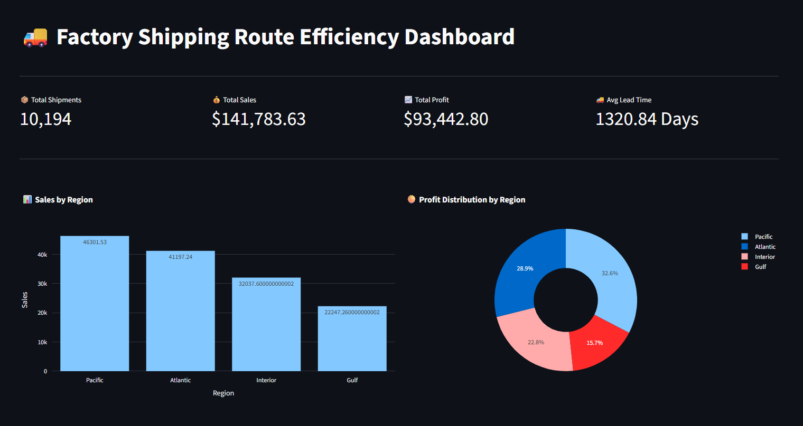
8.3 Profit Analysis
Profit analysis was performed to measure the financial performance of the business. While sales indicate revenue generation, profit represents the actual earnings after considering product costs.
Gross Profit values were analyzed to identify profitable business segments, products, and regions. This analysis assists management in understanding which business areas contribute the highest financial returns
Figure 8.2: Profit Distribution
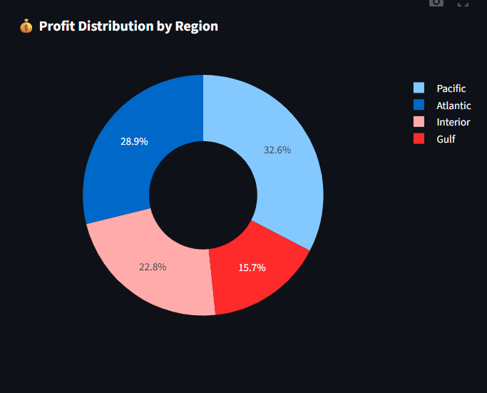

8.4 Regional Analysis
Regional analysis helps compare business performance across different geographical locations.
The Region attribute was analyzed to determine:
- Sales contribution by region
- Profit contribution by region
- Regional business performance
- High-performing and low-performing regions
The analysis enables managers to identify markets requiring operational improvements and regions contributing significantly to overall business growth.

Figure 8.3: Region-wise Sales Analysis
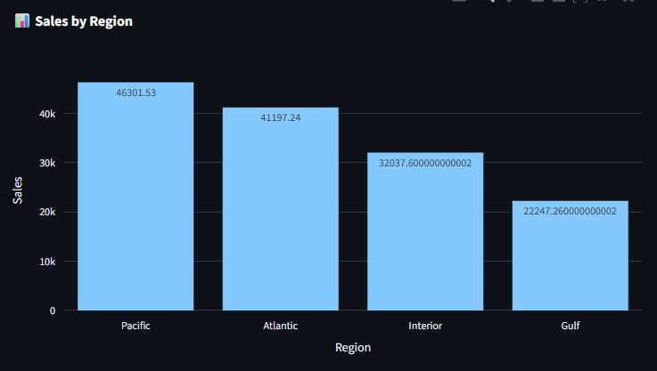

8.5 Shipping Mode Analysis
Different shipping methods directly influence delivery performance and customer satisfaction.
The Ship Mode attribute was analyzed to compare shipment volumes and evaluate shipping efficiency across available delivery methods.
The analysis provides insights into:
- Most frequently used shipping mode
- Shipping performance comparison
- Delivery efficiency

Figure 8.4: Ship Mode Distribution
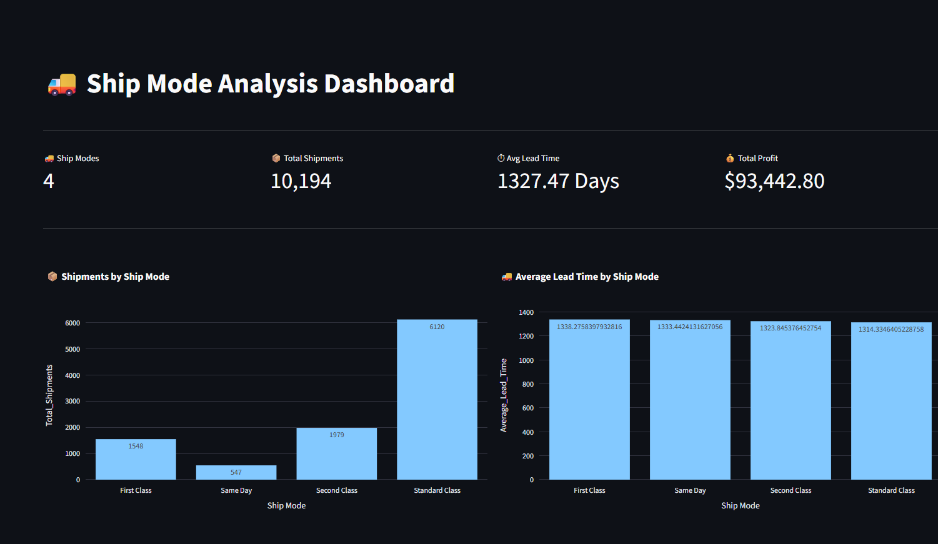
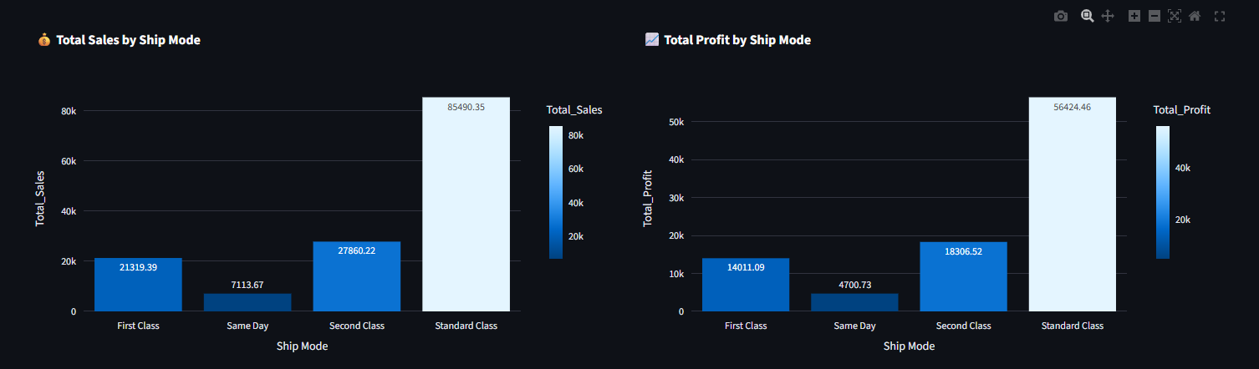

8.6 Product Performance Analysis
Product analysis was performed to identify products contributing the highest sales and profitability.
The Product Name attribute was analyzed to determine:
- Top-selling products
- Highest profit-generating products
- Product demand distribution
These insights support inventory planning and product strategy.
Figure 8.5: Top Products by Sales
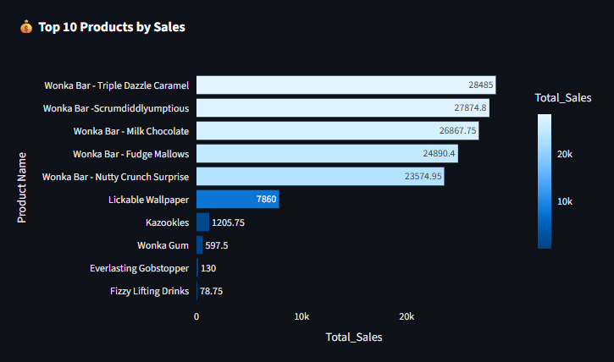

8.7 Shipping Lead Time Analysis
Shipping Lead Time was introduced as a derived feature during preprocessing.
It measures the number of days between the order placement date and shipment date. This metric provides an indication of delivery efficiency and operational performance.
The analysis helps compare delivery performance across shipping modes and identify potential delays in the logistics process.
Figure 8.6: Shipping Lead Time Analysis
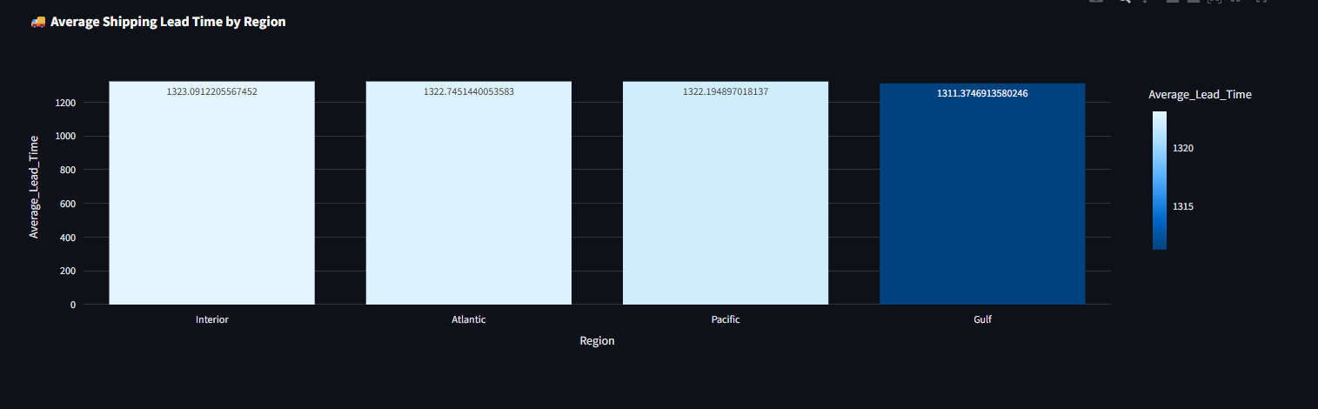

8.8 Summary of EDA
The exploratory data analysis revealed meaningful business insights regarding sales trends, regional performance, product demand, profitability, and shipping efficiency. These findings served as the foundation for KPI generation and dashboard development.
The insights obtained through EDA enabled a deeper understanding of the business and supported the creation of interactive dashboards that facilitate data-driven decision-making.
9. Results and Discussion
9.1 Overview
After completing data preprocessing, feature engineering, exploratory data analysis, and dashboard development, the dataset was analyzed to generate meaningful business insights. The results were presented using Key Performance Indicators (KPIs), statistical summaries, and interactive visualizations. The findings provide valuable information regarding sales performance, profitability, shipping efficiency, and regional business operations.
The interactive dashboards developed in Streamlit and Microsoft Power BI enabled users to monitor business performance efficiently and support data-driven decision-making.

9.2 Key Performance Indicators (KPIs)
To evaluate the overall business performance, five major Key Performance Indicators (KPIs) were developed.
KPI | Description
Total Sales | Total revenue generated from all customer orders
Total Profit | Overall gross profit earned by the business
Total Orders | Total number of customer orders processed
Total Units Sold | Total quantity of products sold
Average Shipping Lead Time | Average number of days between order placement and shipment

9.3 Regional Performance Analysis
Regional analysis was conducted to compare business performance across different geographical regions. The dashboard provides a clear visualization of sales and profitability distribution, helping identify high-performing and low-performing regions.
This analysis supports management in allocating resources efficiently and identifying areas that require operational improvements.
Figure 9.2: Region-wise Sales Dashboard
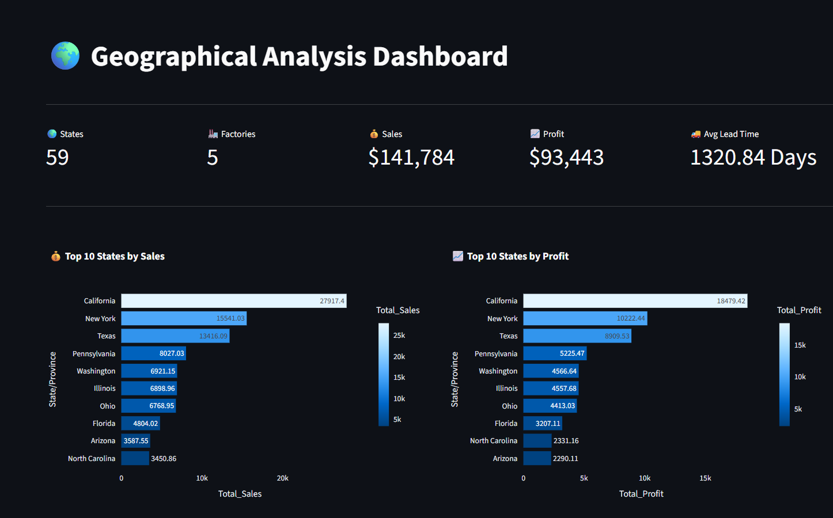

9.4 Product Performance Analysis
Product performance analysis identifies products that contribute significantly to sales and profitability. Understanding product demand enables better inventory management and marketing strategies.
The dashboard highlights top-performing products based on sales volume and profit contribution.

Figure 9.3: Product Performance Dashboard
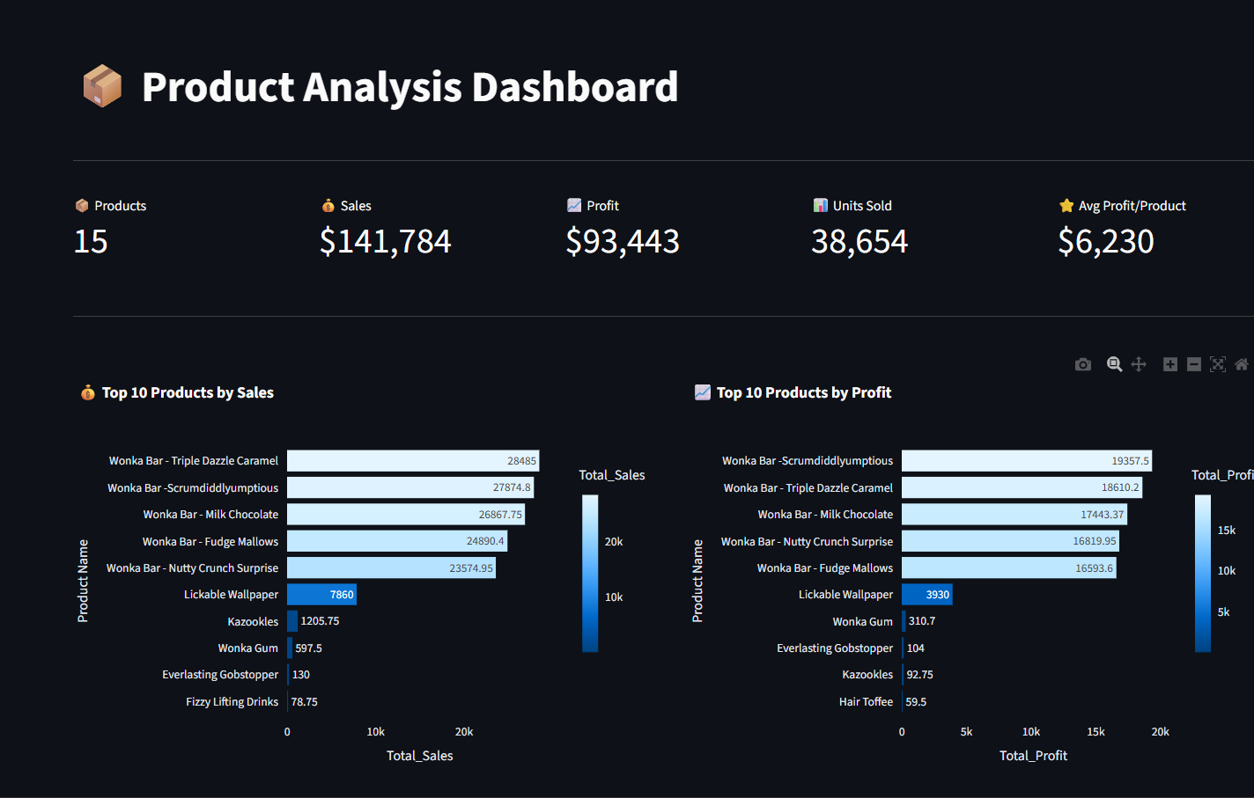

9.5 Shipping Performance Analysis
Shipping efficiency plays an important role in customer satisfaction and supply chain performance. The Shipping Lead Time feature was analyzed to evaluate delivery efficiency across different shipping modes.
This analysis helps identify opportunities to improve logistics operations and reduce delivery delays.
Figure 9.4: Shipping Performance Dashboard
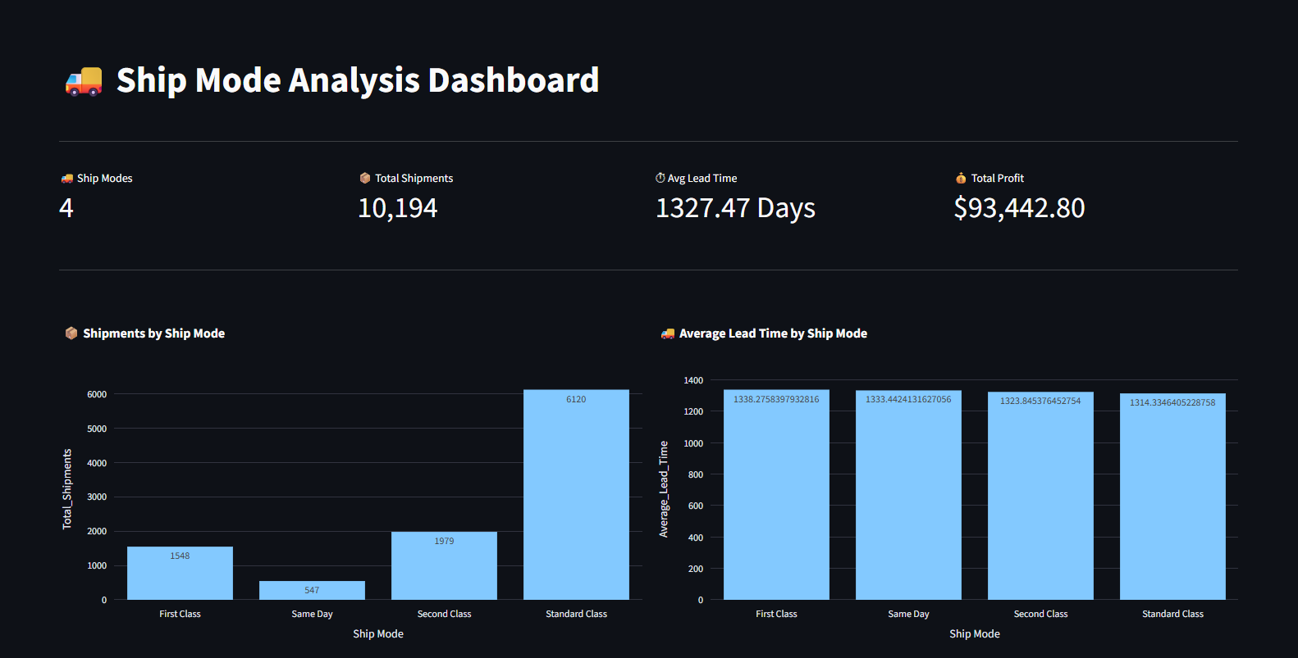
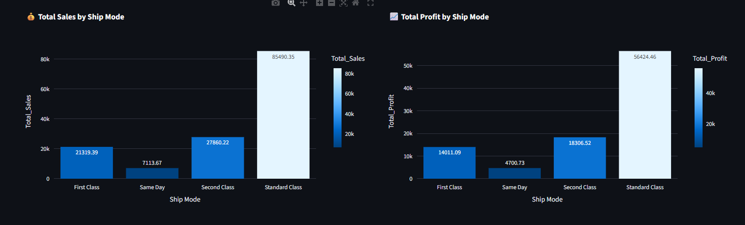

9.6 Business Insights
The analysis performed in this research provides several valuable business insights.
The interactive dashboards enable decision-makers to monitor sales trends, identify profitable regions, evaluate shipping performance, and analyze product demand through a centralized visualization platform. These insights can support strategic planning, improve operational efficiency, and enhance customer satisfaction.
The study also demonstrates the importance of combining data analytics with business intelligence tools for effective supply chain management.

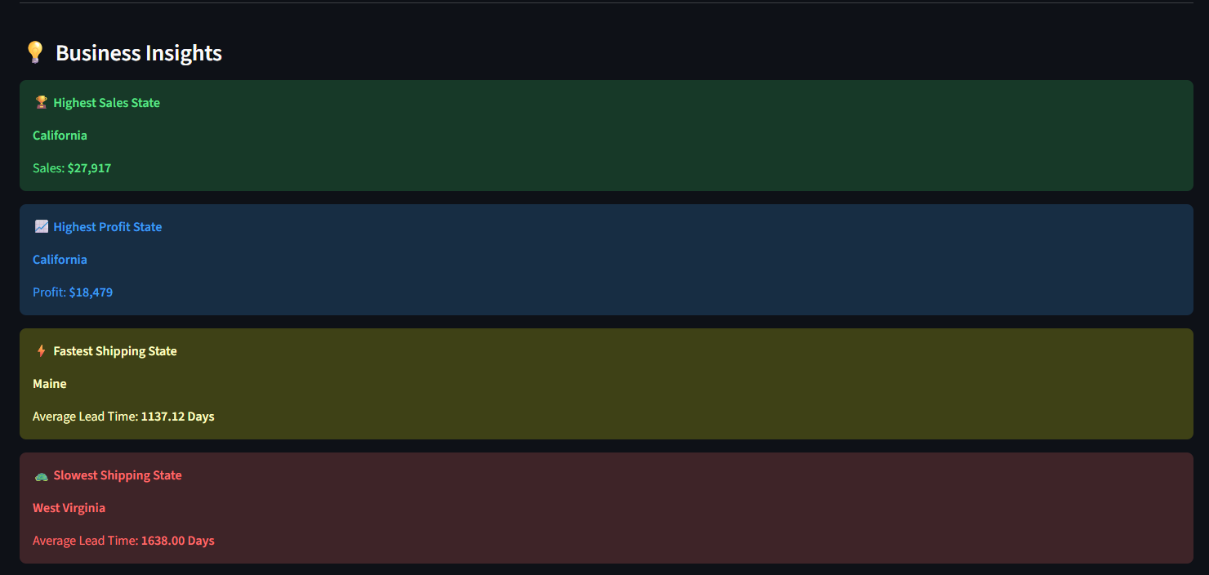
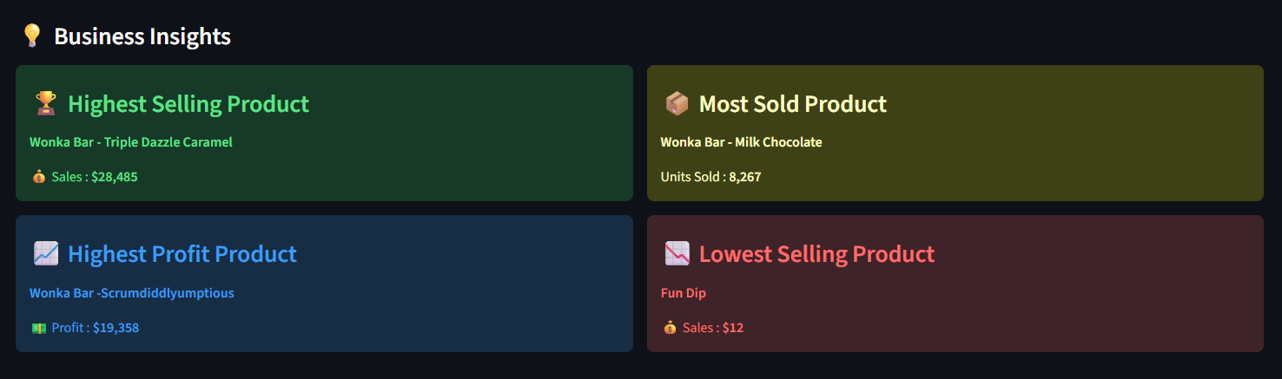

9.7 Discussion
The results indicate that descriptive analytics and interactive dashboards provide an effective solution for understanding business performance. Compared to traditional spreadsheet-based reporting, the proposed approach offers faster access to business information and improves the overall decision-making process.
By integrating Python, Streamlit, and Microsoft Power BI, the developed system transforms raw business data into actionable insights that can assist managers in evaluating logistics performance and monitoring organizational growth.

10. Conclusion and Future Work
10.1 Conclusion
This research presented a comprehensive analysis of the Nassau Candy Distributor Sales Dataset to evaluate business performance and shipping efficiency using data analytics and business intelligence techniques. The study followed a structured methodology consisting of data collection, preprocessing, feature engineering, exploratory data analysis, KPI generation, and dashboard development.
During preprocessing, the dataset was cleaned and transformed to improve its quality and ensure reliable analysis. A new feature, Shipping Lead Time, was created to measure the time between order placement and shipment, enabling an assessment of delivery efficiency. Exploratory Data Analysis (EDA) was then performed to understand sales patterns, profit distribution, regional performance, shipping modes, and product demand.
Interactive dashboards were developed using Python Streamlit providing a user-friendly interface for monitoring key business metrics. These dashboards simplify the interpretation of complex business data and enable decision-makers to identify trends, evaluate operational performance, and make informed strategic decisions.
The findings demonstrate that integrating data analytics with business intelligence tools can significantly improve the understanding of organizational performance. The proposed analytical framework offers a practical solution for transforming raw business data into meaningful insights that support efficient business planning and operational improvement.
Overall, the objectives of this research were successfully achieved, and the developed system demonstrates the value of modern analytics techniques in enhancing supply chain and sales performance evaluation.

10.2 Limitations
Although the proposed research provides valuable business insights, several limitations should be acknowledged:
- The analysis was performed using a single historical dataset.
- The dataset did not include real-time shipment tracking information.
- External factors such as weather conditions, fuel prices, traffic congestion, and supplier disruptions were not available for analysis.
- The study focused on descriptive analytics and visualization rather than predictive modeling.
- Business recommendations are limited to the available attributes within the dataset.
Despite these limitations, the developed analytical framework remains effective for evaluating operational performance and supporting business decision-making.

10.3 Future Work
The proposed system can be extended by incorporating advanced analytical techniques and additional business data. Potential future enhancements include:
- Developing machine learning models to forecast future sales and product demand.
- Implementing predictive analytics to estimate shipping delays before they occur.
- Integrating real-time logistics and shipment tracking for continuous performance monitoring.
- Applying route optimization algorithms to improve delivery efficiency and reduce transportation costs.
- Building an AI-powered decision support system capable of generating automated business recommendations.
- Expanding the dashboard with advanced filtering, forecasting, and drill-down capabilities.
- Integrating cloud-based data sources to enable scalable and real-time business intelligence solutions.
These enhancements would further improve the analytical capabilities of the system and provide stronger support for strategic planning and operational management.

10.4 Final Remarks
The combination of Python, Streamlit, and Microsoft Power BI provides an effective platform for analyzing business data and presenting meaningful insights through interactive dashboards. The methodology adopted in this research can also be applied to similar datasets in retail, logistics, manufacturing, and supply chain management.
This study highlights the importance of data-driven decision-making in modern organizations and demonstrates how business intelligence solutions can improve operational efficiency, profitability, and customer service.

