**Name-Sonu kumar UID – 21MCA2977**

**Group- ON21MCA-9A Date: 20 Oct 2022**

**College- Chandigarh University Company Name- Xenonstack**

**Screenshot of Project**

**Home page**

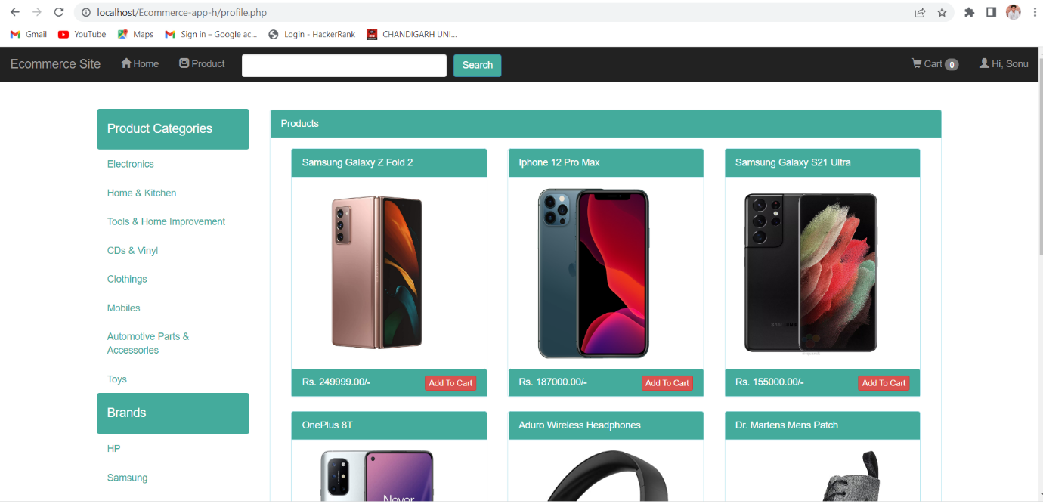

**Login Form**

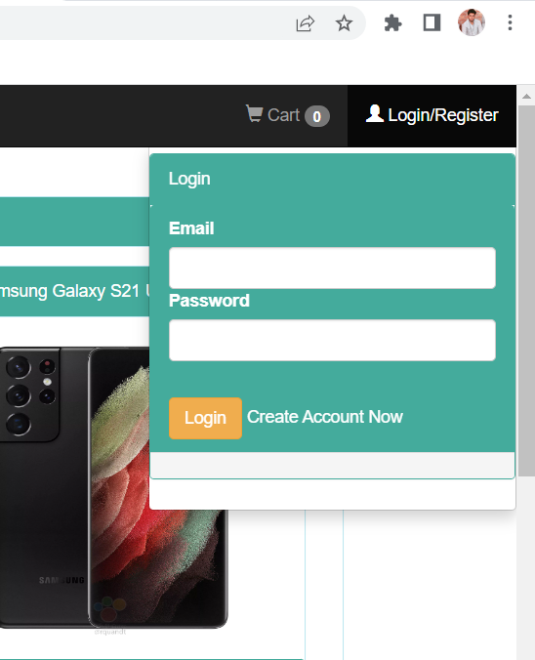

**Create account Now**

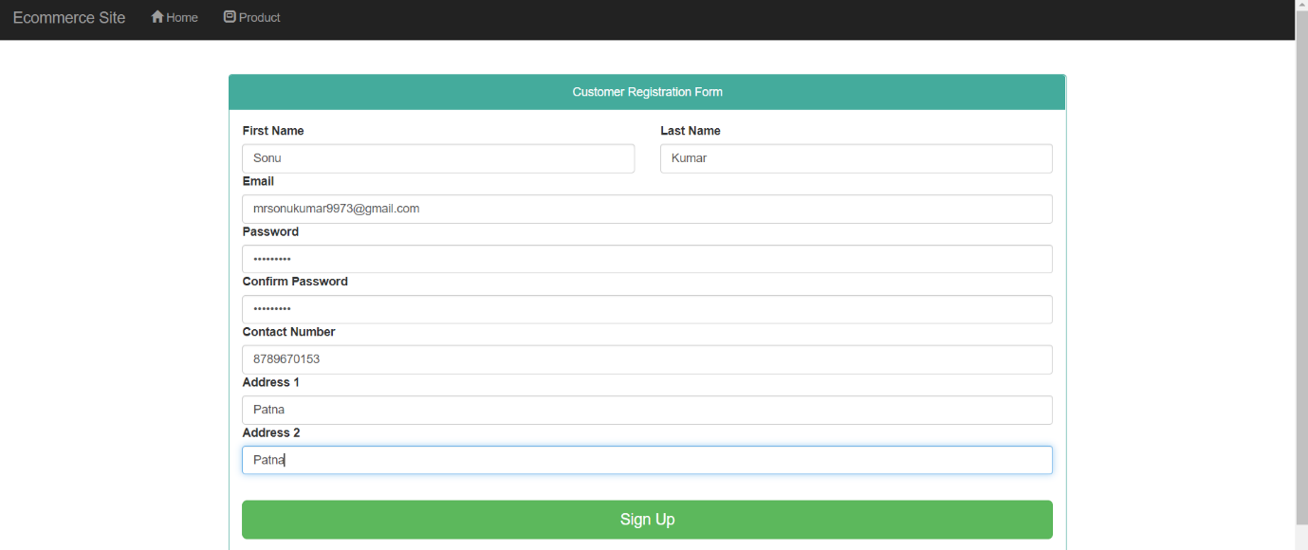

**After Login**

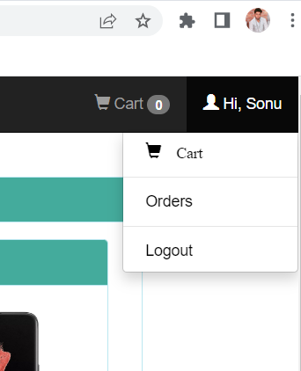

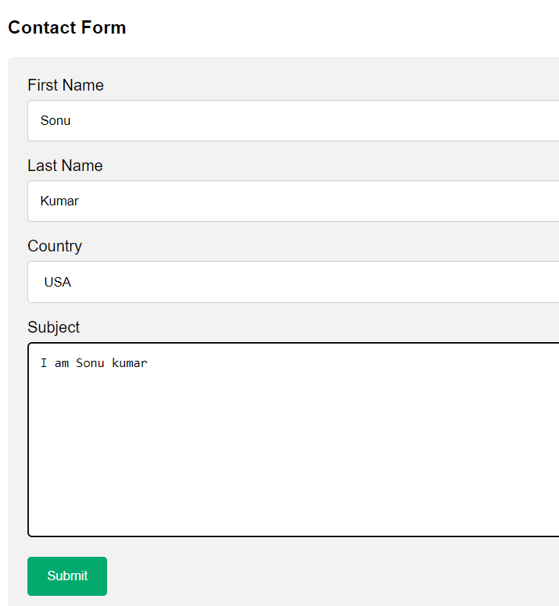

**Database**

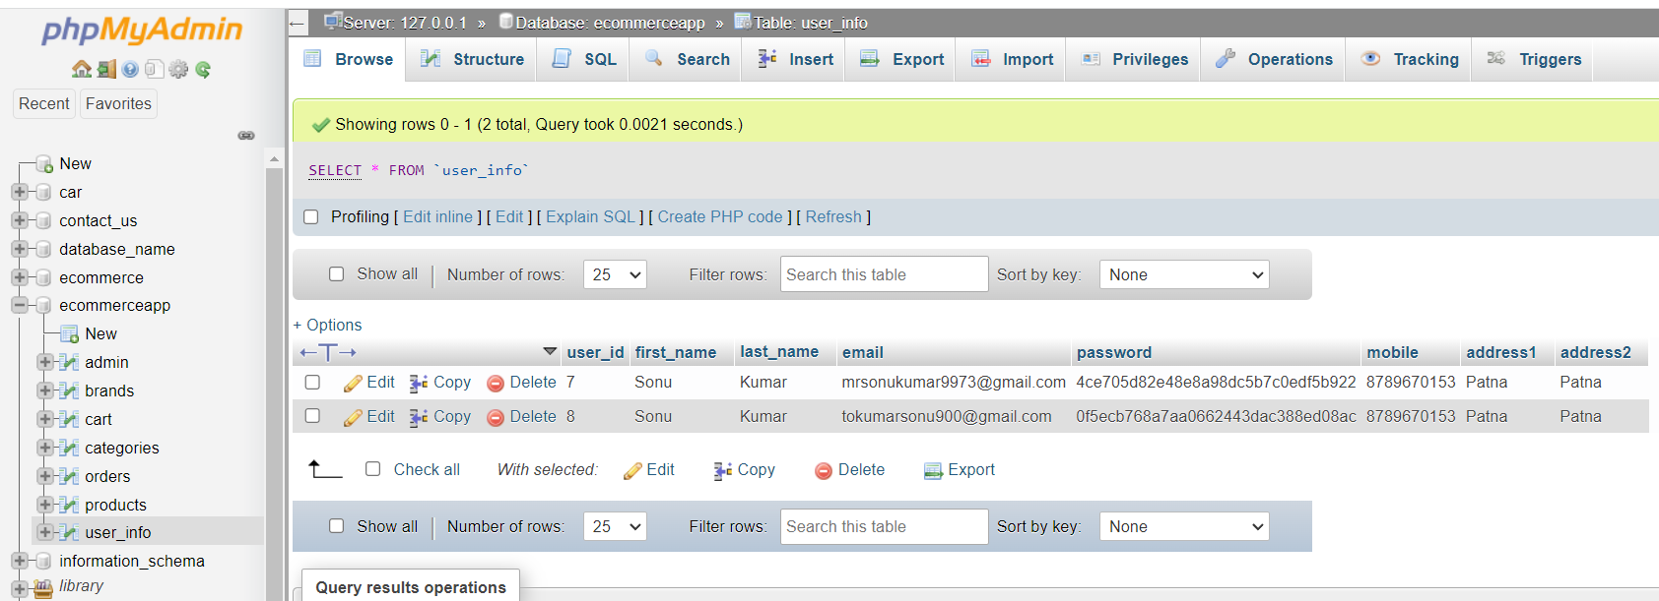

**Brands Name**

