**Ref:** **https://www.codelean.vn/2020/01/huong-dan-ua-web-len-heroku.html**

**1. Chuẩn bị:**

- Heroku account: <https://signup.heroku.com/>

- Cài đặt Heroku CLI (check: **heroku -v**): <https://devcenter.heroku.com/articles/heroku-cli>

- Cài đặt git (check: **git --version**) : <https://git-scm.com/downloads>

**2. Tạo app trên Heroku:**

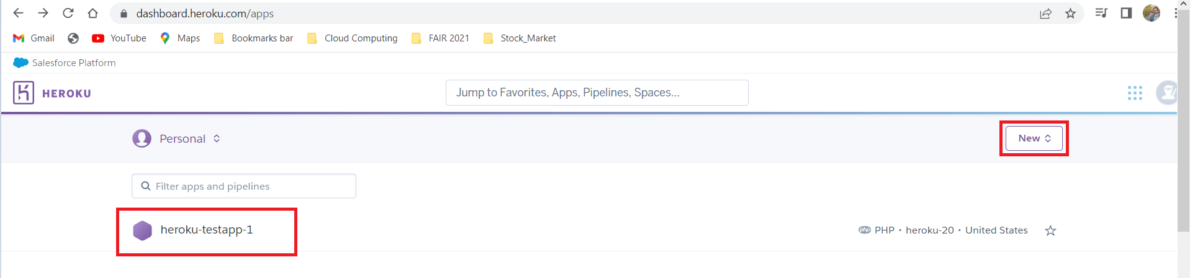

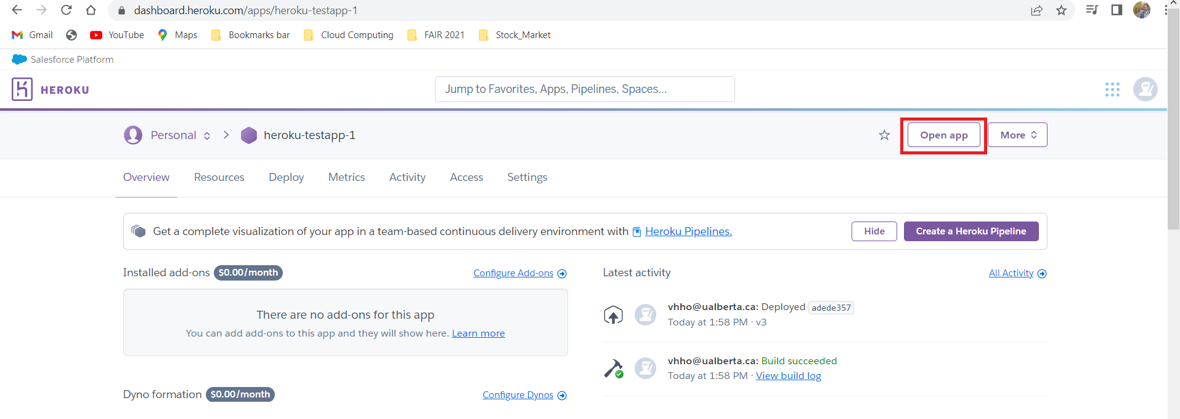

**3. Đưa các tập tin của mình lên Web trên Heroku:**

- Tạo new folder: **heroku-testapp-1** (chứa các file của Web: **home.html** + **index.php**)

- Vào folder này: **cd heroku-testapp-1**

**File: home.html**

**<!DOCTYPE html>**

**<!-- saved from url=(0032)https://fptaptech.herokuapp.com/ -->**

**<html><head><meta http-equiv="Content-Type" content="text/html; charset=UTF-8">**

**<title>Trang web của tôi: Tên tôi</title>**

**</head>**

**<body>**

**<h1>Welcome to my site! Have a nice day!</h1>**

**</body></html>**

**File: index.php**

**<?php include_once("home.html");**

- Dùng các lệnh sau:

**heroku login**

**git init**

**heroku git:remote -a heroku-testapp-1**

**git add .**

**git commit -am "make it better"**

**git push heroku master**

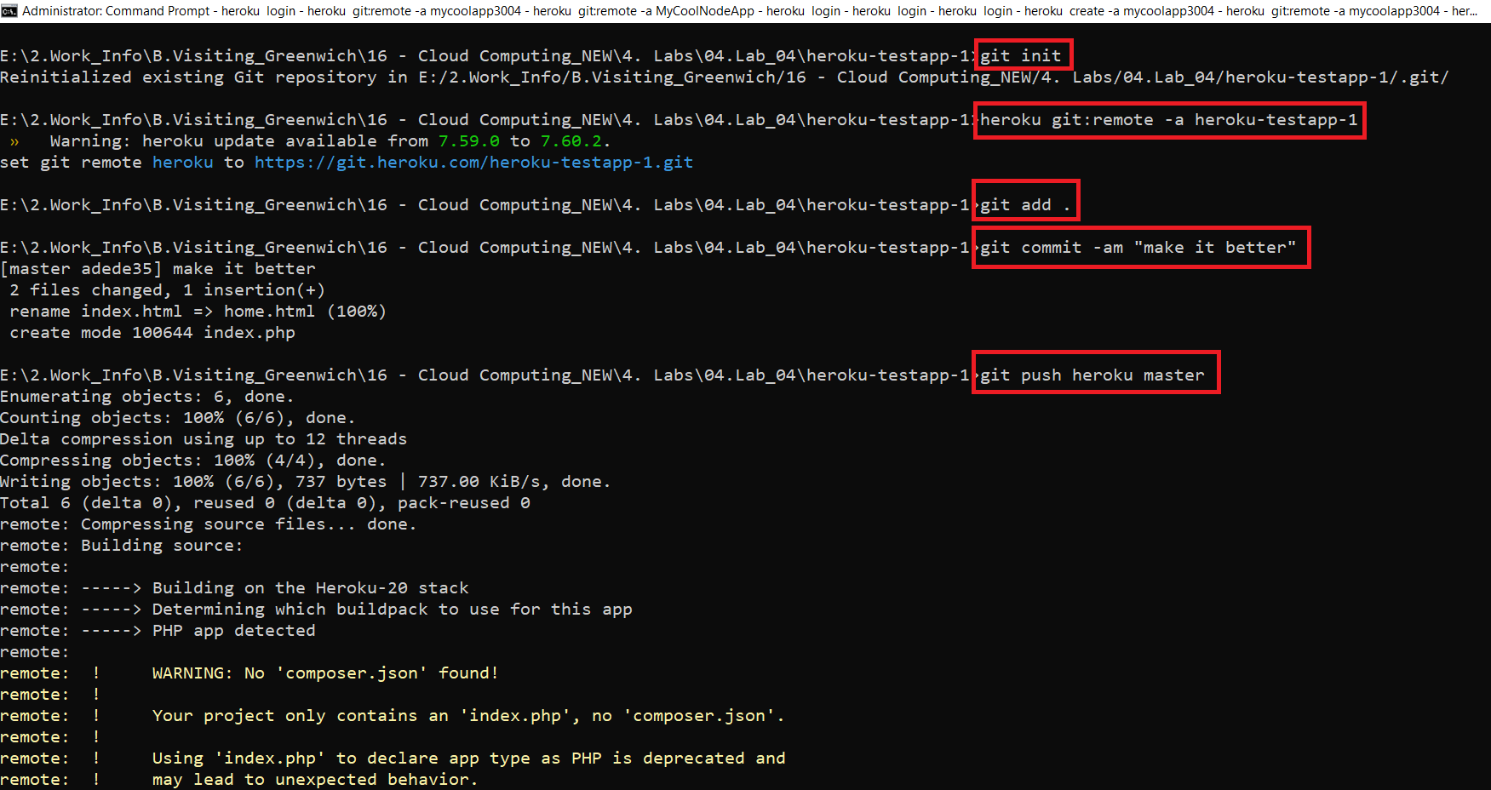

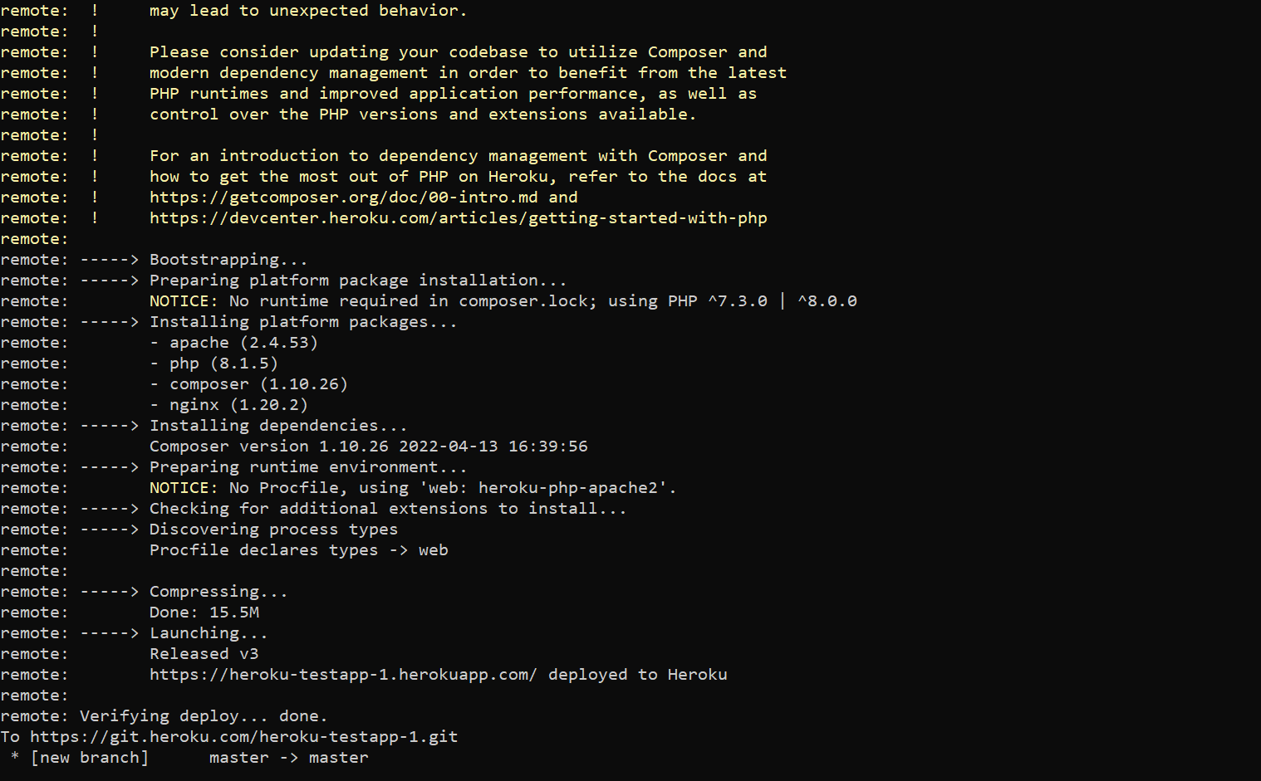

**Open app:** **https://heroku-testapp-1.herokuapp.com/**

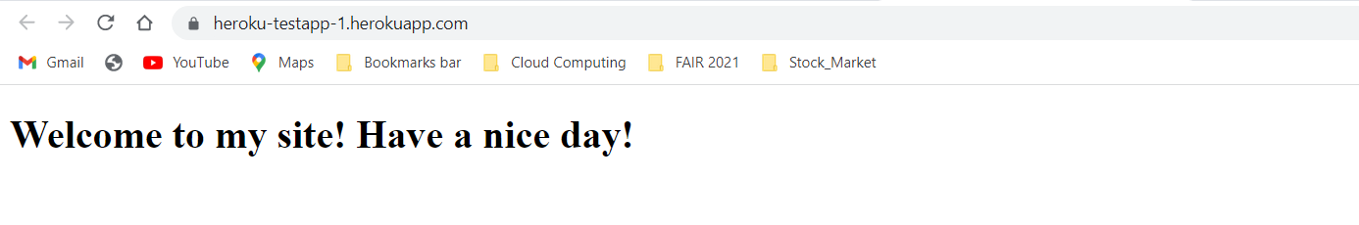

Lưu ý:

ERROR-1:

! [remote rejected] master -> master (pre-receive hook declined)

error: failed to push some refs to 'https://git.heroku.com/heroku-testapp-333.git'

SOLUTION-1:

Heroku config:set DISABLE_COLLECTSTATIC=1

ERROR-2:

Khi đánh command: heroku login xuất hiện lỗi IP address mismatch

Trên trình duyệt.

SOLUTION-2: (link: https://stackoverflow.com/questions/63363085/ip-address-mismatch-on-signing-into-heroku-cli)

Just adding some detailed steps to resolve the issue:

1. Navigate to <https://dashboard.heroku.com/account/applications>
2. In Authorizations click on **Create** **Authorization** button
3. Add **Description** in pop up, e.g., **heroku cli**, and leave **Expire after blank** if you don’t want it to expire
4. You will get **authorization token**
5. in cli run: **heroku login -i**
6. when it prompts for **password** enter the **authoriation token**

