Mongodb
Sony Shrestha
2021-05-25

Table of Contents
SQL vs NOSQL 4
Installation 5
Check version 5
Basic Commands 6
Create Database 8
View currently active database 8
Drop Database 8
Show list of databases 8
Display version of Mongodb 8
Display list of commands 8
CRUD Operation (Create, Read, Update, Delete) 9
Create Operation 9
Create Uncapped Collection 9
Show list of collections 9
Create Capped Collection 9
Check if a collection is capped 10
Insert into Collection 10
Read Operation 11
Specify add condition 13
Specify or condition 13
Arithmetic Operators 13
Logical Operators 13
Sort documents 14
Update Operation 14
Delete Operation 16
Delete Document based on filter 16
Delete whole documents of a collection 16
mongoimport 17
mongoexport 17
Embedded Document 17
Create embedded Document 17
Query Enbedded Document 17
Document with an Array 18
Create document with an array 18
Query document with an array 18
Data Modelling and Aggregation 19
Embedded Data Models 19
Normalized data models 19
Data Model Using an Embedded Document 20
One-to-one Relationship 20
One-to-many relationship 20
Data Model Using Document References 20
One-to-Many Relationships 20
Mangodb GUI Compass 22
Installation 22
Insert new Document from GUI 22

SQL vs NOSQL

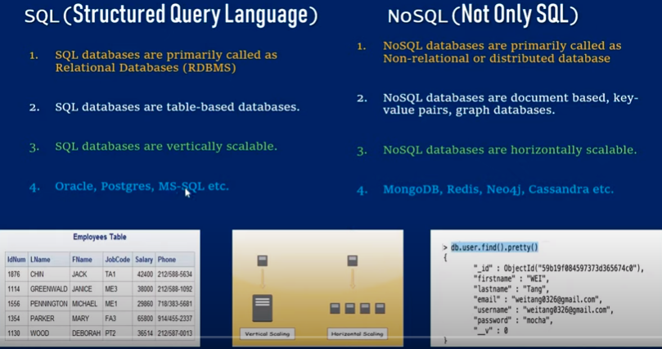

Installation
- Go to https://www.mongodb.com/try/download/community
- Download .msi file
- Install the .msi file
- To check if Mangodb has been installed, go to command prompt and enter
  - "C:\Program Files\MongoDB\Server\4.4\bin\mongo.exe" –version
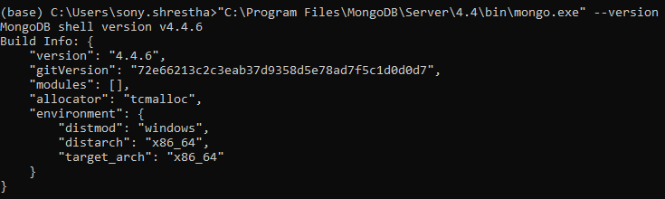

Check version
"C:\Program Files\MongoDB\Server\4.4\bin\mongo.exe" –version
"C:\Program Files\MongoDB\Server\4.4\bin\mongod.exe" –version

Basic Commands
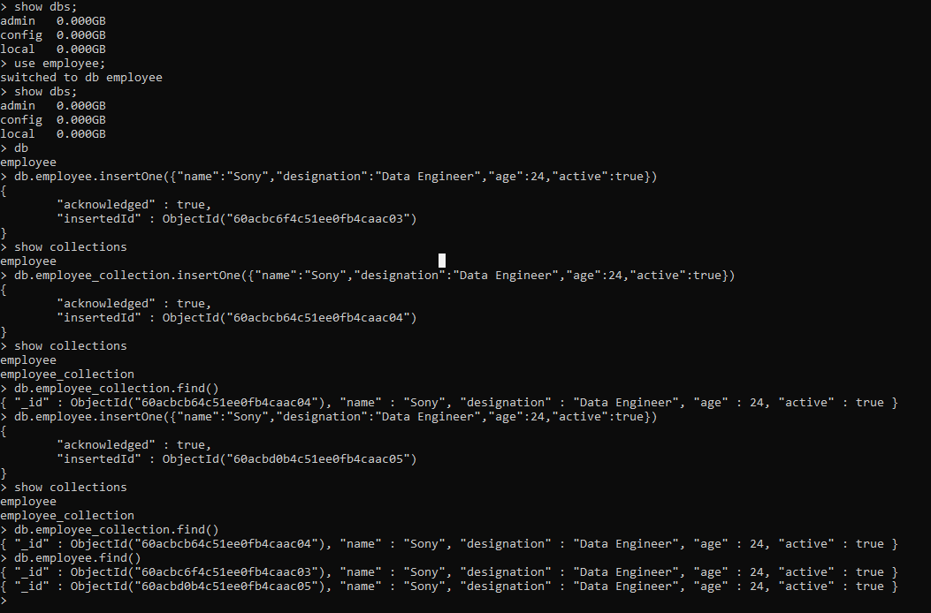

- Show databases
show dbs;
Even though some databases are present, show dbs command will not display it until at least one collections is available in it.

- Create and use database
use employee;
This command will create database if it has not been create yet and switches to that database.

- Drop database
db.dropDatabase()
here, db represents currently active database

- View current active database
db
- Create a collection
db.createCollection(“collection_name”)

- Drop Collection
db.collection_name.drop()

- Insert one collection into a database
db.employee_name.insertOne({"name":"Sony","designation":"Data Engineer","age":24,"active":true})

- To show collections
show collections

- To show fields
db.employee_collection.find()
db.employee_collection.find().pretty()

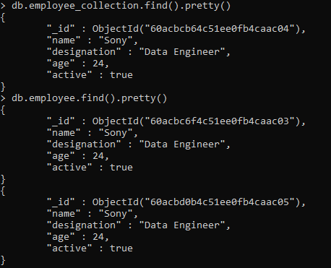

Create Database
use <db_name>

View currently active database
db

Drop Database
db.dropDatabase()

Show list of databases
show dbs
show databases
Note:
Newly created database will not be displayed as it should have at least one collection to be displayed.

Display version of Mongodb
db.version()
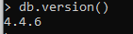

Display list of commands
db.help()
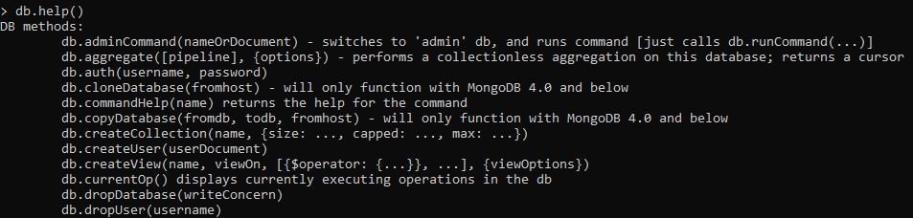

CRUD Operation (Create, Read, Update, Delete)

Create Operation

Create Uncapped Collection
db.createCollection(“collection_name”)
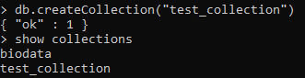

Show list of collections
show collections
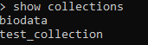

Create Capped Collection
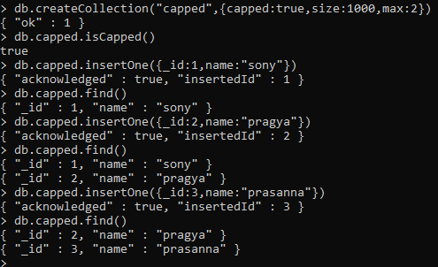
db.createCollection("collection_name",{capped: true,size:1000,max:2})

db.createCollection("student",{capped: true,size:1000,max:2})
Here, size denotes the maximum size of the collection in bytes and max denotes the maximum number of documents allowed.

Check if a collection is capped
db.collection_named.isCapped()

If number of documents exceeds size specified in create statement, older document will be deleted.

Insert into Collection
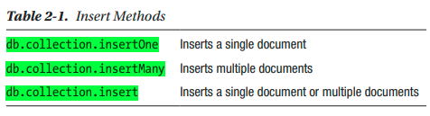

insertOne
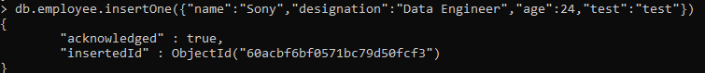
db.employee_collection.insertOne({"name":"Sony","designation":"Data Engineer","age":24,"active":true})

insertMany
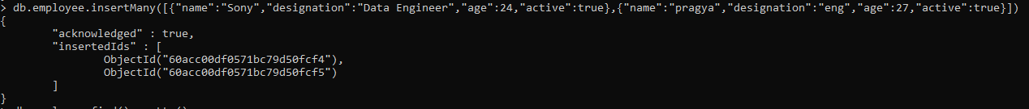
db.employee_collection.insertMany([{},{},{}])
db.employee_collection.insertMany([{"name":"Sony","designation":"Data Engineer","age":24,"active":true},{"name":"pragya","designation":"eng","age":27,"active":true}])

Read Operation

Syntax
{database_name/db}.{collection_name}.find({query},{projection})
Where, query is query we want to perform
Projection is fields we want to display

- Find all the result of given collection
db.employee.find()
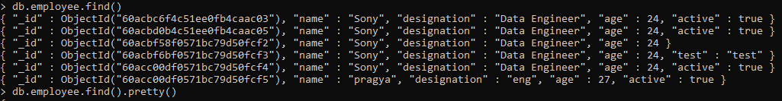

- Find all the result of given collection in pretty format
db.employee.find().pretty()
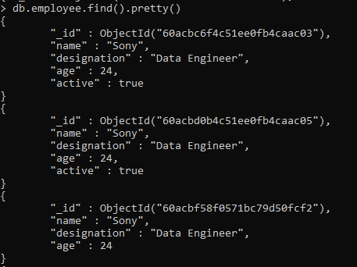

- Count number of documents in a collection
db.collection_name.find().count()

- Fetch all records where name= “pragya”
db.employee.find({"name":"pragya"})
db.employee.find({"name":"pragya"}).pretty()
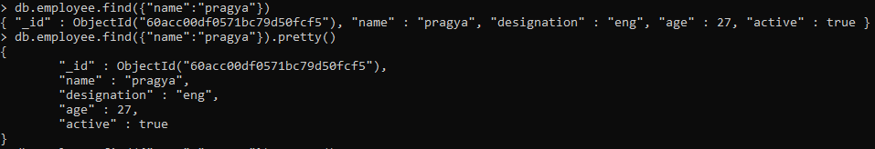

- Fetch name and designation of recors where name= “pragya”
By default command will show id, we can hide that id as well
db.employee.find({"name":"pragya"},{name:1,designation:1}).pretty()
db.employee.find({"name":"pragya"},{_id:0,name:1,designation:1}).pretty()
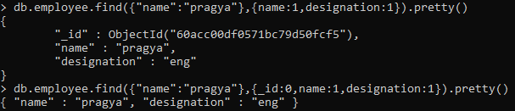

- Fetch limited number of records (say top 2)
db.employee.find({"name":"Sony"},{_id:0,name:1,designation:1}).pretty().limit(2)
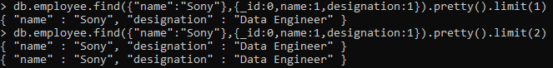

To limit 1 record, we can also use findOne. But, pretty fuction does not work with findOne
db.employee.findOne({"name":"Sony"},{_id:0,name:1,designation:1})

- Print only second record
db.employee.find({"name":"Sony"},{_id:0,name:1,designation:1}).pretty().limit(1).skip(1)

Specify add condition
db.person.find({ name:"shobana",age:{$gt:10}})

Specify or condition
db.person.find( { $or: [ { name: "shobana" }, { age: { $eq: 20 } } ] } )

Arithmetic Operators
$lt, $gt, $et, $ne, $lte, $gte, $in, $nin
db.biodata.find({"age":{$ne:24}})
db.biodata.find({"age":{$e:24}})
db.biodata.find({"age":{$lt:24}})
db.biodata.find({"age":{$in:[24,22]}})9
db.biodata.find({"age":{$nin:[24,22]}})

Logical Operators
Syntax:
db.collection_name.find( {$and: [ {},{} ] } )

db.biodata.find({$and:[{age:24},{emp_name:"Pragya"}]})
db.biodata.find({$or:[{age:24},{emp_name:"Pragya"}]})

Other examples:
db.biodata.find({age:{$not:{$lt:22}}})
db.biodata.find({age:{$not:{$lte:22}}})

Sort documents
db.biodata.find({age:{$not:{$lt:22}}}).sort({"age":1}) : ascending order
db.biodata.find({age:{$not:{$lt:22}}}).sort({"age":-1}) : descending order

Update Operation
Syntax
db.collection_name.updateOne(<filter>,<update>)
db.collection_name.updateMany(<filter>,<update>)

Note:
In case, filter passed in updateOne filters more than one records, first record will only be updated.
To update more than one records, we use update command
$set operator will replace the value of a field with the specified value.

updateOne
Update one record whose name= “Sony” with designation= “DE”
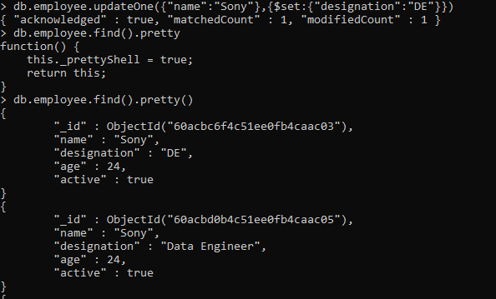

UpdateMany
Update all records whose name= “Sony” with designation= “DE”
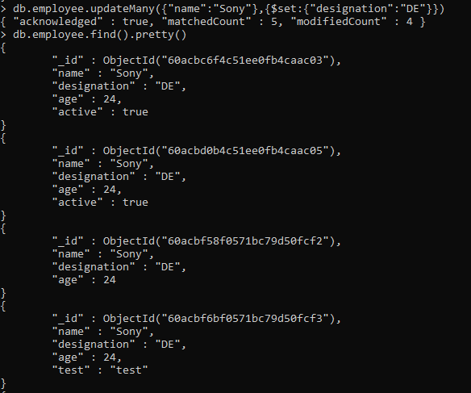

Delete Operation
Syntax
db.collection_name.deleteOne(deletion_criteria)
db.collection_name.deleteMany(deletion_criteria)

Delete Document based on filter
Delete record with id=1
db.employee.deleteOne({_id:1})

Delete all records where name= “Pragya”
db.employee.deleteMany({name:"pragya"})
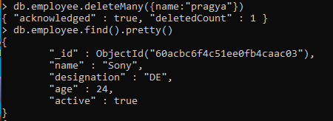

Delete whole documents of a collection
db.employee.deleteMany({})
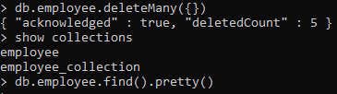

mongoimport
It allows us to import content from JSON, CSV files.
mongoimport --db student --collection students --type csv --headerline --file c:\Sample\student.csv

mongoexport
The MongoDB export tool allows us to export data stored in MongoDB instances as JSON or CSV files.
mongoexport --db student --collection students --out C:\Sample\ student.json

Embedded Document

Create embedded Document
db.capped.insertOne({_id:5,name:"prasanna",address:{temporary:"thimi",permanent:"gatthaghar"}})

Query Enbedded Document
db.capped.find({"address.temporary":"thimi"}).pretty()
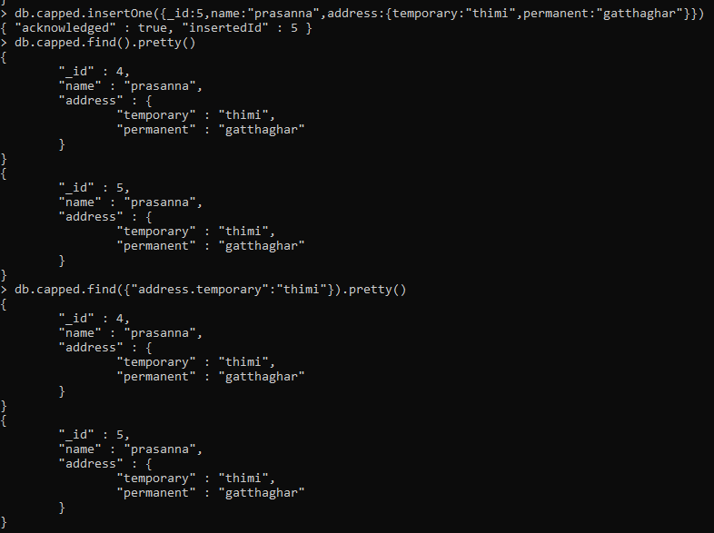

Document with an Array

Create document with an array
db.capped.insertOne({_id:6,name:"prasanna",books:["maths","english","nepali"]})

Query document with an array
db.capped.find({"books":"english"}).pretty()
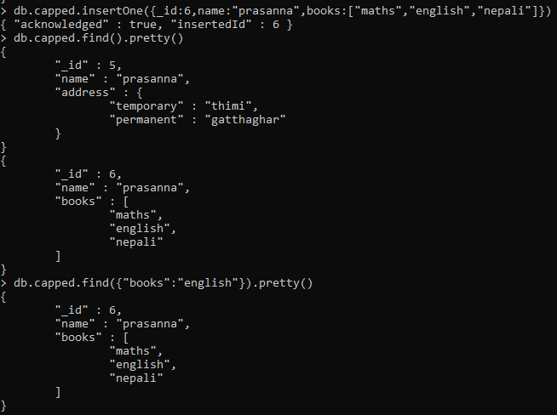

Data Modelling and Aggregation
MongoDB provides two data model designs for data modeling:
• Embedded data models.
• Normalized data models

Embedded Data Models
In MongoDB, we can embed related data in a single document.
This schema design is known as denormalized models.
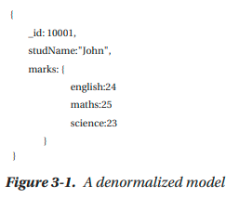

Normalized data models
Normalized data models describe relationships using references.
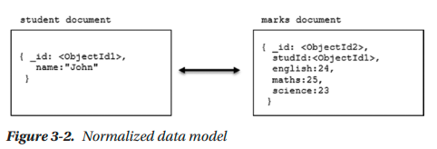
Normalized data models can best be used in the following circumstances:
• When embedding data model results duplication of data.
• To represent complex many-to-many relationships.
• To model large hierarchical data sets.
Normalized data models do not provide good read performance.

Data Model Using an Embedded Document

One-to-one Relationship
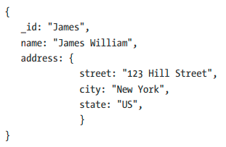

One-to-many relationship
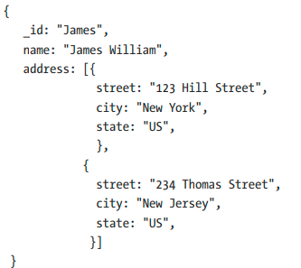

Data Model Using Document References

One-to-Many Relationships
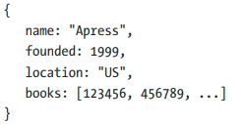
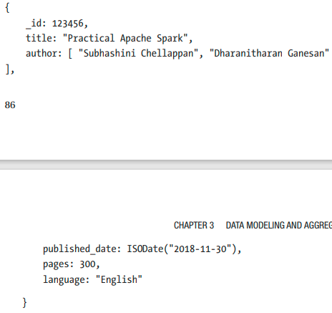
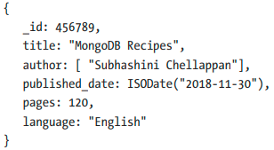

Mangodb GUI Compass

Installation
- Go to https://www.mongodb.com/try/download/compass and download .msi file
- Install the .msi file and Mangodb Compass GUI will appear
- Click on Connect ConnectTo Fill in connection fields individually Connect

Insert new Document from GUI
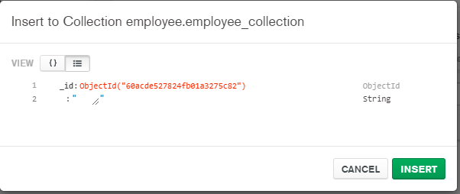
We can change datatype from ObjectId section

