PENTAHO DATA INTEGRATION

-Task for interns

Prepared by

* Sony Shrestha

Important Steps for creating transformation and job

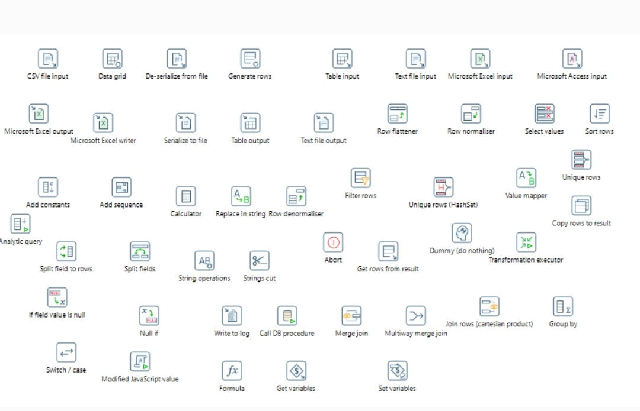

1. Create four databases named fc_raw, fc_rw, fc_master, fc_facts and QA.
2. Create a pentaho transformation that takes input from respective csv and excel files provided in mail and dump them into tables named:
3. fc_rw.fc_account_master
4. fc_rw.fc_balance_summary
5. fc_rw.fc_transaction_base

Here,

In fc_transaction_base tables, value of column dc_indicator(deposit,withdraw) should be transformed into dc_indicator(D,C) 🡪 modified java script, value_mapper

In fc_account_master table, value of column active_flag(‘ACTIVE’, ‘INACTIVE’). should be transformed into active_flag(1,0) 🡪 modified java script, value_mapper

All of the above tables should contain following additional columns as well:

created_by with default value of your name

created_on with default value of current timestamp

modified_by with default value of null

modified_on with default value of null and current timestamp on updating record each time

Note: data type of columns in respective table should be checked properly.

1. Create a pentaho transformation to find avg_monthy_balance,std_monthly_balance.

The result should be dumped into table named fc_facts.fc_balance_facts. This table should contain following fields:

account_number

avg_monthly_balance

std_monthly_balance

created_by

created_on

modified_by

modified_on

* 1. avg_monthly_balance

Find avg(lcy_amount) in monthly level

avg_monthly_balance=avg(above amount) for each account

* 1. std_monthly_balance

Find avg(lcy_amount) in monthly_level

std_monthly_balance=std(above amount) for each account

All null values whould be replaced with 0 in these facts.

1. Create a pentaho transaformation to find avg_monthy_deposit, std_monthly_deposit, avg_monthly_withdraw, std_monthly_withdraw.

account_number

avg_monthly_deposit

std_monthly_deposit

avg_monthly_withdraw

std_monthly_withdraw

created_by

created_on

modified_on

modified_by

* 1. avg_monthly_deposit

Find sum(lcy_amount) in monthly level where dc_indicator= ‘C’

avg_monthly_deposit=avg(above amount) for each account

* 1. std_monthly_deposit

Find sum(lcy_amount) in monthly level where dc_indicator= ‘C’

std_monthly_deposit=std(above amount) for each account

* 1. avg_monthly_withdraw

Find sum(lcy_amount) in monthly level where dc_indicator= ‘D’

avg_monthly_deposit=avg(above amount) for each account

* 1. std_monthly_withdraw

Find sum(lcy_amount) in monthly level where dc_indicator= ‘D’

std_monthly_deposit=std(above amount) for each account

All null values should be replaced with 0.

1. Create a pentaho transformation that generates balance of today and last three days for which entry is present.

The result should be dumped into table named fc_facts.fc_balance_last_3_days.

Resulting table should contain following fields:

account_number

tran_date

balance

balance_before_1_day

balance_before_2_days

balance_before_3_days

created_by

creted_on

moified_by

modified_on

1. Write a SQL script that generate balance of today and last 3 days for which entry is present.
2. Write a SQL script to compare result generated from point 5 and 6 using column name status for balance of each day.
3. Result generated from point 7 should be dumped into table named QA.qa_fc_balance_last_3_days.

This table should conatain following fields:

account_number

customer_code

balance_qa

balance

balance_before_1_day_qa (result from point 6)

balance_before_1_day (result from point 5)

balance_before_1_day_status

balance_before_2_days_qa (result from point 6)

balance_before_2_days (result from point 5)

balance_before_2_days_status

balance_before_3_days_qa (result from point 6)

balance_before_3_days (result from point 5)

balance_before_3_days_status

created_by

created_on

modified_by

modified_on

1. Write a SQL procedure for point 8.
2. Create a pentaho transformation to call procedure created in point 9.
3. Create a master table named fc_master.fc_clients from fc_rw.fc_account_master
4. This table should contain all customers in account master table.

id

customer_code

active_flag

created_by

created_on

modified_by

modified_on

1. In fc_rw, we have created three tables.
2. Create same tables in fc_raw with some of the column names changed.
3. Create two tables in fc_master as:

fc_master.fc_tables with data

|  |  |  |  |  |
| --- | --- | --- | --- | --- |
| id | Source_schema | Source_table | Destination_schema | Destination_table |
| 1 | fc_rw | fc_account_master | fc_raw | fc_account_master |
| 2 | fc_rw | fc_transaction_base | fc_raw | fc_transaction_base |
| 3 | fc_rw | fc_balance_summary | fc_raw | fc_balance_summary |

fc_master.fc_fields_mapping with data

|  |  |  |  |
| --- | --- | --- | --- |
| id | Table_id | Source_field | Destination_field |
| 1 | 1 | account_number | acc_num |
| 1 | 1 | customer_code | cust_code |
|  | (table_id from fc_tables table) | column name of table in source (fc_rw) | column name of table in destination (fc_raw) |
| ……. | ……….. | …………. | …….. |

Basically, second table describes the mapping of field between source and destination (add more entries for all columns in fc_account_master, fc_transaction_base, fc_balance_summary).

1. Create a pentaho transformation to load data from tables in fc_raw to fc_rw based on mappings specified in table.

Note:

Here, source_schema, destination_schema, source_table,destination_table should be dynamic (config driven).

Fields mapping (field name in source table should be dynamic)

1. fc_score.csv file is provided in mail. Dump this into table named fc_facts.fc_score.
2. In fc_master database create following table fc_master.fc_config:

|  |  |  |  |
| --- | --- | --- | --- |
| id | field | sign | Value |
| 1 | confidence_percentage | > | 30 |
| 2 | Confidence_percentage | < | 90 |

1. Create a transformation to get all the records from fc_facts.fc_score based on condition specied in fc_master.fc_config table.
2. Dump the result into a csv or excel file name fc_credit_score.csv
3. Create a pentaho job that executes all above transformations one after another.
4. If execution is sucessful, send success mail containing csv file from point (20) as attachment.
5. If execution is unsuccessful, send error message stating that execution of pentaho job was not successful.