Normalization

It is step by step process of organizing data to minimize data redundancy( data duplication), which in turn ensures data consistency.

Problems without normalization

1. Insertion Anomaly
2. Deletion anomaly
3. Update Anomaly

There are 6 Normal forms.

Most databases are in third normal form .

First Normal Form (1 NF)

A table is said to be in 1 NF if

1. Data in each column should be atomic. No multiple values, seperated by comma.

|  |  |
| --- | --- |
| Dept_name | Employee |
| IT | Sam, Mike, Shan |
| HR | Pam |

|  |  |
| --- | --- |
| Dept_name | Employee |
| IT | Sam |
| IT | Mike |
| IT | Shan |
| HR | Pam |

Second Normal Form – 2NF

A table is said to be in 2NF IF

1. All conditions of 1NF is met
2. Move redundant data to a separate table
3. Create relationship between these tables using foreign keys.

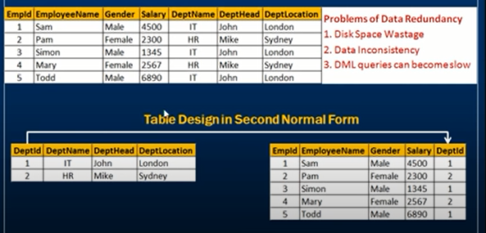

Third Normal Form: 3NF

A table is said to be in 3 NF, if the table

1. Meets all the conditions of 1NF and 2NF
2. Does not contain columns(attributes) that are not fully dependent upon the primary key

