Steps of Supervised Learning

Supervised learning is a type of machine learning where the algorithm learns from labeled training data, and its goal is to make predictions or decisions based on new, unseen data. Here are the general steps involved in supervised learning:

1. **Define the Problem:**
   * Clearly define the problem you want to solve. Whether it's classification, regression, or another type of task, having a clear understanding of the problem is crucial.
2. **Collect and Prepare Data:**
   * Gather a dataset that includes examples of input-output pairs. The data should be labeled, meaning that the correct output or class is associated with each input. Additionally, split the data into training and testing sets to evaluate the model's performance.
3. **Data Preprocessing:**
   * Clean and preprocess the data to handle missing values, outliers, and other issues. This may involve normalization, scaling, or encoding categorical variables. Ensuring the data is in a suitable format is essential for effective model training.
4. **Feature Selection/Extraction:**
   * Identify and select relevant features that contribute to the predictive power of the model. Feature extraction may involve transforming or combining existing features to create new ones that better represent the underlying patterns in the data.
5. **Choose a Model:**
   * Select a suitable machine learning model for your task. The choice of the algorithm depends on the nature of the problem (e.g., linear regression for regression tasks, logistic regression for binary classification, decision trees, support vector machines, neural networks, etc.).
6. **Split the Data:**
   * Split the labeled data into training and testing sets. The training set is used to train the model, while the testing set is reserved to evaluate its performance on unseen data. Common split ratios include 70-30 or 80-20.
7. **Train the Model:**
   * Feed the training data into the chosen model and adjust the model's parameters to minimize the difference between the predicted output and the actual labels. This is often done using optimization algorithms like gradient descent.
8. **Evaluate the Model:**
   * Use the testing set to assess the model's performance. Common evaluation metrics include accuracy, precision, recall, F1 score (for classification), mean squared error (for regression), etc.
9. **Tune Hyperparameters:**
   * Adjust the hyperparameters of the model to optimize its performance. Hyperparameters are settings that are not learned from the data but are set before the training process (e.g., learning rate, number of hidden layers in a neural network).
10. **Make Predictions on New Data:**
    * Once the model is trained and evaluated satisfactorily, it can be used to make predictions on new, unseen data. This is the ultimate goal of the supervised learning process.
11. **Iterate and Improve:**
    * Based on the performance evaluation, iterate on the model by adjusting hyperparameters, trying different algorithms, or incorporating more data. Continuous improvement is key to developing a robust and effective model.

Describe the different data preparation tasks, their goals, and few examples

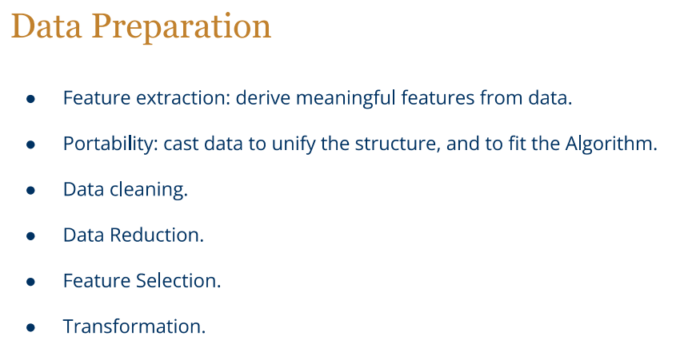

Compare k-means, k-medians and k-medoids

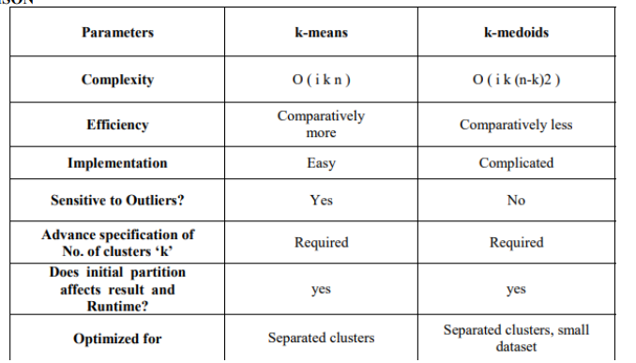

K-Means, K-Medians, and K-Medoids are all clustering algorithms used in unsupervised machine learning to group data points into clusters based on similarity. While they share the goal of partitioning data into groups, they differ in their approaches to defining the center of a cluster and their sensitivity to outliers.

1. **K-Means:**
   * **Centroid-based:** K-Means aims to minimize the sum of squared distances between data points and their assigned cluster centroids.
   * **Sensitivity to Outliers:** K-Means is sensitive to outliers because it uses the mean (centroid) to represent a cluster, and outliers can disproportionately affect the mean.
   * **Computational Efficiency:** It is computationally efficient and often converges quickly.
   * **Applicability:** Suitable for globular-shaped clusters.
2. **K-Medians:**
   * **Medoid-based:** K-Medians, on the other hand, uses the median of the data points in a cluster as the representative (medoid) instead of the mean.
   * **Robust to Outliers:** K-Medians is more robust to outliers than K-Means because the median is less affected by extreme values.
   * **Computational Complexity:** It is computationally more expensive than K-Means, as computing medians requires sorting the data.
   * **Applicability:** Well-suited for data with outliers or clusters of non-globular shapes.
3. **K-Medoids:**
   * **Medoid-based:** Similar to K-Medians, K-Medoids uses the concept of a medoid, but it specifically selects data points as the cluster representatives (medoids).
   * **Robust to Outliers:** Like K-Medians, K-Medoids is robust to outliers because it uses the actual data points as representatives.
   * **Computational Complexity:** It is generally more computationally expensive than both K-Means and K-Medians, as it involves selecting the most centrally located data point in each cluster.
   * **Applicability:** Suitable for datasets with outliers and non-globular clusters, and it can handle different distance metrics.

Cluster Validation

After a clustering of the data has been determined, it is important to evaluate its quality.

This problem is referred to as cluster validation.

Cluster validation is often difficult in real data sets because the problem is defined in an unsupervised way.

Sum of square distances to centroids:

In this case, the centroids of the different clusters are determined, and the sum of squared (SSQ) distances from different data points to the centroid of that cluster are reported as the corresponding objective function. Smaller values of this measure are indicative of better cluster quality. This measure is obviously more optimized to distance-based algorithms, such as k-means, as opposed to a density-based method, such as DBSCAN. Another problem with SSQ is that the absolute distances provide no meaningful information to the user about the quality of the underlying clusters.

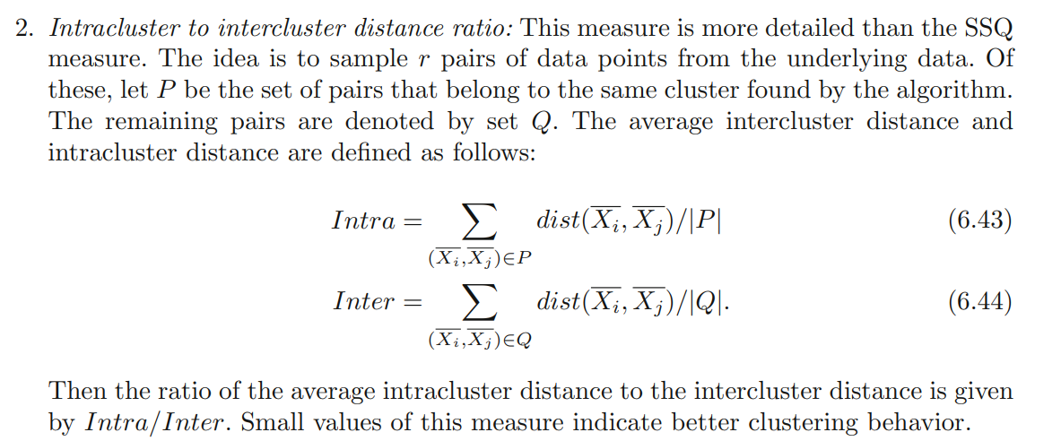

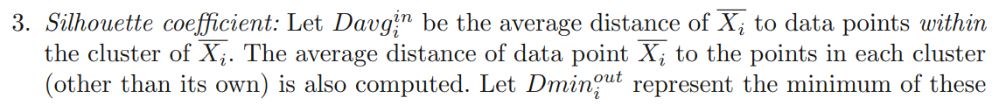

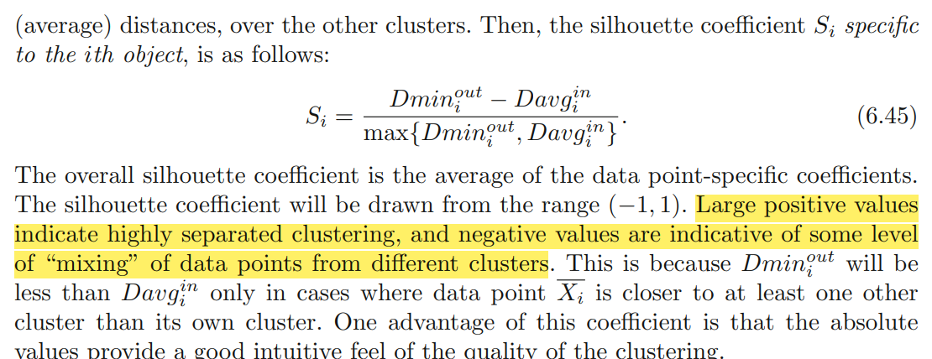

Illustrate with examples the trend, seasonality, and cycle components of a time series

1. **Trend Component:**
   * **Example:** Let’s say over the period of time, store observes consistent increase in sales.
2. **Seasonality Component:**
   * **Example:** Every year, during the holiday season (Christmas), the store observes a significant increase in sales. This regular pattern that repeats at a fixed interval (in this case, annually) is the seasonality component..
3. **Cycle Component:**
   * **Example:** Every three to four years, there's a noticeable pattern of alternating periods of increased and decreased sales, unrelated to the regular seasonal fluctuations. This longer-term pattern, not tied to a fixed calendar interval, is the cycle component. Economic cycles, changes in consumer behavior, or industry trends might influence these longer-term patterns.

Mathematical concepts for analyzing time series, including concepts of white noise, stationarity, and autocorrelation

White noise

**White Noise is a special type of time series where the data doesn’t follow a pattern**.

**White noise is a sequence of random data where every value has a time period associated with it. It behaves sporadically, so there is no way to successfully project it into the future**

In the case of White Noise since no pattern can be found, we can’t predict white noise.

**Example:** Imagine the daily fluctuations in the stock market prices, where each day's movement is random and not influenced by the previous day's performance. If the changes in stock prices are purely random and exhibit no pattern or correlation, it can be considered white noise.

For a Time Series to be categorized as White Noise, it must satisfy these three conditions:

1. A constant mean μ: Mean values are constant across intervals of the Time Series
2. A constant variation σ2: Variation is constant across intervals of the Time Series
3. No Autocorrelation: There is no clear relationship between past and present values of a time series.

Stationarity

Statistically speaking, a time series whose statistical properties, such as mean, variance, etc., remain constant over time, are called a stationary time series. Statistical properties of a Stationary Time Series are independent of the point in time when the observations are recorded.

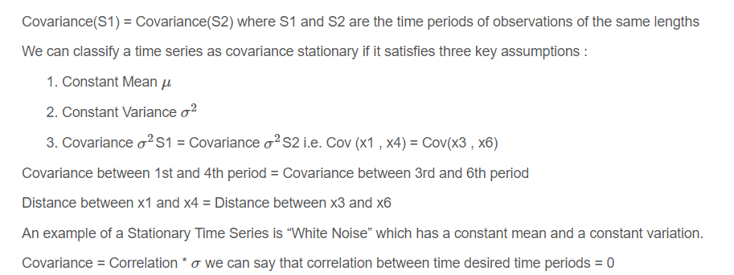

Autocorrelation

Autocorrelation measures the correlation between a time series and its own lagged values.

If the monthly sales of a product are positively autocorrelated with a lag of one month, it means that this month's sales are influenced by the previous month's sales.

**Autocorrelation measures the correlation between the sequence and itself to be more precise, it measures the level of resemblance between a sequence from several periods ago and the actual data. Autocorrelation is a representation of the degree of similarity between a given time series and a lagged version of itself over successive time intervals.**

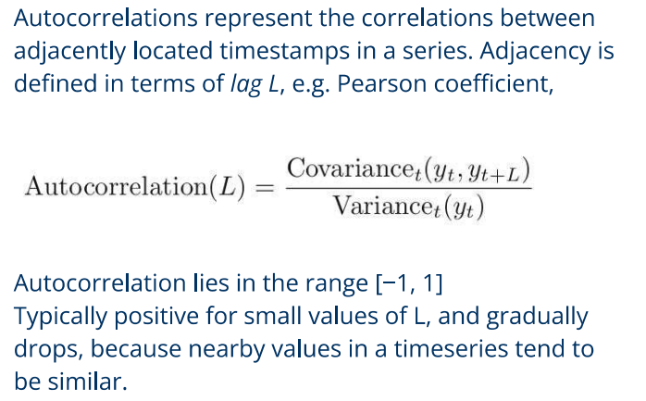

Explain and compare the measures: support, confidence, lift, correlation analysis.

Support, confidence, lift, and correlation analysis are measures used in data mining and association rule analysis. Let's explain and compare each of these measures:

1. **Support:**
   * **Definition:** Support measures the frequency of a particular itemset in the dataset. It indicates how often a set of items (or an association rule) appears in the entire dataset.
   * **Example:** If we are analyzing purchase transactions, the support for an itemset {A, B} is the proportion of transactions that contain both items A and B.
   * **Use:** Higher support values imply that the itemset is more frequently occurring and is considered more significant.
2. **Confidence:**
   * **Definition:** Confidence measures the reliability or certainty of a rule. It is the probability that an item B is purchased given that item A is purchased.
   * **Example:** For a rule {A} -> {B}, confidence is the proportion of transactions containing A where B is also present.
   * **Use:** Higher confidence values indicate a stronger association between items A and B.
3. **Lift:**
   * **Definition:** Lift measures how much more likely item B is purchased when item A is purchased compared to when B is purchased without A. It assesses the strength of the association between A and B, while considering the baseline probability of B.
   * **Example:** If lift = 2, it means that B is twice as likely to be bought when A is bought compared to when A is not bought.
   * **Use:** A lift value greater than 1 suggests a positive association, while less than 1 suggests a negative or weak association.
4. **Correlation Analysis:**
   * **Definition:** Correlation analysis measures the linear relationship between two variables. In the context of association rules, it may be used to assess the strength and direction of association between itemsets.
   * **Example:** If items A and B have a positive correlation, it means that the occurrence of one is likely to be associated with the occurrence of the other.
   * **Use:** Correlation is often expressed as a value between -1 and 1, where 1 indicates a perfect positive correlation, -1 indicates a perfect negative correlation, and 0 indicates no linear correlation.

Q) Explain the conditions for an ensemble of classifiers to yields more accurate predictions than its individuals.

1. **Diversity among Base Classifiers:**
   * The base classifiers in the ensemble should exhibit diversity, meaning they make different errors on different subsets of the data. If individual classifiers are highly correlated or make similar mistakes, the ensemble might not be able to correct those errors effectively.
2. **Accuracy of Base Classifiers:**
   * The individual classifiers within the ensemble should have reasonable predictive accuracy. If the base classifiers perform poorly on the task, combining their predictions may not lead to significant improvements.

**Appropriate Aggregation Method:**

* The method used to combine the predictions of individual classifiers (e.g., averaging, voting, stacking) should be appropriate for the nature of the problem and the characteristics of the base classifiers. Different aggregation methods may be more effective for different types of data and tasks.

**Appropriate Ensemble Algorithm:**

* The choice of ensemble algorithm matters. Popular ensemble methods include Random Forests, AdaBoost, Gradient Boosting, and bagging. The choice depends on the characteristics of the data and the problem at hand.

DBSCAN complexity

Time Complexity

* **Worst-case Time Complexity:** *O*(*n*2) in the simplest form, where *n* is the number of data points.
* **Explanation:** In the basic version of DBSCAN, the algorithm needs to compare each data point with every other data point to determine density-based neighbors. This leads to a quadratic time complexity. However, optimizations like spatial indexing structures (e.g., KD-trees or R-trees) can significantly reduce this complexity, bringing it closer to *O*(*n*log*n*) or even *O*(*n*) in some cases.

Space Complexity

* **Space Complexity:** *O*(*n*), where *n* is the number of data points.
* **Explanation:** The basic space complexity is linear with the number of data points. Additional memory may be used for maintaining data structures such as visited points and the cluster assignments.

DENCLUE Complexity

The DENCLUE (DENsity-based CLUstEring) algorithm is a density-based clustering algorithm that forms clusters based on the underlying probability density function of the data. The time and space complexity of DENCLUE depend on several factors, including the characteristics of the data and the specific implementation details.

**Time Complexity:**

1. **Kernel Density Estimation:**
   * **Worst-case Time Complexity:** *O*(*n*2) in the simplest form, where *n* is the number of data points.
   * **Explanation:** The basic step involves estimating the density at each data point using a kernel function. This density estimation is performed for each data point, resulting in a quadratic time complexity. However, optimizations can be applied to achieve *O*(*n*log*n*) or better.
2. **Hill Climbing:**
   * **Time Complexity:** Varies but often linear or close to linear, especially with efficient implementations.
   * **Explanation:** The hill climbing step involves finding the mode (peak) of the estimated density function. It often involves traversing the data points based on the estimated gradient.
3. **Cluster Assignment:**
   * **Time Complexity:** Generally linear.
   * **Explanation:** Assigning points to clusters based on density contours is typically a linear operation.

**Space Complexity:**

1. **Memory Usage:**
   * **Space Complexity:** *O*(*n*), where *n* is the number of data points.
   * **Explanation:** The basic space complexity is linear with the number of data points. Additional memory may be used for maintaining data structures such as density estimates, cluster assignments, and related information.

**Summary:**

* **Basic DENCLUE:**
  + **Time Complexity:** *O*(*n*2) for density estimation (can be optimized) and linear for hill climbing and cluster assignment.
  + **Space Complexity:** *O*(*n*).
* **DENCLUE with Optimizations:**
  + **Time Complexity:** Optimizations can lead to *O*(*n*log*n*) or better for density estimation, maintaining linear or close-to-linear time complexity for other steps.
  + **Space Complexity:** *O*(*n*) with additional space requirements for data structures.