Hammer Airflow True Wireless Earbuds (Blue), 5 Hours Playtime, with Magnetic Charging case (300mah),Built-in Voice Assistant & Bluetooth 5.0

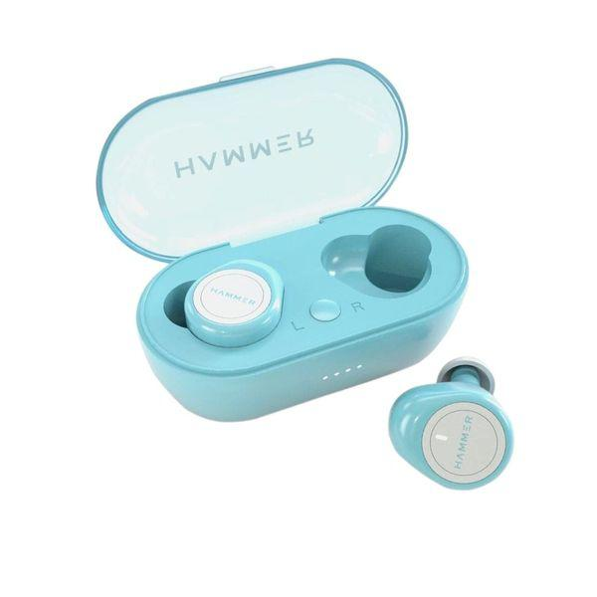

# Available Feature

Cash On Delivery Available

Free Shipping Available

Free One Gift Available(Wired Headset With Mic)

Use Coupon Code for 5% Discount:  Neha@gift  

# Product Details:

Model Name: Airflow TWS with Mic

Brand: ‎Hammer

Manufacturer ‎HAMMER, Mail- info@hammeronline.in, Mob- 9991108081

Model ‎AIRFLOW

Model Name ‎Airflow

Product Dimensions ‎0.4 x 0.4 x 0.7 cm; 40 Grams

Batteries ‎1 Lithium Polymer batteries required. (included)

Item model number ‎AIRFLOW

Compatible Devices ‎Compatible with iOS/Android

Special Features ‎True Wireless Earbuds; Bluetooth 5.0; Stereo Sound with Bass; Voice Assistant; Siri, Google Assistant, Built-in Mic; Sweatproof Earbuds; 3-4 Hrs Playtime with the Charging Case; 60 Hours Standby Time; Auto paired technology; Ultra Long Battery Life; In-Ear & Lightweight Design, With Multi-Function Control Button; 6-Months Warranty., Stylish Earphone; Mono Calling (Single Earbud); Strong 10m Wireless Range; 300mAh Magnetic Charging Case; Just 1 Hours Charge Time

Item Weight ‎40 g

Warranty: Domestic Warranty 1 Year

Warranty Summary: Hammer

comes with 12 months Replacement warranty only in case of manufacturing defects. Product Registration is mandatory at Hammeronline.in within 10 days of your purchase to claim the warranty. Customer Care: Email: info@hammeronline.in & MOB: 9991 108 081

Warranty Service Type:Off Site

Product Description:

A mix of innovative design and technology, this Hammer Airflow Truly Wireless Earbuds (TWS) makes the perfect companion in solitariness. It connects via Bluetooth5.0 and operates up to 10 measures. It comes with a glamorous charging case of 300mAh capacity and insure 3 to 4 hours of playtime with a single charge. The earbuds come with 2 observance-tips that have a soft, secure fit. The kids come with mic to grease calling and can be covered by the multi-function button that also allows switching music, answering or rejecting calls and using voice backing.

Integrated Control Button

Voice Actuated with Siri and Google adjunct

Bluetooth V5.0 Connectivity with 10M Range

300 mAh Lithium Polymer Battery

Hammer tailwind earbuds are designed for calling, music, gaming, sports and active life.

# Battery Tailwind offers continuous playback upto 4 Hrs and fresh 16 Hrs playtime with charging case.

Bluetooth V5.0 Maximize performance, stability, connectivity, effectively reduce power consumption.

Swish charging case TWS earbuds come with swish 300mah charging case which makes it safe & dustproof.

True wireless Bluetooth earbuds with bus paired technology, comfort fit, inconceivable sound quality.

Ultra Long Battery Life An optimized battery provides hours of nonstop play/ talk time on a single charge. Charging case of 400 mah can charge truly wireless earbuds for 7-8 times

Rearmost V5.0 Bluetooth Technology Hammer introduces a new true wireless V5.0 TWS Bluetooth earphones bringing up high speed data transfer, Stable Performance and low battery consumption.