Employees and Managers

- Create constructor functions with properties representing the following:
  - Person: name, surname
  - Employee: inherits Person and has job and salary
  - Developer: inherits from Employee and has specialization
  - Manager: inherits from Employee and has department

- All developers should inherit method:
  - getSpecialization which prints out the name of the specialization

- All managers should inherit methods:
  - getDepartment which prints out the name of the department
  - changeDepartment which sets the department value on the given value

- All employees should inherit methods:
  - getData which returns the name, surname and salary
  - getSalary which prints out the salary
  - increaseSalary which increases the salary by 10%

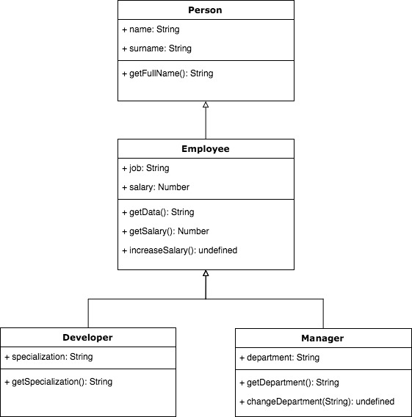

Applications:

- Create constructor functions with properties representing the following:
  - WebApp: name, url, technologies, licence, stars
  - MobileApp: name, platforms, licence, stars

- All web applications should inherit methods:
  - getData which prints out all the information
  - reactBased which checks if one of the used technologies is React

- All mobile applications should inherit methods:
  - getData which prints out all the informations
  - forAndroid which checks if one of the platforms the application is developed for is Android

- Both web and mobile applications should inherit methods:
  - isCCLicence which checks if the licence of the application is CC (Creative Commons)
  - like which increases the number of stars by one
  - showStars which prints out the number of stars

