**Практическая работа «Создание браузера»**

**Результаты работы:**

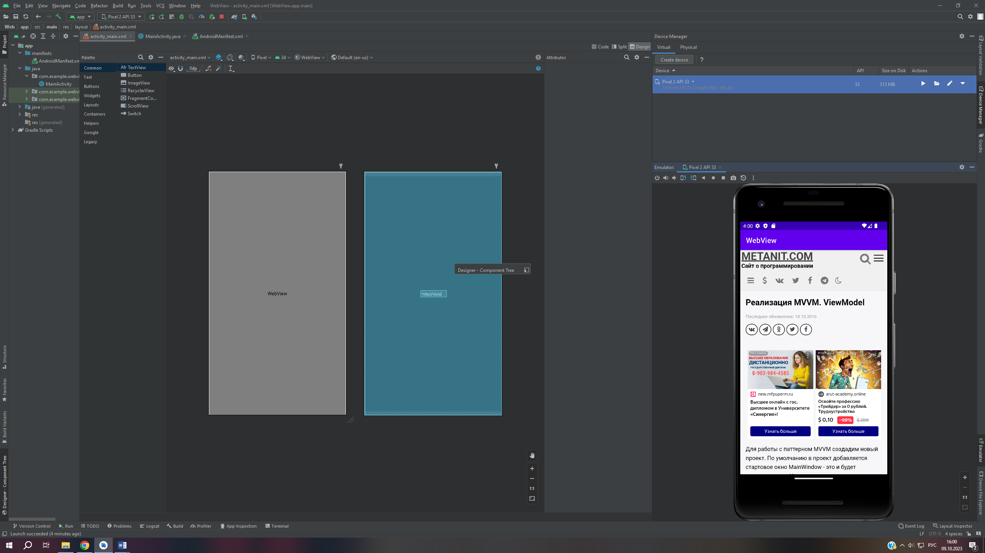

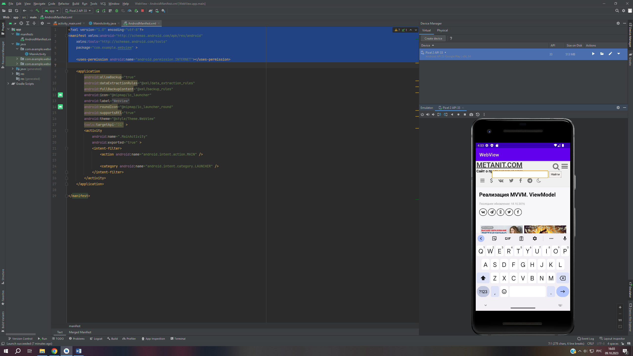

**Activity_main:**

?xml version="1.0" encoding="utf-8"?>  
<androidx.constraintlayout.widget.ConstraintLayout  
 xmlns:android="http://schemas.android.com/apk/res/android"  
 xmlns:tools="http://schemas.android.com/tools"  
 xmlns:app="http://schemas.android.com/apk/res-auto"  
 android:layout_width="match_parent"  
 android:layout_height="match_parent"  
 tools:context=".MainActivity">  
  
 <TextView  
 android:id="@+id/textView2"  
 android:layout_width="wrap_content"  
 android:layout_height="wrap_content"  
 android:text="Hello World!"  
 app:layout_constraintBottom_toBottomOf="parent"  
 app:layout_constraintEnd_toEndOf="parent"  
 app:layout_constraintStart_toStartOf="parent"  
 app:layout_constraintTop_toTopOf="parent" />  
  
 <LinearLayout  
 android:layout_width="410dp"  
 android:layout_height="731dp"  
 android:orientation="vertical"  
 tools:layout_editor_absoluteX="1dp"  
 tools:layout_editor_absoluteY="1dp"  
 tools:ignore="MissingConstraints">  
  
 <WebView  
 android:id="@+id/WebView"  
 android:layout_width="match_parent"  
 android:layout_height="match_parent" >  
 </WebView>  
 </LinearLayout>  
  
</androidx.constraintlayout.widget.ConstraintLayout>

**MainActivity:**

package com.example.webview;  
  
import androidx.appcompat.app.AppCompatActivity;  
import android.os.Bundle;  
import android.webkit.WebSettings;  
import android.webkit.WebView;  
import android.webkit.WebViewClient;  
  
public class MainActivity extends AppCompatActivity {  
  
 private WebView web;  
 @Override  
 protected void onCreate(Bundle savedInstanceState) {  
 super.onCreate(savedInstanceState);  
 setContentView(R.layout.*activity_main*);  
  
 web = (WebView) findViewById(R.id.*WebView*);  
 WebSettings ws = web.getSettings();  
 ws.setJavaScriptEnabled(true);  
 web.loadUrl("https://metanit.com/java/android/15.1.php");  
 web.setWebViewClient(new WebViewClient());  
 }  
 @Override  
 public void onBackPressed() {  
 if(web.canGoBack())  
 web.goBack();  
 else  
 super.onBackPressed();  
 }  
  
}

AndroidManifest:

?xml version="1.0" encoding="utf-8"?>  
<manifest xmlns:android="http://schemas.android.com/apk/res/android"  
 xmlns:tools="http://schemas.android.com/tools"  
 package="com.example.webview" >  
  
 <uses-permission android:name="android.permission.INTERNET"></uses-permission>

Ссылка: