**INTRODUCTION**

Invoice System is a critical activity and an integral milestone for any company and shopping websites. Initially, this application is designed to manage different modules of ***ASHOK SECURE BROADBRAND NETWORK PVT LTD.***

This software “***IBS – Invoice Billing System***” is mainly for billing management. The software informs the owners regarding all works concerned with agency as related from product purchased, product entry, customer information entry, bill entry etc.

The biggest advantage of the software is that when the product price are changed they need to update each and every excel file, maintains automatic billing order and customer details, generation on screen as well as on paper (print out). This system makes a platform, where the owner can easily provide the valuable information regarding the e–billing generation, Bill declaration etc.

**OBJECTIVE**

The purpose of invoice billing system is to take e-receipt in an efficient manner and no time wasting by writing on the receipt. The main objective of invoice billing system is to efficiently evaluate the customers thoroughly and making complete atomization of manual billing and invoicing systemthat not only saves lot of time but also gives fast receipt.

This software is designed in view to automatic computerize the data of invoice billing system. It was required to keep the computerized data, as it was difficult to do manually and is also fast as it takes less time. Purpose of computerize its data automatically to overcome from haphazard of manual system by MS-Excel. This software is developed with an aim to give accurate and immediate product purchased information whenever required in very short span of time.

This software mainly provides all information about company products, company details, product details, product purchased details, bill details, invoice bill. It handles all information of products purchased by the customer required by company. Owner can view monthly bill easily with this software.

The prime objectives of this software:-

1. It involves converting data from Microsoft Excel to the Database, system can import existing customer, product data from predefined MS Excel, CSV format.
2. It reduces the data entry work and quick implementation of the system.
3. Storing information of products required during purchasing.
4. Stores information about products, customers, bill generation.
5. Fast receipt view. No time wasting during billing.

**PROBLEM STATEMENT**

**Existing system**

After analyzing the existing system, different types of problem were found:

* The client uses MS Excel or paper receipt, and maintains their product list, customer list, and prints the invoice.
* The basic problem is that it is not possible them to share the data from multiple system in multi user environment.
* There is lot of duplicate work, and chance of mistake.
* There is no option to find and print previous saved invoice.
* There is no security; anybody can access any report and sensitive data, also no reports to find out the sales volume, stock list, and summary report.
* Generating invoice bill is a tedious task, as everything has to be done manually.
* There are certain additional staffs assigned for generating invoice billing.

**Requirements**

The basic requirement is remove the unwanted mistake in the entry, apart from this reduce the manpower and time consumption. The system should make the task of the entire user quite easy. It should give the required bill without much staff efforts.

**Proposed System**

Based on the analysis of problem areas the proposed system shall be making complete atomization of manual billing so as to have effective Invoice Billing System. This will not only alleviate the current problems but also provide information networks which will strengthen the manner in which the company address its primary core are i.e. Billing System. Proposed system is proposed to feed all the required data in computer and generate the quick, accurate, timely and efficient automatic bill from the system. Client server technology shall be implemented to implemented to have good working, robust software for the system. The huge capabilities of the existing hardware and graphical user interface environment shall be put for the optimum use so as to have user friendly software.

**Objective Proposed System**

* All voluminous data should be fed in to the relational database that shall make it easy to manage.
* Central management of data should remove redundancy of data in the system.
* At any instance of time, current status of any entity could be derived.

It should be easy to query the data base and get necessary information from it at any instance of time.

**Proposed System Solution**

Proposed system provides with following solutions:

* **Customer, Products, Billing Generation**: Automate the

current manual bill generation system and maintain the

searchable customer, products database and product invoice,

maintain the data security, user rights.

* **Report Generation**: A Report Generation system will be

developed for the user and management of billing and

Invoicing System.

* It provides “better and efficient” service to customers.
* Reduced the workload of staffs.
* Faster retrieval of bill information.
* Provides facility for proper monitoring reduces manual

computerized work and provides data security.

* All details will be available on click automatically.

**REQUIREMENT ANALYSIS**

**Hardware:**

* Pentium IV Processor
* 750 MHz
* 80 GB HDD
* 1 GB RAM

**Software:**

**Front End:**  PHP

**Back End:** MY SQL

**Code Behind:**  HTML, CSS,JAVASCRIPT

**Operating System:**

**Development PC:**  IIS, Window7

XAMPP SERVER

(PHP MYADMIN)

MVC ARCHITECTURE

**SYSTEM REQUIREMENT SPECIFICATION**

The requirement analysis phase is the first major step towards the solution of a software problem.

During this phase, the user’s requirements concerning the proposed application are carefully identified and documented. It is a task, which allows the software developer to refine the software allocation and build models of the data, functional and behavioral domains that will be treated by software. System requirements may be either Functional or Non-Functional. **Functional Requirements**

The system is to support the following functions:

***Function 1: Personal IBS system***

The personal IBS system will be used by the user and administrative members thus will run independent of the main IBS system. This IBS system will be used only for work-related purposes. The following functions should be available in the communication system with regards to administration: adding, updating old and new records, forwarding, deleting, and modifying the status of the records, notification of new / unread records, deleting, and the ability to navigate through e-mail received.

***Function 2: View and enter new reports***

For example, user’s number must be unique and when entering reports modules both values must be valid references. Users input must be validated and if not in the range specified, the users must be informed of the correct range. Incorrect data must be prevented in being input, where possible. The serial field should be locked, as it should be calculated automatically.

***Function 3: Security***

The operating system in the department, IMS version 1.0, will be used to enforce security. So that only the administrative members and the manager will have access to the system. However another security layer should also be incorporated, to make the system more secure.

***Function 4: Changing passwords and setting new password***

The facility of changing a new password and setting or adding a new password should be available from a menu.

***Function 5: User’s details***

Administrator need to view and also add new product for user database. It would be very helpful if a user could enter either a user’s name or number in order to retrieve the user’s details and to perform other functions such as deleting data and printing out customer information. It was discussed that the users would not prefer to get help from the system in entering the user names to search for, as this function has been previously been available in the old database and was found to be very annoying rather than helpful after a while.

***Function 7: Product details***

It would be of much use if users could search for information on products. By typing in the serial no of the product. Also there should be a facility where users’ can navigate and view all.

***2.2 Non-functional Requirements***

Mainly in the creation of work-related Management Systems (MS) there has always been an emphasis on automating work-related tasks in order to enhance work productivity. When manual tasks are automated work generally becomes less time consuming, time is money, thus more money is saved, data is easier to manipulate and is more secured. Fig shows the Data Flow Diagram (DFD) of the MIS.

**SYSTEM ANALYSIS**

The system analysis has been conducted with help of Miss. Kavita Pradhan.

* **Reason For Analysis:**

The current manual information system is not meeting the needs of those responsible for the modeling of Invoice management system.

* **Description:**

As we know, System analysis is the first step, which is concerned with devising a precise, under stable and correct model of real world. Before building anything we must analyze about it to understand requirement.

As we mentioned introductory part, this Project assignment is the part of decision support system. It is very difficult for we type of untrained People to understand system easily because we have no knowledge of this application domain. But hard work of 1 to 2 months intimate imagination to understand and feel the ideas about this application domain. In this concerned we are very grateful to my project guide.

In the initial stage of analysis, I formally attained the lecture of my project guide. During this phase I have concentrated on

(i) Technical terms of this application domain

(ii) How to classify different parts of the project? i. e. Prepare

logical break-up about, what we understand?

(iii) What we have to do?

(iv) How map to these ideas to developing language PHP etc.

I have very frankly to say, during these 3 to 4 months I have only what, how …How? And there are so many of how?

To understand the requirements i.e. what is needed. We have broken the whole project into small parts for ease of analysis. Invoice Management System is the key issue for this type of project.

We have sincerely analyzed project site physical situations, social- economy and finally the impact of exhaust on the environment.

**A. Identification of need**

During the interviews and form the research work done by me, we identified the following specific needs: --

1. Management needs uniform, consistent, reliable and fast decision making processes, so that it can attract the various similar software.
2. Project Manager needs proper standardized solution for the preparation of feasibility report to attract consistent, higher no. of investment opportunity.
3. Management wants to avoid the duplications and improve the efficiency, correctness and timeliness of the feasibility analysis so that the appropriate decision can be taken under the time constraint.
4. An efficient system is needed to generate timely and accurate report to various actors.
5. A system is needed to enhance the co-ordination between the various actors like System Analyst, Survey team, Project Manager, Entrepreneur involved in modeling process.
6. Project specific feasibility decision, management and control systems needed.
7. Management wants information technology based solutions.

1. **Preliminary Investigation**

Review of existing manual system, on site observations and interview are conducted for the modeling of office system in the light of user’s need and problem identification yet. Following facts about the nature of the project request are observed.

1. Preliminary area of applications:

The preliminary area of application for this project identified during the investigation phase is Database handling, accounting and Decision-making. Since the data comes from various source and need to store in the system hence the database management system is needed. On the basis of various data that comes from survey report, per unit cost of electricity is calculated. Hence Accounting Process is also needed. The decision-making is the ultimate goal of management; hence this project if developed must assist management for taking appropriate decision regarding modeling process of Office Management system.

(b) Problem definition:

The existing modeling process for Office Management system have number of problems like:

* Lack of Reliability
* Lack Of Proper Standardization
* Timeliness
* Poor Internal Control Of Information
* Lack Of Efficiency
* Problem Of Accuracy
* Problem Of Economy
* Security Problem

**(c) Details of the Problem:**

The details of the problems are:

1. **Lack of Reliability:**

The system varies in quality from one Project to another. Whenever a new project is taken, the whole process is done again through manual process, which results in several of the outcome that desired.

1. **Lack of proper Standardization:**

Since there is no proper standard in the preparation of feasibility reports for such kinds of enterprise, it is difficult to project manager to prepare feasibility reports.

1. **Timelines:**

The bill generation is ultimate goal of the system. Management needs to generate several reports timely, so that it can attract investor. The existing manual system is unable to generate various reports under time constraint. The retrieval of information when and where it is needed is not available.

1. **Poor internal control of information:**

The manual system lacking internal control of information between different modules. What if analysis is needed before preparation of final report regarding project feasibility? Since there is a lack of internal control of information of various modules, it is often difficult to achieve this task. The problem area is also affected due to poor control of information flow.

1. **Lack of efficiency:**

The system needs to store the same piece of data various places. This means that the work is to be duplicated and hence the system becomes inefficient.

1. **The problem of accuracy:**

The modeling process from the embryonic data gathering steps to the processing and decision making steps needs numbers arithmetic calculations. This process is complex and fair amount of errors may occur. Because of inaccuracy, the result that may be generated by the system becomes unreliable and often invalid. These invalid results are often most troublesome for the system manager.

1. **The problem of economy:**

The system also suffers from problem of economy because the existing methods of transmitting, processing and storing information are very costly. The entire process demands a great deal of paperwork.

1. **Security problem:**

The entire process needs paperwork. Paper is not a reliable media for the storing of information. Hence the system also lacks proper security.

**(d) Significance of problem:**

Lack of proper standardization, timeliness & poor internal control of information is the major problem. Due to absence of any such information system, consistent and higher No. of investment opportunity is always being a milestone for a project manager.

Efficiency, accuracy & reliability are another problem that most of time lacking in the existing manual system. The invalid bills that may occur due to the arithmetic errors become troublesome for the project manager. Paper is unreliable, insecure and costly media for the storage of information. Since the entire process starting from the data-gathering step to the decision step involved great deal of paperwork, the selection of storage media as a paper becomes unreliable, insecure and costly.

**PHP**

PHP as its known today is actually the successor to a product named PHP/FI. Created in 1994 by Rasmus Lerdorf, the very first incarnation of PHP was a simple set of Common Gateway Interface (CGI) binaries written in the C programming language. Originally used for tracking visits to his online resume, he named the suite of scripts "Personal Home Page Tools," more frequently referenced as "PHP Tools." Over time, more functionality was desired, and Rasmus rewrote PHP Tools, producing a much larger and richer implementation. This new model was capable of database interaction and more, providing a framework upon which users could develop simple dynamic web applications such as guestbook’s. In June of 1995, Rasmus [released](http://groups.google.com/group/comp.infosystems.www.authoring.cgi/msg/cc7d43454d64d133) the source code for PHP Tools to the public, which allowed developers to use it as they saw fit. In September of that year, Rasmus expanded upon PHP and - for a short time - actually dropped the PHP name. Though it lived a short development life, it continued to enjoy a growing popularity in still-young world of web development. In 1997 and 1998, PHP/FI had a cult of several thousand users around the world. A Net craft survey as of May, 1998, indicated that nearly 60,000 domains reported having headers containing "PHP", indicating that the host server did indeed have it installed. This number equated to approximately 1% of all domains on the Internet at the time. Despite these impressive figures, the maturation of PHP/FI was doomed to limitations; while there were several minor contributors, it was still primarily developed by an individual.

**CSS (CASCADING STYLE SHEET)**

Stands for "Cascading Style Sheet" Cascading style sheets are used to format the layout of Web pages. They can be used to define text styles, table sizes, and other aspects of Web pages that previously could only be defined in a page's HTML.

CSS helps Web developers create a uniform look across several pages of a Web site. Instead of defining the style of each table and each block of text within a page's HTML, commonly used styles need to be defined only once in a CSS document. Once the style is defined in cascading style sheet, it can be used by any page that references the CSS file. Plus, CSS makes it easy to change styles across several pages at once. For example, a Web developer may want to increase the default text size from 10pt to 12pt for fifty pages of a Web site. If the pages all reference the same style sheet, the text size only needs to be changed on the style sheet and all the pages will show the larger text.

While CSS is great for creating text styles, it is helpful for formatting other aspects of Web page layout as well.

**JAVASCRIPT**

Java Script is a user interface scripting language developed by Netscape for its Navigator and Communicator World- Wide Web browsers. Microsoft has developed a compatible language, called J-Script, for its Internet Explorer browser.

While the syntax of the Java Script programming language resembles that of Java, the two languages are actually unrelated. Java Script source code is embedded in HTML documents, and is interpreted by a World-Wide Web browser. Java source code is compiled into a byte code, stored in a separate file, which the World-Wide Web browser downloads and executes separately from an HTML page.

**MY-SQL**

[My SQL](http://mysql.com), the open source database product that puts the "M" in LAMP, was created by My SQL AB, a company founded in 1995 in Sweden. In 2008, My SQL AB announced that it had agreed to be acquired by Sun Microsystems for approximately $1 billion.

My SQL is one of the most widely used open source relational database management systems in the world. With a total distribution amounting to more than 100 million worldwide, the software has become the first choice of large data management corporations spanning over a wide range of internet technologies.

**MVC Architecture**

**M**odel **V**iew **C**ontroller or MVC as it is popularly called, is a software design pattern for developing web applications. A Model View Controller pattern is made up of the following three parts:

* **Model** - The lowest level of the pattern which is responsible for maintaining data.
* **View** - This is responsible for displaying all or a portion of the data to the user.
* **Controller** - Software Code that controls the interactions between the Model and View.

MVC is popular as it isolates the application logic from the user interface layer and supports separation of concerns. Here the Controller receives all requests for the application and then works with the Model to prepare any data needed by the View. The View then uses the data prepared by the Controller to generate a final presentable response. The MVC abstraction can be graphically represented as follows.

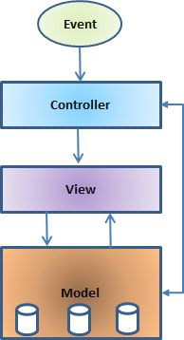

**The model:** The model is responsible for managing the data of the application. It responds to the request from the view and it also responds to instructions from the controller to update itself.

**The view:** A presentation of data in a particular format, triggered by a controller's decision to present the data. They are script based tinplating systems like JSP, ASP, PHP and very easy to integrate with AJAX technology.

**The controller:** The controller is responsible for responding to user input and perform interactions on the data model objects. The controller receives the input, it validates the input and then performs the business operation that modifies the state of the data model.

**DATA FLOW DIAGRAM**

A data-flow diagram (DFD) is a graphical representation of the "flow" of data through an information system. DFDs can also be used for the visualization of data processing (structured design). On a DFD, data items flow from an external data source or an internal data store to an internal data store or an external data sink, via an internal process.

A DFD provides no information about the timing of processes, or about whether processes will operate in sequence or in parallel. It is therefore quite different from a flowchart, which shows the flow of control through an algorithm, allowing a reader to determine what operations will be performed, in what order, and under what circumstances, but not what kinds of data will be input to and output from the system, nor where the data will come from and go to, nor where the data will be stored (all of which are shown on a DFD).

As all system development are divided into different modules and they will interact with information. The module structure is designed consideration of the easy to maintain the logic for modification and maintenance. The system has mainly four parts: -

1. Interaction of agency with candidate’s for enquiry.
2. Interaction of management.
3. Inventory management.
4. Contact students, faculties and member of management.

***CONTEXT ANALYSIS DIAGRAM***

0’Level DFD

*1ST LEVEL DFD*

*2nd LEVEL DFD*

**DATA DICTIONARY**

**Login Table**

Field caption : Email Id

Field name : email_id

Data type : varchar

Length : 50

Description : stores the code of the customer email id

Business Rule : foreign key

Field caption : Password

Field name : password

Data type : varchar

Length : 20

Description : stores the code of the customer password

Business Rule : not null value

**Admin Table**

Field caption : Admin form

Field name : email_id

Data type : varchar

Length : 20

Description : stores the code of the admin email id

Business Rule : primary key

Field caption : Password

Field name : password

Data type : varchar

Length : 20

Description : stores the code of the admin password

Business Rule : not null value

**Customer form**

Field caption : Email Id

Field name : email_id

Data type : varchar

Length : 50

Description : stores the code of the email id of customer

Business Rule : primary key

Field caption : First Name

Field name : first_name

Data type : varchar

Length : 20

Description : stores the first name of customer

Business Rule : not null value

Field caption : Last Name

Field name : last_name

Data type : varchar

Length : 20

Description : stores the description of the last name of customer

Business Rule : not null value

Field caption : Address

Field name : address

Data type : varchar

Length : 50

Description : stores the address of the customer

Business Rule : not null value

Field caption : Phone Number

Field name : phone_no

Data type : char

Length : 10

Description : stores the phone no of the customer

Business Rule : not null value

Field caption : Id Proof

Field name : id_proof

Data type : file

Length : 50

Description : stores the scan copy of the id proof of customer

Business Rule : not null value

Field caption : Caf Form No

Field name : caf_form_no

Data type : int

Length : 11

Description : stores the customer unique form number.

Business Rule: unique value auto increment

**Product form**

Field caption : Serial no

Field name : serial_no

Data type : int

Length : 11

Description : stores the serial no of product

Business Rule : primary key

Field caption : Product Name

Field name : product_name

Data type : varchar

Length : 50

Description : stores the product name

Business Rule : not null value

Field caption : Duration

Field name : duration

Data type : int

Length :11

Description : stores the time duration of product

Business Rule : not null value

Field caption : Price

Field name : price

Data type : int

Length :11

Description : stores the price of product

Business Rule : not null value

**Payment**

Field caption : Transaction Id

Field name : transaction_id

Data type : int

Length : 11

Description : stores the transaction id for bill

Business Rule : primary key

Field caption : email id

Field name : email_id

Data type : varchar

Length : 50

Description : stores the email id of customer

Business Rule : foreign key

Field caption : Serial no

Field name : serial_no

Data type : int

Length :11

Description : stores the serial no of product

Business Rule : foriegn key

Field caption : Caf form No

Field name : caf_form_no

Data type : int

Length : 11

Description: stores the unique customer form number

Business Rule: foriegn key

**E-R DIAGRAM**

User USER

SUBSCRIBER

PRODUCT

**VALIDATION CHECK**

We have incorporated following checks for validation of user input-

1. All primary key fields must not be NULL.
2. All character type fields never accept blank space.
3. Numeric fields must not accept nonnumeric value.
4. Value of fields must not overflow their size.
5. Numeric value must be occurs within their range.
6. In cost benefit report functional cell must not allow to change their value by user.
7. Cursor movement must follow a specific sequence from top to bottom in all entry form.

**SOURCE CODE & SCREEN OUTPUT**

**Customer Login Form**

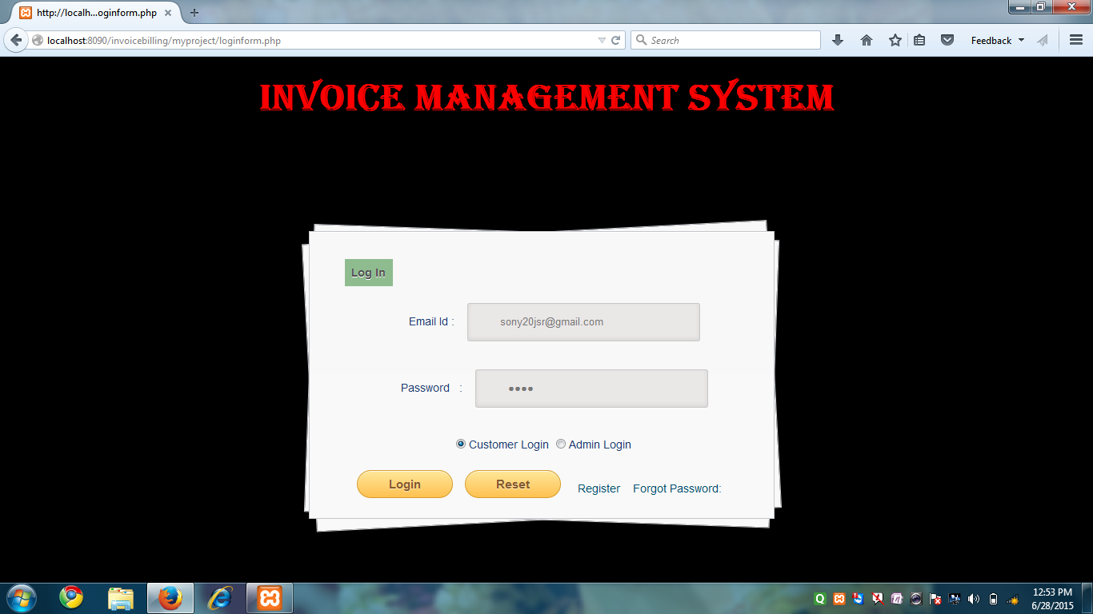

**SOURCE CODE**

<?php session_start();?>

<html><body ulink="#004F6C" vlink="#004F6C" link="#004F6C">

<head><style>body, div,

p, fieldset{margin: 4;padding: 0;border: 0;outline: 0;font-size: 100%;vertical-align: baseline;background: transparent;}body {background:#000;color: #000;font: 14px Arial;margin: 0 auto;padding: 0;position: relative;}

a{ text-decoration: none; }

#content {background: #f9f9f9;background: -moz-linear-gradient(top, rgba(248,248,248,1) 0%, rgba(249,249,249,1) 100%);background: -webkit-linear-gradient(top, rgba(248,248,248,1) 0%,rgba(249,249,249,1) 100%);background: -o-linear-gradient(top, rgba(248,248,248,1) 0%,rgba(249,249,249,1) 100%);background: -ms-linear-gradient(top, rgba(248,248,248,1) 0%,rgba(249,249,249,1) 100%);background: linear-gradient(top, rgba(248,248,248,1) 0%,rgba(249,249,249,1) 100%);filter: progid:DXImageTransform.Microsoft.gradient( startColorstr='#f8f8f8', endColorstr='#f9f9f9',GradientType=0);-webkit-box-shadow: 0 1px 0 #fff inset;-moz-box-shadow: 0 1px 0 #fff inset;-ms-box-shadow: 0 1px 0 #fff inset;-o-box-shadow: 0 1px 0 #fff inset;box-shadow: 0 1px 0 #fff inset;border: 1px solid #c4c6ca;margin: 70 auto;padding: 30px 0 0;position: relative;text-align: center;text-shadow: 0 1px 0 #fff;width: 580px;height:50%;}

#content:after,

#content:before {background: #f9f9f9;background: -moz-linear-gradient(top, rgba(248,248,248,1) 0%, rgba(249,249,249,1) 100%);background: -webkit-linear-gradient(top, rgba(248,248,248,1) 0%,rgba(249,249,249,1) 100%);background: -o-linear-gradient(top, rgba(248,248,248,1) 0%,rgba(249,249,249,1) 100%);background: -ms-linear-gradient(top, rgba(248,248,248,1) 0%,rgba(249,249,249,1) 100%);background: linear-gradient(top, rgba(248,248,248,1) 0%,rgba(249,249,249,1) 100%);filter: progid:DXImageTransform.Microsoft.gradient( startColorstr='#f8f8f8', endColorstr='#f9f9f9',GradientType=0 );border: 1px solid #c4c6ca;content: "";display: block;height: 100%;left: -1px;position: absolute;width: 100%;}

#content:after {-webkit-transform: rotate(2deg);-moz-transform: rotate(2deg);-ms-transform: rotate(2deg);-o-transform: rotate(2deg);transform: rotate(2deg);top: 0;z-index: -1;}

#content:before {-webkit-transform: rotate(-3deg);-moz-transform: rotate(-3deg);-ms-transform: rotate(-3deg);-o-transform: rotate(-3deg);transform: rotate(-3deg);top: 0;z-index: -2;}

#content form { margin: 0 40px; }

#content form input[type="text"],

#content form input[type="password"] {-webkit-border-radius: 3px;-moz-border-radius: 3px;-ms-border-radius: 3px;-o-border-radius: 3px;border-radius: 3px;-webkit-box-shadow: 0 1px 0 #fff, 0 -2px 5px rgba(0,0,0,0.08) inset;-moz-box-shadow: 0 1px 0 #fff, 0 -2px 5px rgba(0,0,0,0.08) inset;-ms-box-shadow: 0 1px 0 #fff, 0 -2px 5px rgba(0,0,0,0.08) inset;-o-box-shadow: 0 1px 0 #fff, 0 -2px 5px rgba(0,0,0,0.08) inset;box-shadow: 0 1px 0 #fff, 0 -2px 5px rgba(0,0,0,0.08) inset;-webkit-transition: all 0.5s ease;-moz-transition: all 0.5s ease;-ms-transition: all 0.5s ease;-o-transition: all 0.5s ease;transition: all 0.5s ease;background: #eae7e7 url(http://cssdeck.com/uploads/media/items/8/8bcLQqF.png) no-repeat;border: 1px solid #c8c8c8;color: #777;font: 13px Helvetica, Arial, sans-serif;margin: 0 0 10px;padding: 15px 10px 15px 40px;width: 60%;}

#username { background-position: 10px 10px !important }

#password { background-position: 10px -53px !important }

#content form input[type="submit"],input[type="reset"] {background: rgb(254,231,154);background: -moz-linear-gradient(top, rgba(254,231,154,1) 0%, rgba(254,193,81,1) 100%);background: -webkit-linear-gradient(top, rgba(254,231,154,1) 0%,rgba(254,193,81,1) 100%);background: -o-linear-gradient(top, rgba(254,231,154,1) 0%,rgba(254,193,81,1) 100%);background: -ms-linear-gradient(top, rgba(254,231,154,1) 0%,rgba(254,193,81,1) 100%);background: linear-gradient(top, rgba(254,231,154,1) 0%,rgba(254,193,81,1) 100%);

filter: progid:DXImageTransform.Microsoft.gradient( startColorstr='#fee79a', endColorstr='#fec151',GradientType=0 );-webkit-border-radius: 30px;-moz-border-radius: 30px;

-ms-border-radius: 30px;-o-border-radius: 30px;border-radius: 30px;-webkit-box-shadow: 0 1px 0 rgba(255,255,255,0.8) inset;-moz-box-shadow: 0 1px 0 rgba(255,255,255,0.8) inset;-ms-box-shadow: 0 1px 0 rgba(255,255,255,0.8) inset;-o-box-shadow: 0 1px 0 rgba(255,255,255,0.8) inset;box-shadow: 0 1px 0 rgba(255,255,255,0.8) inset;border: 1px solid #D69E31;color: #85592e;cursor: pointer;float: left;font: bold 15px Helvetica, Arial, sans-serif;height: 35px;margin: 20px 0 35px 15px;position: relative;text-shadow: 0 1px 0 rgba(255,255,255,0.5);width: 120px;}

p {color:#1C3D70 }

legend { font-weight: bold;border: 0px solid #888;padding: 0.6em;background-color: blue;}

div#content{margin-right: 30%;margin-left: 28%;margin-top: 10%;}

label, legend {background: #8FBC8F;border: 0px solid rgb(0, 0, 0);color: rgb(80, 80, 80);}</style></head>

<h1 align="center" ><font face="Algerian" color="#FF0000" size="+4">INVOICE MANAGEMENT SYSTEM</font></h1><div id="container"><div id="wrapper"> <div id="content">

<form name="form1" id="form1" method="POST" action="classes/controller/login_controller.php">

<?php $msg=" "; if(isset($_SESSION['error_msg'])){$msg = $_SESSION['error_msg']; unset($_SESSION['error_msg']);}

if(!empty($msg)){echo"<p>".$msg."</p>";}?>

<fieldset><legend>Log In</legend><br>

<p>&nbsp &nbsp &nbsp &nbsp Email Id :&nbsp&nbsp&nbsp <input type="text" name="email_id" id="email_id"required aria-required="true"/></p><br><p>&nbsp &nbsp &nbsp &nbsp Password&nbsp&nbsp&nbsp:&nbsp&nbsp&nbsp <input type="password" name="password" id="password" required aria/></p><br>

<p><input type="radio" name="role" value="1" id="role_0">Customer Login<input type="radio" name="role" value="2" id="role_1">Admin Login</p>

<input type="submit" name="login" id="button"value="Login"><input type="reset" name="reset" id="button"value="Reset"><br><br><a href="registerform.php">Register</a>&nbsp&nbsp&nbsp<a href="forgotpass.php">Forgot Password:</a>

</form></fieldset></div></div></div></body></html>

**REGISTERATION FORM**

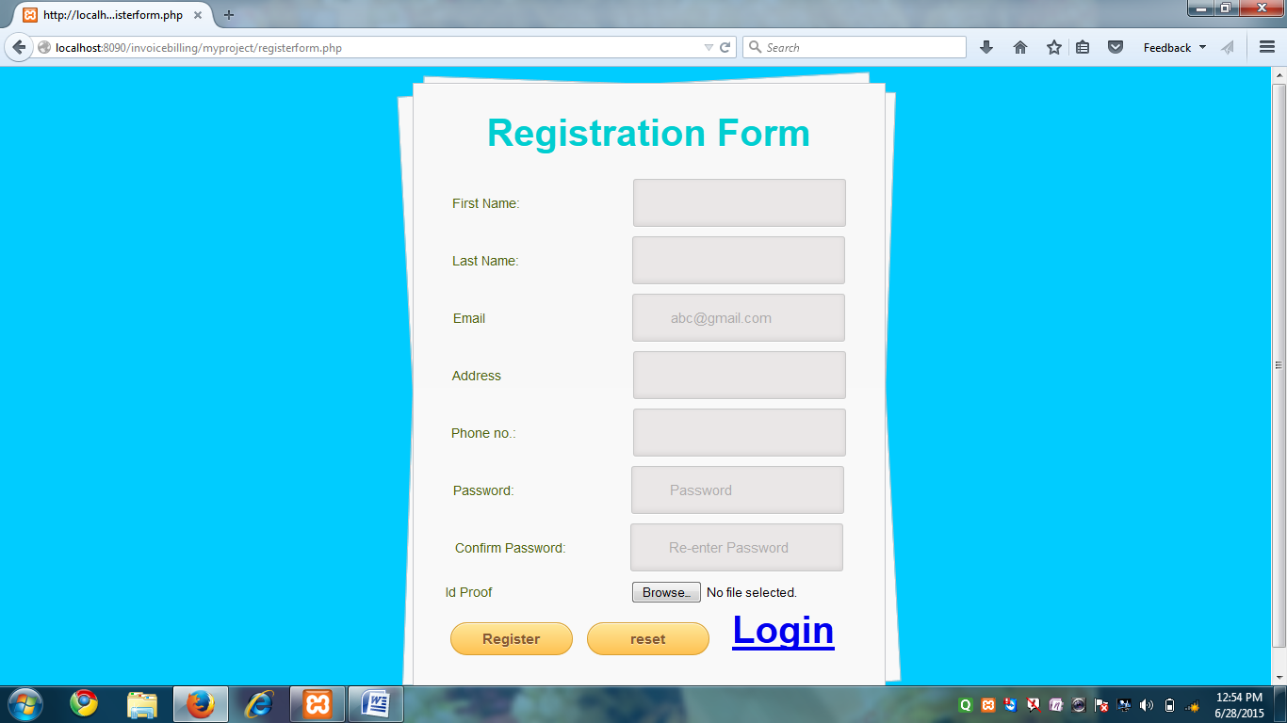

**SOURCE CODE**

<?php session_start();?>

<html><head><style>

html, body, div, span, applet, object, iframe,h1, h2, h3, h4, h5, h6, p, blockquote, pre,a, abbr, acronym, address, big, cite, code,del, dfn, em, font, img, ins, kbd, q, s, samp,small, strike, strong, sub, sup, tt, var,b, u, i, center,dl, dt, dd, ol, ul, li,fieldset, form, label, legend,table, caption, tbody, tfoot, thead, tr, th, td {margin: 4;padding: 0;border: 0;outline: 0;font-size: 100%;vertical-align: baseline;background: transparent;}

body {background:#00CCFF;color: #000;font: 14px Arial;margin: 0 auto;padding: 0;position: relative;}

#content {background: #f9f9f9;

background: -moz-linear-gradient(top, rgba(248,248,248,1) 0%, rgba(249,249,249,1) 100%);

background: -webkit-linear-gradient(top, rgba(248,248,248,1) 0%,rgba(249,249,249,1) 100%);

background: -o-linear-gradient(top, rgba(248,248,248,1) 0%,rgba(249,249,249,1) 100%);

background: -ms-linear-gradient(top, rgba(248,248,248,1) 0%,rgba(249,249,249,1) 100%);

background: linear-gradient(top, rgba(248,248,248,1) 0%,rgba(249,249,249,1) 100%);

filter: progid:DXImageTransform.Microsoft.gradient( startColorstr='#f8f8f8', endColorstr='#f9f9f9',GradientType=0 );

-webkit-box-shadow: 0 1px 0 #fff inset;-moz-box-shadow: 0 1px 0 #fff inset;-ms-box-shadow: 0 1px 0 #fff inset;-o-box-shadow: 0 1px 0 #fff inset;box-shadow: 0 1px 0 #fff inset;border: 1px solid #c4c6ca;margin: 0 auto;padding: 20px 0 0;position: relative;text-align: center;text-shadow: 0 1px 0 #fff;width: 500px;}

#content:after,#content:before {background: #f9f9f9;background: -moz-linear-gradient(top, rgba(248,248,248,1) 0%, rgba(249,249,249,1) 100%);background: -webkit-linear-gradient(top, rgba(248,248,248,1) 0%,rgba(249,249,249,1) 100%);background: -o-linear-gradient(top, rgba(248,248,248,1) 0%,rgba(249,249,249,1) 100%);background: -ms-linear-gradient(top, rgba(248,248,248,1) 0%,rgba(249,249,249,1) 100%);background: linear-gradient(top, rgba(248,248,248,1) 0%,rgba(249,249,249,1) 100%);filter: progid:DXImageTransform.Microsoft.gradient( startColorstr='#f8f8f8', endColorstr='#f9f9f9',GradientType=0 );border: 1px solid #c4c6ca;content: "";display: block;height: 100%;left: -1px;position: absolute;width: 100%;}

#content:after {-webkit-transform: rotate(2deg);-moz-transform: rotate(2deg);-ms-transform: rotate(2deg);-o-transform: rotate(2deg);transform: rotate(2deg);top: 0;z-index: -1;}

#content:before {-webkit-transform: rotate(-3deg);-moz-transform: rotate(-3deg);-ms-transform: rotate(-3deg);-o-transform: rotate(-3deg);transform: rotate(-3deg);top: 0;z-index: -2;}

#content form { margin: 0 20px; position: relative }

#content form input[type="text"],#content form input[type="email"],#content form input[type="password"] {-webkit-border-radius: 3px;-moz-border-radius: 3px;-ms-border-radius: 3px;-o-border-radius: 3px;border-radius: 3px;-webkit-box-shadow: 0 1px 0 #fff, 0 -2px 5px rgba(0,0,0,0.08) inset;-moz-box-shadow: 0 1px 0 #fff, 0 -2px 5px rgba(0,0,0,0.08) inset;-ms-box-shadow: 0 1px 0 #fff, 0 -2px 5px rgba(0,0,0,0.08) inset;-o-box-shadow: 0 1px 0 #fff, 0 -2px 5px rgba(0,0,0,0.08) inset;box-shadow: 0 1px 0 #fff, 0 -2px 5px rgba(0,0,0,0.08) inset;-webkit-transition: all 0.5s ease;-moz-transition: all 0.5s ease;-ms-transition: all 0.5s ease;-o-transition: all 0.5s ease;transition: all 0.5s ease;background: #eae7e7 url(http://cssdeck.com/uploads/media/items/8/8bcLQqF.png) no-repeat;border: 1px solid #c8c8c8;color: #777;font: 15px Helvetica, Arial, sans-serif;margin: 0 0 10px;padding: 15px 10px 15px 40px;width: 50%;}#username { background-position: 10px 10px !important }#password { background-position: 10px -53px !important }

#content form input[type="submit"],input[type="reset"] {background: rgb(254,231,154);background: -moz-linear-gradient(top, rgba(254,231,154,1) 0%, rgba(254,193,81,1) 100%);background: -webkit-linear-gradient(top, rgba(254,231,154,1) 0%,rgba(254,193,81,1) 100%);background: -o-linear-gradient(top, rgba(254,231,154,1) 0%,rgba(254,193,81,1) 100%);background: -ms-linear-gradient(top, rgba(254,231,154,1) 0%,rgba(254,193,81,1) 100%);background: linear-gradient(top, rgba(254,231,154,1) 0%,rgba(254,193,81,1) 100%);filter: progid:DXImageTransform.Microsoft.gradient( startColorstr='#fee79a', endColorstr='#fec151',GradientType=0 );-webkit-border-radius: 30px;-moz-border-radius: 30px;-ms-border-radius: 30px;-o-border-radius: 30px;border-radius: 30px;-webkit-box-shadow: 0 1px 0 rgba(255,255,255,0.8) inset;-moz-box-shadow: 0 1px 0 rgba(255,255,255,0.8) inset;-ms-box-shadow: 0 1px 0 rgba(255,255,255,0.8) inset;-o-box-shadow: 0 1px 0 rgba(255,255,255,0.8) inset;box-shadow: 0 1px 0 rgba(255,255,255,0.8) inset;border: 1px solid #D69E31;color: #85592e;cursor: pointer;float: left;font: bold 15px Helvetica, Arial, sans-serif;height: 35px;margin: 20px 0 35px 15px;position: relative;text-shadow: 0 1px 0 rgba(255,255,255,0.5);width: 130px;}

p {color:#00ced1;font: bold 40px Helvetica, Arial, sans-serif; }

div#content{margin-right: 30%;margin-left: *%;margin-top: 1%;}g{color:#4B610B;}

.date { display: inline; padding: 1.2em; border: inset 1px #CCC; background:#eae7e7 ; border-radius: 4px;color: #777;border: 1px solid #c8c8c8;}.date * { display: inline-block;}

.date input { width: 59px; padding: 0 0.4em; border: none; font-size: 100%; background: none;color: #777;}.date input#year { width:3.6em; }

.date input:focus { outline:none; }

</style></head></style><div id="container"><div id="wrapper"> <div id="content">

<form name="form1" id="form1" method="POST" enctype="multipart/form-data" action="classes/controller/register_controller.php"><fieldset>

<p>Registration Form</p><br><?php $msg=" "; if(isset($_SESSION['error_msg'])){ $msg = $_SESSION['error_msg']; unset($_SESSION['error_msg']);}if(!empty($msg)){echo"<p>".$msg."</p>";}?>

<g for="first_name">First Name:</g> &nbsp&nbsp&nbsp&nbsp&nbsp&nbsp&nbsp&nbsp&nbsp&nbsp&nbsp&nbsp&nbsp&nbsp&nbsp&nbsp&nbsp&nbsp&nbsp&nbsp&nbsp&nbsp&nbsp&nbsp&nbsp&nbsp&nbsp&nbsp <input type="text" name="first_name" title="Enter your name"><br>

<g for="last_name">Last Name:</g> &nbsp&nbsp&nbsp&nbsp&nbsp&nbsp&nbsp&nbsp&nbsp&nbsp&nbsp&nbsp&nbsp&nbsp&nbsp&nbsp&nbsp&nbsp&nbsp&nbsp&nbsp&nbsp&nbsp&nbsp&nbsp&nbsp&nbsp&nbsp <input type="text" name="last_name" title="Enter your last name"><br>

<g for="email_id">Email</g> &nbsp&nbsp&nbsp&nbsp&nbsp&nbsp&nbsp&nbsp&nbsp&nbsp&nbsp&nbsp&nbsp&nbsp&nbsp&nbsp&nbsp&nbsp&nbsp&nbsp&nbsp&nbsp&nbsp&nbsp&nbsp&nbsp&nbsp&nbsp&nbsp&nbsp&nbsp&nbsp&nbsp&nbsp&nbsp&nbsp&nbsp <input type="text" name="email_id" placeholder="abc@gmail.com" title="Enter your email"></br>

<g for="address">Address</g> &nbsp&nbsp&nbsp&nbsp&nbsp&nbsp&nbsp&nbsp&nbsp&nbsp&nbsp&nbsp&nbsp&nbsp&nbsp&nbsp&nbsp&nbsp&nbsp&nbsp&nbsp&nbsp&nbsp&nbsp&nbsp&nbsp&nbsp&nbsp&nbsp&nbsp&nbsp&nbsp&nbsp <input type="text" name="address" id="address"><br>

<g for="phone">Phone no.:</g>&nbsp&nbsp&nbsp&nbsp&nbsp&nbsp&nbsp&nbsp&nbsp&nbsp&nbsp&nbsp&nbsp&nbsp&nbsp&nbsp&nbsp&nbsp&nbsp&nbsp&nbsp&nbsp&nbsp&nbsp&nbsp&nbsp&nbsp&nbsp&nbsp <input type="text" name="phone_no" title="Enter your phone number"><br>

<g>Password:</g>&nbsp&nbsp&nbsp&nbsp&nbsp&nbsp&nbsp&nbsp&nbsp&nbsp&nbsp&nbsp&nbsp&nbsp&nbsp&nbsp&nbsp&nbsp&nbsp&nbsp&nbsp&nbsp&nbsp&nbsp&nbsp&nbsp&nbsp&nbsp&nbsp <input type="password" name="password" placeholder="Password" title="choose any password"><br>

<g>Confirm Password:</g> &nbsp&nbsp&nbsp&nbsp&nbsp&nbsp&nbsp&nbsp&nbsp&nbsp&nbsp&nbsp&nbsp&nbsp&nbsp <input type="password" name="cpass" placeholder="Re-enter Password" title="re-enter your password"><br>

<g for="image">Id Proof</g> &nbsp&nbsp&nbsp&nbsp&nbsp&nbsp&nbsp&nbsp&nbsp&nbsp&nbsp&nbsp&nbsp&nbsp&nbsp&nbsp&nbsp&nbsp&nbsp&nbsp&nbsp&nbsp&nbsp&nbsp&nbsp&nbsp&nbsp&nbsp&nbsp&nbsp&nbsp&nbsp&nbsp&nbsp&nbsp <input type="file" name="image" id="image"><br><input id="button" type="submit" name="submit" value="Register"> <input type="reset" name="reset" value="reset" title="Reset">

<p>

<tr><a href="loginform.php">Login</a></tr></p>

</fieldset></form></div></div></div></body></html>

**FORGOT PASSWORD FORM**

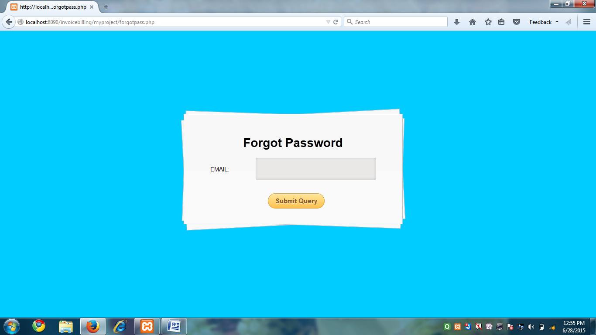

**Source Code:**

<html><body ulink="#004F6C" vlink="#004F6C" background="images\super.jpg"><head><style>

p, fieldset{margin: 4;padding: 0;border: 0;outline: 0;font-size: 100%;vertical-align: baseline;background: transparent;}

body {background:#00CCFF;font: 14px Arial;margin: 10 80;padding: 0;position: relative;}

.container { margin: 25px auto; position: relative; width: 900px; }

#content {background: #f9f9f9;background: -moz-linear-gradient(top, rgba(248,248,248,1) 0%, rgba(249,249,249,1) 100%);background: -webkit-linear-gradient(top, rgba(248,248,248,1) 0%,rgba(249,249,249,1) 100%);background: -o-linear-gradient(top, rgba(248,248,248,1) 0%,rgba(249,249,249,1) 100%);background: -ms-linear-gradient(top, rgba(248,248,248,1) 0%,rgba(249,249,249,1) 100%);background: linear-gradient(top, rgba(248,248,248,1) 0%,rgba(249,249,249,1) 100%);filter: progid:DXImageTransform.Microsoft.gradient( startColorstr='#f8f8f8', endColorstr='#f9f9f9',GradientType=0 );-webkit-box-shadow: 0 1px 0 #fff inset;-moz-box-shadow: 0 1px 0 #fff inset;-ms-box-shadow: 0 1px 0 #fff inset;-o-box-shadow: 0 1px 0 #fff inset;box-shadow: 0 1px 0 #fff inset;border: 1px solid #c4c6ca;margin: 0 auto;padding: 30px 0 0;position: relative;text-align: center;text-shadow: 0 1px 0 #fff;width: 500px;}

#content:after,#content:before {background: #f9f9f9;background: -moz-linear-gradient(top, rgba(248,248,248,1) 0%, rgba(249,249,249,1) 100%);background: -webkit-linear-gradient(top, rgba(248,248,248,1) 0%,rgba(249,249,249,1) 100%);background: -o-linear-gradient(top, rgba(248,248,248,1) 0%,rgba(249,249,249,1) 100%);background: -ms-linear-gradient(top, rgba(248,248,248,1) 0%,rgba(249,249,249,1) 100%);background: linear-gradient(top, rgba(248,248,248,1) 0%,rgba(249,249,249,1) 100%);filter: progid:DXImageTransform.Microsoft.gradient( startColorstr='#f8f8f8', endColorstr='#f9f9f9',GradientType=0 );border: 1px solid #c4c6ca;content: "";display: block;height: 100%;left: -1px;position: absolute;width: 100%;}#content:after {-webkit-transform: rotate(2deg);-moz-transform: rotate(2deg);-ms-transform: rotate(2deg);-o-transform: rotate(2deg);transform: rotate(2deg);top: 0;z-index: -1;}#content:before {-webkit-transform: rotate(-3deg);-moz-transform: rotate(-3deg);-ms-transform: rotate(-3deg);-o-transform: rotate(-3deg);transform: rotate(-3deg);top: 0;z-index: -2;}#content form { margin: 0 20px; position: relative }#content form input[type="text"],input[type="tel"],input[type="email"],

#content form input[type="password"] {-webkit-border-radius: 3px;-moz-border-radius: 3px;-ms-border-radius: 3px;-o-border-radius: 3px;border-radius: 3px;-webkit-box-shadow: 0 1px 0 #fff, 0 -2px 5px rgba(0,0,0,0.08) inset;-moz-box-shadow: 0 1px 0 #fff, 0 -2px 5px rgba(0,0,0,0.08) inset;-ms-box-shadow: 0 1px 0 #fff, 0 -2px 5px rgba(0,0,0,0.08) inset;-o-box-shadow: 0 1px 0 #fff, 0 -2px 5px rgba(0,0,0,0.08) inset;box-shadow: 0 1px 0 #fff, 0 -2px 5px rgba(0,0,0,0.08) inset;-webkit-transition: all 0.5s ease;-moz-transition: all 0.5s ease;-ms-transition: all 0.5s ease;-o-transition: all 0.5s ease;transition: all 0.5s ease;background: #eae7e7 url(http://cssdeck.com/uploads/media/items/8/8bcLQqF.png) no-repeat;border: 1px solid #c8c8c8;color: #777;font: 15px Helvetica, Arial, sans-serif;margin: 0 0 10px;padding: 15px 10px 15px 40px;width: 60%;}#username { background-position: 10px 10px !important }#password { background-position: 10px -53px !important }

#content form input[type="submit"]{background: rgb(254,231,154);background: -moz-linear-gradient(top, rgba(254,231,154,1) 0%, rgba(254,193,81,1) 100%);background: -webkit-linear-gradient(top, rgba(254,231,154,1) 0%,rgba(254,193,81,1) 100%);background: -o-linear-gradient(top, rgba(254,231,154,1) 0%,rgba(254,193,81,1) 100%);background: -ms-linear-gradient(top, rgba(254,231,154,1) 0%,rgba(254,193,81,1) 100%);background: linear-gradient(top, rgba(254,231,154,1) 0%,rgba(254,193,81,1) 100%);filter: progid:DXImageTransform.Microsoft.gradient( startColorstr='#fee79a', endColorstr='#fec151',GradientType=0 );-webkit-border-radius: 30px;-moz-border-radius: 30px;-ms-border-radius: 30px;-o-border-radius: 30px;border-radius: 30px;-webkit-box-shadow: 0 1px 0 rgba(255,255,255,0.8) inset;-moz-box-shadow: 0 1px 0 rgba(255,255,255,0.8) inset;-ms-box-shadow: 0 1px 0 rgba(255,255,255,0.8) inset;-o-box-shadow: 0 1px 0 rgba(255,255,255,0.8) inset;box-shadow: 0 1px 0 rgba(255,255,255,0.8) inset;border: 1px solid #D69E31;color: #85592e;cursor: pointer;float: center;font: bold 15px Helvetica, Arial, sans-serif;height: 35px;margin: 20px 0 35px 15px;position: relative;text-shadow: 0 1px 0 rgba(255,255,255,0.5);width: 130px;}

p {color: #d5bee0;font: bold 30px Helvetica, Arial, sans-serif; }div#content{margin-right: 30%;margin-left: *%;margin-top: 15%;}</style><fieldset><div id="container"><div id="wrapper"> <div id="content">

<h1 align="center">Forgot Password</h1>

<form name="frm_password" action="classes/controller/forgotpass_controller.php" method="post">

EMAIL: &nbsp&nbsp&nbsp&nbsp&nbsp&nbsp&nbsp&nbsp&nbsp&nbsp&nbsp&nbsp&nbsp <input type="email" name="email_id">

<br>

<input type="submit" name="submit" vlaue="submit">

</form>

</fieldset>

</body>

</html>

**CUSTOMER HOMEPAGE FORM**

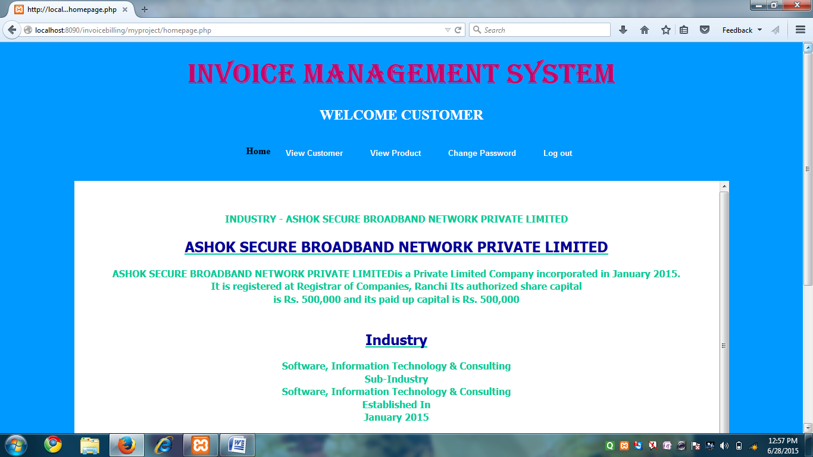

**SOURCE CODE**

<!DOCTYPE HTML><html><style type="text/css">

#menu-bar {color: #000000;}#menu-bar li {margin: 0px 0px 6px 0px;padding: 0px 0px 0px 6px;

float: left;position: relative;list-style: none;}#menu-bar a {font-weight: bolder;font-family: arial;font-style: normal;font-size: 13px;color: #FFFFFF;text-decoration: none;display: block;padding: 6px 20px 6px 20px;margin: 10;margin-bottom: 10px;border-radius: 4px;-webkit-border-radius: 4px;-moz-border-radius: 4px;text-shadow: 0px 0px 0px #9E9D9B;}

#menu-bar li ul li a {margin: 0;}#menu-bar .active a, #menu-bar li:hover > a {background: -ms-linear-gradient(top, #EBEBEB, #A1A1A1);background: -webkit-gradient(linear, left top, left bottom, from(#EBEBEB), to(#A1A1A1)); background: -moz-linear-gradient(top, #EBEBEB, #A1A1A1);color: #254c78; -webkit-box-shadow: 0px 0px rgba(0, 0, 0, 0);-moz-box-shadow: 0px 0px rgba(0, 0, 0, 0);

box-shadow: 0px 0px rgba(0, 0, 0, 0);text-shadow: -0px 0px 0px #FFFFFF;}#menu-bar ul li:hover a, #menu-bar li:hover li a { background: none;border: none;color: #666;-box-shadow: none;-webkit-box-shadow: none; -moz-box-shadow: none;}

#menu-bar ul a:hover {background: #1C3D70 !important; /*008080*/color: #FFFFFF !important;border-radius: 0;-webkit-border-radius: 0;-moz-border-radius: 0;text-shadow: 0px 0px 0px #FFFFFF;}#menu-bar li:hover > ul {display: block;}

#menu-bar ul {background: #DBDBDB;display: none;margin: 0;padding: 0;width: 160px;position: absolute;top: 30px;left: 0;border: solid 1px none; /*#B4B4B4*/border-radius: 11px;-webkit-border-radius: 10px;-moz-border-radius: 10px;-webkit-box-shadow: 0px 0px 0px #222222;-moz-box-shadow: 0px 0px 0px #222222; box-shadow: 2px 2px 4px #222222;}

#menu-bar ul li {float: none;margin: 0;padding: 0;}

#menu-bar ul a {padding:10px 10px 10px 15px;color:#1C3D70 !important; /*#4C4C85*/font-size:13px; font-style:normal;font-family:arial;font-weight: bolder;text-shadow: 2px 2px 3px #FFFFFF;}

#menu-bar ul ul li {top: 20%;}

#menu-bar ul ul {width: 210px;height: 60px;opacity:1;position:absolute;top: 30%;left:162px;padding:0px 0 0px 10;color:#1C3D70 !important; /*#4C4C85*/}

#menu-bar:after {content: ".";display: block;clear: both;visibility: hidden;line-height: 0;height: 0;}

#menu-bar {display: inline-block;}

html[xmlns] #menu-bar {display: block;}

* html #menu-bar {height: 1%;}

#scroll {font-weight: bold;text-align: center; background-color:#3CC;border-radius:3px;}

div.scroll {background-color: #FFFFFF;width: 1100px;height: 768px;overflow: scroll;}

.body_background {background-image:url(images/abstract_3-HD%20(1).jpg);background-repeat: no-repeat;background-color: #0099FF;}

</style><body class="body_background"><span class="body_background"></span>

<font color="#0033FF"><center>

<h1><font face="Algerian" color="#CC0066" size="+6">INVOICE MANAGEMENT SYSTEM</font></h1>

<font color="#FFFFFF"><h2>WELCOME CUSTOMER</h2></font></center>

<div align="center"><div><ul id="menu-bar"><ul> </ul> <li><strong>Home</strong></li>

<li><a href="viewcustomer_form.php">View Customer</a></li><li><a href="viewproductcustomer_form.php">View Product</a></li><li><a href="updatepassword_form.php">Change Password</a></li><li><a href="logout.php">Log out</a></li></ul></div><div class="scroll">

<p><font face="Tahoma" color="#00CC99"><br>

<p><b>INDUSTRY - ASHOK SECURE BROADBAND NETWORK PRIVATE LIMITED </b></p><u><h2><font color="#000099">ASHOK SECURE BROADBAND NETWORK PRIVATE LIMITED</font></u></h2><b>ASHOK SECURE BROADBAND NETWORK PRIVATE LIMITEDis a Private Limited Company incorporated in January 2015.<br> It is registered at Registrar of Companies, Ranchi Its authorized share capital<br> is Rs. 500,000 and its paid up capital is Rs. 500,000</b><br><br><u><h2><font color="#000099">Industry</font></u></h2><b>Software, Information Technology & Consulting</br>Sub-Industry<br>Software, Information Technology & Consulting<br>Established In<br>January 2015<br></b><br><br>

<u><h2><font color="#000099">Overview</font></u></h2><b>Company Type<br>Private Limited<br>Paid up Capital<br>Rs. 500,000<br>Authorised Capital<br>Rs. 500,000<br></b><br><br><br><table class="tg"><b><tr><th class="tg-031e"><font color="#000099">Address</font></th></tr><tr><td class="tg-031e">HOUSE NO-17 A , TEACHERS COLONY BHALUBASA ,</td></tr><tr><td class="tg-031e">POST - AGRICO JAMSHEDPUR</td></tr>

<tr><td class="tg-031e">City:Ranchi - 831009</td></tr><tr><td class="tg-031e">State:Jharkhand</td></tr><tr><td class="tg-031e">Contact</td></tr><tr><td class="tg-031e">Contact</td></tr><tr><td class="tg-031e">ashok.sahu@abnetwork.co.in</td></tr></b></table><br><br><p>©2014 Companies DatabasePrivacy Policy</p> </div></font></form></body></html>

**VIEW CUSTOMER DETAILS**

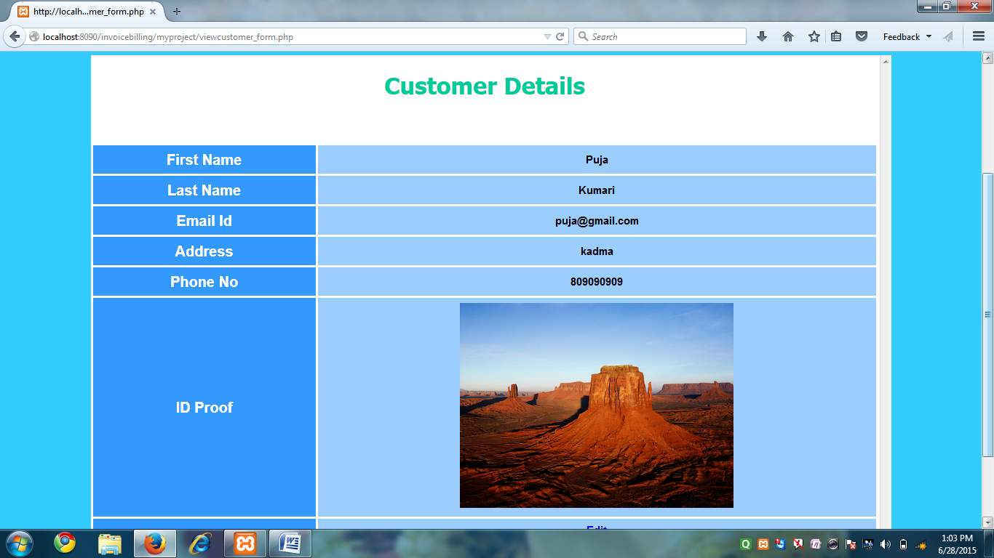

**SOURCE CODE**

<?php session_start(); global $email_id; if(isset($_SESSION['email_id']))

{$email_id = $_SESSION['email_id'];}else {echo 'session empty';}?>

<!DOCTYPE HTML><html><style type="text/css">

#menu-bar {color: #000000;}#menu-bar li {margin: 0px 0px 6px 0px;padding: 0px 0px 0px 6px;float: left;position: relative;list-style: none;}

#menu-bar a {font-weight: bolder;font-family: arial;font-style: normal;font-size: 13px;color: #FFFFFF;

text-decoration: none;display: block;padding: 6px 20px 6px 20px;margin: 10;margin-bottom: 10px;border-radius: 4px;-webkit-border-radius: 4px;-moz-border-radius: 4px;text-shadow: 0px 0px 0px #9E9D9B;}

#menu-bar li ul li a {margin: 0;} #menu-bar .active a, #menu-bar li:hover > a { background: -ms-linear-gradient(top, #EBEBEB, #A1A1A1);background: -webkit-gradient(linear, left top, left bottom, from(#EBEBEB), to(#A1A1A1)); background: -moz-linear-gradient(top, #EBEBEB, #A1A1A1);color: #254c78;-webkit-box-shadow: 0px 0px rgba(0, 0, 0, 0);-moz-box-shadow: 0px 0px rgba(0, 0, 0, 0);box-shadow: 0px 0px rgba(0, 0, 0, 0);text-shadow: -0px 0px 0px #FFFFFF;}

#menu-bar ul li:hover a, #menu-bar li:hover li a {background: none;border: none;color: #666;-box-shadow: none;-webkit-box-shadow: none;-moz-box-shadow: none;}

#menu-bar ul a:hover {background: #1C3D70 !important; /*008080*/color: #FFFFFF !important;

border-radius: 0;-webkit-border-radius: 0;-moz-border-radius: 0;text-shadow: 0px 0px 0px #FFFFFF;}

#menu-bar li:hover > ul {display: block;}

#menu-bar ul {background: #DBDBDB;display: none;margin: 0;padding: 0;width: 160px;position: absolute;top: 30px;left: 0;border: solid 1px none; border-radius: 11px;-webkit-border-radius: 10px;-moz-border-radius: 10px;-webkit-box-shadow: 0px 0px 0px #222222;-moz-box-shadow: 0px 0px 0px #222222;box-shadow: 2px 2px 4px #222222;}

#menu-bar ul li {float: none;margin: 0;padding: 0;} #menu-bar ul a {padding:10px 10px 10px 15px;color:#1C3D70 !important; font-size:13px;font-style:normal;font-family:arial;font-weight: bolder;text-shadow: 2px 2px 3px #FFFFFF;}

#menu-bar ul ul li {top: 20%;}

#menu-bar ul ul {width: 210px;height: 60px;opacity:1;position:absolute;top: 30%;left:162px;padding:0px 0 0px 10;color:#1C3D70 !important; /*#4C4C85*/}

#menu-bar:after {content: ".";display: block;clear: both;visibility: hidden;line-height: 0;height: 0;}

#menu-bar {display: inline-block;}html[xmlns] #menu-bar {display: block;}

* html #menu-bar {height: 1%;} #scroll {font-weight: bold;text-align: center; background-color:#3CC;border-radius:3px;} div.scroll {background-color: #FFFFFF;width: 1100px;height: 768px;overflow: scroll;}.body_background {background-image: url(../entrance-to-industrial-park-building-9824167.jpg);background-repeat: no-repeat;background-color: #33CCFF;}

.table_design {margin:0px;padding:0px;box-shadow: 10px 10px 5px #888888;-webkit-box-shadow: 10px 10px 5px #888888;-moz-box-shadow: 10px 10px 5px #888888;border:1px solid #ffffff;}

.table_design table {margin:0px;padding:0px;} .table_design tr:hover td {background-color:#AED7FF;}

.table_design td{vertical-align:middle;background-color:#9BCDFF;border:1px solid #ffffff;border-width:0px 1px 1px 0px;text-align:center;padding:7px;font-size:15px;font-family:Arial;font-weight:bold;color:#000000;}

.table_design th{background-color:#3399FF;border:1px solid #ffffff;text-align:center;border-width:0px 1px 1px 0px;padding:7px;font-size:20px;font-family:Arial;font-weight:bold;color:#ffffff;}</style>

<body class="body_background"><span class="body_background"></span><font color="#0033FF"><center>

<h1><font face="Algerian" color="#CC0066" size="+6">INVOICE MANAGEMENT SYSTEM</font></h1></h1></font><font color="#00FF99"><h2>WELCOME CUSTOMER</h2>

</font></font></center><div align="center"><div><ul id="menu-bar"><ul> </ul> <li><a href="homepage.php">Home</a></li>

<li><strong>View Customer</strong></li><li><a href="viewproductcustomer_form.php">View Product</a></li><li><a href="updatepassword_form.php">Change Password</a></li><li><a href="logout.php">Log out</a></li></ul></div><div class="scroll"><font color="red"></font>

<p align="middle"><font face="Tahoma" color="#00CC99"><h1>Customer Details</h1><br><?php require_once(dirname(dirname(__FILE__)).'/myproject/classes/service/UserDataService.php');$service = new UserDataService(); $rs_array = $service->getCustomerDetailsById($email_id);if(empty($rs_array)){echo'<p>NO data Found</p>';}else{?>

<p><table class="table_design"><tr>

<th width="20%" align="left" scope="row">First Name</th><td width="50%" align="left"><?php echo $rs_array[0][0]?></td></tr><tr><th width="20%" align="left" scope="row">Last Name</th><td width="50%" align="left"><?php echo $rs_array[0][1]?></td></tr><tr><th width="20%" align="left" scope="row">Email Id</th><td width="50%" align="left"><?php echo $rs_array[0][2]?></td></tr><tr><th width="20%" align="left" scope="row">Address</th><td width="50%" align="left"><?php echo $rs_array[0][3]?></td></tr><tr><th width="20%" align="left" scope="row">Phone No</th><td width="50%" align="left"><?php echo $rs_array[0][4]?></td></tr><tr><th width="20%" align="left" scope="row">ID Proof</th><td width="50%" align="left"><img src="images/<?php echo $rs_array[0][5]?>" width="50%" height="50%" /></td></tr><tr><th width="20%" align="left" scope="row"></th><td width="50%" align="left"><a href="edit_customer.php">Edit</a></td>

</tr></table><br><br></div><?php}?></font></form></body></html>

**EDIT AND UPDATE CUSTOMER DETAILS**

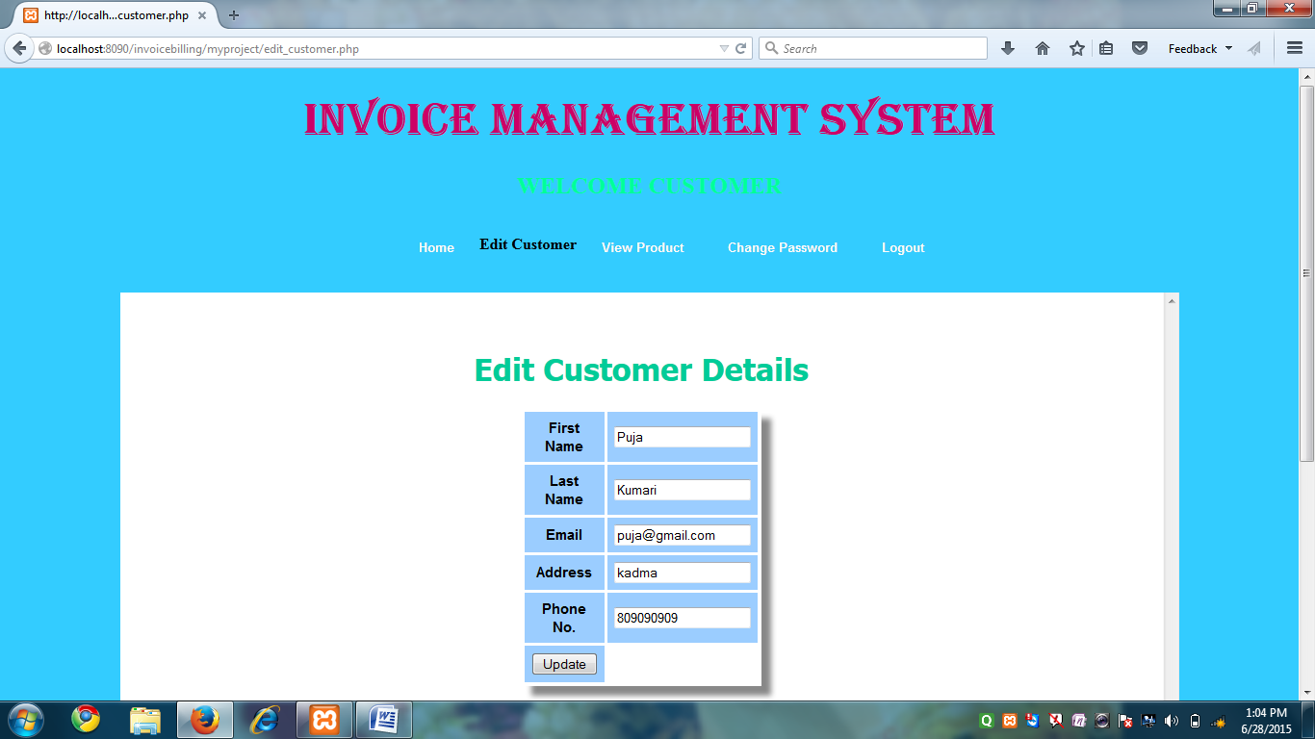

**SOURCE CODE**

<?php session_start(); global $email_id; if(isset($_SESSION['email_id'])){$email_id = $_SESSION['email_id'];}?>

<!DOCTYPE HTML><html><style type="text/css">

#menu-bar {color: #000000;}

#menu-bar li {margin: 0px 0px 6px 0px;padding: 0px 0px 0px 6px;float: left;position: relative;list-style: none;}

#menu-bar a{font-weight: bolder;font-family: arial;font-style: normal;font-size: 13px;color: #FFFFFF;text-decoration: none;display: block;padding: 6px 20px 6px 20px;margin: 10;margin-bottom: 10px;border-radius: 4px;-webkit-border-radius: 4px;-moz-border-radius: 4px;text-shadow: 0px 0px 0px #9E9D9B;}

#menu-bar li ul li a {margin: 0;} #menu-bar .active a, #menu-bar li:hover > a {background: -ms-linear-gradient(top, #EBEBEB, #A1A1A1);background: -webkit-gradient(linear, left top, left bottom, from(#EBEBEB), to(#A1A1A1));background: -moz-linear-gradient(top, #EBEBEB, #A1A1A1);color: #254c78;-webkit-box-shadow: 0px 0px rgba(0, 0, 0, 0);-moz-box-shadow: 0px 0px rgba(0, 0, 0, 0);box-shadow: 0px 0px rgba(0, 0, 0, 0);text-shadow: -0px 0px 0px #FFFFFF;}

#menu-bar ul li:hover a, #menu-bar li:hover li a {background: none;border: none;color: #666;-box-shadow: none;-webkit-box-shadow: none;-moz-box-shadow: none;}

#menu-bar ul a:hover {background: #1C3D70 !important; /*008080*/color: #FFFFFF !important;border-radius: 0;-webkit-border-radius: 0;-moz-border-radius: 0;text-shadow: 0px 0px 0px #FFFFFF;}

#menu-bar li:hover > ul {display: block;} #menu-bar ul {background: #DBDBDB;display: none;margin: 0;padding: 0;width: 160px;position: absolute;top: 30px;left: 0;border: solid 1px none; border-radius: 11px;-webkit-border-radius: 10px;-moz-border-radius: 10px;-webkit-box-shadow: 0px 0px 0px #222222;-moz-box-shadow: 0px 0px 0px #222222;box-shadow: 2px 2px 4px #222222;}

#menu-bar ul li {float: none;margin: 0;padding: 0;}

#menu-bar ul a {padding:10px 10px 10px 15px;color:#1C3D70 !important; font-size:13px;font-style:normal;font-family:arial;font-weight: bolder;text-shadow: 2px 2px 3px #FFFFFF;}

#menu-bar ul ul li {top: 20%;}

#menu-bar ul ul {width: 210px;height: 60px;opacity:1;position:absolute;top: 30%;left:162px;padding:0px 0 0px 10;color:#1C3D70 !important; /*#4C4C85*/}

#menu-bar:after {content: ".";display: block;clear: both;visibility: hidden;line-height: 0;height: 0;}

#menu-bar {display: inline-block;}

html[xmlns] #menu-bar {display: block;}

* html #menu-bar {height: 1%;}

#scroll {font-weight: bold;text-align: center; background-color:#3CC;border-radius:3px;}

div.scroll {background-color: #FFFFFF;width: 1100px;height: 768px;overflow: scroll;}

.body_background {background-repeat: no-repeat;background-color: #33CCFF;}

.table_design {margin:0px;padding:0px;box-shadow: 10px 10px 5px #888888;-webkit-box-shadow: 10px 10px 5px #888888;-moz-box-shadow: 10px 10px 5px #888888;border:1px solid #ffffff;}

.table_design table {margin:0px;padding:0px;}

.table_design tr:hover td {background-color:#AED7FF;}

.table_design td{vertical-align:middle;background-color:#9BCDFF;border:1px solid #ffffff;border-width:0px 1px 1px 0px;text-align:center;padding:7px;font-size:15px;font-family:Arial;font-weight:bold;color:#000000;}

.table_design th{background-color:#3399FF;border:1px solid #ffffff;text-align:center;border-width:0px 1px 1px 0px;padding:7px;font-size:20px;font-family:Arial;font-weight:bold;color:#ffffff;}</style>

<body class="body_background"> <span class="body_background"></span><font color="#0033FF">

<center><h1><font face="Algerian" color="#CC0066" size="+6">INVOICE MANAGEMENT SYSTEM</font></h1></font><font color="#00FF99"><h2>WELCOME CUSTOMER</h2></font></font></center>

<div align="center"><div><ul id="menu-bar"><ul></ul><li><a href="homepage.php">Home</a></li><li><strong> Edit Customer</strong></li><li><a href="viewproductcustomer_form.php">View Product</a></li><li><a href="updatepassword_form.php">Change Password</a></li><li><a href="logout.php">Logout</a></li></ul>

</div><div class="scroll"><font color="red"></font><p align="middle"><font face="Tahoma" color="#00CC99"><br><h1>Edit Customer Details</h1><?php require_once(dirname(dirname(__FILE__)).'/myproject/classes/service/UserDataService.php');$service = new UserDataService ();$rs_array = $service->getCustomerDetailsById ($email_id);

if(empty($rs_array)) {echo'<p>NO data Found</p>';}else{?><p>

<form name="frm_edit" method="POST" action="classes/controller/edit_controller.php">

<?php if(isset($_SESSION['error_msg']))

{$msg = $_SESSION['error_msg'];unset($_SESSION['error_msg']);}

if(!empty($msg)){echo"<p>".$msg."</p>";} /?><table class="table_design"><tr>

<td width="50"><label for="first_name">First Name</label></td><td width="50"><input type="text" name="first_name" value="<?php echo $rs_array[0][0]?>"></td> </tr><tr><td width="50"><label for="last_name">Last Name</label></td><td width="50"> <input type="text" name="last_name" value="<?php echo $rs_array[0][1]?>"></td></tr><tr> <td width="50"><label for="email_id">Email</label></td><td width="50"><input type="text" name="email_id" placeholder="abc@gmail.com" value="<?php echo $rs_array[0][2]?>" readonly></td> </tr> <tr><td width="50"><label for="address">Address</label></td><td width="50"><input type="textarea" name="address" id="address" value="<?php echo $rs_array[0][3]?>"></td></tr><tr><td width="50"><label for="phone_no">Phone No.</label></td><td width="50"><input type="text" name="phone_no" id="phone_no" value="<?php echo $rs_array[0][4]?>"></td></tr> <tr><td width="50"><input type="submit" name="update" value="Update"></td></tr> </table></p></form>

<? php}?></table><br><br></div></form></body>

</html>

**VIEW PRODUCT AND SUBSCRIBE**

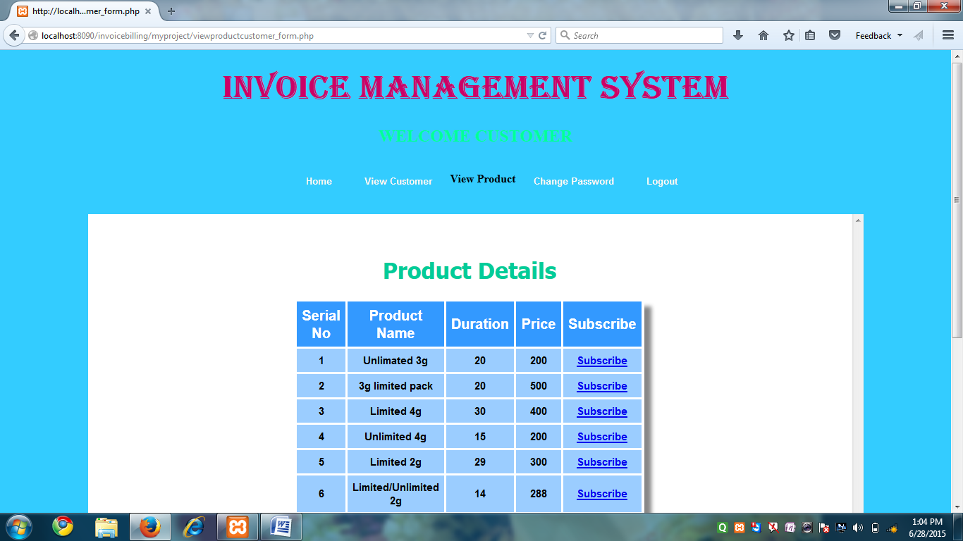

**SOURCE CODE**

<! DOCTYPE HTML><html ><style type="text/css">

#menu-bar {color: #000000;} #menu-bar li {margin: 0px 0px 6px 0px;padding: 0px 0px 0px 6px;float: left;position: relative;list-style: none;} #menu-bar a {font-weight: bolder;font-family: arial;font-style: normal;font-size: 13px;color: #FFFFFF;text-decoration: none;display: block;padding: 6px 20px 6px 20px;margin: 10;margin-bottom: 10px;border-radius: 4px;-webkit-border-radius: 4px;-moz-border-radius: 4px; text-shadow: 0px 0px 0px #9E9D9B;}

#menu-bar li ul li a {margin: 0;} #menu-bar .active a, #menu-bar li: hover > a {background: -ms-linear-gradient(top, #EBEBEB, #A1A1A1);background: -webkit-gradient(linear, left top, left bottom, from(#EBEBEB), to(#A1A1A1));background: -moz-linear-gradient(top, #EBEBEB, #A1A1A1);color: #254c78;-webkit-box-shadow: 0px 0px rgba(0, 0, 0, 0);-moz-box-shadow: 0px 0px rgba(0, 0, 0, 0);box-shadow: 0px 0px rgba(0, 0, 0, 0);text-shadow: -0px 0px 0px #FFFFFF;}

#menu-bar ul li: hover a, #menu-bar li: hover li a {background: none; border: none; color: #666;-box-shadow: none;-webkit-box-shadow: none;-moz-box-shadow: none;}

#menu-bar ul a: hover {background: #1C3D70! important; /*008080*/color: #FFFFFF !important;border-radius: 0;-webkit-border-radius: 0;-moz-border-radius: 0;text-shadow: 0px 0px 0px #FFFFFF;}

#menu-bar li: hover > ul {display: block; }

#menu-bar ul {background: #DBDBDB; display: none; margin: 0; padding: 0;width: 160px;position: absolute;top: 30px;left: 0;border: solid 1px none; /*#B4B4B4*/border-radius: 11px;-webkit-border-radius: 10px;-moz-border-radius: 10px; -webkit-box-shadow: 0px 0px 0px #222222;-moz-box-shadow: 0px 0px 0px #222222;box-shadow: 2px 2px 4px #222222;}

#menu-bar ul li {float: none; margin: 0; padding: 0;}

#menu-bar ul a {padding: 10px 10px 10px 15px; color: #1C3D70 !important; /*#4C4C85*/font-size:13px;font-style:normal;font-family:arial;font-weight: bolder;text-shadow: 2px 2px 3px #FFFFFF;}

#menu-bar ul ul li {top: 20% ;} #menu-bar ul ul {width: 210px; height: 60px; opacity: 1;position :absolute;top: 30%;left:162px;padding:0px 0 0px 10;color:#1C3D70 !important; /*#4C4C85*/}

#menu-bar: after {content: "."; display: block; clear: both; visibility: hidden;line- height: 0;

height: 0;} #menu-bar {display: inline-block;}

html [xmlns] #menu-bar {display: block;}

* html #menu-bar {height: 1%;}

#scroll {font-weight: bold; text-align: center; background-color:#3CC;border-radius:3px;}

div.scroll {background-color: #FFFFFF; width: 1100px; height: 768px; overflow: scroll;}

.body_background {background-repeat: no-repeat; background-color: #33CCFF;}

.table_design {margin: 0px; padding: 0px; box-shadow: 10px 10px 5px #888888;-webkit-box-shadow: 10px 10px 5px #888888;-moz-box-shadow: 10px 10px 5px #888888;border:1px solid #ffffff;}

.table_design table {margin: 0px; padding :0px;}

.table_design tr: hover td {background-color:#AED7FF;}

.table_design td{vertical-align:middle;background-color:#9BCDFF;border:1px solid #ffffff;border-width:0px 1px 1px 0px;text-align:center;padding:7px;font-size:15px;font-family:Arial;font-weight:bold;color:#000000;}

.table_design th {background-color:#3399FF;border:1px solid #ffffff;text-align:center;border-width:0px 1px 1px 0px;padding:7px;font-size:20px;font-family:Arial;font-weight:bold;color:#ffffff;}</style>

<body class="body_background"><span class="body_background"></span><font color="#0033FF">

<center><h1><font face="Algerian" color="#CC0066" size="+6">INVOICE MANAGEMENT SYSTEM</font></h1><font color="#00FF99"></font></h1><font color="#00FF99">

<h2>WELCOME CUSTOMER</h2></font></font></center><div align="center"><div><ul id="menu-bar">

<ul></ul> <li><a href="homepage.php">Home</a></li><li><a href="viewcustomer_form.php">View Customer</a></li><li><strong>View Product</strong></li><li><a href="updatepassword_form.php">Change Password</a></li><li><a href="logout.php">Logout</a></li></ul></ul></div>

<div class="scroll"><font color="red"></font><p align="middle"><font face="Tahoma" color="#00CC99"><br><h1>Product Details</h1><?php

require_once(dirname(dirname(__FILE__)).'/myproject/classes/service/ProductDataService.php');

$obj = new ProductDataService();

$rs_array = $obj->getAllProductDetails();

if(empty($rs_array))

{

echo '<p>No data Found</p>';

}

else

{ ?>

<table class="table_design">

<tr>

<th width="50">Serial No</th>

<th width="50">Product Name</th>

<th width="50">Duration</th>

<th width="50">Price</th>

<th width="50">Subscribe</th>

</tr>

<?php

//list($u, $p) = $rs_array[0];

foreach($rs_array as $arr) {

$serial_no = $arr[0];

?>

<tr>

<td width="50"><?php echo $serial_no?></td>

<td width="50"><?php echo $arr[1]?></td>

<td width="50"><?php echo $arr[2]?></td>

<td width="50"><?php echo $arr[3]?></td>

<td width="50"><a href="make_payment.php?serial_no=<?php echo $serial_no?>">Subscribe</a></td>

</tr>

<?php

}

}

?>

</table>

<br><br>

</div>

</font>

</form>

</body>

</html>

**MAKE PAYMENT**

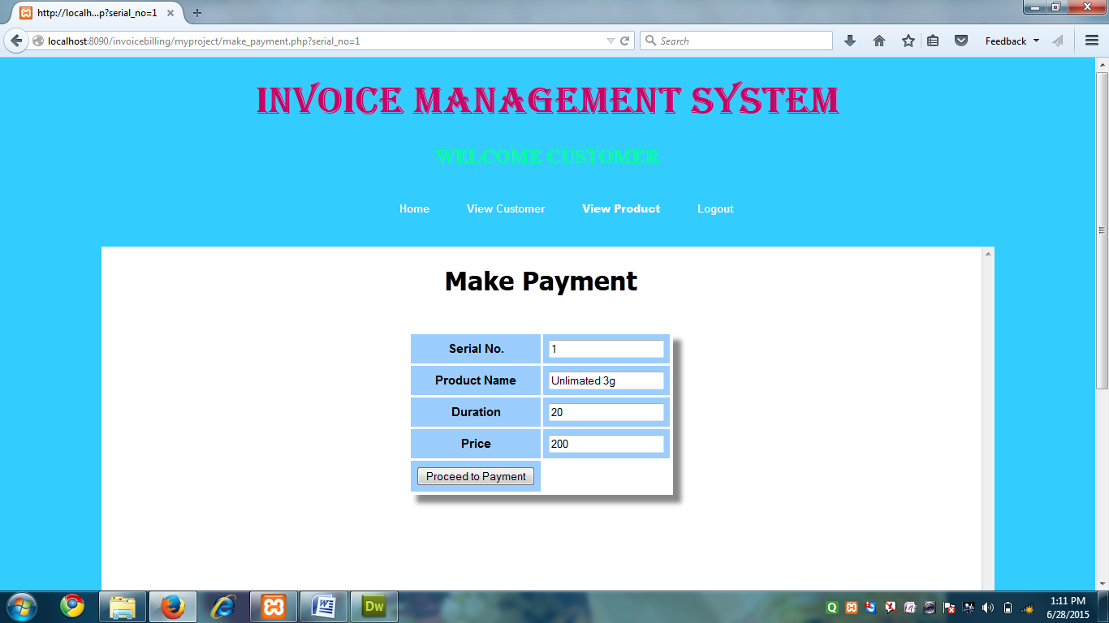

**SOURCE CODE**

<?php

$serial_no=$_GET['serial_no'];

?>

<!DOCTYPE HTML>

<html><style type="text/css">

#menu-bar

{

color: #000000;

}

#menu-bar li {

margin: 0px 0px 6px 0px;

padding: 0px 0px 0px 6px;

float: left;

position: relative;

list-style: none;

}

#menu-bar a

{

font-weight: bolder;

font-family: arial;

font-style: normal;

font-size: 13px;

color: #FFFFFF;

text-decoration: none;

display: block;

padding: 6px 20px 6px 20px;

margin: 10;

margin-bottom: 10px;

border-radius: 4px;

-webkit-border-radius: 4px;

-moz-border-radius: 4px;

text-shadow: 0px 0px 0px #9E9D9B;

}

#menu-bar li ul li a {

margin: 0;

}

#menu-bar .active a, #menu-bar li:hover > a {

background: -ms-linear-gradient(top, #EBEBEB, #A1A1A1);

background: -webkit-gradient(linear, left top, left bottom, from(#EBEBEB), to(#A1A1A1));

background: -moz-linear-gradient(top, #EBEBEB, #A1A1A1);

color: #254c78;

-webkit-box-shadow: 0px 0px rgba(0, 0, 0, 0);

-moz-box-shadow: 0px 0px rgba(0, 0, 0, 0);

box-shadow: 0px 0px rgba(0, 0, 0, 0);

text-shadow: -0px 0px 0px #FFFFFF;

}

#menu-bar ul li:hover a, #menu-bar li:hover li a {

background: none;

border: none;

color: #666;

-box-shadow: none;

-webkit-box-shadow: none;

-moz-box-shadow: none;

}

#menu-bar ul a:hover {

background: #1C3D70 !important; /*008080*/

color: #FFFFFF !important;

border-radius: 0;

-webkit-border-radius: 0;

-moz-border-radius: 0;

text-shadow: 0px 0px 0px #FFFFFF;

}

#menu-bar li:hover > ul {

display: block;

}

#menu-bar ul {

background: #DBDBDB;

display: none;

margin: 0;

padding: 0;

width: 160px;

position: absolute;

top: 30px;

left: 0;

border: solid 1px none; /*#B4B4B4*/

border-radius: 11px;

-webkit-border-radius: 10px;

-moz-border-radius: 10px;

-webkit-box-shadow: 0px 0px 0px #222222;

-moz-box-shadow: 0px 0px 0px #222222;

box-shadow: 2px 2px 4px #222222;

}

#menu-bar ul li {

float: none;

margin: 0;

padding: 0;

}

#menu-bar ul a {

padding:10px 10px 10px 15px;

color:#1C3D70 !important; /*#4C4C85*/

font-size:13px;

font-style:normal;

font-family:arial;

font-weight: bolder;

text-shadow: 2px 2px 3px #FFFFFF;

}

#menu-bar ul ul li {

top: 20%;

}

#menu-bar ul ul {

width: 210px;

height: 60px;

opacity:1;

position:absolute;

top: 30%;

left:162px;

padding:0px 0 0px 10;

color:#1C3D70 !important; /*#4C4C85*/

}

#menu-bar:after {

content: ".";

display: block;

clear: both;

visibility: hidden;

line-height: 0;

height: 0;

}

#menu-bar {

display: inline-block;

}

html[xmlns] #menu-bar {

display: block;

}

* html #menu-bar {

height: 1%;

}

#scroll

{

font-weight: bold;

text-align: center;

background-color:#3CC;

border-radius:3px;

}

div.scroll {

background-color: #FFFFFF;

width: 1100px;

height: 768px;

overflow: scroll;

}

.body_background {

background-image: url(../entrance-to-industrial-park-building-9824167.jpg);

background-repeat: no-repeat;

background-color: #33CCFF;

}

/*

Tables

*/

.table_design {

margin:0px;

padding:0px;

box-shadow: 10px 10px 5px #888888;

-webkit-box-shadow: 10px 10px 5px #888888;

-moz-box-shadow: 10px 10px 5px #888888;

border:1px solid #ffffff;

}

.table_design table {

margin:0px;

padding:0px;

}

.table_design tr:hover td {

background-color:#AED7FF;

}

.table_design td{

vertical-align:middle;

background-color:#9BCDFF;

border:1px solid #ffffff;

border-width:0px 1px 1px 0px;

text-align:center;

padding:7px;

font-size:15px;

font-family:Arial;

font-weight:bold;

color:#000000;

}

.table_design th{

background-color:#3399FF;

border:1px solid #ffffff;

text-align:center;

border-width:0px 1px 1px 0px;

padding:7px;

font-size:20px;

font-family:Arial;

font-weight:bold;

color:#ffffff;

}

/* Table Design End */

</style>

<body class="body_background">

<span class="body_background"></span>

<font color="#0033FF">

<center>

<h1>

<font face="Algerian" color="#CC0066" size="+6">INVOICE MANAGEMENT SYSTEM</font></h1>

</h1>

</font>

<font color="#00FF99">

<h2>WELCOME CUSTOMER</h2>

</font>

</font>

</center>

<div align="center">

<div>

<ul id="menu-bar">

<ul>

</ul>

<li><a href="home.php">Home</a></li>

<li><a href="viewcustomer_form.php">View Customer</a></li>

<li><a><strong>View Product</strong></a></li>

<li><a href="logout.php">Logout</a></li>

</ul>

<!------------>

</div>

<div class="scroll">

<font color="red">

</font>

<p align="middle">

<font face="Tahoma" color="#00CC99">

<h1><font color="#000000">Make Payment</font></h1>

<form name="frm_edit" method="POST" action="classes/controller/bill_controller.php">

<table>

<br>

<?php

require_once(dirname(dirname(__FILE__)).'/myproject/classes/service/ProductDataService.php');

$service = new ProductDataService();

$rs_array = $service->getProductDetailsBySerial_no($serial_no);

if(empty($rs_array))

{

echo'<p>NO data Found</p>';

}

else

{

//print_r($rs_array);

?>

<table class="table_design">

<tr>

<td width="50">Serial No.</td>

<td width="50"><input type="text" name="serial_no" value="<?php echo $rs_array[0][0]?>" readonly></td>

</tr>

<tr>

<td width="50">Product Name</td>

<td width="50"> <input type="text" name="product_name" value="<?php echo $rs_array[0][1]?>" readonly></td>

</tr>

<tr>

<td width="50">Duration</td>

<td width="50"><input type="text" name="duration" value="<?php echo $rs_array[0][2]?>" readonly></td>

</tr>

<tr>

<td width="50">Price</td>

<td width="50"> <input type="text" name="price" value="<?php echo $rs_array[0][3]?>" readonly></td>

</tr>

<tr>

<td width="50"><input type="submit" name="proceed" value="Proceed to Payment" id="proceed"></td>

</tr>

</table>

<br><br>

</form>

<?php

}

?>

</body>

</html>

**BILL FORM**

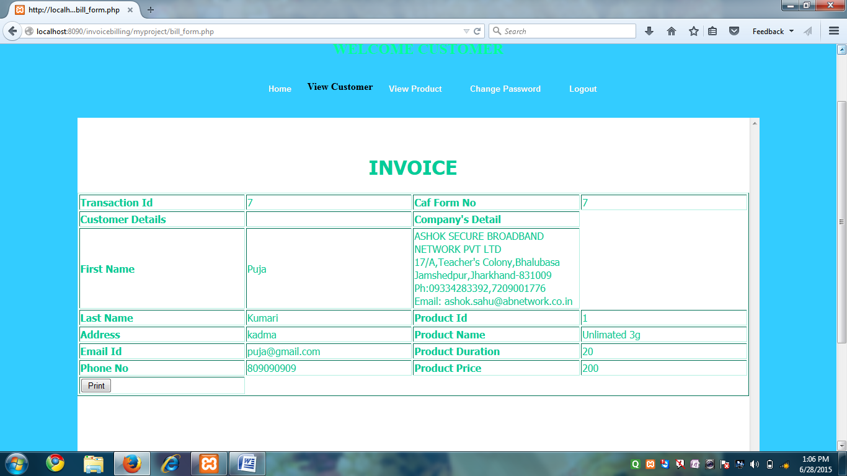

**SOURCE CODE**

<?php

session_start();

global $email_id;

if(isset($_SESSION['email_id']))

{

$email_id = $_SESSION['email_id'];

}

else {

echo 'session empty';

}

$t = $_SESSION['t'];

//unset($_SESSION['t']);

?>

<!DOCTYPE HTML>

<html><style type="text/css">

#menu-bar

{

color: #000000;

}

#menu-bar li {

margin: 0px 0px 6px 0px;

padding: 0px 0px 0px 6px;

float: left;

position: relative;

list-style: none;

}

#menu-bar a

{

font-weight: bolder;

font-family: arial;

font-style: normal;

font-size: 13px;

color: #FFFFFF;

text-decoration: none;

display: block;

padding: 6px 20px 6px 20px;

margin: 10;

margin-bottom: 10px;

border-radius: 4px;

-webkit-border-radius: 4px;

-moz-border-radius: 4px;

text-shadow: 0px 0px 0px #9E9D9B;

}

#menu-bar li ul li a {

margin: 0;

}

#menu-bar .active a, #menu-bar li:hover > a {

background: -ms-linear-gradient(top, #EBEBEB, #A1A1A1);

background: -webkit-gradient(linear, left top, left bottom, from(#EBEBEB), to(#A1A1A1));

background: -moz-linear-gradient(top, #EBEBEB, #A1A1A1);

color: #254c78;

-webkit-box-shadow: 0px 0px rgba(0, 0, 0, 0);

-moz-box-shadow: 0px 0px rgba(0, 0, 0, 0);

box-shadow: 0px 0px rgba(0, 0, 0, 0);

text-shadow: -0px 0px 0px #FFFFFF;

}

#menu-bar ul li:hover a, #menu-bar li:hover li a {

background: none;

border: none;

color: #666;

-box-shadow: none;

-webkit-box-shadow: none;

-moz-box-shadow: none;

}

#menu-bar ul a:hover {

background: #1C3D70 !important; /*008080*/

color: #FFFFFF !important;

border-radius: 0;

-webkit-border-radius: 0;

-moz-border-radius: 0;

text-shadow: 0px 0px 0px #FFFFFF;

}

#menu-bar li:hover > ul {

display: block;

}

#menu-bar ul {

background: #DBDBDB;

display: none;

margin: 0;

padding: 0;

width: 160px;

position: absolute;

top: 30px;

left: 0;

border: solid 1px none; /*#B4B4B4*/

border-radius: 11px;

-webkit-border-radius: 10px;

-moz-border-radius: 10px;

-webkit-box-shadow: 0px 0px 0px #222222;

-moz-box-shadow: 0px 0px 0px #222222;

box-shadow: 2px 2px 4px #222222;

}

#menu-bar ul li {

float: none;

margin: 0;

padding: 0;

}

#menu-bar ul a {

padding:10px 10px 10px 15px;

color:#1C3D70 !important; /*#4C4C85*/

font-size:13px;

font-style:normal;

font-family:arial;

font-weight: bolder;

text-shadow: 2px 2px 3px #FFFFFF;

}

#menu-bar ul ul li {

top: 20%;

}

#menu-bar ul ul {

width: 210px;

height: 60px;

opacity:1;

position:absolute;

top: 30%;

left:162px;

padding:0px 0 0px 10;

color:#1C3D70 !important; /*#4C4C85*/

}

#menu-bar:after {

content: ".";

display: block;

clear: both;

visibility: hidden;

line-height: 0;

height: 0;

}

#menu-bar {

display: inline-block;

}

html[xmlns] #menu-bar {

display: block;

}

* html #menu-bar {

height: 1%;

}

#scroll

{

font-weight: bold;

text-align: center;

background-color:#3CC;

border-radius:3px;

}

div.scroll {

background-color: #FFFFFF;

width: 1100px;

height: 768px;

overflow: scroll;

}

.body_background {

background-image: url(../entrance-to-industrial-park-building-9824167.jpg);

background-repeat: no-repeat;

background-color: #33CCFF;

}

</style>

<body class="body_background">

<span class="body_background"></span>

<font color="#0033FF">

<center>

<h1>

<font face="Algerian" color="#CC0066" size="+6">INVOICE MANAGEMENT SYSTEM</font></h1>

</h1>

</font>

<font color="#00FF99">

<h2>WELCOME CUSTOMER</h2>

</font>

</font>

</center>

<div align="center">

<div>

<ul id="menu-bar">

<ul>

</ul>

<li><a href="homepage.php">Home</a></li>

<li><strong>View Customer</strong></li>

<li><a href="viewproductcustomer_form.php">View Product</a></li>

<li><a href="updatepassword_form.php">Change Password</a></li>

<li><a href="logout.php">Logout</a></li>

</ul>

<!------------>

</div>

<div class="scroll">

<font color="red">

</font>

<p align="middle">

<font face="Tahoma" color="#00CC99">

<br>

<h1> INVOICE</h1>

<?php

require_once(dirname(dirname(__FILE__)).'/myproject/classes/service/BillDataService.php');

$service = new BillDataService();

$rs_array = $service->viewBill($t);

//print_r($rs_array);

if(empty($rs_array))

{

echo'<p>NO data Found</p>';

}

else

{

//print_r($rs_array);

?>

<table border="1">

<tr>

<th width="20%" align="left" scope="row">Transaction Id</label></th>

<td width="20%" align="left"><?php echo $rs_array[0][0]?></td>

<th width="20%" align="left" scope="row">Caf Form No</label></th>

<td width="20%" align="left"><?php echo $rs_array[0][1]?></td>

</tr>

<tr>

<th width="20%" align="left" scope="row">Customer Details</th>

<td></td>

<th width="20%" align="left" scope="row">Company's Detail</th>

</tr>

<tr>

<th width="20%" align="left" scope="row">First Name</th>

<td width="20%" align="left"><?php echo $rs_array[0][3]?></td>

<td width="20%" align="left" scope="row">

ASHOK SECURE BROADBAND NETWORK PVT LTD</br>

17/A,Teacher's Colony,Bhalubasa</br>

Jamshedpur,Jharkhand-831009</br>

Ph:09334283392,7209001776</br>

Email: ashok.sahu@abnetwork.co.in </td>

</tr>

<tr>

<th width="20%" align="left" scope="row">Last Name</th>

<td width="20%" align="left"><?php echo $rs_array[0][4]?></td>

<th width="20%" align="left" scope="row">Product Id</label></th>

<td width="20%" align="left"><?php echo $rs_array[0][7]?></td>

<tr>

<th width="20%" align="left" scope="row">Address</th>

<td width="20%" align="left"><?php echo $rs_array[0][6]?></td>

<th width="20%" align="left" scope="row"> Product Name</label></th>

<td width="20%" align="left"><?php echo $rs_array[0][8]?></td>

</tr>

</tr>

<tr>

<th width="20%" align="left" scope="row">Email Id</th>

<td width="20%" align="left"><?php echo $rs_array[0][2]?></td>

<th width="20%" align="left" scope="row"> Product Duration</th>

<td width="20%" align="left"><?php echo $rs_array[0][9]?></td>

</tr>

<tr>

<th width="20%" align="left" scope="row">Phone No</th>

<td width="20%" align="left"><?php echo $rs_array[0][5]?></td>

<th width="20%" align="left" scope="row"> Product Price</th>

<td width="20%" align="left"><?php echo $rs_array[0][10]?></td>

</tr>

</tr>

<tr>

<td><input type="button" name="print" id="print" value="Print" onClick="window.print();"></td>

</tr>

</table>

<?php

}

?>

<br><br>

</div>

</form>

</body></html>

**CHANGE PASSWORD**

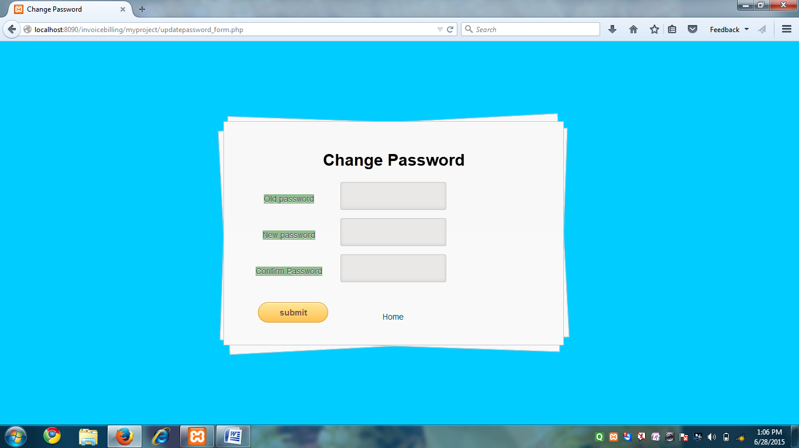

**SOURCE CODE**

<!DOCTYPE HTML>

<html>

<head>

<html>

<body ulink="#004F6C" vlink="#004F6C" link="#004F6C">

<head>

<style>

body, div,

p, fieldset{

margin: 4;

padding: 0;

border: 0;

outline: 0;

font-size: 100%;

vertical-align: baseline;

background: transparent;

}

body {

background:#00CCFF;

color: #000;

font: 14px Arial;

margin: 0 auto;

padding: 0;

position: relative;

}

a{ text-decoration: none; }

#content {

background: #f9f9f9;

background: -moz-linear-gradient(top, rgba(248,248,248,1) 0%, rgba(249,249,249,1) 100%);

background: -webkit-linear-gradient(top, rgba(248,248,248,1) 0%,rgba(249,249,249,1) 100%);

background: -o-linear-gradient(top, rgba(248,248,248,1) 0%,rgba(249,249,249,1) 100%);

background: -ms-linear-gradient(top, rgba(248,248,248,1) 0%,rgba(249,249,249,1) 100%);

background: linear-gradient(top, rgba(248,248,248,1) 0%,rgba(249,249,249,1) 100%);

filter: progid:DXImageTransform.Microsoft.gradient( startColorstr='#f8f8f8', endColorstr='#f9f9f9',GradientType=0);

-webkit-box-shadow: 0 1px 0 #fff inset;

-moz-box-shadow: 0 1px 0 #fff inset;

-ms-box-shadow: 0 1px 0 #fff inset;

-o-box-shadow: 0 1px 0 #fff inset;

box-shadow: 0 1px 0 #fff inset;

border: 1px solid #c4c6ca;

margin: 70 auto;

padding: 30px 0 0;

position: relative;

text-align: center;

text-shadow: 0 1px 0 #fff;

width: 580px;

height:50%;

}

#content:after,

#content:before {

background: #f9f9f9;

background: -moz-linear-gradient(top, rgba(248,248,248,1) 0%, rgba(249,249,249,1) 100%);

background: -webkit-linear-gradient(top, rgba(248,248,248,1) 0%,rgba(249,249,249,1) 100%);

background: -o-linear-gradient(top, rgba(248,248,248,1) 0%,rgba(249,249,249,1) 100%);

background: -ms-linear-gradient(top, rgba(248,248,248,1) 0%,rgba(249,249,249,1) 100%);

background: linear-gradient(top, rgba(248,248,248,1) 0%,rgba(249,249,249,1) 100%);

filter: progid:DXImageTransform.Microsoft.gradient( startColorstr='#f8f8f8', endColorstr='#f9f9f9',GradientType=0 );

border: 1px solid #c4c6ca;

content: "";

display: block;

height: 100%;

left: -1px;

position: absolute;

width: 100%;

}

#content:after {

-webkit-transform: rotate(2deg);

-moz-transform: rotate(2deg);

-ms-transform: rotate(2deg);

-o-transform: rotate(2deg);

transform: rotate(2deg);

top: 0;

z-index: -1;

}

#content:before {

-webkit-transform: rotate(-3deg);

-moz-transform: rotate(-3deg);

-ms-transform: rotate(-3deg);

-o-transform: rotate(-3deg);

transform: rotate(-3deg);

top: 0;

z-index: -2;

}

#content form { margin: 0 40px; }

#content form input[type="text"],

#content form input[type="password"] {

-webkit-border-radius: 3px;

-moz-border-radius: 3px;

-ms-border-radius: 3px;

-o-border-radius: 3px;

border-radius: 3px;

-webkit-box-shadow: 0 1px 0 #fff, 0 -2px 5px rgba(0,0,0,0.08) inset;

-moz-box-shadow: 0 1px 0 #fff, 0 -2px 5px rgba(0,0,0,0.08) inset;

-ms-box-shadow: 0 1px 0 #fff, 0 -2px 5px rgba(0,0,0,0.08) inset;

-o-box-shadow: 0 1px 0 #fff, 0 -2px 5px rgba(0,0,0,0.08) inset;

box-shadow: 0 1px 0 #fff, 0 -2px 5px rgba(0,0,0,0.08) inset;

-webkit-transition: all 0.5s ease;

-moz-transition: all 0.5s ease;

-ms-transition: all 0.5s ease;

-o-transition: all 0.5s ease;

transition: all 0.5s ease;

background: #eae7e7 url(http://cssdeck.com/uploads/media/items/8/8bcLQqF.png) no-repeat;

border: 1px solid #c8c8c8;

color: #777;

font: 13px Helvetica, Arial, sans-serif;

margin: 0 0 10px;

padding: 15px 10px 15px 40px;

width: 60%;

}

#username { background-position: 10px 10px !important }

#password { background-position: 10px -53px !important }

#content form input[type="submit"],input[type="reset"] {

background: rgb(254,231,154);

background: -moz-linear-gradient(top, rgba(254,231,154,1) 0%, rgba(254,193,81,1) 100%);

background: -webkit-linear-gradient(top, rgba(254,231,154,1) 0%,rgba(254,193,81,1) 100%);

background: -o-linear-gradient(top, rgba(254,231,154,1) 0%,rgba(254,193,81,1) 100%);

background: -ms-linear-gradient(top, rgba(254,231,154,1) 0%,rgba(254,193,81,1) 100%);

background: linear-gradient(top, rgba(254,231,154,1) 0%,rgba(254,193,81,1) 100%);

filter: progid:DXImageTransform.Microsoft.gradient( startColorstr='#fee79a', endColorstr='#fec151',GradientType=0 );

-webkit-border-radius: 30px;

-moz-border-radius: 30px;

-ms-border-radius: 30px;

-o-border-radius: 30px;

border-radius: 30px;

-webkit-box-shadow: 0 1px 0 rgba(255,255,255,0.8) inset;

-moz-box-shadow: 0 1px 0 rgba(255,255,255,0.8) inset;

-ms-box-shadow: 0 1px 0 rgba(255,255,255,0.8) inset;

-o-box-shadow: 0 1px 0 rgba(255,255,255,0.8) inset;

box-shadow: 0 1px 0 rgba(255,255,255,0.8) inset;

border: 1px solid #D69E31;

color: #85592e;

cursor: pointer;

float: left;

font: bold 15px Helvetica, Arial, sans-serif;

height: 35px;

margin: 20px 0 35px 15px;

position: relative;

text-shadow: 0 1px 0 rgba(255,255,255,0.5);

width: 120px;

}

p {color:#1C3D70 }

legend {

font-weight: bold;

border: 0px solid #888;

padding: 0.6em;

background-color: blue;

}

div#content{

margin-right: 30%;

margin-left: 28%;

margin-top: 10%;

}

label, legend {

background: #8FBC8F;

border: 0px solid rgb(0, 0, 0);

color: rgb(80, 80, 80);

}

</style>

</head>

<div id="container">

<div id="wrapper"> <div id="content">

<title>Change Password</title>

</head>

<body>

<form id="password" action="classes/controller/changepass_controller.php" method="post">

<h1>

Change Password

</h1>

<?php

//session_start();

if(isset($_SESSION['error_msg']))

{

$msg = $_SESSION['error_msg'];

//echo '<p>Error Message : '.$msg.'</p>';

unset($_SESSION['error_msg']);

}

if (!empty($msg))

{

echo("<p>".$msg."<p>");

}

?>

<table>

<tr>

<td><label> Old password </label></td>

<td><input type="password" name="old_pass" ></td>

</tr>

<tr>

<td><label>New password</label></td>

<td><input type="password" name="new_pass"></td>

</tr>

<tr>

<td><label for="conf_pass">Confirm Password</label></td>

<td><input type="password" name="conf_pass" id="conf_pass"></td>

</tr>

<tr>

<td> <input id="button" type="submit" name="submit" value="submit">

<td><a href="homepage.php">Home</a></td></td>

</tr>

</table>

</form>

</body>

</html>

**ADMIN HOMEPAGE**



**SOURCE CODE**

<!DOCTYPE HTML>

<html><style type="text/css">

#menu-bar

{

color: #000000;

}

#menu-bar li {

margin: 0px 0px 6px 0px;

padding: 0px 0px 0px 6px;

float: left;

position: relative;

list-style: none;

}

#menu-bar a

{

font-weight: bolder;

font-family: arial;

font-style: normal;

font-size: 13px;

color: #FFFFFF;

text-decoration: none;

display: block;

padding: 6px 20px 6px 20px;

margin: 10;

margin-bottom: 10px;

border-radius: 4px;

-webkit-border-radius: 4px;

-moz-border-radius: 4px;

text-shadow: 0px 0px 0px #9E9D9B;

}

#menu-bar li ul li a {

margin: 0;

}

#menu-bar .active a, #menu-bar li:hover > a {

background: -ms-linear-gradient(top, #EBEBEB, #A1A1A1);

background: -webkit-gradient(linear, left top, left bottom, from(#EBEBEB), to(#A1A1A1));

background: -moz-linear-gradient(top, #EBEBEB, #A1A1A1);

color: #254c78;

-webkit-box-shadow: 0px 0px rgba(0, 0, 0, 0);

-moz-box-shadow: 0px 0px rgba(0, 0, 0, 0);

box-shadow: 0px 0px rgba(0, 0, 0, 0);

text-shadow: -0px 0px 0px #FFFFFF;

}

#menu-bar ul li:hover a, #menu-bar li:hover li a {

background: none;

border: none;

color: #666;

-box-shadow: none;

-webkit-box-shadow: none;

-moz-box-shadow: none;

}

#menu-bar ul a:hover {

background: #1C3D70 !important; /*008080*/

color: #FFFFFF !important;

border-radius: 0;

-webkit-border-radius: 0;

-moz-border-radius: 0;

text-shadow: 0px 0px 0px #FFFFFF;

}

#menu-bar li:hover > ul {

display: block;

}

#menu-bar ul {

background: #DBDBDB;

display: none;

margin: 0;

padding: 0;

width: 160px;

position: absolute;

top: 30px;

left: 0;

border: solid 1px none; /*#B4B4B4*/

border-radius: 11px;

-webkit-border-radius: 10px;

-moz-border-radius: 10px;

-webkit-box-shadow: 0px 0px 0px #222222;

-moz-box-shadow: 0px 0px 0px #222222;

box-shadow: 2px 2px 4px #222222;

}

#menu-bar ul li {

float: none;

margin: 0;

padding: 0;

}

#menu-bar ul a {

padding:10px 10px 10px 15px;

color:#1C3D70 !important; /*#4C4C85*/

font-size:13px;

font-style:normal;

font-family:arial;

font-weight: bolder;

text-shadow: 2px 2px 3px #FFFFFF;

}

#menu-bar ul ul li {

top: 20%;

}

#menu-bar ul ul {

width: 210px;

height: 60px;

opacity:1;

position:absolute;

top: 30%;

left:162px;

padding:0px 0 0px 10;

color:#1C3D70 !important; /*#4C4C85*/

}

#menu-bar:after {

content: ".";

display: block;

clear: both;

visibility: hidden;

line-height: 0;

height: 0;

}

#menu-bar {

display: inline-block;

}

html[xmlns] #menu-bar {

display: block;

}

* html #menu-bar {

height: 1%;

}

#scroll

{

font-weight: bold;

text-align: center;

background-color:#3CC;

border-radius:3px;

}

div.scroll {

background-color: #FFFFFF;

width: 1100px;

height: 768px;

overflow: scroll;

}

.body_background {

background-image: url(../entrance-to-industrial-park-building-9824167.jpg);

background-repeat: no-repeat;

background-color: #33CCFF;

}

</style>

<body class="body_background">

<span class="body_background"></span>

<font color="#0033FF">

<center>

<h1><font face="Algerian" color="#CC0066" size="+6">INVOICE MANAGEMENT SYSTEM</font></h1>

<h2><font color="#FFFFFF">WELCOME ADMIN</font></h2></center>

<div align="center">

<div>

<ul id="menu-bar">

<ul>

</ul>

<li><strong>Home</strong></li>

<li><a href="viewcustomeradmin_form.php">View Customer</a></li>

<li><a href="product_form.php">Add product</a></li>

<li><a href="viewproductadmin_form.php">View Product</a></li>

<li><a href="logout.php">Logout</a></li>

</ul>

<!------------>

</div>

<div class="scroll">

<font color="red">

</font>

<p align="middle">

<font face="Tahoma" color="#00CC99">

<br>

<p><b>INDUSTRY - ASHOK SECURE BROADBAND NETWORK PRIVATE LIMITED </b></p>

<u><h2><font color="#000099">ASHOK SECURE BROADBAND NETWORK PRIVATE LIMITED</font></u></h2>

<b>ASHOK SECURE BROADBAND NETWORK PRIVATE LIMITEDis a Private Limited Company incorporated in January 2015.<br> It is registered at Registrar of Companies, Ranchi Its authorized share capital<br> is Rs. 500,000 and its paid up capital is Rs. 500,000</b>

<br><br>

<u><h2><font color="#000099">Industry</font></u></h2>

<b>Software, Information Technology & Consulting</br>

Sub-Industry<br>

Software, Information Technology & Consulting<br>

Established In<br>

January 2015<br>

</b><br><br>

<u><h2><font color="#000099">Overview</font></u></h2>

<b>Company Type<br>

Private Limited<br>

Paid up Capital<br>

Rs. 500,000<br>

Authorised Capital<br>

Rs. 500,000<br>

</b>

<br><br><br>

<table class="tg"><b>

<tr>

<th class="tg-031e"><font color="#000099">Address</font></th>

</tr>

<tr>

<td class="tg-031e">HOUSE NO-17 A , TEACHERS COLONY BHALUBASA ,</td>

</tr>

<tr>

<td class="tg-031e">POST - AGRICO JAMSHEDPUR</td>

</tr>

<tr>

<td class="tg-031e">City:Ranchi - 831009</td>

</tr>

<tr>

<td class="tg-031e">State:Jharkhand</td>

</tr>

<tr>

<td class="tg-031e">Contact</td>

</tr>

<tr>

<td class="tg-031e">Contact</td>

</tr>

<tr>

<td class="tg-031e">ashok.sahu@abnetwork.co.in</td>

</tr>

</b>

</table>

<br><br>

<p>

©2014 Companies Database

Privacy Policy</p> </div></font></form>

</body>

</html>

**VIEW CUSTOMER THROUGH ADMIN**

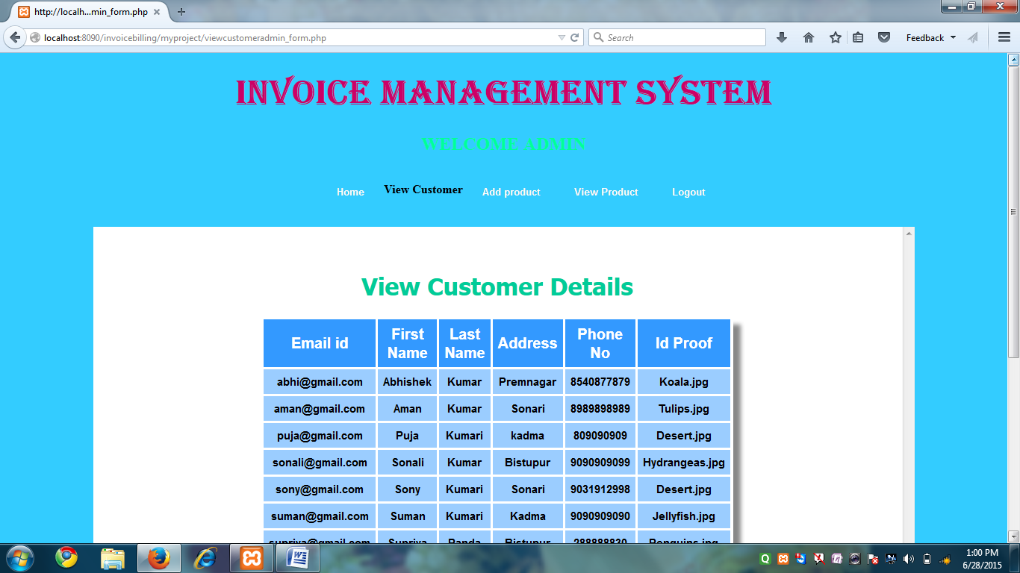

**SOURCE CODE**

<!DOCTYPE HTML>

<html><style type="text/css">

#menu-bar

{

color: #000000;

}

#menu-bar li {

margin: 0px 0px 6px 0px;

padding: 0px 0px 0px 6px;

float: left;

position: relative;

list-style: none;

}

#menu-bar a

{

font-weight: bolder;

font-family: arial;

font-style: normal;

font-size: 13px;

color: #FFFFFF;

text-decoration: none;

display: block;

padding: 6px 20px 6px 20px;

margin: 10;

margin-bottom: 10px;

border-radius: 4px;

-webkit-border-radius: 4px;

-moz-border-radius: 4px;

text-shadow: 0px 0px 0px #9E9D9B;

}

#menu-bar li ul li a {

margin: 0;

}

#menu-bar .active a, #menu-bar li:hover > a {

background: -ms-linear-gradient(top, #EBEBEB, #A1A1A1);

background: -webkit-gradient(linear, left top, left bottom, from(#EBEBEB), to(#A1A1A1));

background: -moz-linear-gradient(top, #EBEBEB, #A1A1A1);

color: #254c78;

-webkit-box-shadow: 0px 0px rgba(0, 0, 0, 0);

-moz-box-shadow: 0px 0px rgba(0, 0, 0, 0);

box-shadow: 0px 0px rgba(0, 0, 0, 0);

text-shadow: -0px 0px 0px #FFFFFF;

}

#menu-bar ul li:hover a, #menu-bar li:hover li a {

background: none;

border: none;

color: #666;

-box-shadow: none;

-webkit-box-shadow: none;

-moz-box-shadow: none;

}

#menu-bar ul a:hover {

background: #1C3D70 !important; /*008080*/

color: #FFFFFF !important;

border-radius: 0;

-webkit-border-radius: 0;

-moz-border-radius: 0;

text-shadow: 0px 0px 0px #FFFFFF;

}

#menu-bar li:hover > ul {

display: block;

}

#menu-bar ul {

background: #DBDBDB;

display: none;

margin: 0;

padding: 0;

width: 160px;

position: absolute;

top: 30px;

left: 0;

border: solid 1px none; /*#B4B4B4*/

border-radius: 11px;

-webkit-border-radius: 10px;

-moz-border-radius: 10px;

-webkit-box-shadow: 0px 0px 0px #222222;

-moz-box-shadow: 0px 0px 0px #222222;

box-shadow: 2px 2px 4px #222222;

}

#menu-bar ul li {

float: none;

margin: 0;

padding: 0;

}

#menu-bar ul a {

padding:10px 10px 10px 15px;

color:#1C3D70 !important; /*#4C4C85*/

font-size:13px;

font-style:normal;

font-family:arial;

font-weight: bolder;

text-shadow: 2px 2px 3px #FFFFFF;

}

#menu-bar ul ul li {

top: 20%;

}

#menu-bar ul ul {

width: 210px;

height: 60px;

opacity:1;

position:absolute;

top: 30%;

left:162px;

padding:0px 0 0px 10;

color:#1C3D70 !important; /*#4C4C85*/

}

#menu-bar:after {

content: ".";

display: block;

clear: both;

visibility: hidden;

line-height: 0;

height: 0;

}

#menu-bar {

display: inline-block;

}

html[xmlns] #menu-bar {

display: block;

}

* html #menu-bar {

height: 1%;

}

#scroll

{

font-weight: bold;

text-align: center;

background-color:#3CC;

border-radius:3px;

}

div.scroll {

background-color: #FFFFFF;

width: 1100px;

height: 768px;

overflow: scroll;

}

.body_background {

background-image: url(../entrance-to-industrial-park-building-9824167.jpg);

background-repeat: no-repeat;

background-color: #33CCFF;

}

/*

Tables

*/

.table_design {

margin:0px;

padding:0px;

box-shadow: 10px 10px 5px #888888;

-webkit-box-shadow: 10px 10px 5px #888888;

-moz-box-shadow: 10px 10px 5px #888888;

border:1px solid #ffffff;

}

.table_design table {

margin:0px;

padding:0px;

}

.table_design tr:hover td {

background-color:#AED7FF;

}

.table_design td{

vertical-align:middle;

background-color:#9BCDFF;

border:1px solid #ffffff;

border-width:0px 1px 1px 0px;

text-align:center;

padding:7px;

font-size:15px;

font-family:Arial;

font-weight:bold;

color:#000000;

}

.table_design th{

background-color:#3399FF;

border:1px solid #ffffff;

text-align:center;

border-width:0px 1px 1px 0px;

padding:7px;

font-size:20px;

font-family:Arial;

font-weight:bold;

color:#ffffff;

}

/* Table Design End */

</style>

<body class="body_background">

<span class="body_background"></span>

<font color="#0033FF">

<center>

<h1>

<font face="Algerian" color="#CC0066" size="+6">INVOICE MANAGEMENT SYSTEM</font></h1>

</h1>

</font>

<font color="#00FF99">

<h2>WELCOME ADMIN</h2>

</font>

</font>

</center>

<div align="center">

<div>

<ul id="menu-bar">

<ul>

</ul>

<li><a href="homepage1.php">Home</a></li>

<li><strong>View Customer</strong></li>

<li><a href="product_form.php">Add product</a></li>

<li><a href="viewproductadmin_form.php">View Product</a></li>

<li><a href="logout.php">Logout</a></li>

</ul>

<!------------>

</div>

<div class="scroll">

<font color="red">

</font>

<p align="middle">

<font face="Tahoma" color="#00CC99">

<br>

<h1>View Customer Details</h1>

<?php

require_once(dirname(dirname(__FILE__)).'/myproject/classes/service/UserDataService.php');

$obj = new UserDataService();

$rs_array = $obj->getAllUserDetails();

//$rs_array = $obj->get_result_array($query);

if(empty($rs_array))

{

echo '<p>No data Found</p>';

}

else

{

//print_r($rs_array);

?>

<table class="table_design">

<tr>

<th width="50"> Email id </th>

<th width="50">First Name </th>

<th width="50">Last Name </th>

<th width="50"> Address </th>

<th width="50">Phone No </th>

<th width="50">Id Proof </th>

</tr>

<?php

foreach($rs_array as $rs)

{

$email_id = $rs[0];

?>

<tr>

<td width="50"><?php echo $rs[0]?></td>

<td width="50"><?php echo $rs[1]?></td>

<td width="50"><?php echo $rs[2]?></td>

<td width="50"><?php echo $rs[3]?></td>

<td width="50"><?php echo $rs[4]?></td>

<td width="50"><?php echo $rs[5]?></td>

</tr>

<?php

}

}

?>

</table>

<a href="homepage1.php">Home</a>

<br><br></div></form></body></html>

**ADD PRODUCT**

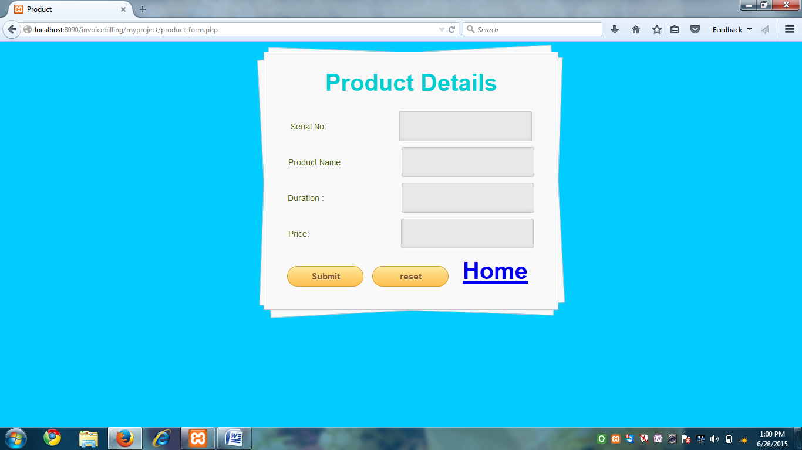

**SOURCE CODE**

<?php

session_start();

?>

<html>

<head>

<style>

html, body, div, span, applet, object, iframe,

h1, h2, h3, h4, h5, h6, p, blockquote, pre,

a, abbr, acronym, address, big, cite, code,

del, dfn, em, font, img, ins, kbd, q, s, samp,

small, strike, strong, sub, sup, tt, var,

b, u, i, center,

dl, dt, dd, ol, ul, li,

fieldset, form, label, legend,

table, caption, tbody, tfoot, thead, tr, th, td {

margin: 4;

padding: 0;

border: 0;

outline: 0;

font-size: 100%;

vertical-align: baseline;

background: transparent;

}

body {

background:#00CCFF;

color: #000;

font: 14px Arial;

margin: 0 auto;

padding: 0;

position: relative;

}

#content {

background: #f9f9f9;

background: -moz-linear-gradient(top, rgba(248,248,248,1) 0%, rgba(249,249,249,1) 100%);

background: -webkit-linear-gradient(top, rgba(248,248,248,1) 0%,rgba(249,249,249,1) 100%);

background: -o-linear-gradient(top, rgba(248,248,248,1) 0%,rgba(249,249,249,1) 100%);

background: -ms-linear-gradient(top, rgba(248,248,248,1) 0%,rgba(249,249,249,1) 100%);

background: linear-gradient(top, rgba(248,248,248,1) 0%,rgba(249,249,249,1) 100%);

filter: progid:DXImageTransform.Microsoft.gradient( startColorstr='#f8f8f8', endColorstr='#f9f9f9',GradientType=0 );

-webkit-box-shadow: 0 1px 0 #fff inset;

-moz-box-shadow: 0 1px 0 #fff inset;

-ms-box-shadow: 0 1px 0 #fff inset;

-o-box-shadow: 0 1px 0 #fff inset;

box-shadow: 0 1px 0 #fff inset;

border: 1px solid #c4c6ca;

margin: 0 auto;

padding: 20px 0 0;

position: relative;

text-align: center;

text-shadow: 0 1px 0 #fff;

width: 500px;

}

#content:after,

#content:before {

background: #f9f9f9;

background: -moz-linear-gradient(top, rgba(248,248,248,1) 0%, rgba(249,249,249,1) 100%);

background: -webkit-linear-gradient(top, rgba(248,248,248,1) 0%,rgba(249,249,249,1) 100%);

background: -o-linear-gradient(top, rgba(248,248,248,1) 0%,rgba(249,249,249,1) 100%);

background: -ms-linear-gradient(top, rgba(248,248,248,1) 0%,rgba(249,249,249,1) 100%);

background: linear-gradient(top, rgba(248,248,248,1) 0%,rgba(249,249,249,1) 100%);

filter: progid:DXImageTransform.Microsoft.gradient( startColorstr='#f8f8f8', endColorstr='#f9f9f9',GradientType=0 );

border: 1px solid #c4c6ca;

content: "";

display: block;

height: 100%;

left: -1px;

position: absolute;

width: 100%;

}

#content:after {

-webkit-transform: rotate(2deg);

-moz-transform: rotate(2deg);

-ms-transform: rotate(2deg);

-o-transform: rotate(2deg);

transform: rotate(2deg);

top: 0;

z-index: -1;

}

#content:before {

-webkit-transform: rotate(-3deg);

-moz-transform: rotate(-3deg);

-ms-transform: rotate(-3deg);

-o-transform: rotate(-3deg);

transform: rotate(-3deg);

top: 0;

z-index: -2;

}

#content form { margin: 0 20px; position: relative }

#content form input[type="text"],

#content form input[type="email"],

#content form input[type="password"] {

-webkit-border-radius: 3px;

-moz-border-radius: 3px;

-ms-border-radius: 3px;

-o-border-radius: 3px;

border-radius: 3px;

-webkit-box-shadow: 0 1px 0 #fff, 0 -2px 5px rgba(0,0,0,0.08) inset;

-moz-box-shadow: 0 1px 0 #fff, 0 -2px 5px rgba(0,0,0,0.08) inset;

-ms-box-shadow: 0 1px 0 #fff, 0 -2px 5px rgba(0,0,0,0.08) inset;

-o-box-shadow: 0 1px 0 #fff, 0 -2px 5px rgba(0,0,0,0.08) inset;

box-shadow: 0 1px 0 #fff, 0 -2px 5px rgba(0,0,0,0.08) inset;

-webkit-transition: all 0.5s ease;

-moz-transition: all 0.5s ease;

-ms-transition: all 0.5s ease;

-o-transition: all 0.5s ease;

transition: all 0.5s ease;

background: #eae7e7 url(http://cssdeck.com/uploads/media/items/8/8bcLQqF.png) no-repeat;

border: 1px solid #c8c8c8;

color: #777;

font: 15px Helvetica, Arial, sans-serif;

margin: 0 0 10px;

padding: 15px 10px 15px 40px;

width: 50%;

}

#username { background-position: 10px 10px !important }

#password { background-position: 10px -53px !important }

#content form input[type="submit"],input[type="reset"] {

background: rgb(254,231,154);

background: -moz-linear-gradient(top, rgba(254,231,154,1) 0%, rgba(254,193,81,1) 100%);

background: -webkit-linear-gradient(top, rgba(254,231,154,1) 0%,rgba(254,193,81,1) 100%);

background: -o-linear-gradient(top, rgba(254,231,154,1) 0%,rgba(254,193,81,1) 100%);

background: -ms-linear-gradient(top, rgba(254,231,154,1) 0%,rgba(254,193,81,1) 100%);

background: linear-gradient(top, rgba(254,231,154,1) 0%,rgba(254,193,81,1) 100%);

filter: progid:DXImageTransform.Microsoft.gradient( startColorstr='#fee79a', endColorstr='#fec151',GradientType=0 );

-webkit-border-radius: 30px;

-moz-border-radius: 30px;

-ms-border-radius: 30px;

-o-border-radius: 30px;

border-radius: 30px;

-webkit-box-shadow: 0 1px 0 rgba(255,255,255,0.8) inset;

-moz-box-shadow: 0 1px 0 rgba(255,255,255,0.8) inset;

-ms-box-shadow: 0 1px 0 rgba(255,255,255,0.8) inset;

-o-box-shadow: 0 1px 0 rgba(255,255,255,0.8) inset;

box-shadow: 0 1px 0 rgba(255,255,255,0.8) inset;

border: 1px solid #D69E31;

color: #85592e;

cursor: pointer;

float: left;

font: bold 15px Helvetica, Arial, sans-serif;

height: 35px;

margin: 20px 0 35px 15px;

position: relative;

text-shadow: 0 1px 0 rgba(255,255,255,0.5);

width: 130px;

}

p {

color:#00ced1;

font: bold 40px Helvetica, Arial, sans-serif;

}

div#content{

margin-right: 30%;

margin-left: *%;

margin-top: 1%;

}

g{

color:#4B610B;

}

.date {

display: inline;

padding: 1.2em;

border: inset 1px #CCC;

background:#eae7e7 ;

border-radius: 4px;

color: #777;

border: 1px solid #c8c8c8;

}

.date * {

display: inline-block;

}

.date input {

width: 59px;

padding: 0 0.4em;

border: none;

font-size: 100%;

background: none;

color: #777;

}

.date input#year { width:3.6em; }

.date input:focus { outline:none; }

</style>

<title>Product</title>

</head>

</style>

<div id="container">

<div id="wrapper"> <div id="content">

<form method="POST" enctype="multipart/form-data" action="classes/controller/product_controller.php">

<form name="form1" id="form1" method="post" action="classes/controller/product_controller.php">

<fieldset>

<p>Product Details</p><br>

<?php

$msg=" ";

if(isset($_SESSION['error_msg']))

{

$msg = $_SESSION['error_msg'];

//echo '<p>Error Message : '.$msg.'</p>';

unset($_SESSION['error_msg']);

}

if(!empty($msg))

{

echo"<p>".$msg."</p>";

}

?>

<g for="serial_no">Serial No:</g>

&nbsp&nbsp&nbsp&nbsp&nbsp&nbsp&nbsp&nbsp&nbsp&nbsp&nbsp&nbsp&nbsp&nbsp&nbsp&nbsp&nbsp&nbsp&nbsp&nbsp&nbsp&nbsp&nbsp&nbsp&nbsp&nbsp&nbsp&nbsp&nbsp

<input type="text" name="serial_no"><br>

<g for="product_name">Product Name:</g>

&nbsp&nbsp&nbsp&nbsp&nbsp&nbsp&nbsp&nbsp&nbsp&nbsp&nbsp&nbsp&nbsp&nbsp&nbsp&nbsp&nbsp&nbsp&nbsp&nbsp&nbsp&nbsp&nbsp

<input type="text" name="product_name"><br>

<g for="duration">Duration</g>

:

&nbsp&nbsp&nbsp&nbsp&nbsp&nbsp&nbsp&nbsp&nbsp&nbsp&nbsp&nbsp&nbsp&nbsp&nbsp&nbsp&nbsp&nbsp&nbsp&nbsp&nbsp&nbsp&nbsp&nbsp&nbsp&nbsp&nbsp&nbsp&nbsp&nbsp&nbsp

<input type="text" name="duration" id="duration"><br>

<g for="phone">Price:</g>

&nbsp&nbsp&nbsp&nbsp&nbsp&nbsp&nbsp&nbsp&nbsp&nbsp&nbsp&nbsp&nbsp&nbsp&nbsp&nbsp&nbsp&nbsp&nbsp&nbsp&nbsp&nbsp&nbsp&nbsp&nbsp&nbsp&nbsp&nbsp&nbsp&nbsp&nbsp&nbsp&nbsp&nbsp&nbsp&nbsp&nbsp

<input type="text" name="price"><br>

<input id="button" type="submit" name="submit" value="Submit">

<input type="reset" name="reset" value="reset" title="Reset">

<p><a href="homepage1.php">Home</a></p>

</fieldset>

</form>

</div>

</div>

</div>

</body>

</html>

**VIEW AND EDIT PRODUCT**

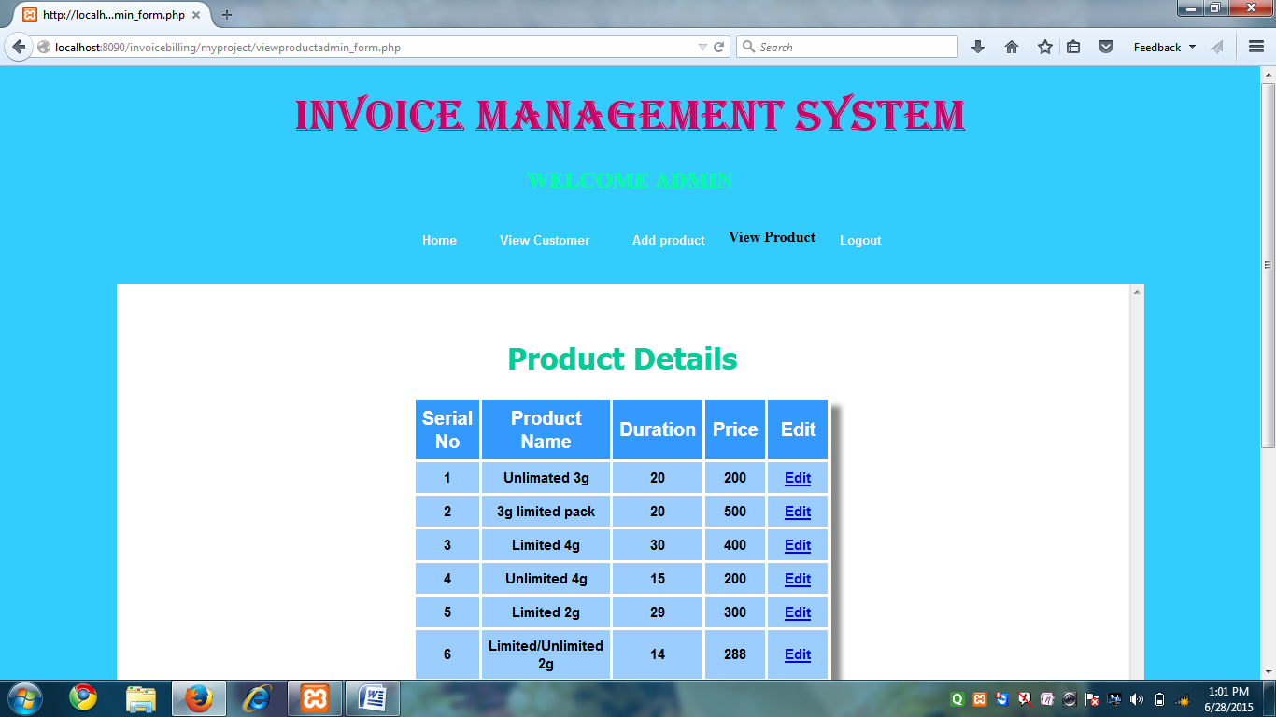

**SOURCE CODE**

<!DOCTYPE HTML>

<html><style type="text/css">

#menu-bar

{

color: #000000;

}

#menu-bar li {

margin: 0px 0px 6px 0px;

padding: 0px 0px 0px 6px;

float: left;

position: relative;

list-style: none;

}

#menu-bar a

{

font-weight: bolder;

font-family: arial;

font-style: normal;

font-size: 13px;

color: #FFFFFF;

text-decoration: none;

display: block;

padding: 6px 20px 6px 20px;

margin: 10;

margin-bottom: 10px;

border-radius: 4px;

-webkit-border-radius: 4px;

-moz-border-radius: 4px;

text-shadow: 0px 0px 0px #9E9D9B;

}

#menu-bar li ul li a {

margin: 0;

}

#menu-bar .active a, #menu-bar li:hover > a {

background: -ms-linear-gradient(top, #EBEBEB, #A1A1A1);

background: -webkit-gradient(linear, left top, left bottom, from(#EBEBEB), to(#A1A1A1));

background: -moz-linear-gradient(top, #EBEBEB, #A1A1A1);

color: #254c78;

-webkit-box-shadow: 0px 0px rgba(0, 0, 0, 0);

-moz-box-shadow: 0px 0px rgba(0, 0, 0, 0);

box-shadow: 0px 0px rgba(0, 0, 0, 0);

text-shadow: -0px 0px 0px #FFFFFF;

}

#menu-bar ul li:hover a, #menu-bar li:hover li a {

background: none;

border: none;

color: #666;

-box-shadow: none;

-webkit-box-shadow: none;

-moz-box-shadow: none;

}

#menu-bar ul a:hover {

background: #1C3D70 !important; /*008080*/

color: #FFFFFF !important;

border-radius: 0;

-webkit-border-radius: 0;

-moz-border-radius: 0;

text-shadow: 0px 0px 0px #FFFFFF;

}

#menu-bar li:hover > ul {

display: block;

}

#menu-bar ul {

background: #DBDBDB;

display: none;

margin: 0;

padding: 0;

width: 160px;

position: absolute;

top: 30px;

left: 0;

border: solid 1px none; /*#B4B4B4*/

border-radius: 11px;

-webkit-border-radius: 10px;

-moz-border-radius: 10px;

-webkit-box-shadow: 0px 0px 0px #222222;

-moz-box-shadow: 0px 0px 0px #222222;

box-shadow: 2px 2px 4px #222222;

}

#menu-bar ul li {

float: none;

margin: 0;

padding: 0;

}

#menu-bar ul a {

padding:10px 10px 10px 15px;

color:#1C3D70 !important; /*#4C4C85*/

font-size:13px;

font-style:normal;

font-family:arial;

font-weight: bolder;

text-shadow: 2px 2px 3px #FFFFFF;

}

#menu-bar ul ul li {

top: 20%;

}

#menu-bar ul ul {

width: 210px;

height: 60px;

opacity:1;

position:absolute;

top: 30%;

left:162px;

padding:0px 0 0px 10;

color:#1C3D70 !important; /*#4C4C85*/

}

#menu-bar:after {

content: ".";

display: block;

clear: both;

visibility: hidden;

line-height: 0;

height: 0;

}

#menu-bar {

display: inline-block;

}

html[xmlns] #menu-bar {

display: block;

}

* html #menu-bar {

height: 1%;

}

#scroll

{

font-weight: bold;

text-align: center;

background-color:#3CC;

border-radius:3px;

}

div.scroll {

background-color: #FFFFFF;

width: 1100px;

height: 768px;

overflow: scroll;

}

.body_background {

background-image: url(../entrance-to-industrial-park-building-9824167.jpg);

background-repeat: no-repeat;

background-color: #33CCFF;

}

/*

Tables

*/

.table_design {

margin:0px;

padding:0px;

box-shadow: 10px 10px 5px #888888;

-webkit-box-shadow: 10px 10px 5px #888888;

-moz-box-shadow: 10px 10px 5px #888888;

border:1px solid #ffffff;

}

.table_design table {

margin:0px;

padding:0px;

}

.table_design tr:hover td {

background-color:#AED7FF;

}

.table_design td{

vertical-align:middle;

background-color:#9BCDFF;

border:1px solid #ffffff;

border-width:0px 1px 1px 0px;

text-align:center;

padding:7px;

font-size:15px;

font-family:Arial;

font-weight:bold;

color:#000000;

}

.table_design th{

background-color:#3399FF;

border:1px solid #ffffff;

text-align:center;

border-width:0px 1px 1px 0px;

padding:7px;

font-size:20px;

font-family:Arial;

font-weight:bold;

color:#ffffff;

}

/* Table Design End */

</style>

<body class="body_background">

<span class="body_background"></span>

<font color="#0033FF">

<center>

<h1>

<font face="Algerian" color="#CC0066" size="+6">INVOICE MANAGEMENT SYSTEM</font></h1>

<font color="#00FF99">

</font></h1>

<font color="#00FF99">

<h2>WELCOME ADMIN</h2>

</font>

</font>

</center>

<div align="center">

<div>

<ul id="menu-bar">

<ul>

</ul>

<li><a href="homepage1.php">Home</a></li>

<li><a href="viewcustomeradmin_form.php">View Customer</a></li>

<li><a href="product_form.php">Add product</a></li>

<li><strong>View Product</strong></li>

<li><a href="logout.php">Logout</a></li>

</ul>

<!------------>

</div>

<div class="scroll">

<font color="red">

</font>

<p align="middle">

<font face="Tahoma" color="#00CC99">

<br>

<h1>Product Details</h1>

<?php

require_once(dirname(dirname(__FILE__)).'/myproject/classes/service/ProductDataService.php');

$obj = new ProductDataService();

$rs_array = $obj->getAllProductDetails();

//$rs_array = $obj->get_result_array($query);

if(empty($rs_array))

{

echo '<p>No data Found</p>';

}

else

{

//print_r($rs_array);

?>

<table class="table_design">

<tr>

<th width="50"> Serial No</th>

<th width="50">Product Name</th>

<th width="50">Duration</th>

<th width="50">Price</th>

<th width="50">Edit</th>

</tr>

<?php

//list($u, $p) = $rs_array[0];

foreach($rs_array as $rs)

{

$serial_no = $rs[0];

?>

<tr>

<td width="50"><?php echo $serial_no?></td>

<td width="50"><?php echo $rs[1]?></td>

<td width="50"><?php echo $rs[2]?></td>

<td width="50"><?php echo $rs[3]?></td>

<td width="50"><a href="edit_product.php?serial_no=<?php echo

$serial_no?>">Edit</a></td>

</tr>

<?php

}

}

?>

</table>

<br><br>

</div>

</font>

</form>

</body>

</html>

**UPDATE PRODUCT**

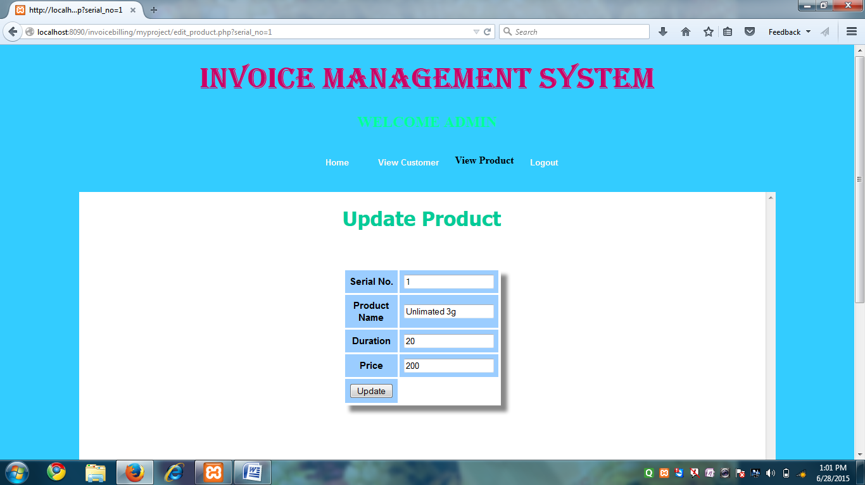

**SOURCE CODE**

<?php

$serial_no=$_GET['serial_no'];

?>

<!DOCTYPE HTML>

<html><style type="text/css">

#menu-bar

{

color: #000000;

}

#menu-bar li {

margin: 0px 0px 6px 0px;

padding: 0px 0px 0px 6px;

float: left;

position: relative;

list-style: none;

}

#menu-bar a

{

font-weight: bolder;

font-family: arial;

font-style: normal;

font-size: 13px;

color: #FFFFFF;

text-decoration: none;

display: block;

padding: 6px 20px 6px 20px;

margin: 10;

margin-bottom: 10px;

border-radius: 4px;

-webkit-border-radius: 4px;

-moz-border-radius: 4px;

text-shadow: 0px 0px 0px #9E9D9B;

}

#menu-bar li ul li a {

margin: 0;

}

#menu-bar .active a, #menu-bar li:hover > a {

background: -ms-linear-gradient(top, #EBEBEB, #A1A1A1);

background: -webkit-gradient(linear, left top, left bottom, from(#EBEBEB), to(#A1A1A1));

background: -moz-linear-gradient(top, #EBEBEB, #A1A1A1);

color: #254c78;

-webkit-box-shadow: 0px 0px rgba(0, 0, 0, 0);

-moz-box-shadow: 0px 0px rgba(0, 0, 0, 0);

box-shadow: 0px 0px rgba(0, 0, 0, 0);

text-shadow: -0px 0px 0px #FFFFFF;

}

#menu-bar ul li:hover a, #menu-bar li:hover li a {

background: none;

border: none;

color: #666;

-box-shadow: none;

-webkit-box-shadow: none;

-moz-box-shadow: none;

}

#menu-bar ul a:hover {

background: #1C3D70 !important; /*008080*/

color: #FFFFFF !important;

border-radius: 0;

-webkit-border-radius: 0;

-moz-border-radius: 0;

text-shadow: 0px 0px 0px #FFFFFF;

}

#menu-bar li:hover > ul {

display: block;

}

#menu-bar ul {

background: #DBDBDB;

display: none;

margin: 0;

padding: 0;

width: 160px;

position: absolute;

top: 30px;

left: 0;

border: solid 1px none; /*#B4B4B4*/

border-radius: 11px;

-webkit-border-radius: 10px;

-moz-border-radius: 10px;

-webkit-box-shadow: 0px 0px 0px #222222;

-moz-box-shadow: 0px 0px 0px #222222;

box-shadow: 2px 2px 4px #222222;

}

#menu-bar ul li {

float: none;

margin: 0;

padding: 0;

}

#menu-bar ul a {

padding:10px 10px 10px 15px;

color:#1C3D70 !important; /*#4C4C85*/

font-size:13px;

font-style:normal;

font-family:arial;

font-weight: bolder;

text-shadow: 2px 2px 3px #FFFFFF;

}

#menu-bar ul ul li {

top: 20%;

}

#menu-bar ul ul {

width: 210px;

height: 60px;

opacity:1;

position:absolute;

top: 30%;

left:162px;

padding:0px 0 0px 10;

color:#1C3D70 !important; /*#4C4C85*/

}

#menu-bar:after {

content: ".";

display: block;

clear: both;

visibility: hidden;

line-height: 0;

height: 0;

}

#menu-bar {

display: inline-block;

}

html[xmlns] #menu-bar {

display: block;

}

* html #menu-bar {

height: 1%;

}

#scroll

{

font-weight: bold;

text-align: center;

background-color:#3CC;

border-radius:3px;

}

div.scroll {

background-color: #FFFFFF;

width: 1100px;

height: 768px;

overflow: scroll;

}

.body_background {

background-image: url(../entrance-to-industrial-park-building-9824167.jpg);

background-repeat: no-repeat;

background-color: #33CCFF;

}

/*

Tables

*/

.table_design {

margin:0px;

padding:0px;

box-shadow: 10px 10px 5px #888888;

-webkit-box-shadow: 10px 10px 5px #888888;

-moz-box-shadow: 10px 10px 5px #888888;

border:1px solid #ffffff;

}

.table_design table {

margin:0px;

padding:0px;

}

.table_design tr:hover td {

background-color:#AED7FF;

}

.table_design td{

vertical-align:middle;

background-color:#9BCDFF;

border:1px solid #ffffff;

border-width:0px 1px 1px 0px;

text-align:center;

padding:7px;

font-size:15px;

font-family:Arial;

font-weight:bold;

color:#000000;

}

.table_design th{

background-color:#3399FF;

border:1px solid #ffffff;

text-align:center;

border-width:0px 1px 1px 0px;

padding:7px;

font-size:20px;

font-family:Arial;

font-weight:bold;

color:#ffffff;

}

/* Table Design End */

</style>

<body class="body_background">

<span class="body_background"></span>

<font color="#0033FF">

<center>

<h1>

<font face="Algerian" color="#CC0066" size="+6">INVOICE MANAGEMENT SYSTEM</font></h1>

</h1>

</font>

<font color="#00FF99">

<h2>WELCOME ADMIN</h2>

</font>

</font>

</center>

<div align="center">

<div>

<ul id="menu-bar">

<ul>

</ul>

<li><a href="homepage1.php">Home</a></li>

<li><a href="viewcustomeradmin_form.php">View Customer</a></li>

<li><strong>View Product</strong></li>

<li><a href="logout.php">Logout</a></li>

</ul>

<!------------>

</div>

<div class="scroll">

<font color="red">

</font>

<p align="middle">

<font face="Tahoma" color="#00CC99">

<h1>Update Product</h1>

<br>

<?php

require_once(dirname(dirname(__FILE__)).'/myproject/classes/service/ProductDataService.php');

$service = new ProductDataService();

$rs_array = $service->getProductDetailsBySerial_no($serial_no);

if(empty($rs_array))

{

echo'<p>NO data Found</p>';

}

else

{ ?>

<p>

<form name="frm_edit" method="POST" action="classes/controller/editproduct_controller.php">

<table class="table_design">

<tr>

<td width="50">Serial No.</td>

<td width="50"><input type="text" name="serial_no" value="<?php echo $rs_array[0][0]?>" readonly></td>

</tr>

<tr>

<td width="50">Product Name</td>

<td width="50"><input type="text" name="product_name" value="<?php echo $rs_array[0][1]?>"></td>

</tr>

<tr>

<td width="50">Duration</td>

<td width="50"><input type="text" name="duration" value="<?php echo $rs_array[0][2]?>"></td>

</tr>

<tr>

<td width="50">Price</td>

<td width="50"><input type="text" name="price" value="<?php echo $rs_array[0][3]?>"></td>

</tr>

<tr>

<td width="50"><input type="submit" name="update" value="Update"></td>

</tr>

</table>

<br><br>

</div>

</form>

<?php

}

?>

</body>

</html>

**LOGOUT**

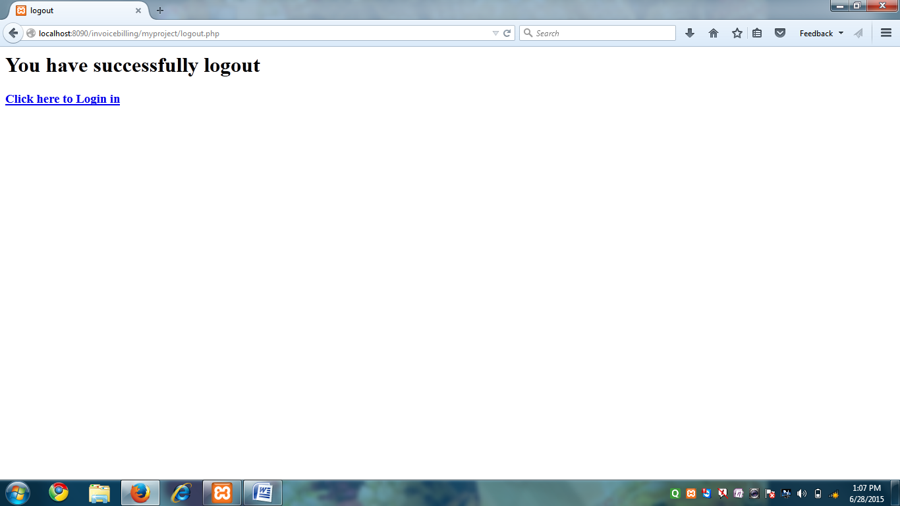

**SOURCE CODE**

<?php

session_start();

session_destroy();

$_SESSION=array();

?>

<html>

<title>

logout

</title>

<body>

<h1> You have successfully logout</h1>

<h3><a href="loginform.php">Click here to Login in</a></h3></body></html>

**TESTING PROCEDURE**

The main objective of the testing here is to execute a program and generate bill, so that software can function according to specification specified for behavioral and performance requirement of the software.

1. **Testing Techniques:**

We have used the following testing technique for finding errors in this software:

(A)  **White Box Testing Technique:**

We have used this method to exercise the internal program logic. During the course of white box testing, I have done the following work.

* All independent paths within a module are exercised at least once.
* All logical decision on their true and false side is also exercised.
* All loops were executed at their boundaries and within their operation bounds.
* Validity of internal data structure was also exercised.

Some of white box testing techniques, which we have used for this software, are:

* 1. **Basis Path Testing:**

The basis path methods enable me to derive a logical complexity measure of a procedure design and this measure is used for defining a basis set of execution path. This path ensures to execute every statement in a program at least once.

2. **Control structure testing** :

Since the basis path testing was not enough, hence the control structure testing is used to exercise the logical condition in a program module. During the course of testing, I have done the following activities, which are described below

* After testing all conditions, we have found some errors like:
* Boolean variable error in the module cost benefit analysis.
* Case:

In cost benefit analysis, we have used the concept of relative cell referencing in this contact; we have taken two types of cell (i) Variable cell, (ii) function based constant value cell. Only user can modify variable cell but function value cell only display manipulated value. If cell is functional cell, its return TURE less FALSE. During course of testing, we have found this function not return value properly. So we have separately test this function for Boolean errors.

Relational operator error. Boolean Parenthesis error.

Arithmetic expression error.

After that we have tested the flow of data across the variable in the module.

All the loops are also tested to ensure the validity. We found that a loop in the cost benefits analysis modules was functioning more than required iteration; it was later corrected to run within the required iteration.

**(B). Black Box Testing:**

This method is used to test the functional requirements of the software as specified in the section of S.E. Requirement Specification. By using this technique I have found errors in the following categories:

o Incorrect or missing functions

o Interface errors

o Errors in data structure

o Behavior or performance errors and

o Initialization and termination errors

Under the Black Box testing we have used the following types of testing methods:

3 **Testing Strategies:**

Testing strategy, which I have used here to integrate software test case design methods into a series of steps, can be categorized into two spectrums:

* Code Testing.
* Specifications testing.

The testing strategies, which I have used here, have the following generic characteristics

→

→

→

First component level testing are performed and then we moved towards the integration of the entire software. During the course of various types of testing, user involvements are also considered.

Different types of testing are performed at different points of time.

1. Unit Testing: I have taken following steps during unit testing:
2. The module interface is tested to ensure that information

properly flows into and out of the program unit under test.

II. The local data structure is examined to ensure that data

stored temporarily maintains its integrity during all steps in a program execution.

III. All independent paths within each module are exercised to ensure that all statements in a module have been exercised at least once.

IV. Boundary is tested to ensure that the module operate properly at boundaries established to limit or restrict processing.

1. Finally all error handling path are tested.

B. Case

During the code implementation, we have face with precision problem In “cost benefit analysis”.

B. Integration Testing: During this phase we have combine all the module and perform integration sting for constructing the program structure while at the same time conducting tests to uncover errors associated with interfacing. In order to integrate all the modules we have used Bottom up approach.

C. Validation Testing:

After the completion of integration testing and removal of interfacing problem, we have conducted validation testing according to reasonable expectation of user specified in the S.E. Requirement specification documents. Since this s/w is designed for management, hence a series of acceptance tests are also conducted. The acceptance test is conducted is conducted by Mr. Neeraj Kant Jha and he is found the satisfactory performance of the software according to their needs.

D. System Testing:

Finally we have conducted the system testing to fully exercise the currently developed computer based system **“Bill Management system”.**

Following tests are performed during this phase:

I. Recovery Testing: During recovery testing we have exercised fault tolerance capacity of system, ability to recover from failure. We found that the system is fault tolerant and processing fault is not causing overall system function to cease.

II. Security Testing: We have made various attempts to penetrate the data stored in the system.

**FEELING ABOUT USER**

Everyone wants to automate the entire process that involved in the IMS-Invoice Management System, so that all the problems uncounted yet can be solved. They feel computerization is the only solution. The use of the information technology for the automation of manual system aim to: ---

* Cut down arithmetic errors
* Provide quicker information
* Provide reliable media for storage
* Remove duplicity of work
* Provide security to the data
* Enhance efficiency

**EVALUATION**

The field data provided by the supervisor, assigned by Mr. Binod Kumar, was put to test. The manually generated bill and reports are compared against the presently developed s/w for verification.

Following points are observed:

1. The results produced by both the system are same and correct.
2. Reports are correct.
3. Bill generation becomes rather easy than manual system.
4. The efficiency of the existing system enhanced significantly.
5. The new information system has changed the completeness of the information significantly.
6. The decision making process now simplified, hence overall saving in management efforts.
7. The productivity of the system increased.

**CONCLUSION**

While writing solution to this problem, I realized that right attitude towards problem solving with at least an average aptitude gives dynamic result. At start, I was having no roadmap, but subsequently as I progressed all become clearer and clearer, finally I am writing the Termination Analysis. All the process that I have used can be used informally, but its formal execution I have found almost necessary to give it a professional touch, which after realizes into its commercial value. I have also realized that, if any project doesn’t have commercial nature, its completion or incompletion doesn’t have any meaning. Additionally talking to seniors and experts, proper documentation and investigating attitude are must to develop a project.

As a formal method I will follow sequential way to develop any solution given to me, in future:

* System study to collect max. Facts in less time.
* System Analysis to understand its pros and cons.
* All (inferior and Superior) designs, that can be used to solve that problem and choosing the best based on the cost-benefits Analysis.
* A severe testing strategy to test even least regretful situations that could occur.
* Comfortable documentation with every step.
* Writing Termination Analysis as an integral step.

**BIBLIOGRAPHY**

* 1. System Analysis & Design Elis M.Awad

(Galgotia Publication (P) Ltd.)

* 1. Humanised Information System & Design

(Mc Graw Hills publication Ltd.)

1. Manual of Existing System of The organization
2. PHP By:-Gerg Perry
3. Bible of MYSQL

-By Evangelos Petroutsos.

-By BPB Publication **.**