TrustGRC AI 360
Live Platform Architecture, Database Schema, URLs and Operating Guide
Unified AI Governance, Risk & Compliance Platform
CURRENT DEPLOYMENT STATUS
GitHub repository -> synchronized
Hostman VPS -> online
FastAPI API -> online as systemd service
PostgreSQL -> connected and verified
Swagger/OpenAPI -> publicly accessible
Database tables -> organizations, ai_systems, generated_risks

Version 0.1.0 | 31 July 2026

Document Contents
1. Executive Summary
2. Current Live Environment
3. Platform Architecture
4. End-to-End Business Workflow
5. Database Schema and Relationships
6. Backend API and Public URLs
7. Frontend Options and Connection Strategy
8. Backend Operations and Service Management
9. Security and Configuration Controls
10. Deployment and Update Workflow
11. MVP Demonstration Scenario
12. Recommended Next Development Steps

1. Executive Summary
TrustGRC AI 360 is now operating as a live cloud-hosted MVP foundation. The backend is deployed on a Hostman Ubuntu VPS, runs through FastAPI and Uvicorn, connects to a managed PostgreSQL database, and is maintained as a persistent systemd service. The source code is synchronized with GitHub. Public API health and Swagger documentation endpoints have been tested successfully from a browser.
The current platform foundation supports the following core workflow:
- Create an organisation
- Register an AI system
- Generate governance, compliance and cybersecurity risks
- Store the generated risks in PostgreSQL
- Display risks, controls and compliance information through dashboards and reports
Important current-state note: The backend API is publicly live. The Next.js frontend has been developed locally but has not yet been confirmed as publicly deployed on a permanent URL. Therefore, frontend URLs in this document are separated into current local options and recommended production options.

2. Current Live Environment
Component | Current value | Status / purpose
Product | TrustGRC AI 360 | Unified AI governance, risk and compliance platform
GitHub repository | github.com/Soobi1008/trustgrc-360-ai | Source code synchronized with VPS
VPS | trustgrc360-api | Hostman Ubuntu server in Frankfurt
VPS public IP | 195.216.168.137 | Public access to the backend API
Backend framework | FastAPI + Uvicorn | REST API and OpenAPI documentation
Backend service | trustgrc-api.service | Runs continuously through systemd
API port | 8000 | Current direct public API port
Database cluster | trustgrc360-db | Managed Hostman PostgreSQL cluster
Database | default_db | Application database
Database user | gen_user | Application database account
PostgreSQL version | 18 | Managed relational database
Database tables | organizations, ai_systems, generated_risks | Current application data model

2.1 Live Backend URLs
Purpose | URL | Expected result
API root | http://195.216.168.137:8000/ | Application name, message and version
Health check | http://195.216.168.137:8000/health | {"status":"healthy","service":"trustgrc-api"}
Swagger UI | http://195.216.168.137:8000/docs | Interactive API documentation and testing
OpenAPI JSON | http://195.216.168.137:8000/openapi.json | Machine-readable API contract
Alternative docs | http://195.216.168.137:8000/redoc | ReDoc API documentation, if enabled by FastAPI defaults

3. Platform Architecture
User / Browser
|
v
Next.js Frontend
|
| HTTP / JSON REST requests
v
FastAPI Backend on Hostman VPS
|
| SQLAlchemy ORM + psycopg driver
v
Hostman PostgreSQL Database
|
v
Risk Engine / Compliance Engine
|
v
Dashboards, controls, evidence and reports

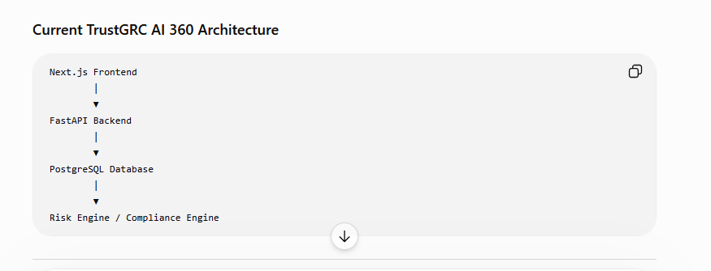
Figure 1. Current TrustGRC AI 360 architecture supplied during the deployment session.

3.1 Component Responsibilities
Layer | Responsibilities
Next.js frontend | User interface, forms, dashboards, navigation, validation, API calls and report views.
FastAPI backend | Business logic, request validation, risk generation, database operations, API routing and OpenAPI documentation.
SQLAlchemy | Maps Python models to PostgreSQL tables and manages queries and relationships.
PostgreSQL | Persistent storage for organisations, AI systems, generated risks and future governance artefacts.
Risk / compliance engine | Evaluates AI-system attributes and creates mapped risks, controls and regulatory references.
systemd | Starts the API automatically after reboot and restarts it if the process fails.
GitHub | Source control, version history, backup and future deployment collaboration.

4. End-to-End Business Workflow
Create Organization
|
v
Register AI System
|
v
Generate Risks
|
v
Store Risks in PostgreSQL
|
v
Dashboard, Review and Reports

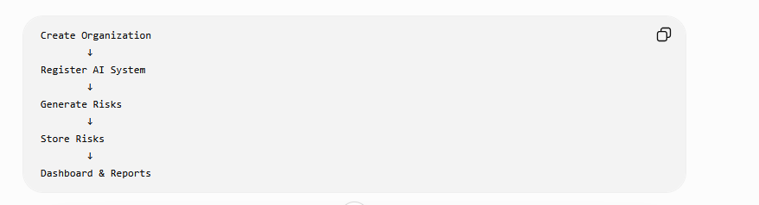
Figure 2. Proposed end-to-end TrustGRC AI 360 user workflow.
Step | User action | System action | Stored result
1 | Create organisation | Validates details and creates the organisation record | organizations
2 | Register AI system | Associates the system with an organisation | ai_systems
3 | Select Generate Risks | Applies risk rules or future AI analysis | Generated risk objects
4 | Confirm/store results | Saves risks linked to the AI system | generated_risks
5 | Review dashboard | Aggregates risk scores, categories and regulations | Dashboard and reports

5. Database Schema and Relationships
organizations (1)
|
| one organisation has many AI systems
v
ai_systems (many)
|
| one AI system has many generated risks
v
generated_risks (many)
Deleting an AI system removes its related generated risks
because the foreign key uses ON DELETE CASCADE.

5.1 organisations Table
Purpose: stores tenant or customer organisation information. The exact columns should be verified against the current SQLAlchemy model before production documentation is finalised. Typical fields include organisation ID, name, industry, size, region and timestamps.

5.2 ai_systems Table
Purpose: provides the AI inventory. It stores each AI system assessed by the platform and links the system to its organisation. Typical attributes may include name, vendor, purpose, department, AI type, deployment status, owner, data categories and risk classification.

5.3 generated_risks Table - Verified Live Schema
Column | Type | Null? | Purpose
id | integer | No | Primary key
ai_system_id | integer | No | Foreign key to ai_systems.id
title | varchar(255) | No | Short risk title
category | varchar(100) | No | Risk category
description | text | No | Detailed risk description
reason_generated | text | Yes | Why the platform generated the risk
likelihood | varchar(50) | No | Likelihood rating
impact | varchar(50) | No | Impact rating
risk_score | integer | No | Calculated risk score
recommended_control | text | No | Recommended mitigating control
regulation | varchar(255) | Yes | Mapped framework or regulation
generation_source | varchar(100) | No | Rule, engine or AI source
review_status | varchar(50) | No | Workflow review status
created_at | timestamp with time zone | No | Record creation timestamp

Verified indexes and constraint:
- Primary key: generated_risks_pkey on id
- Index: ix_generated_risks_ai_system_id on ai_system_id
- Index: ix_generated_risks_id on id
- Foreign key: generated_risks.ai_system_id -> ai_systems.id
- Delete behaviour: ON DELETE CASCADE

6. Backend API and Public URL Options
FastAPI automatically provides interactive documentation. The Swagger interface can be used to inspect routes, view request/response schemas and execute test requests directly from a browser.
Environment | Base URL | Use
Current production-like VPS | http://195.216.168.137:8000 | Live public backend currently tested
Local backend | http://127.0.0.1:8000 or http://localhost:8000 | Development on the same computer
Future domain with HTTPS | https://api.trustgrc360.com | Recommended production pattern after domain and TLS configuration

6.1 Existing Confirmed Routes
Route | Method | Purpose
/ | GET | Application identity and version
/health | GET | Health monitoring
/docs | GET | Swagger UI
/openapi.json | GET | OpenAPI specification
/api/v1/version | GET | Version endpoint previously configured
Organisation router routes | Multiple | Create, retrieve and manage organisations
AI-system router routes | Multiple | Create, retrieve and manage AI systems
Intelligence / generated-risk routes | Multiple | Risk-generation functionality and results

Because route paths inside each router can change during development, Swagger at /docs is the authoritative current list. The platform document should be updated whenever routes are renamed or versioned.

7. Frontend Options and Connection Strategy
Frontend option | Example URL | When to use
Local Next.js development | http://localhost:3000 | Normal local development
Alternative local port | http://localhost:3001 | Used when port 3000 is occupied
Hostman/VPS frontend | http://195.216.168.137:3000 | Possible temporary deployment, but not recommended as the final public arrangement
Production domain | https://app.trustgrc360.com | Recommended final user-facing URL
Single-domain reverse proxy | https://trustgrc360.com | Frontend at / and backend proxied under /api

7.1 Recommended Frontend Environment Variable
# frontend/.env.local for development
NEXT_PUBLIC_API_BASE_URL=http://localhost:8000
# production frontend environment
NEXT_PUBLIC_API_BASE_URL=https://api.trustgrc360.com

Until HTTPS and a domain are configured, the live test value can be:
NEXT_PUBLIC_API_BASE_URL=http://195.216.168.137:8000

The frontend should not hard-code the backend address in many files. It should read one environment variable through a shared API client module. This makes local, test and production deployments easier to manage.

8. Backend Operations and Service Management
Task | VPS command
Check service status | sudo systemctl status trustgrc-api
Restart after code/config changes | sudo systemctl restart trustgrc-api
Stop service | sudo systemctl stop trustgrc-api
Start service | sudo systemctl start trustgrc-api
Enable at boot | sudo systemctl enable trustgrc-api
Recent service logs | sudo journalctl -u trustgrc-api -n 100 --no-pager
Follow live logs | sudo journalctl -u trustgrc-api -f
Local health test | curl http://127.0.0.1:8000/health

8.1 Current systemd Service Design
[Unit]
Description=TrustGRC AI 360 FastAPI Backend
After=network.target
[Service]
User=root
WorkingDirectory=/opt/trustgrc-360-ai/backend
EnvironmentFile=/opt/trustgrc-360-ai/backend/.env
ExecStart=/opt/trustgrc-360-ai/backend/.venv/bin/uvicorn app.main:app --host 0.0.0.0 --port 8000
Restart=always
RestartSec=5
[Install]
WantedBy=multi-user.target

Production hardening recommendation: later replace User=root with a dedicated non-root service account, place Nginx or Caddy in front of Uvicorn, and expose only ports 80/443 publicly.

9. Security and Configuration Controls
- Never commit backend/.env to GitHub. It contains database credentials.
- Keep the database password URL-encoded inside DATABASE_URL when special characters are used.
- Rotate the GitHub personal access token and database password if either is exposed.
- Restrict PostgreSQL network access to the VPS private IP whenever Hostman rules permit.
- Add HTTPS before real customer or personal data is used.
- Use a dedicated application user rather than root for the systemd service.
- Introduce authentication, role-based access control and organisation-level tenant isolation before customer use.
- Replace Base.metadata.create_all() with Alembic migrations as the schema grows.
- Add backups, restore tests, audit logs, rate limiting and security headers.

10. Deployment and Update Workflow
LOCAL DEVELOPMENT
Edit code -> test locally -> git add -> git commit -> git push
VPS UPDATE
SSH/login -> cd /opt/trustgrc-360-ai -> git pull origin main
-> activate virtual environment -> install requirements if changed
-> restart trustgrc-api -> test /health and /docs

Step | Command / action
1 | cd /opt/trustgrc-360-ai
2 | git pull origin main
3 | cd backend && source .venv/bin/activate
4 | pip install -r requirements.txt when dependencies change
5 | sudo systemctl restart trustgrc-api
6 | sudo systemctl status trustgrc-api
7 | curl http://127.0.0.1:8000/health
8 | Open http://195.216.168.137:8000/docs in a browser

11. MVP Demonstration Scenario
A strong demonstration should show one complete business journey rather than many disconnected pages.
Demo stage | Example
Organisation | Create “Example Health Services GmbH”
AI system | Register “Clinical Triage Assistant”
System attributes | Healthcare, NLP, patient data, decision support, production pilot
Generate risks | Prompt injection, sensitive-data leakage, hallucination, bias and unauthorised access
Map frameworks | GDPR, EU AI Act, ISO/IEC 42001 and NIST AI RMF
Recommend controls | Human oversight, access control, logging, data minimisation and testing
Dashboard | Show total risks, high/medium/low counts and compliance score
Report | Export or display an AI risk register

12. Recommended Next Development Steps
1. Connect the frontend to the live API - Create a shared API client and configure NEXT_PUBLIC_API_BASE_URL.
2. Complete organisation creation - Build and test the form, POST route and organisation list.
3. Complete AI inventory - Register AI systems and display them by organisation.
4. Implement Generate Risks - Create rule-based initial risks and save them into generated_risks.
5. Build the risk dashboard - Show severity counts, scores, categories, regulations and review status.
6. Add review workflow - Allow users to accept, edit, reject or mark risks as treated.
7. Add reports - Generate the AI risk register and compliance summary.
8. Deploy the frontend - Run Next.js permanently and place the platform behind HTTPS and a domain.
9. Add authentication and roles - Super Admin, Org Admin, Compliance Officer, AI Governance Officer, Auditor and Executive Viewer.
10. Introduce Alembic migrations - Manage future schema changes safely and reproducibly.

Appendix A - Quick Reference
Item | Value
Live API root | http://195.216.168.137:8000/
Health | http://195.216.168.137:8000/health
Swagger | http://195.216.168.137:8000/docs
OpenAPI | http://195.216.168.137:8000/openapi.json
Local frontend | http://localhost:3000 or http://localhost:3001
Local backend | http://localhost:8000
VPS backend path | /opt/trustgrc-360-ai/backend
systemd service | trustgrc-api
Database | default_db
Database tables | organizations, ai_systems, generated_risks
Repository | github.com/Soobi1008/trustgrc-360-ai

End of document

