**Website Usability**

**CIS 1050**

**Soohwan Kim**

**28 Jan 2025**

Part 1:

This report critically analyzes the website for Diemen Pepper (<https://www.diemenpepper.com/diemen.html>), focusing on its design, navigation, content, functionality, compatibility, and user experience.

To start with, the navigation of the site is straightforward. The links are clearly visible and logical, which ensures users can easily find their way around. However, a minor critique is the use of lowercase letters for the navigation links. Uppercase letters would make the menu items stand out more, providing better emphasis and clarity. Overall, the navigation serves its purpose, but enhancing the text case could improve user interaction.

To talk about image and graphic, the homepage includes a prominent image of the product, but it feels outdated, affecting the overall aesthetic appeal. While the image is relevant to the product being advertised, its quality and presentation do not match modern web design standards. Additionally, the font choice feels unprofessional, and the combination of black background and text makes it hard to read. A more vibrant or neutral color scheme with a more polished image could enhance the overall visual appeal.

The content of the website lacks clarity and conciseness. There is an overwhelming amount of text that doesn’t effectively convey the main purpose of the site. While it is clear that the website promotes Diemen pepper and its products, the layout and presentation make it difficult for users to engage with the content. Simplifying the information and organizing it into digestible sections would greatly improve user experience. Furthermore, the lack of a direct online purchasing option leaves the user to rely on outdated communication methods, such as calling or texting, which feels unproductive and frustrating in today’s e-commerce environment.

However, the website performs well across different browsers, including Chrome, Firefox, and Safari, without any significant issues. Its design is simple enough to ensure compatibility across a wide range of devices and browsers, ensuring that users can access the site regardless of their preferences. However, the overall design could benefit from being more mobile-friendly to cater to a broader audience.

Another positive aspect of the website is its quick load time. Given its minimalistic design and lightweight structure, users can access the site without any noticeable delay. This is a crucial factor for user retention, and the website performs well in this regard.

Functionality wise, the main purpose of the website, which is to advertise and promote Diemen pepper products, is somewhat hindered by the lack of an integrated e-commerce feature. While users can find information about the products, they must resort to outdated communication methods like calling or texting to make a purchase. This lack of functionality could be a major deterrent for users who expect a more seamless and modern shopping experience.

To make it clear, these are the examples of good and bad design features of the website.

Navigation

Good: The navigation menu is clear and intuitive, making it easy for users to explore different sections of the site.

Bad: The use of lowercase letters for the navigation links reduces visibility and emphasis, making it harder for users to navigate quickly.

Image/Graphics

Good: The product image is relevant to the website’s purpose and gives users an idea of what is being offered.

Bad: The outdated image quality and poor background-color contrast make the website appear less professional and can be off-putting to users.

Content Good: The website offers detailed information about the products, which can be useful for those who want to learn more.

Bad: The overwhelming amount of text makes the content difficult to digest, and the absence of an online purchase option significantly reduces user convenience.

Functionality

Good: The website loads quickly, offering a smooth browsing experience for users.

Bad: The lack of an online shopping feature limits the functionality and makes it harder for users to make purchases.

To sum up, while the website for Diemen Pepper offers a straightforward structure with easy navigation and fast load times, its outdated design, unclear content, and lack of modern functionality limit its effectiveness. By improving the aesthetics, organizing the content more clearly, and integrating e-commerce features, the website could better serve its target audience and enhance user experience.

Part2 :

**Flaw 1: Navigation Tool Bar Design**

The navigation bar on the website has a significant design flaw: the text on the navigation links is in lowercase and lacks bold formatting. As the navigation links are essential for guiding users through the website, this design choice detracts from the user experience. Lowercase text does not stand out as much as uppercase text, which is typically used for navigation links to ensure visibility. The lack of boldness further reduces the prominence of these links, making them hard to notice, especially on a dark background. This design issue affects the clarity and accessibility of the website's structure, which is vital for users who want to navigate easily and find relevant information quickly.

Additionally, placing the navigation bar on the left side, while functional, is not the most efficient layout for modern web design. It often leads to wasted space on larger screens and can feel cramped, reducing the overall aesthetic and usability.

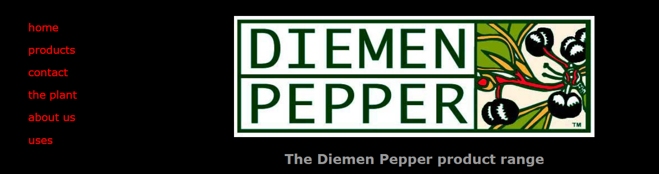

Severity Rating: Major

This flaw significantly impacts the user's ability to navigate the website effectively. As navigation is one of the core functionalities of any website, making the links more visible and accessible is crucial. The flaw can lead to frustration for users, especially those unfamiliar with the website, as it becomes harder to find and interact with the main sections of the site.

Fix Recommendation:

To improve the navigation experience, I recommend changing the text to uppercase and making it bold. This will increase the prominence of the links and make them easier to read. Moving the navigation bar to the top of the page would also align it with more common and user-friendly layouts, ensuring it’s within easy reach without taking up unnecessary space on the left side. These changes would improve both the aesthetics and functionality of the website, providing a better user experience.

**Flaw 2: Inconsistent Image Sizes**

The images on the website are not uniform in size, which leads to a lack of visual coherence. The first image of the Diemen Pepper packaging is significantly larger than the subsequent images of other products like Wattleseed and Lemon Myrtle leaf. This inconsistency in image sizing creates an unprofessional and chaotic look, detracting from the website's overall aesthetic. The mismatch in image sizes can be interpreted as a lack of attention to detail, making the site appear cheap and poorly designed. It gives off an impression of being hastily put together, which is not ideal for a business trying to sell products.

This flaw is especially noticeable when comparing product images to text, which further adds to the feeling that the site was made by a student or someone lacking professional design experience. This visual imbalance disrupts the flow of the page and makes it harder for the user to focus on the content.

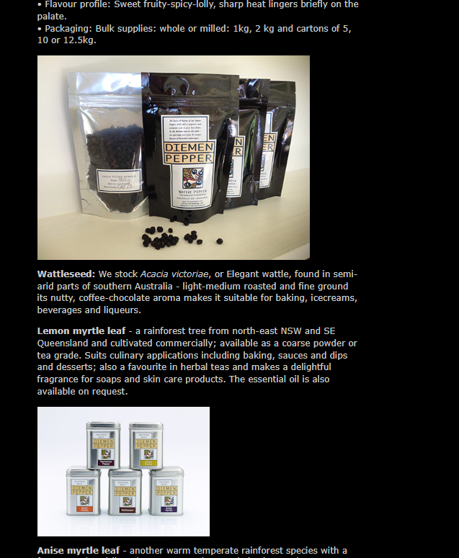

Severity Rating: Major

The inconsistency in image sizes impacts the professionalism of the website significantly. It diminishes the credibility of the brand and distracts users from focusing on the product information. When a website fails to maintain consistency, it can harm the user’s overall perception, which is crucial for businesses in competitive markets.

Fix Recommendation:

I recommend resizing all product images to a consistent size and aligning them properly. This will create a more polished and professional appearance, improving the visual harmony of the website. Additionally, using a grid layout for product images can help ensure that all items are displayed in an orderly, visually appealing manner. Consistency in design elements is key to establishing trust and enhancing the user experience.

**Flaw 3: Misalignment of Icons/Emojis**

The icons/emoji images on this section of the website are not properly aligned. Specifically, one icon is popping out of the indentation, while the other is correctly aligned within the text. This misalignment creates a disorganized and visually unappealing look, which detracts from the overall professionalism of the site. While the icons themselves are not inherently problematic, their improper placement disrupts the flow of the content and affects the readability. Users expect consistent alignment in a website's design, and such small issues can create a sense of sloppiness.

This design flaw, though minor, stands out as it breaks the uniformity and consistency of the page's layout. When these icons are not aligned properly, they may cause users to question the attention to detail in the website's design, which could potentially lower the credibility of the brand.

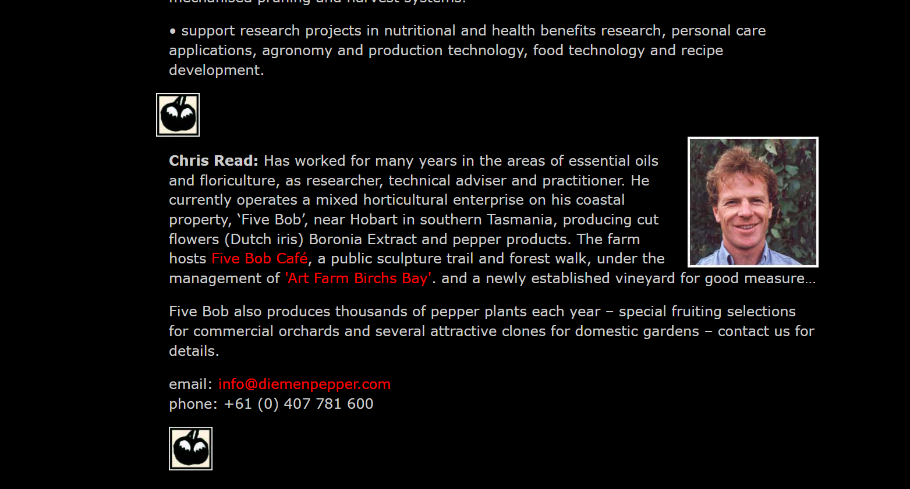

Severity Rating: Minor

Although this flaw does not drastically affect the website’s usability, it can negatively impact the overall visual appeal. Since it is a minor issue, users will likely overlook it unless they are paying close attention to the design. Nevertheless, it still impacts the professionalism of the site, which is crucial for maintaining a strong online presence.

Fix Recommendation:

To resolve this issue, I recommend adjusting the alignment of the icons so that they are all positioned consistently within the indentation. Ensuring uniformity in icon placement will improve the website’s visual appeal and make the content appear more polished. A simple alignment fix can significantly enhance the overall user experience and give a more professional impression.