David Goldfarb

ME 404 Final Project Report

Modeling the Action Potential of Neurons with Stochastic Sodium Channels

**Abstract**

The neuron is the core component of the nervous system and is responsible for transmitting information through the body. Information is transmitted within the body via the action potential, which is an electrical pulse that travels along the cell's axon and triggers further cells. The voltage in a cell is controlled by sodium and potassium channels, which open and close, changing the porosity/conductance of the cell membrane.

Reliable models of action potentials are important for analyzing sensory stimuli and motor control. The goal of this project was to simulate the action potential of a cell with two different methods and to compare the computational efficiency. The first method is a statistical method, which considers the total porosity as an expectation. The second method is a discrete markov model, which assumes a single channel is in a discrete number of states, and adds the conductance of each channel in the open state.

Qualitatively, the statistical model has the shape of an action potential, with reasonable magnitudes for time and voltage. Reducing the time step of the model produced a nearly identical result, validating the assumption that the model was correct.

The stochastic model did not produce reliable results. The shape of the simulated action potential was only correct under some conditions, and did not accurately describe the voltage magnitude or the time duration of the pulse.

The validity of both models is based on real data. Action potentials have been measured reliably by several independent research groups.

**Introduction**

The neuron is the core component of the nervous system and is responsible for transmitting information through the body. A key element of the neuron's function is the action potential, which is an electrical pulse that travels along the cell's axon and triggers further cells. The voltage in a neuron is controlled by chemical- and voltage-controlled ion channels, which control the flow of sodium, potassium, and other ions. When the voltage in a neuron rises high enough to open a majority of the voltage-gated ion channels, ions flood into the cell and an action potential is generated.

The nervous system is extremely relevant in current biomedical research. Neurons are known to control motor functions in the body by sending signals from the brain and spinal cord to muscles and other organs. In patients with spinal injuries, neural commands are issued in the brain, but do not reach limbs or other targets. Neural prosthetics hope to read neural commands from the brain in order to command the function of the arm, leg, or other prosthetic devices.

**Background**

Hodgkin and Huxley wrote the pioneering paper studying action potentials in 1952 and received a Nobel Prize; in it they attempted to write a set of deterministic equations that describe the in-out characteristics of a general neuron based on measurements performed on a giant squid neuron1. Their equations modeled the action potential well in terms of duration, amplitude, and other parameters but further research found that some action potentials erupted spontaneously and the model does not account for that. The model of a neuron that emerged was a stochastic adaptation of Hodgkin and Huxley's original equations, which involves modeling the conductance of an ion channel as a Markov process.

The first paper employing stochastic methods was by Strassberg and Defelice in 19933, and in 1997 Fox used an approximation of Hodgkin and Huxley's equations using Langevin's equation4. Mino, Rubinstien, and White compared the methods of Strassberg and Defelice, Fox, and several other authors in a paper in 20022.

**Objective**

The goal of this project was to employ both stochastic methods and approximation methods to solve Hodgkin and Huxley’s equations, and to compare the runtime of the two methods.

One of the stated goals of the proposal was to ‘animate the time course of the action potential,’ which assumed there would be a spatial dependence in the equation. Hodgkin and Huxley gave a relation for the propagation of an action potential, but there was not enough time to complete this part of the project.

**Methods** The governing equations relating the membrane potential and current is

$$C_{m}\frac{dV_{m}(t)}{dt}+g_{Na}\left[V_{m}\left(t\right)-E_{Na}\right]+g_{K}\left[V_{m}\left(t\right)-E_{K}\right]+g_{L}[V_{m}\left(t\right)-E_{L}]=I_{app}(t)$$

where Iapp(t) is the applied current, Vm and Cm are the transmembrane voltage and capacitance, gNa, gK, andgL are the sodium, potassium, and leakage conductance, and ENa, EK, andEL are the resting potential of sodium ions, potassium ions, and other ions in the cell. Resting potential has been measured experimentally, as has capacitance. Current and voltage are independent and dependent variables, and conductances are dependent on voltage, and are calculated differently for the different models.

Calculating the conductance for the Markov process is done by counting the number of gates in the open state and multiplying by the conductance of a single state. A single sodium channel is modeled as three activating gates with 4 states and one inactivating gate with two states, for a total of 8 states, and a single potassium channel as for activating gates with five states. The two channels are independent, barring voltage. They are illustrated in the figure below.



Figure 1: Sodium state transitions. The first row represents the three activating gates’ states and the closed state of the inactivating gate. The second row represents the three activating gates’ states and the open state of the inactivating gate. m3h1 is the open state.



Figure 2: Potassium state transitions. n4 is the open state.

The transition rates αn, βn, αm, βm, αh, and βh are dependent on membrane voltage, so the current equation and the state transitions are simultaneous equations of voltage.

Calculating the conductance for approximation algorithm uses the ordinary differential equations:

$$\frac{dn(t)}{dt}=α_{n}\left[1-n\left(t\right)\right]-β_{n}n\left(t\right)+g_{n}(t)$$

$$\frac{dm(t)}{dt}=α_{m}\left[1-m\left(t\right)\right]-β_{m}m\left(t\right)+g_{m}(t)$$

$$\frac{dh(t)}{dt}=α_{h}\left[1-h\left(t\right)\right]-β_{h}h\left(t\right)+g_{h}(t)$$

where gm(t) and gh(t) are Gaussian random variables. The conductance is then calculated as (maximum sodium conductance)*m3*h and (maximum potassium conductance)*n4.

Simulation of the models involves applying either a small pulse or two-step input to Iapp(t) in order to trigger an action potential. The output of both models is the number of sodium channels activated and the membrane voltage.

Below is the table of values used.



**Results**

Computational Time

Mino, Rubinstien, and White claimed that the ratio of runtime of the differential model (Fox) and the stochastic model (Strassberg and Defelice) was 1:36, when 1000 gates were simulated. I was unable to verify this claim.

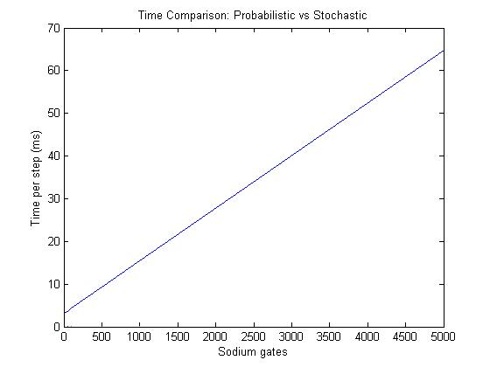

Figure 3: Runtime of the stochastic model vs number of sodium gates simulated.

Figure 3 shows the relationship between runtime and number of sodium gates. The relationship is apparently linear, and is around 15ms at 1000 gates. The runtime of the probabilistic method was about .1ms, and doesn’t depend on the number of gates.

Accuracy

The best measure of the model’s success is how closely it follows what is intended.

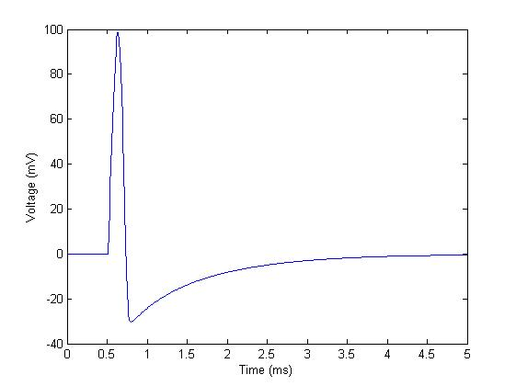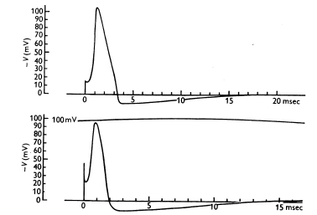

Figure 4, left; figure 5, right

Figures 4 and 5 provide a side-by side comparison of probabilistic simulation and the original model. The time course of figure 4 is much shorter – the pulse duration is only about a .25ms and the refractory period is less than 5ms. The dip in voltage during the refractory period is also too deep, going to nearly -30mV, and the shape is a little too pointed.

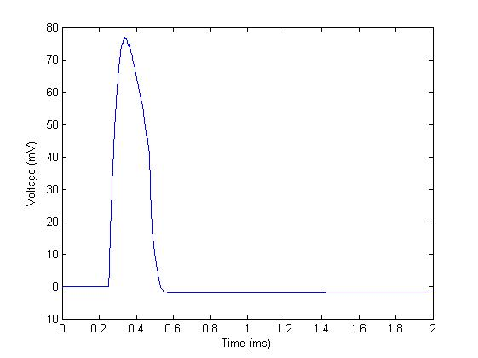

Figure 6: stochastic simulation of the action potential

In contrast to the probabilistic simulation, the stochastic action potential does not have a deep enough refractory period, and drops too quickly in voltage.

**Conclusion**

The results of the runtime simulations are not surprising. Both methods employed 4th order Runge-Kutta approximation. The differential method performed Runge-Kutta on a system of differential equations, and solving a system of ODE’s would have comparable runtime to solving a single ODE. Suppose the differential method performed 100 calculations per step. The stochastic method, for 1000 gates, performs in the thousands, perhaps 5000 or more calculations per step. The differential method is therefore much faster.

Mino, Rubinstien, and White used a model that didn’t consider potassium conductance. It is possible that they made some further simplifications that resulted in speedups.

The failure of the stochastic model was due to time constraints. Unit analysis was not performed. If unit analysis was performed, the model might produce results with reliable magnitudes.

The probabilistic model had some success. An action potential of proper form and reasonable voltage magnitude was achieved. If the goal is to reproduce Hodgkin and Huxley’s voltage equations, it does not make sense to apply a current pulse; one should instead apply the current that H&H achieved at output. Furthermore the effect of voltage threshold was not tested.