Huffman
Introduction:
What is Huffman Coding?
In simple terms, Huffman coding is a method of data compression.
Why compress data? Imagine you want to send a message to a friend far away, and the message contains only four letters: A, B, C, D.
Traditional approach (fixed-length coding): Computers are rigid—they assign codes of the same length to each letter. Eg: A = 00 B = 01 C = 10 D = 11 If you send 100 A's, you have to send 200 bits.
Huffman's approach (variable-length coding): Suppose A appears very frequently, while D is rarely used. Huffman's idea:
Could we assign A a very short code, such as 0? And assign the infrequently used D a longer code, such as 110?
In this way, the total number of bits sent is significantly reduced—that is compression.
Official definition:
Huffman coding is an entropy encoding algorithm used for lossless data compression. It constructs an optimal binary prefix code based on the frequency of occurrence of each character.

Huffman Tree
Official definition:
In computer science, the Hufman tree is also known as the optimal binary tree.
Given a weight as a leaf node, construct a binary tree. If the weighted path length (WPL) of the tree reaches the minimum, it is called a Huffman tree.
Three core components:
To understand the Huffman tree, we must first understand these three concepts:
A. Path Length (Path Length)

The number of "edges" passed from one node of the tree to another.
Intuitive understanding: It's like opening a folder in the file system, clicking two layers of folders from the root directory to see the file, and the path length is 2.
B. Power (Weight)
A value assigned to the leaf node represents its importance or frequency of occurrence.
Intuitive understanding: In a paragraph, the letter "e" appears 100 times, and the letter "z" appears only once. Then the power of "e" is 100, and the power of "z" is 1.
C. Weighted Path Length (WPL - Weighted Path Length)
This is the only indicator to measure the "good or bad" of this tree.
Calculation method: the sum of all leaf nodes (path length from weight to root node).
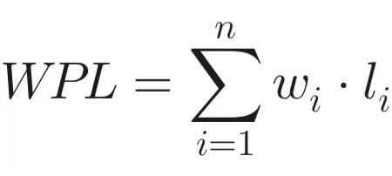
(Among them is the weight and the path length.)
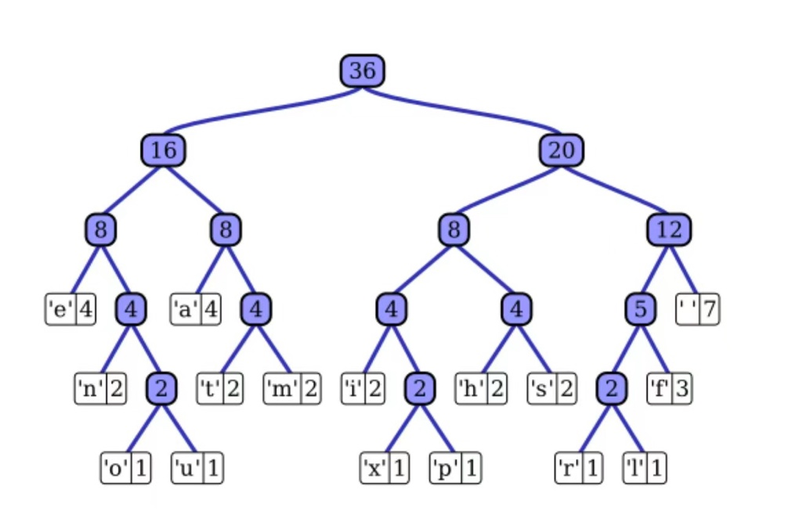
1. Variable Mapping:
In the Huffman tree formula $WPL=\sum_{i=1}^{n}{w_{i}}⋅l_{i}$, the elements in the image correspond as follows:
$w_{i}$ (weight): Corresponds to the number inside each leaf node (white box) in the diagram.
For example: the character 'e' has a weight of $w=4$, and the character 'x' has $w=1$.
$l_{i}$ (path length): Corresponds to the number of layers traversed from the top node (36) to reach that character.
For example: 'e' is located at layer 3 (passing through 16 and 8), so $l=3$.
For example: 'x' is at layer 5, so $l=5$.
$n$: The total number of leaf nodes in the diagram (there are 15 characters in total).
2.Calculation: Substituting into the Formula
You may select several typical branches to illustrate how the formula is computed.
Partial Calculation Demonstration:
For the character 'e': $w×l=4×3=12$
For the character 'space': $w×l=7×3=21$
For the character 'x': $w×l=1×5=5$
Total WPL = 12+12+21+8+8+8+8+8+8+12+5+5+5+5+5+5 = 135
Python Implementation of the Huffman Tree (Based on Image Data)：
