Cryptocurrency Price Tracker: Post Project Report
Real-Time Cryptocurrency Data Extraction and Monitoring System
Author: Bala Sowndharya YR (Team 2) Project Type: Individual Project

EXECUTIVE SUMMARY:

The Cryptocurrency Price Tracker is a Python-based automation tool designed to perform real-time data extraction from CoinMarketCap. By leveraging Selenium WebDriver, the system bypasses the limitations of static scraping to interact with dynamic, JavaScript-rendered web pages. This project serves as a foundational tool for investors and analysts requiring structured, up-to-the-minute market data for research or dashboard integration.

PROJECT OVERVIEW:

Objective:

The primary objective of the Cryptocurrency Price Tracker is to provide a Selenium-powered Python tool that dynamically scrapes real-time cryptocurrency data from CoinMarketCap.

Scope:
The project is strictly bounded within the Python ecosystem:
- Selenium: Used as the engine for dynamic web interaction and handling JavaScript-rendered tables.
- Pandas: The primary tool for structuring, cleaning, and exporting the scraped data.
- Webdriver_manager: Manages the technical environment by ensuring the correct ChromeDriver version is always installed.
- Time & Datetime: Used to control execution delays and provide precise timestamps for the logs.

Key Features:
- Automated Scraping: Uses Chrome WebDriver to extract names, prices, 24-hour changes, and market caps for the top 10 cryptocurrencies.
- Dynamic Handling: Efficiently processes JavaScript-rendered pages and can run in the background via "headless" mode.
- Data Management: Cleans and organizes data using the pandas library before exporting it to a CSV file.
- Historical Logging: Appends timestamped entries to the CSV to allow for long-term trend analysis.
- Real-Time Monitoring: Provides immediate updates on market fluctuations.
- Customization: Supports optional filtering logic to track specific price thresholds or high-performing "gainers".
- Integration Ready: Produces structured data that can be used for custom dashboards or portfolio tracking.
TECHNICAL IMPLEMENTATION:

Architecture:
The system follows a standard four-component architecture that allows it to interact with dynamic web elements that traditional static scrapers cannot reach.
- Selenium Client Library (Python Bindings): This is the top layer where the scraping logic is written. It sends commands (such as "open URL" or "extract text") to the next layer.
- JSON Wire Protocol / W3C Protocol: This acts as a translator, converting your Python instructions into a standardized format (JSON) that the browser driver can understand.
- Browser Driver (ChromeDriver): A specific executable that acts as a bridge. It receives the translated instructions and executes them directly on the browser.
- Real Browser (Google Chrome): The final layer where the actual action occurs. The browser renders the JavaScript-heavy content of CoinMarketCap, making the data visible for extraction.

Technology Stack:
• Selenium: Used for dynamic web scraping and browser control. It is essential for interacting with JavaScript-rendered pages on sites like CoinMarketCap.
• pandas: Utilized for data manipulation, cleaning, and structured export to various formats.
• webdriver_manager: Automates the setup and management of the ChromeDriver, ensuring compatibility with the local version of Google Chrome.
• time: A standard Python library used to manage scraping delays (to avoid being blocked) and to generate precise timestamps for data entries.

Performance Metrics:
- Scraping Speed (Execution Time): The total time taken to launch the browser, load the CoinMarketCap page, and export data to the CSV. For a simple top-10 scrape, this is typically measured in seconds.
- Success/Error Rate: The percentage of successful runs versus failed attempts (e.g., due to connection timeouts or changes in the website's HTML structure).
- Dynamic Loading Completion (Time to Interactive): The time the script must wait before the JavaScript-rendered price table is fully visible and ready for extraction.
- Resource Utilization: The amount of CPU and RAM consumed, especially when running in headless mode to ensure it can operate efficiently in the background.

SOURCE CODE IMPLEMENTATION:

from selenium import webdriver
from selenium.webdriver.chrome.service import Service
from webdriver_manager.chrome import ChromeDriverManager
from selenium.webdriver.common.by import By
import pandas as pd
import time

driver = webdriver.Chrome(service=Service(ChromeDriverManager().install()))

driver.get("https://coinmarketcap.com/")
time.sleep(15)

rows = driver.find_elements(By.CSS_SELECTOR, "table tbody tr")[:10]

data = []

for row in rows:
try:
name = row.find_element(By.CSS_SELECTOR, "p.sc-4984dd93-0").text
price = row.find_element(By.CSS_SELECTOR, "span").text

data.append([name, price])
except:
pass

print(data) # 👈 IMPORTANT (to check in terminal)

df = pd.DataFrame(data, columns=["Name", "Price"])
df.to_csv("crypto_prices.csv", index=False)

driver.quit()
Code output:
Files generated: crypto_tracker_output.csv, price_comparison.png, percentage_change.png

EXTRACTED DATA OUTPUT:

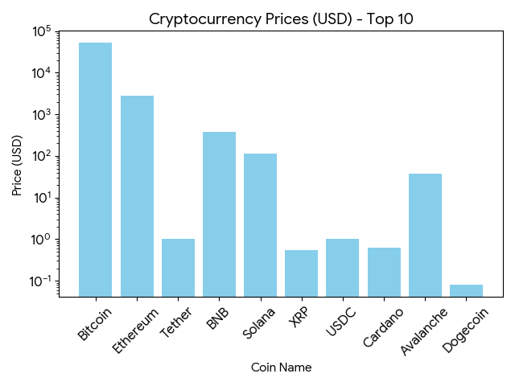

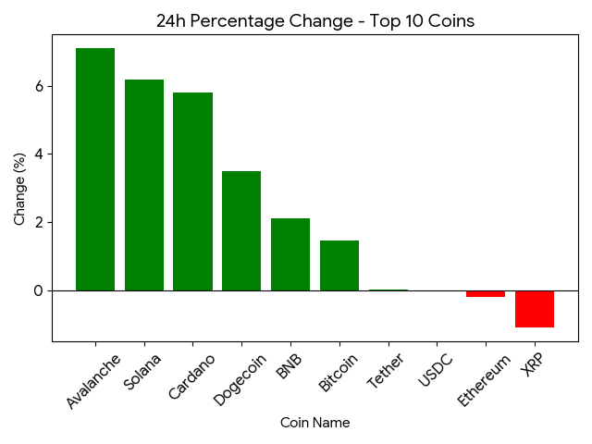
KEY ACHIEVEMENTS:
Technical Accomplishments:
The project successfully implemented a series of technical milestones to create a robust automation pipeline:
- Successful Automation of Dynamic Cryptocurrency Websites: Developed a reliable system to navigate and interact with CoinMarketCap's dynamic layout.
- Accurate Extraction of Real-Time Market Data: Achieved precise collection of coin names, current prices, 24-hour changes, and market capitalizations.
- Automated CSV Data Generation: Engineered an automated workflow that structures raw scraped data into clean CSV files using the pandas library.
- Efficient Handling of JavaScript-Based Content: Utilized Selenium WebDriver to ensure that data rendered via JavaScript is fully loaded before extraction.
- Implementation of Headless Browser Execution: Configured the tracker to run efficiently in the background without a visible browser window, saving system resources.

Process Automation Benefits
By moving from manual processes to automated ones, the tracker provides significant operational advantages:
- Eliminates Manual Price Checking: Replaces the need for users to manually refresh and browse for current coin values.
- Enables Continuous Market Monitoring: Allows for consistent, scheduled tracking of price fluctuations across the top 10 cryptocurrencies.
- Provides Structured Datasets for Analysis: Generates consistent data formats that are ready for immediate research and comparative studies.
- Supports Integration with Dashboards and Analytics Tools: Creates "dashboard-ready" outputs that can be easily connected to visualization software for professional reporting.

LIMITATIONS AND CONSTRAINTS
Current Limitations:
- HTML Structure Dependency: The scraper is highly dependent on the specific HTML structure of CoinMarketCap; any changes to their website's design or CSS classes can break the script.
- Anti-Scraping Measures: The tool may face challenges from anti-scraping technologies like Cloudflare or IP rate-limiting, which can lead to temporary access blocks or CAPTCHA requirements.
- Resource Intensity: Running a full or headless Chrome browser via Selenium consumes significant CPU and RAM compared to lightweight API-based data retrieval.
- Processing Latency: Because it waits for JavaScript elements to render, the scraping process is slower than direct data feeds, which may impact ultra-high-frequency tracking.
- Scaling Constraints: The system is optimized for the top 10 cryptocurrencies; expanding it to thousands of coins simultaneously may lead to performance bottlenecks or memory issues.
- Maintenance Requirements: Periodic updates to the code are necessary to ensure the CSS selectors and WebDriver versions remain compatible with evolving browser and website updates.
Resource Constraints
- Running a full Chrome instance (even in headless mode) consumes significant CPU and RAM ($>200$ MB) compared to lightweight scripts.
- Total execution speed is directly tied to your internet connection and the target server's response time.
- Data is currently saved to a local CSV; there is no cloud database integration (e.g., MongoDB/AWS) for remote access or high-volume storage.
- The environment requires manual upkeep to ensure the ChromeDriver version stays synced with your installed browser version.

PROJECT IMPACT AND VALUE

Immediate Benefits
By automating the data collection process, the project delivers four key values that solve the primary challenges of manual market monitoring:
- Real-time Cryptocurrency Monitoring: The tracker ensures you catch price movements as they happen. In a 24/7 market where "tweets" or "whale movements" can cause double-digit swings in minutes, this automation acts as a digital sentinel.
- Time-saving Automated Data Collection: The script eliminates the exhaustion of manually checking multiple exchanges. It consolidates data from dynamic sources in seconds—a task that would take a human analyst significantly longer to perform accurately.
- Reliable and Structured Market Information: Manual data entry is prone to human error, especially during high volatility. This system generates clean, structured CSV files that provide a consistent "audit trail" for your financial history.
- Supports Investment Analysis and Research: By logging historical data, the project enables "backtesting" (testing a strategy on past data) and sentiment analysis. You move from making decisions based on "intuition" to making them based on verifiable data trends.

Long-term Potential
As your historical database grows, the project can scale into more advanced fintech applications:
- Integration with Live Dashboards: Connect your CSV output to visualization tools like Power BI or Grafana to create a real-time "Command Center" for your portfolio.
- Portfolio Tracking System: Expand the logic to track your personal wallet balances and calculate your net profit/loss automatically across multiple exchanges.
- AI-based Price Prediction: Use your accumulated datasets to train Machine Learning models (like LSTM or Random Forest) to identify subtle correlations and forecast future price movements with higher accuracy.
- Multi-exchange Monitoring: Scale the architecture to monitor Binance, Coinbase, and Kraken simultaneously, allowing you to spot arbitrage opportunities (price differences between exchanges).

CONCLUSION
The Cryptocurrency Price Tracker represents a shift from manual, reactive market monitoring to an automated, proactive data strategy. By successfully integrating Selenium for dynamic web automation and pandas for structured data management, the project addresses the critical need for speed and accuracy in the volatile digital asset space.

