**Network address = 192.168.40.0**

No. of Subnet = no. of departments = 2

2^n = no. of subnets 🡪 2^n = 2 🡪 **n=1**

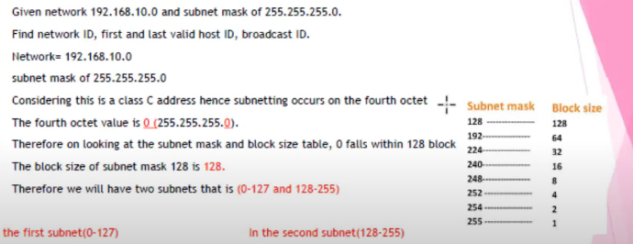

**N=1**

255.255.255.255

1111 1111. 1111 1111. 1111 1111. 1000 0000

255.255.255.128🡪 SUBNET MASK

*1st Subnet*

Subnet mask = 255.255.255.128

Network ID = **192.168.40.0**

Range of Valid Host = 192.168.40.1 to 192.168.40.126

Broadcast ID = 192.168.40.127

*2st Subnet*

Subnet mask = 255.255.255.128

Network ID = **192.168.40.128**

Range of Valid Host = 192.168.40.129 to 192.168.40.254

Broadcast ID = 192.168.40.255