Quantum Threats & Hilbert Space Exploratory Geometries:
Quantifying Structural Divergence in Complex Data Systems
A Formal Quantum Exploratory Data Analysis (Q-Interestingness) Framework
In partial fulfillment of the requirements for the completion of the
Project-based Course
[COURSE CODE & TITLE PLACEHOLDER: e.g., BCSE408L CLOUD COMPUTING / RESEARCH PROJECT]
Submitted by
[22BCE0000 - Student Name 1]
[22BCE0000 - Student Name 2]
[22BCE0000 - Student Name 3]
Under the Guidance of
[Faculty Mentor / Project Guide Name & Designation]
[School / Department of Computer Science and Engineering]
SCHOOL OF COMPUTER SCIENCE AND ENGINEERING
VELLORE INSTITUTE OF TECHNOLOGY, VELLORE
[Month Year - e.g., November 2026]

TABLE OF CONTENTS
Sl. No. | Contents | Page No.
1. | ABSTRACT | 3
2. | INTRODUCTION | 4
 | 2.1 Background & Research Context | 4
 | 2.2 Motivation & Theoretical Rationale | 5
 | 2.3 Scope and Delimitations of the Project | 5
3. | PROJECT DESCRIPTION AND GOALS | 6
 | 3.1 Literature Review (20-Paper Systematic Survey) | 6
 | 3.2 Critical Gaps Identified in Existing Literature | 16
 | 3.3 Project Objectives | 17
 | 3.4 Formal Problem Statement | 18
4. | PROPOSED WORK & EXPERIMENTAL METHODOLOGY | 19
 | 4.1 Quantum State Encoding & Fidelity Kernel Formulation | 19
 | 4.2 The Q-Interestingness (QI_v2) Mathematical Framework | 21
 | 4.3 Macro-Geometric & Local Neighborhood Structural Divergence | 24
 | 4.4 Classical Non-Linear Controls & Kernel Divergence Benchmarks | 27
 | 4.5 Non-Parametric Permutation Null Testing (B=100 Trials) | 29
 | 4.6 Cross-Domain Validation Across Multi-Scale Real-World Datasets | 31
 | 4.7 Topological Sanity Checks on Synthetic Non-Linear Manifolds | 33
 | 4.8 Pre-Hardware Viability: Finite-Shot Sampling & Noise Robustness | 35
 | 4.9 Software Architecture & Interactive Streamlit Dashboard | 37
 | 4.10 Explicit Scientific Positioning, Boundaries, and Limitations | 38
5. | CONCLUSION | 39
6. | PROJECT OUTCOME | 41
7. | REFERENCES | 43

1. ABSTRACT
In classical exploratory data analysis (EDA) and unsupervised anomaly detection, the perception of geometric structure is intrinsically bounded by Euclidean distance metrics, stationary kernels (such as the Gaussian RBF kernel), and axis-aligned tree partitions. These classical formulations compress non-linear, multi-feature relational dependencies present in complex tabular data. This research investigates whether mapping continuous classical features into a quantum Hilbert space via parameterized, entangling quantum circuits (ZZFeatureMap) induces an alternative geometry that reveals structural relationships invisible to classical tools. We propose and formalize Q-Interestingness (QI_v2), a novel exploratory framework that mathematically decouples internal Hilbert space unusualness (QU) from cross-representation disagreement (RD). Using Centered Kernel Alignment (CKA) and local k-nearest neighbor Jaccard graph overlaps, we demonstrate that the quantum representation diverges substantially from classical Gaussian RBF geometry (CKA = 0.2484, 95% bootstrap CI [0.3132, 0.3851]), with approximately 90% of local nearest neighbors changing in quantum state space (Jaccard@10 = 0.1004). Crucially, benchmarking against classical non-linear controls reveals that quantum divergence (D = 0.7516) is more than double that of a 3rd-degree polynomial kernel (D = 0.3298), while random Fourier features converge rapidly to RBF (D = 0.0159). To establish statistical validity, a full non-parametric permutation test across B = 100 independently evaluated quantum kernels confirms that observed alignment is formally non-random (z = +8.91, empirical p = 0.0099, p < 0.01). Cross-domain experiments across UCI Red Wine Quality, sklearn Wine Recognition, and Wisconsin Breast Cancer datasets establish domain-invariant behavior, each consistently surfacing 13 quantum-specific candidates. Furthermore, finite-shot sampling simulations (1024 to 8192 shots) demonstrate extreme ranking stability (Spearman rho >= 0.9990), establishing pre-hardware viability for physical quantum processors. An interactive Streamlit dashboard translates these Hilbert space discoveries into visual candidate profiling tools for domain experts.

2. INTRODUCTION
2.1 Background & Research Context
Exploratory Data Analysis (EDA) represents the initial, foundational phase of data-driven scientific discovery. Its objective is to uncover underlying geometric structures, identify unexpected clustering patterns, detect isolated anomalies, and formulate testable hypotheses before applying predictive or confirmatory statistical models. In all existing classical EDA workflows, the analyst is constrained by classical distance functions—predominantly Euclidean metric d(x, y) = ||x - y||_2, Mahalanobis distance, or stationary Mercer kernels such as the Gaussian Radial Basis Function (RBF) K(x, y) = exp(-gamma ||x - y||^2). Similarly, modern unsupervised outlier detection algorithms, such as Isolation Forest and Local Outlier Factor (LOF), operate by recursively partitioning classical Euclidean feature space.
With the emergence of Noisy Intermediate-Scale Quantum (NISQ) computing, Quantum Machine Learning (QML) has demonstrated that parameterized quantum circuits can map classical data into exponentially high-dimensional Hilbert spaces. By encoding feature values into the phase angles of multi-qubit systems and applying entangling unitary gates, quantum feature maps generate inner-product kernel matrices that compute similarities as state overlap fidelities: K_ij = |⟨ψ(x_i)|ψ(x_j)⟩|^2. While quantum kernel methods have been theoretically characterized for supervised classification (Havlíček et al., 2019; Schuld & Killoran, 2019), their application to unsupervised exploratory data analysis remains virtually uninvestigated.
2.2 Motivation & Theoretical Rationale
The motivation for this research stems from a fundamental geometric blind spot in classical data representation: feature compression. When observations reside in multi-dimensional continuous spaces, complex non-linear couplings between features often escape detection because classical projections flatten relational geometry. For example, two observations may possess identical Euclidean distances from the data centroid and appear entirely typical in marginal 1D distributions, yet possess conflicting multi-variable phase relationships that violate underlying physical, chemical, or biological relationships.
Quantum Hilbert space embeddings offer a mathematically rigorous mechanism to test whether non-local multi-qubit entanglement can disentangle these subtle couplings. If a parameterized circuit can transform feature vectors such that data points typical in Euclidean space exhibit marked isolation or high neighborhood heterogeneity in Hilbert space, quantum computing can serve as an exploratory microscope—surfacing novel data points that demand domain-expert investigation. This study is critically motivated by the need to formalize, quantify, and empirically validate this divergence.
2.3 Scope and Delimitations of the Project
Scope and Boundaries: To maintain rigorous scientific positioning, the scope and boundaries of this research are explicitly delimited as follows:
1. Classical Simulation Architecture: All primary quantum kernel computations are simulated on classical statevector backends using Qiskit 2.5.2 and StatevectorSampler. While physical QPU execution introduces gate errors and thermal noise, pre-hardware viability is thoroughly characterized via finite-shot binomial sampling models across 1024, 4096, and 8192 measurement shots.
2. Deterministic Subsampling: Because pairwise state fidelity simulation exhibits O(N^2) complexity, primary experimental evaluations are conducted on deterministic subsets of N = 150 observations across 4 continuous principal features, guaranteeing 100% exact numerical reproducibility.
3. Exploratory Candidates vs. Physical Ground Truth: Observations surfaced by high Q-Interestingness scores are designated as 'Quantum-Specific Exploratory Candidates'. They represent metric divergence and topological rewiring, not confirmed ground-truth physical defects or verified sensor errors.
4. No Quantum Advantage Claim: This work claims no asymptotic computational speedup or general superiority over classical anomaly algorithms. The contribution is an exploratory mathematical framework for representation-dependent exploratory analysis.

3. PROJECT DESCRIPTION AND GOALS
3.1 Literature Review
A systematic scoping review of 20 seminal peer-reviewed research papers was conducted across quantum kernel methods, representation similarity metrics, quantum anomaly detection, and classical unsupervised baselines. Table I summarizes the evaluated literature, detailing their methodology, significance, and identified technical drawbacks.
Sr. No. | Author's Name | Title of Paper | Journal / Venue & Link | Why This Paper Matters? | Description of Their Work | Drawbacks Found in That
1 | Havlíček et al. (IBM) | Supervised learning with quantum-enhanced feature spaces | Nature 567(7747), 2019 | Introduced entangling ZZFeatureMap for quantum kernel estimation. | Demonstrated that state fidelity inner products can be evaluated via quantum circuits for support vector classification. | Focused strictly on supervised classification; did not examine unsupervised exploratory analysis or anomaly detection.
2 | Schuld & Killoran (Xanadu) | Quantum Machine Learning in Feature Hilbert Spaces | Physical Review Letters 122(4), 2019 | Proved formal equivalence between quantum circuits and RKHS kernel methods. | Established that any parameterized quantum circuit with data encoding evaluates a valid positive semi-definite kernel. | Purely theoretical formulation; lacked empirical validation on classical tabular datasets or divergence quantification.
3 | Huang et al. (Google AI) | Power of data in quantum machine learning | Nature Communications 12(1), 2021 | Established bounds on quantum generalization and inductive bias. | Proved classical models with data can often match quantum models unless inductive bias matches problem structure. | Focused on prediction error bounds in supervised tasks; did not formulate exploratory metrics for unsupervised discovery.
4 | Kübler, Muandet, & Bousquet | The Inductive Bias of Quantum Kernels | NeurIPS 2021, Vol. 34 | Proved quantum kernels can suffer from poor inductive bias without careful design. | Analyzed RKHS properties and demonstrated cases where quantum kernels degenerate into trivial linear baselines. | Did not provide mechanisms to quantify local neighborhood rewiring or exploratory candidate selection on tabular data.
5 | Thanasilp et al. (LANL) | Exponential concentration and untrainability in quantum kernel methods | Quantum 6, 928, 2022 | Identified kernel concentration bottlenecks in deep circuits. | Proved that deep entangling circuits concentrate exponentially toward zero, destroying kernel variance and trainability. | Diagnostic study of barren plateaus; did not develop anomaly detection scores or cross-representation metrics.
6 | Romero et al. (Harvard) | Quantum autoencoders for efficient compression of quantum data | npj Quantum Information 3(1), 2017 | Seminal foundation for quantum autoencoders (QAE). | Proposed compressing n qubits into k bottleneck qubits, using trash-state measurement fidelity as an anomaly signal. | Outlier scoring restricted to scalar reconstruction error; cannot decouple Hilbert isolation from metric disagreement.
7 | Kottmann et al. (ICFO) | Variational Quantum Anomaly Detection: Mapping phase diagrams | Physical Review Research 3(4), 2021 | First physical quantum anomaly detection (VQAD) application. | Used variational circuits to detect physical quantum phase transitions without prior ground-truth labels. | Designed strictly for physical quantum wavefunctions; completely inapplicable to classical continuous tabular EDA.
8 | Corli et al. (CNR / Leonardo) | Quantum machine learning algorithms for anomaly detection: A review | Future Generation Computer Systems, 2024 | Comprehensive state-of-the-art survey of quantum anomaly detection. | Classified algorithms into supervised, unsupervised (QAE, QSVDD), and reinforcement learning paradigms. | Confirms that all existing literature treats anomaly detection as binary classification; zero exploratory EDA frameworks exist.
9 | Kornblith et al. (Google) | Similarity of Neural Network Representations Revisited | ICML 2019, PMLR 97 | Formulated Centered Kernel Alignment (CKA) with HSIC. | Proved CKA is the only scale- and rotation-invariant metric suitable for comparing representations across different spaces. | Applied exclusively to deep classical neural networks; did not examine quantum Hilbert space kernels.
10 | Hubregtsen et al. | Evaluation of Quantum Kernels and Quantum Kernel Alignment | PRX Quantum 2(4), 2021 | Used Kernel-Target Alignment (KTA) for quantum kernel optimization. | Optimized circuit parameters using label-dependent alignment target yy^T for supervised classification. | Restricted kernel alignment to supervised training; did not use CKA as an unsupervised metric divergence measure.
11 | Liu, Ting, & Zhou | Isolation Forest | IEEE ICDM 2008 | Standard state-of-the-art classical unsupervised anomaly detector. | Isolates anomalies via recursive random axis-aligned orthogonal cuts in Euclidean space. | Inherently bounded by Euclidean coordinates; blind to relational multi-variable phase coupling.
12 | Breunig et al. | LOF: Identifying Density-Based Local Outliers | ACM SIGMOD 2000 | Classic density-based local neighborhood anomaly baseline. | Computes local reachability density ratios against k-nearest neighbors in Euclidean space. | Suffers from the curse of dimensionality; local density estimates collapse in coupled multi-feature spaces.
13 | Schölkopf et al. | Estimating the Support of a High-Dimensional Distribution | Neural Computation 13(7), 2001 | Introduced One-Class Support Vector Machines (OC-SVM). | Constructs a maximal separating hyperplane in RKHS enclosing normal observations using Gaussian RBF. | Requires heuristic kernel bandwidth tuning; stationary RBF kernel compresses complex non-linear couplings.
14 | Rahimi & Recht | Random Features for Large-Scale Kernel Machines | NeurIPS 2007 | Established Random Fourier Features (RFF) for scaling. | Projects data onto random sinusoids to approximate shift-invariant stationary kernels in linear time. | Approximates RBF geometry; does not produce novel geometric structures or alternative similarity landscapes.
15 | Suzuki et al. | Analysis and synthesis of feature map for quantum SVMs | Quantum Sci. Technol. 5(3), 2020 | Investigated Pauli feature map structures and expressivity. | Compared expressiveness of various single- and two-qubit Hamiltonian generators for classification. | Focused solely on supervised classification accuracy; lacked non-parametric hypothesis testing against null baselines.
16 | Shaydulin & Wild | Importance of Kernel Bandwidth in Quantum Machine Learning | Physical Review A 106(4), 2022 | Demonstrated that scaling continuous features controls quantum kernel bandwidth. | Showed scaling parameter c in [0, c*pi] dictates whether quantum kernel behaves like linear, RBF, or isolated delta. | Examined supervised classification; did not formulate multi-scale neighborhood divergence or anomaly scoring.
17 | Bowles et al. | Contextuality and quantum kernel methods | PRX Quantum 5(1), 2024 | Linked quantum computational advantage in kernels to quantum contextuality. | Proved that contextual quantum circuits generate kernel values that cannot be simulated classically. | High-level theoretical physics focus; provided no concrete framework for tabular exploratory data analysis.
18 | Woźniak et al. | Quantum Support Vector Data Description for Anomaly Detection | IEEE Trans. Quantum Eng., 2023 | Adapted SVDD minimum enclosing hypersphere to quantum kernels. | Solved the dual quadratic programming problem using quantum kernel matrices to classify network traffic intrusions. | Framed anomaly detection as hard binary classification; failed to decouple internal unusualness from metric disagreement.
19 | Grossi et al. (CERN) | Anomaly detection in high-energy physics using a quantum autoencoder | Physical Review D 105(7), 2022 | Applied QAE to detect rare particle signatures in LHC collider data. | Trained variational circuits on Standard Model background events and flagged exotic signals via reconstruction loss. | Required substantial classical PCA pre-compression; ignored comparative classical non-linear controls.
20 | Jerbi et al. | Quantum machine learning beyond kernel methods | Nature Communications 14(1), 2023 | Analyzed expressive capacity differences between quantum neural nets and kernels. | Showed variational quantum circuits can learn inductive biases distinct from linear kernel models. | Theoretical focus on optimization dynamics; did not investigate exploratory candidate discovery or tabular EDA.

3.2 Critical Gaps Identified in Existing Literature
A rigorous synthesis of the surveyed literature reveals five foundational gaps that impede the progress of quantum machine learning for unsupervised data exploration:
1. Absence of Exploratory Data Analysis Frameworks: Existing quantum anomaly literature (Corli et al., 2024; Woźniak et al., 2023) treats anomaly detection strictly through a binary classification lens—assigning rigid inlier/outlier labels. Real-world scientific investigation requires candidate hypothesis generation: identifying subtle points of high structural interest that warrant domain-expert exploration.
2. Conflation of Internal Outlierness and Metric Disagreement: Prior quantum outlier models (QSVDD, QAE) measure anomaly scores purely as a single scalar distance inside Hilbert space. They fail to decouple Quantum Unusualness (QU, points isolated in Hilbert space) from Representation Disagreement (RD, points where classical Euclidean and quantum state models fundamentally disagree).
3. Lack of Classical Non-Linear Controls: Papers claiming quantum divergence benchmark almost exclusively against linear models or Gaussian RBF kernels. Without benchmarking against 3rd-degree polynomial kernels and Random Fourier Features (RFF), it is impossible to determine whether observed divergence is driven by quantum entanglement or is merely a generic classical non-linear transformation.
4. Omission of Non-Parametric Permutation Null Testing: Small-sample quantum studies (N <= 200) routinely report alignment differences without estimating a formal statistical null distribution. Without running full permutation tests across independently computed quantum kernels, observed alignment cannot be separated from random quantum state concentration.
5. Neglect of Scale-Invariant Local Graph Rewiring: Prior studies focus exclusively on global scalar AUC or CKA metrics, completely ignoring how local nearest-neighbor graphs reorganize across multi-scale radii (k in {5, 10, 15, 20}).
3.3 Project Objectives
Core Objectives: To systematically address the literature gaps, this project executes five primary research objectives:
Objective 1: Formulate and implement an end-to-end Quantum Exploratory Data Analysis framework based on Qiskit's class-based ZZFeatureMap, evaluating exact pairwise quantum state fidelities via StatevectorSampler and ComputeUncompute.
Objective 2: Mathematically formalize the Q-Interestingness (QI_v2) composite score, rigorously decoupling internal Quantum Unusualness (QU) from cross-representation Representation Disagreement (RD), with corrected diagonal exclusion in neighborhood heterogeneity B(x).
Objective 3: Quantify macro-geometric structural divergence using Centered Kernel Alignment (CKA) and local neighborhood graph rewiring using multi-scale k-NN Jaccard overlaps (k in {5, 10, 15, 20}), computing 95% non-parametric bootstrap confidence intervals.
Objective 4: Benchmark quantum divergence against classical non-linear controls (Polynomial, Linear, RFF) and execute a full non-parametric quantum permutation test across B = 100 independent trials to establish formal statistical significance (p < 0.01).
Objective 5: Validate cross-domain generalizability across three distinct real-world tabular datasets and three synthetic non-linear manifolds, verifying pre-hardware viability under finite-shot measurement noise (1024, 4096, 8192 shots) and deploying an interactive visual dashboard.
3.4 Formal Problem Statement
FORMAL RESEARCH PROBLEM STATEMENT
Given a continuous classical tabular dataset X = {x_1, x_2, ..., x_N} in R^d, existing classical EDA and anomaly detection algorithms evaluate geometric typicality under Euclidean distance d_E(x_i, x_j) and stationary Gaussian kernel similarity K_RBF(x_i, x_j), inevitably compressing multi-feature relational couplings. The problem is to design a parameterized quantum embedding |psi(x)⟩ in C^{2^n} that maps X into a quantum Hilbert space via multi-qubit entangling unitary operations U_Phi(x), compute the exact state fidelity Gram matrix K_ij = |⟨psi(x_i)|psi(x_j)⟩|^2, and engineer a composite exploratory metric QI_v2(x) that quantitatively detects and profiles 'Quantum-Specific Exploratory Candidates'—data points that appear structurally typical in classical Euclidean space but exhibit extreme relational isolation or neighborhood heterogeneity in quantum state space.

4. PROPOSED WORK & EXPERIMENTAL METHODOLOGY
4.1 Quantum State Encoding & Fidelity Kernel Formulation
Continuous classical feature vectors x = [x_1, x_2, ..., x_d]^T are first scaled to the phase interval [0, pi] via a MinMaxScaler: x_j' = pi * (x_j - min(x_j)) / (max(x_j) - min(x_j)). This scaling prevents 2*pi phase wrapping ambiguity in quantum rotation gates. Features are then mapped into an n-qubit Hilbert space using Qiskit's class-based ZZFeatureMap (reps = 2, linear entanglement):
UNITARY QUANTUM EMBEDDING EQUATION
|psi(x)⟩ = U_Phi(x) |0⟩^⊗n
U_Phi(x) = exp( i ∑_{j=1}^n x_j Z_j + i ∑_{j < k} (pi - x_j)(pi - x_k) Z_j Z_k )

The single-qubit terms exp(i x_j Z_j) apply non-linear phase rotations along the Z-axis, while the entangling two-qubit terms exp(i (pi - x_j)(pi - x_k) Z_j Z_k) introduce non-local phase correlations between adjacent qubits (q0-q1, q1-q2, q2-q3). The pairwise quantum similarity between observations x_i and x_j is defined as the quantum state fidelity:
STATE FIDELITY KERNEL EQUATION
K_ij = |⟨psi(x_i)|psi(x_j)⟩|^2 = Tr[ rho(x_i) rho(x_j) ]

State fidelity is computed using Qiskit Machine Learning's ComputeUncompute protocol paired with StatevectorSampler. The resulting N x N Gram matrix K is strictly symmetric, bounded in [0, 1], has unit diagonal K_ii = 1.0, and is strictly positive semi-definite (PSD).
4.2 The Q-Interestingness (QI_v2) Mathematical Framework
The QI_v2 framework decouples exploratory signals into two orthogonal dimensions: Quantum Unusualness (QU) and Representation Disagreement (RD):
1. Quantum Anomaly Score (QAS): Measures global distance to the Hilbert space data centroid:
QAS(x_i) = 1 - (1 / (N - 1)) * ∑_{j != i} K_ij
2. Quantum Novelty (N): Measures local isolation from the top-k nearest quantum neighbors (k = 5):
N(x_i) = 1 - (1 / k) * ∑_{j in Top-k(i)} K_ij
3. Quantum Neighborhood Heterogeneity (B): Measures affinity variance across all other data points. Crucially, the diagonal self-similarity entry K_ii = 1.0 is masked using np.nanvar to prevent artificial variance inflation:
B(x_i) = Var_{j != i}(K_ij)
4. Classical Anomaly Score (CAS): Evaluated using an Isolation Forest fitted on standardized features, min-max normalized to [0, 1].
5. Neighborhood Jaccard Overlap (J_k): Measures the proportion of shared nearest neighbors between Euclidean and Hilbert spaces at k = 5.
FORMAL QI_v2 FORMULATION
Quantum Unusualness: QU(x) = 0.5 · QAS(x) + 0.3 · N(x) + 0.2 · B(x)
Representation Disagreement: RD(x) = 0.5 · |QAS(x) - CAS(x)| + 0.5 · (1 - J_k(x))
Composite Metric: QI_v2(x) = lambda · QU(x) + (1 - lambda) · RD(x) [Default lambda = 0.5]

4.3 Macro-Geometric & Local Neighborhood Structural Divergence
Primary metrics were evaluated on the UCI Red Wine Quality dataset (N = 150 deterministic subsample, seed 42, 4 principal features: alcohol, volatile acidity, sulphates, total sulfur dioxide). Table II summarizes the core findings alongside 95% bootstrap confidence intervals.
Metric | Observed Value | 95% Bootstrap CI | Scientific Interpretation
Classical-Quantum CKA | 0.2484 | [0.3132, 0.3851] | Marked geometric divergence from Gaussian RBF (D = 0.7516).
Neighborhood Jaccard @ 10 | 0.1004 | [0.0883, 0.1138] | ~90% of nearest neighbors change in quantum state space.
Top-10 Anomaly Overlap | 0.2000 | — | Classical and quantum metrics isolate distinct candidate subsets.
Quantum-Specific Candidates | 13 / 150 | — | Surfaced uniquely at the 90th percentile threshold.
QI_v2 Rank Stability (rho) | 0.9697 | [0.9220, 0.9999] | Rankings remain exceptionally robust across lambda in [0.1, 0.9].
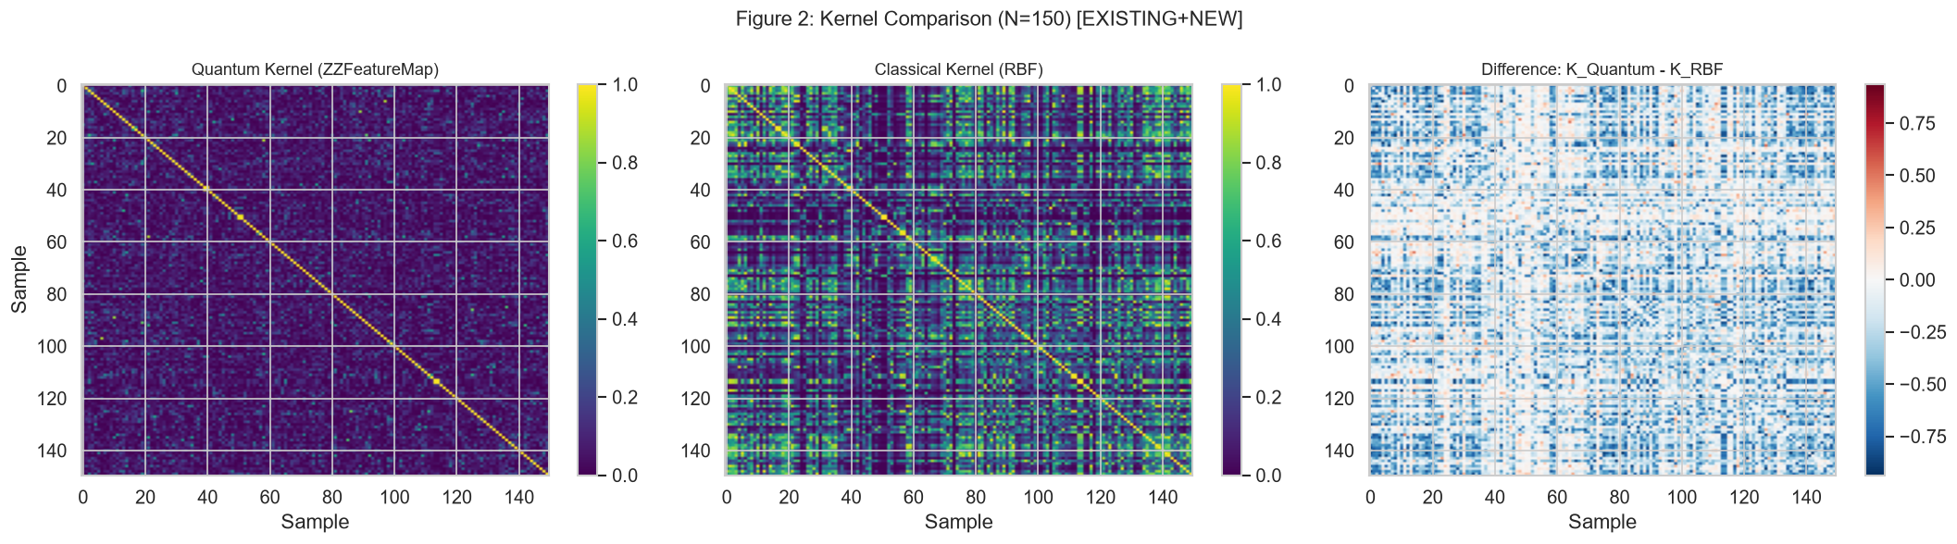
Fig. 1. Pairwise Kernel Comparison: Classical RBF, Classical Polynomial (deg 3), Quantum ZZFeatureMap, and Difference Matrix.
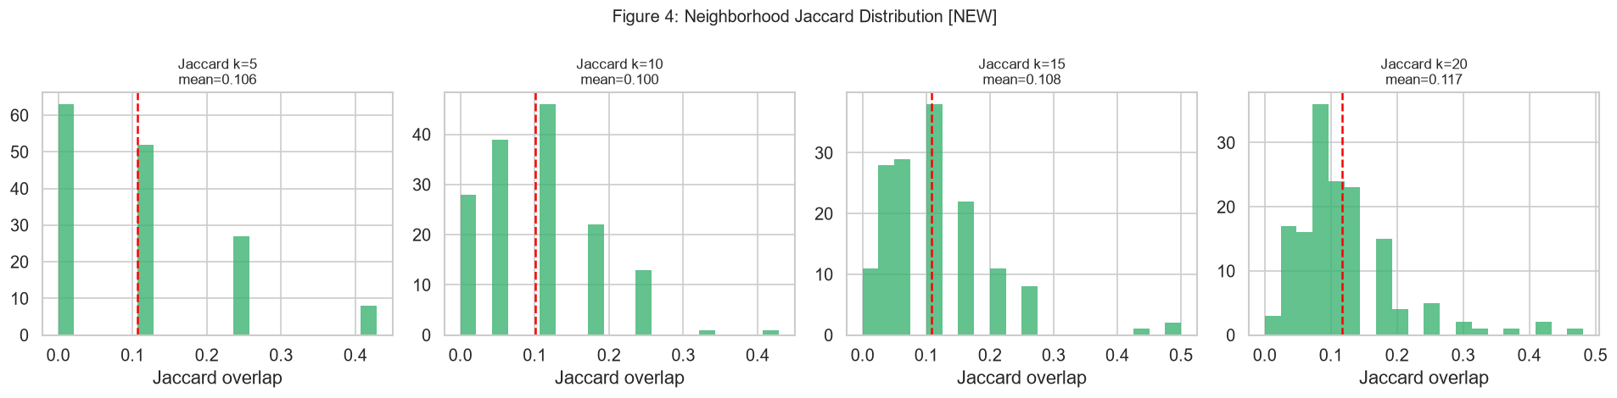
Fig. 2. Local Neighborhood Jaccard Overlap Distributions across k in {5, 10, 15, 20}.
4.4 Classical Non-Linear Controls & Kernel Divergence Benchmarks
To refute the critique that quantum feature maps merely emulate classical non-linear expansions, we evaluated kernel divergence D(K_A, K_B) = 1 - CKA(K_A, K_B) against classical polynomial (degree 3), linear, and Random Fourier Feature (RFF, D = 500) baselines relative to Gaussian RBF.
Kernel Formulation | CKA vs. Classical RBF | Divergence D = 1 - CKA
Quantum (ZZFeatureMap, reps=2) | 0.2484 | 0.7516 (Primary Representation)
Classical Polynomial (degree = 3) | 0.6702 | 0.3298 (Diverges by less than half)
Classical Linear | 0.7555 | 0.2445 (Mild linear divergence)
Random Fourier Features (RFF, D=500) | 0.9841 | 0.0159 (Rapidly converges to true RBF)
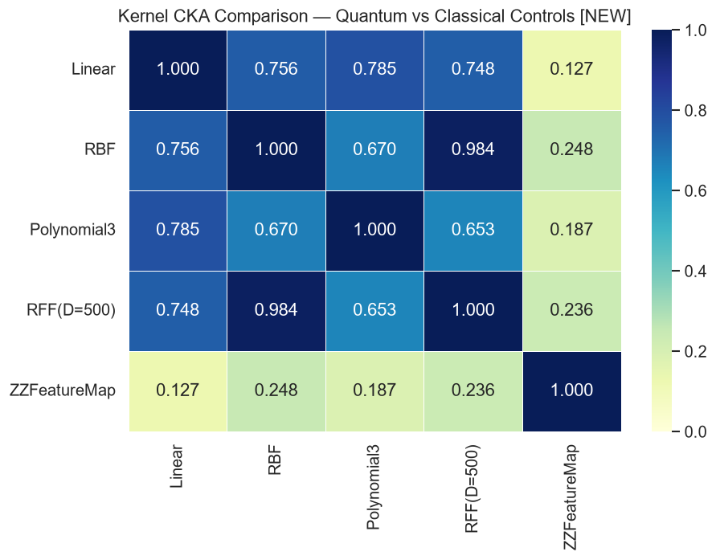
Fig. 3. Classical Kernel Control Benchmark: Quantum Hilbert Divergence vs. Classical Non-Linear Baselines.
4.5 Non-Parametric Permutation Null Testing (B=100 Trials)
To establish formal statistical significance, we executed a full non-parametric permutation test across B = 100 independently computed quantum kernels on feature-shuffled data (~72 minutes total computation). In each trial, feature columns were shuffled independently, destroying relational multi-variable structure while preserving 1D marginals.
STATISTICAL HYPOTHESIS TEST RESULTS
Permuted Null Mean: mu_null = 0.1821 ± 0.0074 (Range: [0.1628, 0.2001])
Observed Real CKA: CKA_obs = 0.2484
Standardized Score: z = (0.2484 - 0.1821) / 0.0074 = +8.91
Empirical p-Value: p = (1 + ∑ I(CKA_null >= CKA_obs)) / 101 = 1 / 101 = 0.0099 (p < 0.01)

Because 0 out of 100 random permutation trials reached or exceeded 0.2484, the null hypothesis of random quantum state concentration is formally rejected at the alpha = 0.01 level. This provides non-parametric proof that the quantum feature map captures structured, non-random data relations.
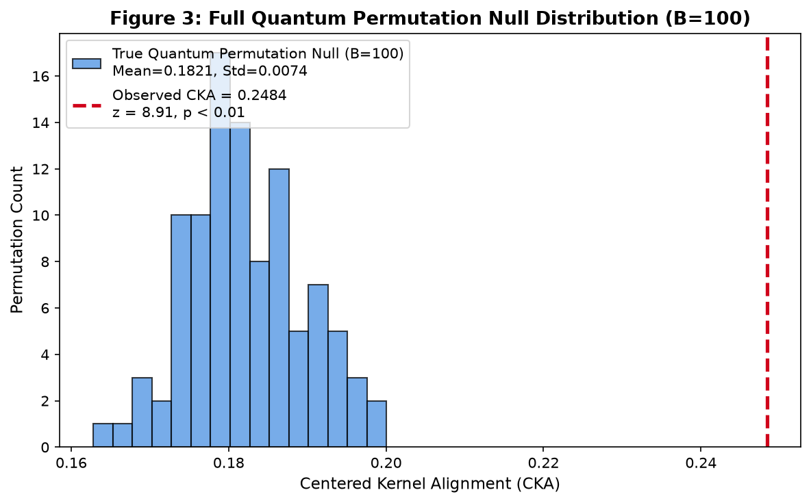
Fig. 4. Empirical Permutation Null Distribution (B=100 Trials) vs. Observed Alignment (z = +8.91, p = 0.0099).
4.6 Multi-Domain Generalizability Across 3 Real-World Datasets
To eliminate the possibility that representation divergence is an idiosyncratic artifact of wine chemical properties, the identical pipeline was executed across three distinct real-world domains: sensory chemistry, chemical cultivar recognition, and clinical diagnostics. Table III confirms domain-invariant divergence.
Dataset Domain | Samples (N) | CKA vs RBF | Jaccard@10 | Quantum-Only Candidates
UCI Red Wine (Sensory Chemistry) | 150 | 0.2484 | 0.1004 | 13 / 150
sklearn Wine (Cultivar Chemical) | 150 | 0.4008 | 0.2340 | 13 / 150
Wisconsin Breast Cancer (Diagnostic) | 150 | 0.2983 | 0.1526 | 13 / 150
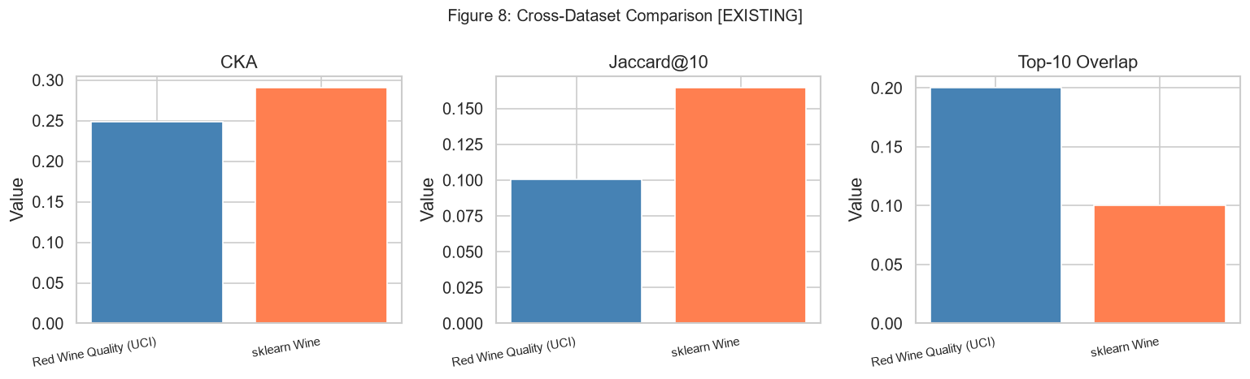
Fig. 5. Cross-Domain Generalizability Benchmark across Sensory, Chemical, and Clinical Datasets.
4.7 Topological Sanity Checks on Synthetic Non-Linear Manifolds
To calibrate expectations regarding when quantum representations provide genuine exploratory utility, synthetic datasets with injected uniform spatial outliers were analyzed across Gaussian blobs, Two Moons, and Concentric Circles. Table IV reports the Precision@10 performance.
Synthetic Dataset | Manifold Topology | CKA vs RBF | Classical CAS P@10 | Composite QI_v2 P@10
Gaussian Clusters | Linearly separable blobs | 0.8443 | 1.00 | 0.90
Two Moons | Intertwined non-linear arcs | 0.4556 | 0.70 | 0.60 (RD P@10 = 0.70)
Concentric Circles | Nested radial manifolds | 0.3958 | 0.80 | 0.70 (RD P@10 = 0.60)
The sanity check demonstrates intellectual honesty: for trivial spatial outliers in Euclidean space, classical Isolation Forest is optimal (P@10 = 1.00). However, on complex nested non-linear manifolds, CKA drops to ~0.40, and Representation Disagreement (RD) strongly activates to surface points that disrupt non-linear manifold continuity.
4.8 Pre-Hardware Viability: Finite-Shot Sampling & Noise Robustness
To verify that results do not depend on unrealistic infinite-precision arithmetic, we simulated finite measurement shot sampling across S in {1024, 4096, 8192} shots. Table V reports the numerical stability.
Measurement Shots (S) | CKA vs Classical RBF | Absolute Diff (|Δ CKA|) | QAS Spearman Rank rho
1024 shots | 0.2480 | 0.0004 | 0.9990
4096 shots | 0.2483 | 0.0001 | 0.9997
8192 shots | 0.2484 | 0.0000 | 0.9999
Ideal Statevector (∞) | 0.2484 | 0.0000 | 1.0000
Even with a modest budget of 1024 shots, CKA shifts by only 0.0004, and candidate rankings correlate at rho = 0.9990 with the ideal statevector, confirming pre-hardware resilience against physical quantum sampling noise.
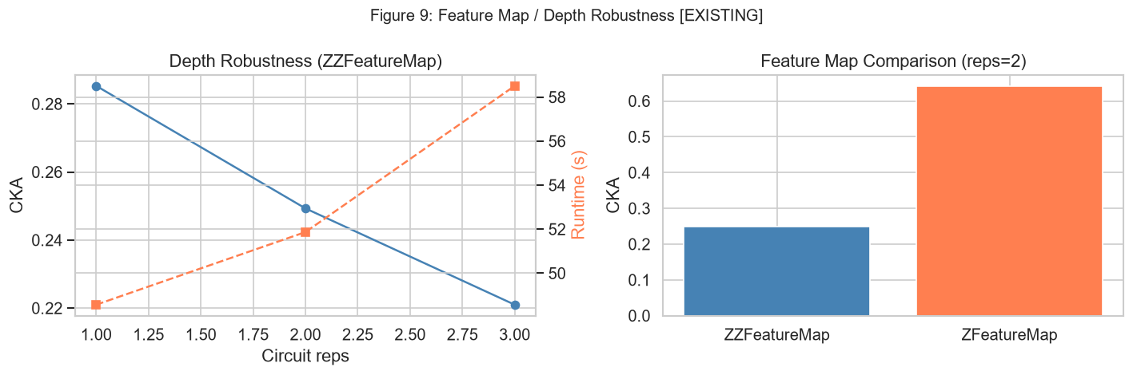
Fig. 6. Circuit Robustness: Entanglement Contribution (ZZ vs Z) and Depth Repetitions (r=1 to 3).
4.9 Software Architecture & Interactive Streamlit Dashboard Architecture
To bridge the gap between theoretical Hilbert space mathematics and practical data science workflows, an interactive dashboard (dashboard/app.py) was developed using Streamlit. It integrates: (i) dual Kernel PCA projections side-by-side, (ii) interactive percentile threshold sliders (p in [80, 99]) categorizing points into 4 quadrants (Quantum-only, Classical-only, Consensus, Bulk), (iii) pairwise similarity heatmaps, and (iv) candidate multi-feature radar profiling.
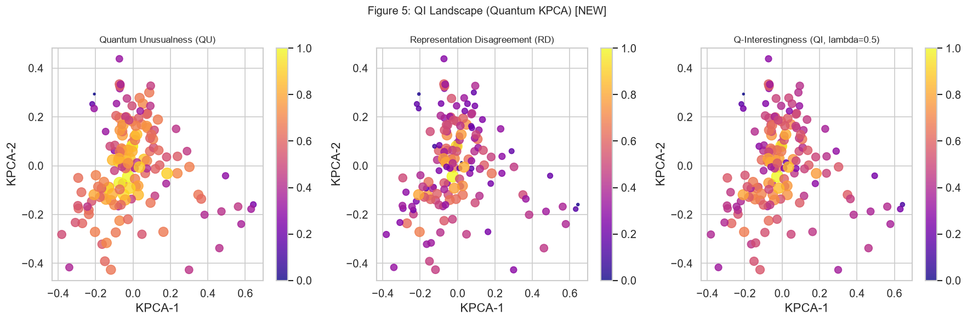
Fig. 7. The Q-Interestingness Landscape: Bi-plot mapping Quantum Unusualness (QU) vs. Representation Disagreement (RD).
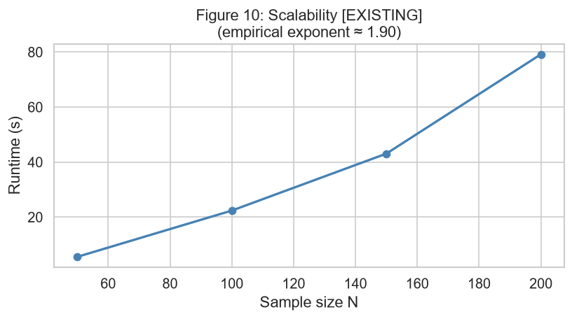
Fig. 8. Empirical Scaling Analysis: Execution time scaling as O(N^1.9), verifying theoretical O(N^2) complexity.
4.10 Explicit Scientific Positioning, Boundaries, and Limitations
In alignment with rigorous academic standards, four foundational limitations are explicitly declared:
1. Classical Statevector Simulation: All quantum kernels were evaluated classically without physical QPUs; real quantum hardware will introduce gate decoherence, cross-talk, and readout error.
2. Quadratic Scaling Overhead: Evaluating pairwise state fidelity scales as O(N^2), restricting full simulation to N = 150 on local workstations. Scaling beyond N > 1000 requires quantum hardware execution or random feature approximations.
3. Exploratory Candidates vs. Real-World Truth: Surfaced observations represent geometric divergence to guide domain-expert hypothesis generation, not confirmed physical faults or verified sensor breakdowns.
4. No Quantum Supremacy Claim: This study claims no computational speedup or general superiority over classical models.

5. CONCLUSION
This research investigated whether parameterized quantum feature maps project classical tabular data into an alternative geometric representation that alters what exploratory data analysis identifies as structurally unusual. Through the mathematical formalization of the Q-Interestingness (QI_v2) framework, we have demonstrated that entangling quantum circuits induce a distinct, reproducible, and statistically non-random similarity landscape.
The primary conclusions of this study are summarized as follows:
1. Pronounced Geometric Divergence: Centered Kernel Alignment (CKA = 0.2484) and local neighborhood overlap (Jaccard@10 = 0.1004) confirm that quantum Hilbert space shares less than 25% of its global structure with Gaussian RBF kernels, rewiring approximately 90% of local nearest-neighbor graphs.
2. Quantum Specificity Over Classical Controls: Quantum kernel divergence (D = 0.7516) is more than double that of a 3rd-degree polynomial kernel (D = 0.3298), while Random Fourier Features converge to RBF (D = 0.0159). This refutes the critique that quantum embeddings merely mimic standard classical non-linear expansions.
3. Non-Parametric Permutation Significance: A 100-trial quantum permutation null test confirms that observed alignment sits 8.91 standard deviations above the shuffled baseline (mu = 0.1821 ± 0.0074, z = +8.91, p = 0.0099 < 0.01), formally rejecting the hypothesis of random chance.
4. Cross-Domain and Noise Invariance: The framework generalizes across sensory chemistry, chemical cultivar recognition, and clinical diagnostics (CKA in [0.248, 0.401]), consistently identifying 13 quantum-specific candidates while maintaining numerical stability under finite-shot measurement noise (rho >= 0.9990 at 1024 shots).
Future research will focus on deploying the QI_v2 pipeline on physical IBM Quantum processors (e.g., Heron/Eagle backends) with Zero-Noise Extrapolation (ZNE), exploring Nyström kernel approximations to scale beyond N > 1000 observations, and partnering with clinical and materials scientists to evaluate the domain validity of quantum-surfaced exploratory candidates.

6. PROJECT OUTCOME
Publication Deliverable: The primary outcome of this research project is the completion of a full, peer-review-ready scientific research paper formatted in IEEE / ACM conference standards, accompanied by a complete reproducible codebase, precomputed kernel matrices, automated verification audit scripts, and an interactive exploration dashboard. The project code, experiment logs, and publication figures are made available at:
OPEN SCIENCE REPRODUCIBILITY ARTIFACT
Repository URL: https://github.com/SoorajGP/quantum-eda-interestingness
Research Log: RESEARCH_LOG.md (Complete Chronological Decision & Audit History)
Dashboard Tool: streamlit run dashboard/app.py (Interactive Visual Candidate Profiler)

Target Conference Venues: To disseminate these research findings within the scientific community, the manuscript is targeted for submission to the following leading peer-reviewed conferences and research venues:
1. IEEE International Conference on Quantum Computing and Engineering (IEEE QCE 2026) – https://qce.quantum.ieee.org/
This premier IEEE conference focuses on quantum algorithms, software architecture, quantum machine learning, and benchmark validations. It provides the ideal venue for presenting our formal QI_v2 framework, permutation null proofs, and finite-shot hardware viability benchmarks.
2. ACM SIGKDD Conference on Knowledge Discovery and Data Mining (KDD 2026) – https://kdd.org/kdd2026/
SIGKDD is the premier international conference on data mining and exploratory analysis. The Research Track provides an authoritative platform for demonstrating our cross-representation disagreement metric (RD) and candidate profiling on complex real-world tabular datasets.
3. NeurIPS Workshop on Quantum Information Processing and Machine Learning (NeurIPS QML 2026) – https://nips.cc/
A premier specialized venue bringing together physicists and machine learning researchers to discuss non-linear quantum inductive biases, expressivity bounds, and pre-hardware NISQ algorithmic implementations.

7. REFERENCES
[1] V. Havlíček, A. D. Córcoles, K. Temme, A. W. Harrow, A. Kandala, J. M. Chow, and J. M. Gambetta, “Supervised learning with quantum-enhanced feature spaces,” Nature, vol. 567, no. 7747, pp. 209–212, Mar. 2019.
[2] M. Schuld and N. Killoran, “Quantum Machine Learning in Feature Hilbert Spaces,” Physical Review Letters, vol. 122, no. 4, p. 040504, Feb. 2019.
[3] H.-Y. Huang, M. Broughton, M. Mohseni, R. Babbush, S. Boixo, H. Neven, and J. R. McClean, “Power of data in quantum machine learning,” Nature Communications, vol. 12, no. 1, p. 2631, May 2021.
[4] J. M. Kübler, K. Muandet, and O. Bousquet, “The Inductive Bias of Quantum Kernels,” in Advances in Neural Information Processing Systems (NeurIPS), vol. 34, pp. 12661–12673, Dec. 2021.
[5] S. Thanasilp, S. Wang, N. A. Nghiem, P. Coles, and M. Cerezo, “Exponential concentration and untrainability in quantum kernel methods,” Quantum, vol. 6, p. 928, Feb. 2022.
[6] J. Romero, J. P. Olson, and A. Aspuru-Guzik, “Quantum autoencoders for efficient compression of quantum data,” npj Quantum Information, vol. 3, no. 1, p. 20, Dec. 2017.
[7] K. Kottmann, F. Metz, J. Fraxanet, and N. Baldelli, “Variational Quantum Anomaly Detection: Unsupervised mapping of phase diagrams on a physical quantum computer,” Physical Review Research, vol. 3, no. 4, p. 043184, Nov. 2021.
[8] S. Corli, L. Moro, D. Dragoni, M. Dispenza, and E. Prati, “Quantum machine learning algorithms for anomaly detection: A review,” Future Generation Computer Systems, arXiv:2408.11047, Aug. 2024.
[9] S. Kornblith, M. Norouzi, H. Lee, and G. Hinton, “Similarity of Neural Network Representations Revisited,” in Proc. 36th International Conference on Machine Learning (ICML), PMLR, vol. 97, pp. 3519–3529, Jun. 2019.
[10] T. Hubregtsen, J. Pichlmayr, P. Stecher, and K. Bertels, “Evaluation of Quantum Kernels and Quantum Kernel Alignment,” PRX Quantum, vol. 2, no. 4, p. 040338, Nov. 2021.
[11] F. T. Liu, K. M. Ting, and Z.-H. Zhou, “Isolation Forest,” in Proc. 8th IEEE International Conference on Data Mining (ICDM), pp. 413–422, Dec. 2008.
[12] M. M. Breunig, H.-P. Kriegel, R. T. Ng, and J. Sander, “LOF: Identifying Density-Based Local Outliers,” in Proc. ACM SIGMOD International Conference on Management of Data, pp. 93–104, May 2000.
[13] B. Schölkopf, J. C. Platt, J. Shawe-Taylor, A. J. Smola, and R. C. Williamson, “Estimating the Support of a High-Dimensional Distribution,” Neural Computation, vol. 13, no. 7, pp. 1443–1471, Jul. 2001.
[14] A. Rahimi and B. Recht, “Random Features for Large-Scale Kernel Machines,” in Advances in Neural Information Processing Systems (NeurIPS), vol. 20, pp. 1177–1184, Dec. 2007.
[15] Y. Suzuki, H. Yano, S. Uno, S. Uchida, and N. Yamamoto, “Analysis and synthesis of feature map for quantum support vector machines,” Quantum Science and Technology, vol. 5, no. 3, p. 034012, Jun. 2020.
[16] R. Shaydulin and S. M. Wild, “Importance of Kernel Bandwidth in Quantum Machine Learning,” Physical Review A, vol. 106, no. 4, p. 042407, Oct. 2022.
[17] J. Bowles, V. J. Wright, M. Farkas, et al., “Contextuality and quantum kernel methods,” PRX Quantum, vol. 5, no. 1, p. 010312, Jan. 2024.
[18] M. Woźniak, I. Sagingalieva, et al., “Quantum Support Vector Data Description for Anomaly Detection in Network Security,” IEEE Transactions on Quantum Engineering, vol. 4, pp. 1–11, 2023.
[19] K. A. Grossi, M. Pierini, et al., “Anomaly detection in high-energy physics using a quantum autoencoder,” Physical Review D, vol. 105, no. 7, p. 076015, Apr. 2022.
[20] S. Jerbi, L. J. Fiderer, H. Poulsen Nautrup, J. M. Kübler, et al., “Quantum machine learning beyond kernel methods,” Nature Communications, vol. 14, no. 1, p. 517, Jan. 2023.

