**Indian Traditional Knowledge 18LEM109T**

**Task – 1**

*Draw the map of India and locate the early agricultural settlements and also indicate the timeline*

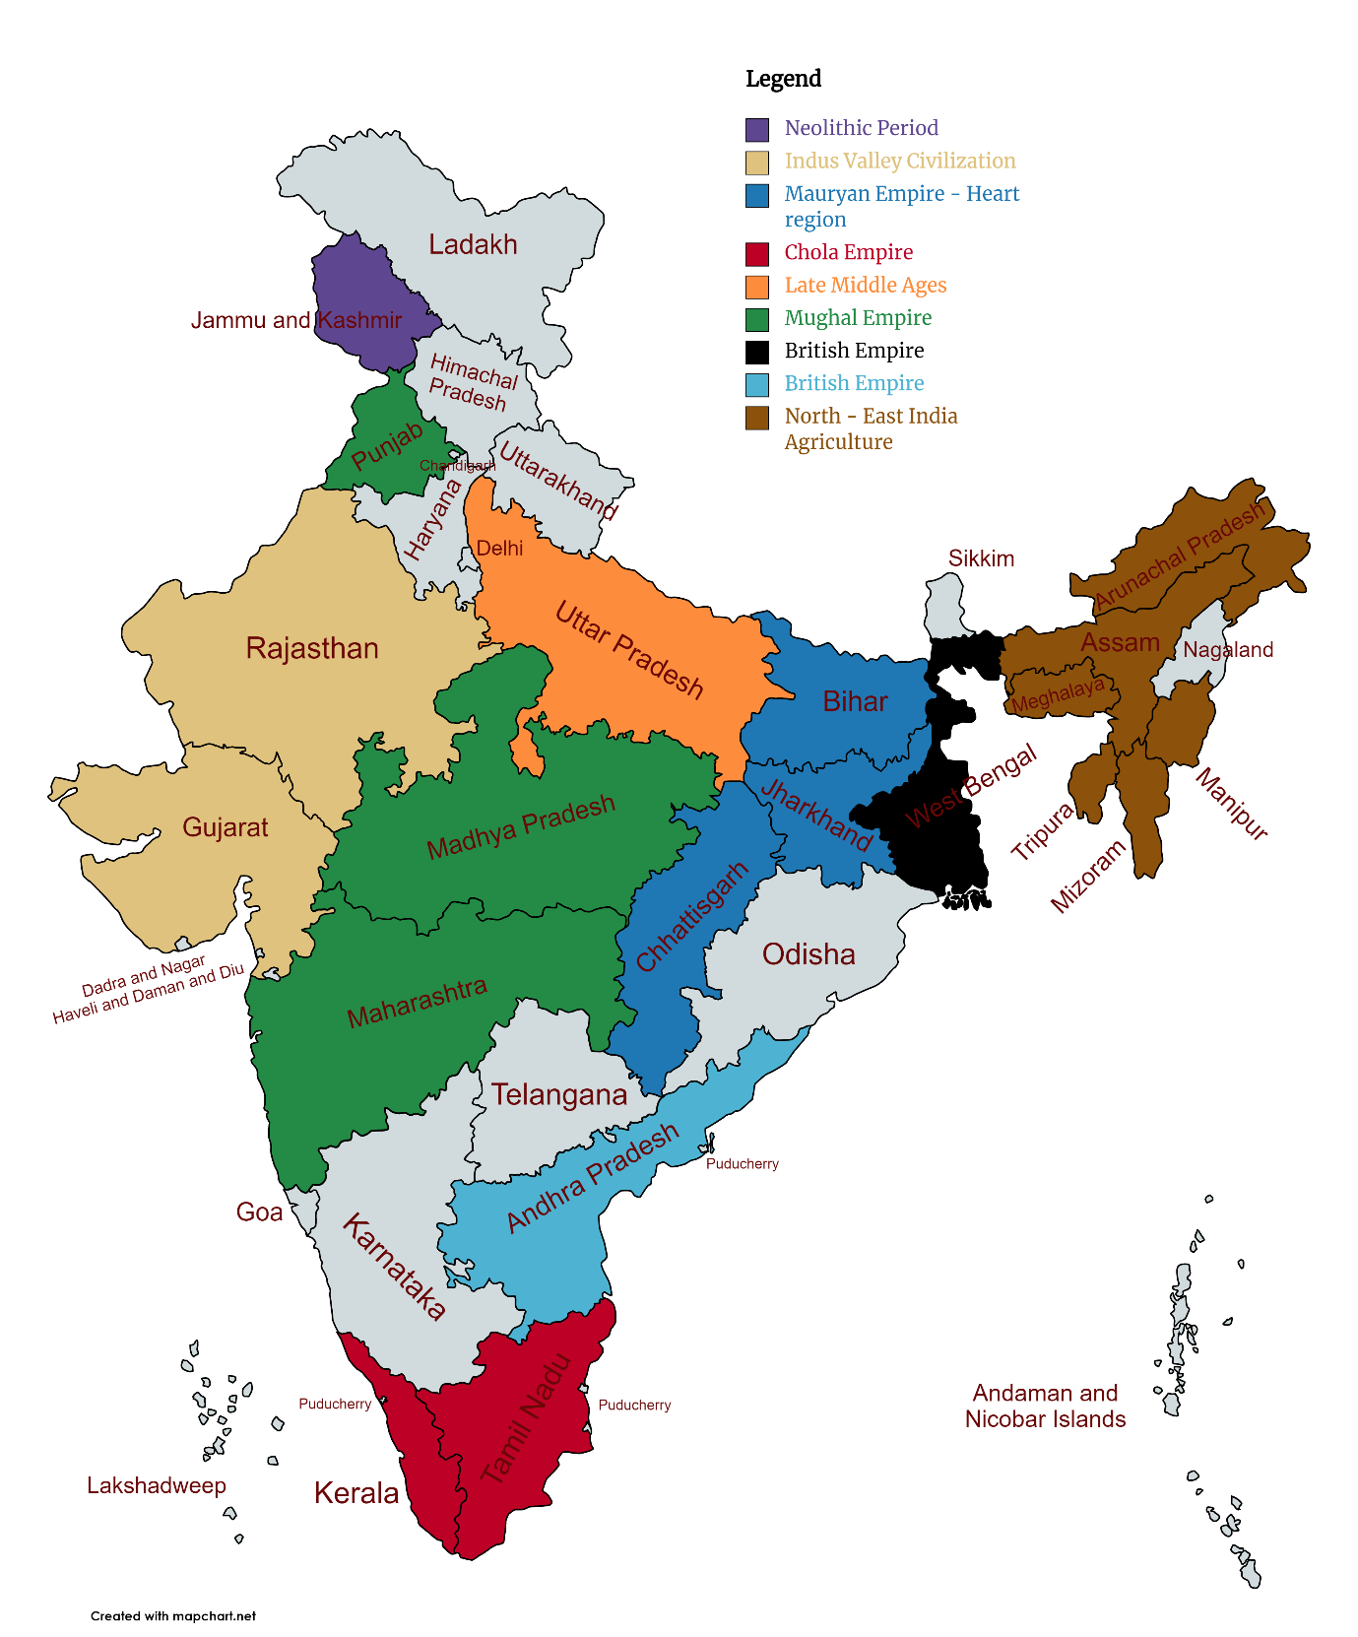

* In the period of the Neolithic revolution, roughly 8000-4000 BCE, Agro pastoralism in India included threshing, planting crops in rows—either of two or of six—and storing grain in granaries. Barley and wheat cultivation—along with the rearing of cattle, sheep and goat—was visible in Mehrgarh by 8000-6000 BCE. **(8000 – 4000 BCE)**
* **Irrigation was developed in the Indus Valley civilisation by around 4500 BCE**. The size and prosperity of the Indus civilisation grew as a result of this innovation, which eventually led to more planned settlements making use of drainage and sewers. Sophisticated irrigation and water storage systems were developed by the Indus Valley Civilisation, including artificial reservoirs at Girnar dated to 3000 BCE, and an early canal irrigation system from circa 2600 BCE. Archaeological evidence of an animal-drawn plough dates back to 2500 BC in the Indus Valley Civilisation. **(4500 – 1700 BCE)**
* The **Mauryan Empire (322–185 BCE)** categorised soils and made meteorological observations for agricultural use. Other Mauryan facilitation included construction and maintenance of dams, and provision of horse-drawn chariots—quicker than traditional bullock carts. India has many huge mountains which abound in fruit-trees of every kind, and many vast plains of great fertility. The greater part of the soil, moreover, is under irrigation, and consequently bears two crops in the course of the year. In addition to cereals, there grows throughout India much millet and much pulse of different sorts, and rice also, and what is called bosporum [Indian millet]. Since there is a double rainfall [i.e., the two monsoons] in the course of each year the inhabitants of India almost always gather in two harvests annually. **(1500 BCE – 200 CE)**
* The Tamil people cultivated a wide range of crops such as rice, sugarcane, millets, black pepper, various grains, coconuts, beans, cotton, plantain, tamarind and sandalwood. Jackfruit, coconut, palm, areca and plantain trees were also known. Systematic ploughing, manuring, weeding, irrigation and crop protection was practiced for sustained agriculture. Water storage systems were designed during this period. **Kallanai (1st-2nd century CE)**, a dam built on river Kaveri during this period, is considered to be one of the oldest water-regulation structures in the world still in use. Research of the agrarian society in South India during the **Chola Empire (875-1279)** reveals that during the Chola rule land was transferred and collective holding of land by a group of people slowly gave way to individual plots of land, each with their own irrigation system. The growth of individual disposition of farming property may have led to a decrease in areas of dry cultivation. The Cholas also had bureaucrats which oversaw the distribution of water—-particularly the distribution of water by tank-and-channel networks to the drier areas. **(200-1200 CE)**
* The construction of water works and aspects of water technology in **Medieval India** is described in Arabic and Persian works. The diffusion of Indian and Persian irrigation technologies gave rise to an irrigation system which brought about economic growth and growth of material culture. Agricultural 'zones' were broadly divided into those producing rice, wheat or millets. Rice production continued to dominate Gujarat and wheat dominated north and central India. Sugar mills appeared in India shortly during this era. Evidence for the use of a draw bar for sugar-milling appears at Delhi in 1540, but may date back earlier, and was mainly used in the northern Indian subcontinent. Geared sugar rolling mills later appeared in Mughal India, using the principle of rollers as well as worm gearing, **by the 17th century**. **(1200-1526)**
* **Indian agricultural production increased under the Mughal Empire**, during which India's population growth accelerated. A variety of crops were grown, including food crops such as wheat, rice, and barley, and non-food cash crops such as cotton, indigo and opium. By the mid-17th century, Indian cultivators begun to extensively grow two new crops from the Americas, maize and tobacco. Land management was particularly strong during the regime of **Akbar the Great (reigned 1556–1605)**, under whom scholar-bureaucrat Todarmal formulated and implemented elaborated methods for agricultural management on a rational basis. Indian crops—such as cotton, sugar, and citric fruits—spread visibly throughout North Africa, Islamic Spain, and the Middle East. The Mughal government funded the building of irrigation systems across the empire, which produced much higher crop yields and increased the net revenue base, leading to increased agricultural production. **(1526–1761)**
* **Agricultural performance in the interwar period** **(1918–1939)** was dismal. **From 1891 to 1946**, the annual growth rate of all crop output was 0.4 %, and food-grain output was practically stagnant. There were significant regional and intercrop differences, however, nonfood crops doing better than food crops. Among food crops, by far the most important source of stagnation was rice. Bengal had below-average growth rates in both food and nonfood crop output, whereas Punjab and Madras were the least stagnant regions. In the interwar period, population growth accelerated while food output decelerated, leading to declining availability of food per head. The crisis was most acute in Bengal, where food output declined at an annual rate of about 0.7 % from **1921 to 1946**, when population grew at an annual rate of about 1 %. **(19th Century)**
* Few Indian commercial crops—such as Cotton, indigo, opium, wheat, and rice—made it to the global market **under the British Raj in India**. The second half of the 19th century saw some increase in land under cultivation and agricultural production expanded at an average rate of about 1% per year by the later 19th century. Due to extensive irrigation by canal networks **Punjab, Narmada valley, and Andhra Pradesh** became centres of agrarian reforms. **(19th Century)**
* Agriculturally, **North-East India** lies in the Southeast Asia rice domain. Rice is the principal food crop. Besides, the region, especially Assam, is famous for tea. New plantation crops that have entered the area are rubber and several varieties of tropical and temperate fruits. The most traditional tree crop that is grown in homesteads, and not in commercially organised plantations, is areca nut. The region, however, does not have much cultivable land, which is confined to the two alluvial valleys of Assam. The region is known for ‘slash and burn’ type of shifting cultivation, locally known as jhuming. Besides rice, other important crops in the region are pulses and maize. Rubber plantation is becoming a popular commercial plantation in Tripura. Agriculture, in the region, suffers from low productivity, and floods frequently damage even better crops. The average yield of rice for the region is around 1,600 kg/ha, though in Manipur the rice yields are higher and linger around 2,400 kg/ha. Tea plantation is the principal plantation crop of the region. Over 95 % of the area of the region under tea is in Assam, centred largely in Darrang; Lakhimpur, on the north bank; and Tinsukia, Dibrugarh, Sibsagar and Jorhat on the southern bank of Brahmaputra. **(8000 BC – Till date)**

**SUBMITTED BY:**

**SOORAJ TOMAR**

**RA2011030010224**

**N1 SECTION**