**18CSC204J – Design and Analysis of Algorithms**

**MINOR PROJECT REPORT**

***Submitted by***

**SOORAJ TOMAR [RA2011030010224]**

**HARSHIT SHARMA [RA2011030010206]**

**PANKAJ BHATTARAI [RA2011030010230]**

***Under the Guidance of***

**Dr. K A Varun Kumar**

**Assistant Professor, Department of Networking and Communications**

***In partial satisfaction of the requirements for the degree of***

**BACHELOR OF TECHNOLOGY**

**in**

**COMPUTER SCIENCE AND ENGINEERING**

**with specialization in Cyber Security**



**SCHOOL OF COMPUTING**

**COLLEGE OF ENGINEERING AND TECHNOLOGY SRM INSTITUTE OF SCIENCE AND TECHNOLOGY KATTANKULATHUR - 603203**

**JUNE 2022**

**Content Contribution Table**

|  |  |
| --- | --- |
| **Name** | **Contribution** |
| Harshit Sharma | Research |
| Sooraj Tomar | Testing and Documentation |
| Pankaj Bhattarai | Programming |

**18CSC204J – Design and Analysis of Algorithms Project**

**Problem statement:** *To make a “Car Management System”.*

**Objective**

This system is named as Car Management System. This system is designed to help the customers to take access information about a particular car’s records; update or view it. When we go on any trip outside the town or country, we want to be free of time so instead of going through metros and taxis, we prefer to have our own vehicle for rent.

This system has only one admin account and cannot have more than one admin account. Admin can verify and register the user who is registering. If the admin does not verify, the user cannot register. All other features are explained further in detail.

**Algorithm**

Step 1: Start

Step 2: Give appropriate input (1/2/3/4/5/6)

Step 3: Give appropriate sub-input (information etc.)

Step 4: Display appropriate output

Step 5: Stop

**Approach**

IT IS A SIMPLE “TOUCH-AND-GO” PROJECT THEREFORE THE APPROACH IS “NAIVE” OR “BRUTE FORCE”.



WE HAVE DECIDED TO FOLLOW THE “KIS” PRINCIPLE (KEEP IT SIMPLE).

**Architecture Diagram**

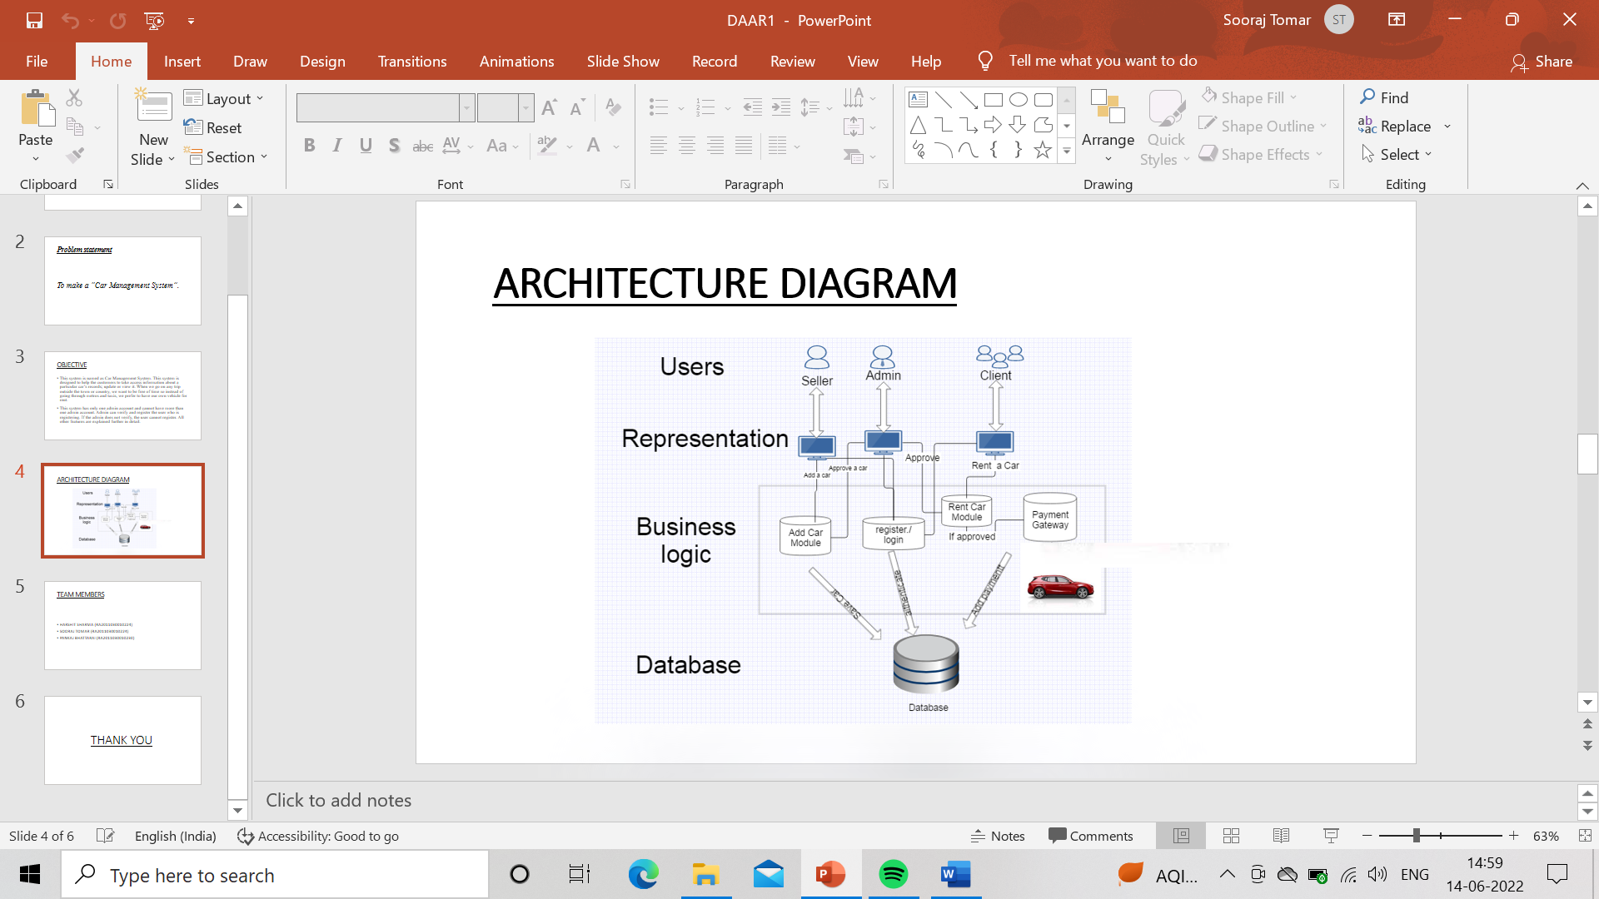

**Dry Run**

<https://drive.google.com/file/d/1xVnEgIQmHPLx810LVbNajDPlk8qMqSq/view?usp=sharing>

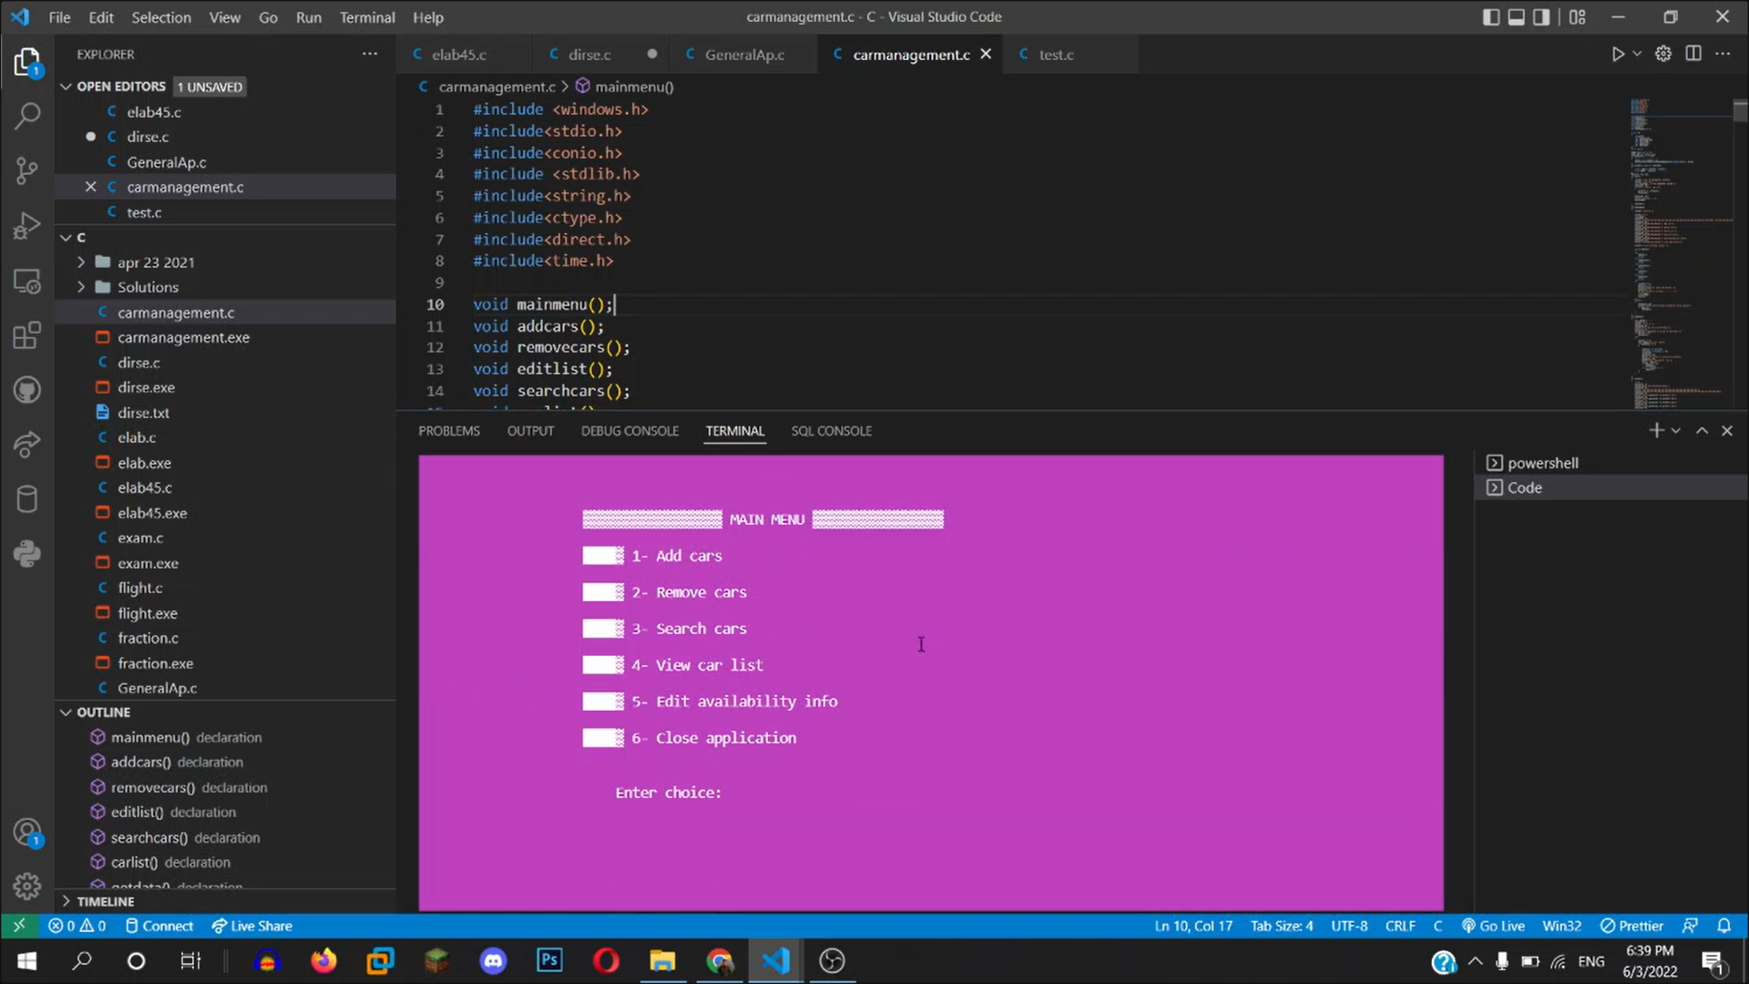

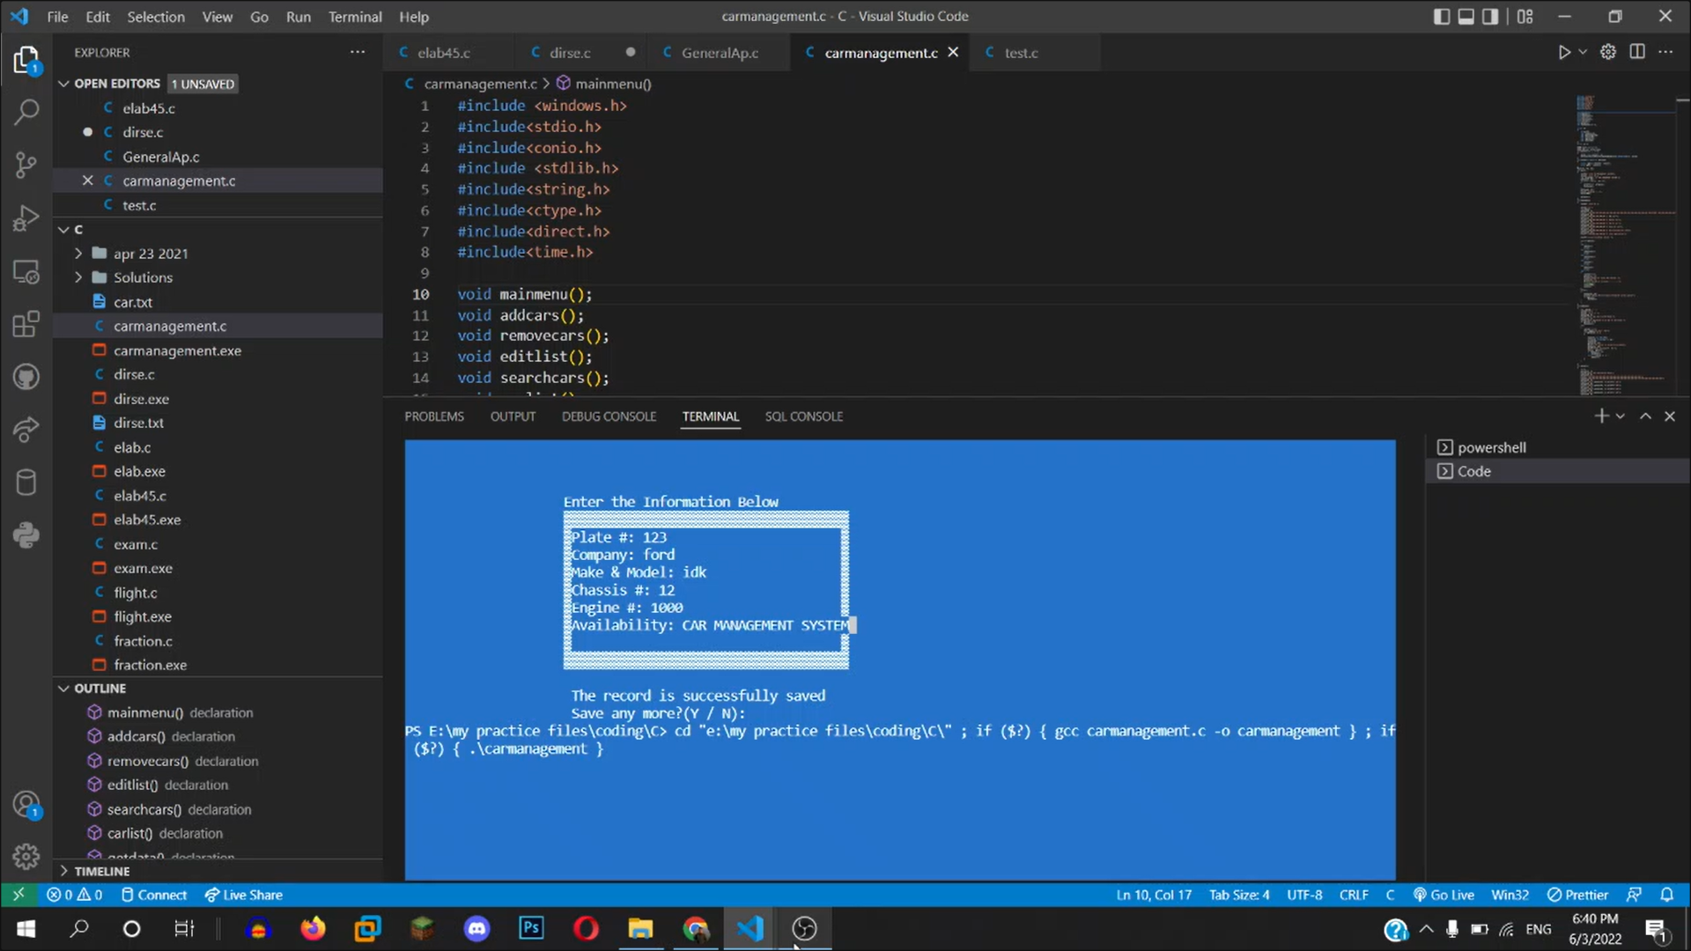

**Code**

#include <windows.h>

#include<stdio.h>

#include<conio.h>

#include <stdlib.h>

#include<string.h>

#include<ctype.h>

#include<direct.h>

#include<time.h>

void mainmenu();

void addcars();

void removecars();

void editlist();

void searchcars();

void carlist();

int getdata();

int checkplate(int t);

struct car

{

int plate;

char company[20];

char make_model[20];

char chasis[20];

char engine[20];

char avail[20];

};

struct car a;

COORD coord = { 0, 0 };

COORD max_res, cursor_size;

void gotoxy(int x, int y)

{

coord.X = x; coord.Y = y;

SetConsoleCursorPosition(GetStdHandle(STD_OUTPUT_HANDLE), coord);

}

void delay(unsigned int mseconds)

{

clock_t goal = mseconds + clock();

while (goal > clock());

}

FILE *fp, *ft, *fs;

int main()

{

system(" title Car Management System");

system(" color 1A");

char array[50] = { "CAR MANAGEMENT SYSTEM" };

gotoxy(35, 10);

for (int x = 0; x < 21; x++)

{

printf("%c", array[x]);

delay(200);

}

gotoxy(38, 15);

printf("Loading......");

delay(4000);

mainmenu();

}

void mainmenu()

{

system(" color 5F ");

system("cls");

int choice;

gotoxy(20, 3);

printf("\xB2\xB2\xB2\xB2\xB2\xB2\xB2\xB2\xB2\xB2\xB2\xB2\xB2\xB2\xB2\xB2\xB2 MAIN MENU \xB2\xB2\xB2\xB2\xB2\xB2\xB2\xB2\xB2\xB2\xB2\xB2\xB2\xB2\xB2\xB2");

gotoxy(20, 5);

printf("\xDB\xDB\xDB\xDB\xB2 1- Add cars");

gotoxy(20, 7);

printf("\xDB\xDB\xDB\xDB\xB2 2- Remove cars");

gotoxy(20, 9);

printf("\xDB\xDB\xDB\xDB\xB2 3- Search cars");

gotoxy(20, 11);

printf("\xDB\xDB\xDB\xDB\xB2 4- View car list");

gotoxy(20, 13);

printf("\xDB\xDB\xDB\xDB\xB2 5- Edit availability info");

gotoxy(20, 15);

printf("\xDB\xDB\xDB\xDB\xB2 6- Close application");

printf("\n\n\n\t\t\tEnter choice: ");

switch (getch())

{

case '1':

addcars();

break;

case '2':

removecars();

break;

case '3':

searchcars();

break;

case '4':

carlist();

break;

case '5':

editlist();

break;

case '6':

{

system("cls");

gotoxy(16, 3);

printf("Thanks for using the Program..");

gotoxy(10, 7);

printf("Exiting in 5 second...........>");

//flushall();

delay(5000);

exit(0);

}

default:

{

gotoxy(10, 23);

printf("\aWrong Entry!!Please re-entered correct option");

if (getch())

mainmenu();

}

}

}

void addcars()

{

char choice = ' ';

system("cls");

system(" color 2F ");

gotoxy(20, 3);

printf("Press any key to enter data.");

gotoxy(20, 4);

printf("Press backspace to go back to main menu.");

if (getch() == 8)

mainmenu();

else

{

system("cls");

fp = fopen("car.txt", "ab+");

if (getdata() == 1)

{

fseek(fp, 0, SEEK_END);

fwrite(&a, sizeof(a), 1, fp);

fclose(fp);

gotoxy(21, 14);

printf("The record is successfully saved");

gotoxy(21, 15);

printf("Save any more?(Y / N):");

choice = getch();

if (choice == 'n')

mainmenu();

else if (choice == 'y')

addcars();

}

}

}

int getdata()

{

int t;

gotoxy(20, 3);

printf("Enter the Information Below");

gotoxy(20, 4);

printf("\xB2\xB2\xB2\xB2\xB2\xB2\xB2\xB2\xB2\xB2\xB2\xB2\xB2\xB2\xB2");

printf("\xB2\xB2\xB2\xB2\xB2\xB2\xB2\xB2\xB2\xB2\xB2\xB2\xB2\xB2\xB2\xB2\xB2\xB2\xB2\xB2\xB2");

gotoxy(20, 5);

printf("\xB2"); gotoxy(55, 5); printf("\xB2");

gotoxy(20, 6);

printf("\xB2"); gotoxy(55, 6); printf("\xB2");

gotoxy(20, 7);

printf("\xB2"); gotoxy(55, 7); printf("\xB2");

gotoxy(20, 8);

printf("\xB2"); gotoxy(55, 8); printf("\xB2");

gotoxy(20, 9);

printf("\xB2"); gotoxy(55, 9); printf("\xB2");

gotoxy(20, 10);

printf("\xB2"); gotoxy(55, 10); printf("\xB2");

gotoxy(20, 11);

printf("\xB2"); gotoxy(55, 11); printf("\xB2");

gotoxy(20, 12);

printf("\xB2\xB2\xB2\xB2\xB2\xB2\xB2\xB2\xB2\xB2\xB2\xB2\xB2");

printf("\xB2\xB2\xB2\xB2\xB2\xB2\xB2\xB2\xB2\xB2\xB2\xB2\xB2\xB2\xB2\xB2\xB2\xB2\xB2\xB2\xB2\xB2\xB2");

gotoxy(21, 5);

printf("Plate #:\t");

gotoxy(30, 5);

scanf("%d", &t);

if (checkplate(t) == 0)

{

gotoxy(21, 13);

printf("\aThe car already exists\a");

getch();

mainmenu();

return 0;

}

a.plate = t;

gotoxy(21, 6);

printf("Company:");

gotoxy(30, 6);

scanf("%s", a.company);

gotoxy(21, 7);

printf("Make & Model:"); gotoxy(35, 7);

scanf("%s", a.make_model);

gotoxy(21, 8);

printf("Chassis #:"); gotoxy(32, 8);

scanf("%s", a.chasis);

gotoxy(21, 9);

printf("Engine #:"); gotoxy(31, 9);

scanf("%s", a.engine);

gotoxy(21, 10);

printf("Availability:"); gotoxy(35, 10);

scanf("%s", &a.avail);

return 1;

}

int checkplate(int t)

{

rewind(fp);

while (fread(&a, sizeof(a), 1, fp) == 1)

if (a.plate == t)

return 0;

return 1;

}

void removecars()

{

system("cls");

system("color 2A");

int c = 0;

int d, e;

int i;

gotoxy(20, 4);

printf("**** Remove cars ****");

char another = 'y';

while (another == 'y')

{

system("cls");

gotoxy(15, 6);

printf("Enter Plate # to be removed: ");

scanf("%d", &d);

fp = fopen("car.txt", "rb+");

while (fread(&a, sizeof(a), 1, fp) == 1)

{

if (checkplate(d) == 0)

{

gotoxy(15, 7);

printf("The car is available.");

gotoxy(15, 8);

printf("Plate #: %d", a.plate);

gotoxy(15, 9);

printf("Company: %s", a.company);

gotoxy(15, 10);

printf("Make % Model: %s", a.make_model);

gotoxy(15, 11);

printf("Chassis #: %s", a.chasis);

gotoxy(15, 12);

printf("Engine #: %s", a.engine);

gotoxy(15, 13);

printf("Car Removed: ");

a.avail[0] = 'R';

a.avail[1] = 'E';

a.avail[2] = 'M';

a.avail[3] = 'O';

a.avail[4] = 'V';

a.avail[5] = 'E';

a.avail[6] = 'D';

gotoxy(15, 16);

printf("The car is removed");

fseek(fp, ftell(fp) - sizeof(a), 0);

fwrite(&a, sizeof(a), 1, fp);

fclose(fp);

c = 1;

}

if (c == 0)

{

gotoxy(15, 9);

printf("No record found.");

}

}

gotoxy(15, 17);

printf("Modify another record?(Y/N): ");

fflush(stdin);

another = getch();

if (another == 'n')

mainmenu();

}

}

void searchcars()

{

char findcar;

system("color 2A");

system("cls");

int d;

gotoxy(18, 8);

printf("***************************** Search Cars *********************************");

gotoxy(20, 10);

printf("\xDB\xDB\xDB\xB2 1. Search By Plate #.");

gotoxy(20, 12);

printf("\xDB\xDB\xDB\xB2 2. Search By Company.");

gotoxy(20, 16);

printf("Press backspace to return to main menu.");

gotoxy(20, 18);

printf("Enter Your Choice: ");

fp = fopen("car.txt", "rb+"); //open file for reading propose

rewind(fp); //move pointer at the begining of file

switch (getch())

{

case '1':

{

system("cls");

gotoxy(25, 4);

printf("**** Search Cars By Plate# ****");

gotoxy(20, 5);

printf("Enter the Plate #: ");

scanf("%d", &d);

gotoxy(20, 7);

printf("Searching........");

while (fread(&a, sizeof(a), 1, fp) == 1)

{

if (a.plate == d)

{

delay(2);

gotoxy(20, 7);

printf("The car is available");

gotoxy(20, 8);

printf("\xB2\xB2\xB2\xB2\xB2\xB2\xB2\xB2\xB2\xB2\xB2\xB2\xB2\xB2");

printf("\xB2\xB2\xB2\xB2\xB2\xB2\xB2\xB2\xB2\xB2\xB2\xB2\xB2\xB2");

gotoxy(20, 9);

printf("\xB2 Plate #: %d", a.plate); gotoxy(47, 9); printf("\xB2");

gotoxy(20, 10);

printf("\xB2 Company: %s", a.company); gotoxy(47, 10); printf("\xB2");

gotoxy(20, 11);

printf("\xB2 Make & Model: %s ", a.make_model); gotoxy(47, 11); printf("\xB2");

gotoxy(20, 12);

printf("\xB2 Chassis #: %s ", a.chasis); gotoxy(47, 12); printf("\xB2"); gotoxy(47, 11); printf("\xB2");

gotoxy(20, 13);

printf("\xB2 Engine #: %s", a.engine); gotoxy(47, 13); printf("\xB2");

gotoxy(20, 14);

printf("\xB2 Availability: %s ", a.avail); gotoxy(47, 14); printf("\xB2");

gotoxy(20, 15);

printf("\xB2\xB2\xB2\xB2\xB2\xB2\xB2\xB2\xB2\xB2\xB2\xB2\xB2\xB2");

printf("\xB2\xB2\xB2\xB2\xB2\xB2\xB2\xB2\xB2\xB2\xB2\xB2\xB2\xB2");

findcar = 't';

}

}

if (findcar != 't') //checks whether conditiion enters inside loop or not

{

gotoxy(20, 8);

printf("\xB2\xB2\xB2\xB2\xB2\xB2\xB2\xB2\xB2\xB2\xB2\xB2\xB2\xB2\xB2\xB2\xB2\xB2\xB2");

gotoxy(20, 9); printf("\xB2"); gotoxy(38, 9); printf("\xB2");

gotoxy(20, 10);

printf("\xB2\xB2\xB2\xB2\xB2\xB2\xB2\xB2\xB2\xB2\xB2\xB2\xB2\xB2\xB2\xB2\xB2\xB2\xB2");

gotoxy(22, 9); printf("\aNo Record Found");

}

gotoxy(20, 17);

printf("Try another search?(Y/N): ");

if (getch() == 'y')

searchcars();

else

mainmenu();

break;

}

case '2':

{

char s[15];

system("cls");

gotoxy(25, 4);

printf("**** Search Cars By Company ****");

gotoxy(20, 5);

printf("Enter Company Name: ");

scanf("%s", s);

int d = 0;

int j = 10;

fp = fopen("car.txt", "rb");

while (fread(&a, sizeof(a), 1, fp) == 1)

{

if (strcmp(a.company, (s)) == 0) //checks whether a.name is equal to s or not

{

gotoxy(20, 7);

printf("Search results ");

gotoxy(3, 8);

printf("Plate # Company Make & Model Chassis # Engine # Availability ");

gotoxy(3, j);

printf("%d", a.plate);

gotoxy(15, j);

printf("%s", a.company);

gotoxy(26, j);

printf("%s", a.make_model);

gotoxy(47, j);

printf("%s", a.chasis);

gotoxy(53, j);

printf("%s", a.engine);

gotoxy(76, j);

printf("%s", a.avail);

j++;

d++;

}

}

if (d == 0)

{

gotoxy(20, 8);

printf("\xB2\xB2\xB2\xB2\xB2\xB2\xB2\xB2\xB2\xB2\xB2\xB2\xB2\xB2\xB2\xB2\xB2\xB2\xB2");

gotoxy(20, 9); printf("\xB2"); gotoxy(38, 9); printf("\xB2");

gotoxy(20, 10);

printf("\xB2\xB2\xB2\xB2\xB2\xB2\xB2\xB2\xB2\xB2\xB2\xB2\xB2\xB2\xB2\xB2\xB2\xB2\xB2");

gotoxy(22, 9); printf("\aNo Record Found");

}

gotoxy(20, j + 2);

printf("Try another search?(Y/N): ");

if (getch() == 'y')

searchcars();

else

mainmenu();

break;

}

case 8:

{

mainmenu();

}

default:

getch();

searchcars();

}

fclose(fp);

}

void editlist()

{

system("cls");

system("color 2A");

int c = 0;

int d, e;

gotoxy(20, 4);

printf("**** Edit Car Availability ****");

char another = 'y';

while (another == 'y')

{

system("cls");

gotoxy(15, 6);

printf("Enter Plate # to be edited: ");

scanf("%d", &d);

fp = fopen("car.txt", "rb+");

while (fread(&a, sizeof(a), 1, fp) == 1)

{

if (checkplate(d) == 0)

{

gotoxy(15, 7);

printf("The car is available.");

gotoxy(15, 8);

printf("Plate #: %d", a.plate);

gotoxy(15, 9);

printf("Company: %s", a.company);

gotoxy(15, 10);

printf("Make % Model: %s", a.make_model);

gotoxy(15, 11);

printf("Chassis #: %s", a.chasis);

gotoxy(15, 12);

printf("Engine #: %s", a.engine);

gotoxy(15, 13);

printf("Update availability info: "); scanf("%s", &a.avail);

gotoxy(15, 16);

printf("The record is modified");

fseek(fp, ftell(fp) - sizeof(a), 0);

fwrite(&a, sizeof(a), 1, fp);

fclose(fp);

c = 1;

}

if (c == 0)

{

gotoxy(15, 9);

printf("No record found.");

}

}

gotoxy(15, 17);

printf("Modify another record?(Y/N): ");

fflush(stdin);

another = getch();

if (another == 'n')

mainmenu();

}

}

void carlist()

{

int j = 4;

system("cls");

system(" color 3B ");

gotoxy(1, 1);

printf(" ************************************ Car List *************************************");

gotoxy(3, 2);

printf("Plate # Company Make & Model Chassis # Engine # Availability ");

fp = fopen("car.txt", "rb");

while (fread(&a, sizeof(a), 1, fp) == 1)

{

gotoxy(3, j);

printf("%d", a.plate);

gotoxy(15, j);

printf("%s", a.company);

gotoxy(26, j);

printf("%s", a.make_model);

gotoxy(47, j);

printf("%s", a.chasis);

gotoxy(63, j);

printf("%s", a.engine);

gotoxy(76, j);

printf("%s", a.avail);

j++;

}

printf("\n\n\n Press enter to return to main menu.");

if (getchar())

mainmenu();

}

**Time and Space Complexity**

Time Complexity: O (N2)

Space Complexity: O (N)

**Result**

Thus, an effective and efficient algorithm and code was designed for the mentioned problem statement.

**References**

https://wikipedia.org/wiki/Windows.h

**SUBMITTED BY:**

**HARSHIT SHARMA (RA2011030010206)**

**SOORAJ TOMAR (RA2011030010224)**

**PANKAJ BHATTARAI (RA2011030010230)**