|  |  |
| --- | --- |
| **Exp. No 3** | **Name of the Exercise**  Simple TCP/IP Client Server Communication |
| **Date**  **1/9/22** |

**Aim:** To establish simple TCP/IP Client Server Communication.

**Algorithm:**

Server:

Step 1: Start

Step 2: Bind host and port

Step 3: Listen for Clients

Step 4: Connect to client and display details of connection

Step 5: Communicate until needed

Step 6: Terminate Connection

Step 7: Stop

Client:

Step 1: Start

Step 2: Get host and port

Step 3: Connect to server

Step 4: Connect to server

Step 5: Communicate until needed

Step 6: Terminate Connection

Step 7: Stop

**Program:**

Server:

from socket import *

s=socket()

h=gethostname()

port=5000

s.bind((h,port))

s.listen(5)

c,a=s.accept()

print('Got connection from:'+str(a))

msg='Hello'

while(msg!='Bye'):

msg=c.recv(1024).decode()

print('Client says:',msg)

c.close()

Client:

from socket import *

s=socket()

h=gethostname()

port=5000

s.connect((h,port))

#print('Got connection from:'+str(a))

msg='Hello'

while(msg!='Bye'):

msg=input('Enter message to send to server:')

s.send(msg.encode())

s.close()

**Output**

Server:

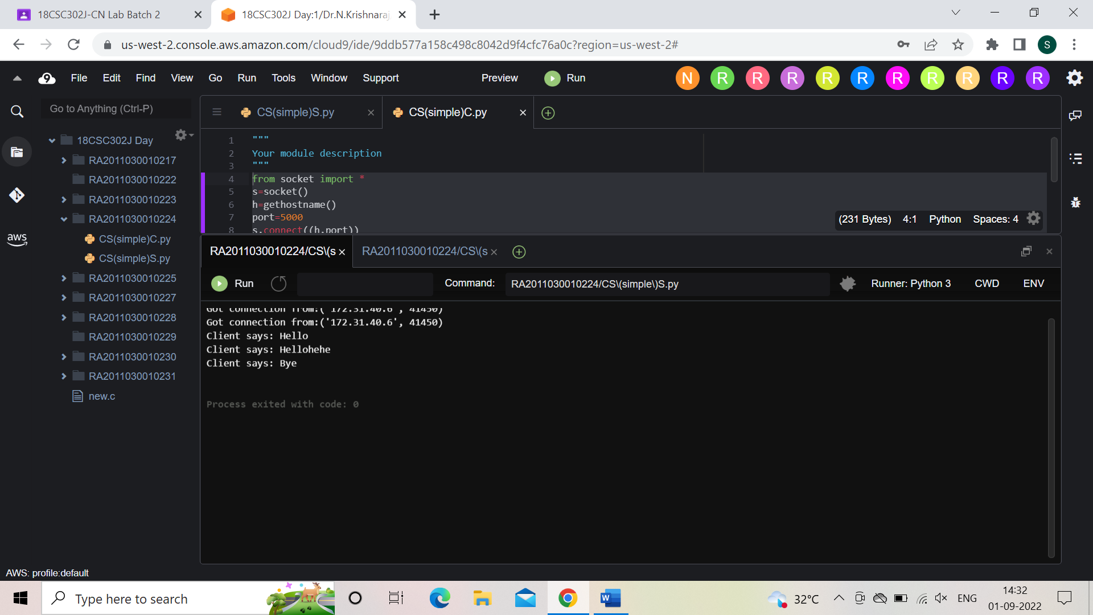

Client:

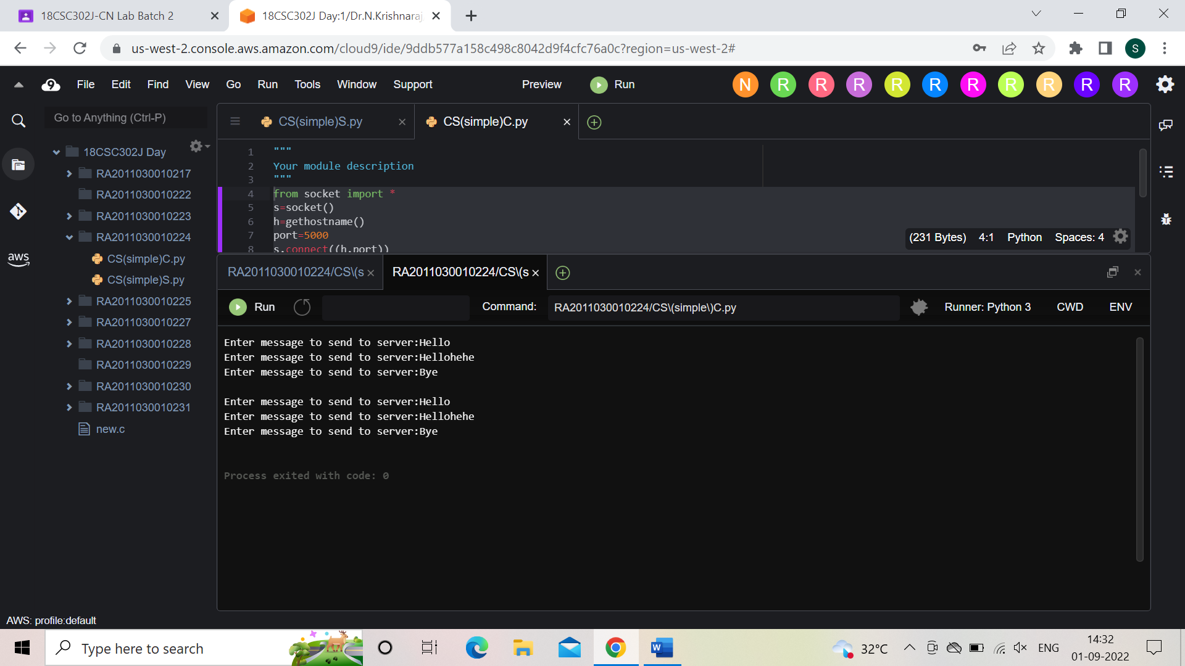

**Result:**  Simple TCP/IP Client Server Communication established successfully.