|  |  |
| --- | --- |
| **Exp. No 4** | **Name of the Exercise**  UDP ECHO CLIENT SERVER COMMUNICATION |
| **Date 7/9/22** |

**Aim:**  To implement an UDP Echo Client-Server application, where the Client on establishing a connection with the Server, sends a string to the Server. The Server reads the String, prints it and echoes it back to the Client.

**Algorithm:**

Server

Step 1: Start

Step 2: Bind host and port using UDP

Step 3: Listen for Clients

Step 4: Connect to client and display details of connection

Step 5: Echo string back to client

Step 6: Communicate until needed

Step 7: Terminate Connection

Step 8: Stop

Client

Step 1: Start

Step 2: Get host and port

Step 3: Connect to server

Step 4: Connect to server

Step 5: Communicate until needed

Step 6: Print strings echoed from server

Step 7: Terminate Connection

Step 8: Stop

**Program:**

Server

from socket import *  
s=socket(AF_INET,SOCK_DGRAM)  
h=gethostname()  
port=12345  
s.bind((h,port))  
msg='Hello'  
while msg!=b'Bye':  
 msg,add=s.recvfrom(1024)  
 print('Client says:',msg)  
 s.sendto(msg,add)  
s.close()

Client

from socket import *  
s=socket(AF_INET,SOCK_DGRAM)  
h=gethostname()  
port=12345  
msg='Hello'  
while msg!='Bye':  
 msg=input('Give data:')  
 s.sendto(msg.encode(),(h,port))  
 x,y=s.recvfrom(1024)  
 print('Server says:',x)  
s.close()

**Output**

Server

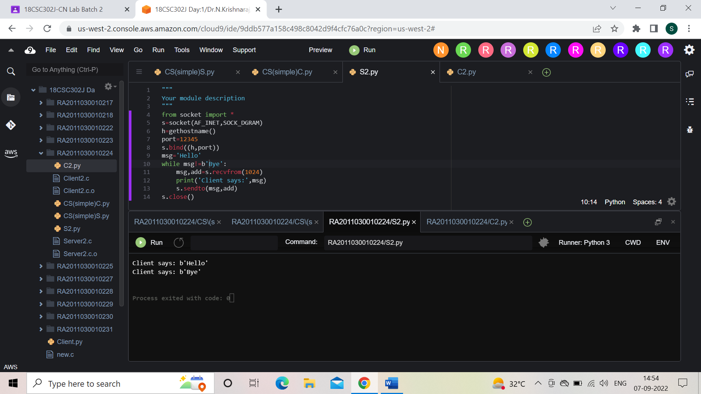

Client

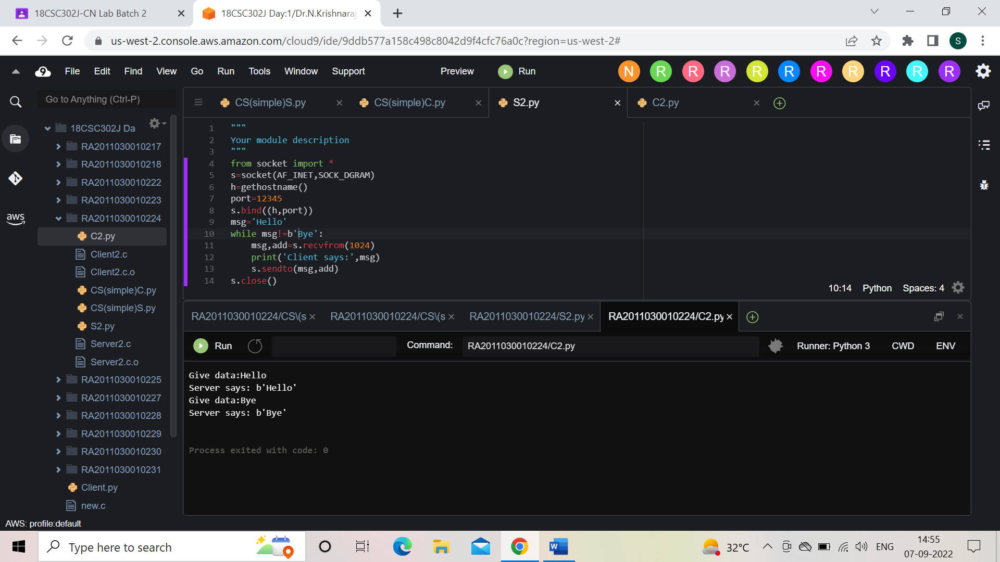

**Result:** Client Server UDP Echo communication done successfully.