|  |  |
| --- | --- |
| **Exp. No 5** | **Name of the Exercise**  CONCURRENT TCP/IP DAY-TIME SERVER |
| **Date 14/9/22** |

**Aim:** There are two hosts, Client and Server. The Client requests the concurrent server for the date and time. The Server sends the date and time, which the Client accepts and prints.

**Algorithm:**

Server

Step 1: Start

Step 2: Bind host and port using TCP

Step 3: Listen for Clients

Step 4: Connect to client and display details of connection and multithread another server

Step 5: Send datetime back to client

Step 6: Communicate until needed

Step 7: Terminate Connection

Step 8: Stop

Client

Step 1: Start

Step 2: Get host and port

Step 3: Connect to server

Step 4: Ask for datetime

Step 5: Communicate until needed

Step 6: Print datetime from server

Step 7: Terminate Connection when user is done

Step 8: Stop

**Program:**

Server

import socket

import datetime

from _thread import *

import threading

print_lock = threading.Lock()

# thread function

def threaded(c):

while True:

# data received from client

data = c.recv(1024)

if not data:

print('Bye')

# lock released on exit

print_lock.release()

break

x=datetime.datetime.now()

s=str(x)

c.send(s.encode())

# connection closed

c.close()

def Main():

host = ""

# reserve a port on your computer

# in our case it is 12345 but it

# can be anything

port = 12344

s = socket.socket(socket.AF_INET, socket.SOCK_STREAM)

s.bind((host, port))

print("socket binded to port", port)

# put the socket into listening mode

s.listen(5)

print("socket is listening")

# a forever loop until client wants to exit

while True:

# establish connection with client

c, addr = s.accept()

# lock acquired by client

print_lock.acquire()

print('Connected to :', addr[0], ':', addr[1])

# Start a new thread and return its identifier

start_new_thread(threaded, (c,))

s.close()

if __name__ == '__main__':

Main()

Client

import socket

def Main():

# local host IP '127.0.0.1'

host = '127.0.0.1'

# Define the port on which you want to connect

port = 12344

s = socket.socket(socket.AF_INET,socket.SOCK_STREAM)

# connect to server on local computer

s.connect((host,port))

# message you send to server

message = "What is the time??"

while True:

# message sent to server

s.send(message.encode('ascii'))

data = s.recv(1024)

print('Received from the server :',str(data.decode('ascii')))

# ask the client whether he wants to continue

ans = input('\nDo you want to continue(y/n) :')

if ans == 'y':

continue

else:

break

# close the connection

s.close()

if __name__ == '__main__':

Main()

**Output**

Server

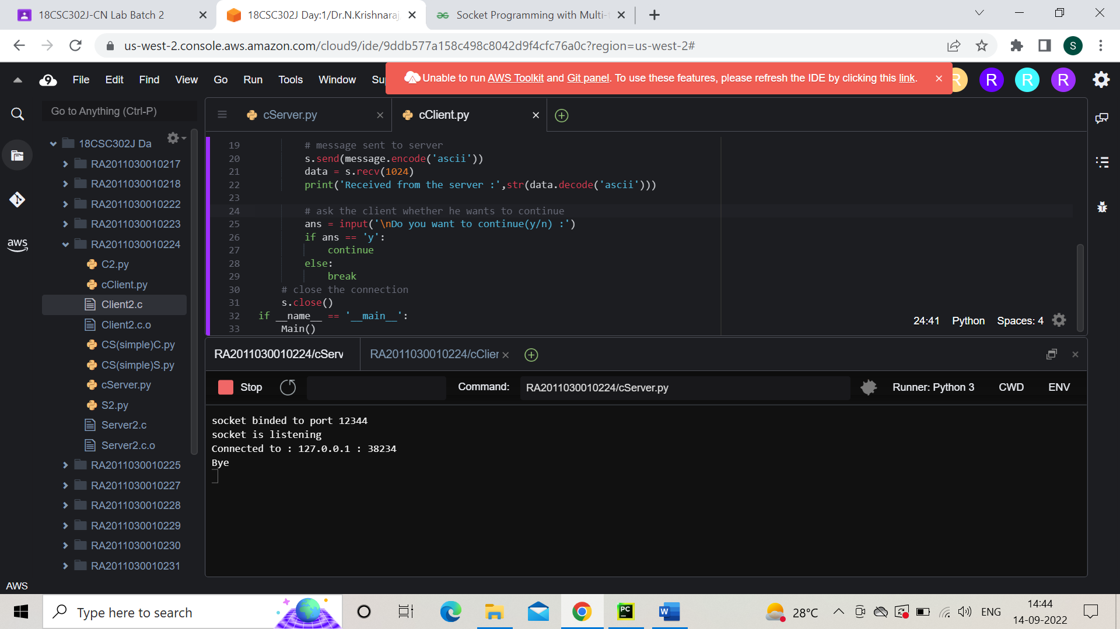

Client

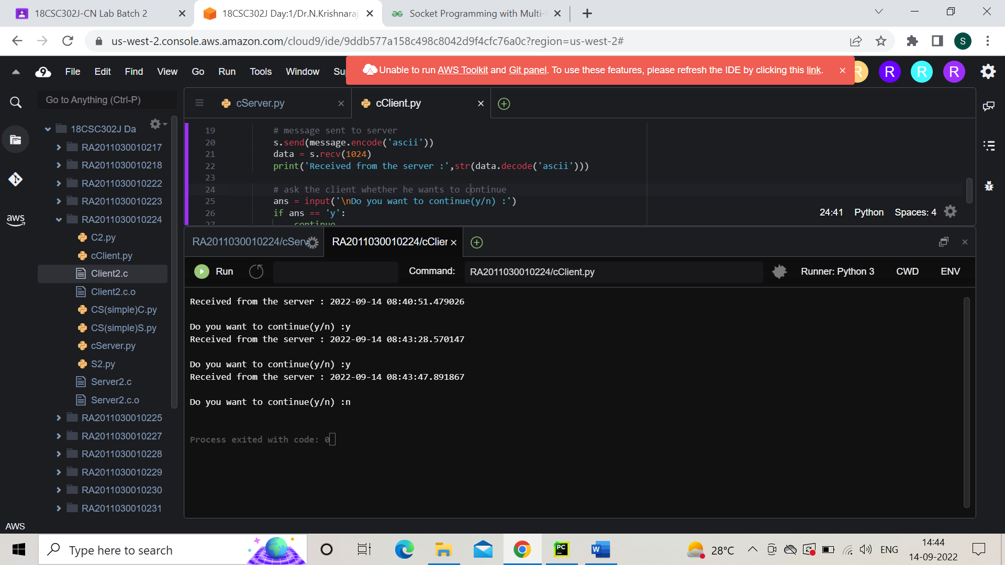

**Result:** Thus, the concurrent daytime client- server communication is established by sending the request message from the client to the concurrent server and the server sends its time to all the clients and displays it.