**18CSS202J Computer Communications Hybrid Topology Assignment**

**Ques:** Design an effective and efficient Hybrid topology network for a University Lab arrangement such that:

* The **Computer Networking Lab** students can interact with the other devices freely and no obstruction shall be made even after some wiring failures.
* A **General Lab**, not such important work needed, just a simple lab in which a few failures can affect certain systems, but the large number of systems will suffice the work needed.
* An **Administrative Lab** in which a few devices can work together and work on sensitive information. Any wiring failure can be resolved by simply rerouting the data.
* Finally, a **Data Structures Lab** where the students can code and certain updates can be installed quickly. Failures can be resolved quickly.
* As always, **proper wiring** shall be used.

**Solution:**

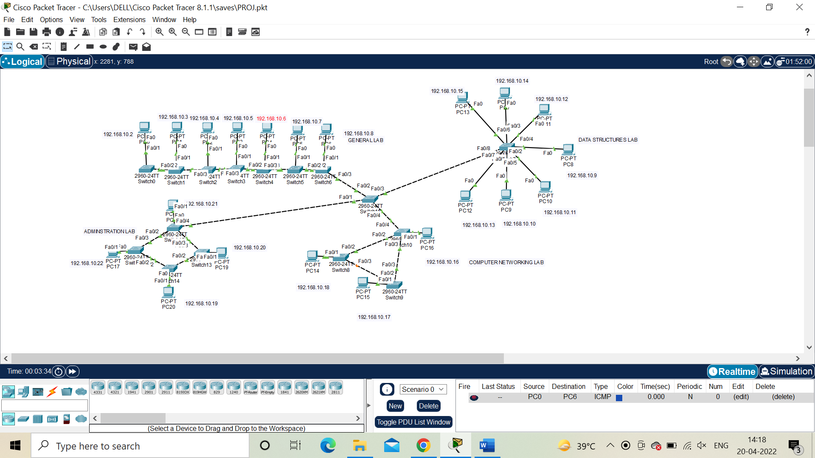

**Sending Message (Packet) from PC0 to PC6:**

**INTERMEDIATE NODES:**

PC0->SWITCH0->SWITCH1-> PC1->SWITCH2->PC2->SWITCH3->PC3->SWITCH4->PC4->SWITCH5->PC5->SWITCH6->PC6

**Pinging from PC0 to PC19 also works with 0% Packet Loss.**

**SUBMITTED BY:**

**SOORAJ TOMAR**

**RA2011030010224**

**N1 SECTION**