**18CSC202J Computer Communications Project**

**Submission by Team:**

1. **HARSHIT SHARMA (RA2011030010206)**
2. **SOORAJ TOMAR (RA2011030010224)**
3. **PANKAJ BHATTARAI (RA2011030010230)**

**Scenario Question:**

*You are responsible for configuring the new network to connect your company’s HR (IP starting from 192.168.10.2), Marketing (IP starting from 192.168.10.34), Engineering (IP starting from 192.168.10.66), and accounting (IP starting from 192.168.10.98) departments. The physical devices have just been installed and are connected by Fast Ethernet and serial cables. Your task is to configure the devices to enable full connectivity between all departments. Ensure proper IP connectivity amongst routers of different departments (IP starting from 10.0.0.1 and 11.0.0.1). Also show the differences between the different configuring protocols you have used.*

**Objectives**

* To allot proper IP addresses to the devices mentioned.
* To select an appropriate topology for the network (provided by the organization).
* To select more than one proper routing protocols for the connections.
* To show a visual difference between the 2 protocols (if any).
* To showcase the knowledge gained throughout the course (18CSC202J).
* To showcase proper teamwork and responsibility within the team.

**Prerequisites**

* Knowledge of Classless and Classful Addressing
* Knowledge of Static and RIP Protocols of Routing
* Basic usage of Cisco Packet Tracer

**Components Used**

|  |  |
| --- | --- |
| COMPONENT NAME | REQUIRED NUMBER |
| Pc | 10 |
| Router | 4 |
| Switch | 5 |
| Copper Straight Through Wire | 14 |
| Copper Cross-Over Wire | 1 |
| Serial DCE Wire | 4 |

**Addressing Table**

|  |  |  |  |  |
| --- | --- | --- | --- | --- |
| NAME | INTERFACE | IP | SUBNET MASK (/27) | GATEWAY |
| PC1 | FA0/0 | 192.168.10.2 | 255.255.255.224 | 192.168.10.1 |
| PC0 | FA0/0 | 192.168.10.3 | 255.255.255.224 | 192.168.10.1 |
| PC8 | FA0/0 | 192.168.10.4 | 255.255.255.224 | 192.168.10.1 |
| PC4 | FA0/0 | 192.168.10.34 | 255.255.255.224 | 192.168.10.33 |
| PC5 | FA0/0 | 192.168.10.35 | 255.255.255.224 | 192.168.10.33 |
| PC6 | FA0/0 | 192.168.10.66 | 255.255.255.224 | 192.168.10.65 |
| PC9 | FA0/0 | 192.168.10.67 | 255.255.255.224 | 192.168.10.65 |
| PC7 | FA0/0 | 192.168.10.68 | 255.255.255.224 | 192.168.10.65 |
| PC2 | FA0/0 | 192.168.10.98 | 255.255.255.224 | 192.168.10.97 |
| PC3 | FA0/0 | 192.168.10.99 | 255.255.255.224 | 192.168.10.97 |
| ROUTER 0 | FA0/0 | 192.168.10.1 | 255.255.255.224 | - |
| ROUTER 0 | SE 0/0/0 | 10.0.0.1 | 255.0.0.0 | - |
| ROUTER 0 | SE 0/0/1 | 11.0.0.1 | 255.0.0.0 | - |
| ROUTER 1 | FA0/0 | 192.168.10.33 | 255.255.255.224 | - |
| ROUTER 1 | SE 0/0/0 | 10.0.0.2 | 255.0.0.0 | - |
| ROUTER 1 | SE 0/0/1 | 11.0.0.2 | 255.0.0.0 | - |
| ROUTER 2 | FA0/0 | 192.168.10.65 | 255.255.255.224 | - |
| ROUTER 2 | SE 0/0/0 | 10.0.0.3 | 255.0.0.0 | - |
| ROUTER 2 | SE 0/0/1 | 11.0.0.3 | 255.0.0.0 | - |
| ROUTER 3 | FA0/0 | 192.168.10.97 | 255.255.255.224 | - |
| ROUTER 3 | SE 0/0/0 | 10.0.0.4 | 255.0.0.0 | - |
| ROUTER 3 | SE 0/0/1 | 11.0.0.4 | 255.0.0.0 | - |

**Theory**

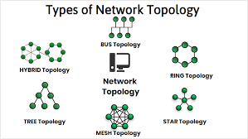

**Classless addressing is an IPv4 addressing architecture that uses variable-length subnet masking.** The solution would come in 1993, as Classless Inter-Domain Routing (CIDR) introducing the concept of classless addressing. You see, with classful addressing, the size of networks is fixed. Each address range has a default subnet mask. Classless addressing, however, decouples IP address ranges from a default subnet mask, allowing for variable-length subnet masking (VLSM). Using classless addressing and VLSM, addresses can be allocated much more efficiently. This is because network admins get to pick network masks, and in turn, blocks of IP addresses that are the right size for any purpose.

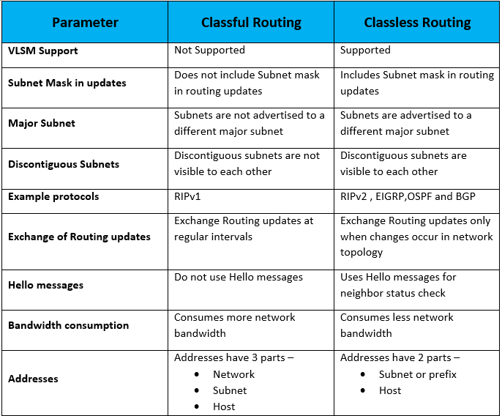

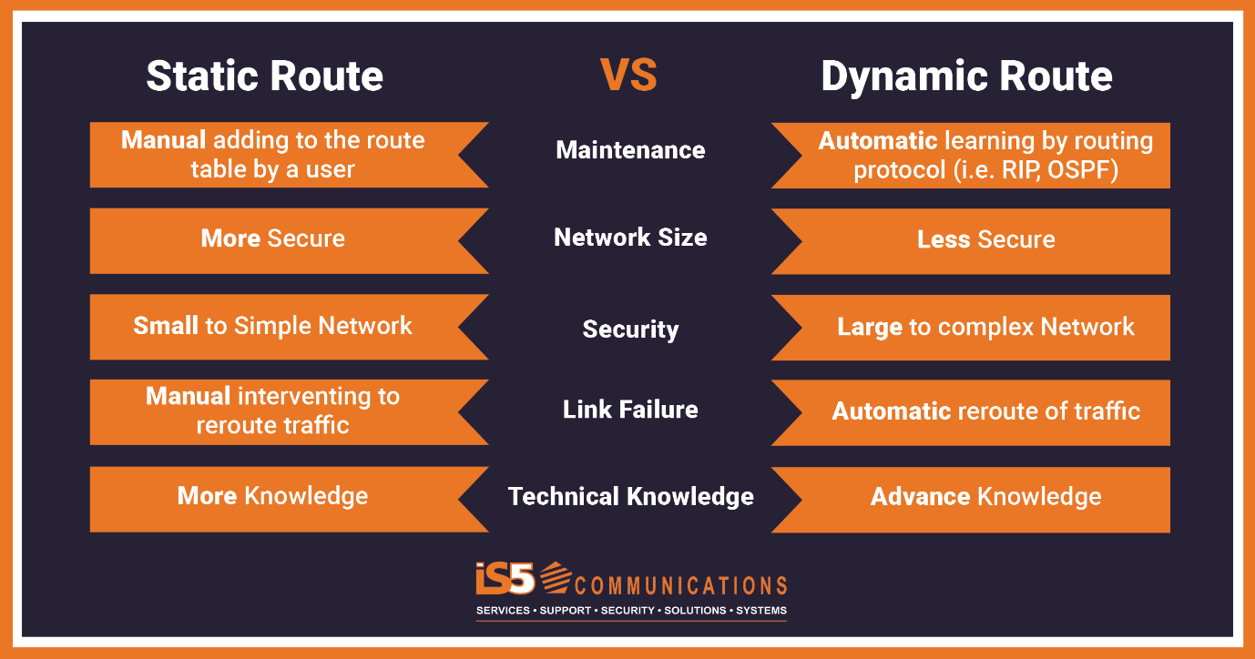

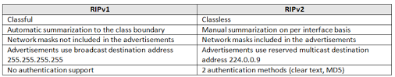

Therefore, we have used Classless Addressing and Static as well as Dynamic (RIPv2) routing.

**Implementation**

**STATIC ROUTING**

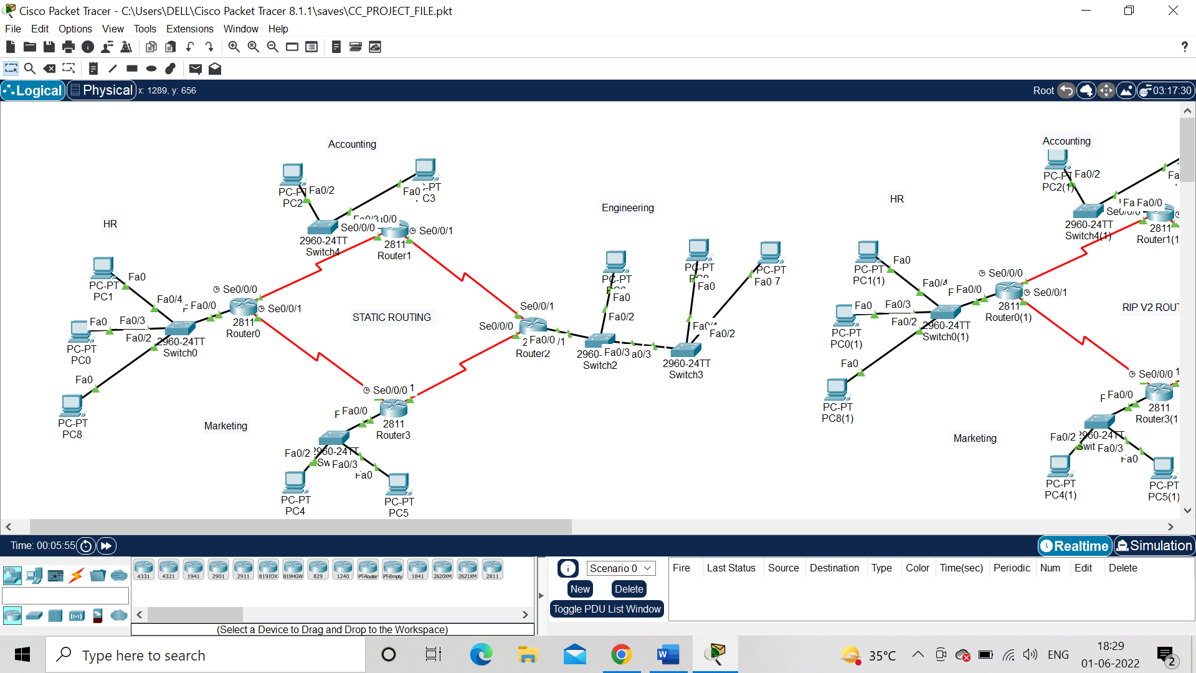

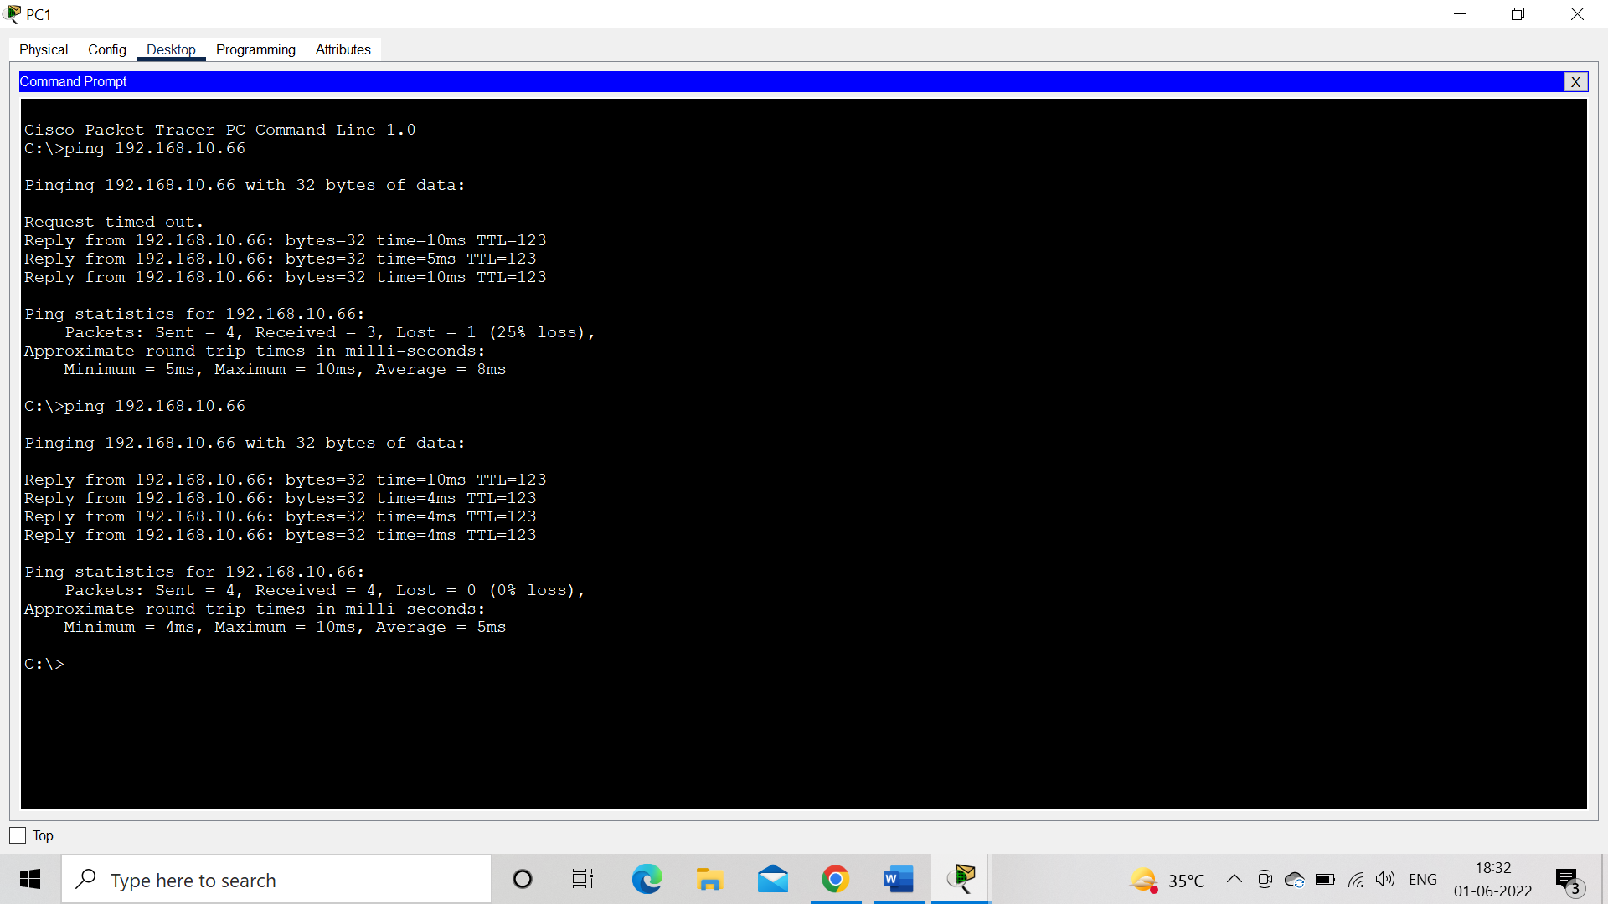(Pinging from PC1 (192.168.10.2) to PC6 (192.168.10.66))

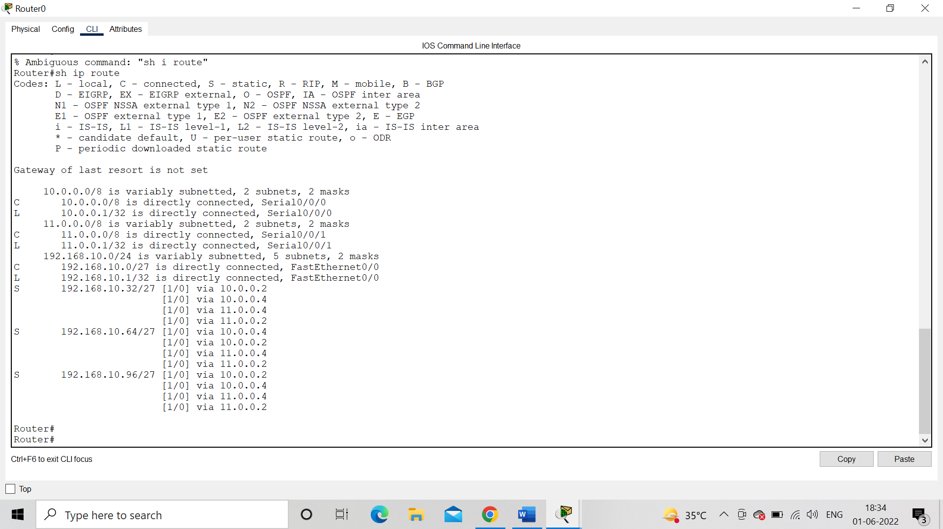(Routing table of Router0)

**DYNAMIC ROUTING (RIPV2)**

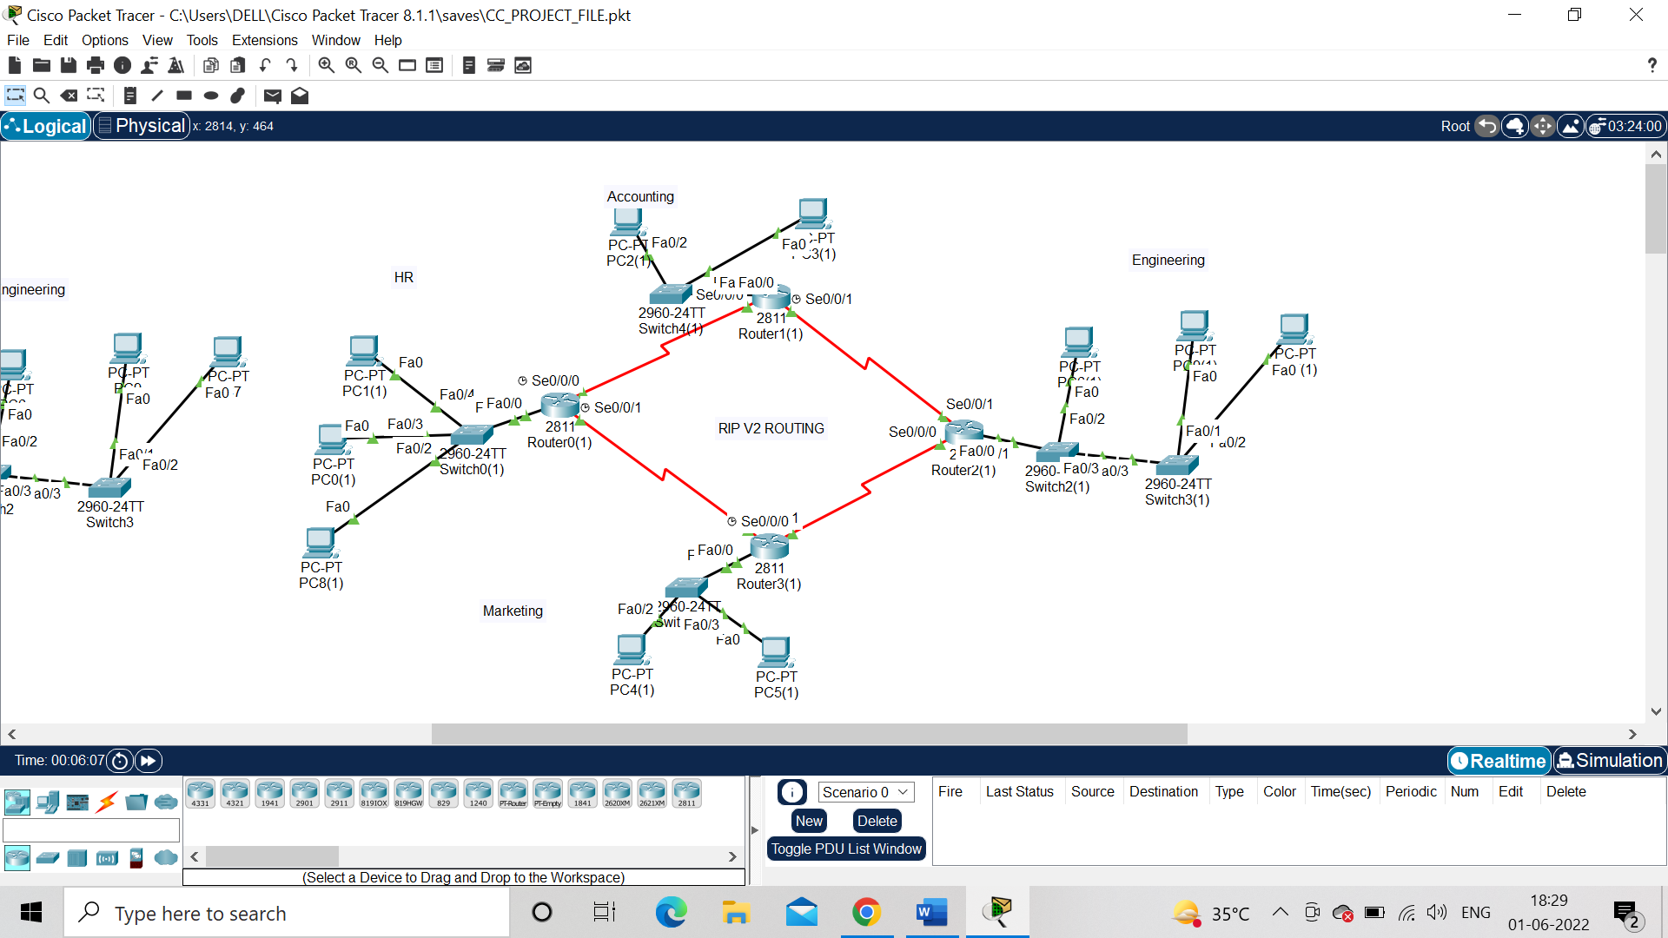

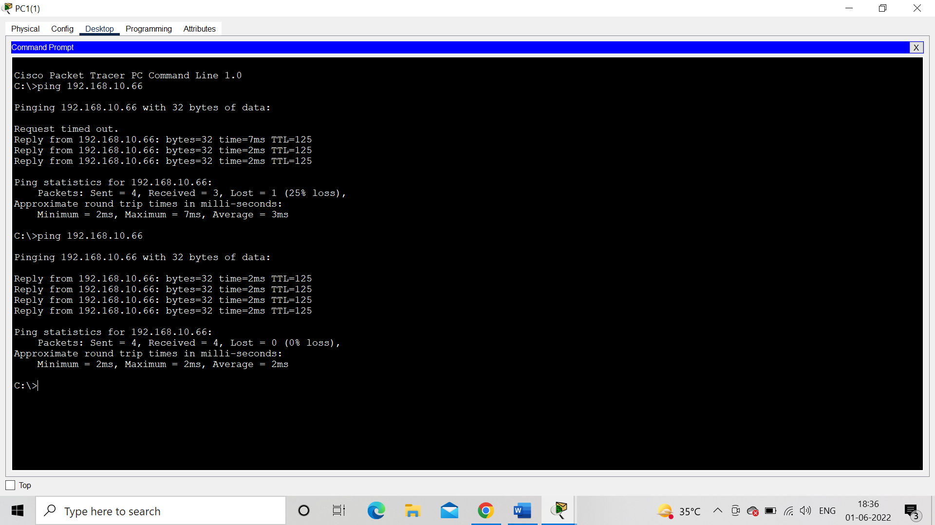(Pinging from PC1 (192.168.10.2) to PC6 (192.168.10.66))

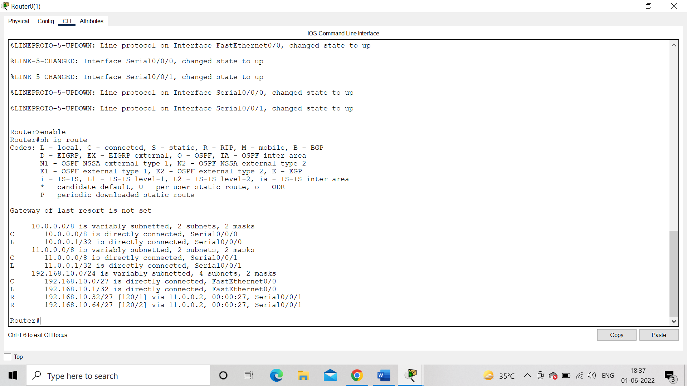(Routing table of Router0)

**Result**

The connections were made, IPs were given and routing was done successfully.

* We can see the significant difference in the routing tables.
* Also, the TTL for RIPv2 for the same ping came out to be 125 and time =2ms for each reply whereas for static it was TTL=123 and time=10,4,4,4ms resp.
* Both had 0% packet loss.
* Average time for Static is 5ms whereas for RIPv2 is 2ms.
* RIPv2 seems faster here in a small network but in a large one, static is faster and secured. However, RIPv2 can adapt better and is much more practical.

Therefore, we can safely conclude that RIPv2 is much easier to implement and much more practical than STATIC ROUTING.