**Ethical Hacking Day 3 Assignment**

**Submission by:**

Name - **Sooraj Tomar**

Reg. No. - **RA2011030010224**

Section – **N1**

Year – **III**

Semester – **V**

College – **SRM Institute of Science and Technology, Kattankulathur**

**Practice of Wireshark on Windows 10**

1. Wireshark showing interface of the connections and traffic of computer networks

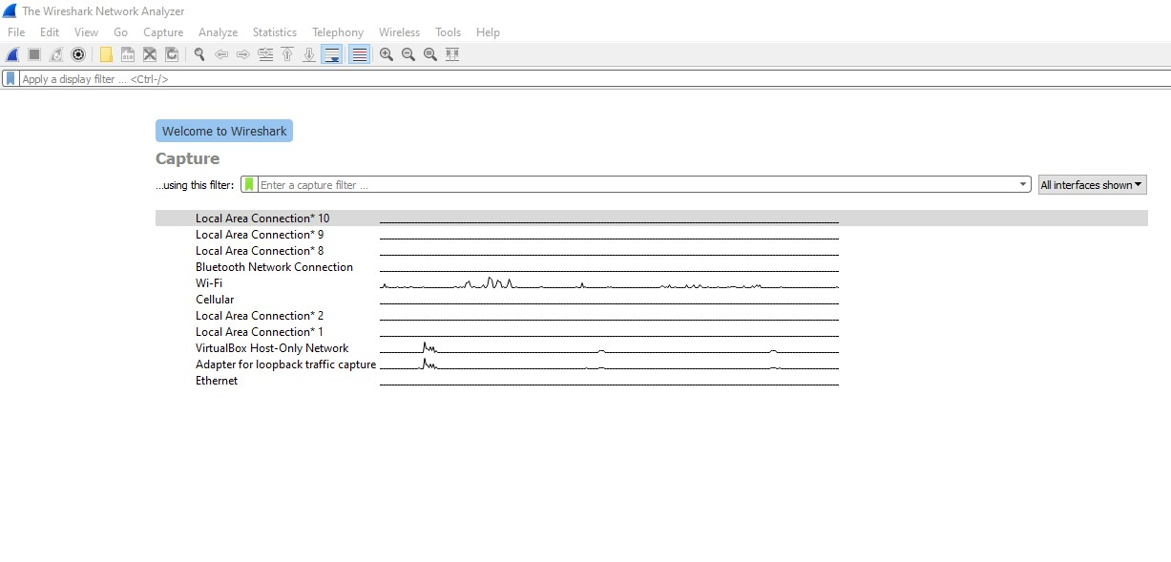

1. Wireshark capturing all traffic going through a computer interface. It shows time, source of IP address, destination, Protocol used etc.

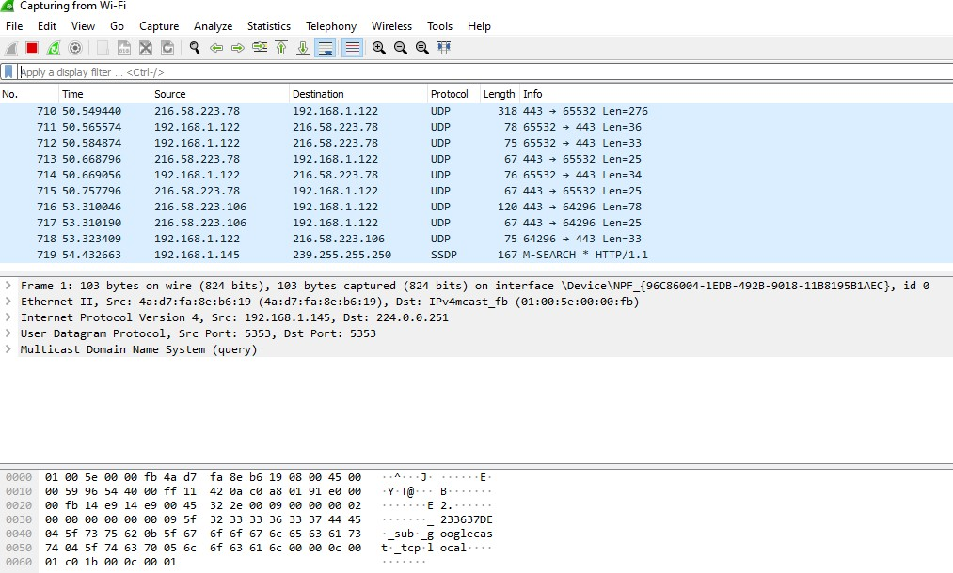

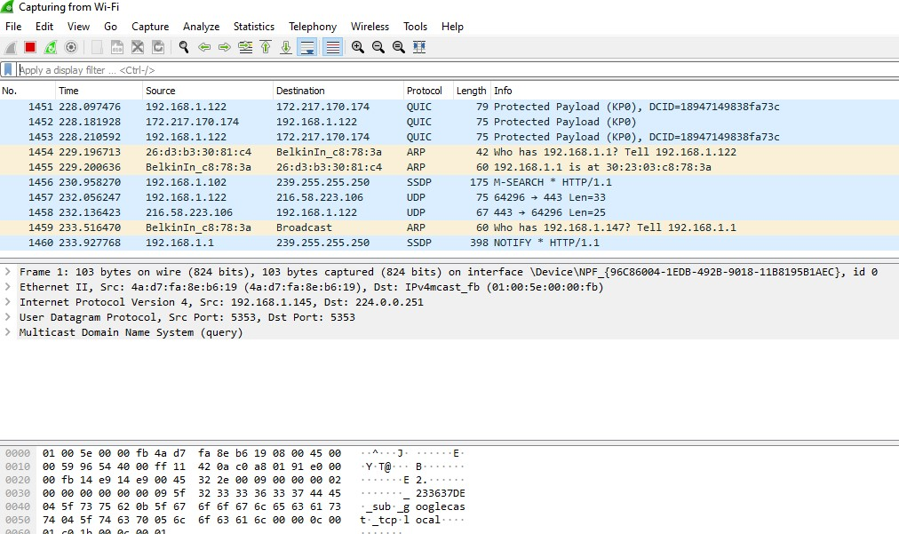

1. Filtering of protocol in Wireshark

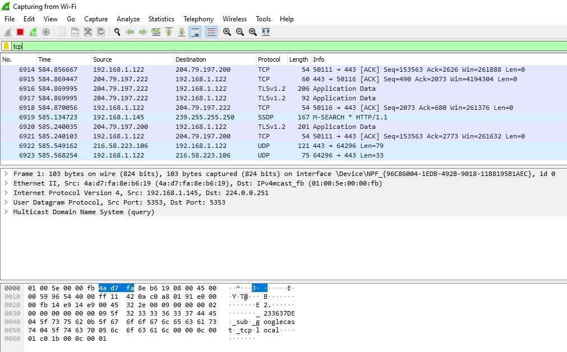

1. Using Etho to show number of packets and destination

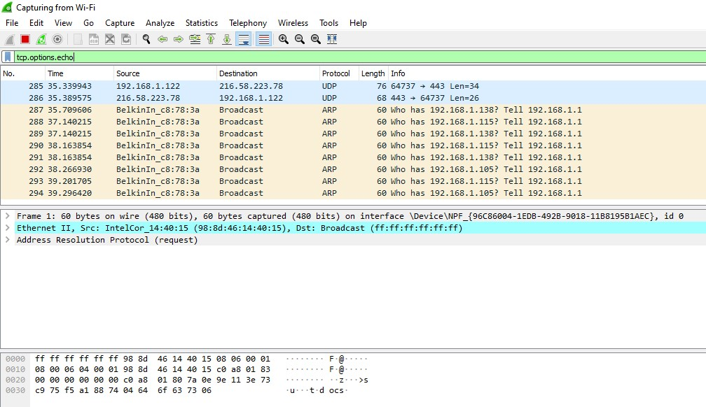

1. Filtering by specifying the host IP address and Port Number

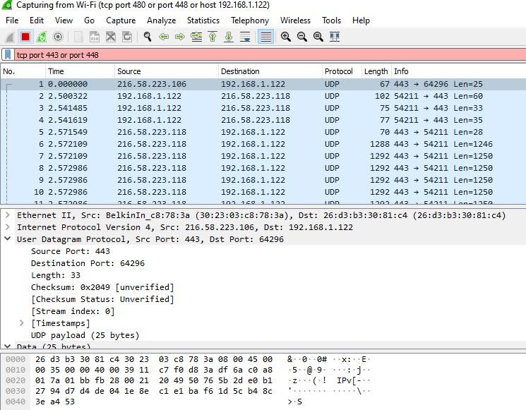

1. Sniffing Username and Password using Wireshark, tested using by logging into vulnweb.com for Username and Password

