**Ethical Hacking Day 1 Assignment**

**Submission by:**

Name - **Sooraj Tomar**

Reg. No. - **RA2011030010224**

Section – **N1**

Year – **III**

Semester – **V**

College – **SRM Institute of Science and Technology, Kattankulathur**

**Ques 1.** Use who is to find the web administrator

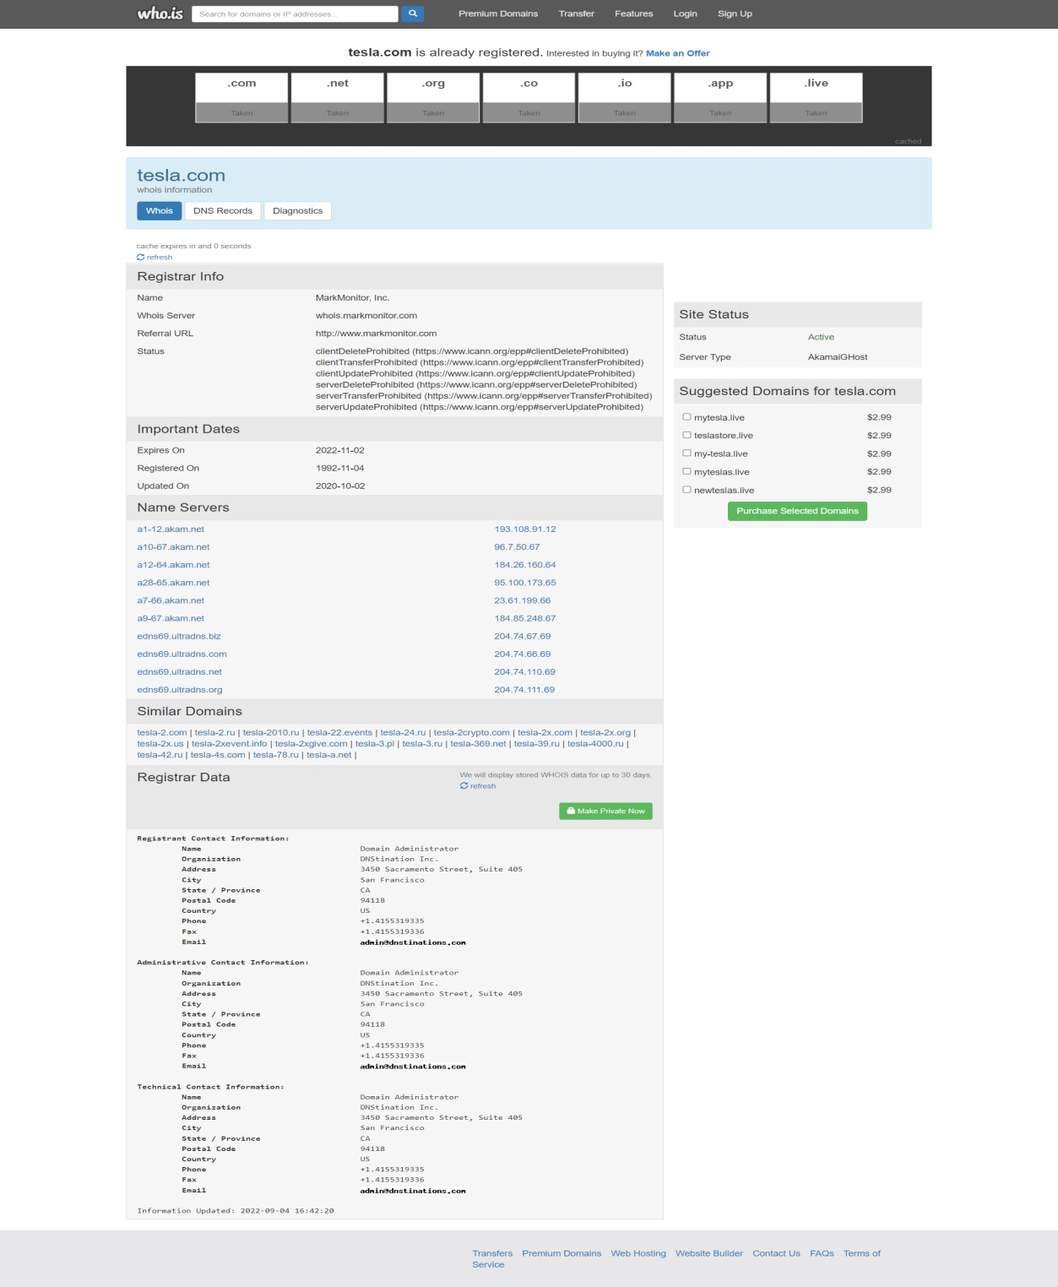

**Ques 2.** nslookup to find the dns details

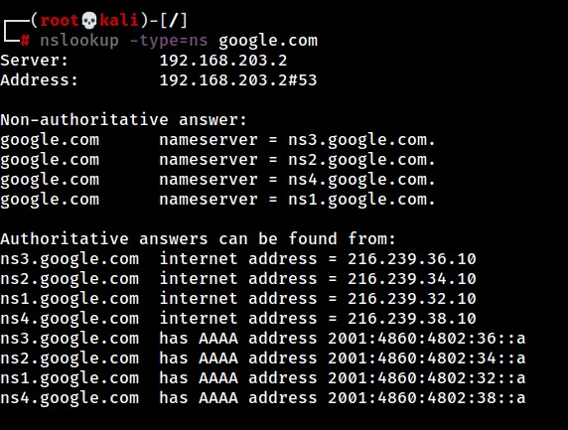

**Ques 3.** Use netcraft to find subdomains and OS versions

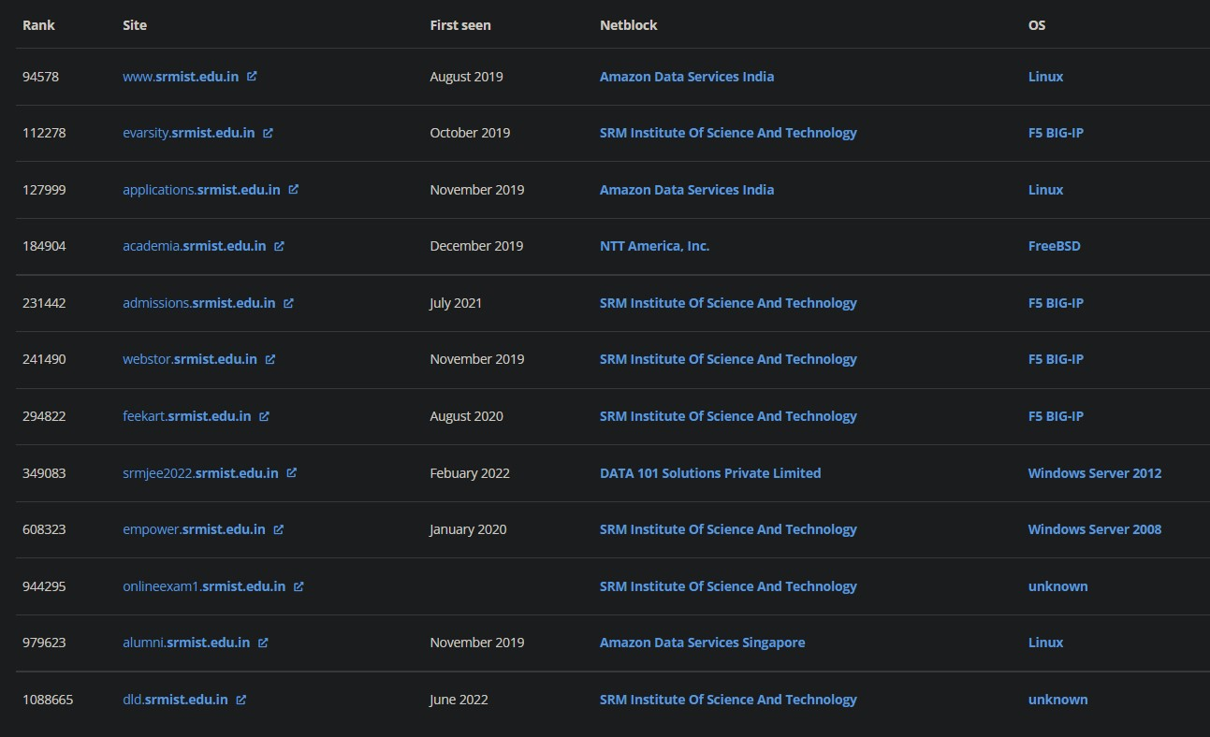

**Ques 4.** Use dnsdumpster.com to find website details

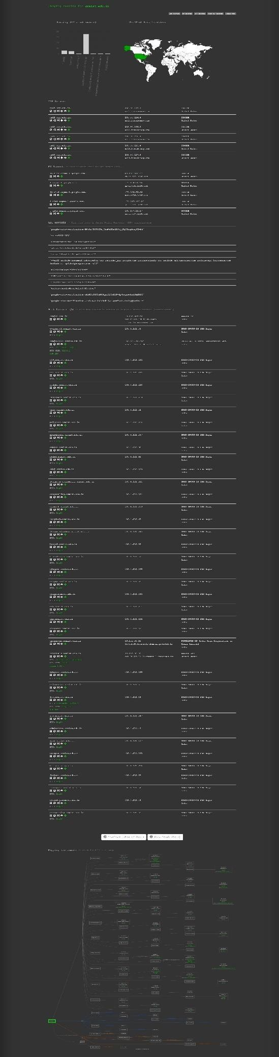

**Ques 5.** Use nmap for network scanning and port scanning

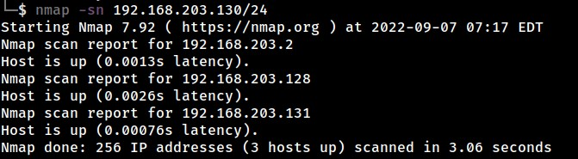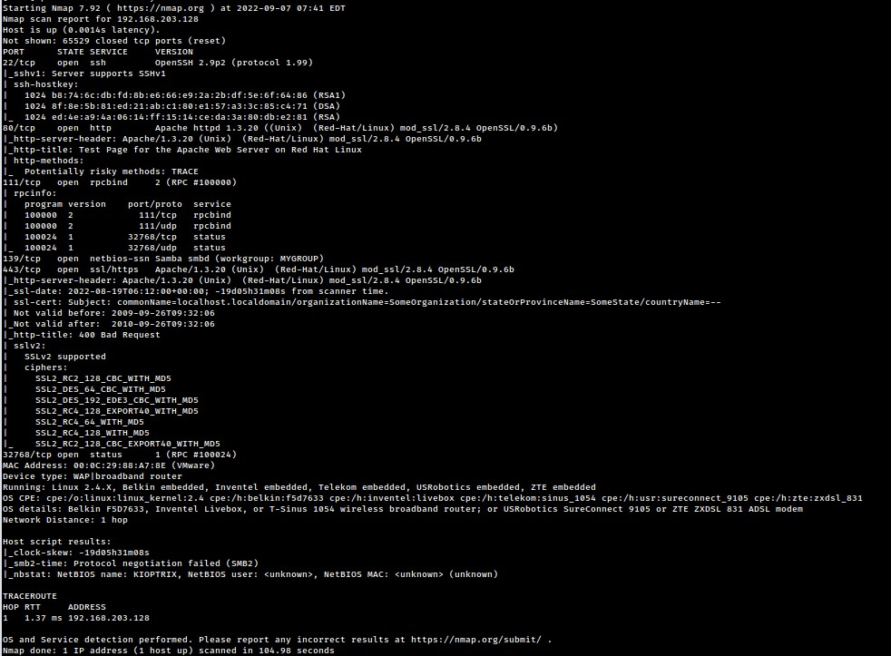

**Ques 1.** Use who is to find the web administrator

**Ques 1.** Use who is to find the web administrator

**Ques 1.** Use who is to find the web administrator

**Ques 1.** Use who is to find the web administrator

**Ques 6.** Use Nessus to find vulnerability of your friend’s computer

