

**School of Computing**

**SRM IST, Kattankulathur – 603 203**

**Course Code: 18CSC206J**

**Course Name: Software Engineering and Project Management**

|  |  |
| --- | --- |
| **Experiment No** | 13 |
| **Title of Experiment** | Provide the details of Architecture Design/Framework/Implementation |
| **Name of the candidate** | **SOORAJ TOMAR** |
| **Team Members** | **HARSHIT SHARMA (RA2011030010206), PIYUSH BISHT (RA2011030010226)** |
| **Register Numbers** | **RA2011030010224** |
| **Date of Experiment** | **6/6/22** |

**Mark Split Up**

|  |  |  |  |
| --- | --- | --- | --- |
| **S. No** | **Description** | **Maximum Mark** | **Mark Obtained** |
| 1 | Exercise | 5 |  |
| 2 | Viva | 5 |  |
| **Total** | | **10** |  |

**Staff Signature with date**

**Aim**

To provide the details of architectural design/framework/implementation.

**Team Members:**

|  |  |  |  |
| --- | --- | --- | --- |
| **S No** | **Register No** | **Name** | **Role** |
| **1** | **RA2011030010224** | **SOORAJ TOMAR** | **Rep/Member** |
| **2** | **RA2011030010206** | **HARSHIT SHARMA** | **Member** |
| **3** | **RA2011030010226** | **PIYUSH BISHT** | **Member** |

**Project Description:**

The software is a STUDENT ATTENDANCE MANAGEMENT SYSTEM where students can efficiently and easily check their details, attendance, detained subjects and edit their details. Faculty can also use the same. It is fast, efficient, easy to use and can help institutions worldwide when at its full potential.

**Modules:**

* Login page: Login for the users.
* Student details: Details of student (or faculty in later version) are displayed.
* Attendance Details: Attendance details of students.
* Detained Subjects: Detained subjects specially displayed for convenience.
* Edit Details: Students can edit their details (up to an extent).

**Screenshots:**

* Student Details:

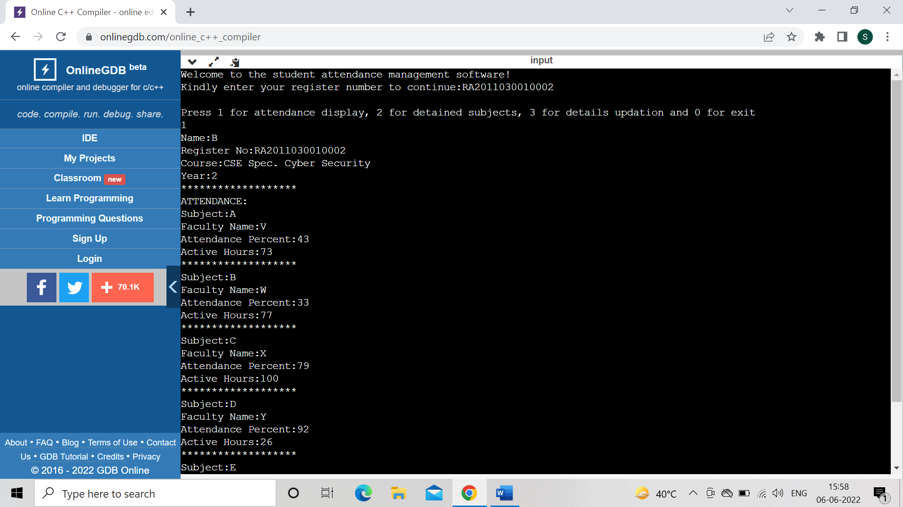

* Attendance Display:

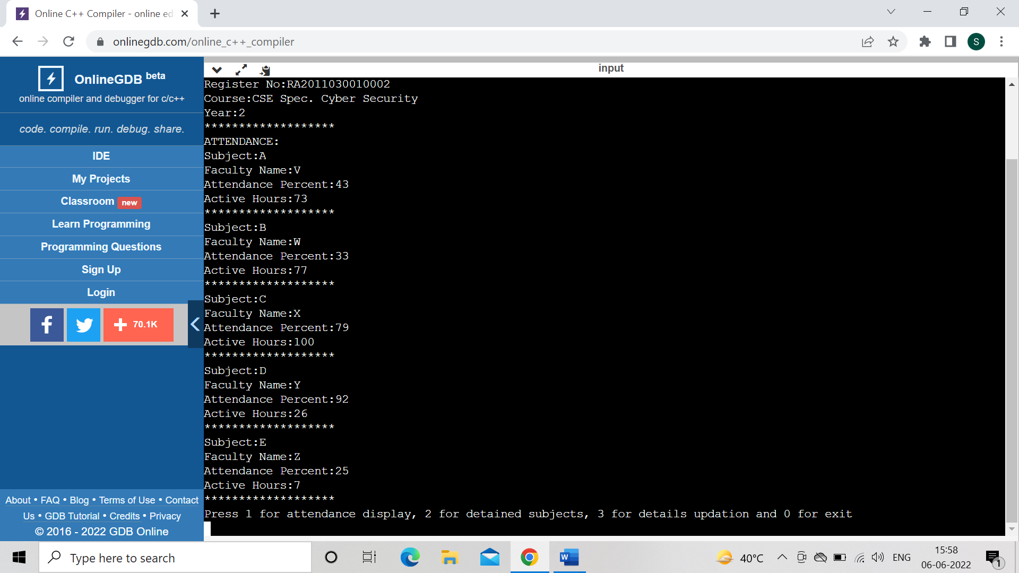

* Detained Subjects:

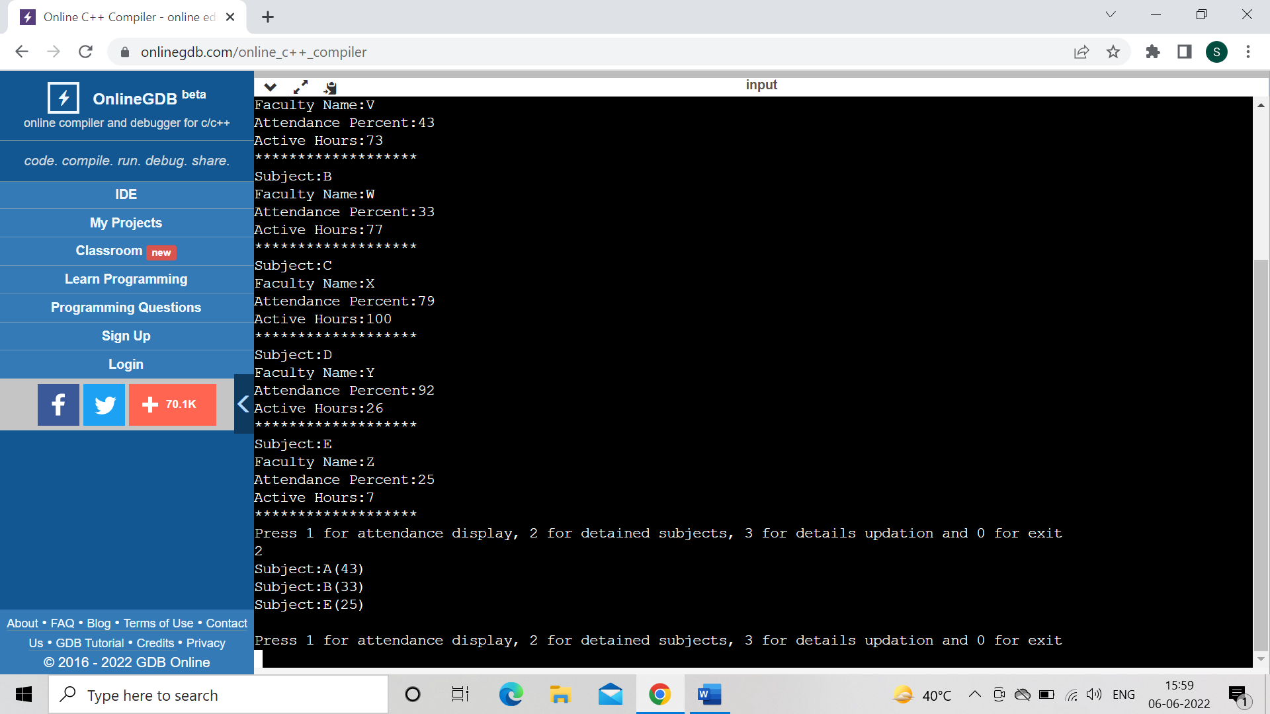

* Edit Details:

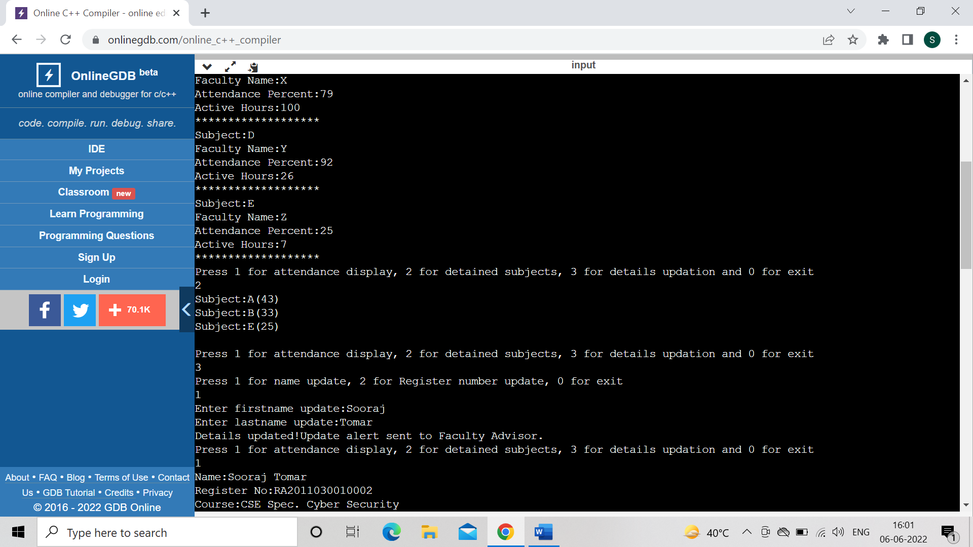

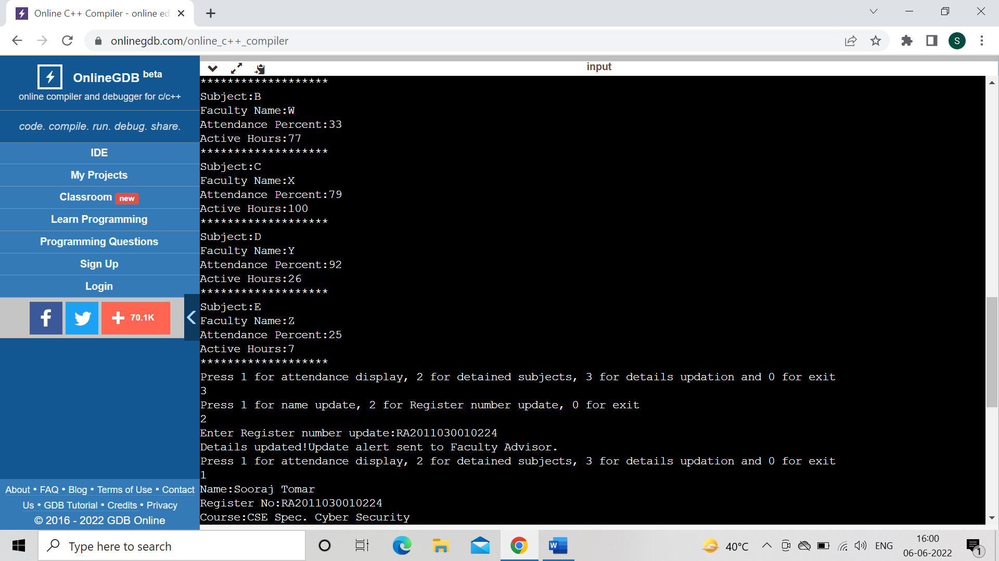

**Code:**

#include <bits/stdc++.h>

using namespace std;

struct Student

{

long regno,y,attendanceper[5],activehours[5];

string name,subject[5],facname[5],course;

}s[10];

void inputval()

{

unsigned seed = time(0);

srand(seed);

for(int i=0;i<10;i++)

{

s[i].name='A'+i;

s[i].y=2;

s[i].course="CSE Spec. Cyber Security";

for(int j=0;j<5;j++){

s[i].subject[j]='A'+j;

s[i].facname[j]='V'+j;

s[i].attendanceper[j]=(rand() % 100) + 1;

s[i].activehours[j]=(rand() % 100) + 1;

}

s[i].regno=2011030010001+i;

}

}

long getstudent(long rno)

{

for(int i=0;i<10;i++)

if(s[i].regno==rno)

return i;

return -1;

}

void displayval(int i)

{

cout<<"Name:"<<s[i].name<<"\nRegister No:RA"<<s[i].regno<<"\nCourse:"<<s[i].course<<"\nYear:"<<s[i].y<<"\n*******************\nATTENDANCE:";

for(int i1=0;i1<5;i1++)

{

cout<<"\nSubject:"<<s[i].subject[i1]<<"\nFaculty Name:"<<s[i].facname[i1]<<"\nAttendance Percent:"<<s[i].attendanceper[i1]<<"\nActive Hours:"<<s[i].activehours[i1];

cout<<"\n*******************";

}

}

void detained(int i)

{

for(int j=0;j<5;j++)

{

if(s[i].attendanceper[j]<75)

cout<<"Subject:"<<s[i].subject[j]<<"("<<s[i].attendanceper[j]<<")\n";

}

}

int main()

{

inputval();

long val;

cout<<"Welcome to the student attendance management software!\nKindly enter your register number to continue:RA";

cin>>val;

long rno=getstudent(val);

if(rno!=-1)

{

while(val!=0){

redo1:

cout<<"\nPress 1 for attendance display, 2 for detained subjects, 3 for details updation and 0 for exit\n";

cin>>val;

switch(val){

case 1:

displayval(rno);

break;

case 2:

detained(rno);

break;

case 3:

redo:

cout<<"Press 1 for name update, 2 for Register number update, 0 for exit\n";

int x;cin>>x;

switch(x){

case 1:{

string a,b;

cout<<"Enter firstname update:";

cin>>a;

cout<<"Enter lastname update:";

cin>>b;

s[rno].name=a+" "+b;

cout<<"Details updated!Update alert sent to Faculty Advisor.";

break;}

case 2:

cout<<"Enter Register number update:RA";

cin>>s[rno].regno;

cout<<"Details updated!Update alert sent to Faculty Advisor.";

break;

case 0:

goto exit2;

break;

default:

cout<<"INVALID CHOICE!!!!";

goto redo;

break;

}

break;

case 0:

goto exit1;

break;

default:

cout<<"INVALID CHOICE!!!!";

goto redo1;

break;

}

exit2:;

}

}

else

cout<<"NO SUCH REGISTER NUMBER!!!!!!";

exit1:

cout<<"\nThank you for visiting!";

cout<<"\nDeveloped by BiToSh Systems© Pvt. Ltd.\n(v1.3)";

return 0;

}

Result:

Thus, the details of architectural design/framework/implementation along with the screenshots were provided.