

**Department of Networking and Communications**

**SRM IST, Kattankulathur – 603 203**

**Course Code: 18CSC206J**

**Course Name: Software Engineering and Project Management**

|  |  |
| --- | --- |
| **Experiment No** | 2 |
| **Title of Experiment** | Identification of Process Methodology and Stakeholder Description |
| **Name of the candidate** | SOORAJ TOMAR |
| **Team Members** | HARSHIT SHARMA(RA2011030010206), PIYUSH BISHT(RA2011030010226) |
| **Register Number** | RA2011030010224 |
| **Date of Experiment** | 30/3/22 |

**Mark Split Up**

|  |  |  |  |
| --- | --- | --- | --- |
| **S.No** | **Description** | **Maximum Mark** | **Mark Obtained** |
| 1 | Exercise | 5 |  |
| 2 | Viva | 5 |  |
| **Total** | | **10** |  |

**Staff Signature with date**

**Aim**

To identify the appropriate Process Model for the project and prepare Stakeholder and User Description.

**Team Members:**

|  |  |  |  |
| --- | --- | --- | --- |
| **S. No.** | **Register No** | **Name** | **Role** |
| **1** | **RA2011030010224** | **SOORAJ TOMAR** | **Rep/Member** |
| **2** | **RA2011030010206** | **HARSHIT SHARMA** | **Member** |
| **3** | **RA2011030010226** | **PIYUSH BISHT** | **Member** |

**Project Title: STUDENT ATTENDANCE MANAGEMENT SYSTEM**

**Selection of Methodology**

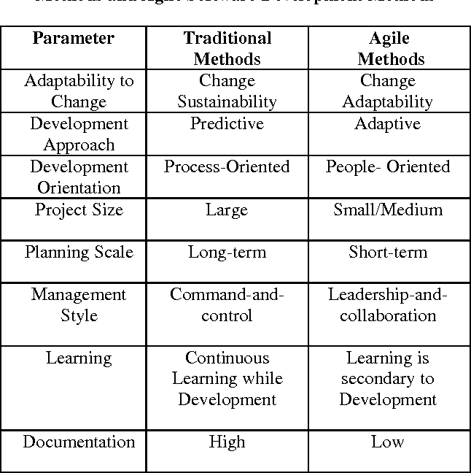

We have selected AGILE Methodology since our project is a relatively small project and it gives us flexibility to update our requirements as well as keep the software relevant in these changing times where we shall need fresh requirements or change the existing to be more efficient and productive. It also keeps LOW Documentation, so, we can focus on the project more.

Incorporate information to below table regarding stakeholders of the project:

|  |  |  |  |  |
| --- | --- | --- | --- | --- |
| Stakeholder Name | Activity/ Area /Phase | Interest | Influence | Priority (High/ Medium/ Low) |
| Student (User) | Login  Check Attendance details  Check detained Subjects  Update Other Details | High | Medium | High |
| Admin Staff | Login  Check Details for Attendance Take action for detained students | Medium | Low | Low |
| Developers | Create Software  Manage Software  Update Software | High | High | High |
| Server Management | Manage Connections  Communication between Database and User | Medium | Medium | Low |
| Database Management | Manage Data Transmission and updation | Medium | High | Medium |
| Teaching Staff (User) | Login  Check Attendance Details  Update Attendance Details  Update Other Details | High | High | Medium |

Result

Thus, the Project Methodology was identified and the stakeholders were described.