

**Department of Networking and Communications**

**SRM IST, Kattankulathur – 603 203**

**Course Code: 18CSC206J**

**Course Name: Software Engineering and Project Management**

|  |  |
| --- | --- |
| **Experiment No** | 5 |
| **Title of Experiment** | Prepare Work breakdown structure, Timeline chart, Risk identification table |
| **Name of the candidate** | SOORAJ TOMAR |
| **Team Members** | HARSHIT SHARMA(RA2011030010206), PIYUSH BISHT (RA2011030010226) |
| **Register Number** | RA2011030010224 |
| **Date of Experiment** | 13-04-22 |

**Mark Split Up**

|  |  |  |  |
| --- | --- | --- | --- |
| S. No. | Description | Maximum Mark | Mark Obtained |
| 1 | Exercise | 5 |  |
| 2 | Viva | 5 |  |
| Total | | 10 |  |

**Staff Signature with date**

**Aim**

To Prepare Work breakdown structure, Timeline chart and Risk identification table

**Team Members:**

|  |  |  |  |
| --- | --- | --- | --- |
| **S No** | **Register No** | **Name** | **Role** |
| **1** | **RA2011030010224** | **SOORAJ TOMAR** | **Rep** |
| **2** | **RA2011030010206** | **HARSHIT SHARMA** | **Member** |
| **3** | **RA2011030010226** | **PIYUSH BISHT** | **Member** |

**WBS**

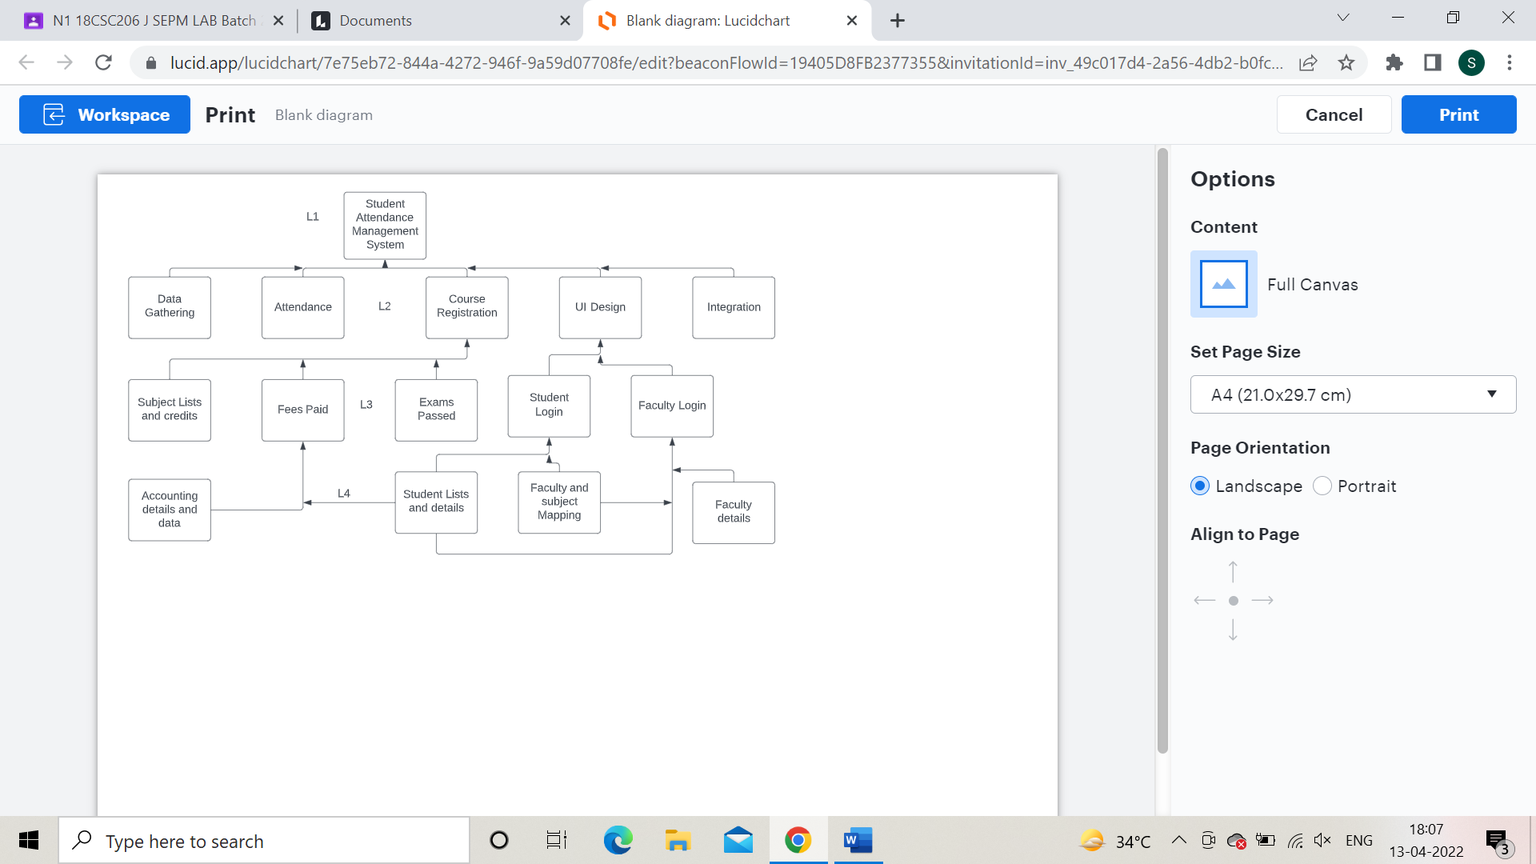

**TIMELINE – GANTT CHART**

|  |  |  |  |  |  |  |  |  |
| --- | --- | --- | --- | --- | --- | --- | --- | --- |
| **Activity** | **13/3** | **20/3** | **27/3** | **1/4** | **8/4** | **15/4** | **22/4** | **29/4** |
| Initial Stage  Planning |  |  |  |  |  |  |  |  |
| Requirement Gathering |  |  |  |  |  |  |  |  |
| Analysis |  |  |  |  |  |  |  |  |
| Design |  |  |  |  |  |  |  |  |
| Coding |  |  |  |  |  |  |  |  |
| Testing |  |  |  |  |  |  |  |  |
| Optimization, Debugging |  |  |  |  |  |  |  |  |
| Implementation |  |  |  |  |  |  |  |  |

**RISK ANALYSIS – SWOT & RMMM**

**SWOT Analysis**

**Strengths**

* Dedicated Skillful Staff
* Knowledge of the software
* Well experience in student attendance management
* Many inbuilt management software templates
* Low Budget requirements
* Support from University
* Provision of Internet
* Online links for learning
* Access to database and data

**Weaknesses**

* Facilities cannot be easily accessed by community
* Low coding expertise
* Low budget
* Less room for error
* Insufficient staff
* Insufficient Time
* Need for additional equipment
* Novice approach to software management
* Lack of communication/understanding

**Opportunities**

* Provide a well-functioning model of Attendance Management system to make life easier and efficient for students, teachers as well as admins
* Staff training and empowerment
* Build positive staff attitudes
* Increase our skill set
* Increase our moral and boost our software project management capabilities
* Increasing demand for services

**Threats**

* Occasional disruptive behavior of community
* Large data set can be difficult to manage effectively and efficiently
* Misunderstanding between developer and user aspect
* Maintenance can be treated as disruption to daily activity

**RMMM**

Impact Rating taken as (In Ascending order): Negligible, marginal, critical, and catastrophic

Score as 0-100: 0- Low Scare , 100- Large Scare

|  |  |  |  |
| --- | --- | --- | --- |
| **Risk Event** | **Probability** | **Impact Rating** | **Score(0-100)** |
| Late delivery of Hardware leading to late delivery of Software | 35% | Critical | 70 |
| Data loss due to large amount | 90% | Catastrophic | 90 |
| Delay in service due to server issues | 90% | Marginal | 30 |
| Unauthorized Login | 10% | Catastrophic | 100 |
| Incorrect data entry by admin or teacher leading to incorrect data display | 90% | Negligible | 15 |

Result:

Thus, the work breakdown structure with timeline chart and risk table were formulated successfully.