

**Department of Networking and Communications**

**SRM IST, Kattankulathur – 603 203**

**Course Code: 18CSC206J**

**Course Name: Software Engineering and Project Management**

|  |  |
| --- | --- |
| **Experiment No** | 6 |
| **Title of Experiment** | Design a System Architecture, Use Case and Class Diagram |
| **Name of the candidate** | SOORAJ TOMAR |
| **Team Members** | HARSHIT SHARMA (RA2011030010206), PIYUSH BISHT (RA2011030010226) |
| **Register Number** | RA2011030010224 |
| **Date of Experiment** | 22/4/22 |

**Mark Split Up**

|  |  |  |  |
| --- | --- | --- | --- |
| **S.No** | **Description** | **Maximum Mark** | **Mark Obtained** |
| 1 | Exercise | 5 |  |
| 2 | Viva | 5 |  |
| **Total** | | **10** |  |

**Staff Signature with date**

**Aim**

To Design a System Architecture, Use case and Class Diagram

**Team Members:**

|  |  |  |  |
| --- | --- | --- | --- |
| **S No** | **Register No** | **Name** | **Role** |
| **1** | RA2011030010224 | **SOORAJ TOMAR** | **Rep** |
| **2** | RA2011030010206 | **HARSHIT SHARMA** | **Member** |
| **3** | RA2011030010226 | **PIYUSH BISHT** | **Member** |

**Requirements:**

System Architecture, Use Case and Class Diagram.

**SYSTEM ARCHITECTURE**

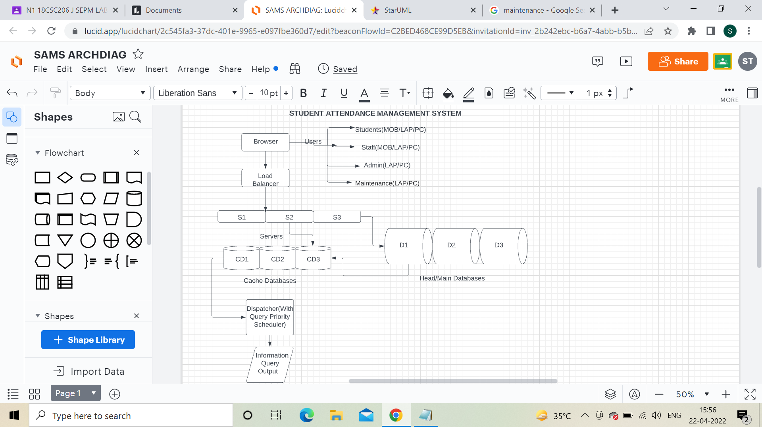

**USE CASE DIAGRAM**

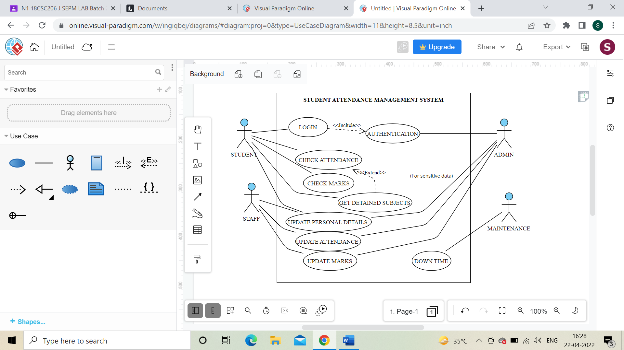

**CLASS DIAGRAM**

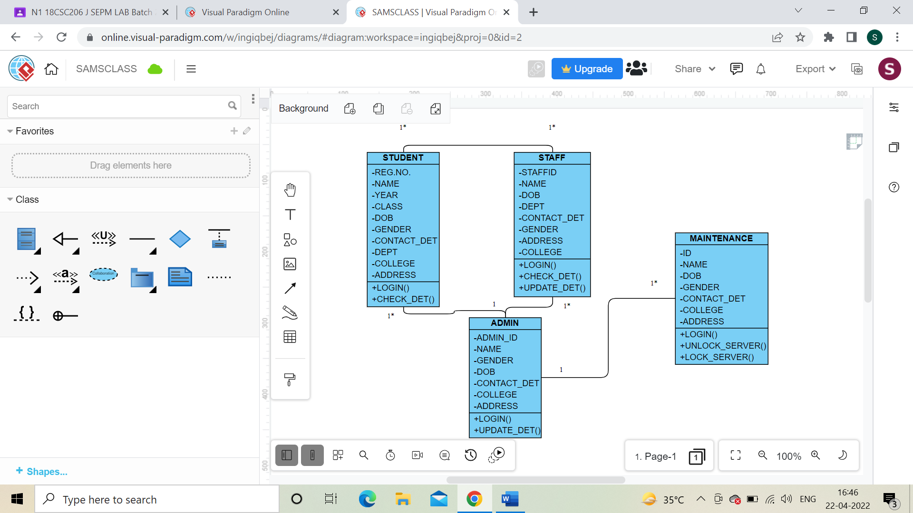

Result: Thus, the system architecture, use case and class diagram created successfully.