**Soorya P**

**Integrated MCA S9**

UML diagram

**Mini Project: E-Ration Shop**

Use Case Diagram

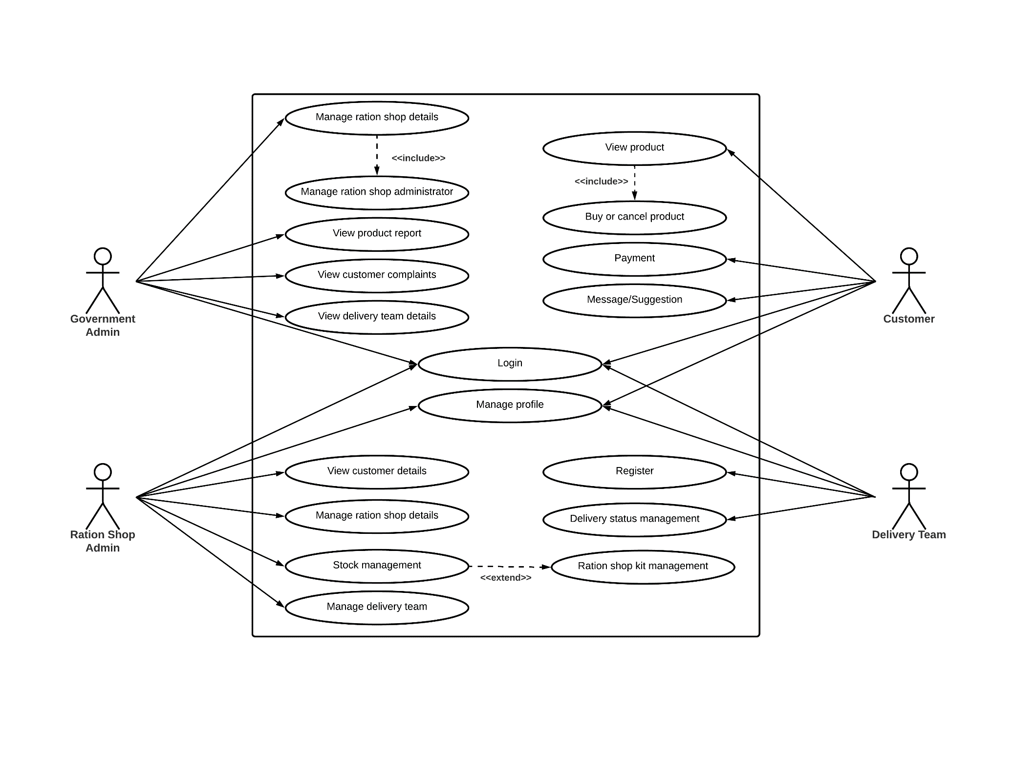

Sequence Diagram

**Customer**

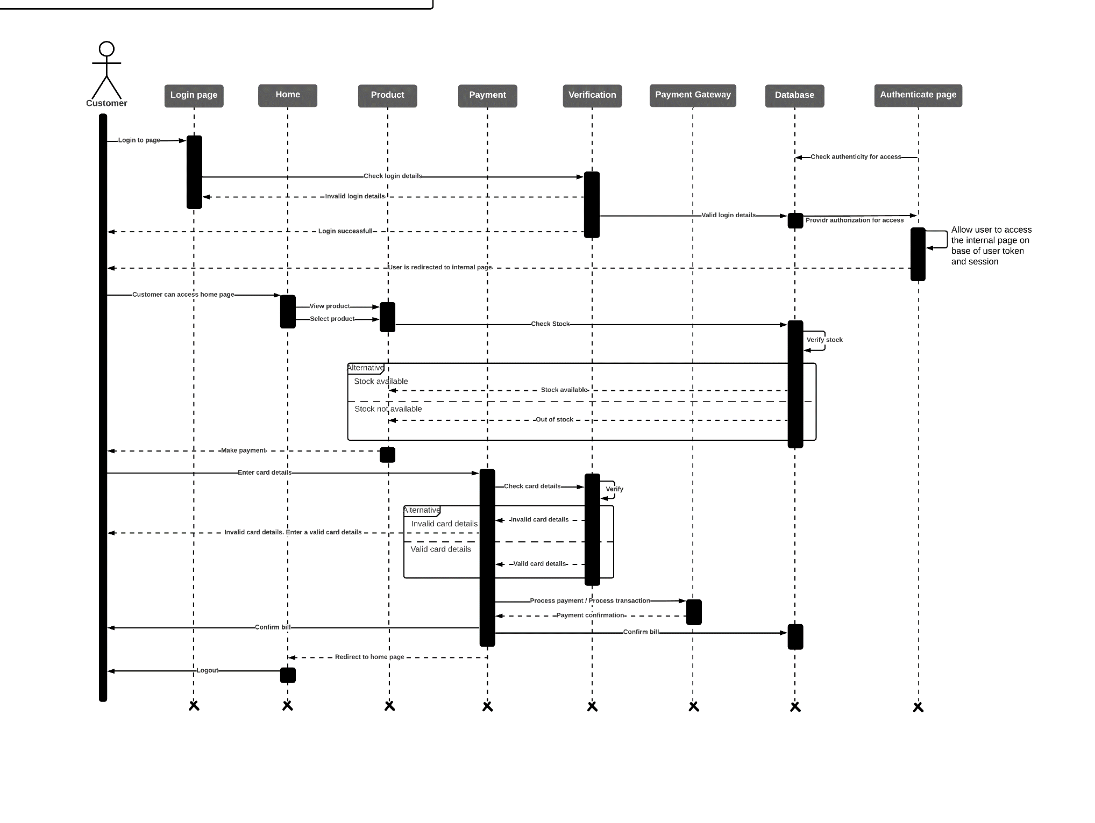

State Chart Diagram

**Customer**

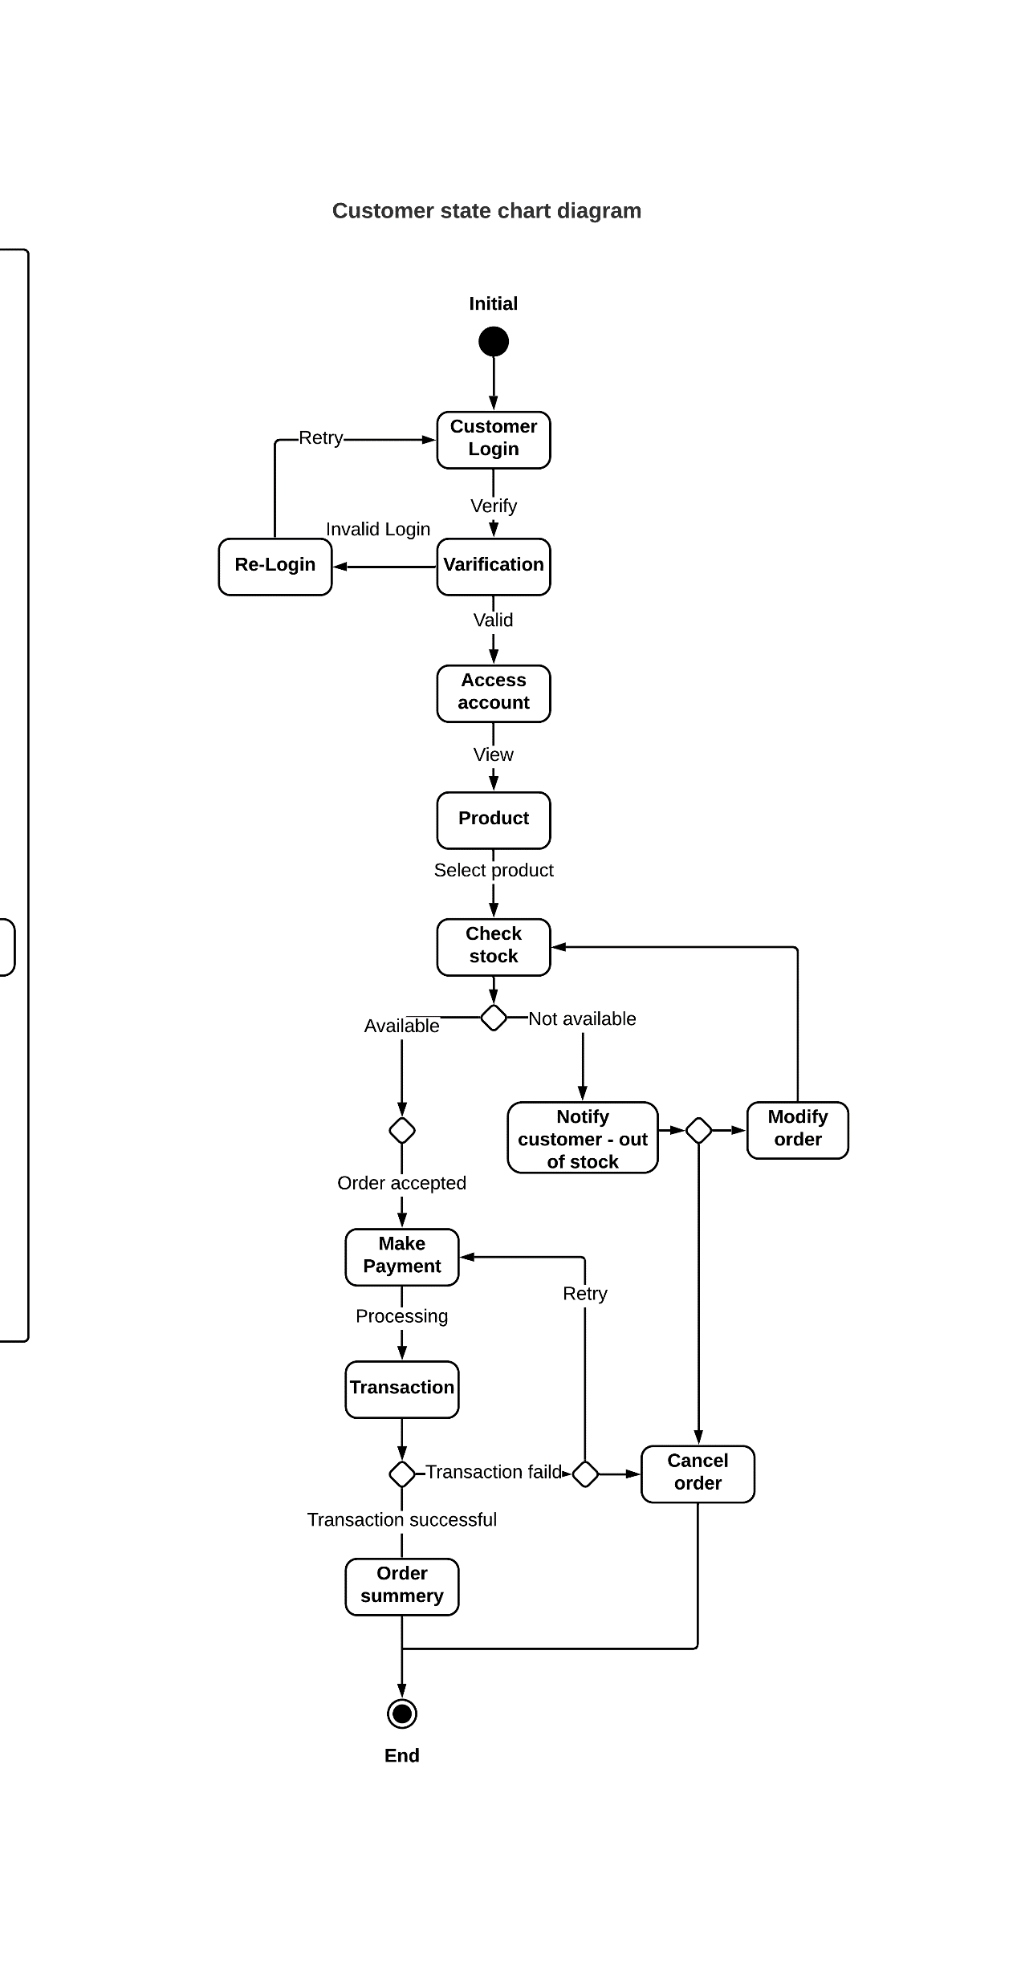

Activity Diagram

**Process shopping order**

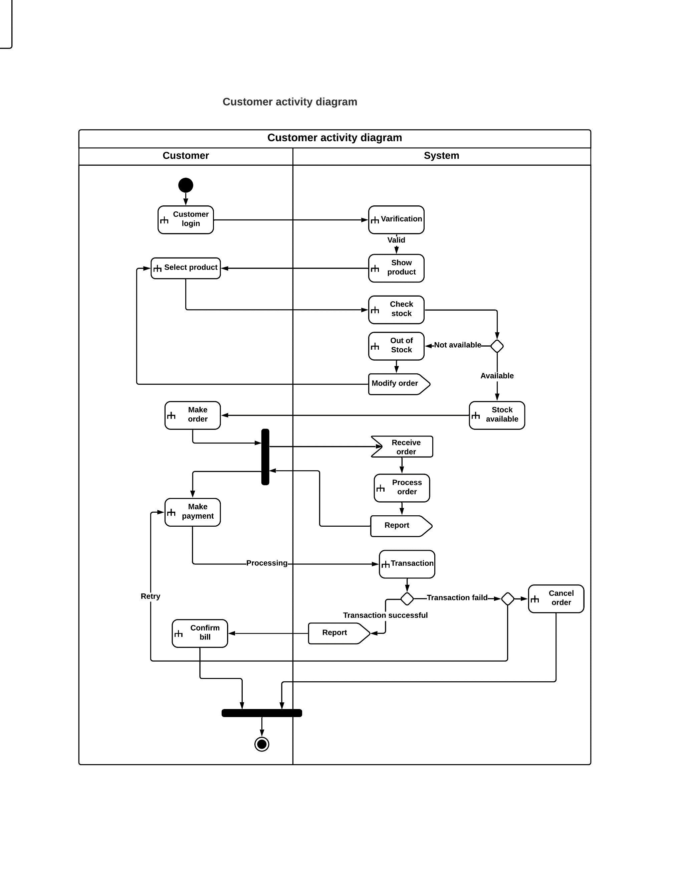

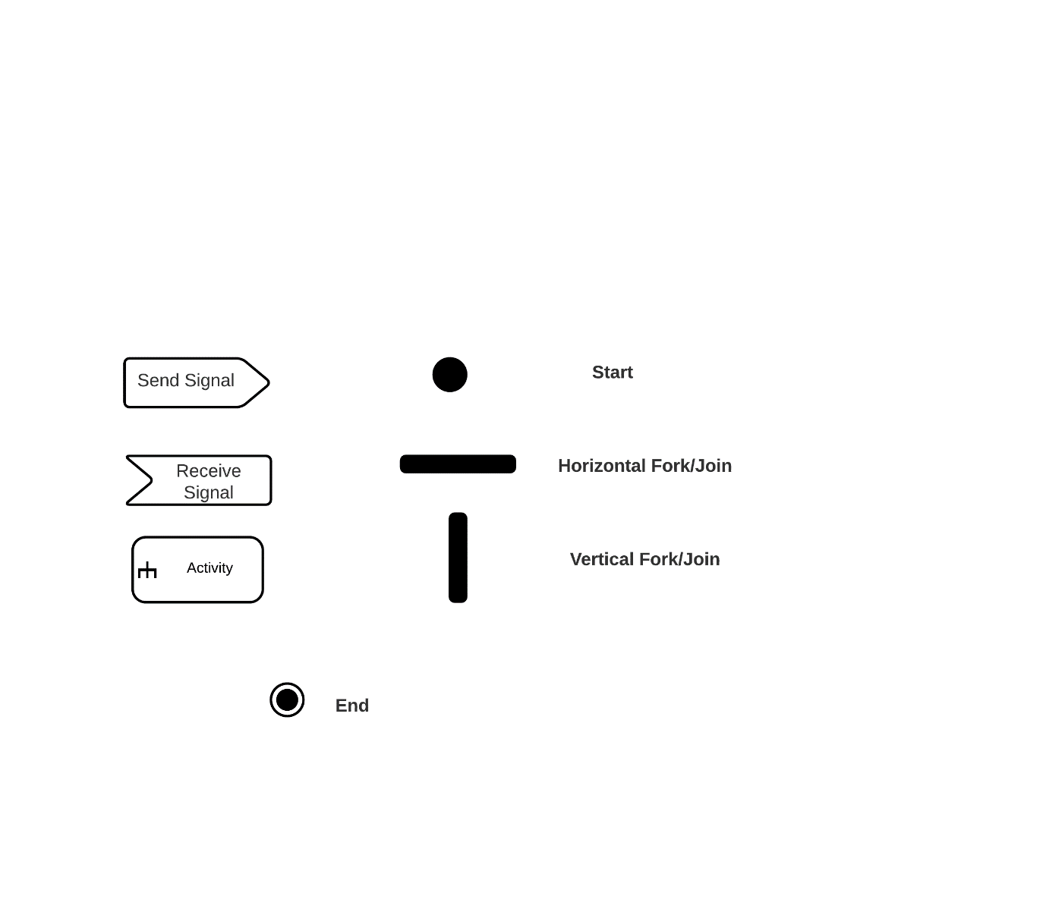

Component Diagram

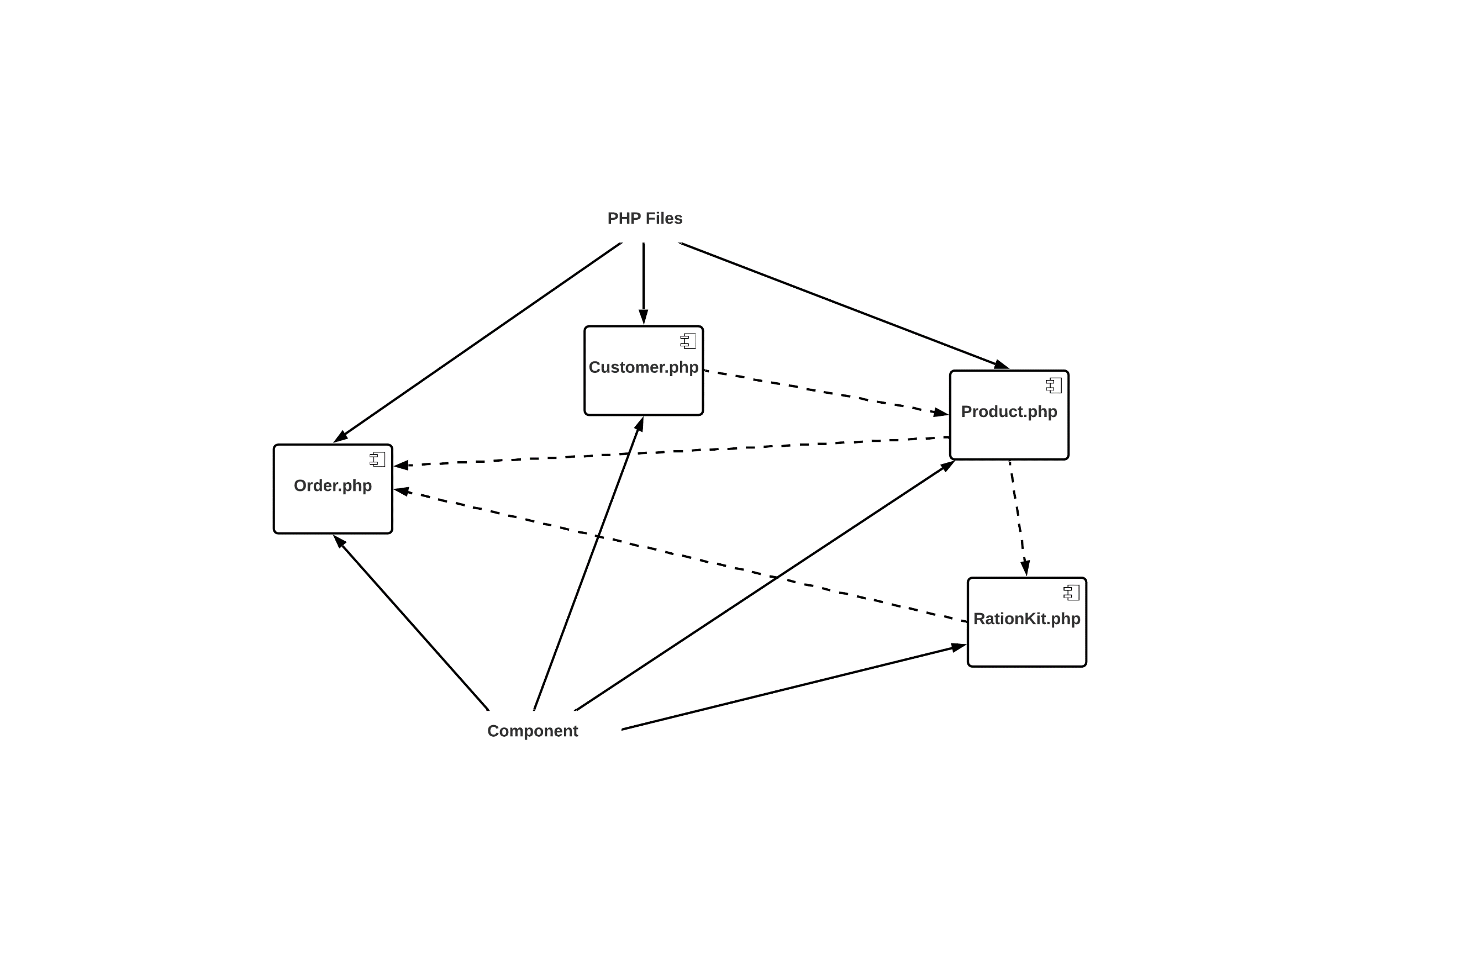

Deployment Diagram

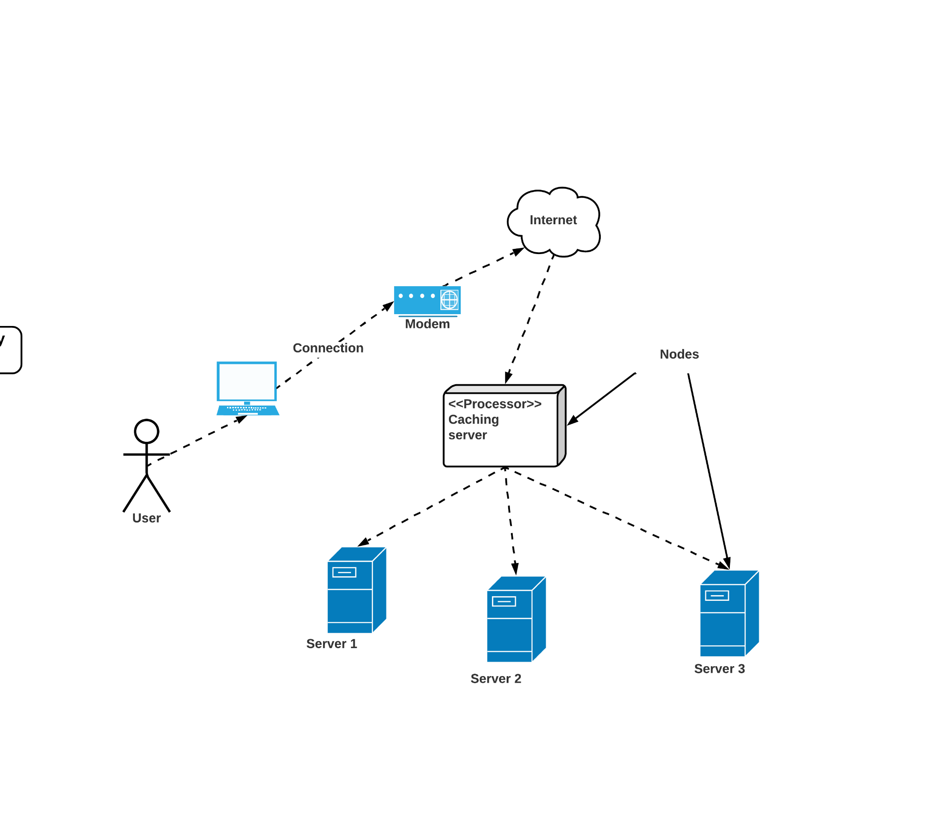

Class Diagram

