**CIA-1**

**1)**

**CODE:**

package com.Test.Testing;

import org.openqa.selenium.By;

import org.openqa.selenium.WebDriver;

//import org.openqa.selenium.WebElement;

import org.openqa.selenium.chrome.ChromeDriver;

import org.openqa.selenium.chrome.ChromeOptions;

import io.github.bonigarcia.wdm.WebDriverManager;

public class Ciaone_1 {

public static void main(String[] args) throws InterruptedException {

// TODO Auto-generated method stub

ChromeOptions co=new ChromeOptions();

co.addArguments ("--remote-allow-origins=*");

WebDriverManager.chromedriver().setup ();

WebDriver driver=new ChromeDriver(co);

driver.get ("https://www.amazon.in/Spigen-Urban-Fabric-Compatible-MacBook/dp/B09R2KCXD2/?_encoding=UTF8&pd_rd_w=hN3t9&content-id=amzn1.sym.e0e8ce89-ede3-4c51-b6ad-44989efc8536&pf_rd_p=e0e8ce89-ede3-4c51-b6ad-44989efc8536&pf_rd_r=10MH3SN3ES208H0RRNSQ&pd_rd_wg=wPWJi&pd_rd_r=13f23fa2-e355-40ad-a989-abace7275caf&ref_=pd_gw_ci_mcx_mr_hp_d");

driver.manage().window().maximize() ;

String currentTitle=driver.getTitle();

System.out.println(currentTitle);

String expectedTitle="Spigen Urban Fit Fabric Case Cover Compatible with MacBook Pro 14 inch (2021) - Black - Buy Spigen Urban Fit Fabric Case Cover Compatible with MacBook Pro 14 inch (2021) - Black Online at Low Price in India - Amazon.in";

if(currentTitle.equals(expectedTitle)) {

System.out.println("Title Matched");

}

else {

System.out.println("Title not Matched");

}

driver.findElement(By.xpath("//*[@id=\"add-to-cart-button\"]")).click();

driver.findElement(By.xpath("//*[@id=\"nav-cart\"]")).click();

driver.findElement(By.xpath("//*[@id=\"a-autoid-0-announce\"]")).click();

driver.findElement(By.xpath("//*[@id=\"quantity_4\"]")).click();

driver.findElement(By.xpath("//*[@id=\"sc-buy-box-ptc-button\"]/span/input")).click();

Thread.sleep(5000);

}

}

**OUTPUT:**

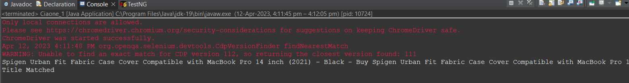

**2)**

**CODE:**

package com.Test.Testing;

import org.openqa.selenium.By;

import org.openqa.selenium.WebDriver;

import org.openqa.selenium.WebElement;

import org.openqa.selenium.chrome.ChromeDriver;

import org.openqa.selenium.chrome.ChromeOptions;

import io.github.bonigarcia.wdm.WebDriverManager;

public class Ciaone_2 {

public static void main(String[] args) {

// TODO Auto-generated method stub

ChromeOptions co=new ChromeOptions();

co.addArguments ("--remote-allow-origins=*");

WebDriverManager.chromedriver().setup ();

WebDriver driver=new ChromeDriver(co);

driver.get ("https://www.amazon.in/");

driver.manage().window().maximize() ;

String currentTitle=driver.getTitle();

System.out.println(currentTitle);

String expectedTitle="Online Shopping site in India: Shop Online for Mobiles, Books, Watches, Shoes and More - Amazon.in";

if(currentTitle.equals(expectedTitle)) {

System.out.println("Title Matched");

}

else {

System.out.println("Title not Matched");

}

WebElement txtBoxl=driver.findElement(By.xpath("//*[@id=\"twotabsearchtextbox\"]"));

txtBoxl.sendKeys("macbook");

driver.findElement(By.xpath("//*[@id=\"nav-search-submit-button\"]")).click();

//displaying 5 products

String txt1=driver.findElement(By.xpath("//*[@id=\"search\"]/div[1]/div[1]/div/span[1]/div[1]/div[3]/div/div/div/div/div/div/div/div[2]/div/div/div[1]/h2/a/span")).getText();

System.out.println(txt1);

String txt2=driver.findElement(By.xpath("//*[@id=\"search\"]/div[1]/div[1]/div/span[1]/div[1]/div[4]/div/div/div/div/div/div/div/div[2]/div/div/div[1]/h2/a/span")).getText();

System.out.println(txt2);

String txt3=driver.findElement(By.xpath("//*[@id=\"search\"]/div[1]/div[1]/div/span[1]/div[1]/div[5]/div/div/div/div/div/div[2]/div/div/div[1]/h2/a/span")).getText();

System.out.println(txt3);

String txt4=driver.findElement(By.xpath("//*[@id=\"search\"]/div[1]/div[1]/div/span[1]/div[1]/div[6]/div/div/div/div/div/div[2]/div/div/div[1]/h2/a/span")).getText();

System.out.println(txt4);

String txt5=driver.findElement(By.xpath("//*[@id=\"search\"]/div[1]/div[1]/div/span[1]/div[1]/div[7]/div/div/div/div/div/div[2]/div/div/div[1]/h2/a/span")).getText();

System.out.println(txt5);

//filter

driver.findElement(By.xpath("//*[@id=\"p_36/7252032031\"]/span/a/span")).click();

driver.findElement(By.xpath("//*[@id=\"p_n_pattern_browse-bin/1464446031\"]/span/a/span")).click();

}

}

**OUTPUT:**

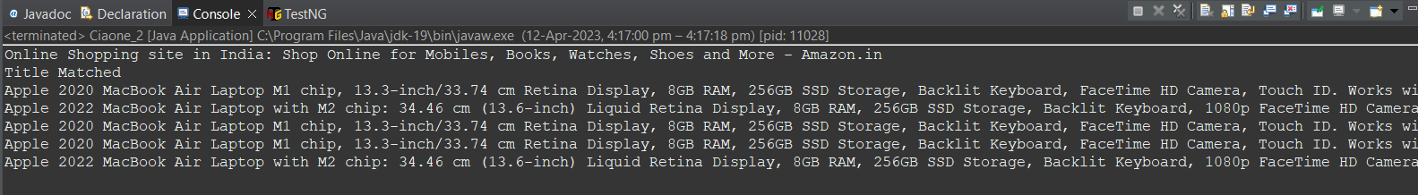

**3)**

**Code:**

package com.Test.Testing;

import org.openqa.selenium.By;

import org.openqa.selenium.WebDriver;

import org.openqa.selenium.WebElement;

import org.openqa.selenium.chrome.ChromeDriver;

import org.openqa.selenium.chrome.ChromeOptions;

import io.github.bonigarcia.wdm.WebDriverManager;

public class Ciaone_3 {

public static void main(String[] args) {

ChromeOptions co=new ChromeOptions();

co.addArguments ("--remote-allow-origins=*");

WebDriverManager.chromedriver().setup ();

WebDriver driver=new ChromeDriver(co);

driver.get ("https://www.amazon.in/");

driver.manage().window().maximize() ;

String currentTitle=driver.getTitle();

System.out.println(currentTitle);

String expectedTitle="Online Shopping site in India: Shop Online for Mobiles, Books, Watches, Shoes and More - Amazon.in";

if(currentTitle.equals(expectedTitle)) {

System.out.println("Title Matched");

}

else {

System.out.println("Title not Matched");

}

driver.findElement(By.xpath("//*[@id=\"nav-link-accountList\"]")).click();

WebElement txtBoxl=driver.findElement(By.xpath("//*[@id=\"ap_email\"]"));

txtBoxl.sendKeys("8688797149");

driver.findElement(By.xpath("//*[@id=\"continue\"]")).click();

WebElement txtBox2=driver.findElement(By.xpath("//*[@id=\"ap_password\"]"));

txtBox2.sendKeys("C0llin_H00v3r");

driver.findElement(By.xpath("//*[@id=\"signInSubmit\"]")).click();

driver.findElement(By.xpath("//*[@id=\"nav-link-accountList\"]")).click();

driver.findElement(By.xpath("//*[@id=\"a-page\"]/div[2]/div/div[2]/div[1]/a/div/div")).click();

driver.findElement(By.xpath("//*[@id=\"a-autoid-2-announce\"]")).click();

driver.findElement(By.xpath("//*[@id=\"ordersInPackage-container\"]/div/div/a[1]")).click();

}

}

**OUTPUT:**

