ASSIGNMENT 3
SYSTEMS ENGINEERING FOR
DEEP LEARNING

Submitted By: Sooryakiran (ME17B174)

STEP 1
A neural network with the given architecture was trained on the FMNIST dataset. The network weights were initialized with Xavier uniform initialisation. Stochastic Gradient Descend optimizer with momentum was used with a learning rate of 0.001 and with a momentum weightage of 0.9.

Dataset  Table 1.1:  Model and training hyperparameters. | FMNIST  60000 Training samples  10000 Testing samples
Preprocessing | Normalization
Optimizer | SGD with momentum
Learning Rate | 1e-3
Momentum (β) | 0.9
Batch Size | 32
Network initialization | Weights : Xavier uniform  Biases : Zero
Network Architecture | Layer 1 :  Conv 3x3, 16 Channels, ReLU  Layer 2:  Conv 3x3, 16 Channels, ReLU  Layer 3:  Dense 100 neurons, ReLU  Layer 4:  Dense 10 neurons, Softmax

The network was trained in a CPU only instance on Google Colaboratory. With a batch size of 32, I got 90.18 % training accuracy and a test accuracy of 88.33%. The loss vs batches plots and accuracy vs batches plots and the final results are given in the following page.

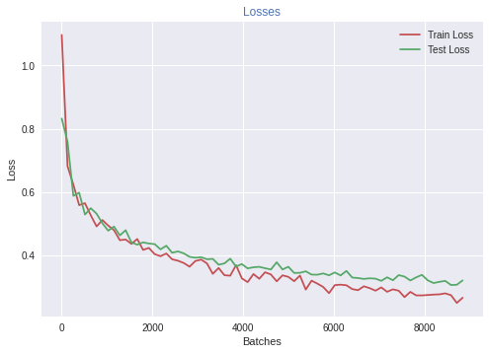

Figure 1.1.a:
Loss vs Batches plot

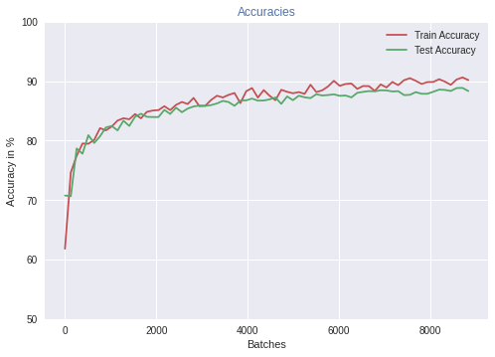

Figure 1.1.b:
Accuracy vs Batches plot

Google Facets was used to analyse the prediction performance of the trained model. Google Facets allow inputs only in CSV format. So the first the model was used to generate predictions for the entire test dataset. Then a CSV file was generated with columns being the True and Predicted labels. This CSV file was uploaded to Google Facets website. Many visualizations like the confusion matrix, distribution of predictions were obtained.

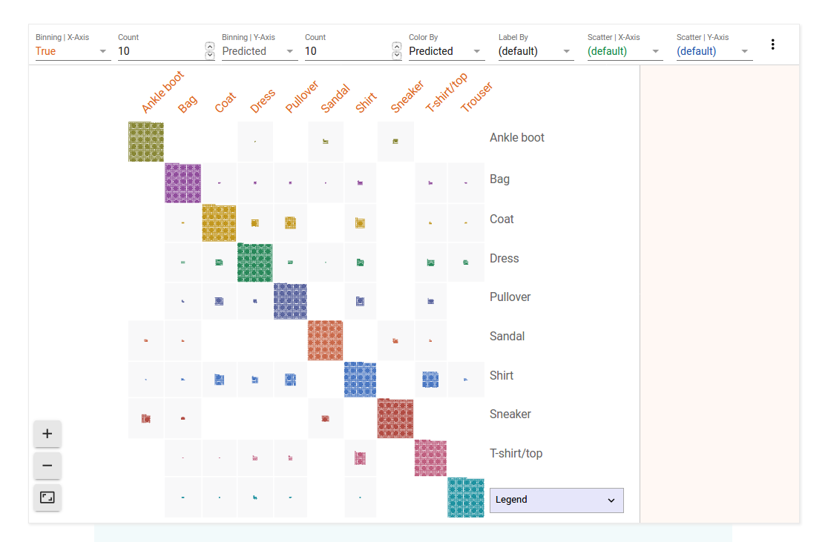

Figure 1.2.a:
Confusion Matrix

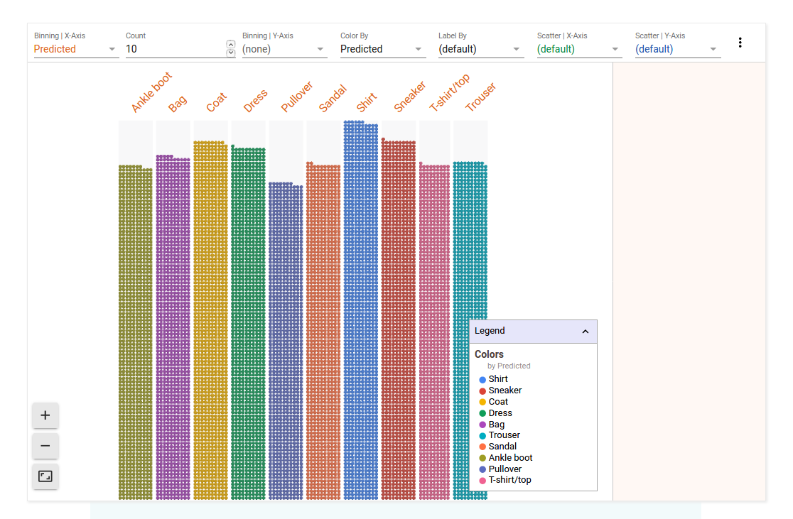

Figure 1.2.b:
Distribution of predictions.

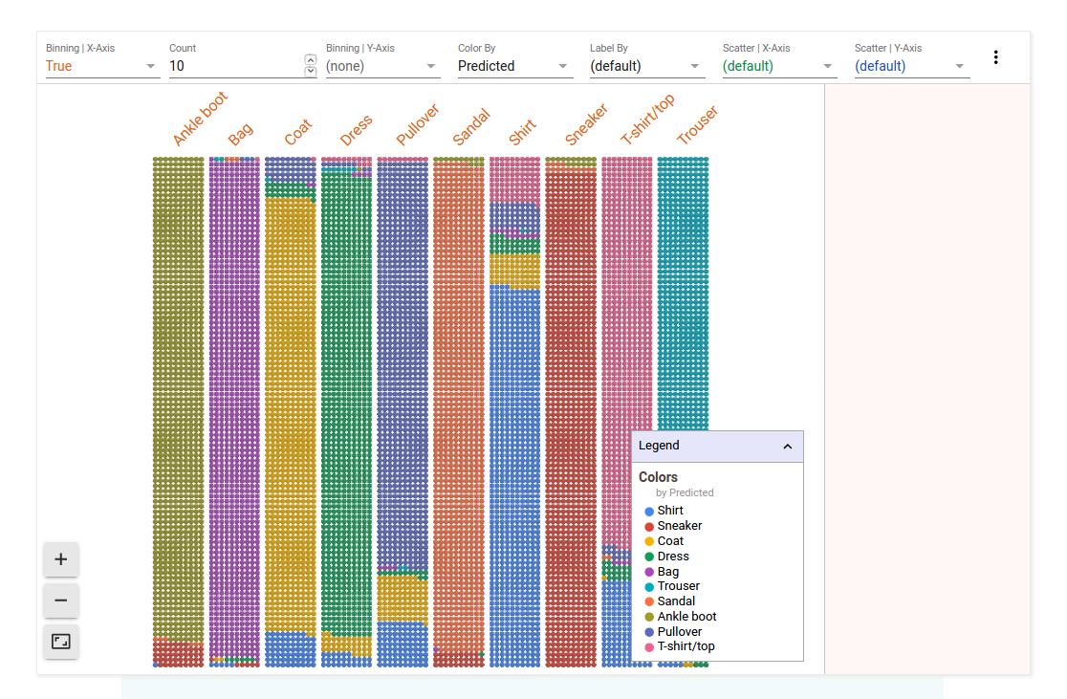

Figure 1.2.c:
Predictions for each true label.

These visualizations helps us to understand where out model is failing to perform. For example, in Fig. 1.2.c, we can see that nearly 30% of T-shirts/tops are misclassified as shirts.

¯\_(ツ)_/¯  Table 1.2:  Train and test performances | Loss | Accuracy
Training | 0.267 | 90.186 %
Testing | 0.321 | 88.338 %

STEP 2
MLflow was used to conduct grid search to find the optimial hyperparameters for the model. Two experiments were conducted, one to find the right Model Hyperparameters and another one to find the right Training Hyperparameters. These experiments were conducted one by one. The optimal model architecture obtained from the first experiment was used for the second experiment.

The first experiment search space is as follows:

Hyperparameter  Table 2.1.a:  The search space for experiment 1 | Values
Conv 1 kernel sizes | 3x3, 5x5
Conv 2 kernel sizes | 3x3, 5x5
Conv 1 no of filters | 8, 16, 32
Conv 2 no of filters | 8, 16, 32
Dense 1 no of neurons | 64, 100
Results are as follows.

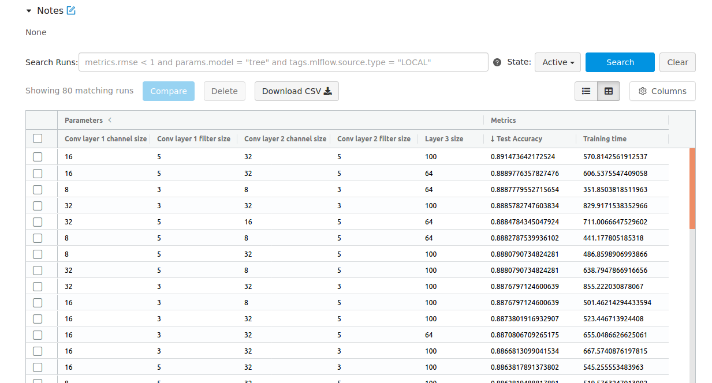

Fig 2.1.a:
Experiment results sorted by decreasing accuracy on the test dataset.

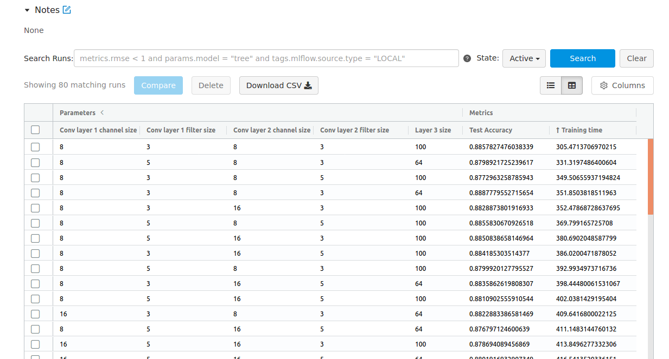
Fig 2.1.b:
Experiment results sorted by increasing training time required to reach 90% train accuracy.

.
Top 3 results are as shown below:

Table 2.1.a:  Top 3 results based on test accuracy. | #1 | #2 | #3
Conv 1 | 5x5, 16 filters | 5x5, 16 filters | 3x3, 8 filters
Conv 2 | 5x5, 32 filters | 5x5, 32 filters | 3x3, 8 filters
Dense 3 | 100 neurons | 64 neurons | 64 neurons
Test Accuracy | 89.14 % | 88.89 % | 88.87 %
Training Time | 570.81s | 606.53s | 351.85s

Table 2.1.b:  Top 3 results based on training time. | #1 | #2 | #3
Conv 1 | 3x3, 8 filters | 5x5, 8 filters | 3x3, 8 filters
Conv 2 | 3x3, 8 filters | 3x3, 8 filters | 5x5, 8 filters
Dense 3 | 100 neurons | 64 neurons | 100 neurons
Test Accuracy | 88.57 % | 87.98 % | 87.72 %
Training Time | 305s | 331s | 349s
Smaller filter sizes have smaller training time because there are less parameters and less computation involved. But filters with larger receptive field performs better as they have higher representative power. This effect is more profound for shallow networks like the one we experimented with. Also, netoworks with higher number of filters can represent more features and are likely to have higher performance but compromises on training time. When the number of neurons on the dense layer is incresed, it improves the performance but increases the training time.

I decided to choose the model with lowest training time for the next experiment because it is acceptable to sacrifice 0.64% of accuracy for 46% reduction in training time.
Experiment 2 was conducted on the model that had the smallest training time.

Hyperparameter  Table 2.2:  The search space for experiment 2 | Values
Initialisation | Xavier Uniform, Xavier Normal, Kaiming Uniform
Batch sizes | 8, 16, 32, 64
Optimizer params | 1. Learning rate : 0.001  Momentum : 0.9  2. Learning rate : 0.01  Momentum : 0.9  3. Learning rate : 0.001  Momentum : 0.5  4. Learning rate : 0.01  Momentum : 0.5

Results are as follows.

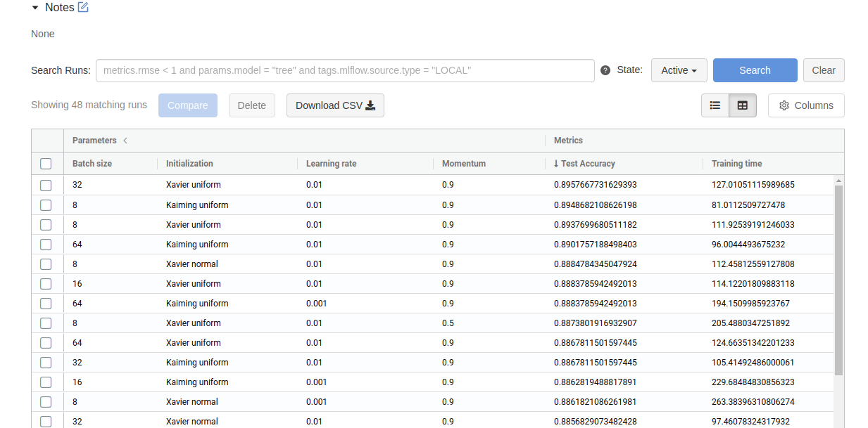

Fig 2.2.a:
Experiment 2 results sorted by decreasing accuracy on the test dataset.

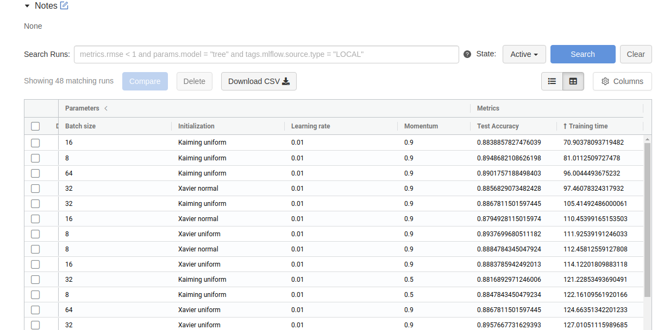

Fig 2.2.b:
Experiment 2 results sorted by increasing training time required to reach 90% train accuracy.

Top 3 results are as shown below:

Table 2.2.a:  Top 3 results based on test accuracy. | #1 | #2 | #3
Batch size | 32 | 8 | 8
Initialization | Xavier Uni. | Kaiming Uni. | Xavier Uni.
Learning rate | 0.01 | 0.01 | 0.01
Momentum | 0.9 | 0.9 | 0.9
Test Accuracy | 89.57 % | 89.48 % | 89.37 %
Training Time | 127s | 81s | 111s

Table 2.2.b:  Top 3 results based on training time. | #1 | #2 | #3
Batch size | 16 | 8 | 64
Initialization | Kaiming Uni. | Kaiming Uni. | Kaiming Uni.
Learning rate | 0.01 | 0.01 | 0.01
Momentum | 0.9 | 0.9 | 0.9
Test Accuracy | 88.38 % | 89.48 % | 89.01 %
Training Time | 70s | 81s | 96s

Learning rate of 0.01 performed well in most cases. It converges faster and results in better performance on the test dataset. Also models with momentum of 0.9 outperformed models with momentum of 0.5 because it is better in escaping local minima traps. Kaiming initialization is found to converge faster. A smaller batch size give rise to gradients that are more randomized comparitively. This might help in escaping the local minima traps.

Here are some scatter plots that can help us choose even better models. However, not every one of these plots are conclusive. Plots like the one for learning rate, momentum, and mumber of filters can help us generalise how different models behave according to different hyperparameters. The MLflow logs are converted to CSV files and uploaded to Google Facets.

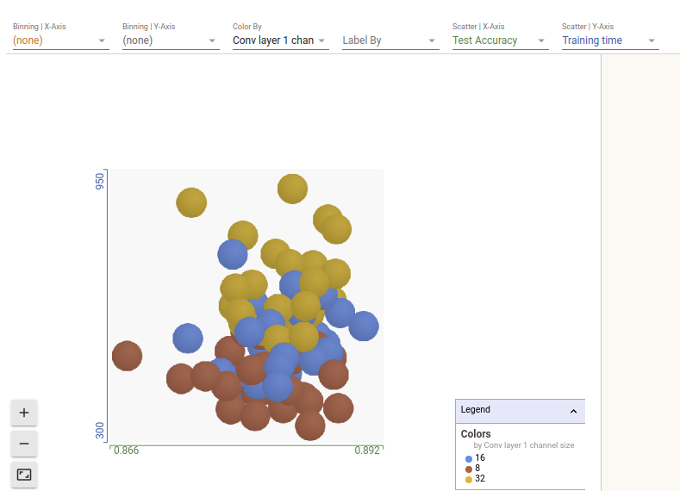
Fig 2.3.a:
Conv 1 no of filters
x-axis : Test accuracy
y-axis: Training time

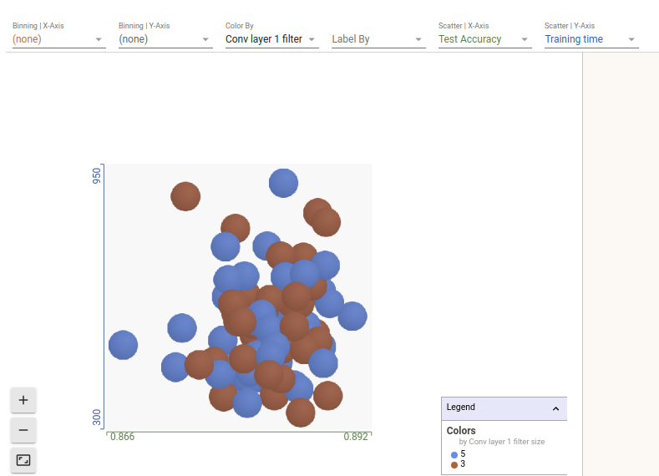

Fig 2.3.b:
Conv 1 kernel size
x-axis : Test accuracy
y-axis: Training time

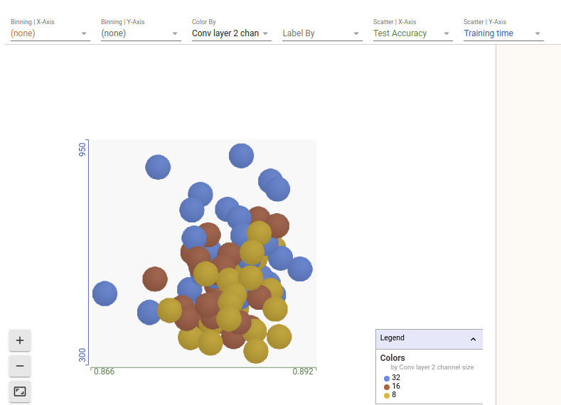

Fig 2.3.c:
Conv 2 no of filters
x-axis : Test accuracy
y-axis: Training time

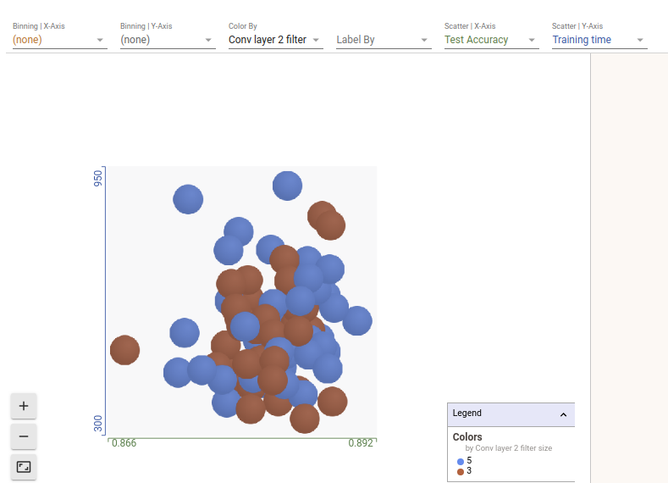

Fig 2.3.d:
Conv 2 kernel size
x-axis : Test accuracy
y-axis: Training time

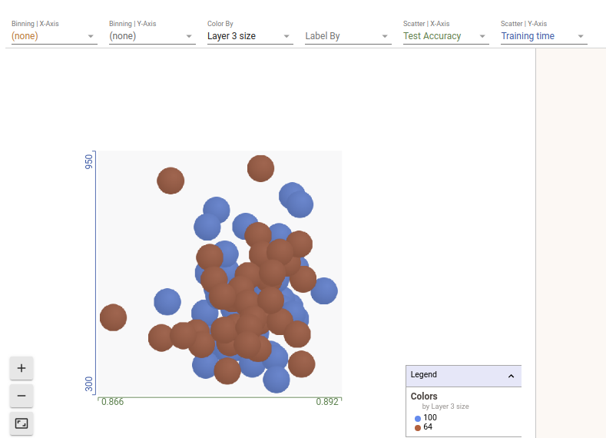

Fig 2.3.e:
Number of neurons in layer 3
x-axis : Test accuracy
y-axis: Training time

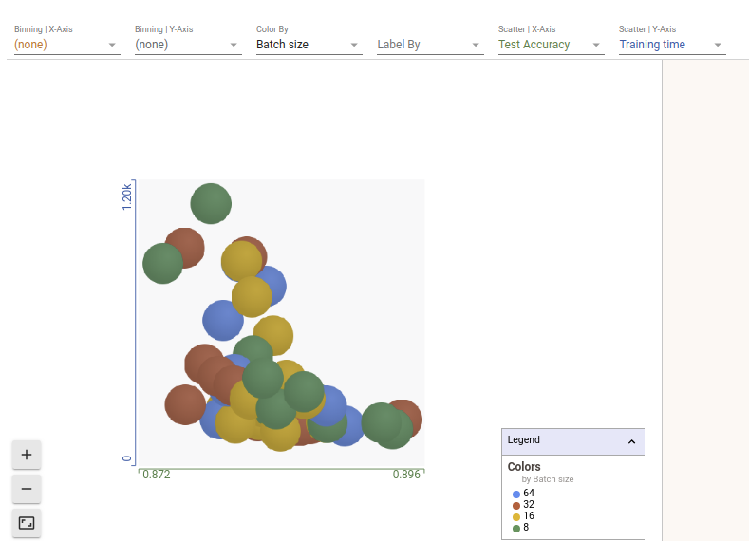

Fig 2.3.f:
Batch size
x-axis : Test accuracy
y-axis: Training time

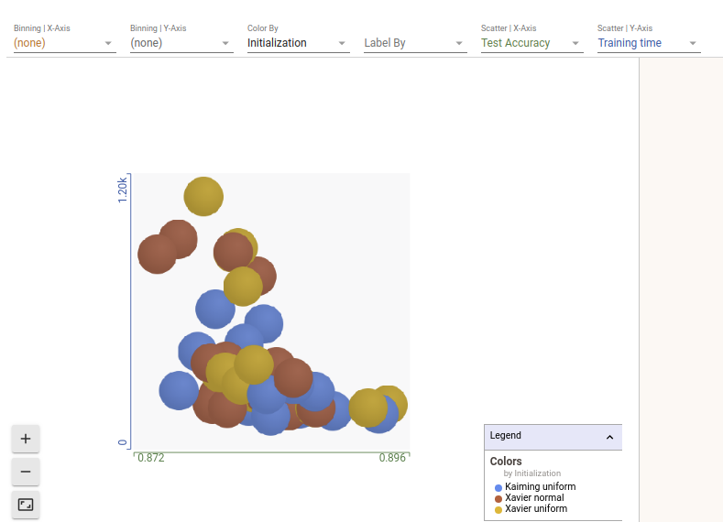

Fig 2.3.g:
Initialization
x-axis : Test accuracy
y-axis: Training time

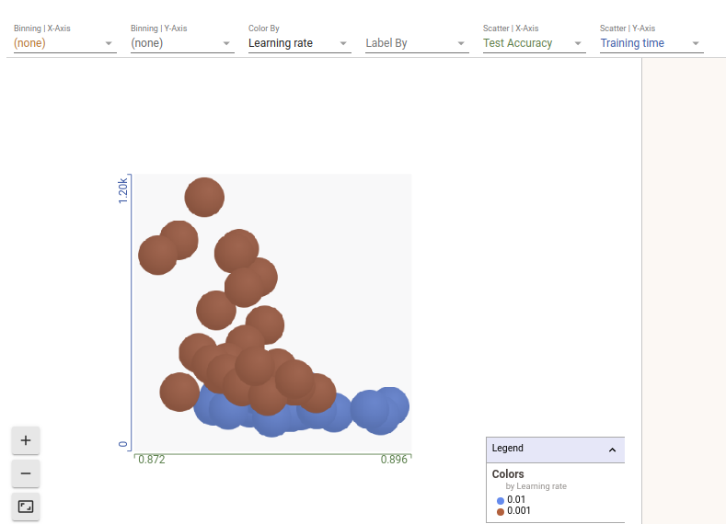

Fig 2.3.h:
Learning rate
x-axis : Test accuracy
y-axis: Training time

Fig 2.3.i:
Momentum
x-axis : Test accuracy
y-axis: Training time

The pareto plots of all models with respect to testing accuracy and training time are as given below.

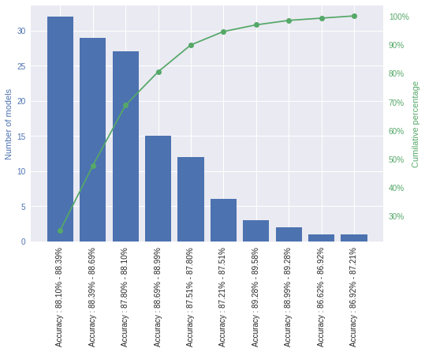

Fig 2.4.a:
Pareto plot of all models with respect to testing accuracy.

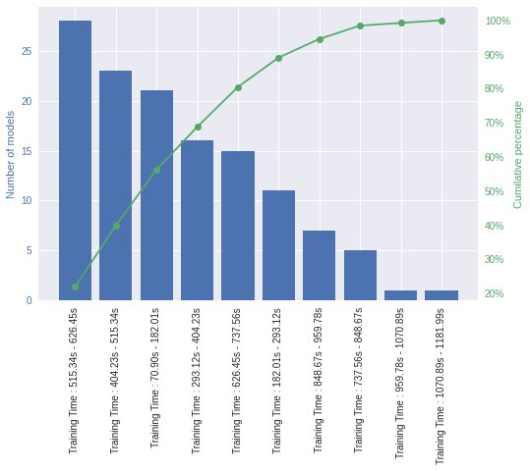
Fig 2.4.b:
Pareto plot of all models with respect to training time.

Loss vs epoch/batches plots for some special cases asked in the question are given below.

Learning rate too high: The largest learning rate used for the experiment was 0.01. This is not a high learning rate. Therfore to produce the plot, I trained a model separately with learning rate. We can see that the loss plot has got many irregular jumps.

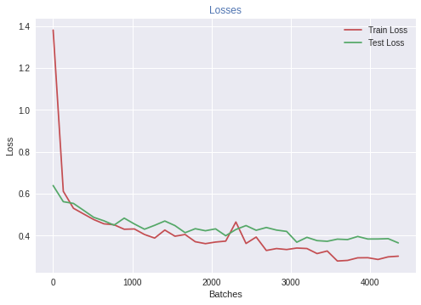

Fig 2.5.a:
High learning rate (0.05). Loss plot has irregular jumps.

Learning rate too low: The MLflow experiment did not contain any examples for low learning rates. So I trained a separate model to demonstrate. The network is taking longer to converge.

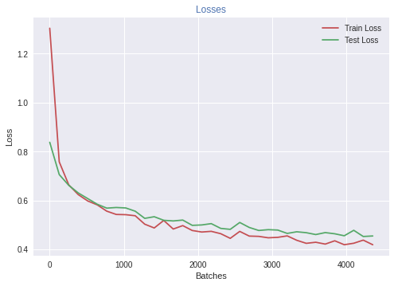

Fig 2.5.b:
Low learning rate (0.0001). Loss plot takes very longer to converge.

Momentum too high: This plot is also generated by running an experement separately. We can see that the plot has got an oscillatory nature. The model oscillates around local minimas. Sometimes the network is able to escape local minimas, but sometimes it keeps on oscillating.

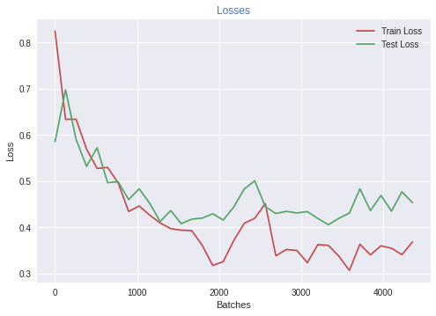

Fig 2.5.c:
High momentum (0.99, lr: 0.001). The loss oscillates too much.

Batch size too low: When a network is trained using stochastic gradient descend on a very small batch size. The updates become more randomized. The plot below shows a network trained with batch size of 4. All other settings were similar to that of the above given networks.

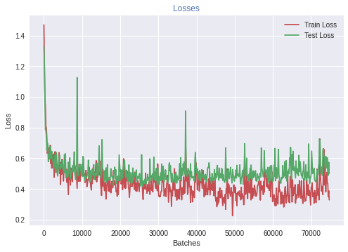

Fig 2.5.d:
Low batch size. All the updates become more approximate and randomized, thus leading to a rugged loss plot.

Overfitting due to large model: The experiments conducted did not have any good exaples of overfitting. So a different larger model was trained to demonstrate the effect. This example was trained longer than others to make the effect more profound. We can see the test loss actually diverging.

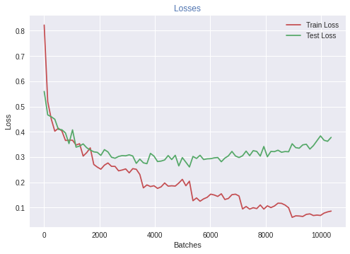

Fig 2.5.e:
Overfitting on a large model.(Conv 5x5, 64; Conv 5x5, 64; 100 neurons)

