Healthcare Analytics & Intelligence Platform
(HAIP)
Exploratory Data Analysis Report
Data Engineering Phase — Medallion Architecture & EDA
Bronze → Silver → Gold | PostgreSQL | Python ETL

Table of Contents

- Introduction — 3 1.1 Project Overview — 3
- 1.2 Objectives — 3 1.3 Business Problem — 3
- 1.4 Importance of Healthcare Analytics — 3
- Dataset Overview — 4 2.1 Patients & Admissions Dataset — 4 2.2 Mortality Dataset — 4 2.3 Billing Dataset — 4 2.4 ICU Dataset — 5 2.5 Laboratory Dataset — 5 2.6 Medical Documents Dataset (RAG) — 5
- Data Engineering Pipeline — 6 3.1 Layer Responsibilities — 6 3.2 Pipeline Components — 6
- Data Profiling — 7
- Data Cleaning & Transformation — 8 5.1 Categorical Standardization — 8 5.2 Type Conversions — 8 5.3 Missing Value Handling — 8 5.4 Validation Rules — 8 5.5 Dirty-Value Treatment — 8
- Exploratory Data Analysis — 9 6.1 Missing-Value Patterns — 9 6.2 Patient Analysis — 9 6.3 Mortality Analysis — 9 6.4 Billing Analysis — 10 6.5 ICU Analysis — 10 6.6 Mortality by Comorbidity — 10 6.7 Laboratory Analysis — 10
- Correlation & Relationships — 11 7.1 ICU Severity vs Sepsis — 11
- Key Insights — 12
- Gold Layer Analytics Views — 13
- Data Quality Findings — 14 10.1 Missing Values — 14 10.2 Outliers — 14 10.3 Data Limitations & Potential Biases — 14
- Conclusion — 15 11.1 Major Findings — 15 11.2 Healthcare Implications — 15 11.3 Recommendations — 15
- Future Work — 16
- Module Flowcharts — 18 13.1 Data Collection — 18 13.2 Exploratory Data Analysis — 18 13.3 Database Design (Medallion) — 19 13.4 ETL Pipeline — 19

1. Introduction

1.1 Project Overview
The Healthcare Analytics & Intelligence Platform (HAIP) is an end-to-end data platform that consolidates fragmented hospital data into a single, governed, analytics-ready foundation. It ingests six independent healthcare data sources, processes them through a layered medallion architecture (Bronze, Silver, Gold) on PostgreSQL, and exposes clean, validated data for analytics, machine learning, and a Retrieval-Augmented Generation (RAG) system over medical documents.

1.2 Objectives
- Establish a reliable, reproducible healthcare data foundation for analytics, ML, and RAG.
- Ingest and standardize six heterogeneous data sources into a governed PostgreSQL database.
- Apply a medallion architecture to separate raw, cleaned, and analytics-ready data.
- Identify and document missing values, outliers, and data-quality characteristics.
- Validate that cleaned data preserves real clinical relationships.

1.3 Business Problem
Hospital data typically lives in disconnected systems — admissions, billing, ICU monitoring, and laboratory results each use different identifiers, formats, and conventions. This fragmentation prevents unified analysis, slows clinical insight, and blocks the development of predictive models. HAIP addresses this by building a single trustworthy data layer with explicit data-quality guarantees.

1.4 Importance of Healthcare Analytics
Reliable healthcare analytics supports earlier identification of high-risk patients, more efficient resource allocation, transparent cost analysis, and evidence-based decision-making. A well-governed data foundation is the prerequisite for any downstream predictive modeling or clinical decision support — models are only as trustworthy as the data beneath them.

2. Dataset Overview
HAIP integrates six data sources. Five are tabular (loaded into PostgreSQL) and one is a document corpus used for the RAG system. A central design decision: the five tabular sources use inconsistent patient identifiers (MRD No., Patient_ID, subject_id) and the laboratory source has none, so they are treated as independent analytical domains rather than being force-joined.
# | Dataset | Rows | Cols | Purpose
1 | Patients & Admissions | 15,757 | 56 | Demographics, admissions, comorbidities, labs, outcomes
2 | Mortality | 359 | 6 | Records of patients brought dead / in-hospital deaths
3 | Billing | 984 | 10 | Treatment cost, procedure, satisfaction, readmission
4 | ICU | 5,000 | 77 | Vitals, severity scores, interventions, sepsis labels
5 | Laboratory | 27 | 11 | Lab test results with reference ranges (reference sample)
6 | Medical Documents (RAG) | Corpus | — | Clinical guidelines for retrieval-augmented generation

2.1 Patients & Admissions Dataset
- Source: Real hospital admission data (HDHI Admission dataset).
- Size: 15,757 rows × 56 columns.
- Purpose: Core clinical table — patient demographics, admission/discharge dates, comorbidities, lab values, and outcome.
- Key attributes: age, gender, rural/urban, type of admission, duration of stay, outcome, plus comorbidity flags (DM, HTN, CAD, CKD, heart failure) and labs (HB, glucose, urea, creatinine, EF, BNP).

2.2 Mortality Dataset
- Source: Hospital mortality records (HDHI Mortality dataset).
- Size: 359 rows × 6 columns.
- Purpose: Lookup table of deaths — age, gender, location, date.
- Key attributes: age, gender, rural/urban, date of death.

2.3 Billing Dataset
- Source: Hospital billing / financial records.
- Size: 984 rows × 10 columns.
- Purpose: Financial analysis — cost per condition and procedure, satisfaction, readmission.
- Key attributes: condition, procedure, cost, length of stay, readmission, outcome, satisfaction.

2.4 ICU Dataset
- Source: MIMIC-IV-style structured ICU dataset (no credentialing constraints).
- Size: 5,000 rows × 77 columns.
- Purpose: Critical-care analysis — vitals, severity scoring, interventions, sepsis prediction.
- Key attributes: heart rate, blood pressure, SpO2, SOFA / APACHE / qSOFA scores, mechanical ventilation, vasopressors, sepsis label, 30-day readmission.

2.5 Laboratory Dataset
- Source: Anonymized laboratory test results (public).
- Size: 27 rows × 11 columns (small reference sample).
- Purpose: Demonstrates lab result structure with reference ranges and status flags.
- Key attributes: test name, result, unit, reference range, status, min/max reference.

2.6 Medical Documents Dataset (RAG)
- Source: epfl-llm/guidelines (HuggingFace) — real clinical guidelines.
- Format: Arrow / parquet with dataset metadata (kept native for RAG loading).
- Purpose: Source corpus for the retrieval-augmented generation system over medical procedures — real documents only, never synthetic.

3. Data Engineering Pipeline
Data flows through a medallion architecture, where each layer has a single, well-defined responsibility. This separation makes the pipeline auditable, reproducible, and safe to re-run.
Raw Sources | → | Bronze | → | Silver | → | Gold | → | Analytics
Figure 1. HAIP medallion data flow: Raw → Bronze → Silver → Gold → Analytics.

3.1 Layer Responsibilities
Layer | Role | Typing | Idempotent
Bronze | Raw landing zone — ingest as-is, never fail on bad data | All TEXT | Yes (truncate + load)
Silver | Cleaned, typed, standardized; validated | Real types | Yes (truncate + load)
Gold | Analytics-ready aggregated views | Views on silver | Rebuilt each run

3.2 Pipeline Components
- extract.py — reads all six sources into DataFrames (CSV + Arrow), logging row/column counts.
- load.py — maps messy CSV headers to clean column names and loads into Bronze tables transactionally.
- transform.py — cleans, maps categorical codes, coerces types, and writes typed Silver tables.
- validate.py — runs row-count, null-percentage, and domain-rule checks on Silver.
- config.py / utils.py — centralized configuration, env-based credentials, shared logging and DB engine.
Engineering standards applied throughout: PEP 8, type hints, docstrings, logging instead of print, configuration separation, error handling, single responsibility, and idempotency. A dedicated PostgreSQL role (haip_user) holds least-privilege access — write to Bronze/Silver, read-only on Gold.

4. Data Profiling
Each Silver table was profiled for structure, types, and completeness. The depth of analysis was matched to each source's size: deep for Patients and ICU, moderate for Billing, light for Mortality, and descriptive for the small Laboratory sample.
Dataset | Rows | Cols | Numeric | Text/Date | Duplicates | Quality
Patients | 15,757 | 56 | 48 | 8 | None | Clean, typed
Mortality | 359 | 6 | 2 | 4 | None | Clean
Billing | 984 | 10 | 4 | 6 | None | No missing values
ICU | 5,000 | 77 | 72 | 5 | None | Clean, typed
Labs | 27 | 11 | 2 | 9 | None | Small sample

Type integrity was confirmed: binary comorbidity flags loaded as integers, continuous lab measurements as floats, dates parsed correctly, and categorical codes mapped to readable labels. No duplicate records were found in any source.

5. Data Cleaning & Transformation

5.1 Categorical Standardization
Coded values were mapped to readable, consistent labels across sources:
- Gender: M / F → Male / Female.
- Location: R / U → Rural / Urban.
- Admission type: E / O → Emergency / OPD.
- Outcome: DISCHARGE / EXPIRY / DAMA → Discharge / Expiry / Dama.
- Billing readmission: Yes / No → Boolean.

5.2 Type Conversions
Date strings (e.g. M/D/YYYY for patients, ISO for labs) were converted to DATE; numeric columns coerced from text, with invalid or empty values becoming NULL rather than causing failures. The laboratory result column was deliberately kept as text because it legitimately holds both numeric values (e.g. 28.9) and qualitative results (e.g. Normal, Negatif).

5.3 Missing Value Handling
Missing values were preserved as NULL in Silver rather than imputed. Imputation is a modeling decision deferred to the feature-engineering stage; the Silver layer's responsibility is to be clean and honest, not to invent data.

5.4 Validation Rules
The validation framework runs three checks per table:
- Row-count verification against expected loads (detects silent data loss).
- Null-percentage reporting per column.
- Domain rules flagging impossible values (e.g. age outside 0–120, negative cost, BMI outside 5–100).
All row counts matched expectations and all domain rules passed — no impossible ages, costs, or BMI values were present.

5.5 Dirty-Value Treatment
The mortality source contained junk in the rural/urban field (stray values M and 0). These were mapped to NULL rather than forced into a valid category — preserving honesty over false completeness.

6. Exploratory Data Analysis

6.1 Missing-Value Patterns
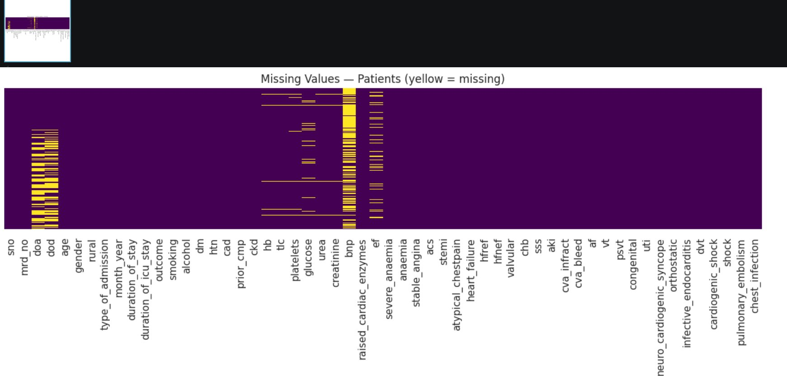
Figure 2. Patients missing-value map (yellow = missing).
Missingness is informative rather than random. BNP (57.6% missing) is a specialized cardiac test ordered selectively; admission/discharge dates (~35%) cluster together structurally; ICU lab panels (~10–11%) are missing in coherent blocks. This means “test not done” itself carries clinical signal.

6.2 Patient Analysis
- Age: range 4–110, mean ~61 — an older, cardiac-skewed population.
- Gender: predominantly male, consistent with cardiac admission demographics.
- Rural vs Urban: both represented after standardization.
- Admission type: dominated by Emergency over OPD.

6.3 Mortality Analysis
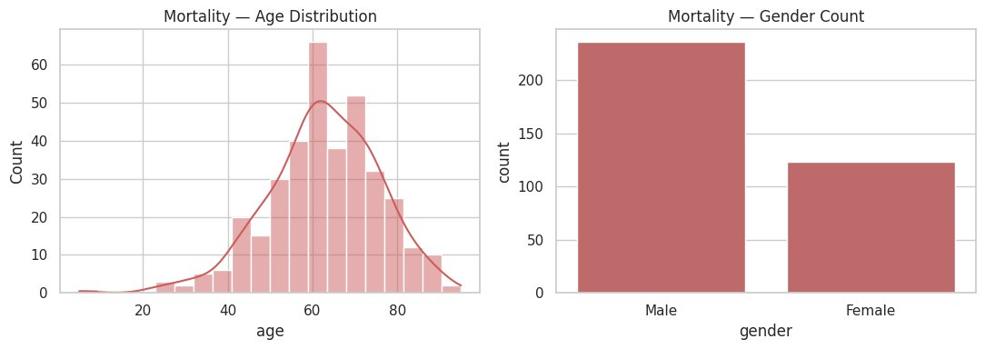
Figure 3. Mortality by age (left) and gender (right).
- Deaths peak in the 60–70 age band — mortality rises with age.
- Male deaths outnumber female roughly 2:1.
- High-risk groups concentrate among older patients with organ-failure comorbidities (see 6.6).

6.4 Billing Analysis
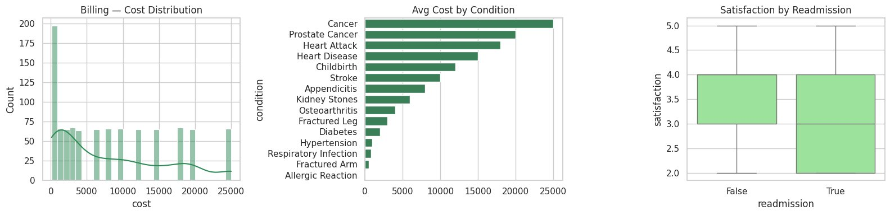
Figure 4. Cost distribution, average cost by condition, and satisfaction by readmission.
- Cost distribution is right-skewed — many low-cost cases, a long tail of expensive ones.
- Cancers and cardiac events (heart attack, heart disease) are the costliest conditions.
- Readmitted patients report slightly lower median satisfaction.

6.5 ICU Analysis
- ICU length of stay ranges widely, with a long upper tail of complex long-stay cases.
- Severity indicators (SOFA, APACHE, lactate) show right-skewed distributions — the upper tail represents the sickest patients, not data errors.
- Outlier highs in creatinine, lactate, and BNP correspond to genuinely critical patients and were retained.

6.6 Mortality by Comorbidity
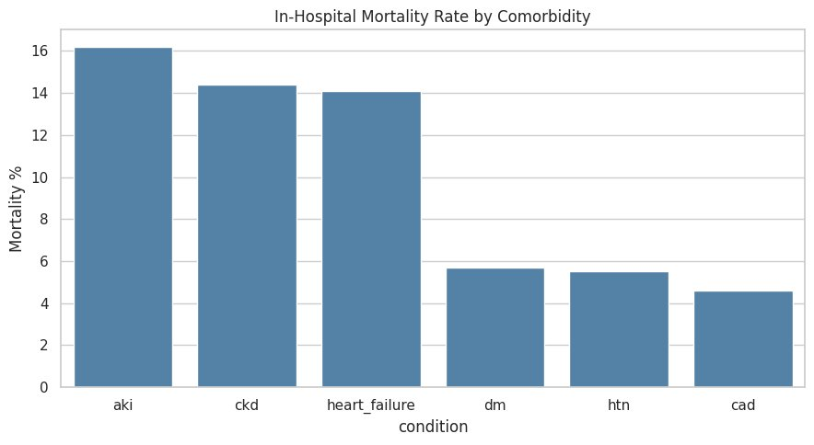
Figure 5. In-hospital mortality rate by comorbidity.
Organ-failure conditions carry roughly three times the mortality of chronic managed conditions: AKI 16.2%, CKD 14.4%, and heart failure 14.1%, versus diabetes 5.7%, hypertension 5.5%, and CAD 4.6%. This clean separation validates the alignment of outcome labels with comorbidity flags.

6.7 Laboratory Analysis
With only 27 rows, the laboratory source is a reference sample unsuitable for statistical analysis. Descriptively, results split between Normal and Yüksek (High) status flags, and roughly 30% of rows (strip tests) have no numeric reference bounds — correctly handled as NULL.

7. Correlation & Relationships
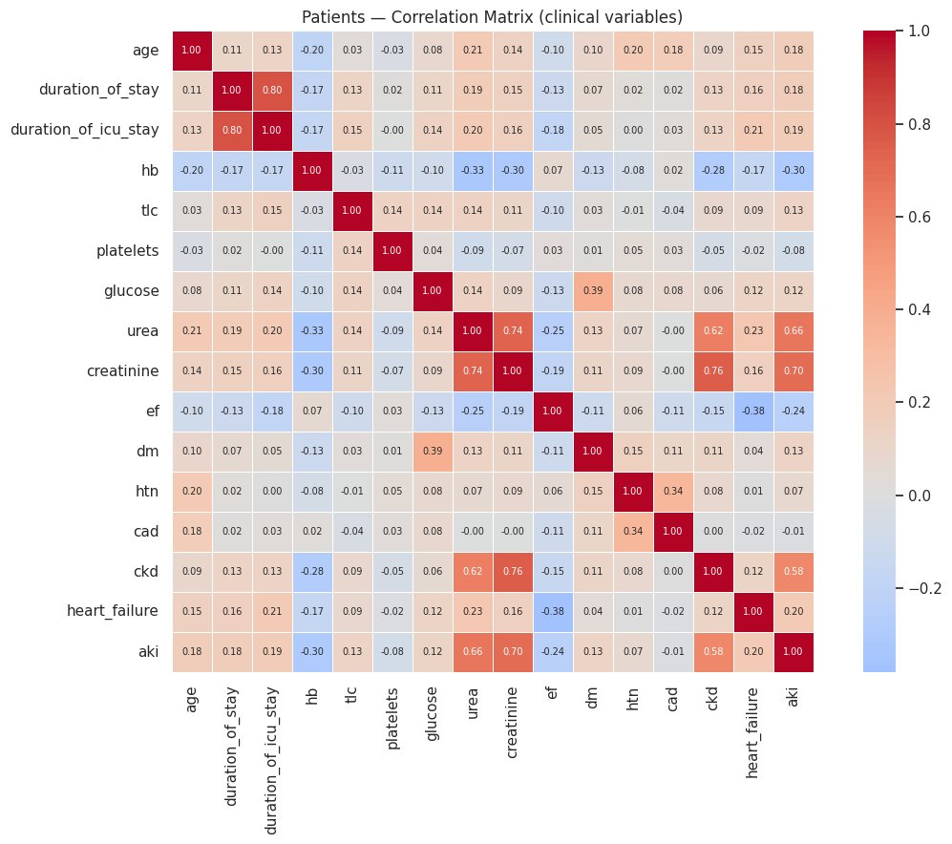
Figure 6. Patients correlation matrix (clinical variables).
Every meaningful correlation reproduces an established clinical relationship, confirming that cleaning and typing preserved the data's integrity:
- Creatinine–urea (0.74) and creatinine–CKD (0.76): kidney-function markers move together.
- EF–heart failure (−0.38): low ejection fraction drives heart failure (negative as expected).
- Duration of stay–ICU stay (0.80): longer hospitalization tracks longer ICU time.
- Glucose–diabetes (0.39): diabetics show higher glucose.
- Hemoglobin–CKD/AKI (negative): kidney disease is associated with anemia.

7.1 ICU Severity vs Sepsis
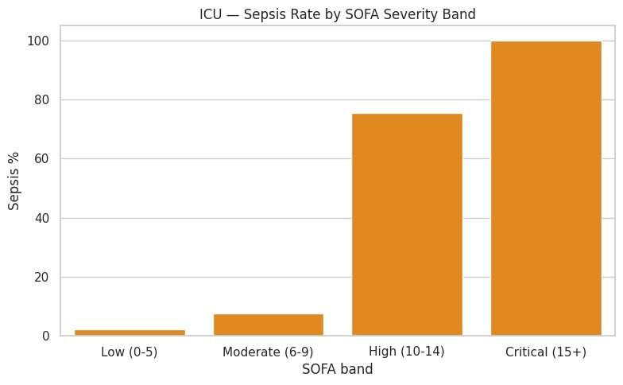
Figure 7. ICU sepsis rate by SOFA severity band.
Sepsis rate rises sharply with SOFA severity — approximately 2% (Low) → 7% (Moderate) → 75% (High) → 100% (Critical). Because SOFA measures organ dysfunction and sepsis causes it, this steep gradient is mechanistically expected and confirms label integrity.

8. Key Insights
- Elderly patients (60–70+) carry the highest mortality risk, concentrated among those with organ-failure comorbidities.
- Acute kidney injury, chronic kidney disease, and heart failure roughly triple in-hospital mortality versus chronic managed conditions.
- ICU sepsis risk escalates steeply with SOFA severity, reaching 100% in the critical band.
- Cancers and cardiac events are the dominant cost drivers; cost distribution is heavily right-skewed.
- Readmission is associated with lower patient satisfaction.
- Missingness is clinically informative — absent tests reflect clinical decisions, not random gaps.

9. Gold Layer Analytics Views
Six analytics-ready views summarize each domain. Implemented as SQL views, they always reflect current Silver data with no maintenance.
View | Business Question Answered
admissions_summary | Admission trends over time, mortality and discharges per month and type
outcome_distribution | Share of patients discharged vs expired vs DAMA
comorbidity_prevalence | How common each comorbidity is across patients
billing_by_condition | Average cost, stay, satisfaction, and readmissions per condition
icu_severity_summary | ICU outcomes banded by SOFA severity score
lab_test_summary | Test frequency and normal/high status breakdown

Example result — outcome distribution: Discharge 87.3%, Expiry 7.0%, DAMA 5.7%. Comorbidity prevalence: CAD 67.0%, Hypertension 48.6%, Diabetes 32.3% — a profile consistent with a cardiac unit.

10. Data Quality Findings

10.1 Missing Values
Source | Notable Missingness | Interpretation
Patients | BNP 57.6%, dates ~35%, EF 10% | Selective testing / structural gaps
ICU | Lab panels ~10–11% | Tests not run for all patients
Mortality | rural/urban 0.6% | Junk values nulled
Labs | reference bounds ~30% | Strip tests lack numeric ranges
Billing | None | Complete

10.2 Outliers
Statistical outliers were predominantly genuine critical patients (high creatinine, lactate, BNP, SOFA) and were retained. Only a tiny fraction of values were physiologically implausible and flagged: ~26 in Patients (~0.16%) and ~17 in ICU (~0.3%), such as impossible body temperatures or sustained heart rates. These were identified and documented but not deleted in Silver.

10.3 Data Limitations & Potential Biases
- The laboratory source is a 27-row reference sample, not a population dataset.
- Sources cannot be linked at the patient level (inconsistent / absent identifiers), so cross-domain joins are intentionally avoided.
- The patient population is cardiac-skewed, which shapes comorbidity and mortality distributions.
- Informative missingness means naive imputation could introduce bias; “test not done” should be modeled as signal.

11. Conclusion

11.1 Major Findings
HAIP successfully established a reliable, validated healthcare data foundation across six sources. Every analytical finding reproduced established clinical patterns — kidney-marker correlations, the ejection-fraction/heart-failure relationship, mortality stratification by comorbidity, and sepsis escalation with SOFA severity — confirming that the pipeline preserved data integrity end to end.

11.2 Healthcare Implications
The platform can support earlier identification of high-risk patients (organ-failure comorbidities, high SOFA), transparent cost analysis by condition, and a trustworthy basis for predictive modeling and clinical document retrieval.

11.3 Recommendations
- Model informative missingness explicitly rather than imputing blindly.
- Prioritize organ-failure comorbidities and SOFA severity as predictive features.
- Expand the laboratory source beyond the current reference sample before lab-based modeling.

12. Future Work
- Predictive Analytics & ML: mortality and sepsis risk models built on the Gold layer.
- RAG System: retrieval-augmented generation over the medical-guideline corpus using embeddings and pgvector.
- Dashboard Development: an interactive Plotly Dash / Streamlit dashboard reading the Gold views.
- Feature Engineering: principled handling of missingness and outliers for downstream models.

Project Achievements to Date
- ✓ Collected 6 healthcare datasets (real-world sourced)
- ✓ Built PostgreSQL database with medallion architecture
- ✓ Created Bronze, Silver, and Gold layers
- ✓ Developed reproducible ETL pipeline (extract / load / transform)
- ✓ Implemented a validation framework
- ✓ Created 6 Gold analytics views
- ✓ Completed full EDA with clinical validation
- ✓ Applied least-privilege database security (haip_user role)
- ✓ Created module flowcharts (collection, EDA, database, ETL)

13. Module Flowcharts
The following flowcharts document the four core modules of the data engineering phase: data collection, EDA, database design, and the ETL pipeline. Each reflects the process as actually implemented.

13.1 Data Collection
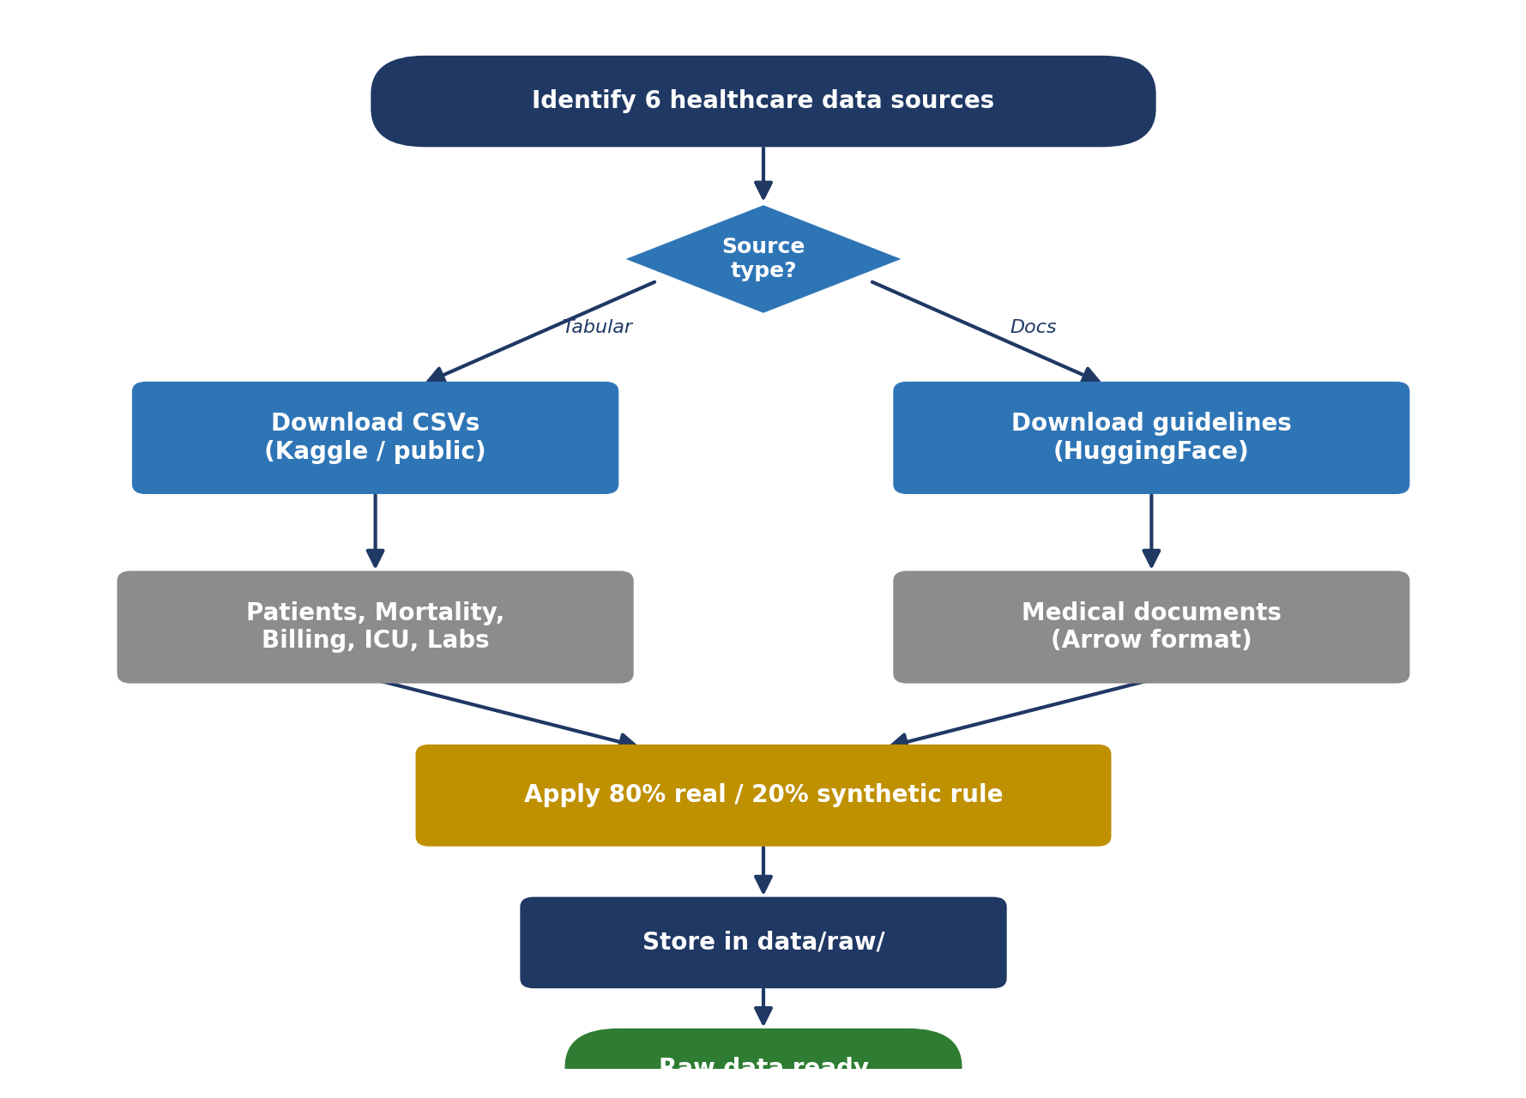
Figure 8. Data collection workflow — sourcing, the 80/20 rule, and raw storage.

13.2 Exploratory Data Analysis
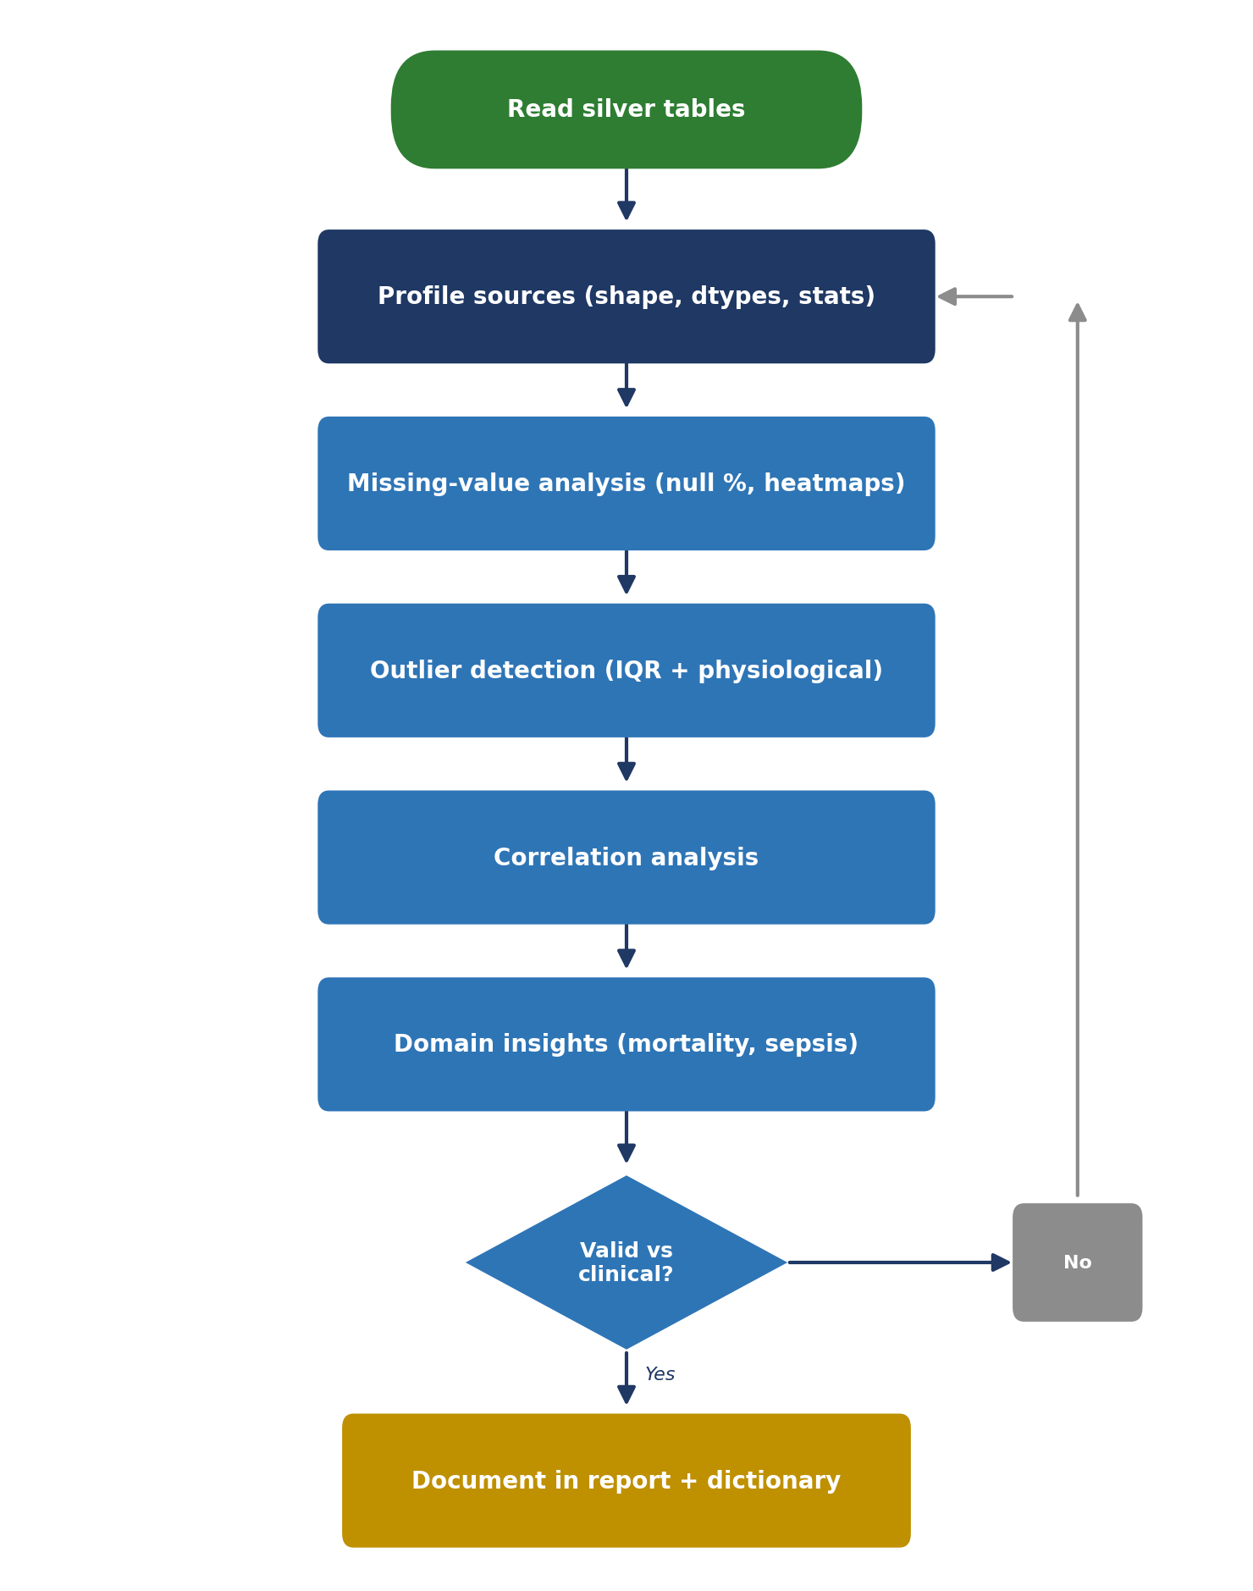
Figure 9. EDA workflow — profiling through clinical validation and documentation.

13.3 Database Design (Medallion)
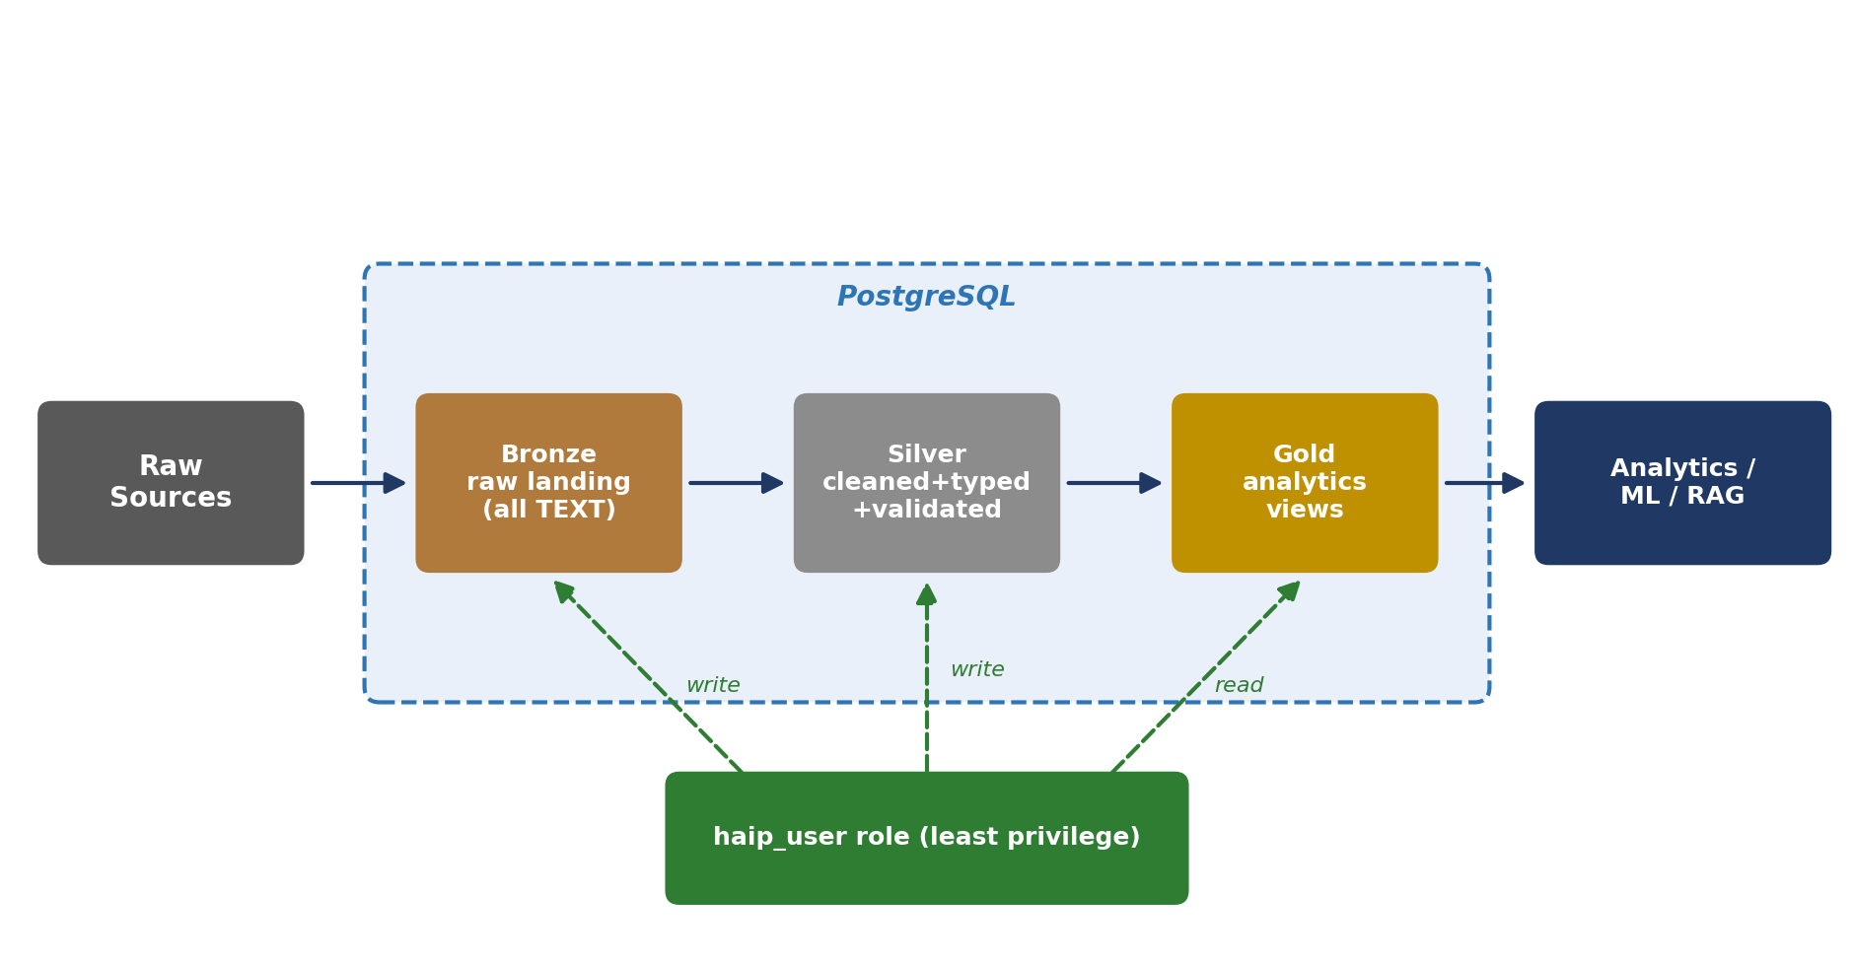
Figure 10. Medallion database design — Bronze/Silver/Gold with least-privilege access.

13.4 ETL Pipeline
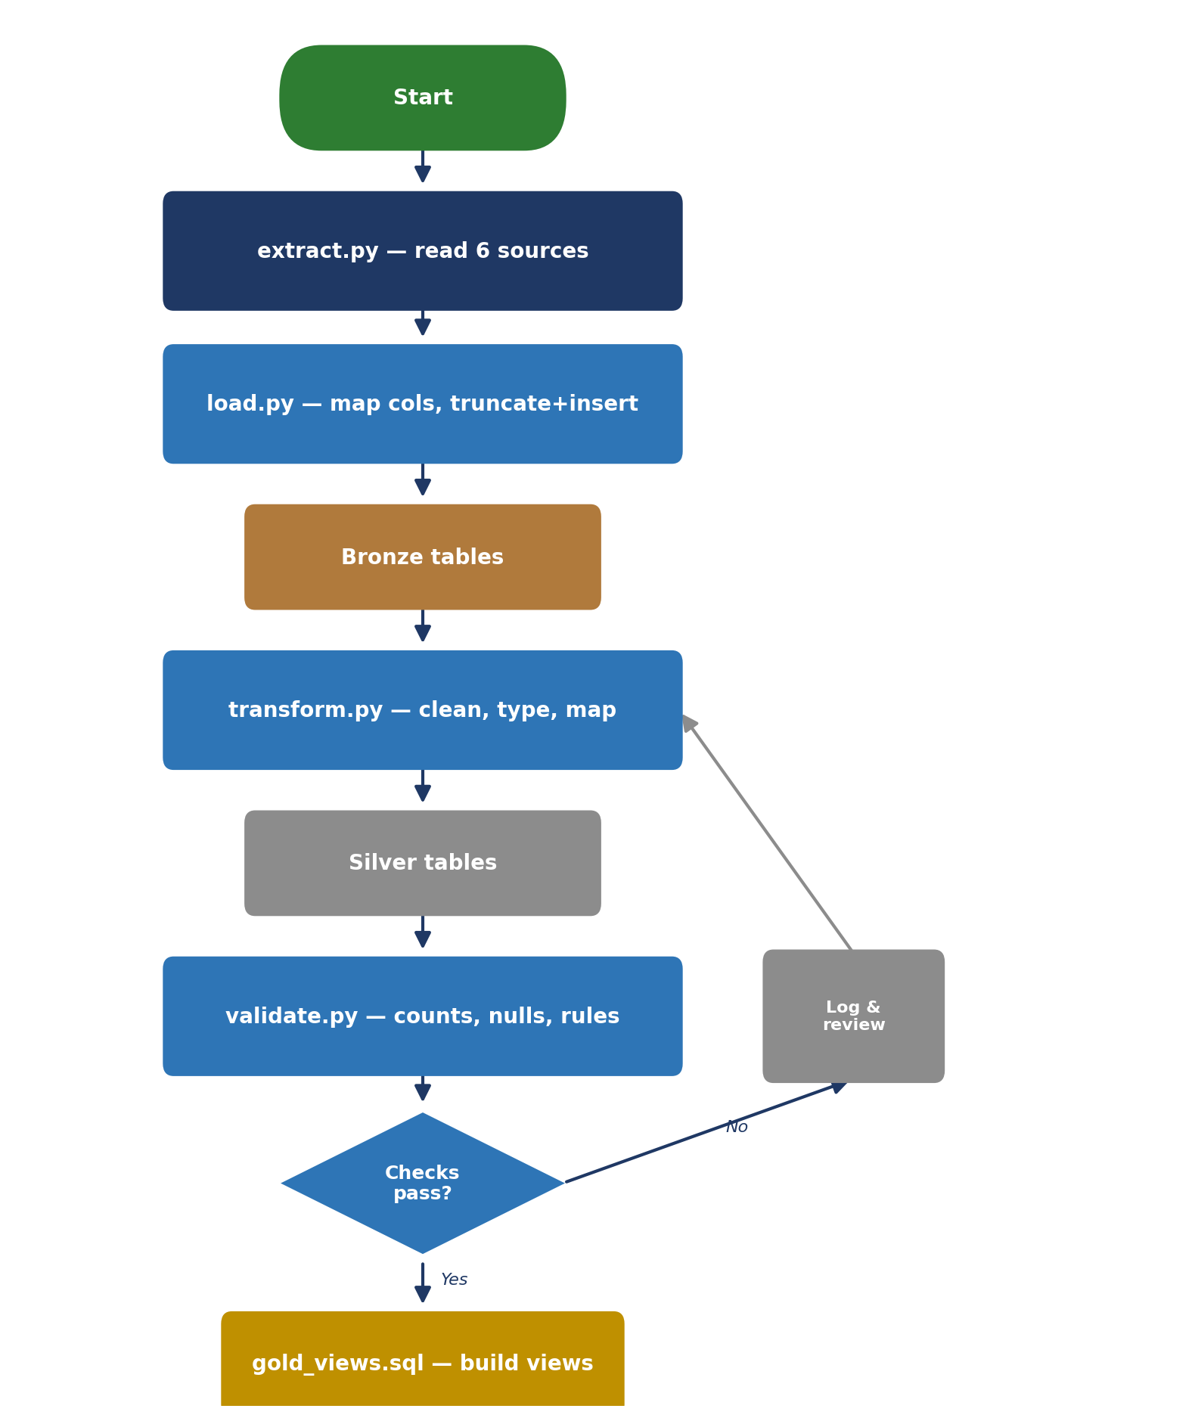
Figure 11. ETL pipeline — extract, load, transform, validate, and build gold views.

