**BBMDS Simulation**

**Sooyeong 6/30/19**

**1. Sample Data -Dichotomous (Source BBMDS – Shao et al.,)**

|  |  |  |
| --- | --- | --- |
| [Dose] | [N] | [Incidence] |
| 0 | 50 | 1 |
| 25 | 50 | 2 |
| 50 | 50 | 15 |
| 75 | 50 | 27 |

This data was drawn from Shao’s BBMDS web page and this data’s fitting summary (loglogistic) is featured in Shao’s paper [Fig.2]. With this data, we are going to generate 100 simulation dataset to compare the performance between BBMD & BMDS

**2. BMDS Fitting Results**

The BMDS fitting result shows that Logistic model has smallest AIC. We will assume this logistic model’s fitting estimates as true distribution and will generate 100 data for the simulations.

**2.1. Summaries from BMDS**

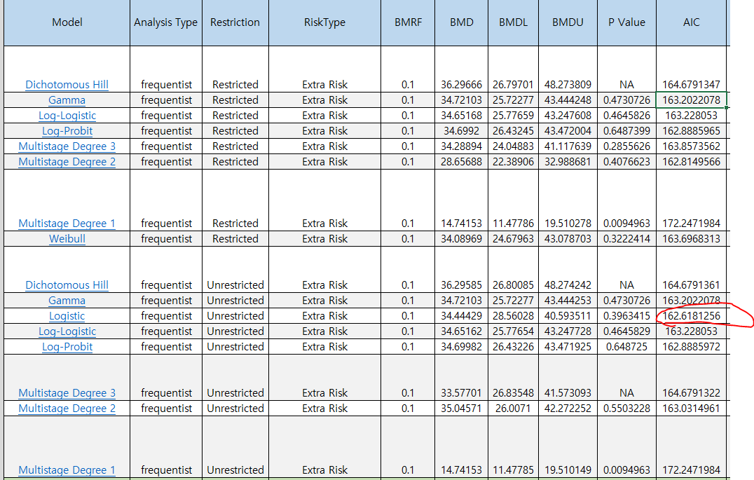

**2.2 Logistic Model Fitting Result (BMDS)**

|  |  |
| --- | --- |
| Dose-Response Model | P[dose] = 1/[1+exp(-a-b*dose)] |

|  |  |
| --- | --- |
| **Benchmark Dose** | |
| BMD | 34.44428927 |
| BMDL | 28.56027972 |
| BMDU | 40.59351107 |
| AIC | 162.6181256 |
| P-value | 0.396341468 |
| D.O.F. | 2 |
| Chi2 | 1.850958293 |

|  |  |
| --- | --- |
| **Model Parameters** | |
| # of Parameters | 2 |
| Variable | Estimate |
| a | -3.980145153 |
| b | 0.056735264 |

The estimated result from BMDS shows that a=-3.98 and b=0.056. With these parameter, we are going to generate instances of each dose for 100 cases

**3. Data Generation**

Seed for data generation – 1234.

For more detail, please check attached R code.

**4. Fitting BBMD & BMDS**

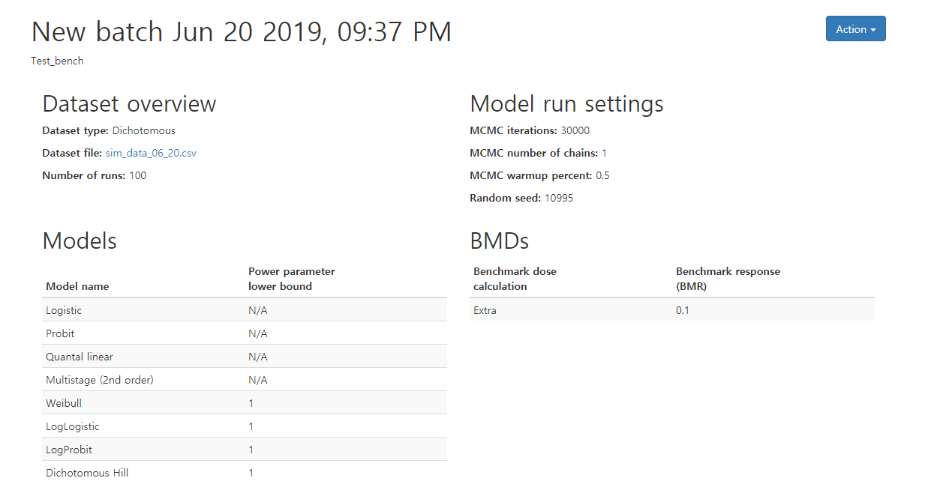

The fitted result from of BBMD is saved in the attached file Model_summary_batch, BMD_summary_batch. With BMD_summary, we can calculate coverage, half width & CI, Bias, MSE.

Unfortunately, BMDS software’s batch process isn’t that convenient as BBMD. We should find a better way to give an input of 100 dataset to the program (Should we have to ask about it to Matt?).