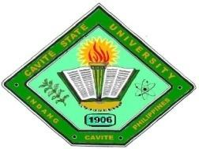**CAVITE STATE UNIVERSITY**

**Imus Campus**

Cavite Civic Center Palico IV, Imus, Cavite

*(046) 471-66-07 / (046) 471-67-70/ (046) 686-2349*

[www.cvsu.edu.ph](http://www.cvsu.edu.ph)

***(off-campus activity)***

**STUDENT INFORMATION**

|  |  |  |  |  |  |  |  |
| --- | --- | --- | --- | --- | --- | --- | --- |
| 0 | 9 | 2 | 0 | 2 | 0 | 0 | 2 |

**Pacifico Christian I M**

**_________________________ _________________________ _____ ____**

Last Name First Name M.I Sex Date of Birth (mm/dd/yyyy)

|  |  |  |  |  |  |  |  |  |
| --- | --- | --- | --- | --- | --- | --- | --- | --- |
| 2 | 0 | 2 | 1 | 1 | 0 | 0 | 9 | 1 |

____________381 Dahlia st, P.F. Espiritu 4 Bacoor City, Cavite__________

Mailing Address Student Number

Contact Number: ____09504222701 ✓ Academic

Non-Academic

Name of Department: _Faculty __________________________________ Performing Arts

Group

Name of Subject/s Adviser/s in charge: ITEC - 110 - System Integration and Maintenance _Sir. Benedick Sarmiento

**_____________________________________________________________________________**

**PARENT/GUARDIAN PERMIT/CONSENT**

**This is to certify that I have full knowledge of and permission for my son/daughter/foster child to go to school for subject requirements compliance**:

Subject/s Title: **ITEC - 110 - System Integration and Maintenance**

Date & Time: February 4. 2024: 5:00 pm

Place of Consultation/Requirements submission: **Grade Consultation**

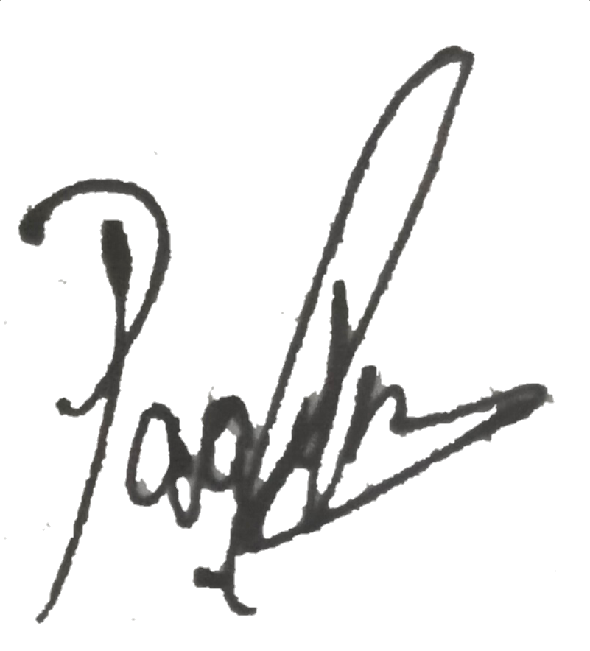 I concur and agree on the rules, policies & regulations being implemented by the concerned personnel or organizers.

_____________**Noime Pacifico**__________________ ________09772132146__________

Name & Signature of Parent/Guardian Contact Number

Subscribed & sworn to me this 4th day of February 2025 at 381 Dahilia st. P. F. Espiritu 4, Bacoor City, Cavite

