Lab 3: source terms and spectrum evolution

A hands-on test of lecture 6 concepts

# Part 1: A very simple wave model

NOTE: There are 5 questions (in red) that you need to answer.

## 1.1 Introduction

Before Owen Phillips suggested that non-linear interactions could be important for the spectral evolution, and before Klaus Hasselmann (1961, 1962) actually gave the theoretical expression for the non-linear 4-wave scattering term Snl, the first generation of numerical wave models assumed that the spectrum evolves according to

**dE/dt = Sin + Sds**

Let’s try it out!

If the **ocean is homogeneous**, d /dx and d /dy are zero and **d / dt** , the derivative following a wave packet is a **true time derivative (as if I had ∂E/∂t)**.

We can define a discrete spectrum E(fi,theta_j) and compute its evolution in time, without bothering about its evolution (propagation at group speed Cg) with x and y.

Everything you need is on this google drive:

<https://drive.google.com/drive/folders/1jZeXhj4qqskHvFa8fZHDL9ppZdhaYayz?usp=sharing>

You can start from the matlab version of the code: [lab3_part1.m](https://drive.google.com/file/d/1daDpIjimF6b0JBUETq1xRXe6kCD3XCCy/view?usp=sharing)

Or the python notebook: (thanks to Sophia)

Here is for example how we define the spectral discretization (below is a Matlab version):

grav=9.81; % Yes we will use SI units… this is the apparent gravity

nth=24; % Number of directions for our discrete spectrum

nk=36; % Number of wavenumbers : in practice we work with

% spectral density in wavenumber space

XFR=1.1; % ratio of frequencies f(i+1)/f(i)

% Now we define our vector of discrete frequencies

freq=0.034.*exp(linspace(0,nk-1,nk).*log(XFR))’;

sig=2.*pi.*freq;

% and corresponding wavenumbers

k=sig.^2/grav;

% now we define the discrete directions

dth=360./nth; % direction increment in degrees

dir=linspace(0,(nth-1).*dth,nth);

dthr=dthd.*d2r; % direction increment in radians

Then we discretize time, initialize our spectrum to zero at t=0, and w are ready to compute the spectral evolution:

tmax=48*3600; % time at end of integration (in seconds)

dt=100;nt=tmax/dt+1; % time step and number of steps

E=zeros(nk,nth);

Now we need to define the wint forcing and the resulting source terms.

Let’s do it for U10=10 m/s and thetaw=180° (direction to which the wind blows, i.e. from 0)

Let’s start with Phillips linear wind-wave growth term, as parameterized by Luigi Cavaleri & Paola Malanotte-Rizzoli (1981),

Sin,lin(k,theta) = 80 (rhoa/rhow)^2 / g^2 * Cd* U10^4 / k.*max[0,cos(theta-thetaw)]^4 * G

With G a “filter function” introduced by Tolman (1992) to avoid unrealistic build up of energy at high frequency.

We can now integrate the spectrum evolution.

## 1.2 Using only a linear wind input

As time passes, energy builds up in the high frequencies

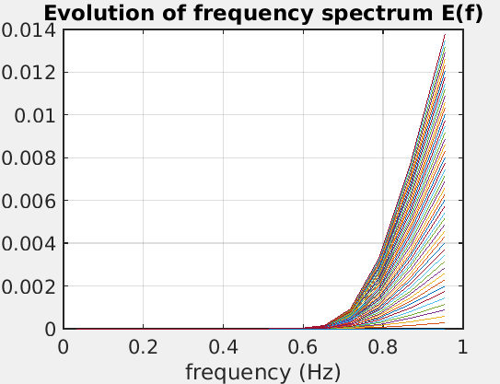

For the wave height you should get this after 48 hours of integration:

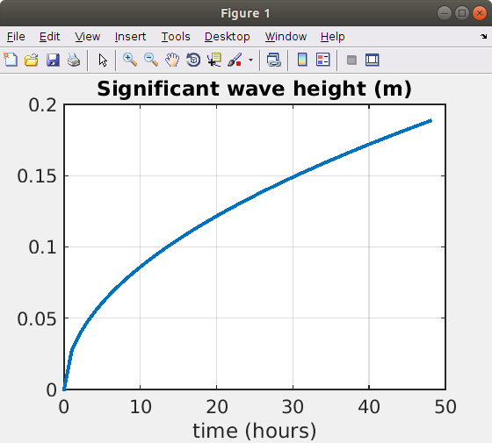

I recall that the significant wave height Hs is 4*sqrt(E) where E is the integral of the spectrum. Be careful with spectral densities: E(k,theta) transforms in E(f,theta) by multiplying by dk/df

## 1.3 Adding exponential growth and dissipation

OK, it turns out that the Phillips mechanism of wave growth is very weak: in reality the air pressure at the surface is modified by the waves. Hence the growth term is proportional to the spectrum itself.

So we have Sin = Sin,lin + Sin,exp

One simple parameterization for Sin,exp is given by Snyder et al. (1981) based on measurements in the Bahamas (with wind speed 5 m/s in the bight of Abaco) :

Sin,exp(k,theta) = 0.25.*rhoa./rhow*max(0,28.*ustar./c2d.*cos(theta-thetaw)-1)*E(k,theta)

And a dissipation parameterization by Komen et al. (1985) that is actually pretty hard to justify on first principles but that basically says that dissipation rate increases with the wave steepness to the power 4,

Sds(k,theta) = -2.36E-5*fmean.*(s2mean./s2PM).^2.*k2d./kmean* E(k,theta)

Using the same 48 hour integration now. The wave heights look like this:

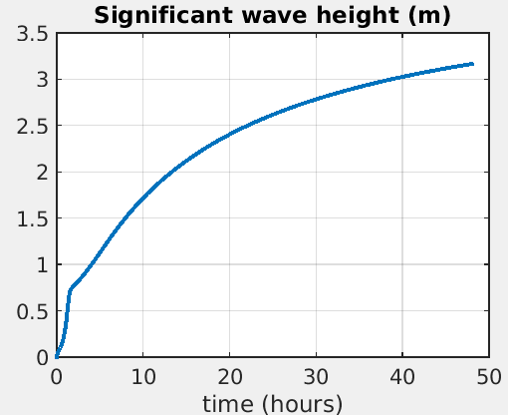

And the spectra have evolved like that:

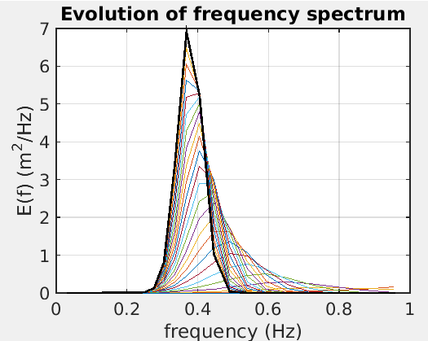

The last spectrum (in black) has the following frequency direction distribution (you can try making a nice polar plot if you prefer )

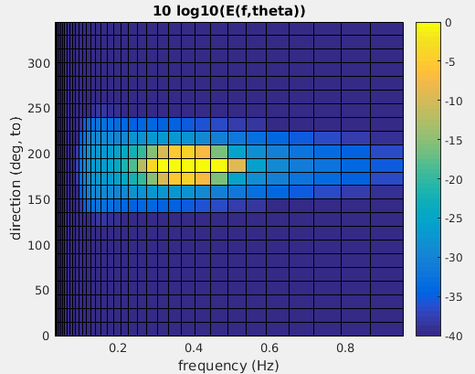

You can see that there is some distribution of energy around the wind direction but it is rather narrow.

**QUESTIONS (this one will take a bit of time, so you are probably going to do it at home):**

**Q1.** How can you quantify the width of the directional spectrum ? Plot your “width parameter” as a function of frequency.

**NB: there are many ways to define a “width parameter”... some are more useful because they can be measured with buoys or with remote sensing (radar back scatter), others are related to microseism sources!**

This 2D spectrum shape is associated to the near-balance of input and dissipation:

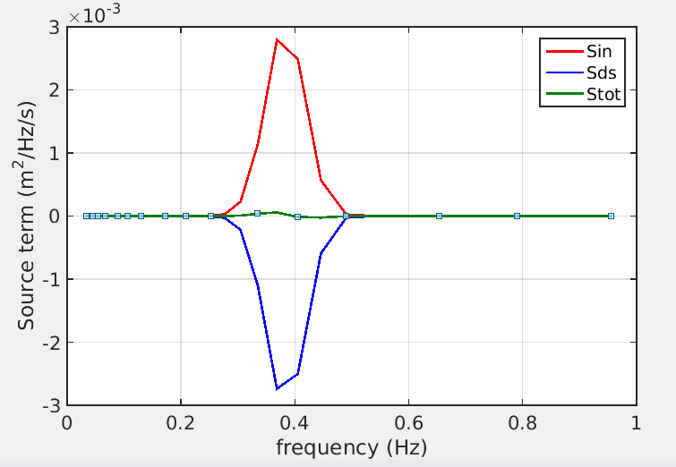

**QUESTIONS (this one will take a bit of time, so you are probably going to do it at home):**

**Q2.** What are the directional width of these source terms? Is Sin wider than Sds ?

**QUESTIONS FOR YOU TO ANSWER IN CLASS:**

Q3. What is the minimum frequency for which there is some generation?

Q4. What is not correct in the shape of the wave spectrum?

Q5 (do that at home if you run out of time during class). What happens if you blow the wind at 20 m/s for 48 hours and then reduce it to 5 m/s and keep integrating for another 48 hours. Can you split the spectrum in a wind sea and swell to help understand the Hs evolution ?

*NB: the time integration of the spectrum used a VERY CRUDE 1st order forward method that can be unstable if dt is too large…*

# Part 2: Different flavors of the source term parameterizations

The important missing term in part 1 was the non-linear 4-wave scattering term Snl. Computing it takes more than a few lines of code… so I have preferred to do the integration for you. Also, the simple numerical scheme above is not very well adapted to this very nonlinear term that gives very fast evolutions at high frequencies.

Today most ocean forecasting systems use the “Discrete Interaction Approximation” (DIA) of Snl that was proposed by Susanne Hasselmann and Klaus Hasselmann. As you will see, it is a relatively crude approximation of the more accurate solution.

We are going to plot and look at 5 different model runs that are all in

<https://drive.google.com/drive/folders/1jZeXhj4qqskHvFa8fZHDL9ppZdhaYayz?usp=sharing>

They all correspond to the same uniform ocean and constant wind speed.

The Lab3 folder contain sub-folders for the different model set-up and runs:

**ST3-Default** : Version of source terms used in ECMWF coupled IFS model until June 2019, and based on the ideas of Hasselmann (1978) and Komen et al. (1985) for the dissipation. INCLUDING a f-5 diagnostic tail for f > 2.5 fPM.

**ST4-T471**: Version of source terms used by NOAA/NCEP since 2012 (ECMWF since June 2019 is very close) with a dissipation based on Phillips (1985) as adapted by Ardhuin et al. (2010) including a specific swell dissipation by Ardhuin et al. (2009)

**ST4-T475:** Minor adjustment by Alday et al. (paper submitted in January 2021)

**ST4-T700:** Update by Romero (2019) using a new breaking probability, dissipation rate and “cumulative effect” loosely based on modulation ideas by Dulov et al. (2002) and Peureux et al. (2021).

**STYNL2: same as ST4-T700 but using “exact” Snl calculation instead of DIA.**

## 1.1 Wave heights and frequency spectra

If you plot the 5 model runs you should get this. There are differences, but they all look more or less reasonable…

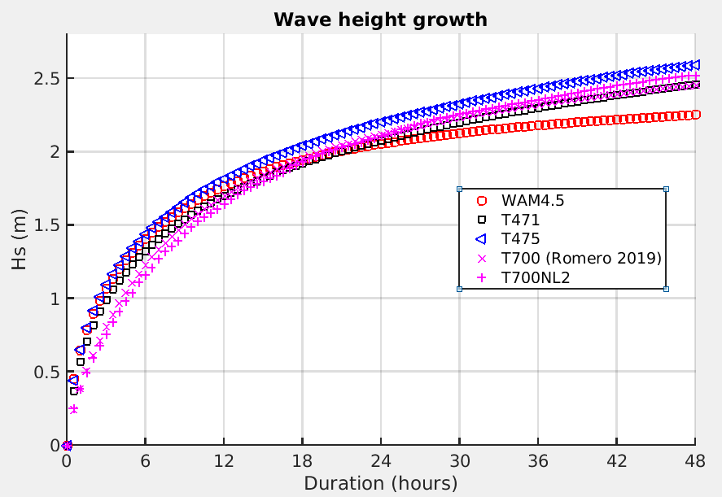

Now, these values of Hs are coming from wave spectra.

**Q6: How does that compare to eq. 4.9 ? (hint: you may need tu use eq. 4.11)**

**Q7. Compute the peak frequencies for the 5 model runs and compare them to the empirical relationship given in chapter 4 (eq. 4.8 and 4.10).**

One big difference between these model parameterizations is the treatment of the high frequencies … let us plot the frequency spectra at t=24 hours (time step number 49)

Multiplying by f^5 enhances the high frequencies. The only run that uses exact non-linear interactions may have some stability issues at high frequencies (in particular we have to make assumptions on the shape of the wave spectrum beyond the highest model frequency)

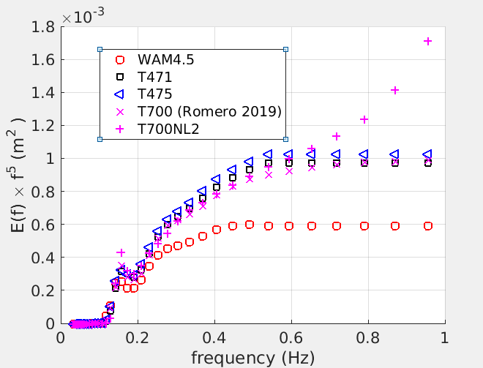

As you can see, 3 of the models go “flat” at high frequencies… well this is because these models are forced to go flat: the spectrum above some frequency fm is taken as E(f,theta)=E(fm,theta)*(fm/f)^5 : these models have given up on trying to reproduce the proper spectrum by a balance of source terms.

It took a lot of creative efforts by Romero (2019) to arrive at a decent balance not only for the frequency spectrum but also for the directional distributions.

Here are the directional distributions at t=24h and f=0.5 Hz

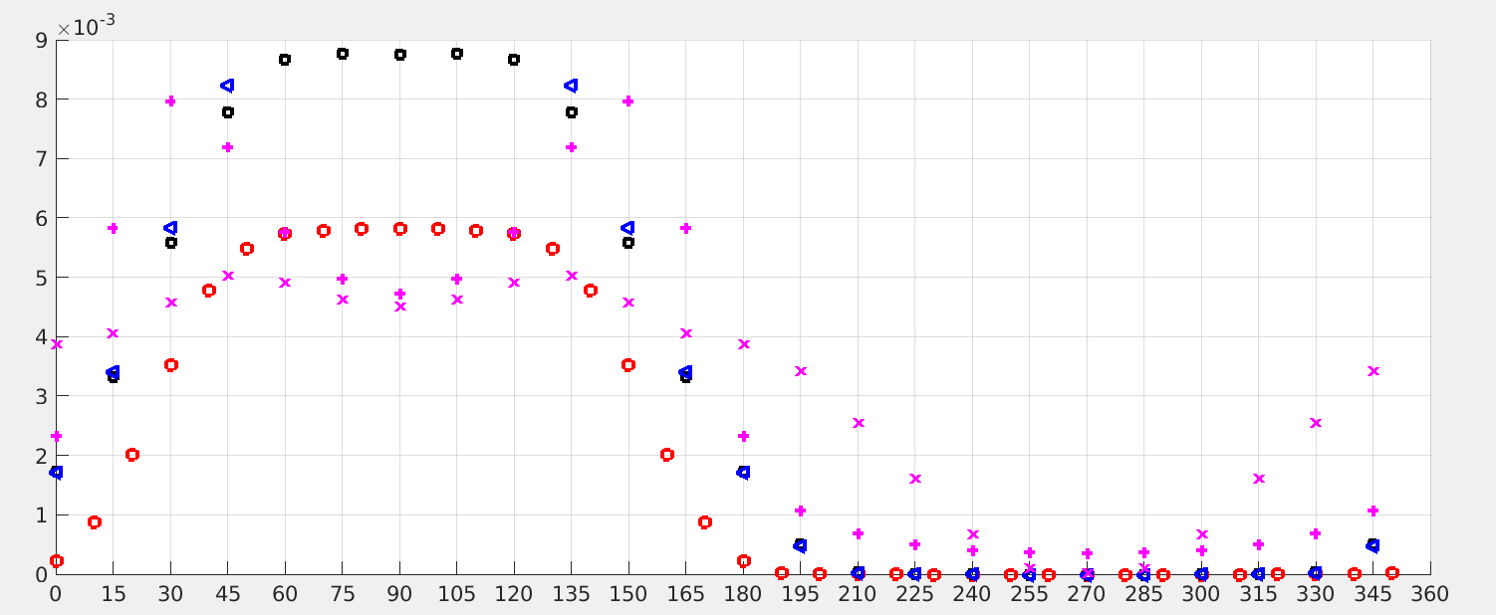

They are very different.

As a result, some directional measures of the spectral width such as the “opposition integral” or the ratio of mean square slopes mss2 in the secondary direction (usually cross wind) and mss1 in the primary direction (usually downwind), which are measurable (when integrated over all frequencies out to 10 Hz or so …) from space, are also very different. Those measurements should allow us to pick the “best model”

|  |  |
| --- | --- |
|  |  |

## 1.2 Applications to other stuff

The Stokes drift associated to each spectral component with a surface elevation variance E(f,theta)*df*dtheta is, for deep water, 2*sigma*k*E(f,theta)*df*dthea, in the direction theta.

**Q8. Compute the contribution of each frequency for the Stokes drift Us for the different model runs. How big of a fraction of the wind do they represent?**

**Q9: What about the contributions from f > 1 Hz that are not resolved in those model runs? Are they negligible ? (you may assume the spectrum decreases like 1/f^5 beyond the last resolved frequency … Can you estimate the full Stokes Drift? What if the spectra decreased like 1/f^4 ?**

**Q10: How do these numbers (fraction of wind speed) compare to the wind-driven currents?**

# Part 3: Why source terms matter for air-ice-sea coupling

When you integrate source terms you are getting energy fluxes, (when properly multiplied by rhow*g these should be in Watt/m²).

Can you trace where the energy is coming from and going to (more details in chapter 10 / Lecture 9? )

When dividing by the phase speed (or, as the seismologists call it, multiplying by the slowness vector ***k***/sigma ) before the integration of the source term, you get a flux of … horizontal momentum. Which is a vector too.

**QUESTIONS (this one will take a bit of time, so you are probably going to do it at home):**

**Q11** Compute the fraction of the wind to wave momentum flux, that is retained in the wave field.

**Q12: How does these fluxes (wind to waves and net wind-dissipaton to waves flux) compare to the wind stress?**

# References:

Hasselmann, S., Hasselmann, K., Allender, J. H., & Barnett, T. P. (1985). *Computations and Parameterizations of the Nonlinear Energy Transfer in a Gravity-Wave Specturm. Part II: Parameterizations of the Nonlinear Energy Transfer for Application in Wave Models. Journal of Physical Oceanography, 15(11), 1378–1391.* doi:10.1175/1520-0485(1985)015<1378:capotn>2.0.co;2

Munk, W. (2009). An Inconvenient Sea Truth: Spread, Steepness, and Skewness of Surface Slopes. Annual Review of Marine Science, 1(1), 377–415. doi:10.1146/annurev.marine.010908.163940

Peureux, C., Ardhuin, F., & Guimarães, P. V. (2020). *On the unsteady steepening of short gravity waves near the crests of longer waves in the absence of generation or dissipation. Journal of Geophysical Research: Oceans.* doi:10.1029/2020jc016735

*To be continued*