1.

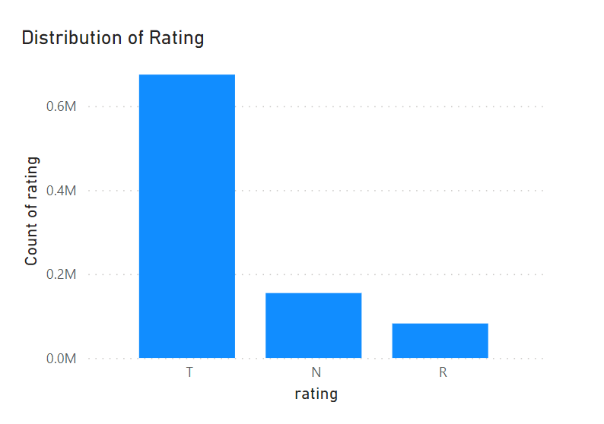

This graph shows how the number of news distributes across three categories of rating.The majority is news with truthful domains while news with untruthful domains ranks the second, and repeat offenders ranks the last. Because of the uneven distribution of rating, it is important to avoid metrics such as ‘count’ or ‘sum’ when comparing ratings against other features.

2.

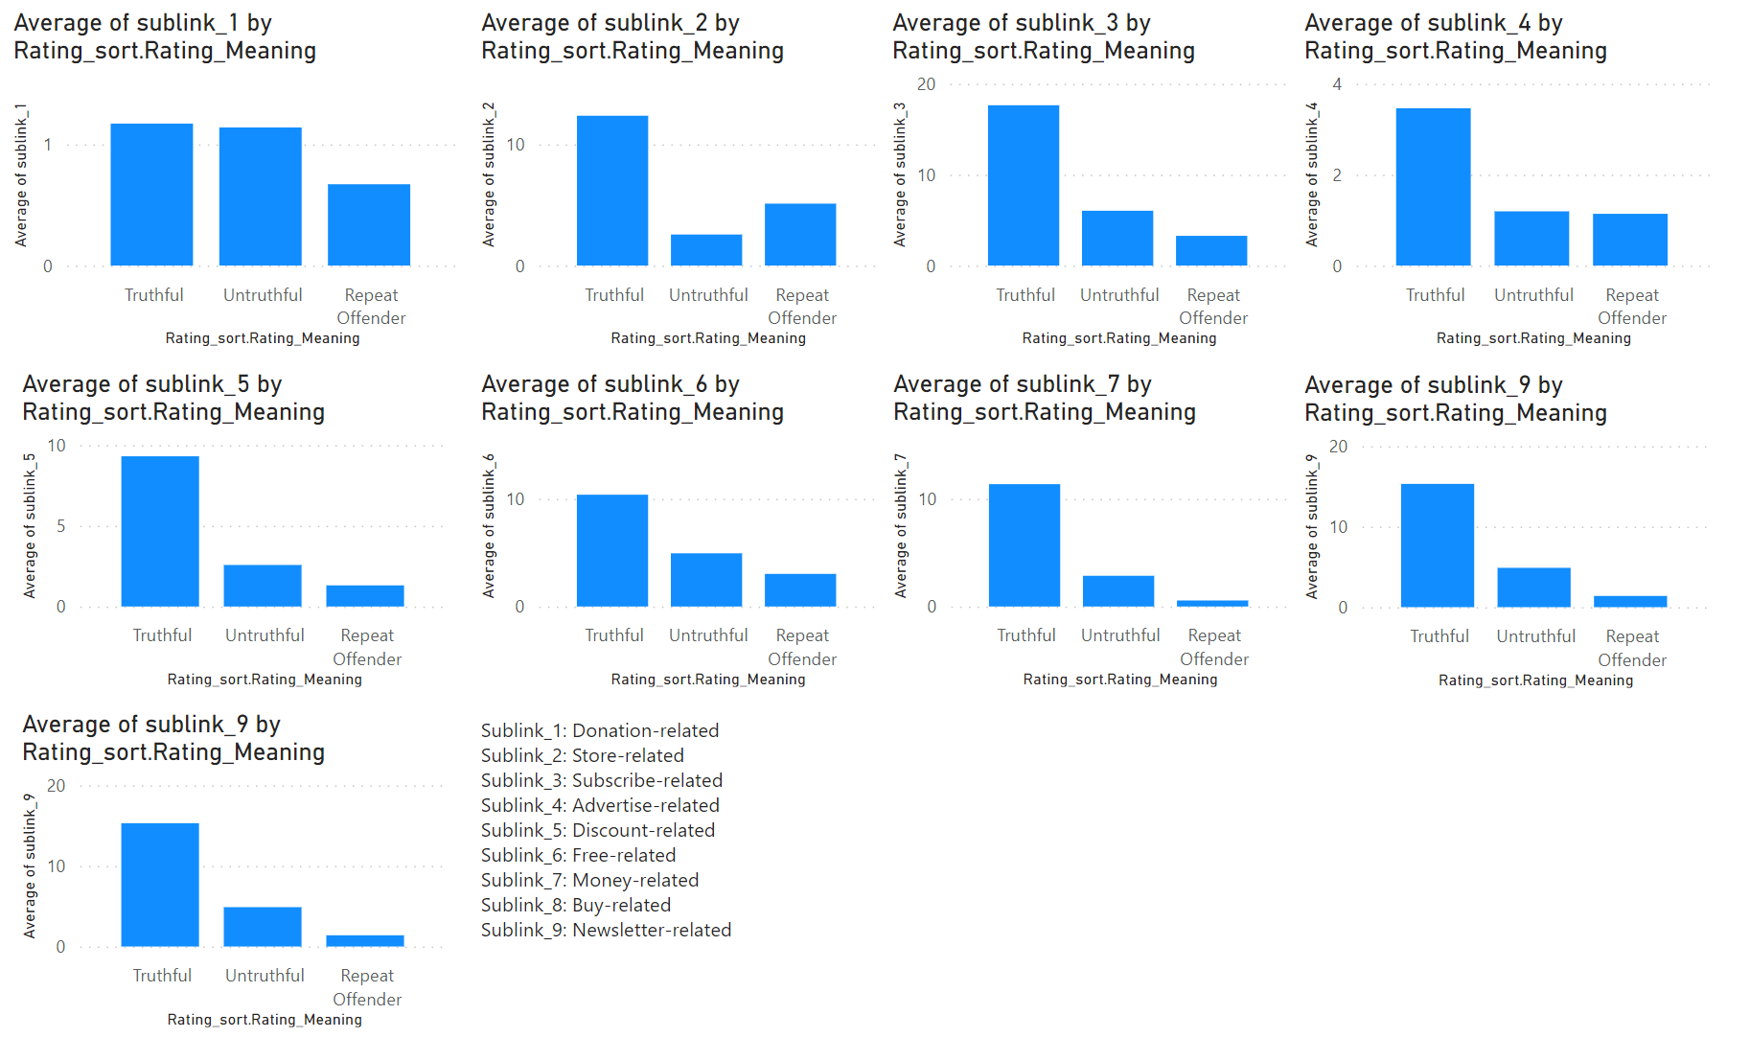

This graph displays the average count of news by rating for each topic in sublinks. For most of the topics, truthful domains tend to have higher average count while repeat offenders tend to have less average count.

3.

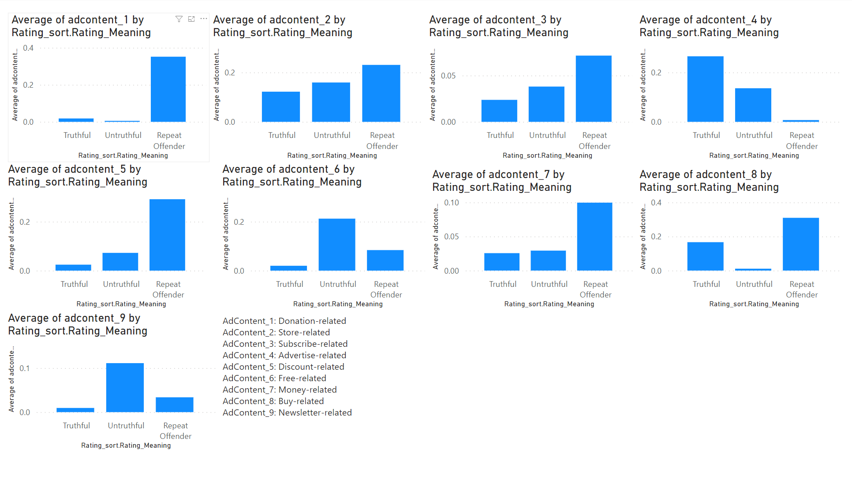

This graph shows the average count of news by rating for each topic in ad contents. Interestingly, the pattern changes when searching for ad contents. For topics like donation, store, subscribe, discount, and money-related ones, repeat offenders rank the highest and truthful domains rank the lowest. The difference between them is very significant for most of the topics with donation related one being the most significant.

4.

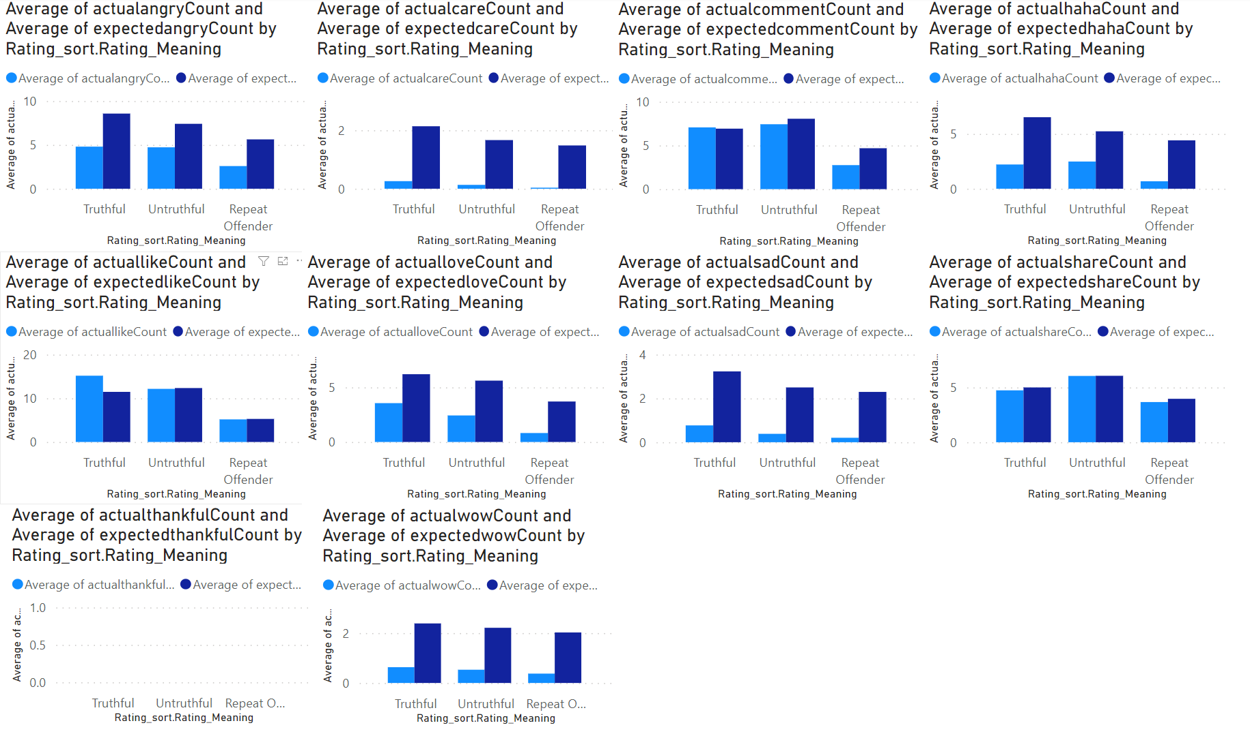

This graph shows the comparison between the average of actual emote(light blue) and the average of expected emote(dark blue) for each category of rating. For most of the emote, the expected average is larger than the actual average for all three categories of rating, with the exception of engagement metrics (count in the 5th). There is no significant difference across ratings in terms of the difference between actual and expected average for most emote.

5.

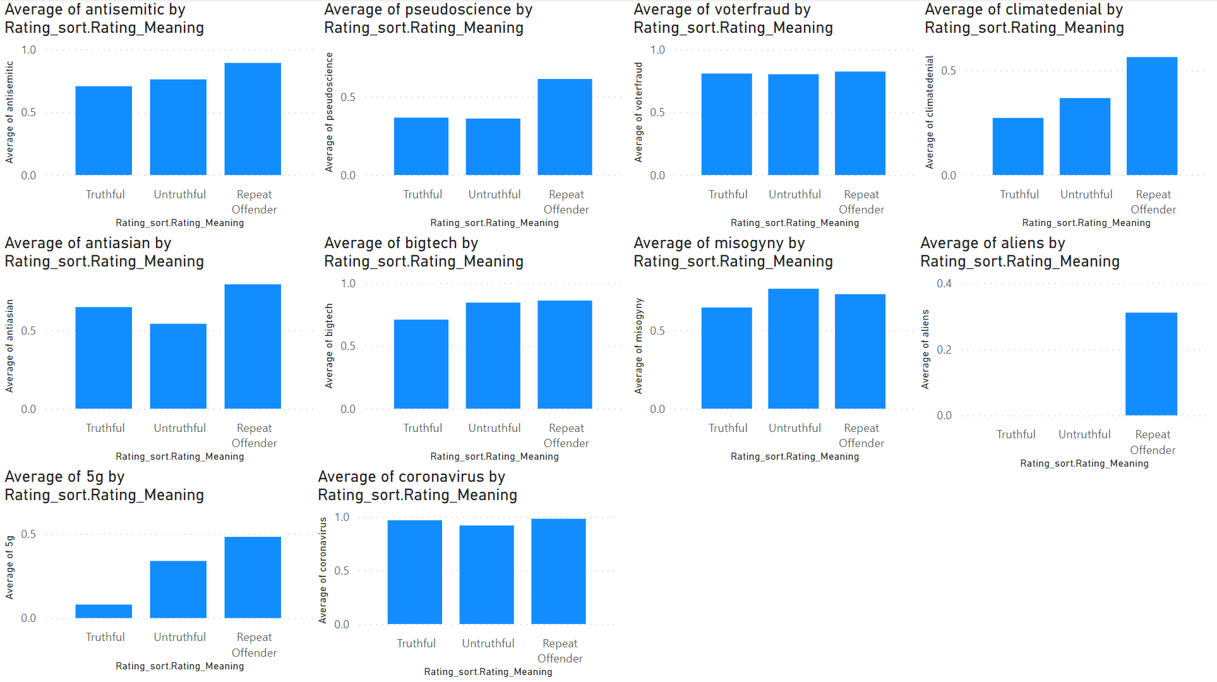

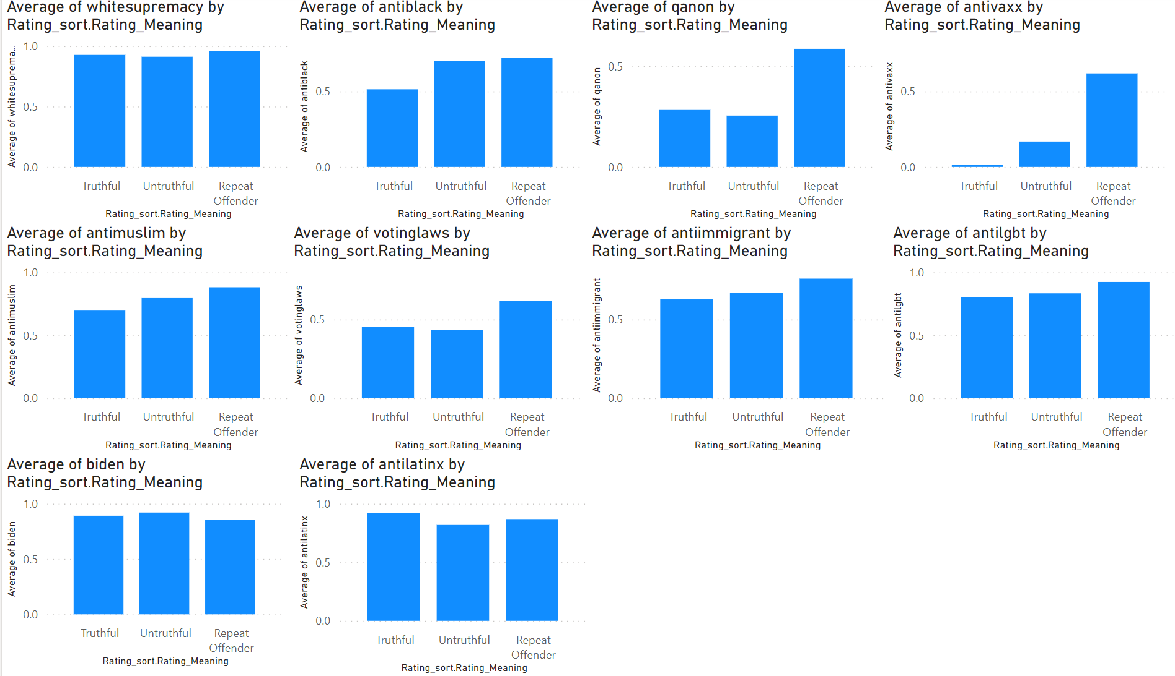

The two graphs above show the average of 20 topics per category of rating. For some topics, there is a significant difference across the three categories of rating, such as climate denial, aliens, 5g, and anti-vaccine. The pattern of truthful domain having the lowest average while repeat offenders having the highest average is also observed on other topics, such as antisemtic, pseudoscience, antiblack, antimuslim, votinglaws, anti-immigrant, and anti-lgbt, although the significance can not be determined without running statistical tests.

6.

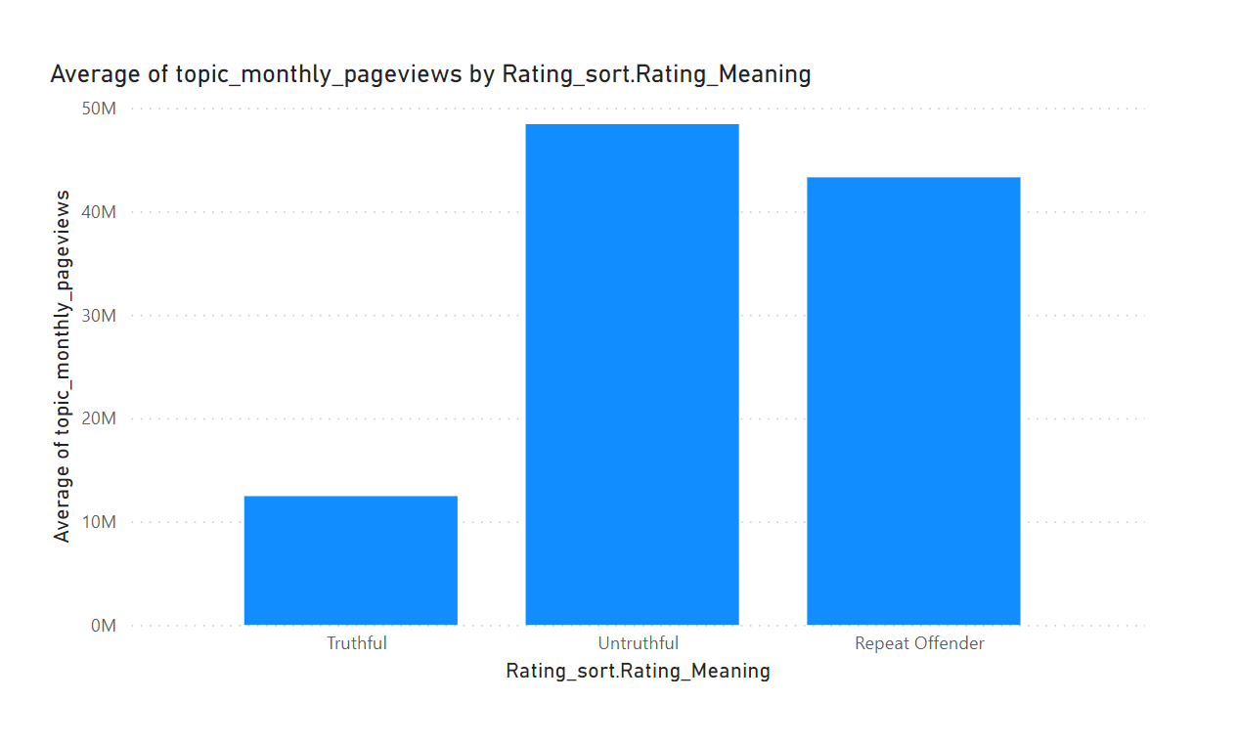

This graph shows the average monthly pageviews per category of rating. It demonstrates that compared to truthful domains, untruthful domains and repeat offenders tend to be associated with higher average monthly pageviews.

7.

The graph below shows the Ads TAG ratio per category of rating, where Ads TAG ratio is calculated as the number of Ads TAG count divided by the number of total Ads for each domain. We call tell there is no significant difference between each category of rating in terms of Ads TAG ratio.

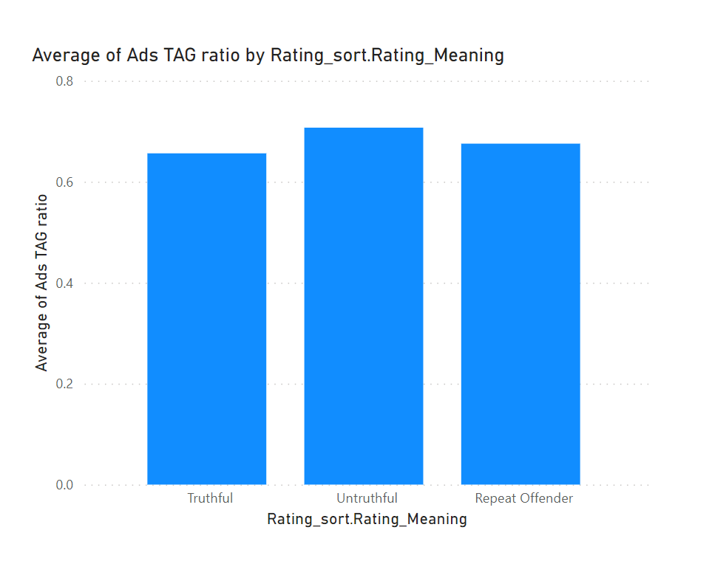

8.

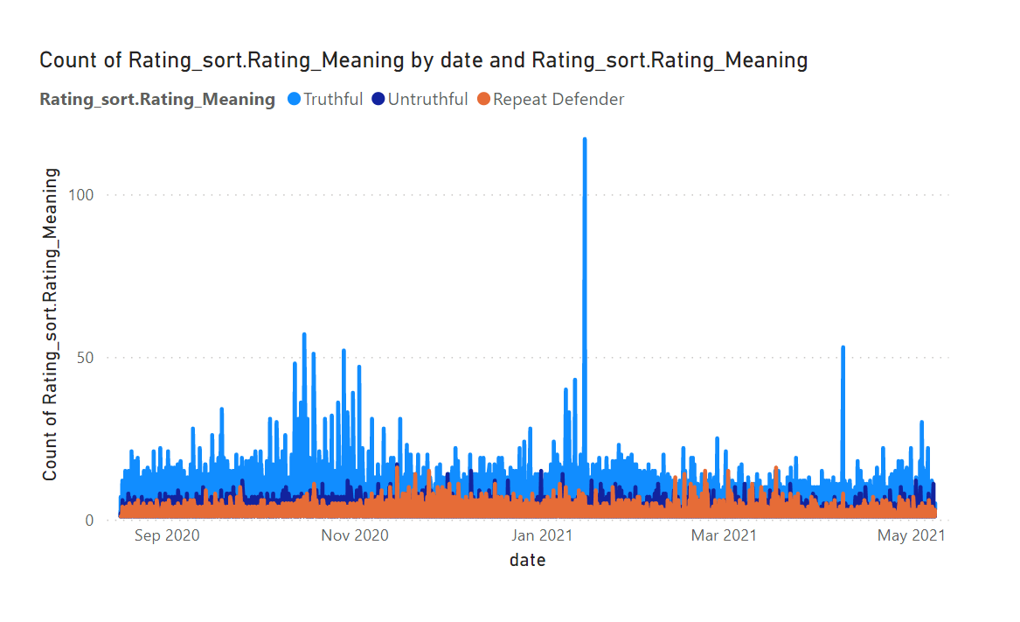

This time-series graph indicates how the number of domains vary over time for each type of rating. There were some spikes about truthful domains in late 2020 and the highest happened on Jan 14th, 2021. No apparent spikes are observed for untruthful domains or repeat offenders.

9.

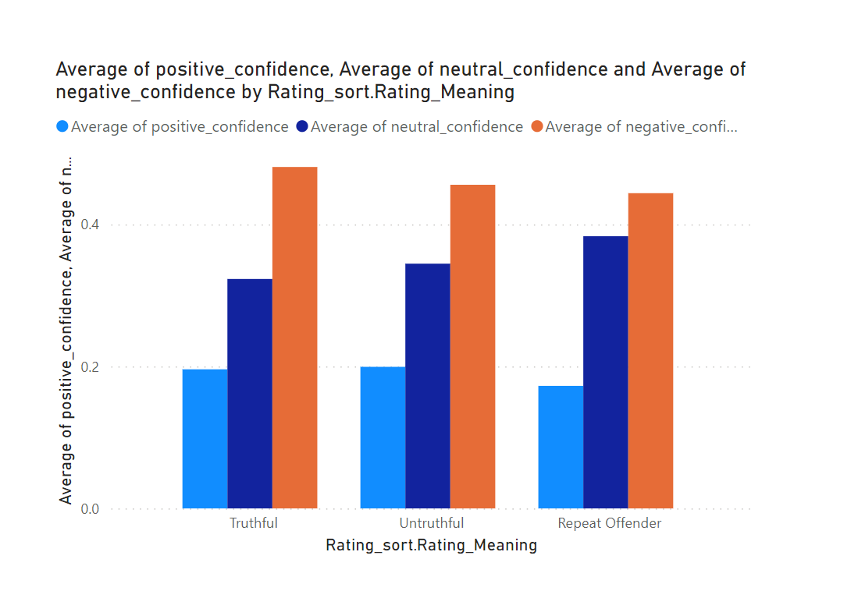

This graph summarizes the average of positive, neutral and negative confidence scores for domains with different ratings. There is no significant difference noticed between each type of ratings.

10.

The graph below shows the composition of ratings by orientation. It looks like most of the repeat offenders are far right or slightly right.

Repeat offenders are identified by NewGuard and are defined as domains that repeatedly spread misinformation after they have already been fact-checked. This means they are likely malicious actors instead of simply ignorant.

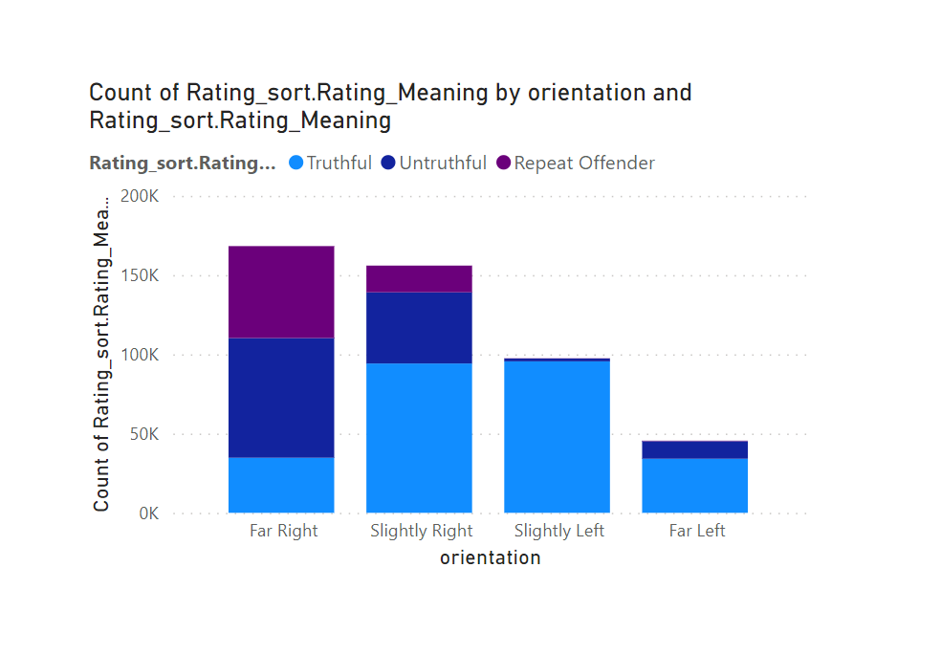

11.

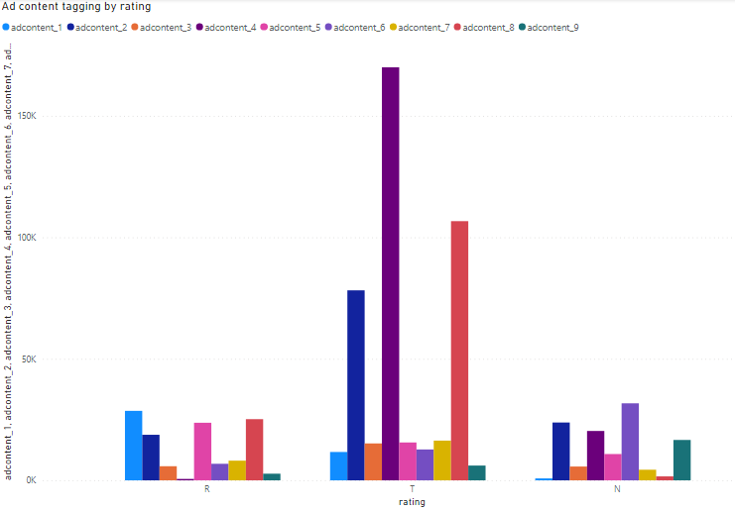

Most of the ad content taggings are truthful, with the majority of the truthful ones being AdContent_6(Free-related), AdContent_8(Buy-related), and AdContent_2(Store-related).

12

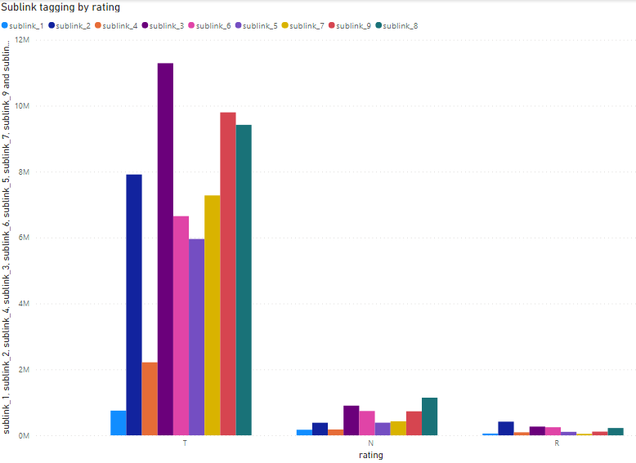

Most of the sublink taggings are truthful, with very few taggings being repeat-offenders.

13

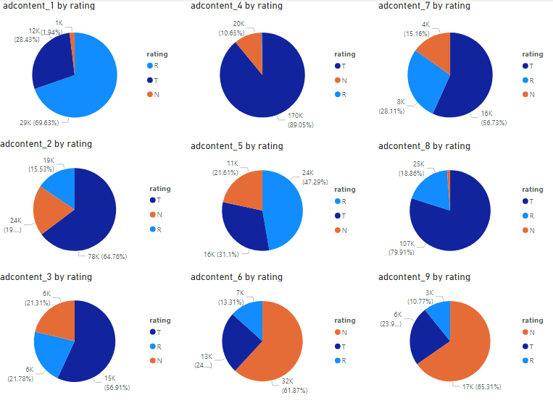

AdContent_1: Donation-related

AdContent_2: Store-related

AdContent_3: Subscribe-related

AdContent_4: Advertise-related

AdContent_5: Discount-related

AdContent_6: Free-related

AdContent_7: Money-related

AdContent_8: Buy-related

AdContent_9: Newsletter-related

AdContent_1(Donation-related) and AdContent_5(Discount-related) have the highest portions of repeat offenders. AdContent_6(Free-related) and AdContent_9(Newsletter-related) have the highest portions of non-truthful contents. AdContent_7(Money-related) are not driving non-truthful contents. For ad content, the user bases are driving non-truthful content, such as newsletter-related contents and increasing the user follower number, instead of asking for money or donations.

14

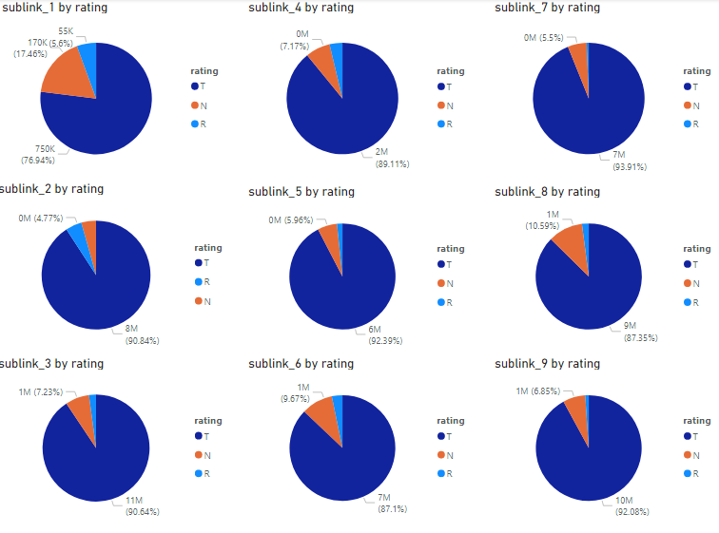

Sublink_1: Donation-related

Sublink_2: Store-related

Sublink_3: Subscribe-related

Sublink_4: Advertise-related

Sublink_5: Discount-related

Sublink_6: Free-related

Sublink_7: Money-related

Sublink_8: Buy-related

Sublink_9: Newsletter-related

For sublink, most of the contents are truthful. Sublink_1(Donation-related) has the highest percentage of non-truthful content

15

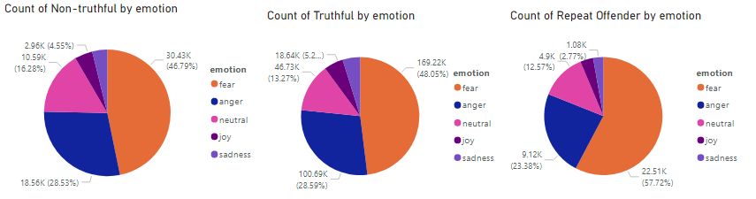

Fear is the major emotion that is propagating. There is a lot of sentiment, such as anger and fear, getting propagated by truthful news, comparing the non-truthful news

16

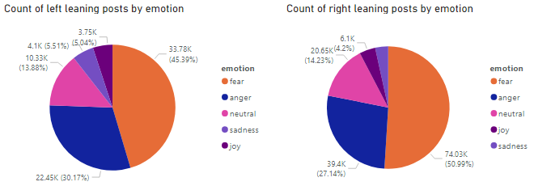

There is a small difference between the counts for posts showing anger and fear for the left leaning posts, whereas there is a big difference for the right leaning posts. People on the right leaning side are more motivated by fear than the people on the left leaning side.

17

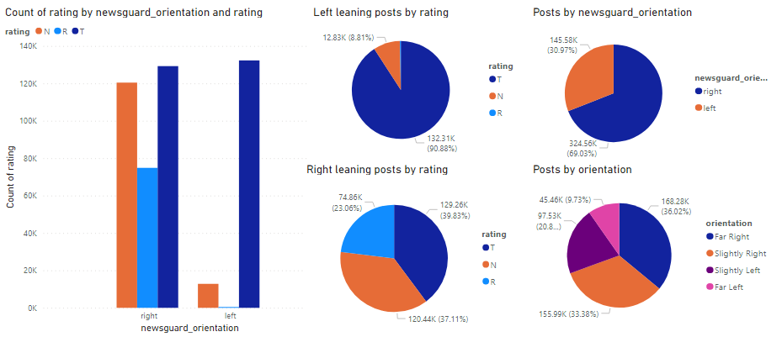

On the left leaning side, there are nearly no repeat offenders, but on the right leaning side, there are a lot of repeat offenders. On the left leaning side, there is more truthful news, and very few non-truthful news.

18

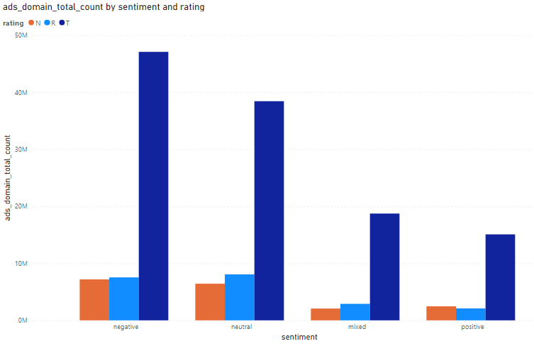

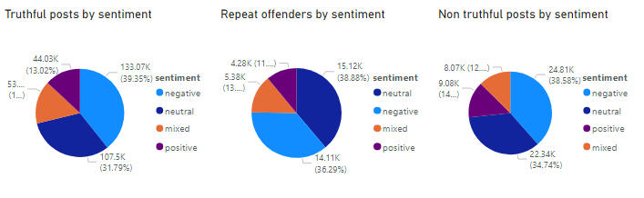

Truthful posts, non-truthful posts, and repeat offenders have basically the same composition of sentiments.

19.

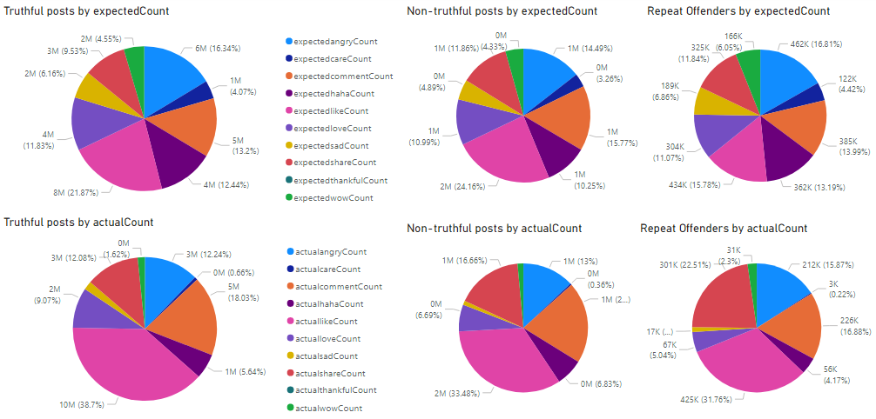

ExpectedCount: Number of expected engagements with the xxx emote based on internal crowdtangle model (<https://help.crowdtangle.com/en/articles/3213537-crowdtangle-codebook>). The expected values in the dataset are referred to as 'benchmark' in the Crowdtangle codebook (e.g. Benchmark Likes = Expected Likes).

ActualCount: Number of engagements with the xxx emote.

The actual count is lower than the expected count for angry, care, haha, love, sad, and wow emote. Repeat offenders get extremely low counts for all actions. There is no actual count nor expected count for the thankful emote.