中南民族大学
实验报告
实验课名称： 数值分析 指导教师： 娄联堂
学生姓名： 莫茴茜 年级专业： 2016信息 学号： 201621102017
实验名称： Newton插值法
实验目的 | 熟悉Newton插值法基本用法；
实验内容 | - 数据  Set Default 默认数据  X = 0.4,0.55,0.65,0.80,0.90,1.05  Y = 0.41075,0.57815,0.69675,0.88811,1.02652,1.25382  Order = 5  二、实验原理  假设已知n+1n+1个点相对多项式函数ff的值为：(x0,f(x0)),(x1,f(x1)),(x2,f(x2)),⋯,(xn,f(xn))(x0,f(x0)),(x1,f(x1)),(x2,f(x2)),⋯,(xn,f(xn))，求此多项式函数f。  先从求满足两个点(x0,f(x0)),(x1,f(x1))(x0,f(x0)),(x1,f(x1))的函数f1(x)f1(x)说起：  假设f1(x)=f(x0)+b1(x−x0)f1(x)=f(x0)+b1(x−x0)，  现在我们增加一个点，(x0,f(x0)),(x1,f(x1)),(x2,f(x2))(x0,f(x0)),(x1,f(x1)),(x2,f(x2))，求满足这三个点的函数f2(x)f2(x)：
实验内容 | 假设f2(x)=f1(x)+b2(x−x0)(x−x1)f2(x)=f1(x)+b2(x−x0)(x−x1)，  由此我们可以推出牛顿插值公式  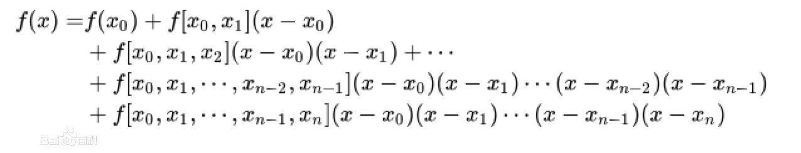  三、实验步骤  1、用IDE编写基本界面  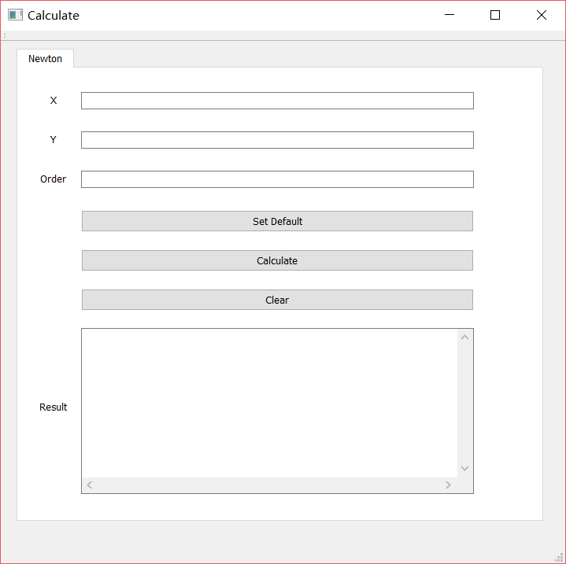  1.1界面解释  界面提供运用newton插值法的用户交互界面。  设置参数设置框X,Y,Order,以填写x,y数组与阶数  设置结果显示框Result,显示计算结果与提示信息  设置三個按钮Set Default, 可提供默认的参数  Calculate,计算按钮  Clear，清除结果框按钮  1.2 界面代码（附后）  界面采用XML/HTML编写  - 前后端连接  2.1 default数据设置  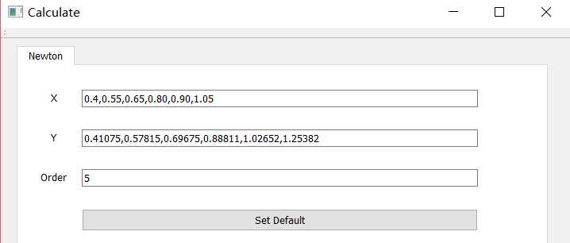  void MainWindow::on_defaultB_clicked()  {  ui->xLine->setText("0.4,0.55,0.65,0.80,0.90,1.05");  ui->yLine->setText("0.41075,0.57815,0.69675,0.88811,  1.02652,1.25382");  ui->orderLine->setText("5");  }  2.2 计算  while(i < order){  j = order;  while(j > i){  if(i==0){  data[j] = ((yv[j]-yv[j-1])/(xv[j]-xv[j-1]));  }else{  data[j]=(data[j]-data[j-1])/(xv[j]-xv[j-1-i]);  }  print.push_back(data[j]);  j--;  }  i++;  }  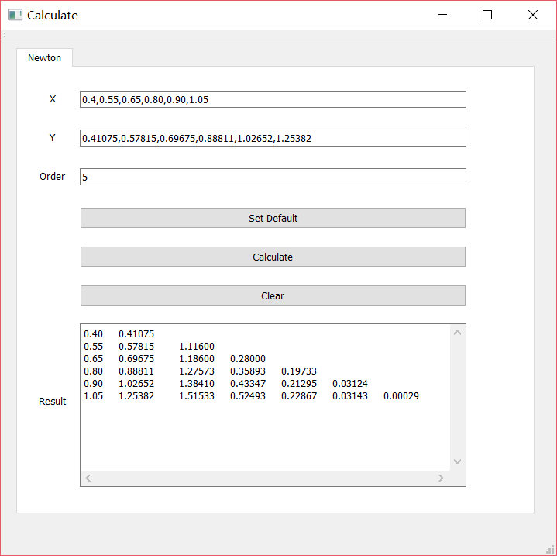  2.3其他功能  2.3.1错误提示  参数为空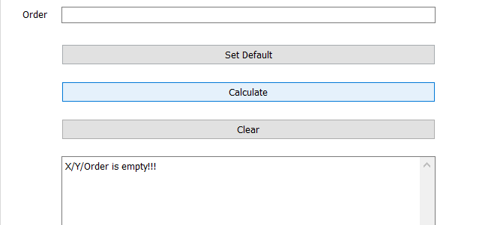  bool MainWindow::isEmpty(){  if(ui->orderLine->text().isEmpty()||  ui->xLine->text().isEmpty()||  ui->yLine->text().isEmpty()){  ui->resultLine->append("X/Y/Order is empty!!!");  return false;  }else return true;  }  bool MainWindow::isValid(vector<double> xv,  vector<double> yv,int order){  if(xv.size()!=yv.size()||order<=0){  ui->resultLine->append("X/Y/Order is invalid!!!");  return false;  }else return true;  }  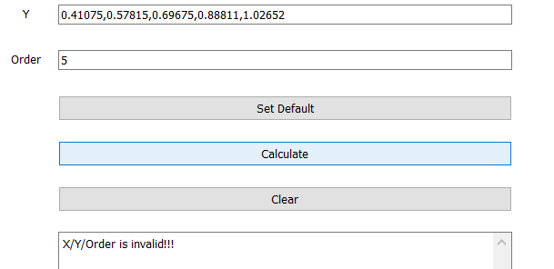  XY维数不同  2.3.2 清除结果  void MainWindow::on_clearB_clicked()  {  ui->resultLine->clear();  }
实验内容
心得体会 | 通过实验了解了如何通过计算机操作数组来执行newton插值法
教师评语
实验日期： 2018 年 10 月 8 日 实验成绩：

Codes:

#ifndef MAINWINDOW_H
#define MAINWINDOW_H

#include <QMainWindow>
#include <QDialog>
#include <vector>
#include <iostream>
#include <QMessageBox>
using namespace std;

namespace Ui {
class MainWindow;
}

class MainWindow : public QMainWindow
{
Q_OBJECT

public:
explicit MainWindow(QWidget *parent = nullptr);
~MainWindow();

private slots:

void on_newtonCal_clicked();

void on_clearB_clicked();

void on_defaultB_clicked();

bool isEmpty();

bool isValid(vector<double> xv,vector<double> yv,int order);

private:
Ui::MainWindow *ui;
};

#endif // MAINWINDOW_H

#include "mainwindow.h"
#include "ui_mainwindow.h"

MainWindow::MainWindow(QWidget *parent) :
QMainWindow(parent),
ui(new Ui::MainWindow)
{
ui->setupUi(this);
}

MainWindow::~MainWindow()
{
delete ui;
}

bool MainWindow::isEmpty(){
if(ui->orderLine->text().isEmpty()||ui->xLine->text().isEmpty()||ui->yLine->text().isEmpty()){
ui->resultLine->append("X/Y/Order is empty!!!");
return false;
}else return true;
}

bool MainWindow::isValid(vector<double> xv,vector<double> yv,int order){
if(xv.size()!=yv.size()||order<=0){
ui->resultLine->append("X/Y/Order is invalid!!!");
return false;
}else return true;
}

void MainWindow::on_newtonCal_clicked()
{

QString tmp = "1";
QString tp = "2";
bool *ok;
vector<double> xv;
vector<double> yv;
int order;

if(!isEmpty()){

}else{
for(int i = 0; tmp!=0; i++){
tmp = ui->xLine->text().section(",",i,i);
xv.push_back(tmp.toDouble(ok));
}//0.4,0.55,0.65,0.80,0.90,1.05

for(int i = 0; tp!=0;i++){
tp = ui->yLine->text().section(",",i,i);
yv.push_back(tp.toDouble(ok));
}//0.41075,0.57815,0.69675,0.88811,1.02652,1.25382

order = ui->orderLine->text().toInt();

if(isValid(xv,yv,order)){
int i = 0;
int j;
vector<double> data(order*(order+1),0);
vector<double> print;

while(i < order){
j = order;
while(j > i){
if(i==0){
data[j] = ((yv[j]-yv[j-1])/(xv[j]-xv[j-1]));
}else{
data[j] = (data[j]-data[j-1])/(xv[j]-xv[j-1-i]);
}
print.push_back(data[j]);
j--;
}
i++;
}

for(int count=0;count<order+1;count++){
if(count!=0){
ui->resultLine->append("");
ui->resultLine->insertPlainText(QString::number(xv[count],10,2)+" "+QString::number(yv[count],10,5)+" ");

int p=5;
int tt = order-count-1+1;
for(int t=0;t+1<=count;t++){
ui->resultLine->insertPlainText(QString::number(print[tt],10,5)+" ");
tt = tt+p;
p--;
}
}
if(count==0){
ui->resultLine->append(QString::number(xv[count],10,2)+" "+QString::number(yv[count],10,5)+" ");
}
}
}else{

}
}
}

void MainWindow::on_clearB_clicked()
{
ui->resultLine->clear();
}

void MainWindow::on_defaultB_clicked()
{
ui->xLine->setText("0.4,0.55,0.65,0.80,0.90,1.05");
ui->yLine->setText("0.41075,0.57815,0.69675,0.88811,1.02652,1.25382");
ui->orderLine->setText("5");
}

#include "mainwindow.h"
#include <QApplication>

int main(int argc, char *argv[])
{
QApplication a(argc, argv);
MainWindow w;
w.show();

return a.exec();
}

mainwindow.ui

<?xml version="1.0" encoding="UTF-8"?>
<ui version="4.0">
<class>MainWindow</class>
<widget class="QMainWindow" name="MainWindow">
<property name="geometry">
<rect>
<x>0</x>
<y>0</y>
<width>717</width>
<height>678</height>
</rect>
</property>
<property name="windowTitle">
<string>Calculate</string>
</property>
<widget class="QWidget" name="centralWidget">
<widget class="QTabWidget" name="tabWidget">
<property name="geometry">
<rect>
<x>20</x>
<y>10</y>
<width>671</width>
<height>601</height>
</rect>
</property>
<property name="whatsThis">
<string>&lt;html&gt;&lt;head/&gt;&lt;body&gt;&lt;p&gt;&lt;br/&gt;&lt;/p&gt;&lt;/body&gt;&lt;/html&gt;</string>
</property>
<property name="styleSheet">
<string notr="true">QTabWidget tabWg = new QTabWidget(this);
QWidget *Tab1 = new QWidget();
QWidget *Tab2 = new QWidget();
tabWg.addTab(Tab1, &quot;Tab1&quot;);
tabWg.addTab(Tab2, &quot;Tab2&quot;);
tabWg.setCurrentIndex(0);
tabWg.setCurrentIndex(1);
</string>
</property>
<property name="currentIndex">
<number>0</number>
</property>
<widget class="QWidget" name="Newton">
<property name="accessibleName">
<string/>
</property>
<attribute name="title">
<string>Newton</string>
</attribute>
<widget class="QLabel" name="order">
<property name="geometry">
<rect>
<x>10</x>
<y>130</y>
<width>70</width>
<height>20</height>
</rect>
</property>
<property name="text">
<string>Order</string>
</property>
<property name="alignment">
<set>Qt::AlignCenter</set>
</property>
</widget>
<widget class="QLineEdit" name="orderLine">
<property name="geometry">
<rect>
<x>80</x>
<y>130</y>
<width>499</width>
<height>22</height>
</rect>
</property>
</widget>
<widget class="QTextBrowser" name="resultLine">
<property name="geometry">
<rect>
<x>80</x>
<y>330</y>
<width>499</width>
<height>211</height>
</rect>
</property>
<property name="layoutDirection">
<enum>Qt::LeftToRight</enum>
</property>
<property name="autoFillBackground">
<bool>false</bool>
</property>
<property name="verticalScrollBarPolicy">
<enum>Qt::ScrollBarAlwaysOn</enum>
</property>
<property name="horizontalScrollBarPolicy">
<enum>Qt::ScrollBarAlwaysOn</enum>
</property>
<property name="html">
<string>&lt;!DOCTYPE HTML PUBLIC &quot;-//W3C//DTD HTML 4.0//EN&quot; &quot;http://www.w3.org/TR/REC-html40/strict.dtd&quot;&gt;
&lt;html&gt;&lt;head&gt;&lt;meta name=&quot;qrichtext&quot; content=&quot;1&quot; /&gt;&lt;style type=&quot;text/css&quot;&gt;
p, li { white-space: pre-wrap; }
&lt;/style&gt;&lt;/head&gt;&lt;body style=&quot; font-family:'MS Shell Dlg 2'; font-size:7.8pt; font-weight:400; font-style:normal;&quot;&gt;
&lt;p style=&quot;-qt-paragraph-type:empty; margin-top:0px; margin-bottom:0px; margin-left:0px; margin-right:0px; -qt-block-indent:0; text-indent:0px;&quot;&gt;&lt;br /&gt;&lt;/p&gt;&lt;/body&gt;&lt;/html&gt;</string>
</property>
</widget>
<widget class="QPushButton" name="defaultB">
<property name="geometry">
<rect>
<x>80</x>
<y>180</y>
<width>499</width>
<height>28</height>
</rect>
</property>
<property name="text">
<string>Set Default</string>
</property>
</widget>
<widget class="QPushButton" name="newtonCal">
<property name="enabled">
<bool>true</bool>
</property>
<property name="geometry">
<rect>
<x>80</x>
<y>230</y>
<width>499</width>
<height>28</height>
</rect>
</property>
<property name="text">
<string>Calculate</string>
</property>
</widget>
<widget class="QPushButton" name="clearB">
<property name="geometry">
<rect>
<x>80</x>
<y>280</y>
<width>499</width>
<height>28</height>
</rect>
</property>
<property name="text">
<string>Clear</string>
</property>
</widget>
<widget class="QLabel" name="label">
<property name="geometry">
<rect>
<x>10</x>
<y>390</y>
<width>70</width>
<height>79</height>
</rect>
</property>
<property name="text">
<string>Result</string>
</property>
<property name="alignment">
<set>Qt::AlignCenter</set>
</property>
</widget>
<widget class="QLabel" name="xLabel">
<property name="geometry">
<rect>
<x>10</x>
<y>30</y>
<width>70</width>
<height>20</height>
</rect>
</property>
<property name="text">
<string>X</string>
</property>
<property name="alignment">
<set>Qt::AlignCenter</set>
</property>
</widget>
<widget class="QLabel" name="yLabel">
<property name="geometry">
<rect>
<x>10</x>
<y>80</y>
<width>70</width>
<height>20</height>
</rect>
</property>
<property name="text">
<string>Y</string>
</property>
<property name="textFormat">
<enum>Qt::AutoText</enum>
</property>
<property name="scaledContents">
<bool>false</bool>
</property>
<property name="alignment">
<set>Qt::AlignCenter</set>
</property>
<property name="wordWrap">
<bool>false</bool>
</property>
<property name="buddy">
<cstring></cstring>
</property>
</widget>
<widget class="QLineEdit" name="xLine">
<property name="geometry">
<rect>
<x>80</x>
<y>30</y>
<width>499</width>
<height>22</height>
</rect>
</property>
</widget>
<widget class="QLineEdit" name="yLine">
<property name="geometry">
<rect>
<x>80</x>
<y>80</y>
<width>499</width>
<height>22</height>
</rect>
</property>
<property name="maximumSize">
<size>
<width>16777215</width>
<height>22</height>
</size>
</property>
</widget>
</widget>
</widget>
</widget>
<widget class="QMenuBar" name="menuBar">
<property name="geometry">
<rect>
<x>0</x>
<y>0</y>
<width>717</width>
<height>26</height>
</rect>
</property>
</widget>
<widget class="QToolBar" name="mainToolBar">
<attribute name="toolBarArea">
<enum>TopToolBarArea</enum>
</attribute>
<attribute name="toolBarBreak">
<bool>false</bool>
</attribute>
</widget>
<widget class="QStatusBar" name="statusBar"/>
</widget>
<layoutdefault spacing="6" margin="11"/>
<resources/>
<connections/>
</ui>

