**Nom: Jarjoura Sophia**

**Matricule: 220590**

**Approach 1: The Context Passes Data to the Strategy**

In this approach, the context class (Sorter) passes directly the array as a parameter to the strategy method:

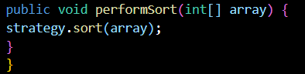

So, the context class (Sorter) explicitly passes the array to the strategy when calling the performSort() method.

**Approach 2: The Strategy Retains a Reference to the Context**

In this approach, the sorting strategy retains a reference to the context class (Sorter), and the array is retrieved from the context using a method (getData()), instead of being passed directly as a parameter.



int[] array = context.getData(); 🡪 Array is retrieved from the context