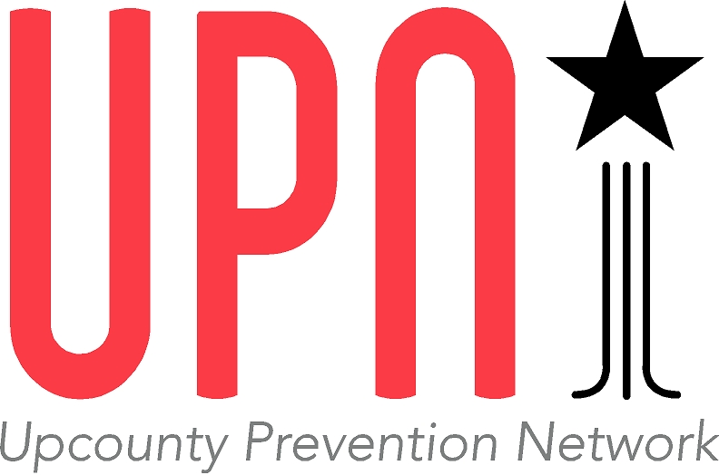

**Contest Rules**

The Upcounty Prevention Network (UPN) in collaboration with community partner Riverworks Art Center is organizing a contest for creative students in the Poolesville, Maryland area.

The object is to design a mural to be located in downtown Poolesville with the theme ***Mindful of the Past, Hopeful for the Future.***

The winning design will be painted with collaboration from student and adult artists and will be unveiled this spring!

In addition to participating in the creation of a major community art installation, contest winners will receive cash prizes: $500 for first place; $250 for second place; $150 for third place.

The contest is open to any student, Grades 6 – 12, who lives in the attendance area for Poolesville High School or who attends John Poole Middle School or Poolesville High School.

All entries must be submitted by 3:00 PM on Sunday, March 26. They may be sent with the application form to UPN at PO Box 383, Poolesville MS 20837, postmarked no later than March 25; dropped off at Locals Farm Market, 19929 Fisher Ave, Poolesville; or emailed to contact@RiverworksArt.org

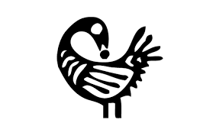Entries are to be full-color designs for a mural in landscape orientation. They may be accomplished by hand or by computer. No text or logos may be included, but images that relate to Poolesville’s heritage and culture should be emphasized. Artists are encouraged to take inspiration from the image of the Sankofa bird, which symbolizes taking from the past what is good and bringing it into the present to make progress in the future.

Questions about the contest may be addressed to Lynne Stahl Rolls ([lynnerolls@aol.com](mailto:lynnerolls@aol.com)) or David Therriault ([aldenfarms@aldenfarms.net](mailto:aldenfarms@aldenfarms.net)).