Gases and Stoichiometry
Chem 1211 Lab
Sophia Chen

Introduction
The goal of this lab was to figure out what controls the volume of gas made in a chemical reaction. Gases are the simplest state of matter because their particles are far apart and have almost no attractions between them. Because of this, an ideal gas can be described by four variables: pressure (P), volume (V), moles (n), and temperature (T). These are tied together by the ideal gas law, where R is the ideal gas constant (0.08206 L·atm/(mol·K)):

The ideal gas law says nothing about which gas it is. The mass or size of the gas particles should not matter, only how many moles there are. In Part A, we tested this by splitting water into hydrogen and oxygen gas by electrolysis and collecting each gas in a separate eudiometer. Water splits as 2 H₂O → 2 H₂ + O₂, so if volume depends on moles, the hydrogen tube should fill with about twice as much gas as the oxygen tube.
Using what we saw in Part A, our group asked the research question: How does the number of moles of gas produced in a reaction affect the volume of gas collected? Our hypothesis was that the volume of gas produced is determined by the moles of gas made, so the volume should increase in direct proportion to the moles when temperature and pressure stay the same. To test this, we reacted different amounts of magnesium with excess hydrochloric acid, which makes hydrogen gas in a 1:1 mole ratio with magnesium:
Since the acid is in excess, magnesium is the limiting reactant, so the mass of magnesium tells us how many moles of H₂ should form. Comparing the measured volume to the expected moles also let us calculate an experimental value of R and see how close the gas came to behaving ideally.

Methods
In Part A, water was decomposed with a 9 V battery in an electrolysis device for 10 minutes. The hydrogen and oxygen were sent through tubing into two water-filled eudiometers turned upside down in beakers of water. The starting and final water levels were read, and the difference gave the volume of each gas.
In Part C, three trials were run with magnesium ribbon and excess 2.0 M HCl. For each trial, a piece of magnesium was weighed on a balance so that it would make between 0.001 and 0.002 mol of H₂, and the HCl was measured out by pipette. The reaction was done in a filter flask sealed with a rubber stopper so no gas could escape, and the gas traveled through tubing into a water-filled eudiometer. The initial and final volume readings in the eudiometer were recorded, and the difference was the volume of hydrogen made. Room temperature (294.2 K) and atmospheric pressure (1.000 atm) were also recorded.
To analyze the data, the mass of magnesium was converted to theoretical moles of H₂ using stoichiometry. The measured volume, temperature, and pressure were put into the ideal gas law to find the moles of gas actually produced. Finally, R was calculated from the measured P, V, and T and the theoretical moles, and it was compared to the accepted value with a percent error.

Results
All three trials produced hydrogen gas, and the volume collected went up each time more magnesium was used. The data are summarized in Table 1. Room temperature was 294.2 K and the pressure was 1.000 atm for every trial.
Table 1. Reaction data and moles of gas produced (T = 294.2 K, P = 1.000 atm)
 | Trial 1 | Trial 2 | Trial 3
Reactant A | Mg | Mg | Mg
Reactant B | HCl | HCl | HCl
Theoretical Moles (mol) | 0.0010 | 0.0014 | 0.0019
Measured Gas Volume (mL) | 23.60 | 32.80 | 40.90
Moles of Gas Produced (mol) | 0.00098 | 0.00136 | 0.00169

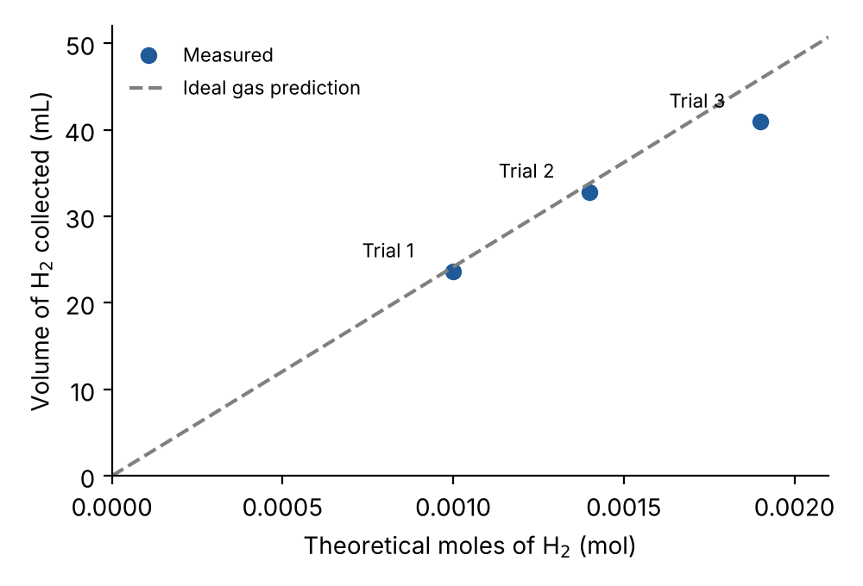
Figure 1. Volume of H₂ collected versus theoretical moles of H₂. The dashed line is the volume predicted by the ideal gas law.
Figure 1 shows that volume rises steadily as moles increase. Trials 1 and 2 fall close to the ideal gas line, while Trial 3 falls below it. The experimental values of R are shown in Table 2. Trials 1 and 2 were within 3% of the accepted value, while Trial 3 was about 11% low. The average R was 0.0777 L·atm/(mol·K), a 5.3% error.
Table 2. Experimental values of R (accepted R = 0.08206 L·atm/(mol·K))
 | Trial 1 | Trial 2 | Trial 3
Value of R Measured (L·atm/(mol·K)) | 0.0802 | 0.0796 | 0.0732
Percent Error of R (%) | 2.2 | 3.0 | 10.8

Sample calculations (Trial 1):
Theoretical moles of H₂ from the mass of magnesium (1 mol Mg makes 1 mol H₂):
Moles of gas produced, from the measured volume using the ideal gas law:
Experimental value of R, using the theoretical moles:
Percent error of R:
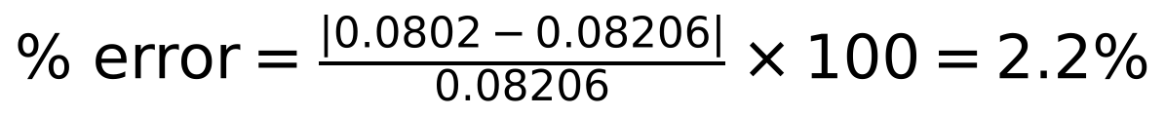

Conclusion
Our revised hypothesis was that the volume of gas made in a reaction depends on the moles of gas produced, and the results support this claim. As the theoretical moles of H₂ went from 0.0010 to 0.0014 to 0.0019 mol, the volume collected went from 23.60 to 32.80 to 40.90 mL. More moles always gave more volume, and the points in Figure 1 follow the ideal gas prediction fairly well. This makes sense with the ideal gas law: when P and T are held constant, V = (RT/P)·n, so volume should be directly proportional to moles. Our prediction matched the outcome, since the volume grew in step with the moles in every trial.
Looking back at the hypotheses from Part A, the idea that volume depends on the moles produced is the one the evidence supports best. In the electrolysis of water, the hydrogen tube collected about twice as much gas as the oxygen tube, which matches the 2:1 mole ratio in the balanced equation. The idea that the two volumes would be equal because of atmospheric pressure is not supported. Both gases were at the same room pressure, yet their volumes were clearly different. Pressure does affect volume in general, but it was the same for both gases, so it could not explain the difference. The idea that volume depends on the mass of the gas is also refuted. An oxygen molecule is 16 times heavier than a hydrogen molecule, but it did not take up 16 times more or less space; the volumes only followed the mole ratio. Finally, the idea that volume depends on particle size is refuted too. Gas particles are tiny compared to the empty space between them, so their size has almost no effect on the total volume. This is why the ideal gas law uses only moles and not the identity of the gas.
The measured values of R were fairly accurate for Trials 1 and 2 (2.2% and 3.0% error) but less accurate for Trial 3 (10.8% error), giving an average of 0.0777 L·atm/(mol·K). All three values were lower than the accepted value, which means slightly less gas was collected than expected. Likely reasons include small gas leaks around the stopper or tubing, some hydrogen staying in the flask and tubing, rounding of the theoretical moles to two significant figures, and the magnesium possibly not reacting completely or having a thin oxide coating. We also did not correct for water vapor in the eudiometer, which would actually make the calculated R a little lower still if it were included, so gas loss is the more likely main cause. Trial 3, with the most gas, may have had a bigger leak or a reading error. Even so, the results from Trials 1 and 2 were close to the accepted R, and volume rose in proportion to moles, so the data support that hydrogen behaved close to an ideal gas under room conditions. Overall, the volume of a gas made in a reaction is controlled by the number of moles produced, not by the mass or size of the gas particles.

