Sophie Turner

  Artificial Intelligence for Environmental Risk

MRes project report 2022

Optimising remote field station FOOD PURCHASING

# Abstract

The British Antarctic Survey’s operations teams are responsible for providing all the resources required to sustain hundreds of people working at Antarctic research stations daily. The food purchasing problem is a large search problem which is currently solved by human experts, but they do not achieve optimal solutions.

The aim of this project was to create a model to suggest meal plans and food purchasing strategies which minimise the associated carbon footprint, financial cost and waste. Constraint-satisfaction programming was used to attempt to model the knowledge of the human operations team and to search the space efficiently.

The output from the model suggests a plan with a possible 16% reduction of global warming potential while satisfying the practical and nutritional constraints. The model offered improvements on all objectives during its runtime. It could be used to help the operations teams plan food purchasing strategies.

Contents

Abstract 1

Introduction 3

Background 3

Methodology 4

Organisation 4

Data and technology 4

Dietary requirements 5

Transport 7

Practical considerations and assumptions 8

Constraint modelling 8

Solving technique 10

Objective function 12

Results & discussion 14

Conclusions and Suggestions 18

References 19

Appendices 22

Appendix A – Links to work 22

Appendix B – Full outputs 23

Appendix C – Meeting minutes 24

MRes Project Meeting 1 24

MRes Project Meeting 2 26

MRes Project Meeting 3 29

MRes Project Meeting 4 32

MRes Project Meeting 5 35

MRes Project Meeting 6 37

Appendix D – FAIR data statement 39

Appendix E – ReadMe 40

Appendix F – Physical intensity labels 43

Appendix G – Transport estimates 45

Appendix H – Timing benchmarks 46

# Introduction

The British Antarctic Survey (BAS) conduct research on a range of topics including climate change and the natural sciences, facilitated by expeditions to Antarctica. BAS operations teams are responsible for providing the resources required to sustain personnel working at Antarctic research stations. The Rothera research station is the largest, regularly housing over a hundred people at once. Demanding work in harsh conditions necessitates that these people eat the best possible diets, and there is no room for oversight when planning their nutritional intake. However, supplying the food is logistically challenging and has a considerable carbon footprint and financial cost. The food purchasing problem is a large search problem which is solved by experienced humans, but they do not achieve optimal solutions.

Dickens (2021) investigated where BAS could improve their carbon footprint, and identified food supply adjustments as having the most potential, because although food at Rothera amounts to around one percent of greenhouse gas (GHG) emissions associated with BAS’ operations, it is easier to change than other things such as shipping schedules, which are more tightly constrained.

This work uses carbon dioxide equivalent (CO2e) to express the global warming potential of GHG emissions associated with actions and objects. Global warming potential (GWP) is used to express the potential effect of choices on GHG emissions and their contribution to climate change, and is used by the Department for Environment, Food and Rural Affairs (2014). CO2e values are estimated based on averages but are universally understood and food production data using this measurement were plentiful.

Artificial intelligence (AI) was used in this project to attempt to model the knowledge of the human operations team and search the space efficiently. Machine learning was not applicable because of the lack of data. The problem was therefore approached as a combinatorial optimisation problem. Modelling and optimisation of constraint-satisfaction problems is a topic of AI in which combinations of parameters are chosen to search for solutions to a given problem, measuring performance by a defined objective (Hooker, 2002).

The aim of this project was to create a model to suggest meal plans and food purchasing strategies which minimise the associated GWP, financial cost and waste.

# Background

Rothera houses 22 to 170 people at once, including a chef who prepares the meals. Movements of people, aircraft and the Sir David Attenborough (SDA) ship are scheduled a year ahead and food orders are made according to this. Food is brought in bulk on the SDA. Because the food needs to last a long time in storage, fresh food is not part of the standard menu, although some is brought by air when there is space available. Food waste is incinerated at Rothera and packaging waste is returned to the UK on the SDA to be handled according to UK waste disposal practices. The team at BAS advised that for this plan, meals would be offered as buffets with a number of options. Some staff stay at the station for 18 months. Due to their long stay in such a bleak environment, their mental health is a serious concern. It is essential for meals to be varied to help prevent boredom.

Although the project’s aim is expressed simply in human language, it is a multi-objective problem which is computationally complex to solve (Dechter, 2003). The program seeks to minimise GWP, financial cost, food waste and packaging waste while maximising the variety of meals and satisfying nutritional requirements, dietary restrictions and delivery schedules. A satisfactory solution could be used to produce a plan for the coming year and its associated food order with measurements of objective performance to help the operations team.

# Methodology

## Organisation

Fortnightly meetings were held between the developer and supervisor. A meeting with BAS was held near the start of the project to agree on the specifications. Meeting minutes are in appendix C. A backlog of tasks was based on these requirements to ensure that milestones were met. A Trello board was used for task organisation, and code was held in a GitHub repository. The first three weeks were spent attending a Coursera programme on modelling for discrete optimisation in MiniZinc, delivered by Lee and Stuckey (2016) so that the developer could gain the necessary skills.

## Data and technology

A spreadsheet containing the previous year’s schedules for people and vehicles, and people’s job roles and genders, was provided by BAS. A copy was created with personal information removed to protect identities and ensure the original data remained unchanged. No data related to food purchasing or meal arrangements were available. This meant the developer had no knowledge of where food was purchased, whether there was a budget, the costs or quantities of food items or how meals were organised. There was no information regarding people’s dietary restrictions. Estimates were made for purchasing using a UK supermarket website (Tesco, 2022) and assumptions were made about the structure of meals. It was assumed that three different choices of breakfast, lunch and tea would be offered daily.

The project follows the principles of Findable, Accessible, Interoperable and Reusable (FAIR) data, defined by Wilkinson et al. (2016). A copy of the schedule data was included in the program files with people's names removed to comply with General Data Protection Regulations (Information Commissioner's Office, 2018). A FAIR data statement was included in the program files (appendix D). Instructions on how to reproduce the results were given in the ReadMe file (appendix E).

MiniZinc is a language created by Brand et al. (2007) specifically for constraint programming and it is the modelling language for this project, with Python for data pre-processing and post-processing. Random dietary requirements were generated for the MiniZinc data. These data were included in the repository so that the results shown could be reproduced.

## Dietary requirements

People’s required nutrition were estimated according to the NHS (2019) who state that requirements depend on age, gender, health, lifestyle, height and other genetic considerations. They state that, typically, men require 25% more calories, with an average daily calorie requirement given as 2000 for women and 2500 for men. All the personnel at Rothera are adults of working age, so it was assumed that age would not be a significant consideration. The physically demanding job roles were important to consider. Boltz (2005) advised that people with the most physically demanding jobs may require double the daily calories they would consume if they had a sedentary lifestyle. Other nutrients must also be scaled up, including carbohydrate, fat, fibre and protein. The NHS (2020) explains that getting enough micronutrients should not be of concern to people who eat a balanced diet because micronutrients are found in abundance in many ingredients. The exception is vitamin D. The NHS (2020) advises that people who do not regularly expose their skin to sunlight take a vitamin D supplement alongside a healthy diet.

To calculate nutritional requirements, baseline figures were defined as the average required by a healthy woman with a mildly active lifestyle. Men were identified from the data and their required amount of each macronutrient was increased by 25%. Job roles were assessed using descriptions from BAS (2015b) and categorised as sedentary, moderately active, with a 50% increase in nutritional requirements, or very active, with a 100% increase in requirements. These labels (appendix F) considered the amount of physical work and the amount of time spent outdoors in the harsh climate. Anyone whose role included field work was classed as very active even if their job role was typically more sedentary. Most personnel were classed as moderately or very active, and an average requirement of 3261 calories per person per day was estimated, as shown in table one.

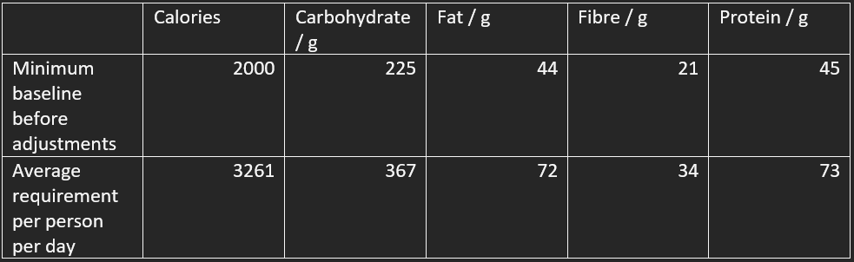

*Table one - Nutritional requirements.*

Because no information was provided about dietary restrictions, a function was created to append random restrictions to the personnel data to use with the model. Random numbers conforming to a Gaussian distribution assigned numbers of people per group who should not be given meals containing any combination of meat, milk, egg, seeds, nuts, gluten and sugar. The probability of each of these was around 0.1 which was deliberately higher than in the general British population, with approximately one percent of people being vegan, according to Ipsos (2019) and around three percent of people having an allergy to any of the listed ingredients, according to Food Standards Agency (2020), to ensure robustness of the program. This takes into account vegetarian and vegan diets, allergies and intolerances, and diabetes. Other considerations include religious diets, but it was decided with BAS that since a variety of meats and vegan foods would be offered, this would not likely become a problem. Red meat, white meat and fish could be included in the list if necessary. Alcohol was not included in this list because it is an optional treat. It was important to confirm that people with any dietary restrictions could eat a varied diet. Table two shows an example of a meal plan and which options would be available to some people. Person A is vegan. They could choose porridge for breakfast, and two of the three options for lunch and tea, and both side dishes. Person B cannot eat gluten. They can choose two of the three options for breakfast, lunch and tea, and both side dishes. Person C represents the worst case. They can eat a selection of foods. Side dishes helped to ensure that all personnel could eat as much as they wish. If there are no people with a certain restriction, the model is not obligated to satisfy that restriction.

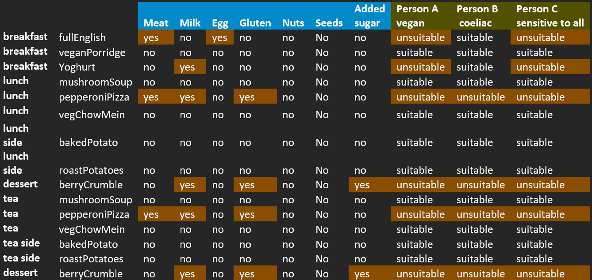

*Table two - Typical daily buffet and its consequences for dietary restrictions.*

An anticipated problem with the buffet arrangement was that all the servings of an option might be taken by people at the front of the queue, leaving only unsuitable options for those who arrive later. This problem is not specific to this project and could occur at any buffet. One option is to prepare more servings to create a surplus, but this could increase food waste. Another option is to provide everyone with a set meal and no choice, but this would be restrictive. A less extreme option would be to provide a menu so people could select their meals and the chef would know how many servings to prepare. Doing this daily would introduce the risk of running out of ingredients, as exact amounts could not be ordered a year ahead. This could be tackled by providing a future menu and asking for meal selections a year ahead, giving the operations team time to order the food and reducing waste.

Regarding the specification for a buffet, the approach taken in this project to reduce food waste and the risk of running out of options was to prepare larger batches of meals, so rather than preparing three different meals for lunch and another three for tea, three different meals would be prepared daily and offered for both lunch and tea. Since there are three options spread over two mealtimes, people should not be forced to eat the same dish twice in a row. This takes into consideration that there is sometimes only one chef for the entire group, which is a demanding job.

The plan includes breakfasts, main meals, side dishes, desserts and occasional treats. Occasional treats were requested by BAS to improve morale and include a snack and an alcoholic beverage, and should not contribute to nutritional calculations but should be included in the order. The set frequency for treats was weekly. Although plant-based diets are associated with reduced GWP, and research by Röös and Rysselberge (2021) supports this, BAS advised that some personnel were unwilling to adopt a plant-based diet. The program therefore offers a variety of meats.

## Transport

Most food is brought to Rothera from the UK yearly on the SDA. Dash-7 aircraft make frequent deliveries of equipment, passengers and fresh food, from South America and the Falklands (BAS, 2021a). The data show that there was no scheduled transit in the winter, so the program does not allow fresh foods to be included during winter.

To estimate the GWP and costs of food transport, assumptions were made in the absence of data (appendix G). For the SDA, the capacity for food was assumed to be the total cargo capacity minus the fuel storage capacity, from BAS (2021b). The voyage was assumed to take 20 days from the UK to Rothera. The emissions and fuel consumption were based on cargo ship consumptions (Tiseo, 2021) but this is not accurate because the SDA is a multi-purpose vessel. British fuel prices were applied. The cost and emissions of moving portions of food were estimated from the cost of the journey, one-way, divided by the number of portions that could be transported.

For the aircraft, it was assumed that the journey was direct from the Falklands to Rothera. The Dash-7 could not travel this distance fully loaded. The loading capacity was taken from Frawley (1995). The average number of people per flight was calculated from the personnel data. The average mass of British men in Antarctic attire was subtracted from the carrying capacity along with the required extra fuel. The emissions and fuel consumption were taken from Campbell (2022) and UK aviation fuel prices were applied.

Realistically, neither the SDA nor the Dash-7 would travel with their entire capacity full of food, but this was assumed to enable a proportional comparison. Journeys were considered one-way because the vehicles may return via other research stations with equipment and passengers.

## Practical considerations and assumptions

It was not known where BAS purchased food, so Tesco (2022) was used to get costs, quantities, packaging and nutrition of ingredients. It is likely that BAS buy ingredients in bulk and the cost and packaging waste are less. Values for frozen foods were based on running costs and emissions for UK domestic freezers, for 100g portions of ingredients. It was assumed that non-refrigerated ingredients would be kept in a heated building. Barreneche et al. (2015) showed that the energy required for cooling is typically more than the energy required for heating a space, and the ambient temperate has little effect on the energy cost of cooling, but larger spaces are heated so the overall requirement is higher for heating. The cost of electricity in the UK was applied, which is not accurate for Rothera, which uses petrol generators and solar panels, but it should still be possible to draw relative comparisons. People in the Arctic have stored frozen food in cellars dug into permafrost which could maintain low enough temperatures year-round (Brown et al., 2017). This method requires no electricity and has a smaller cost and GWP than electric refrigeration. Although summertime temperatures at Rothera can stay above 0°C for several weeks, there is permafrost (Baio et al., 2014) so perhaps BAS could investigate this.

Cooking costs and emissions were based on cooking times and methods and the number of portions to be cooked at once. As explained by Janestad et al. (2003) the energy required for oven cooking does not increase linearly with cooking time due to the hot air being insulated inside the oven. The GWP of cooking was found to be negligible compared to production, transport and storage, but the financial cost was included.

Packaging waste could be viewed from the perspective of the environmental effects of disposal methods, or from the logistic perspective of the cost and emissions of its transportation. It was assumed that packaging waste would be returned on the SDA on its return journey after the food delivery, and because this would leave the SDA with a large available capacity, it was determined more useful to consider the disposal methods. The focus was on non-recyclable packaging. Non-recyclable packages with and without their contents were weighed and masses of packaging were estimated for different ingredients per kilogram of ingredient. It was assumed that some recyclable packaging would end up in landfill or become lost (Greenpeace, 2021) so a penalty was included for recyclable, non-biodegradable packaging.

## Constraint modelling

When modelling the constraints of the program, the aim was to capture the conditions usually communicated by human language and embed the reasoning of the operations team in the model. Fixed requirements which were uncompromisable, such as the requirement that everybody is provided with enough nutrition, were encoded as hard constraints. Flexible goals, such as the GWP of the food order, were encoded in the objective function as soft constraints. A satisfactory solution satisfies all the hard constraints and offers a reasonable optimisation of the objective function. For a problem of this complexity, the goal is to find the best possible solution but the search space is too large to realistically expect to find it exhaustively (Dechter, 2003). The definitions of constraints can affect the complexity of the program so they should be modelled carefully to avoid intensive loop kernels, although these are sometimes necessary. Several nested loops were required and splitting data into separate arrays and iterating over each one individually was more suitable than combining them all into one loop.

The model was developed on a week of dummy data for 25 people. The meals and number of portions of each option were chosen for each day. When the real data were added, it became computationally costly for options to be assigned in this way as the number of days and people increased. To simplify this, the model chose one week of meals, as in the earlier version. That weekly menu was repeated throughout the period, adjusting the number of servings of each meal daily according to the personnel data.

Breakfasts and main meals were considered essential and contained the largest quantities of food so to ensure adequate nutrition and reduce food waste, the number of servings of these was constrained to be equal to the number of people present. Side dishes, desserts and treats were considered non-essential, so the number of servings of these were allowed to vary to give the model some freedom to find different solutions.

Without constraints to introduce variety, one or two recipes were continuously repeated. Constraints were set so that all meal options must be different throughout the week. For breakfasts and main meals, constraints were set to ensure that everyone with dietary restrictions could eat something and that there were enough servings of suitable foods.

Because treats would not be served daily, they were chosen for the entire period, not weekly, and then spread out according to the given frequency of treats. This was constrained to prevent the same treats occurring twice in a row. Treats were not included in the daily nutrition plan because their purpose was for mental, not physical, health.

Fresh ingredients are not available in the winter so a constraint was added to prevent fresh foods from being chosen during this time. Fresh eggs were replaced with powdered egg for some meals, but those requiring a distinct egg texture, such as omelettes, were discounted from the winter options.

A minimum number of servings of each meal option was set because otherwise the model chose to offer many portions of one option and few or no servings of the other options at the buffet. The minimum was defined as a proportion of the number of people present. Figure one shows an example of a constraint in the MiniZinc model to ensure that the number of breakfasts served is equal to the number of diners and that at least the minimum number of servings are offered of each option.

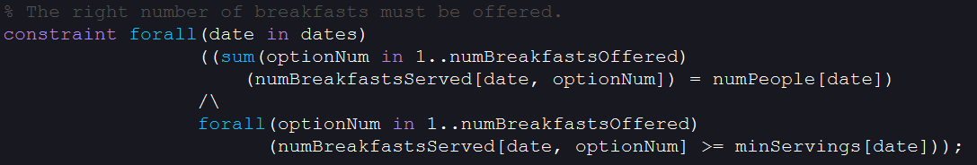

*Figure one – Constraint on the number of servings of each daily breakfast option.*

Finally, constraints ensured that personnel were provided with enough of each nutrient daily.

Introducing and tightening hard constraints reduced the number of valid solutions, making the optimisation process faster but restricted to generally worse solutions. A considerable amount of time was spent seeking a balance between solving ability, objective performance and reasonable variety. Improving one of these usually worsened the others. Solving time was not deemed important due to the long-term nature of the application but running the model on a personal computer implied a limit on the complexity in order to receive solutions. To achieve realistic solutions, the variety of meals was implemented as both a hard and a soft constraint. This is an example of why humans must evaluate decisions made by AI before implementing them in the real world (Chen et al., 2021).

Some of the model code appears repetitive because using enumerables for courses was an effective way of processing different meal types but enumerables cannot be passed as parameters in MiniZinc functions. Combining the calculations and constraints into fewer loops with larger kernels and fewer iterations through the complete sets resulted in slower processing.

## Solving technique

Gecode is constraint-satisfaction problem solving software which has performed well at a range of tasks (Stuckey et al., 2014). Gecode interprets the model and data to create a search tree which depends on the constraints. A simple example is shown in figure two. During traversal of the tree, Gecode behaves adaptively and visits nodes up, down and along the tree’s branches, sometimes breaking it up into separate spaces to quickly restore previous positions or to compute sections in parallel. This enables faster searching of large, complex spaces than a simple stepwise algorithm such as a typical depth-first traversal.

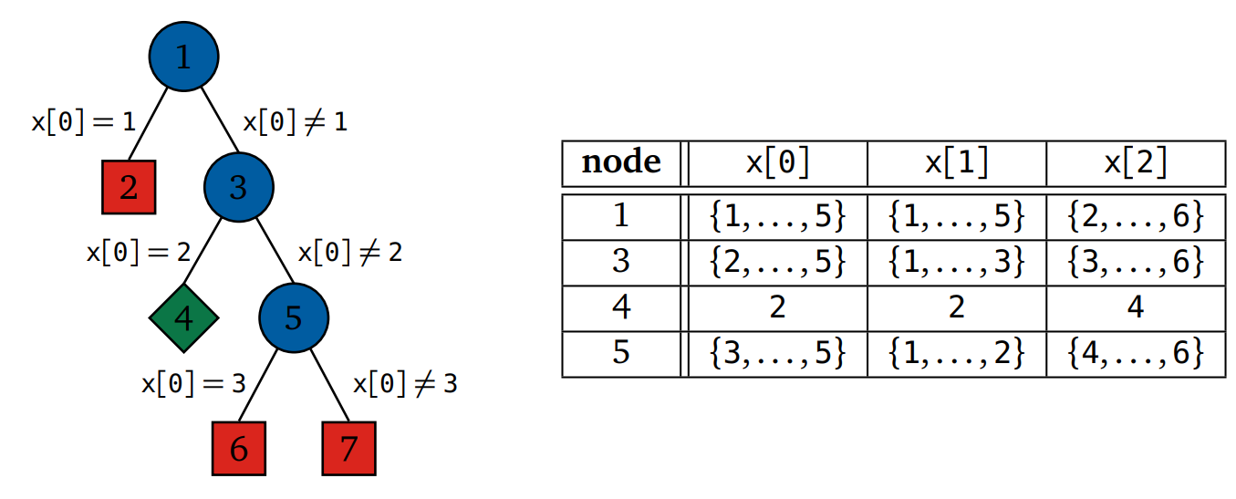

*Figure two – Search tree and matrix constructed by Gecode for a constraint that the sum and product of x[0] and x[1] = x[2], from Lagerkvist et al. (2019).*

Gecode was chosen for this project due to its overall success and because it is incorporated in MiniZinc, enabling the human requirements of the application to be prioritised for development. Other solving software, such as Chuffed (Chu et al., 2019), were not compatible with floating point data-types or some operators; Gecode is better able to generalise to a range of data and expressions. It could be useful to investigate other solving software, create a custom search engine using Gecode, or create a search algorithm from scratch designed specifically for this problem. The default technique employed by Geocode was based on an exhaustive traversal through the tree and began at certain positions of each data structure, leading to repetitive, similar results and taking too long to find more varied solutions. Other areas of AI could be used to introduce more randomness and adaptiveness, such as reinforcement learning to trial randomised routes through the tree, or an evolutionary algorithm to refine sequences of parameters, possibly without the need to construct the entire tree (Neumann & Wegener, 2007).

Due to the complexity of the search space and constraints, attempting to solve the problem with the entire 370 days of data resulted in no improvement of the solution over time for at least three hours and was prone to memory overflows. The data were split into smaller batches and the model processed each batch consecutively. The maximum size of each batch was determined so that it contained a matrix of people and days with around 3000 elements. Figure three shows tests to determine the ideal batch size. Tests with data matrix sizes larger than 4000 elements failed to find any solution within 20 minutes. The plot indicates that the model produced consistent results with a variety of data, except when the data were so small that not a full week’s menu was constructed.

*Figure three – Tests on data with different numbers of days and people. Excess food was measured by nutrients above the required amount and has been scaled relatively.*

## Objective function

Various expressions of the objective were tested, attempting to minimise financial cost, GWP, excess food, packaging waste and the lack of variety of meals, which was the difference between the number of servings of each option so that a larger number represented fewer options for most people. Minimising the lack of variety was preferable to maximising variety because all components of the function were positive. Potential food waste was measured as the excess nutrition above the minimum requirements. Figure four shows how the objective function could be encoded and weighted. The outcomes are similar when values are scaled, which suggests a possible lack of variety of solutions and a need for more flexible constraints, more solving time or more ingredients. The single-objective functions led to optimisation of only those objectives and had little effect on the sum of all objectives.

*Figure four – Comparison different objectives.*

The objective function could not contain floating-point numbers without causing a nonlinear expression or relation error in Gecode, and MiniZinc is strongly typed with static data structures, so the objective function was restricted to integer addition with little opportunity for scaling. A benefit of this was the small memory space requirement during runtime. Some values were scaled in the output to match sensible units. It could have been useful to be able to normalise all the objectives and multiply them in the objective function. This would enable work with an unbiased objective, with the opportunity to include specific weights. Summing and not normalising the objectives creates the risk of variables with large values being prioritised over those with smaller values. To reduce this risk, units were manipulated in the data files to produce variables of similar magnitudes.

Finally, the objective function chosen was the sum of financial cost, emissions, excess food, packaging waste and the lack of variety of meals, because although this did not perform the best on any one objective, it captured the genuine requirements of the application. With this objective function and the chosen batch sizes, initial solutions were usually produced within 90 seconds and solutions ceased to regularly improve after about four minutes (appendix H). The program is complex because it contains five objectives and variety is inversely related to the other objectives. Having too many objectives, particularly inversely related ones, can reduce performance because the optimisation of each variable may be sacrificed to produce a solution near the middle of the pareto front of equally performing solutions, or one objective may dominate the others to find a position at one end of the pareto front (MATLAB, 2016).

# Results & discussion

Figures five and six show a comparison of different diet types. Beef and lamb are prioritised because they are associated with the highest GWP from production (Röös and Rysselberge, 2021). As animal products are reduced, waste decreases. This could be because animal products contain more calories, fat and protein than vegetables so have more potential to waste nutrients. A benefit of this is that they easily satisfy the nutritional demands. Some vegetables were assumed to be bought without packaging, which is likely the reason for the reduction in waste as the diet shifts to more vegetable-based meals. There is a slight increase in cost for vegetarian and vegan diets, possibly due to the high cost of animal alternatives and the need for larger quantities of food to satisfy nutritional requirements. There was a reduction in emissions for winter meals - 0.5kg CO2e per person per day on average - when no flights were scheduled, but it was not considered useful to discuss this further because flights are unlikely to be adjusted based on this. There is a risk of bad weather delaying flights so the menu is not reliant on aircraft. All essential meals are made from bulk ingredients. There was a small reduction in GWP as animal products were phased out, which is possibly not larger because most meals the model chose for the omnivorous versions were plant-based to satisfy dietary restrictions and minimise GWP. To test this, a version was run with more animal-based meals, no dietary restrictions and no objective and compared with the optimised version of omnivorous meals. The GWP of this version was 37% higher, indicating that reducing animal-based meals and optimising the objectives was effective in reducing the GWP, and optimisation was as effective as a blanket policy. Some objectives may occasionally become slightly worse as the overall function is optimised, as a combination may be found which performs so well on one objective that the others are sacrificed.

Table three shows an example of a one-week plan allocated to people with a variety of dietary restrictions. Tables four and five show the order for the full 370-day period. The total mass of food to be delivered is well within the carrying capacities of the SDA and Dash-7.

*Figures five and six – Solutions for different diets.*

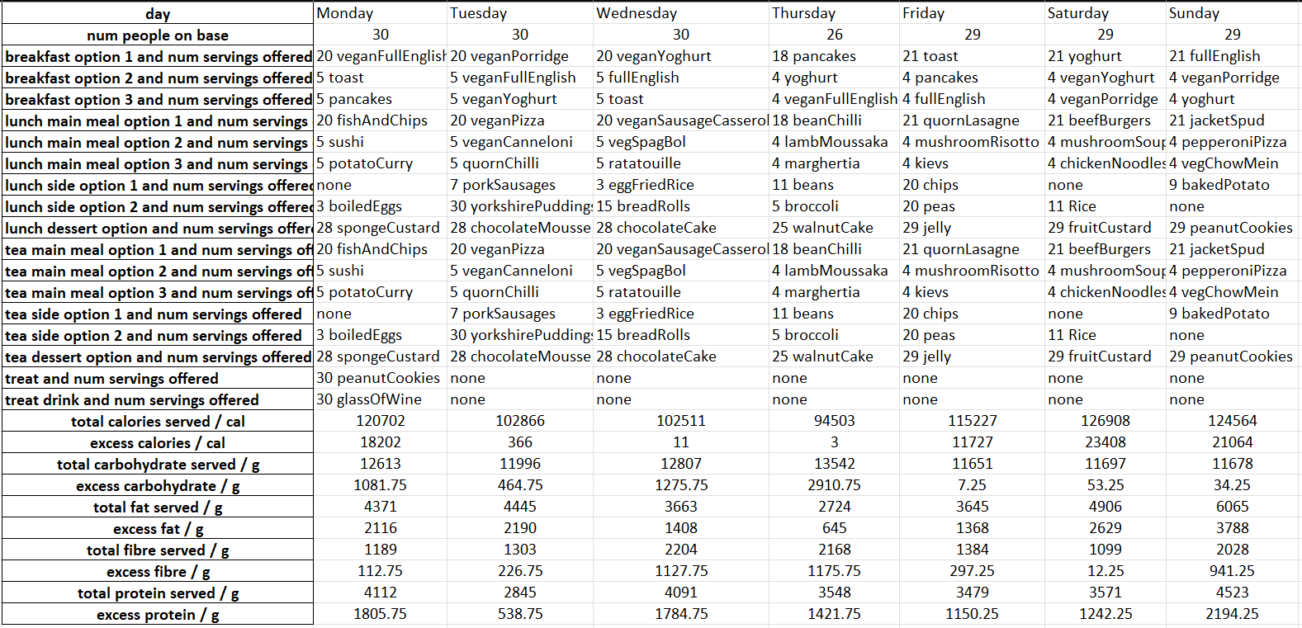

*Table three – One-week plan.*

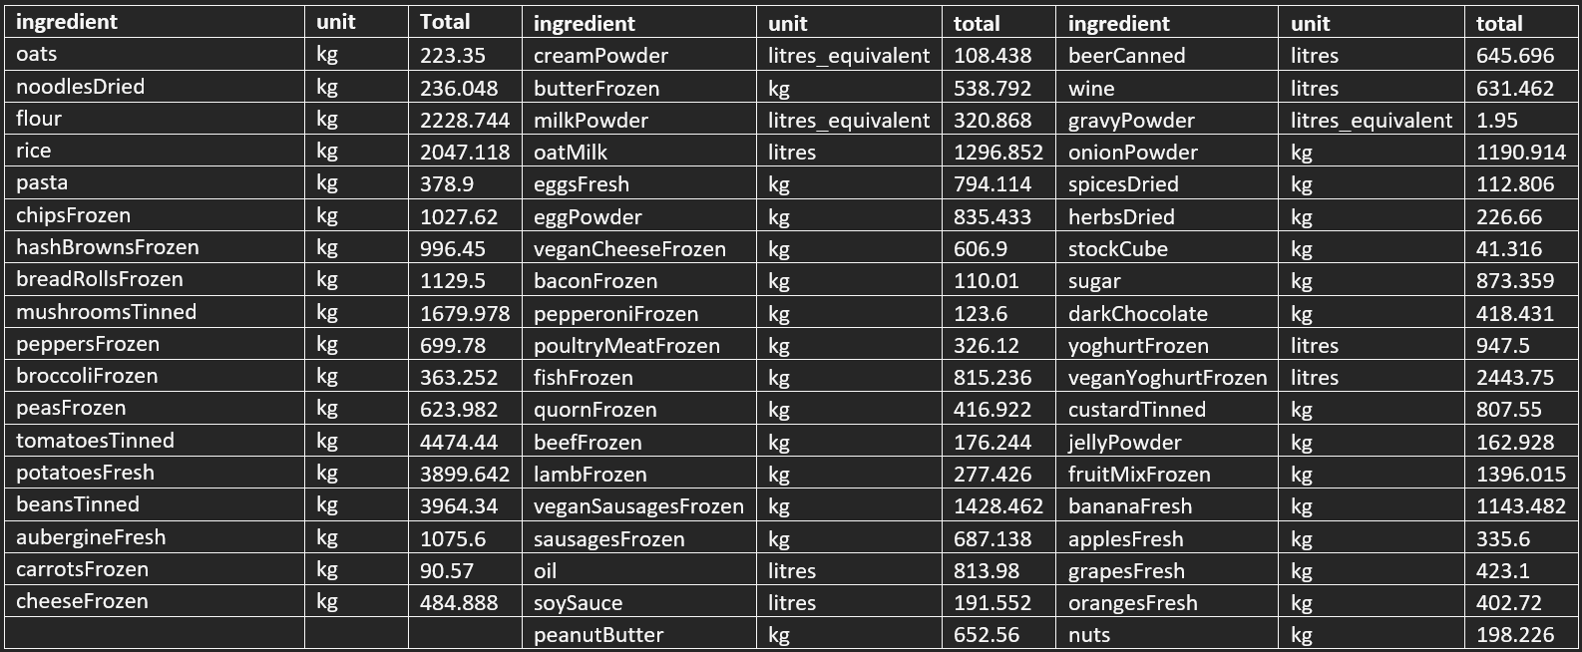

*Table four – Yearly shopping list.*

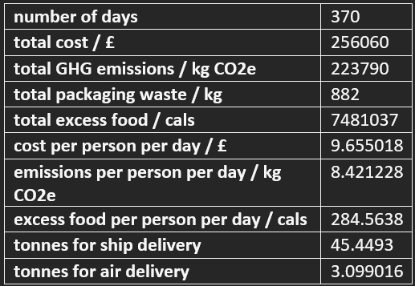

*Table five – Order summary.*

Dickens (2021) estimated that food sent to Rothera on the SDA for 2020 contributed approximately 263,919 kg CO2e, not including deliveries by air, which have higher transportation GWP. The output suggests a plan which estimates 221,370 kg CO2e GWP for 366 days including deliveries by air, a possible reduction of 42,549 kg, or 16%. The improved efficiency of the SDA compared to its predecessor was not considered in the shipping calculations due to a lack of data. The other objectives cannot be compared because there were no data available about them, although the model offered improvements compared to starting benchmarks on all objectives during its runtime.

# Conclusions and Suggestions

The output suggests a plan with a possible 16% reduction of GWP while satisfying all the constraints. This indicates that AI could help BAS plan food purchasing strategies to optimise objectives. Other AI methods could be used to incorporate randomness and adaptiveness of the search. Acquiring more data could introduce opportunities to use other methods. BAS can potentially improve the GWP of their food orders without implementing a ban on red meats or other strict policies.

It may be beneficial to provide staff at Rothera with vitamin D supplements. BAS could consider building cellars in permafrost to reduce the need for refrigeration. BAS could provide guests with a future menu before they arrive, giving the operations team time to order the food in advance and reducing food waste, possibly with a note to diners explaining the environmental impacts of their choices. BAS could survey personnel to determine their preferences.

# References

Baio F, Convey P, Guglielmin M, Worland MR. (2014). Permafrost and snow monitoring at Rothera Point (Adelaide Island, Maritime Antarctica): implications for rock weathering in cryotic conditions.. *Geomorphology*. 225, p47-56.

Barreneche C, Cabeza LF, Petrichenko K, Serrano S, Ürge-Vorsatz D. (2015). Heating and cooling energy trends and drivers in buildings. *Renewable and Sustainable Energy Reviews*. 41, p85-98.

Boltz P. (2005). *Burning Calories on the Job.* Available: https://www.lhsfna.org/burning-calories-on-the-job/#:~:text=What%20should%20be%20said%20is,and%20maintain%20normal%20body%20temperature. Last accessed 25th Jun 2022.

Brand S, Duck GJ, Nethercote N, Stuckey PJ, Tack G (2007). *MiniZinc: Towards a Standard CP Modelling Language*. University of Melbourne, Australia, and Saarland University, Germany: Springer-Verlag Berlin Heidelberg.

British Antarctic Survey. (2015). *Station and Field Support Roles.* Available: https://www.bas.ac.uk/jobs/careers-at-bas/operational-support/. Last accessed 25th Jun 2022.

British Antarctic Survey. (2021a). *Offices, labs and research facilities.* Available: https://www.bas.ac.uk/polar-operations/sites-and-facilities/. Last accessed 26th Jun 2022.

British Antarctic Survey. (2021b). *RRS Sir David Attenborough.* Available: https://www.bas.ac.uk/polar-operations/sites-and-facilities/facility/rrs-sir-david-attenborough/. Last accessed 26th Jun 2022.

Brown J, Klene AE, Nelson FE, Nyland KE, Shiklomanov NI, Streletskiy DA, Yoshikawa K. (2017). Traditional Iñupiat Ice Cellars (SIĠḷUAQ) in Barrow, Alaska: Characteristics, Temperature Monitoring, and Distribution. *Geographical Review*. 107 (1), p143-158.

Campbell I. (2022). *Aviation.* Available: https://www.carbonindependent.org/22.html. Last accessed 26th Jun 2022.

Chen C, Lai V, Liao V, Smith-Renner A, Tan C (2021). *Towards a Science of Human-AI Decision Making: A Survey of Empirical Studies*. USA: Cornell University.

Chu G, Ehlers T, Francis K, Gange G, Schutt A, Stuckey PJ. (2019). *Chuffed, a lazy clause generation solver.* Available: https://github.com/chuffed/chuffed. Last accessed 27th Jun 2022.

Dechter R (2003). *Constraint Processing*. University of California: Morgan Kaufmann.

Department for Environment, Food & Rural Affairs. (2014). *Calculate the carbon dioxide equivalent quantity of an F gas.* Available: https://www.gov.uk/guidance/calculate-the-carbon-dioxide-equivalent-quantity-of-an-f-gas. Last accessed 25th Jun 2022.

Dickens A. (2021). *The Future of Food in the Antarctic: a report prepared for the British Antarctic Survey investigating the carbon intensity of food supplied to an Antarctic research station*. Exeter: University of Exeter.

Food Standards Agency (2020). *Using NHS Data to monitor trends in the occurrence of severe, food induced allergic reactions*. London: Imperial College London.

Frawley G, Thorn J (1995). *International Directory of Civil Aircraft*. Australia: Aerospace Publications

Greenpeace. (2021). *What really happens to your plastic recycling?.* Available: https://www.greenpeace.org.uk/news/plastic-recycling-export-incineration/#:~:text=The%20government%20claims%20that%20almost,waste%20incinerators%20in%20the%20UK. Last accessed 26th Jun 2022.

Hooker J. (2002). Logic, Optimization, and Constraint Programming. INFORMS Journal on Computing. 14. 295-321. 10.1287/ijoc.14.4.295.2828.

Information Commissioner's Office. (2018). *Guide to the General Data Protection Regulation.* Available: https://www.gov.uk/government/publications/guide-to-the-general-data-protection-regulation. Last accessed 25th Jun 2022.

Ipsos. (2019). *Poll Conducted for The Vegan Society: Incidence of Vegans Research.* Ipsos Mori.

Janestad H, Raaholt B, Sonesson U (2003). Energy for preparation and storing of food: models for calculation of energy use for cooking and cold storage in households. SIK Institutet för livsmedel och bioteknik.

Lagerkvist MZ, Schulte C, Tack G (2019). *Modeling and Programming with Gecode*. p170-175.

Lee JHM, Stuckey P. (2016). *Basic Modeling for Discrete Optimization.* Available: https://www.coursera.org/learn/basic-modeling/home/week/3. Last accessed 26th Jun 2022.

MATLAB. (2016). *Pareto Front for Two Objectives.* Available: https://lost-contact.mit.edu/afs/inf.ed.ac.uk/group/teaching/matlab-help/Yesterday/R2016b/gads/pareto-front-for-two-objectives.html. Last accessed 26th Jun 2022.

Neumann F, Wegener I. (2007). Randomized local search, evolutionary algorithms, and the minimum spanning tree problem. *Theoretical Computer Science*. 378 (3), p32-40.

NHS. (2019). *What should my daily intake of calories be?.* Available: https://www.nhs.uk/common-health-questions/food-and-diet/what-should-my-daily-intake-of-calories-be/. Last accessed 25th Jun 2022.

NHS. (2020). *Vitamins and minerals.* Available: https://www.nhs.uk/conditions/vitamins-and-minerals/. Last accessed 25th Jun 2022.

Röös E, Van Rysselberge P. (2021). *Carbon footprint of meat, egg, cheese and plant-based protein sources*. Sweden: Swedish University of Agricultural Sciences.

Stuckey PJ, Feydy T, Fischer J, Schutt A, Tack G. (2014). The MiniZinc Challenge 2008-2013. AI Magazine 35 (2), p55-60.

Tesco. (2022). *Groceries.* Available: https://www.tesco.com/groceries/. Last accessed 25th Jun 2022.

Tiseo I. (2021). *Carbon footprint of cargo ship types in the UK 2021.* Available: https://www.statista.com/statistics/1233482/carbon-footprint-of-cargo-ships-by-type-uk/. Last accessed 26th Jun 2022.

Wilkinson MD, Dumontier M, Aalbersberg IJ, Appleton G, Axton M, Baak A, Blomberg N, Boiten JW, da Silva Santos LB, Bourne PE, Bouwman J, Brookes AJ, Clark T, Crosas M, Dillo I, Dumon O, Edmunds S, Evelo CT, Finkers R, Gonzalez-Beltran A, Gray AJ, Groth P, Goble C, Grethe JS, Heringa J, 't Hoen PA, Hooft R, Kuhn T, Kok R, Kok J, Lusher SJ, Martone ME, Mons A, Packer AL, Persson B, Rocca-Serra P, Roos M, van Schaik R, Sansone SA, Schultes E, Sengstag T, Slater T, Strawn G, Swertz MA, Thompson M, van der Lei J, van Mulligen E, Velterop J, Waagmeester A, Wittenburg P, Wolstencroft K, Zhao J, Mons B. The FAIR Guiding Principles for scientific data management and stewardship. *Nature*. Sci Data 3, 160018.

# Appendices

## Appendix A – Links to work

GitHub repository – <https://github.com/Sophie-Turner/Antarctic-Food-Optimisation>

Trello board – <https://trello.com/b/RtXafRBN/antarctic-food-optimisation>

Personnel data - <https://github.com/Sophie-Turner/Antarctic-Food-Optimisation/blob/main/Data/MasterPAX.xlsx>

## Appendix B – Full outputs

The entire spreadsheets generated by the program are too large to fit into this document, so please download them from the repository:

Meal plan - <https://github.com/Sophie-Turner/Antarctic-Food-Optimisation/blob/main/Output/Ouptut_menu.xlsx>

Order details - <https://github.com/Sophie-Turner/Antarctic-Food-Optimisation/blob/main/Output/Output_order.xlsx>

## Appendix C – Meeting minutes

### MRes Project Meeting 1

Attendees: Maria Fox, Sophie Turner.

Date: 31/3/22.

Time: 14:00.

Location: Zoom.

Agenda

Introduction to each other and the project.

Discussion

The project seeks to identify ways to reduce the carbon footprint of food purchases.

Sophie expects to spend 5 full days per week on the project, minus time spent in other course sessions.

Maria and Sophie will meet for lunch in about a month.

Sophie will be busy with the Cambridge festival for the rest of this week so will begin her tasks next week.

Data will probably reside entirely on csv spreadsheets.

Next tasks

|  |  |  |
| --- | --- | --- |
| Task | Assignee(s) | Deadline |
| Do Coursera course – Basic Modeling for Discrete Optimisation | Sophie | 9/4/22 |
| Set up MiniZinc | Sophie | 9/4/22 |
| Read literature | Sophie | 9/4/22 |
| Arrange meeting with BAS operations people | Maria | 4/4/22 |
| Arrange weekly meeting timeslot | Maria | 9/4/22 |
| Give Sophie access to video from Exeter student’s project | Maria | 9/4/22 |

Next meeting

Agenda

Meet people from BAS operations to learn about data format and database expectations. Learn from them where to start with the project.

Attendees: Maria Fox, Sophie Turner.

Date: TBC.

Time: TBC.

Location: Zoom.

### MRes Project Meeting 2

Attendees: Maria Fox, Sophie Turner, Nopi Exizidou, Beatrix Schlarb-Ridley.

Date: 6/4/22.

Time: 16:00.

Location: Zoom.

Agenda

Meet people from BAS operations to learn about data format and database expectations. Learn from them where to start with the project.

Progress

Sophie is starting the first assignment of the Coursera course now.

|  |  |  |  |  |
| --- | --- | --- | --- | --- |
| Task | Assignee(s) | Deadline | Completed | Comments |
| Do Coursera course – Basic Modeling for Discrete Optimisation | Sophie | 9/4/22 | Ongoing |  |
| Set up MiniZinc | Sophie | 9/4/22 | Yes |  |
| Read literature | Sophie | 9/4/22 | Yes |  |
| Arrange meeting with BAS operations people | Maria | 4/4/22 | Yes |  |
| Arrange weekly meeting timeslot | Maria | 9/4/22 | Yes | Fortnightly |
| Give Sophie access to video from Exeter student’s project | Maria | 9/4/22 | No | Soon |

Questions/problems

Is there a backup or buffer of food supplies in case the supply vessel is unable to reach them in time? Yes. Excess food is stocked at the station and yearly orders include extra food which are stocked.

Does the food need to contain halal meat? Possibly but probably not. Find out from last year’s orders.

How often is food delivered? Once a year by the SDA. Fresh foods are usually brought by aircraft every few days with the passengers, but not always. BAS are open to reviewing this if required

How far in advance is food ordered? 1 year, but BAS are open to reviewing this if required.

Is the project for all consumables including cleaning supplies and toiletries? No. Just food and drink.

Is there a database, or will there be database server space for me to use for a database if required? Possibly. Find out from Rachael, John and BAS IT team later.

Should my code repo be public or private? Private. Invite Maria and Nopi.

Will HPC be required? No.

Discussion

The project will focus on the Rothera research station due to its relatively large size and remote location.

People arrive at and leave Rothera every few days by aircraft.

The suppliers used could constrain the ability to reduce plastic waste. The suppliers will not be changed but items ordered may be changed. Food waste is burnt. Consider packaging, e.g. beer provided in bottles, cans or a barrel.

Use public health info to plan nutrition. The calorie intake required at meals is high due to the high physical demand of the work done and the harsh environment. Individuals require different calorie intakes based on their work role, age, gender, height, etc. Analyse this and take the higher end as a baseline to ensure everyone is well fed. Assume that people with the highest calorie requirements will opt for extra sides with meals. Hot food is required to keep them warm. They must enjoy their meals, as Antarctica is a depressing place and this could affect their mental health. Beer, wine and snacks are also provided to benefit their mental health. Rothera has a resident chef and a canteen but smaller stations require scientists/workers to allocate and cook their own or their team’s meals. Different diets and intolerances must be catered for. Some fresh fruit and vegetables must be provided. Almost all the people are healthy adults, younger than 50. 80 to 100 % of them are men. Many of them are unwilling to adopt a vegetarian diet. Consider replacing beef and cheese with chicken and eggs, and mixing meat with mycoprotein to reduce the environmental impact of meat.

Discuss the sustainable food programme and report with Rachael and John later.

Minimise food waste, plastic waste, travel cost, storage cost, purchase cost and associated GHG emissions. Maximise enjoyment of food.

The data will probably be spreadsheets. Put them into CSV format. Discuss this with Rachel later.

A front end may also be required.

Next tasks

|  |  |  |
| --- | --- | --- |
| Task | Assignee(s) | Deadline |
| Do Coursera course – Basic Modeling for Discrete Optimisation | Sophie | 14/4/22 |
| Define exactly what needs to be done | Sophie | 14/4/22 |
| Create a project management board | Sophie | 14/4/22 |
| Create a code repo | Sophie | 14/4/22 |
| Arrange a meeting with Rachael and John to discuss data | Maria | 14/4/22 |
| Give Sophie access to video from Exeter student’s project | Maria | 14/4/22 |

Next meeting

Agenda: Discuss occupancy data.

Attendees: Maria Fox, Sophie Turner.

Date: 14/4/22.

Time: 09:00.

Location: Zoom.

### MRes Project Meeting 3

Attendees: Maria Fox, Sophie Turner.

Date: 03/05/22

Time: 15:00

Location: Zoom.

Agenda

Progress review, discuss occupancy data.

Progress

|  |  |  |  |  |
| --- | --- | --- | --- | --- |
| Task | Assignee(s) | Deadline | Done | Comments |
| Implement a practice 'banquet' optimisation program in Minizinc with criteria specified by Maria. | Sophie | 3/5/22 | Yes | Continue expanding this. |
| Get access to all the necessary Rothera data (future booked stays and past food orders). | Sophie | 3/5/22 | No | Try emailing Rachael and asking again. |

Sophie finished the discrete modelling Coursera course.

Questions/problems

Need access to data. Ask Nopi for food order historical data.

Does the canteen prepare a selection of meals that people choose from at meal time, or do people get a menu at meal times and then their chosen meal is prepared, or do people get a menu before their stay (like on cruise ships) which is planned in advance, or is there no choice of meals? The latter two options would be better for minimising waste. Asked Nopi but Nopi is on leave. For now Sophie will assume no choice of meals to simplify the program in its early stages of development.

Last week was very busy and this week is also very busy for Sophie with a lot of University sessions and other work to do. Sophie does not have much time to work on this project at the moment.

Discussion

Include nutritional information as constraints in the program.

As well as including necessary amounts of nutrients, limit the amounts of unhealthy foods such as sugar.

Maria gave a dataset to Sophie containing greenhouse gas emissions associated with Rothera. Check Edmund’s report and references for units and more information.

Sophie has implemented dietary categories as constrainable features in the practice program, including vegetarian diets. Maria suggested splitting this into fish, white meat and red meat to allow more flexible variants of these diets. This could also help to cut out/down red meats from the menu, as they are the highest contributors to greenhouse gas emissions.

Sophie should learn how to interact MiniZinc with other languages and read in data from .csv format, starting with the numbers of people data. Sophie should try reconstructing the plots from the data to check she has the right data in the right form. Sophie should only look at New Bransfield House for now as that is the building containing the kitchen.

Scaling up the program data from 10 to 100 people has caused the computation time to increase too much. One way around this might be to divide people into dietary categories based on nutritional requirements and restrictions and perform computation on each category rather than each individual person. The result could then be multiplied up as required depending on the number of people. For now, numbers alone will suffice and specific meals need not be prescribed to individuals.

Next tasks

|  |  |  |  |
| --- | --- | --- | --- |
| Task | Assignee(s) | Deadline | Comments |
| Figure out how to read in .csv and large amounts of data to MiniZinc. | Sophie | 17/3/22 |  |
| Ask Nopi for all the data and information required. | Sophie | 17/3/22 | Nopi is on leave. |
| Figure out how to use MiniZinc with other languages. | Sophie | 17/3/22 |  |
| Try reconstructing the plots from the kitchen data. | Sophie | 17/5/22 |  |
| Reduce execution time of current algo where possible. Improve scalability. | Sophie | Ongoing |  |
| Continue to expand program skeleton to include more aspects of the project. | Sophie | Ongoing |  |

Next meeting

Agenda: Progress review.

Attendees: Maria Fox, Sophie Turner.

Date: 17/5/22

Time: 15:00

Location: Zoom.

### MRes Project Meeting 4

Attendees: Maria Fox, Sophie Turner.

Date: 17/05/22.

Time: 15:00.

Location: Zoom.

Agenda

Progress review.

Progress

|  |  |  |  |  |
| --- | --- | --- | --- | --- |
| Task | Assignee(s) | Deadline | Done | Comments |
| Figure out how to read in .csv and large amounts of data to MiniZinc. | Sophie | 17/3/22 | No | Deadline extended. |
| Ask Nopi for all the data and information required. | Sophie | 17/3/22 | Yes | Food data not available. Made dummy data. |
| Figure out how to use MiniZinc with other languages. | Sophie | 17/3/22 | No | Deadline extended. |
| Try reconstructing the plots from the kitchen data. | Sophie | 17/5/22 | Yes |  |
| Reduce execution time of current algo where possible. Improve scalability. | Sophie | Ongoing | Yes | Categorised fields and added constraints. Down to 13 seconds for 20 people, 1 week. |
| Continue to expand program skeleton to include more aspects of the project. | Sophie | Ongoing | Ongoing |  |

Created a weekly plan which selects meals, side dishes, desserts, and their quantities on different days of the week, optimising the financial cost while providing variety and meeting all dietary requirements including avoiding allergens and tailoring caloric intake for people’s jobs and circumstances, minimising food waste. Execution time is around 13 seconds in MiniZinc.

Questions/problems

The default solvers in MiniZinc don’t work with floating point numbers. This means small quantities of food are expressed as 0 and division calculations are often impossible. The MIP solver might work with floats but the MIP solver is not available in the list of default solvers. Try and find a download. Alternatively, try using the LP Solve program instead of MiniZinc. Code will need to be converted and LP solve only works with linear numerical calculations with no division but does support floats.

Discussion

Emissions costs of ingredients can be written in the same way as financial costs, considering production, transport, storage and cooking.

When assessing food packaging waste, include alternatives. Dried egg powder exists as an alternative to fresh eggs.

Vitamin D is mostly only found in meat and direct sunlight on the skin and in the eyes. Because of the conditions in Antarctica it is unlikely that most people will be able to get enough vitamin D. The NHS recommends taking vitamin D supplements in these circumstances. It is reasonable to assume that every guest will be given a daily vitamin D supplement tablet but that all other nutritional requirements will be met by their diet.

Include drinks. Guests should also be provided with alcohol (wine and beer) to drink because this improves their mood and morale. Include enjoyment as an objective.

The next stage will be to keep a standard weekly menu but vary the quantities of the servings daily depending on people arriving and leaving. Read in personnel data like a calendar.

Although the code would be more computationally efficient if multiple calculations were performed inside the same loop kernel where possible, loops have been separated out for now to keep it simple and enable changes to be made easily. Later, code will be optimised by modularising similar code into functions, standardising data structures and possibly integrating loop bodies to reduce the number of memory accesses and array iterations.

Next tasks

|  |  |  |
| --- | --- | --- |
| Task | Assignee(s) | Deadline |
| Account for people arriving and leaving. | Sophie | 31/5/22 |
| Include emissions data and minimise it. | Sophie | 31/5/22 |
| Include packaging waste data and minimise it. | Sophie | 31/5/22 |
| Try getting floats and division to work with MIP or LP solve. | Sophie | 31/5/22 |
| Try reading in csv data to MiniZinc. | Sophie | 31/5/22 |
| Try combining MiniZinc with an imperative language. | Sophie | 31/5/22 |
| Create a ‘shopping list’ from output. | Sophie | 31/5/22 |

Next meeting

Agenda: Progress review.

Attendees: Maria Fox, Sophie Turner.

Date: 31/5/22.

Time: 15:00.

Location: Zoom.

### 

### MRes Project Meeting 5

Attendees: Maria Fox, Sophie Turner.

Date: 7/6/2022.

Time: 15:00.

Location: Zoom.

Agenda

Progress review.

Progress

|  |  |  |  |  |
| --- | --- | --- | --- | --- |
| Task | Assignee(s) | Deadline | Done | Comments |
| Account for people arriving and leaving. | Sophie | 31/5/22 | Yes |  |
| Include emissions data and minimise it. | Sophie | 31/5/22 | Yes |  |
| Include packaging waste data and minimise it. | Sophie | 31/5/22 | No | Deadline extended |
| Try getting floats and division to work with MIP or LP solve. | Sophie | 31/5/22 | No | Not necessary |
| Try reading in csv data to MiniZinc. | Sophie | 31/5/22 | Yes |  |
| Try combining MiniZinc with an imperative language. | Sophie | 31/5/22 | Yes | Python |
| Create a ‘shopping list’ from output. | Sophie | 31/5/22 | Yes |  |

Questions/problems

The personnel spreadsheet contains data for people who will be based at the station and people who will go out on field expeditions. Should the program also plan food for those on field trips? Yes.

Discussion

Maria was on holiday last week so the meeting was pushed back to this week. We will have another meeting next week.

Sophie plans to continue working on the code until the end of next week. Then, she will stop developing the project and spend the remaining time writing the report.

Some additional treats should be offered now and then including alcoholic beverages, perhaps once a week. These treats should not contribute to the nutrition calculations for the guests because they are not part of the general meal plan.

The program is offering regular fish meals, possible because it is minimising cost and emissions and finds fish to be preferable to other meats by these objectives. Guests may want more meat variety. Try requiring one serving of each major meat group each week.

Output a spreadsheet of the results for the operations people. Present the work to BAS during the summer.

The calculations have been performed for Twin Otter aircraft but the data show that the Dash 7 planes are used more frequently. Change calculations accordingly.

Next tasks

|  |  |  |
| --- | --- | --- |
| Task | Assignee(s) | Deadline |
| Add treats and drinks | Sophie | 14/6/22 |
| Including field campers’ rations | Sophie | 14/6/22 |
| Create a spreadsheet of results | Sophie | 14/6/22 |
| Include a variety of different meat types each week | Sophie | 14/6/22 |
| Include packaging waste data and minimise it. | Sophie | 20/6/22 |
| Change calculations from Twin Otter to Dash 7. | Sophie | 20/6/22 |

Next meeting

Agenda: Final review.

Attendees: Maria Fox, Sophie Turner.

Date: 14/6/22.

Time: 15:00.

Location: Zoom.

### MRes Project Meeting 6

Attendees: Maria Fox, Sophie Turner.

Date: 14/6/2022.

Time: 15:00.

Location: Zoom.

Agenda

Final review.

Progress

|  |  |  |  |  |
| --- | --- | --- | --- | --- |
| Task | Assignee(s) | Deadline | Done | Comments |
| Add treats and drinks | Sophie | 14/6/22 | Yes | Once a week |
| Including field campers’ rations | Sophie | 14/6/22 | No | Deadline extended |
| Create a spreadsheet of results | Sophie | 14/6/22 | Yes |  |
| Include a variety of different meat types each week | Sophie | 14/6/22 | Yes |  |

Questions/problems

Solver was not varying breakfast options at all in accordance with the objective criteria. Sophie and Maria investigated the code but were unable to identify any errors. Sophie will look into this bug in more detail in an isolated test environment.

Discussion

Entire dataset of personnel schedules was too large to run due to nested loops and time complexity. Data were split into batches of smaller sizes. Ensure that food is not leftover from batches and wasted.

Randomly include different meals in addition to the typical weekly plan to increase variety.

In the report, show the differences between different diet types such as meat, vegan, etc.

Provide operations people with a shopping list. They don’t need the menu. The chef and guests need the proposed menu.

Next tasks

|  |  |  |
| --- | --- | --- |
| Task | Assignee(s) | Deadline |
| Include packaging waste data and minimise it. | Sophie | 20/6/22 |
| Change calculations from Twin Otter to Dash 7. | Sophie | 20/6/22 |
| Finish all code and begin report. | Sophie | 20/6/22 |

Next meeting

Agenda: Last wrap-up.

Attendees: Maria Fox, Sophie Turner.

Date: 21/6/22.

Time: 15:00.

Location: Zoom.

## Appendix D – FAIR data statement

**FAIR data statement**

The project aims to satisfy the [FAIR data principles](https://www.go-fair.org/fair-principles/).

A copy of the personnel schedule data provided by the British Antarctic Survey is included in the program files, at [/Data/MasterPAX.xlsx](https://github.com/Sophie-Turner/Antarctic-Food-Optimisation/blob/main/Data/MasterPAX.xlsx), but people's names have been removed to protect their identities and comply with [General Data Protection Regulations](https://www.gov.uk/government/publications/guide-to-the-general-data-protection-regulation). For more information, contact Maria Fox at [marfox@bas.ac.uk](mailto:marfox@bas.ac.uk) or Nopi Exizidou at [pardou@bas.ac.uk](mailto:pardou@bas.ac.uk). Other information sources used for the development of the program are listed in the program files, at [/Documentation/References/References.txt](https://github.com/Sophie-Turner/Antarctic-Food-Optimisation/tree/main/Documentation/References)

[Python](https://www.python.org/downloads/) and [MiniZinc](https://www.minizinc.org/) were used for this project and are both open-source. Pandas, numpy and matplotlib were imported into the python code and are also open-source. They can be installed using [Pip](https://pypi.org/project/pip/) by typing into the terminal:  
pip install pandas  
pip install numpy  
pip install matplotlib  
[Gecode](https://www.gecode.org/) was used as the solver in MiniZinc. It is open-source.  
No specialist computing infrastructure is required to run this code other than a typical personal computer with an up-to-date operating system.

Random dietary requirements were generated for the batches of MiniZinc data. These data files have been included in the [code folder](https://github.com/Sophie-Turner/Antarctic-Food-Optimisation/tree/main/Code) so that the results shown can be exactly reproduced. Running the [batch generation script](https://github.com/Sophie-Turner/Antarctic-Food-Optimisation/blob/main/Code/Batches_read_write.py) will create a new random set of dietary restrictions.

## Appendix E – ReadMe

**Antarctic-Food-Optimisation**

**Optimising remote field station food supplies for the British Antarctic Survey**

Optimising logistics operations has a crucial impact on the overall carbon emissions entailed when planning a science campaign in Antarctica. One important problem is the planning of the food supply to feed a science team based at one of the remote Antarctic field stations over a season. The objective is to minimise waste, financial cost and the carbon emissions associated with the foods. This is done in the context of a variety of constraints. The daily menu meets nutritional requirements, is satisfying and enjoyable and satisfies individual dietary restrictions. These requirements are expressed as constraints with an objective to be optimised.

The aim of this project is to construct a constraint program to solve this problem. The program scales to instances of about 160 people over 20 days, or 25 people over 4 months, and batches of data can be combined to allow planning for longer periods of time. The example provided in the program files is for 370 days of a real Rothera schedule. The food purchasing strategy is chosen according to availability of fresh foods brought by air.

Not all the necessary real data were available for this project so the implementation was based on some dummy data. Real data were used for Rothera personnel movements, Rothera schedule, emissions and aircraft fuel calulations. In the abscence of data specific to Rothera, dummy data were created, based on [other sources](https://github.com/Sophie-Turner/Antarctic-Food-Optimisation/blob/main/Documentation/References/References.txt), for meal arrangements, recipes, food costs, ship fuel calculations and people's dietary restrictions.

**How to use**

1. [Python](https://www.python.org/downloads/) and [MiniZinc](https://www.minizinc.org/) are required and are both open-source. Pandas, numpy and matplotlib were imported into the Python code and are also open-source. They can be installed using [Pip](https://pypi.org/project/pip/) by typing into the terminal:  
   pip install pandas  
   pip install numpy  
   pip install matplotlib  
     
   If you wish to use the existing data, skip step 2. If you wish to generate new batches:
2. Run the 'Batches_read_write.py' Python script on an up-to-date version of the 'MasterPAX.xlsx' spreadsheet. The script randomly generates fictional dietary restrictions for the group because these data were not provided. Update the script to include these if real data become available.
3. Run the 'Meals.mzn' model in MiniZinc with the Gecode solver, specifying 'Food_data.dzn' and a 'batchX.dzn' as MiniZinc datafiles. If you wish to see the effects of removing certain ingredients from the menu, select the relevant files from the test folder.
4. Give MiniZinc 3 to 12 minutes to produce a satisfactory solution per batch. The output will be a menu, nutritional information and a shopping list to order with its costs.  
     
   If you wish to save the menu and its nutritional information:
5. Save the menu output portion as plain text. If running multiple batches, one after the other, the output can all be placed in the same .txt file.
6. Run the 'Format_output.py' script on the text output. This will create a spreadsheet in the same directory.

**File structure**

[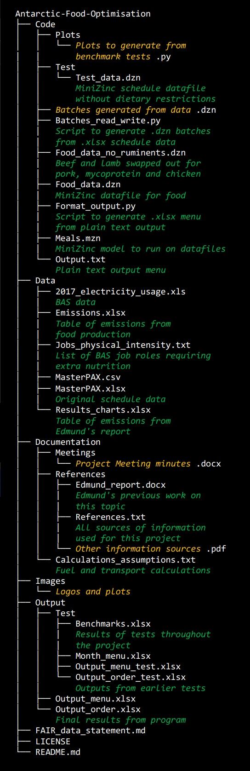](https://github.com/Sophie-Turner/Antarctic-Food-Optimisation/blob/main/Images/Tree.jpg)

**Notes**

Some of the model code appears repetitive for the following reasons:

* Using different enumerables is an effective way of processing different meal types but enumerable types cannot be passed as parameters in functions or predicates in MiniZinc.
* Combining the calculations and constraints into fewer loops with larger bodies and fewer repeated iterations through the complete sets resulted in slower processing and loop unrolls or tiles were found to improve the situation.

## Appendix F – Physical intensity labels

0 (low):

Communications Officer

Radio Officer

Doctor

Mobile Plant Operator

Vehicle Operator

IT Engineer

Network and Security Engineer

Mariner

Tower supervisor

Station leader

Station Logistics Manager

Station Ops Manager

Forecaster

Captain

Vehicles Manager

Pax

Admin Assistant

Operations Director

Student

Project Manager

1 (moderate):

Antarctic Atmospheric Scientist

Boating Officer

Chef

Data Manager

Electrical Power Generation Technicians

Electronics Engineer

Maintenance Technician

Maintenance Technician

Mobile Plant Mechanic

Station Support Assistants

Electrician

Mechanic

Genny Mech

Air Mech

Plumber

Welder

Scientist

anyone who falls into both this category and the mild category but not the high category

2 (high):

Carpenter

Joiner

Construction

Builder

Field Dive Officer

Field Guide

Field Assistant

General Assistant

GA

Marine Biologist

Steel Erector

Pilot

Air unit

Traverse

Cladder

Mast Erector

Mooring Team

Hut Install

anyone who will soon stay overnight on the field or has recently returned, regardless of job

anyone who falls into both this category and a lower category

## Appendix G – Transport estimates

SDA FROM UK

ship has 1440 m3 max food capacity (total storage capacity minus fuel storage)

100g of dired pasta is

11cm x 6cm x 5cm = 330 cm3 = 0.00033 m3

1440 / 0.00033 = 4363636

The ship can carry about 4363636 x 100g portions of food (436 tonnes)

ship fuel costs £20,000 per day

= 2,000,000p

voyage takes 20 days

distance from uk to rothera via falklands = 14,581 km

mixed cargo ship causes 13 g CO2e per ton of cargo per km travelled

= 0.0013 kg CO2e per 100g per km

x 14,581 km = 18.96 g CO2e = 0.018 kg CO2e

cost of moving 100g food = (2,000,000p x 20) / 4363636

= 9p

emissions of moving 100g food = 0.01896 kg CO2e

considering only 1-way journey (not the return journey)

TWIN OTTER from Falkands

distance from Stanley, Falklands to Rothera = 1873 km = 1164 mi

travels 1.27 km per kg of fuel

but idk how much fuel is required for takeoff so didn't include that yet

aviation fuel currently costs 61p per kg

Twin Otter is designed to carry 20 people

but BAS ones carry 5 people

Assume max food capacity of Twin Otter is equivalent to 15 people

Average British man in clothes and shoes weighs 84 kg

84kg x 15 = 1260 kg

Twin Otter can carry max 12600 x 100g portions of food

requires = 1873km / 1.27km per kg = 1475 kg of fuel

which costs 1475kg x 61p = 89975p = £899.75

and causes ghg emissions of 1475kg x 3.15 = 4646 kg CO2e

cost of moving 100g food = 89975p / 12600 = 7p

emissions of moving 100g food = 4646 kg / 12600 = 0.369 kg CO2e

considering only 1-way journey (not the return journey)

but probably more due to takeoff

DASH 7 FROM FALKLANDS

distance from Stanley, Falklands to Rothera = 1873 km = 1164 mi

can't fully load the plane or it would not be able to travel this far.

for this journey it can carry 16 passengers or 2,000kg of cargo

number of people travelling on scheduled Dash 7 trips: 7,7,1,9,8,2,2,5,3,3,3,5,2,4,3 avg = 4.26

Average British man in clothes and shoes weighs 84 kg

84kg x 4.26 = 358.4 kg

2000 - 358.4 = 1641.6 kg capacity left for cargo

total number of 100g cargo capacity portions = 16416

equipment is bulky so allocate 1/4 of that to food = 410.4 kg

number of 100g portions of food which can be moved = 4104

maximum useable fuel = 4501.904 kg. Assume this much is required for 1 way journey.

including takeoff

aviation fuel currently costs 61p per kg

cost of fuel = 0.61 £/kg x 4501.904 kg = £2746

cost of fuel per 100g cargo capacity = £2746 / 16416 = 17p

emissions of moving 1 kg cargo = (3.15 x 4501.904 kg) / 1641.6 kg = 8.64 kg CO2e

emissions of moving 100g cargo = 0.846 kg CO2e

considering only 1-way journey (not the return journey)

## Appendix H – Timing benchmarks

