**Smart Contracts in Go — No Limits.**

With the NEAR Blockchain, it's now reality.

**Step 1:** Create your smart contract project

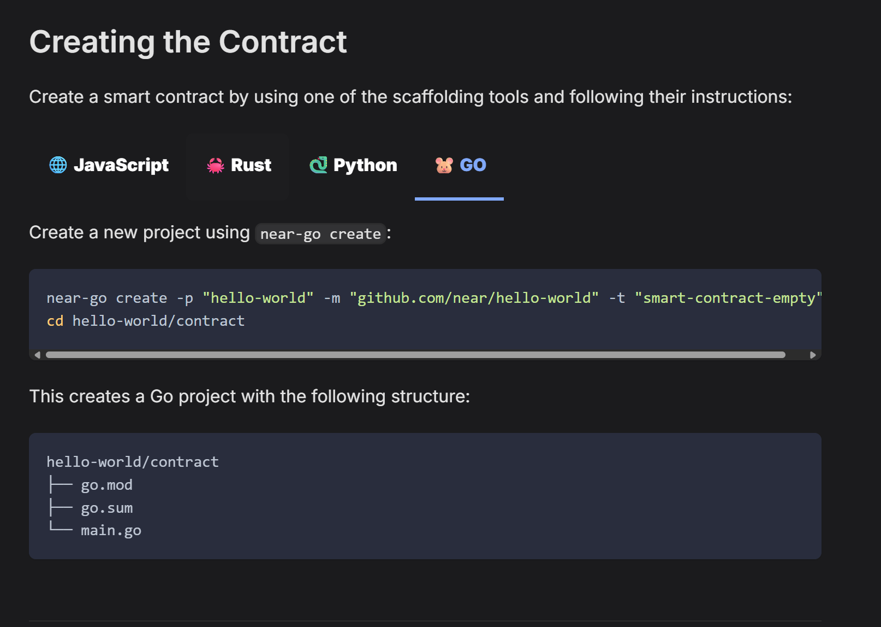

**Step 2:** Build your smart contract

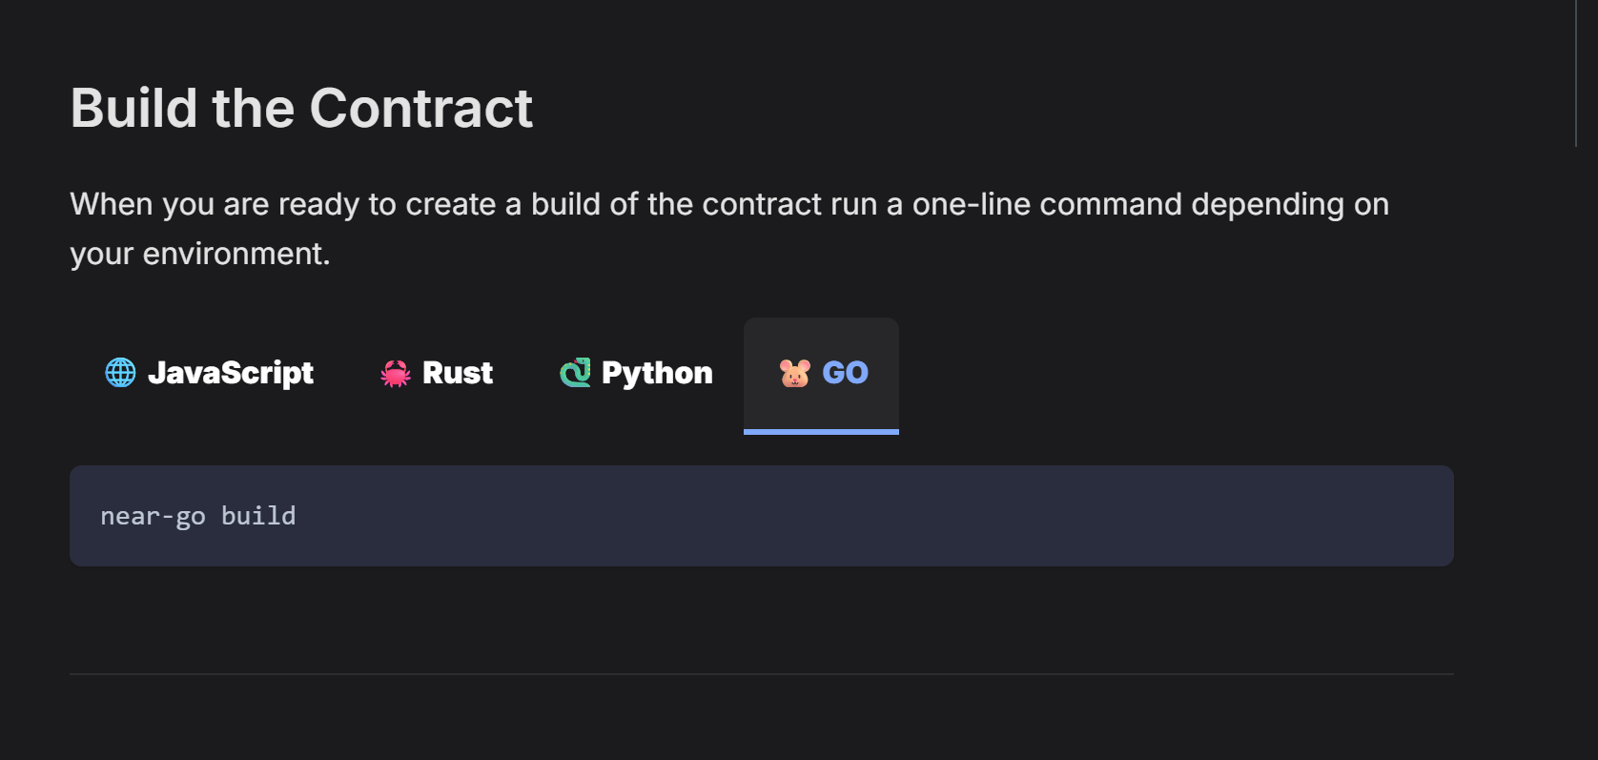

**Step 3:** Create your testnet account

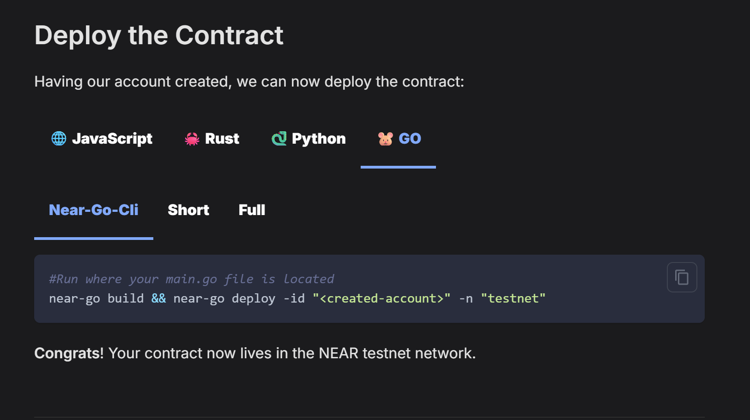

**Let’s build the Web 3.0 future together!**

#GoLang #NEARProtocol #Web3 #SmartContracts #BlockchainDev