Feeding experiment snails:

Background of the experiment:
Biofilm was colonised in artificial streams for 7 weeks chemical free until an adult biofilm layer (and enough biomass for analyses and feeding assay) was obtained. The colonisation was performed in 3 “runs”, 1 week apart from each other (1. Run started on 27th of January 2023; 2. Run started one week later on the 3rd of February and the 3. Run started on the 10th of February). This was done to change the food (biofilm tiles) in the following feeding assay weekly, to obtain ad libitum feeding of the snails. After 7 weeks of chemical free colonisation, biofilms were chronically exposed for 14 days to three different chemical treatments and an uncontaminated control: 1) herbicide propyzamide, 2) antibiotic ciprofloxacin and 3) the mixture of both. The 1. Biofilm run was introduced in the feeding assay on the 31st of March, 2. Run one week later on the 7th of April and the 3rd run on the 14th of March. The feeding assay was finished on the 21st of April. In total, the feeding assay therefore lasted 21 days.
- We took biofilm samples after 14 days of chronic contamination to analyse the endpoints: 1) ash free dry mass, 2) chlorophylls and 3) fatty acid composition.
- We sampled all snails after the 21-day feeding assay to analyse the endpoints: 1) fatty acid composition and 2) growth.
- Additionally, we sampled the 7-day old biofilm tiles, to analyse (its grazed area) the feeding rate of the snails.
Overall explanatory variables: 1) chemical treatments and 2) time
Overall response variables: the biofilm endpoints: 1) ash free dry mass, 2) chlorophylls and 3) fatty acid composition; the snail endpoints 1) fatty acid composition and 2) growth and the (grazed area) feeding rate of the snails µ ²

Chemical analyses

- No leaching of the chemicals from biofilm to water phase
- Uncontaminated negative control

- Nominal Propyzamide conc: 10 ug/L, measured average: 7.2 ug/L
- Can we change the nominal concentration in the paper to 8 ug/L?
- Deviation for 8 ug/L from -30 % and + 15 % (Min: 5.56 ug/L and Max: 9.21 ug/L)

In Mix-Treatment average: 6.7 ug/L and deviation for 8 ug/L would be -48 % and + 11 % (Min: 4.09 ug/L and Max: 8.91 ug/L)

- Nominal Ciprofloxacin conc: 100 ug/L, measured average: 65.9 ug/L
- Can we change the nominal conc to 60 ug/L?
- Deviation for 60 ug/L from -55 % and +72% (Min: 27 ug/L and Max: 103 ug/L)

In Mix-Treatment average: 44 ug/L and deviation for 60 ug/L would be -78 % and + 8.5 % (Min: 12.6 ug/L and Max: 65 ug/L)

- Can I write (in the text, or appendix next to the table with all measured concentrations): “Due to the high volume (40 L) in the flumes, the strong evaporation, the weekly medium change and potential metabolization by the biofilm, the concentrations varied over the length of the study.” auch von sorption sprechen!

- Do I add a table with all measured concentrations in the appendix? Or is it enough, as I want to publish all raw data anyway in havard dataverse, if the raw data is there?

- In supplements eine aggregierte Tabelle mit sd und dabei sagen, dass man treatment unterschiede sieht! und je nachdem mit vor und nach WW und im Text keine +/- % angabe abweichung angeben, sondern durchschnittsabweichung

Sonstiges:
- Tabellen eher vermeiden, eher Graphik, wenn Tabelle in Supplements
- Unter graphik in beschreibung dann schreibne, exact p values sind in supplements
- Supplements sollte auch logische abfolge haben
- Für generelle Verlgeiche der Endpunkte im Text einfach mean nehmen!
- Feeding rate für Model log- tranformieren und für graphik dann nochmal rücktransfomieren ( bei schreiner 2023 standard versus natural) code bei github
- Log 10 auf jeden fall machen warum nochmal log 10 und nicht log? siehe Email von 11.03.24
- Feeding rate: 1) log 10 transfomieren, 2) skewness anschauen & und NV testen und dann entscheiden, ob die werte >30 ausreißer sind

Tabelle für Model:
Treatment | timepoint ( als Faktor also week 1, week , week 3) | response variable und dann LMM ( siehe foto)
Also 1 Tabelle für Schnecken, eine Tabelle für feeding rate und eine tabelle für biofiolm endpunkte

- Man könne auch feeding rate mit FA modellieren
- Bei feeding rate plot unten: NC als erstes und Mix als letztes
- Wenn bei chlorophyll und afdw nach kolonisierung modell rauskommt, dass es keine Unterschiede zwischen den wochen gibt und daher davon ausgegangen wird, dass der biofilm sehr ähnlich ist = Ziel Futter vergleichbar
- NDMS: Für treatment farbe und zeitpunkt form , eher polygon // entweder NMDS absolute oder relative values nicht beides, und wenn beides dann Argument für beides!
Höchstens in Anhang!
Siehe Paper Verena RDA
- Falls man graphiken nochmal verschönert in inkspake oder affinityphoto oder so, einfach in r skript schreiben
- Langzeitziel: quarto dokument

Dryweight/growth snails

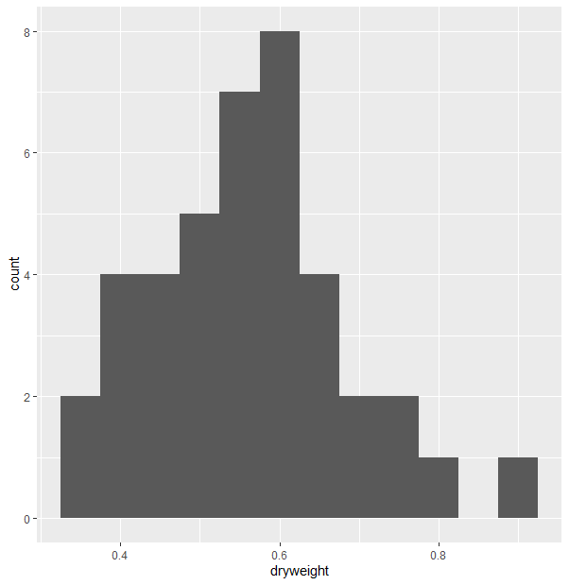
- Normally distributed (also checked with Shapiro test) then mean?
“Snail growth was calculated in µg dry weight/day by subtracting the mean dry weight of the 10 lyophilized snails from the final dry weight of each organism divided by the study duration in days.”
- n = 10, response variable
- dryweight: only NC snails were significantly heavier compared to cultured snails. Just mention in text and argument with growth? As the calculation of growth is based on the mean dry weight of cultured snails?
- Sampling after the feeding assay 30 snails per treatment, only one sampling point

FA snails
- Absolute values (ug/mg dw snail) b) relative values (%)
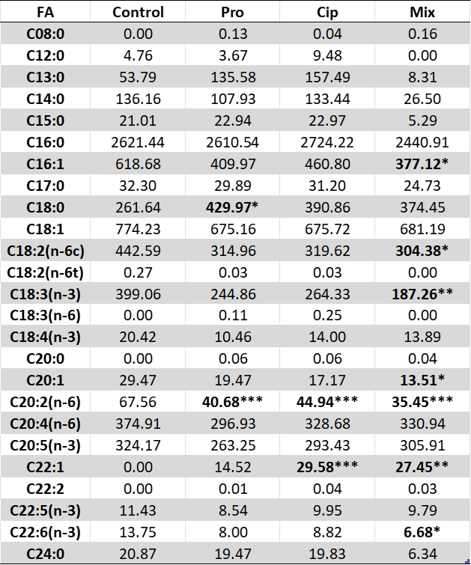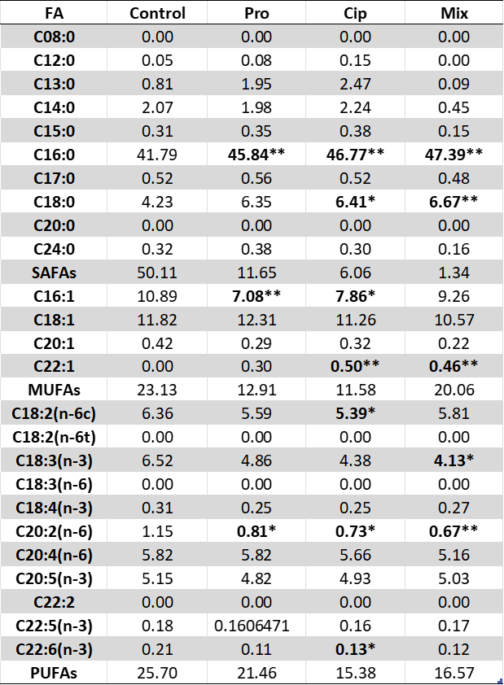

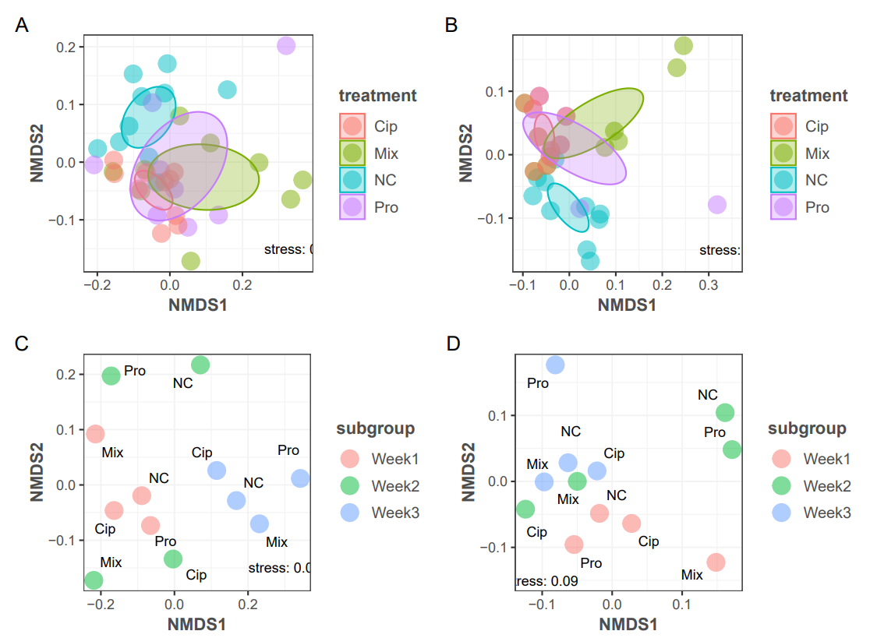
A = NMDS for absolute values snails, B) relative values snails, C) absolute values biofilm separated in weeks and D) relative values biofilm separated in weeks

- Response variable
- Median or mean? n = 10 per treatment, some outliers found
/ Mean with outlier removal or just median?
- Total SAFA, MUFA & PUFA content: just add the total contents for each snail and then compare?
- FA composition important endpoint, as it refers to the fitness of the animals
- Sampling after the feeding assay, just 10 snails were used for FA analyses. We can combine growth and feeding rate, as I know which snails fed how much.

FA Biofilm

- Absolute values (ug/mg dw snail) b) relative values (%)

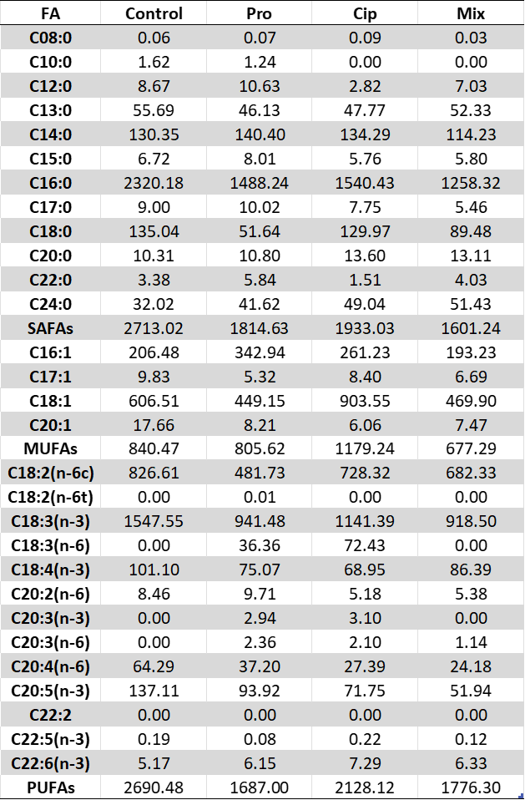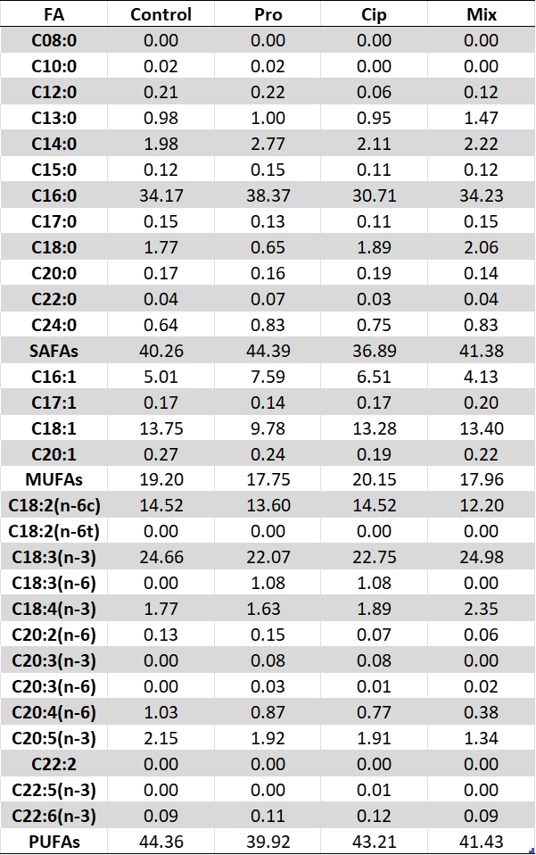

- 3 replicates used for FA analysis, sampling after 14 days of contamination (to investigate the “food quality”), sampling of every week, so we have 3 replicates of each treatment, but after 3 different time points (Week 1, Week2 and Week 3, respectively

Feeding rate (same for ash free dry mass after feeding)

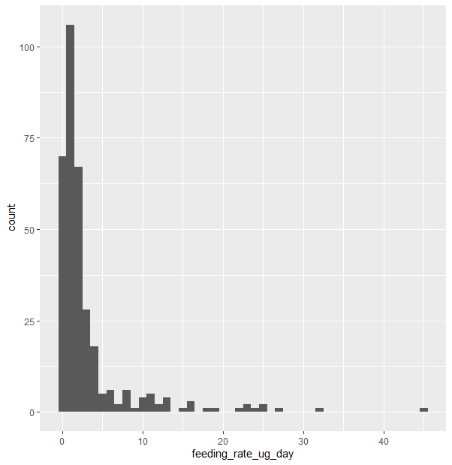
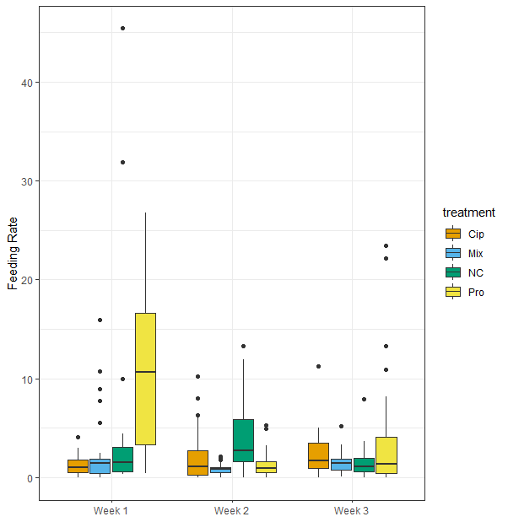

- Response variable
- Feeding rate histogram of all treatments and all weeks (n = 30 per treatment / per week; in total: 4treatments*3weeks*30replicates = 360 samples)
- Feeding rate histograms of separated weeks looks the same, all right skewed
- remove outlier?
- The feeding rate is calculated by the ash free dry mass (of the tiles after 7 days of feeding – tiles were changed every 7 days), therefore we have 30 replicates, after 7 / 14 and 21 days in total ( 1 Week / 2 Weeks or 3 Weeks, respectively).

Ash free dry mass and chlorophyll concentration after biofilm colonisation

- Response variables
- n = 3 per treatment and per week (in total: 3weeks * 4treatments * 3replicates = 36 samples)
- here, as for the FA analysis of the biofilm, I took 3 replicates per treatment right after the 14 days of contamination, so 3 different time points ( 1 Week / 2 Weeks or 3 Weeks, respectively).

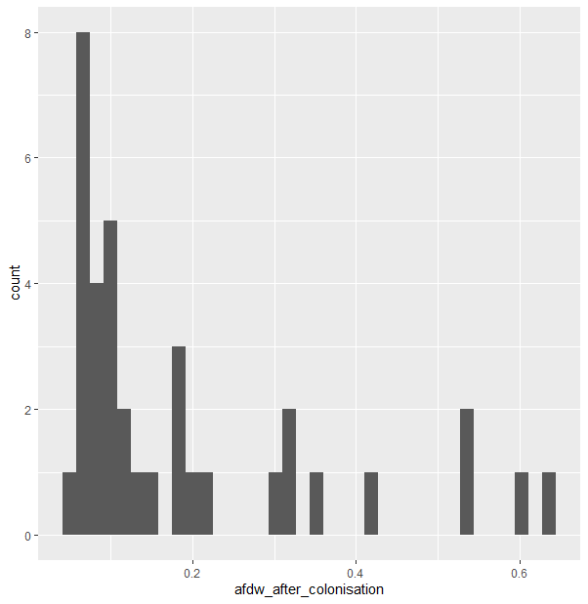
µ
