Table of Contents
Table of Contents ..1
Chapter 1: Introduction 2
Chapter 2: Background 3
2.1 Socket Comparison.................................................................................................................... 3

2.1.1 SCTP socket.......................................................................................................................3

2.1.2 TCP socket.........................................................................................................................5

2.2 SCTP History and Association...................................................................................................6

2.3 SCTP Multi-homing Feature......................................................................................................7

2.4 SCTP DAR extension..............................................................................................................9

2.4.1 Three Parameters of DAR extension.................................................................................9

2.4.2 Two control chunks of DAR extension...........................................................................10

2.5 Related Research......................................................................................................................12

2.5.1 RFC …………................................................................................................................12
2.5.2 Performance Modeling of SCTP Multihoming...............................................................12

2.5.3 Media independent handover transport using cross-layer optimized stream control transmission protocol................................................................................................................13
2.5.4 Dynamic transport layer handover for heterogeneous communication environments....13
2.5.5 A Review of Multihoming Issues Using the Stream Control Transmission Protocol ....13
2.5.6 Seamless Handover between CDMA2000 and 802.11b WLAN using mSCTP.............14
Chapter 3: Design and Implementation 15
3.1 System Design..........................................................................................................................15
3.1.1 System function design....................................................................................................15
3.1.2 Overall system design......................................................................................................16
3.1.3 Server system design.......................................................................................................18
3.1.4 Client system design........................................................................................................21
3.2 Test bed Development..............................................................................................................23
3.2.1 Software Setting..............................................................................................................24
3.2.2 Hardware Setting.............................................................................................................27
3.2.3 Router Setting..................................................................................................................28
Chapter 4: Results and Discussion 29
4.1 TCP Handover System.............................................................................................................29
4.1.1 TCP Handover Results....................................................................................................29
4.1.2 TCP Handover Discussion..............................................................................................30
4.2 mSCTP Handover System........................................................................................................31
4.2.1 mSCTP Handover Results...............................................................................................31
4.2.2 mSCTP Handover Discussion.........................................................................................33
4.3 Comparison between TCP and mSCTP Handover...................................................................37
Chapter 5: Conclusion and Further Work 38
5.1 Conclusion................................................................................................................................38
5.2 Further Work.............................................................................................................................38
References 40
Acknowledgement 42
Appendix 43
Risk Assessment 44
Environmental Impact Assessment 45

Chapter 1: Introduction
Nowadays, increasing number of devices have equipped with multiple interfaces, so they can connect to multiple networks at the same time. If a host has multiple network addresses, then it is said to be multihomed. This increasing popularity of multihoming makes handover become a more important technique, which guarantees the connectivity and continuity of data transfer when the host is moving around networks. This project is aiming at achieving mSCTP handover between two networks and investigating how mSCTP outperformed the traditional transport layer protocol (like TCP) during handover.

The new transport-layer protocol，Stream Control Transmission Protocol (SCTP) is applied in this project. It provides multihoming feature and allows one SCTP endpoint to have multiple IP address to form several paths with corresponding endpoint. The core technology applied in this project is SCTP with Dynamic Address Reconfiguration (DAR) extension, or Mobile SCTP (mSCTP). The key functions of mSCTP includes add/delete IP address to/from an association and sets the primary address, which is necessity for implement handover system.

This project is to do the research on SCTP’s multihoming feature and its DAR extension, design and implement handover system. The handover is intelligent which means that the decision for handover will be performed automatically. During the handover process, no connection broken will occur and no package will be lost. In addition, when applying TCP to achieve handover, the drawbacks of TCP connection, such as suspension and retransmission during handover will be observed. Also, the comparison of the handover performance under these two different protocols will be done.

This report is organised in chapter:
Chapter 2 related background will be introduced and gives a basic knowledge about this project.
Chapter 3 show the detailed SCTP handover system structure and elaborate handover procedure between networks. This chapter also includes how the testbed built and set up correctly.
Chapter 4 show the result of both mSCTP and TCP handover, discuss performance of these two systems.
Chapter 5 come to conclusion and discuss the further work.

Chapter 2: Background
2.1 Socket Comparison
2.1.1 SCTP socket
SCTP socket has two different types, one-to-one style and one-to-many style, in this project, one-to-many style is using to support multihoming feature. This socket style has an advantage that it can handle multiple clients without managing too much socket descriptors. When sending message, function sendto, sendmsg and sctp_sendmsg can be used while function send and write are not usable. SCTP one-to-many style socket is shown in Figure 1.
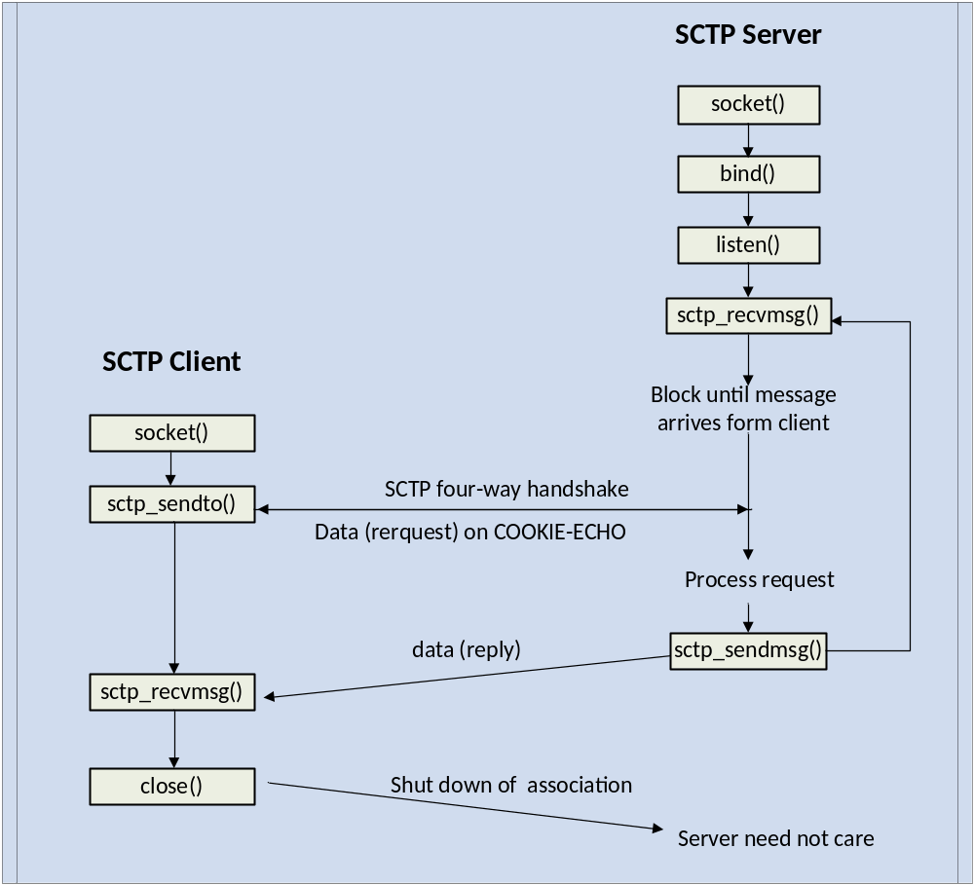
Figure 1: SCTP one-to-many style socket [1]

To begin with, server called socket, bind, listen and sctp_recvmsg to wait for incoming request. After that, client called the socket and sctp_sendto and started the four-way handshake. The flow chart of SCTP four-way handshake is shown in Figure 2.
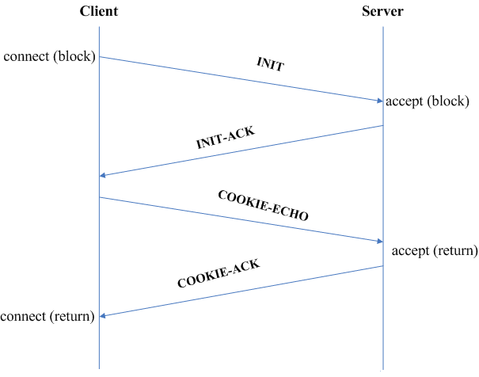
Figure 2: Flow chart of SCTP four-way handshake [2]

- When client called connect, it will open the association and send an ‘INIT’ message to the server which contained client address and some other information.
- Server received the ‘INIT’ and it will send back acknowledgement ‘INIT_ACK’ message, server address and other information are contained in this message. One different is that a state cookie is also included in this message.
- The different between SCTP and TCP handshake is that SCTP will generate cookie. Client received the state cookie in message ‘INIT_ACK’, and it will send back a ‘COOKIE_ECHO’ message.
- When server has confirmed the cookie is correct, it will send an acknowledgement ‘COOKIE_ACK’. Then the four-way handshake is complete and association is established.

Using following statement to create a SCTP one-to-many style socket:
sockfd = socket (AF_INET, SOCK_SEQPACKET, IPPROTO_SCTP);

SCTP socket can use IPv4, so the family is AF_INET. Type of socket is SOCK_SEQPACKET which stands for sequenced packet socket, the protocol for SCTP is IPPROTO_SCTP.

2.1.2 TCP socket
TCP socket is shown in Figure 3.
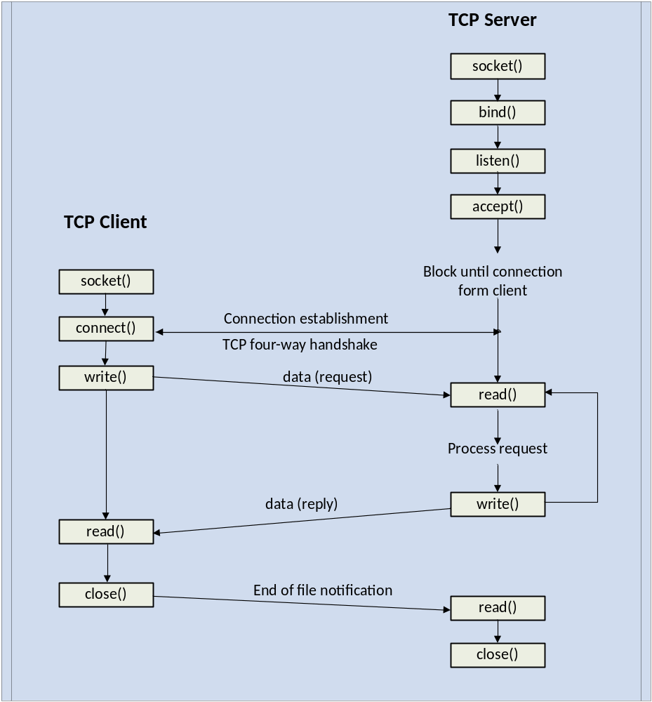
Figure 3: TCP one-to-many style socket [1]

To begin with, server called socket, bind, listen and accept to wait for incoming request. Then client called socket and connect to start the three-way handshake to establish a connection. Different from SCTP, TCP uses three-way handshake to establish the connection, flow chart of TCP three-way handshake is shown in Figure 4.
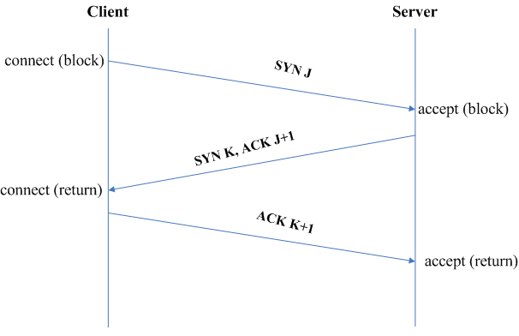
Figure 4: Flow chart of TCP three-way handshake

- Client sends a ‘SYN J’ message to initialize a connection. In this message, an initial sequence number J is contained.
- Server received the ‘SYN J’ and sent back ‘SYN K’ and an acknowledgement ‘ACK J+1’ to client to confirm the sequence number.
- Finally, client will confirm the massage ‘SYN K’ and sent an acknowledgement ‘ACK K+1’. When server received the acknowledgement, TCP connection will be established.

Using following statement to create a TCP style socket:
sockfd = socket (AF_INET, SOCK_STREAM, IPPROTO_TCP);

TCP socket use both IPv4, so the family is AF_INET. Type of socket is SOCK_STREAM which stands for stream socket, the protocol for TCP is IPPROTO_TCP.

2.2 SCTP History and Association
Nowadays, a new transport-layer protocol, Stream Control Transmission Protocol (SCTP) becomes more and more popular in computer networking. Stream Control Transmission Protocol (SCTP) is a Transport Layer Protocol which was defined by Internet Engineering Task Force (IETF) in October 2000, firstly aiming at transporting Public Switched Telephone Network (PSTN) signalling messages over IP networks, but its variable features and services make it capable of much broader applications. RFC 4960 provides the definition of SCTP and RFC 3286 does the introduction. [3] Moreover, many RFC are written to defined specific features of SCTP, we mainly study here is RFC 5061 which is standard track of SCTP- Dynamic Address Reconfiguration (DAR).

SCTP has similar feature with Transport Control Protocol (TCP) such as reliable transmission and order of transmission delivery of data, but it is more likely to be seen as the advanced protocol of TCP. SCTP not only combines the advantages of both TCP and UDP, but also defines new features to overcome the drawback of the TCP and UDP in order to support more advanced applications. In the other hand, SCTP is message-oriented rather than stream-oriented which is inconvenient like TCP. The services of SCTP are at the same layer of TCP and UDP services, SCTP association is shown in figure 5.

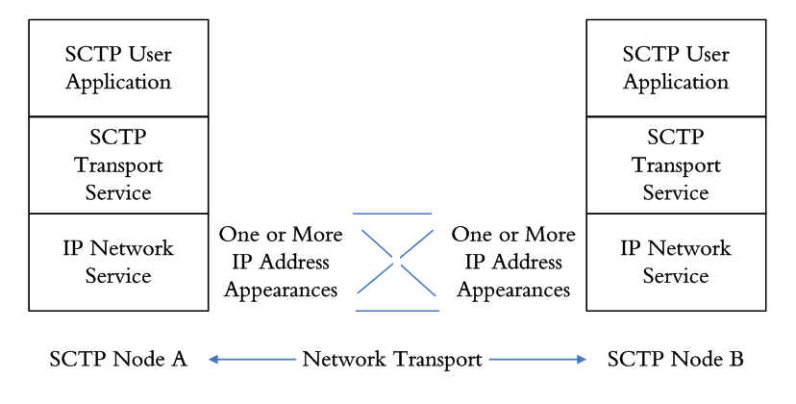
Figure 5: SCTP association

2.3 SCTP Multi-homing Feature
If a host has multiple network addresses, then it is multihomed. It allows one SCTP endpoint to have multiple IP address to form several paths with corresponding endpoint.

The most important advantage of multihoming is greatly improvement of the ability to tolerant network failure. In conventional single home connection, path failure will lead to unavailable transmission of information. And the suspension of the transmission will be eliminated only after the recovery of failure by IP routing protocol. In contrast, multi-homed SCTP uses redundant network access to remove the dependence on one failure connection.

Multi-homed SCTP will choose one IP address as the primary address, and all data chunk will use this primary address as destination in normal transmission. If path failure occurs, the retransmission data chunk will use the alternative address until the available primary address is reestablished. An example of multi-homed SCTP is shown in figure 6.

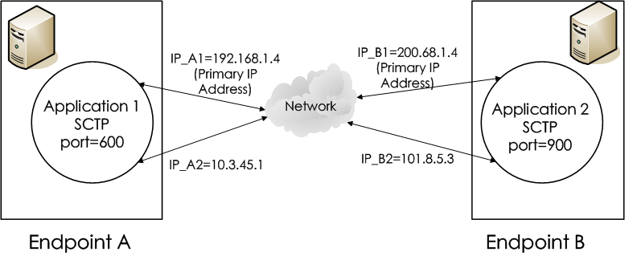

Figure 6: Multi-homed SCTP association between two endpoints

There is only one association between the endpoint A= [192.168.1.4, 10.3.45.1:600] and endpoint B= [200.68.1.4, 101.8.5.3:900], and four possible paths of this association = {[192.168.1.4, 10.3.45.1:600]: [200.68.1.4, 101.8.5.3:900]}. It uses multiple IP addresses, but only one sender address and destination address are considered as primary addresses. In figure 3, the primary address of endpoint A is IP_A1 and the primary address of endpoint B is IP_B1, all other addresses are used as backup addresses such as IP_A2 and IP_B2. When the primary IP address IP_A1 and IP_B1 are not reachable, the backup IP addresses IP_A2 and IP_B2 will replace them.

One mechanism-heartbeat is very important in helping implement of multihoming feature of SCTP. The heartbeat chunks will be sent periodically to the destination through idle path (not primary path), and a counter is used to count the number of times that the sender not receiving acknowledgement. If the number exceeds the set up threshold, the destination will be considered as inactive and another IP address will be used. In figure 6, endpoint B keeps sending heartbeat chunks to endpoint A to check the states of IP_A1 and IP_A2, if the number of non-acknowledge exceeds the threshold, then IP_A1 will be treated as inactive and IP-A2 will become the primary IP address.

2.4 SCTP DAR extension
SCTP takes the advantage of multihoming to avoid hardware failure, but the complication of IP provider and network cards, or interface plugged into the modern computer will lead to a gap between ideal fault tolerance and currently defined SCTP protocol. Moreover, in order to take the advantage defined by SCTP protocol, the association must be restarted, which can be seen as outage. Therefore, an extension- Dynamic Address Reconfiguration (DAR) extension is introduced to fix this undesirable problem for the applications which require higher fault toleration.

Basic SCTP does not have the function to change IP addresses of the association without breaking the connection, so Dynamic Address Reconfiguration (DAR) extension for SCTP or Mobile SCTP (mSCTP) is introduced to meet the requirement. It provides three features for SCTP association: (1) dynamic addition of IP address to an association, (2) dynamic deletion of IP address from an association, (3) request to set the primary address. [4] If the primary path failure occurs, DAR extension of SCTP will update a new IP addresses as primary address without appearing any outage, which provides reliable communication and data transfer.

2.4.1 Three Parameters of DAR extension
Three parameters are used in DAR extension to support above three features, they are add IP, delete IP and set primary IP. The message formats of these three parameters are shown in figure 7.
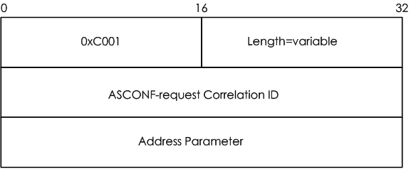
- Message Format-Add IP
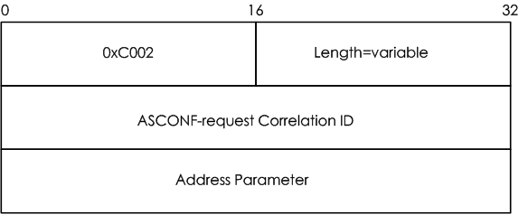
- Message Format-Delete IP
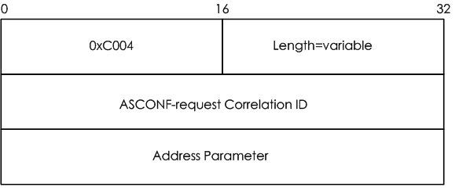
- Message Format-Set primary IP

Figure 7: Message format of three parameters

These three message formats are quite similar, and there are four fields in the message format. The first filed indicates the type of parameter, in Figure 7(a), the type value is 0xC001 which represents add IP address. The type value in Figure 7(b) is 0xC002, means delete IP address. And finally, the type value is 0xC004 in Figure 7(c) stands for set primary IP address. The second field states the length of DAR parameter, the value of this field defined by the number of IP address carried in this message. The third field is used as identifier to distinguish the specific chunk, the sender can use this filed to find which request the response for. The last filed is Address Parameter, it contains the IPv4 or IPv6 address, and it is in TLV format to inform the receiver add/remove or set specific IP address as primary address.

2.4.2 Two control chunks of DAR extension
In the introduction, SCTP packet structure is introduced and we know that user data and control information are included in separate chunks. In DAR extension, two new chunk types are used to transfer these control information, the parameters add IP, delete IP and set primary IP are included in these chunks. These two new chunks are Address Configuration Change Chunk (ASCONF) and Address Configuration Acknowledgement (ASCONF-ACK), their message formats are shown in Figure 8.
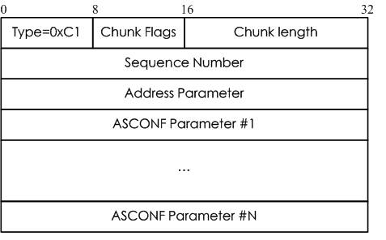
- Message Format-ASCONF Chunk
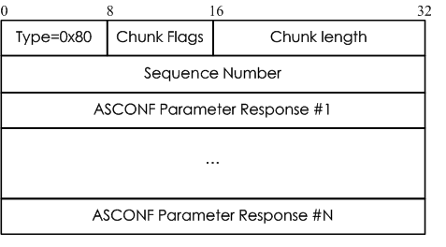
- Message Format-ASCONF-ACK Chunk

Figure 8: Message format of two new chunks

The message format of ASCONF and ASCONF-ACK are similar, the first filed indicates the chunk type, 0xC1 represents ASCONF and 0x80 stands for ASCONF-ACK. The second field, chunk flags are set to be 0. Sequence number is a 32 bits unsigned integer which is used to represent the sequence number of ASCONF chunk, and the valid range is 0 to 2³²-1(4294967295). The sequence number filed in ASCONF-ACK chunk represents the sequence number of the received chunk acknowledged by this chunk, so the sequence number is directly copy from the ASCONF chunk. The address parameter field includes the address of the sender and it can be either IPv4 or IPv6. The receiver can acquire both the source and destination addresses, so the address field is not needed in ASCONF-ACK chunk. The ASCONF parameter field in ASCONF chunk is in TLV format and must be one of the DAR parameters to alter current association state. The ASCONF parameter response field in ASCONF-ACK chunk is used to indicate the status of processing, if no error cause in the response, the success will be indicated. Therefore, the sender always send the first four fields-chunk type, chunk flags, chunk length and sequence number to show the full success. Otherwise, some more field will be use to indicates the error.

2.5 Related Research
2.5.1 RFC
RFC 4960 introduces the basic feature and information about SCTP. [4] It gives a briefly view about SCTP and specifies package structure and association usage elaborately. RFC 3286 is a brief summary about SCTP key features, and it mentions a very significant feature, SCTP multihoming. This feature of SCTP allows one host has multiple interfaces, so that the host can connected to more than one network at the same time. [5] RFC 5061 is the standard track for SCTP Dynamic Address Reconfiguration extension. It defines the function for SCTP to add or delete IP address to or from an association and set primary IP address. [6]

2.5.2 Performance Modeling of SCTP Multihoming
Muitihoming can be seen as one of the most attractive features of SCTP, which is not available in TCP. It provides means for host to use the free network and allows the application remain undisturbed during network switch over. Some research has been done to build an analytical model in order to forecast the throughput of TCP. But the limitation of TCP makes it difficult to be applied in SCTP directly. Fu et al. [8] proposed Seamless IP diversity based Generalized Mobility Architecture (SIGMA), however, this model fails to notice of the analytical framework to forecast SCTP throughput over a multihomed association. This paper proposed a new model which takes multihoming into account to model the throughput of SCTP multihoming. The result shows that this model is precise in estimating SCTP throughput on both primary and alternative paths. [7]

2.5.3 Media independent handover transport using cross-layer optimized stream control transmission protocol
To support vertical handover between heterogeneous networks, the IEEE 802.21 Working Group (WG) has designed the Media Independent Handover (MIH) architecture. Mobile devices are now able to connect many different networks, such as WiMAX, 4G, LTE or UMB. So it is important for users to get the continuous connection when they roaming different networks. Previous research is designed for wired network such as UDP and TCP, so it is obstacle to be used in wireless environment. In order to meet this requirement, a solution is proposed to transport MIH message using SCTP's multihoming, multistreaming, partial reliability, and address reconfiguration to achieve seamless handovers in heterogeneous environments. The result shows that this proposed solution reduces transmission delay and package loss. [9]

2.5.4 Seamless Handover between CDMA2000 and 802.11b WLAN using mSCTP
With the development of 3G network and other wireless network technology like Wireless Local Area Network (WLAN), seamless handover become more and more significant. SCTP is proposed to handle the handover based on IP networks between Code Division Multiple Access 2000 (CDMA2000) and WLAN networks. Some studies have been done to research the seamless handover of this scenario on transport level and mSCTP is used as main method to solve handover problem by providing a standard mechanism.

The result shows that handover based on mSCTP between CDMA2000 and WLAN networks is fast and smooth. Moreover, the handover delay can be ignored and the specific handover performance is based on the signal strength of CDMA2000. [10]

    - Dynamic transport layer handover for heterogeneous communication environments
In heterogeneous communication networks, vertical handover is required to provide seamless access for mobile user. By using multihoming feature of SCTP in dynamic transport layer, the most suitable path can be selected according to user’s preference, application’s requirement and network quality. The handover depends on the multihoming feature of SCTP and its DAR extension will be used to add or delete IP addresses of association between two endpoints. The result shows that SCTP is more robust against packet loss and influence of delay than TCP, so it is a suitable choice in wireless network.

Cellular network like GSM and UMTS has large coverage areas but the bandwidth of data transfer is limited. In the other hand, 802.11abg and WiMAX can offer higher transfer data rate, but the coverage area is small. Combining the advantages of these networks by using the multihoming capability of SCTP and mobile SCTP will establish a seamless network access and will provide “Always Best Connected” for mobile devices. [11]

2.5.6 A Review of Multihoming Issues Using the Stream Control Transmission Protocol Devices with more than one network interface can enhance their performance by utilizing the unused network resources. Wireless communication has reach a high advancements, it covers workplace and city, even the remote areas where no wired can reach. Current means utilize TCP, which does not support multihoming. In order to satisfy the demands for higher data rates, this research proposed a solution, multihoming, to improve performance by exploiting unused resources. Three aspects of handover is considered in this research, (1) preemptive path selection, (2) fault tolerant path selection, and (3) post handover synchronization. The connection migration from one access point to another is the finest usage of multihoming and dynamic address reconfiguration (DAR). So applications' requirement for higher throughput can be solved. [12]

Chapter 3: Design and Implementation
3.1 System design
3.1.1 System function design
The flow chart of the system function design is shown in figure 9. This flow chart is the basic idea of how the system will function.
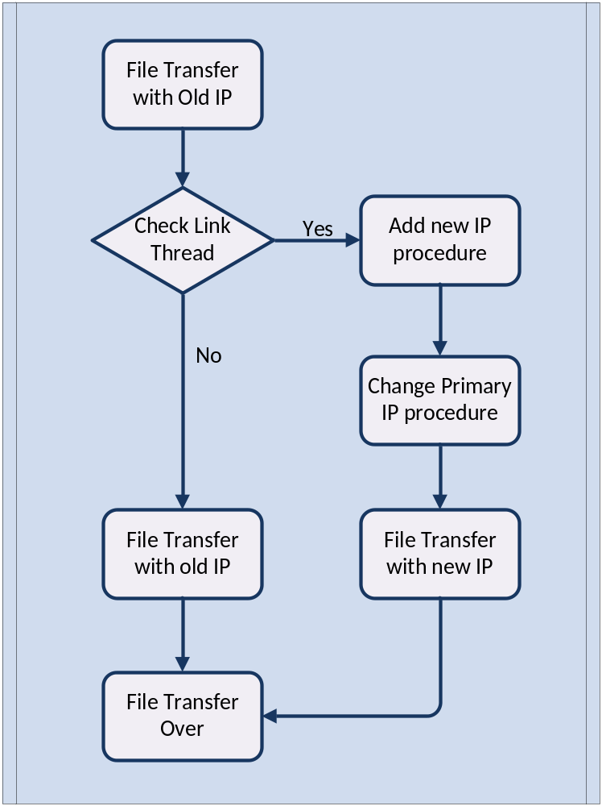
Figure 9: mSCTP handover system design

The handover procedural steps are roughly shown as follows:
Step 1) Client connects to the wireless AP for data transmission by using old wireless IP address

Step 2) Check link procedure will keep running to check whether the client connected by a cable or not.

Step 3) If a cable is detected when it connected to the client, this procedure will send a signal to a procedure to change primary client address.

Step 4) Then this procedure will add the new wired IP address to SCTP association and the primary address of client will be changed to the new one.

Step 5) Finally, the file will be transferred using the new wired IP address.

3.1.2 Overall system design
The overall structure of the system is shown in Figure 10. It is important to establish the connection of the system and acquire the necessary parameters. One of the most significant parameter is assoc id, and it is indispensable in the procedure ‘change primary address’.
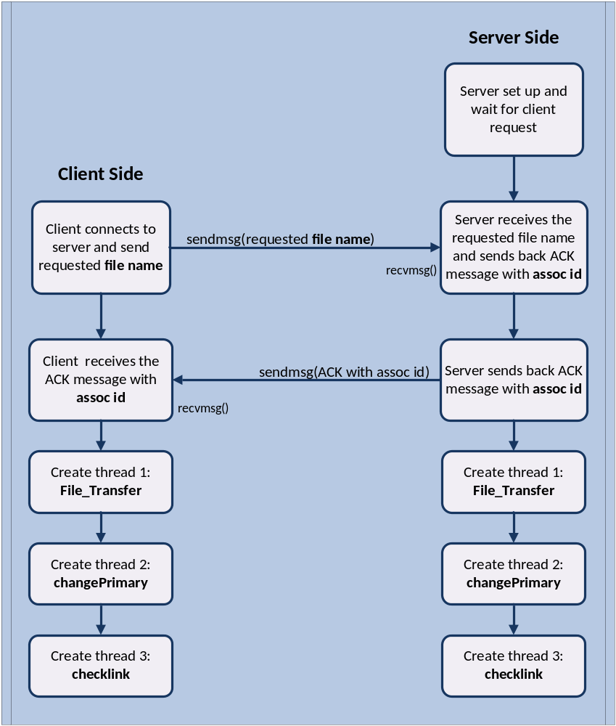
Figure 10: Overall system design

The overall system communication steps can be shown as follows:
Step 1) Server is running and waiting for client request.

Step 2) The client will send the requested file name by using the function - sendmsg(requested file name).

Step 3) Server received the requested file name by using the function - recvmsg(requested file name).

Step 4) Server sent an acknowledgement (ACK) to client with the important parameter of its association id. It uses struct msghdr and strcuture cmsghdr to send the additional information of SCTP association.

Step 5) Client received the ACK and took out the additional information of SCTP association by using CMSG_FIRSTHDR(&msg) and CMSG_DATA(cmsg). Then the most significant parameter - assoc id is acquired and this parameter will be used in thread ‘changePrimary’.

Step 6) Both server and client will create three threads: File_Transfer, changePrimary and checklink to achieve the main function of mSCTP handover.

3.1.3 Server system design
The server system design is shown in figure 11.
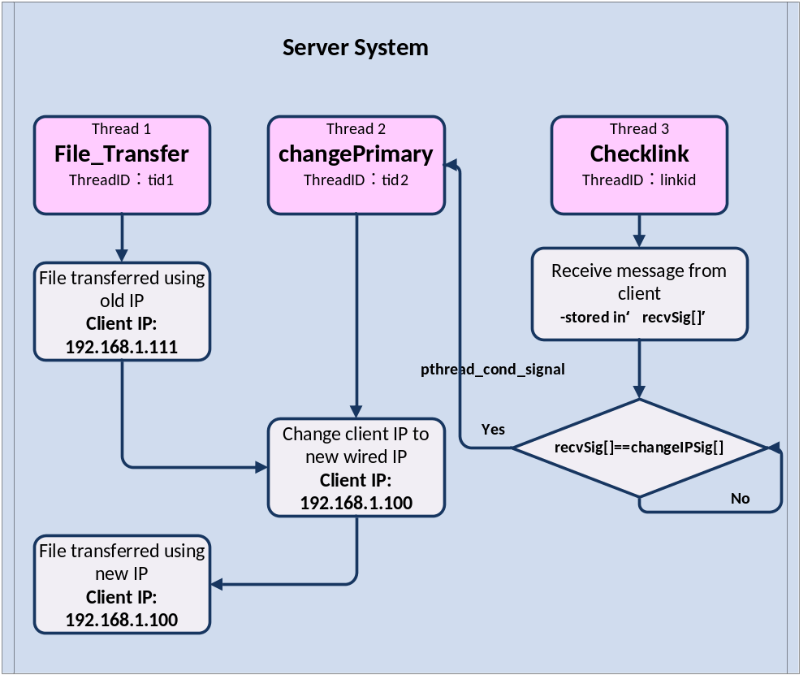
Figure 11: Server system design

In server system, three threads are implemented to achieve different functions, the function of these threads are shown in table 1:
Table 1: Server threads description
Thread  Name | Thread ID | Thread  Function | Running  Status
File_Transfer | tid1 | This thread is used to implement the file transfer function. It opens the requested file by client and using sctp_sendmsg( ) to transfer the file to client. | Running all the time until the file transfer finished
changePrimary | tid2 | This thread set up the new client IP when getting the signal from thread ‘checklink’. | Locked until triggered by signal from thread ‘checklink’
checklink | linkid | This thread is used to check whether the client is starting to change primary client IP address. If a message is received from client checked, it will send a signal to trigger the thread ‘changePrimary’. | Loop until receive the message recvSig[] sent from client side and equal to changeIPSig[].

The server side procedural steps can be shown as follows:
Step 1) Server is running and waiting for client request.

Step 2) Thread ‘File_Transfer’ will open the requested file by client and use sctp_sendmsg( ) to send the file to client.

Step 3) Thread ‘checklink’ will always running to check whether the client is sent a message ‘changeIP’. The received message stored in buffer recvSig[], if the received message equal to the predefined message ‘changeIP’ stored in buffer changeIPSig[], this thread will send a signal to thread ‘changePrimary’.

Step 4) When ‘changePrimary’ thread gets the signal from ‘checklink’ thread, it will add new wired IP address 192.168.1.100 to the SCTP association. Then change primary IP procedure will change the primary IP address to the new wired IP address 192.168.1.100

Step 5) Finally, the file will be transferred by using the new wired IP address 192.168.1.100

- Very importantly, thread ‘File_Transfer’ is running while thread ‘checklink’ and ‘changePrimary’ are implemented the function to change primary IP address. Therefore, file transfer is not suspended or affected during the IP change procedure.

3.1.4 Client system design
The client system design is shown in figure 12.
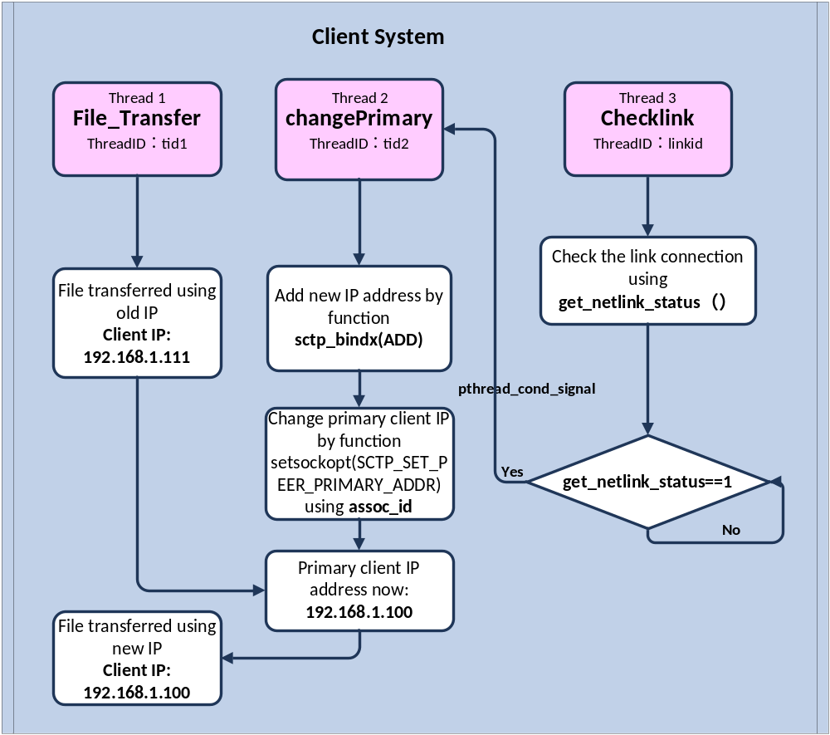
Figure 12: Client system design

In client system, three threads are implemented to achieve different functions, the function of these threads are shown in table 2:
Table 2: Client threads description
Thread Name | Thread ID | Thread Function | Running Status
File_Transfer | tid1 | This thread is used to implement the file transfer function. It receive the requested file by using recv_sendmsg( ). Then it will create a new file and write in the received message. | Running all the time until the file transfer finished
changePrimary | tid2 | This thread changes the primary IP to the new client IP when getting the signal from thread ‘checklink’. It changes primary address by using the important parameter ‘assoc_id’ and setsockopt(SCTP_SET_PEER_PRIMARY_ADDR). | Locked until triggered by signal from thread ‘checklink’
checklink | linkid | This thread is used to check whether a cable is connected to the client. If a cable is detected, it will send a signal to trigger the thread ‘changePrimary’. | Loop until a cable connection is detected when get_netlink_status()=1

The client side procedural steps can be shown as follows:
Step 1) Client sends the requested file name.

Step 2) Thread ‘File_Transfer’ will receive the file by using recv_sendmsg( ) from the server.

Step 3) Thread ‘checklink’ will always running to check whether whether a cable is connected to the client. If a cable is detected, this thread will send a signal to trigger the thread ‘changePrimary’.

Step 4) When ‘changePrimary’ thread gets the signal from ‘checklink’ thread, it will add new wired IP address 192.168.1.100 to the SCTP association. Then change primary IP procedure will change the primary IP address to the new wired IP address 192.168.1.100 by using setsockopt(SCTP_SET_PEER_PRIMARY_ADDR).

Step 5) Finally, the file will be transferred by using the new wired IP address 192.168.1.100

- Very importantly, thread ‘File_Transfer’ is running while thread ‘checklink’ and ‘changePrimary’ are implemented the function to change primary IP address. Therefore, file transfer is not suspended or affected during the IP change procedure.

- In order to implement the function change primary address, it is necessary to acquire the assoc id of the association.

3.2 Test bed Development
My test bed consists of two computers, a router and a wireless network card. A desktop running Fedora 14 is performed as the server. In this project, Fedora-14-i386-DVD.iso is used to install the system and the Linux kernel version is 2.6.35. Another laptop running Fedora 14 with the same kernel version is performed as the client. The client laptop uses a DWA-125 wireless network card to build another network interface. Figure 13 shows the two computer of my test bed.
The type of router used here is TP-Link TL-WR841N. And this router provides sufficient function for the project. The router and wireless network card is shown in Figure 14.

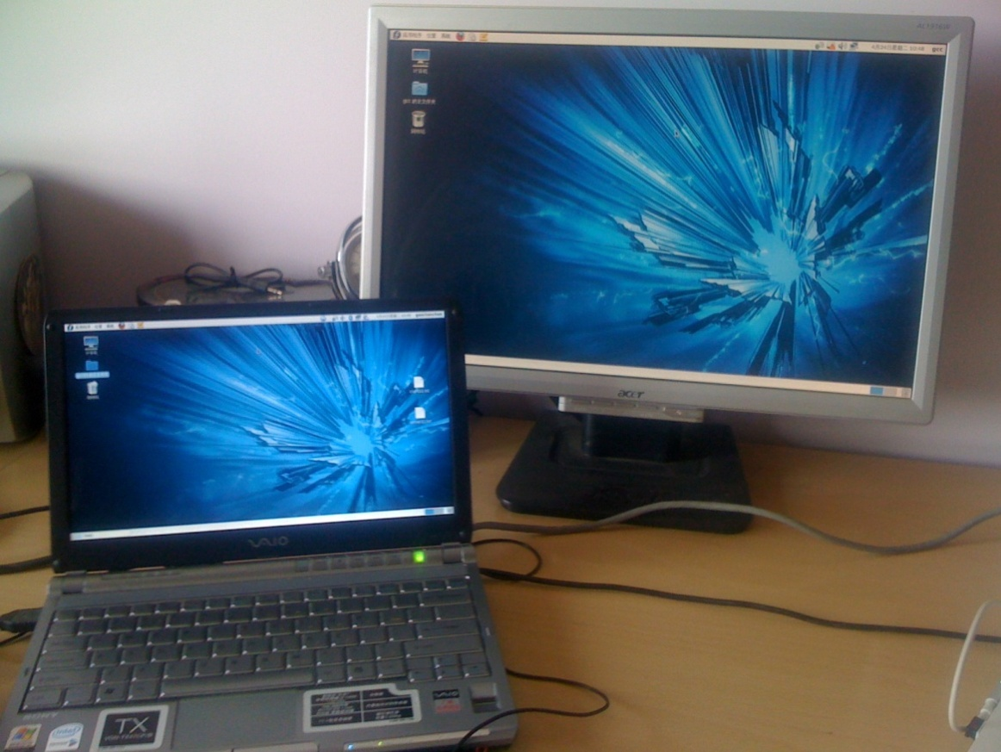
Figure 13: Test bed
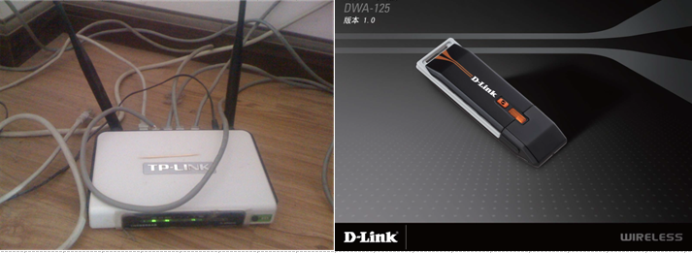
Figure 14: TP-Link Router and DWA-125 wireless network card

There are three main tasks in setting up the test bed. The first one is to implement mSCTP on the client side. SCTP can be used in many OS (operation system) platforms such as FreeBSD, Windows XP and Linux. In this project, I use Linux based operation system-Fedora 14, since it can support mSCTP and it is more convenient to install useful tools.

The second task is to set up the hardware properly. In order to make the DWA-125 wireless network card function correctly, the driver of this adapter must be installed and set up the parameter properly.

The third task is to set up the router correctly. A router is needed in this project to provide two IP addressed for the client to download the file from.

3.2.1 Software Setting
1. In order to finish this project, fundamental software is needed and they should be installed first. The most important ones are listed in table 3:
Table 3: Fundamental Software
Software Name | Function | Version
gcc | C language complier | 3.4.6-20.fc14
wireless-tools | support wireless devices setting | 29-5.1.fc12
wireshark | package analyzer | 1.4.10-1.fc14

2. Fedora 14 has SCTP kernel as the kernel module, so kernel recompile is not needed. But, the SCTP kernel module should be loaded into the RAM memory of Fedora 14 system using the command ‘modprobe’. When loading SCTP module into the RAM, enter the command ‘modprobe SCTP’ as seen in Figure 15.
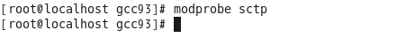
Figure 15: Loaded SCTP kernel module

3. Now both the server and client are ready to support the SCTP protocol under Linux Operating System (OS). In order to support the most significant feature of SCTP, DAR extension, next step is needed to enable the DAR extension of SCTP. One important variable-‘addip_enable’ is used to enable or disable DAR extension whose function is defined in RFC5061. This extension allows SCTP protocol to add or remove IP addresses from associations. The parameter of this variable is shown in table 4.
Table 4: Parameter of ‘addip_enable’ and ‘addip-enable’
Default value | 0
Disable extension | 0
Enable extension | 1

When ‘addip_enable’ is 0, Add-IP extension is disable, and it is enabled when ‘addip-enable’ is 1.
Using command ‘echo 1>/proc/sys/net/sctp/addip_enable’ to set up the variable and make Linux support mSCTP. Then check the variable status by using the command ‘more /proc/sys/net/sctp/addip_enable’ as shown in Figure 16.
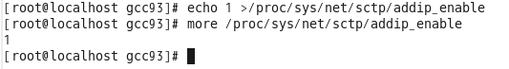
Figure 16: Enable DAR extension and show detail
4. Another important variable that need to be set is ‘auth_enable’, this variable is used to enable or disable Authenticated Chunks extension. This extension provides the ability to send and receive authenticated chunks and is required for secure operation of Dynamic Address Reconfiguration (ADD-IP) extension. [13] The parameter of this variable is shown in Table 4.
Using command ‘echo 1>/proc/sys/net/sctp/auth_enable’ to enable the extension. Then check the variable status by using the command ‘more /proc/sys/net/sctp/auth_enable’ as shown in Figure 17.
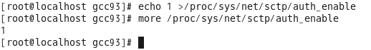
Figure 17: Enable Authenticated Chunks and show detail
5. One problem of Linux is that it does not support SCTP APIs, but SCTP APIs are need to be used for doing the programming of mSCTP handover between wireless and wired WLAN networks. In order to make SCTP protocol usable, I install an additional tool called LKSCTP, this tool provides Linux system SCTP API functions. There are many versions of the LKSCTP tool, the one used in my test bed is version 1.0.11-1.fc13. The following steps have been taken to build LKSCTP in Linux:
1) Open the terminal in the system
2) Become root user to install LKSCTP by command ‘su’, and enter the password
3) Type the command ‘yumex –root’ to open the Yum Extender
4) Search for ‘lksctp’ and install all the founded files

After all the above steps completed, then check whether LKSCTP is supported by Linux OS. Enter command ‘checksctp’ to check LKSCTP of the system as shown in figure 18. The result shows that the test bed now is supporting LKSCTP.
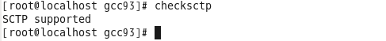
Figure 18: SCTP supported check

6. In order to make the connection working, it is necessary to shut down the firewall in both server and client side. Use command ‘/etc/init.d/iptables status’ to check the status of the firewall. And use command ‘/etc/init.d/iptables stop’ to shut down the firewall.

3.2.2 Hardware Settings
1. DWA-125 wireless network card
This subsection describes how to install the DWA-125 wireless network card under Linux and how to set up the card. Although several wireless drivers are built into the Linux kernel, none of them supports the USB WiFi card. In order to make the adapter work, the following steps is needed to install the driver of DWA-125:
1) Open the file in os/linux/config.mk,and set 'HAS_WPA_SUPPLICANT=y' and ' HAS_NATIVE_WPA_SUPPLICANT_SUPPORT=y'.
2) Because of a missing reference to the driver 'license', so open the file in /RT3070_LinuxSTA_V2.3.0.1_20100208/os/linux/usb_main_dev.c, and add the highlighted line in red - 'MODULE_LICENSE("GPL");'.
3) Become root user to install the driver by command: su
4) Enter the driver directory and run command: make, make install
5) Enter the command: insmod rt2870sta.ko to boot the wireless network card

Now command “iwconfig” is used to obtain the detail information of D-Link Wireless network card. The results show that the wireless network card cannot get an “ESSID” and “IP address” by itself, so it is necessary to set up important parameters. Following steps should be done to configure the wireless network card:
1) Find available the access points by command: iwlist ra0 scan. After this command, all the access points and their basic information will be listed in the terminal.
2) Choose the access point and connect to it by command: iwconfig essid ‘TP-LINK_A0042A’.
3) Then set up IP address and netmask for this network by command: iwconfig 192.168.1.111 netmask 255.255.255.0 broadcast 192.168.255.255.

Now the wireless network card has been installed and set up completely. Use the command “iwconfig” to show all the detail information of wireless network card in Figure 19:

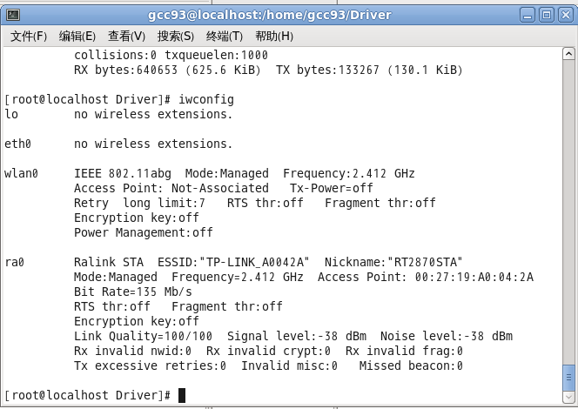
Figure 19: Wireless card information

3.2.3 Router setting
1. Shut down wireless security options
A router is necessary to support the file transfer between the server and client. In order to make the programming working correctly, some of the parameters should be setting. One important step to do is turning off the Wireless security options, so the wireless card in client side can access to the router easily.

2. Setting the speed limitation
The speed of file transfer through the wireless or wired connection is relatively high, and the high speed transfer cause a problem that it is difficult to do some manipulation during the file transfer. In order to make the handover procedure become more easily to control, the speed limitation is necessary. The imitation bandwidth is setting to 500K.

Chapter4: Results and Discussion
  - TCP Handover System
    - TCP Handover Results
When applying TCP in handover, the result is shown in IO graph in Figure 20.
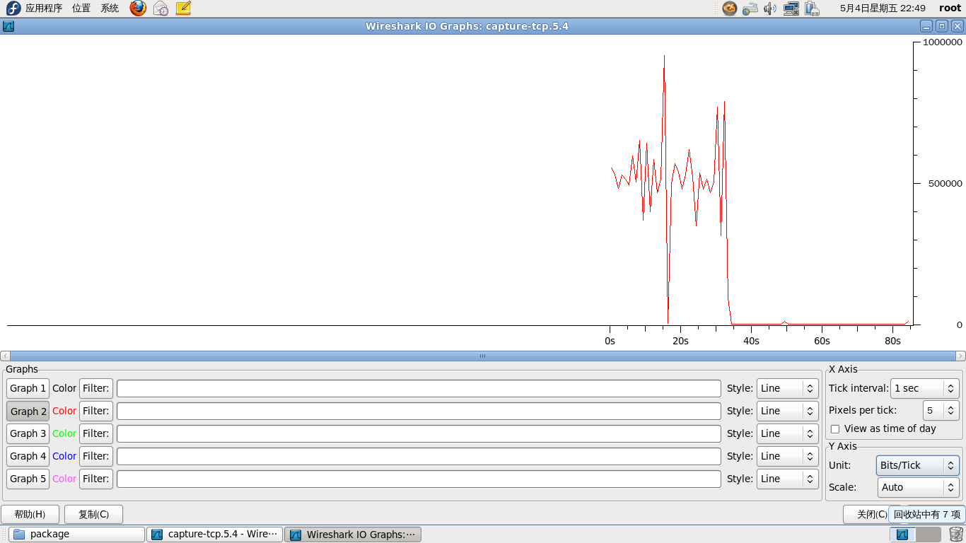
1
Figure 20: IO Graph of TCP handover

The IO graph in Figure 20 shows the whole process of TCP handover system. The horizontal coordinate stands for time in seconds and the vertical coordinate stand for the data flow in bits/s. The red line shows the data flow from wireless IP address ‘192.168.1.111’.

An arrow is drawn in the IO graph to point out the important points and handover process along with the time axis is described as followed.
- First, client is connected to server through three-way handshake and sent request to server for file transfer.
- The data will be transferred using wireless IP address ‘192.168.1.111’
- When another cable is connected to the client while the wireless network is still connected, nothing will be done by TCP.
- Then shut down the wireless network card and the wireless connection is broken, TCP will suspended the application and retransmit the data package when server did not receive acknowledgement.
- At the time marked by arrow one, data flow is dropping to zero because the wireless network card is shutting down. And there is no further data transfer can be received by client.
- After a while, the data flow is still zero, which means that the reconnection is unsuccessful, and file transfer failed.

    - TCP Handover Discussion
TCP provides a mechanism known as positive acknowledgment. It is used to ensure the reliability of packet transfers. This mechanism demands the receiver to send back acknowledgment message when it receives the packet. Figure 21 shows TCP packages captured by Wireshark, at time 33.900998 second, the connection is broke and TCP start to retransmission the packages which did not return acknowledgement.
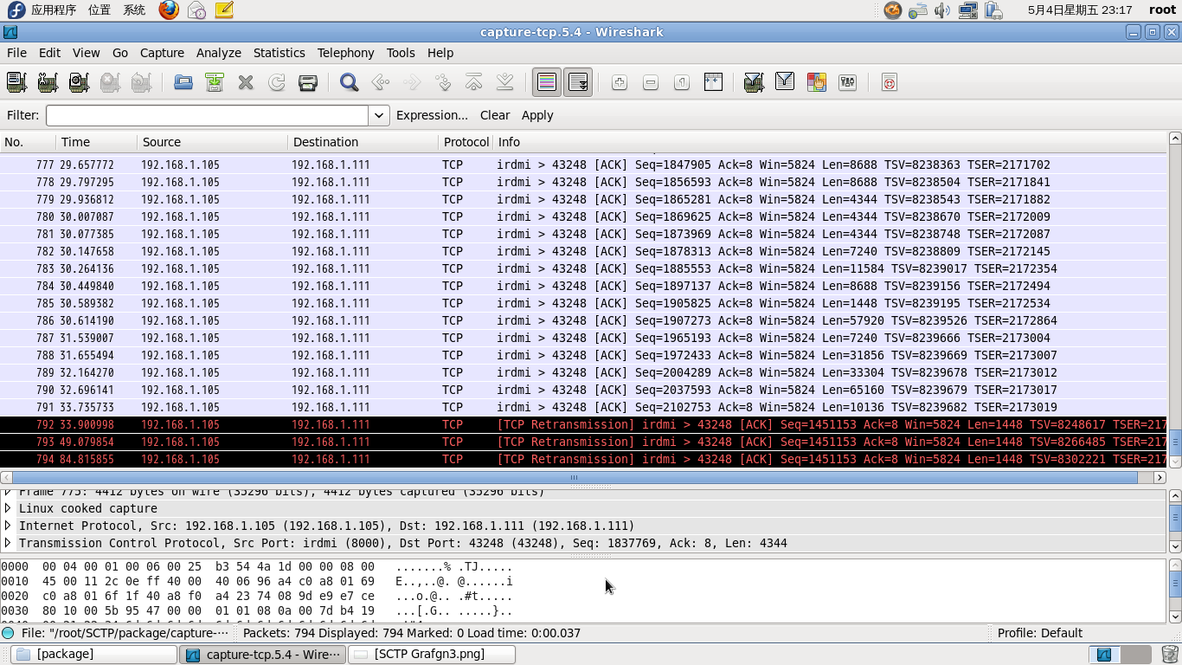
Figure 21: Retransmission when wireless connection broken
TCP has very poor performance at handover, when the original IP address is unavailable, data transmission is suspended and TCP is trying to connect to the new IP address. Unfortunately, the reconnection can not perform automatically, and it has to be reconnected manually. Therefore, time spend in this process is unmeasurable. On the other hand, TCP does not support resume broken transfer function, after the reconnection, the requested file has to be retransmit from the beginning. As a result, TCP handover is very inconvenient and has extremely low efficiency.

  - mSCTP Handover System
4.2.1 mSCTP Handover Results
The topology of mSCTP handover system is shown in Figure 22.
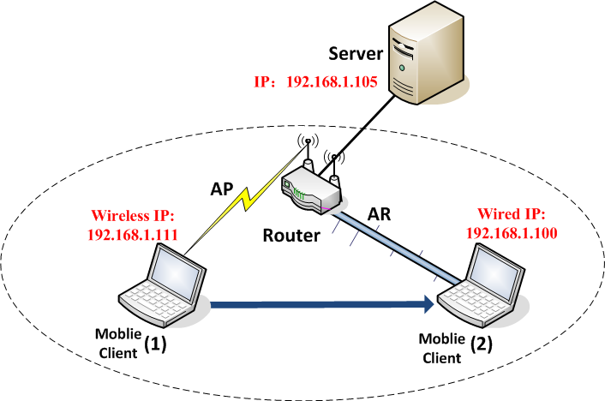
Figure 22: Topology of mSCTP handover system

From the topology, the handover process can be seen clearly. As said before, server is performed by a computer and its IP address is ‘192.168.1.105’. A router is connected to the server as middle network and it performs as both a wireless access point (AP) and an Ethernet access router (AR). The IP address of AP is ‘192.168.1.111’ and the IP address of AR is ‘192.168.1.100’.

The IO graph in Figure 23 shows the whole process of mSCTP handover system. The horizontal coordinate stands for time in seconds and the vertical coordinate stand for the data flow in bits/s. The red line shows the data flow from wireless IP address ‘192.168.1.111’ while the green line shows the data flow from wired IP address ‘192.168.1.100’.
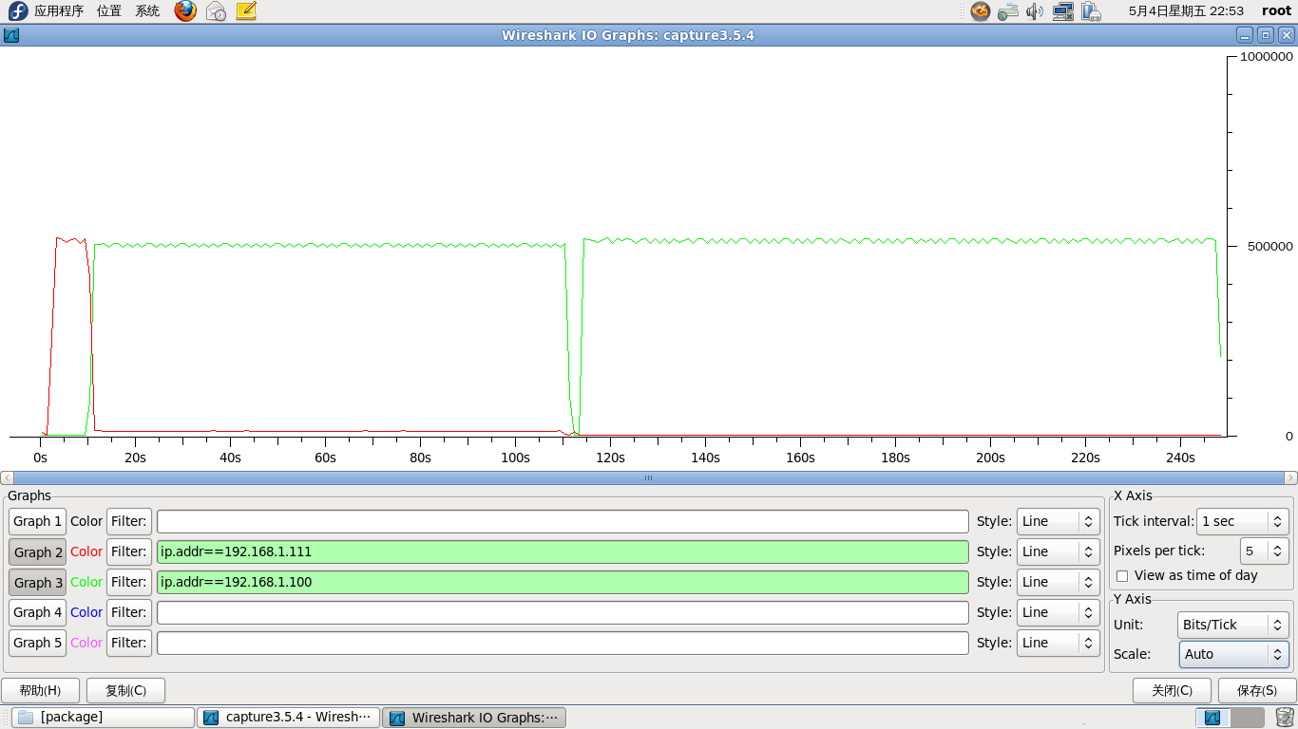
1
2
3
4
Figure 23: IO Graph of mSCTP handover system

Four arrows are drawn in the IO graph to point out the important points and handover process along with the time axis is described as followed:
- At first, client using the wireless address ‘192.168.1.111’ to transfer data, so the red line begins to rise and reaches the highest point at time about 2 second. Then the file transfer reaches a uniform speed and last about 8 seconds.
- At the time marked by arrow one, data flow from wireless address ‘192.168.1.111’ is dropping while data flow from wired address ‘192.168.1.100’ is starting to rise. That means a new wired address is added to SCTP association and the primary address has changed from the wireless one to the wired one. So the two lines of data flow cross through each other.
- At the time marked by arrow two, data flow from wireless address ‘192.168.1.111’ is dropping to zero while data flow from wired address ‘192.168.1.100’ is rising to the highest point. Figure 24 shows the data flow change from IP address ‘192.168.1.111’ to ‘192.168.1.100’. At time 10.824 second, the handover process has completed and all the data transfer will through the wired IP address ‘192.168.1.100’ at an average speed. In IO graph, the green line becomes flat.
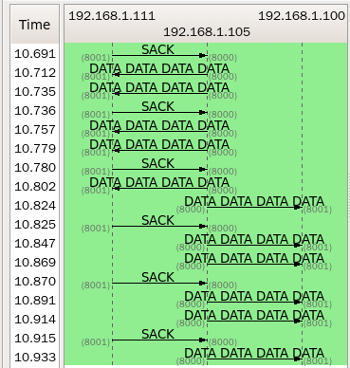
Figure 24: Data flow changing from IP ‘192.168.1.111’ to ‘192.168.1.100’
- At the time marked by arrow three, there is a gap of the green line in flat. That is because the wireless network card has been shut down manually, and the system has to process and adjust this action, it has a little affection on the file transfer. When the action completed, the data flow is retuning back to normal.
- Then the data transfer will continue until the whole file is received. At the time marked by arrow four, the file transfer is about finished so the data flow is dropping.

4.2.2 mSCTP Handover Discussion
Flow chart of mSCTP handover process is depicted in figure 25.

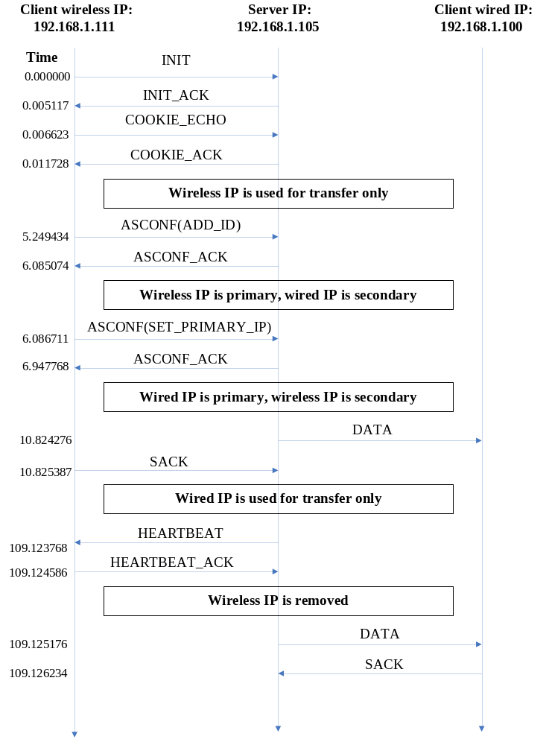
Figure 25: Flow chart of the handover process
1. Procedure analyse
1) The Round Trip Time of add IP address is: 6.085074s - 5.249434s= 0.83564s. During this period, the new IP ‘192.168.1.100’ is added to SCTP association and there are two addresses exist in association. But the primary address is still the wireless one ‘192.168.1.111’ and file transfer is using primary IP address. At mean time, the secondary address is the wired address ‘192.168.1.100’, and it is not used for file transfer now.

2) The Round Trip Time of set primary IP address is: 6.947768s – 6.086711s =0.861057s. During this period, the primary IP address has been changed, the wireless address became the secondary address and the wired address is the primary one now.

3) The time gap between ASCONF_ACK of ASCONF (SET_PRIMARY_IP) and server first time sends data to new IP address is: 10.824276s – 6.947768s =3.876508s. During this period, server will perform its process to change the old client IP address to the new one. At the same time, the data is still transferred through wireless IP address.

4) At time 10.824276 second, the data is transfer through the wired IP address ‘192.168.1.100’ which means that the server side has set up the new client address successfully. At this time, the primary changing process is over and the handover has completed.

2. Discussion about time spent in handover process
In order to study the time spent in handover process, I have repeated the handover process for three times to get more accurate and reliable result. The IO graph of these three handover process is shown in Figure 26.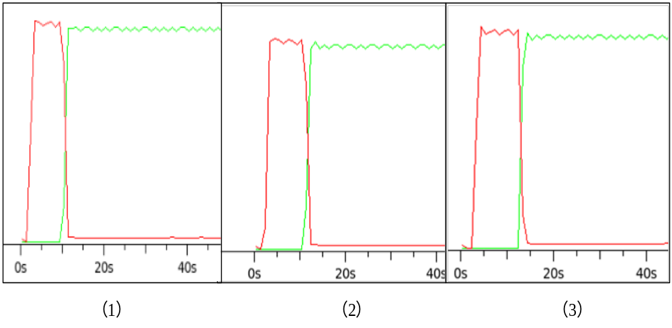
Figure 26: Time spend in handover process

Define the period between ASCONF_ACK of ASCONF (SET_PRIMARY_IP) and server first time sends data to new IP address is the handover process time. Time spending for above three handover process is:
The time spending for handover in Figure 25(1) is: 11.796435s – 8.325121s =3.471341s.
The time spending for handover in Figure 25(2) is: 10.824276s – 6.947768s =3.876508s.
The time spending for handover in Figure 25(3) is: 13.150394s – 9.525032s =3.625362s.

The average time spending of handover process is:
Average Time = (3.471341s+3.876508s+3.625362s)/3=3.657734s

The average time used in the whole handover process started from the time when server sent back ASCONF_ACK of ASCONF (SET_PRIMARY_IP) to the client first time sends data to new IP address is 3.657734s. The time spend in handover process is relatively short compared with the entire time of file transfer.

Suppose a situation, a user needs to download a movie from server. Suppose wireless network bandwidth is 2M and the file size is 1G. In China, the network speed of 2M bandwidth network is about 256kb/s. The total time spend for file transfer is:
1G / (256kb/s) =1*1024*1024kb / (256kb/s) = 4096s = 68.27min.

Compared with the total file transfer time 68.27min, time spend for handover process 3.66s is very short and it can be overlooked. In addition, the handover process is performed smooth and seamless, even user cannot realize this process. Besides, the file transfer is continuous and no package loss, handover process time is short enough and well acceptable, performance of mSCTP handover is superior.

  - Performance comparison between TCP and mSCTP
- Connection style
TCP socket connection is one-to-one style, so a server cannot handle more than one client for connection. It can only bind a single IP address, so changing IP address will kill active process. Compare with SCTP socket, which using one-to-many style socket, it is well usable for connecting multiple clients and provides a basic condition for seamless handover.

- IP address changing procedure
When another IP address is detected, TCP dose not has the mechanism to add the new IP address. Instead, it has to break down the old connection and reconnected to new IP address. Besides, the reconnection can not perform automatically, and it has to be reconnected manually.
mSCTP can add the new IP address dynamically to its association and set new IP address as the primary one. The whole IP changing process is performed automatically when wired network is detected.

- Data transfer situation
After connection is broken, TCP will retransmit the data to old client address which does not return an acknowledgement. On the other hand, TCP does not support resume broken transfer function, after the reconnection, the requested file has to be retransmit from the beginning. Even though the file does not need to transmit from beginning, the package loss is badly and inevitable.
In contrary, mSCTP handover is smooth and reliable, and handover process has no disturbance on data transfer. The data flow is continuous during the whole transmission procedure, once client primary IP address is changed, data flow shift to new path immediately which can be seen as a seamless handover procedure.

Chapter 5: Conclusion and Further Work
5.1 Conclusion
In my project, I have successfully design and complete mSCTP handover system. SCTP provides multi-homing feature and allows one SCTP endpoint to have multiple IP address to form several paths with corresponding endpoint. When a wired network with better link quality is detected, the handover process will be performed automatically without influence on the data transfer process. During the handover process, no connection broken will occur and no package will be lost. The handover is intelligent and the decision for handover will be performed automatically. Therefore, the continuous of file transfer is supported by smoothly handover process between two networks. And it is reliable and efficient to transfer data when the client moving around different networks.

In addition, I have finish TCP system for file transfer and tested its performance during handover. Using TCP to achieve handover, the drawbacks of TCP connection, such as suspension and retransmission is observed. Moreover, handover process is clearly unsuccessful when applying TCP protocol. First, it cannot add new IP address as its new download address. Second, it cannot choose the IP address with better link quality to transmit file. Third, since the reconnection must be done manually, so time spending for that handover will waste a quantity of time. More importantly, once the connection is broken, TCP will suspend the application and reconnection will lead to file transfer failure.

From the comparison in last chapter, I came to the conclusion that mSCTP is outperformed TCP for providing a perfect solution for seamless handover due to its no loss, less latency and high efficiency performance.

5.2 Further work
Time spent for handover process is not ideally short in this project. The time consumption of changing primary IP address on server side may make the whole handover time become longer. Therefore, future works can further reduce the handover process time. Some mechanism should be developed for server to decrease the time consumption when changing its client IP address. And the handover process will become more fast and efficient.

mSCTP handover performed in this project is automatically, and the decision making does not take into account different factors, such as network bandwidth, download speed and whether the network is in idle. Further work can introduce some algorithm to evaluate these factors together to get the comprehensive network quality, and handover decision will be made when a network is detected and it has better comprehensive quality. Overall consideration can ensure high quality services for using the best choice network.
References
[1] W. Richard Stevens, Bill Fenner, Andrew M. Rudoff, (2003). UNIX® Network Programming Volume 1, Third Edition: The Sockets Networking API. Addison Wesley.

[2] Aurola, (2008). The Transport Layer: SCTP Association Establishment and Termination. http://hi.baidu.com/zhangliulin/blog/item/61e4decb84bddd40f21fe7f2.html

[3] Wikipedia, (2011). Stream Control Transmission Protocol. http://en.wikipedia.org/wiki/Stream Control Transmission Protocol.

[4] R. Stewart, Q. Xie, M. Tuexen, S. Maruyama, M. Kozuka, (2007). Stream Control Transmission
Protocol (SCTP) Dynamic Address Reconfiguration, RFC 5061(Proposed Standard).

[5] R. Stewart, Ed, (2002). Stream Control Transmission Protocol, RFC 3286(Proposed Standard).

[6] L. Ong, J. Yoakum, (2002). An Introduction to the Stream Control Transmission Protocol (SCTP), RFC 4960(Proposed Standard).

[7] Deng Feng, (2006). Seamless Handover between CDMA2000 and 802.11 WLAN using mSCTP, Department of Electrical and Computer Engineering University of Canterbury Christchurch.

[8]Shaojian Fu and Mohammed Atiquzzaman, (2005). Performance Modeling of SCTP Multihoming. IEEE Communications Society subject.

[9]S. Fu, L. Ma, M. Atiquzzaman, and Y. Lee, architecture and performance of SIGMA: A seamless mobility architecture for data networks, 40th IEEE Internationl Conference on Communications (ICC), Seoul, Korea, May 2005.

[10]Richard Rouil, Nada Golmie, Nicolas Montavont, (2010).Media independent handover transport using cross-layer optimized stream control transmission protocol

[11] Sven Lahde, Michael Doering, Lars Wolf, (2007). Dynamic transport layer handover for heterogeneous communication environments. Technische Universitat Braunschweig, Institute of Operating Systems and Computer Networks, Muhlenpfordtstrae 23, D-38106 Braunschweig, Germany.

[12]T. Daniel Wallace and Abdallah Shami, (2011).A Review of Multihoming Issues Using the Stream Control Transmission Protocol. IEEE COMMUNICATIONS SURVEYS & TUTORIALS.

[13] The Linux Kernel Archives, (2012). Documentation of networking ip-sysctl. http://www.kernel.org/doc/Documentation/networking/ip-sysctl.txt

Acknowledgement
I would like to express my sincere thanks and gratitude to my supervisor, Professor Xu Changqiao for his guidance and support during the time of my research.

I will thank the Next Generation Internet Technology Research Centre, Institute of Network Technology of BUPT. The lab provides necessary equipments for me to complete this project. The project cannot be finished without supporting from the lab.

Special thanks to Li Zhuofeng for his great help and good advices during the whole time of my research. I would like to express my sincere thanks for his patience and great guidance.

I will also thank An Lu and other classmate for their advices on editing the final report and remind me to notice some important requirements.

To my parents, thank you for the love and support throughout the whole time of my research. Especially, I will give my thanks to my father for supporting me during the most difficult moment of my research.
Appendix
IETF
The Internet Engineering Task Force (IETF) is a large open international community of network designers, operators, vendors, and researchers concerned with the evolution of the Internet architecture and the smooth operation of the Internet. It is open to any interested individual. The IETF Mission Statement is documented in RFC 3935.

In computer network engineering, a Request for Comments (RFC) is a memorandum published by the Internet Engineering Task Force (IETF) describing methods, behaviors, research, or innovations applicable to the working of the Internet and Internet-connected systems.
Through the Internet Society, engineers and computer scientists may publish discourse in the form of an RFC, either for peer review or simply to convey new concepts, information, or (occasionally) engineering humor. The IETF adopts some of the proposals published as RFCs as Internet standards.
Request For Comments (RFC) documents were invented by Steve Crocker in 1969 to help record unofficial notes on the development of the ARPANET. They have since become the official record for Internet specifications, protocols, procedures, and event.

Risk Assessment
In my project, the whole test bed including two computers, a router and a wireless network card. The programming may not cause problems, but the hardware may come up with some difficult situation. The risk assessment table is shown in table 5.

Table 5: Risk Assessment
Risk  Description | Impact Description | Likelihood  Level L | Consequence  Level C | Preventative Actions
Computer crush | Linux based system- Fedora 14 installation failed. And original OS will be crashed. | Moderate | Serious | Check out the computer which will be installed the system and chose the most suitable means to do the installation.
Router does not work properly | Some parameter of router must be set up to make sure the wireless card can connect to it. | Unlikely | Serious | Before the programming started, it is necessary to check out the parameter setting of the router.
Wireless network card driver install and parameter setting | The driver of wireless network card must installed properly and setting up the parameters. | Unlikely | Serious | Check out the type of the wireless network card and install the driver strictly follow the instruction of README file, then setting the parameter correctly.
Cable  broken | The cable is necessary to link the test bed, broken link will cause failure. | Rare | Serious | Before the programming started, it is necessary to check out the cable to ensure they are usable.
Environmental Impact Assessment
In my project, main goal is to design and implement handover system applying a new protocol, SCTP with its DAR extension or mSCTP. Some environment impact assessments are listed below.

- Cost of manufacture
In order to apply mSCTP handover, client device should have at least two network interfaces. Usually, our computer has only one network interface, so it is necessary to install a wireless network card for our device. It is easy to use the wireless network card on our computer, so no manufacture cost will happen. Dlink DWA-125 wireless network card costs about 100RMB, consider the good services provided, the price is well acceptable.

- Waste disposal and recycling
This project is only involving some software and reusable hardware, and no disposal.

- Energy use in service
Energy usage in my project is the basic power consumption of computer, and it does not waste extra energy.

- Savings in energy
Once the application is applying in practice, improvement of data transfer efficiency will reduce electric usage and save energy.

