Detecting Menstrual Cycle Patterns in Reddit Language
Research Update – November 3, 2025

OBJECTIVE

Test whether menstrual cycle phases affect emotional language in Reddit posts on a the whole moon 1 file. The main difference from yesterday: use the whole file and apply both text blob and linguistics features.

METHOD

What I Did
- Filtered for posts from the first cut (moon.xlsx) that explicitly stated "today" (e.g., "started my period today") to simplify the initial analysis.
- Extracted from Reddit all posts within 0–28 days after self-identification of period start.
- Included submissions and comments ≥100 characters (short comments were excluded due to measurable positive bias from social pleasantries).
- Tested multiple menstrual cycle phase definitions and selected the one that best revealed patterns consistent with biological expectations.
- Applied VADER and TextBlob sentiment analysis and ran the linguistic feature extraction from the code provided by Elad.

KEY FINDINGS
The menstrual cycle shows modest but measurable effects on language, with submissions providing cleaner signals than comments.

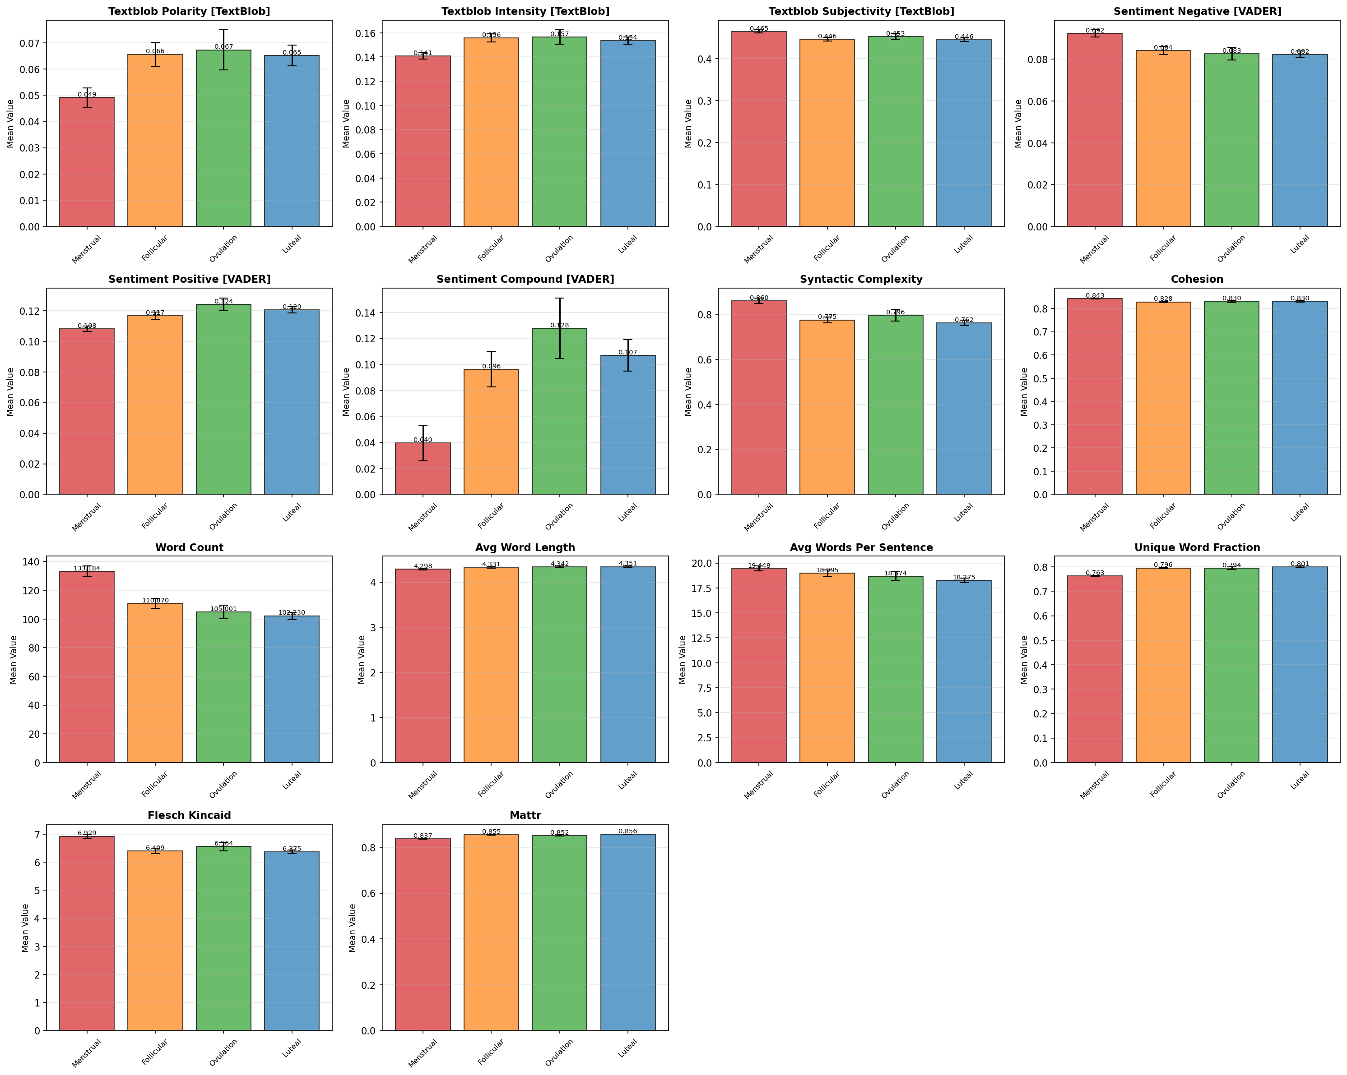
Summary of Core Metrics:
Metric | Menstrual | Ovulation | Note
VADER Sentiment (Compound) | 0.040 | 0.128
TextBlob Polarity | 0.049 | 0.067
Word Count | 133 | 102 | ≈30% more words during menstruation
Negative Sentiment | Highest | Lowest | Directionally consistent
Lexical Diversity | Lowest | — | Lowest during menstruation
Effect sizes are modest but consistent across ~3,900 users and ~18,000 submissions, and are biologically plausible (menstrual phase = most negative, ovulation = most positive).

LIMITATIONS
- Effect sizes are modest;
- Anchoring relies on self-reported timing (“started my period today”), which may include phrasing variability.
- Comments show a measurable positivity bias from short social responses; mitigation applied via ≥100‑character threshold.

FUTURE IMPROVEMENTS
Next Steps:
- Pre-processing for all three data files we have.

