Comparison of results from different codes:
URGENT, US, SRW and pySRU
for zero emittance calculations

This document compares the results of undulator emission by different codes (US. URGENT. SRW and pySRU).

The calculations are:
- Flux emission or radiance at an aperture (x,y) placed at a given distance for a monochromatic photon energy E0
- Flux spectrum integrated over the aperture
- Power density distribution (versus x,y) at the aperture.

Zero emittance has been used for all calculations in this document.

The purpose of the document is a validation of our pySRU code. This code calculates the emission at an aperture I(x,y) for a photon energy E0, thus I(E0,x,y). For different energies one can calculate the stack array I(E,x,y). Integration over the zero axis gives the power density P(x,y). Integration over axes 1 and 2 gives the energy spectrum I(E). Certainly, this is not the most efficient way for computing the spectrum and the power density, but in this document it is done in this way for testing the pySRU results. Other more efficient formulas will be added to pySRU for quick spectral and power density calculations, as used in the other codes.

The calculated cases are 1) the figure 2.5 of the X-ray Data Booklet http://xdb.lbl.gov/Section2/Sec_2-1.html, and 2) the ESRF electron beam with undulators at various K values: K=0.25 (SHADOW_DEFAULTS), K=1.68 (ESRF_NEW_OB), and K=4.0 (ID16_NA).

Parameters of the cases studied

XRAY_BOOKLET
ElectronBeamDivergenceH = 1e-30
ElectronBeamDivergenceV = 1e-30
ElectronBeamSizeH = 1e-30
ElectronBeamSizeV = 1e-30
ElectronEnergySpread = 1e-30
ElectronCurrent = 1.0
ElectronEnergy = 1.3
Kv = 1.87
NPeriods = 14
PeriodID = 0.035
distance = 100.0
gapH = 0.2
gapV = 0.2

ID16_NA
ElectronBeamDivergenceH = 1e-30
ElectronBeamDivergenceV = 1e-30
ElectronBeamSizeH = 1e-30
ElectronBeamSizeV = 1e-30
ElectronEnergySpread = 1e-30
ElectronCurrent = 0.2
ElectronEnergy = 6.04
Kv = 4.0
NPeriods = 77
PeriodID = 0.026
distance = 20.0
gapH = 0.015
gapV = 0.015

ESRF_NEW_OB
ElectronBeamDivergenceH = 1e-30
ElectronBeamDivergenceV = 1e-30
ElectronBeamSizeH = 1e-30
ElectronBeamSizeV = 1e-30
ElectronEnergySpread = 1e-30
ElectronCurrent = 0.2
ElectronEnergy = 6.0
Kv = 1.68
NPeriods = 222
PeriodID = 0.018
distance = 30.0
gapH = 0.001
gapV = 0.001

SHADOW_DEFAULTS
ElectronBeamSizeH = 1e-30
ElectronBeamSizeV = 1e-30
ElectronBeamDivergenceH = 1e-30
ElectronBeamDivergenceV = 1e-30
ElectronEnergySpread = 1e-30
ElectronCurrent = 0.2
ElectronEnergy = 6.04
Kv = 0.25
NPeriods = 50.0
PeriodID = 0.032
distance = 10.0
gapH = 0.002
gapV = 0.002

Radiance at first harmonic
XRAY_BOOKLET
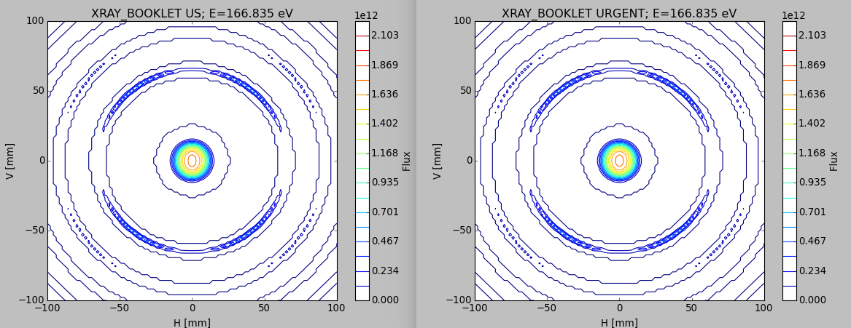
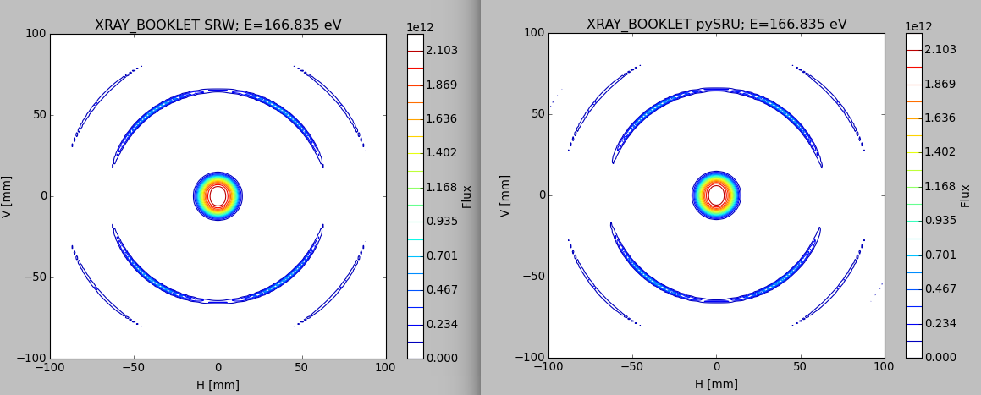
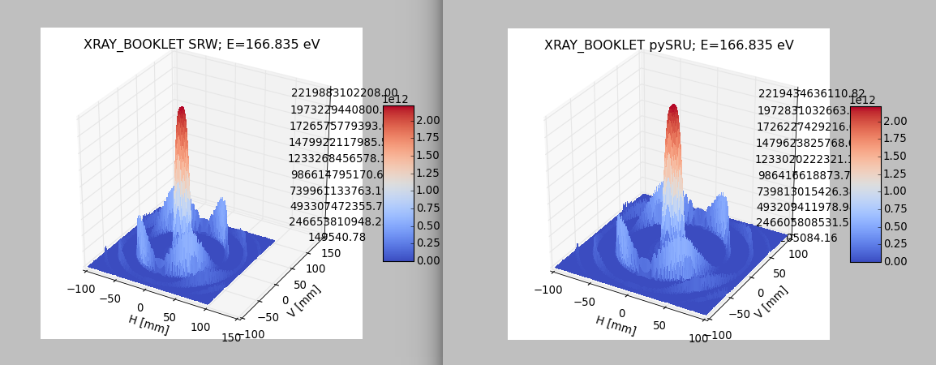
ID16_NA
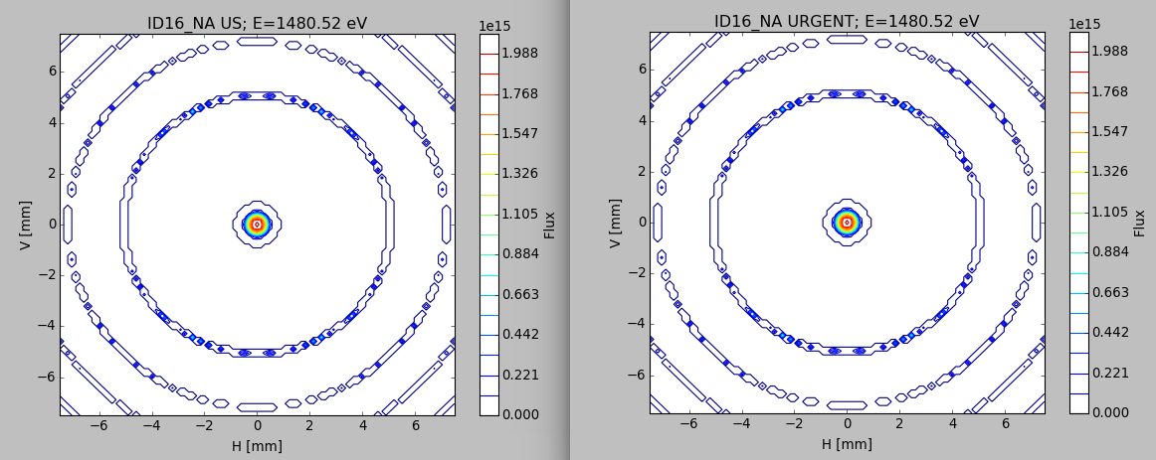
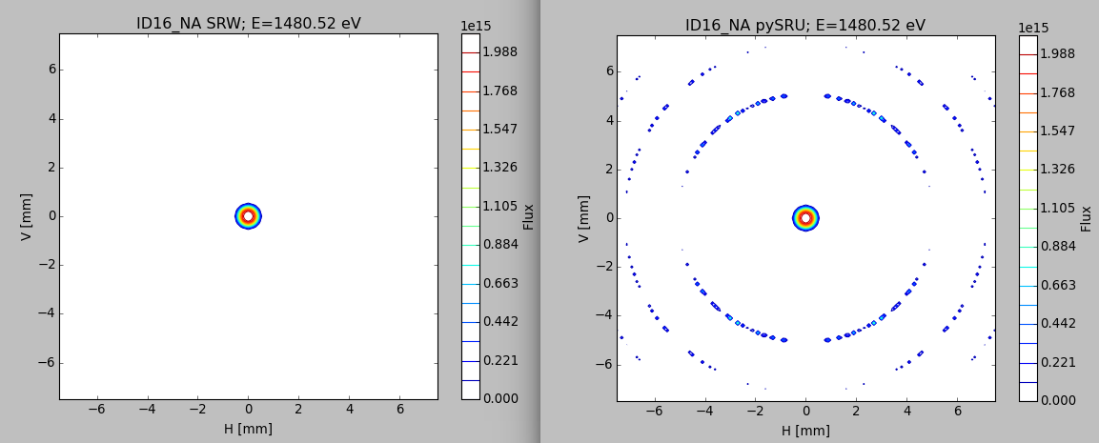
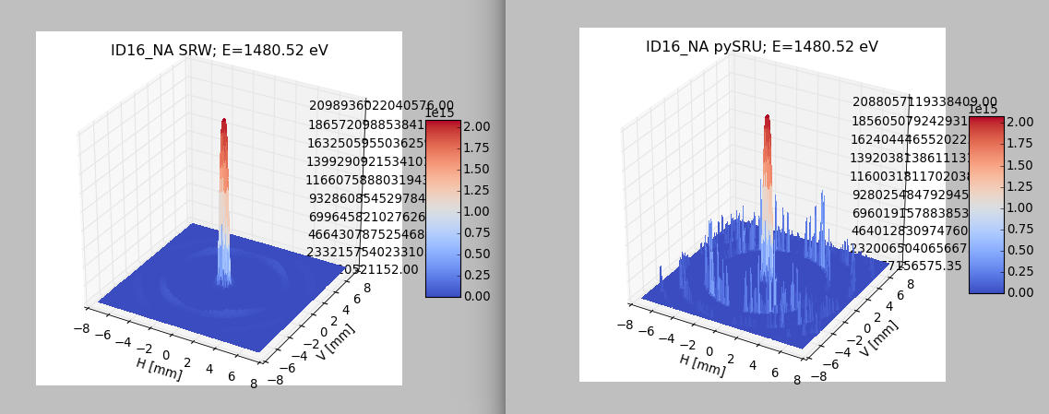

ESRF_NEW_OB
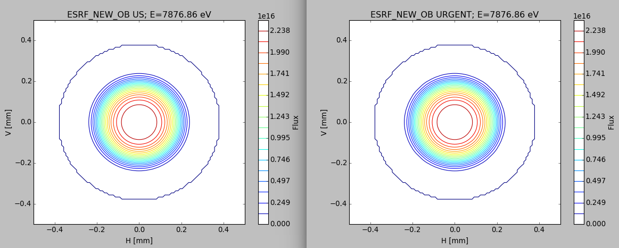
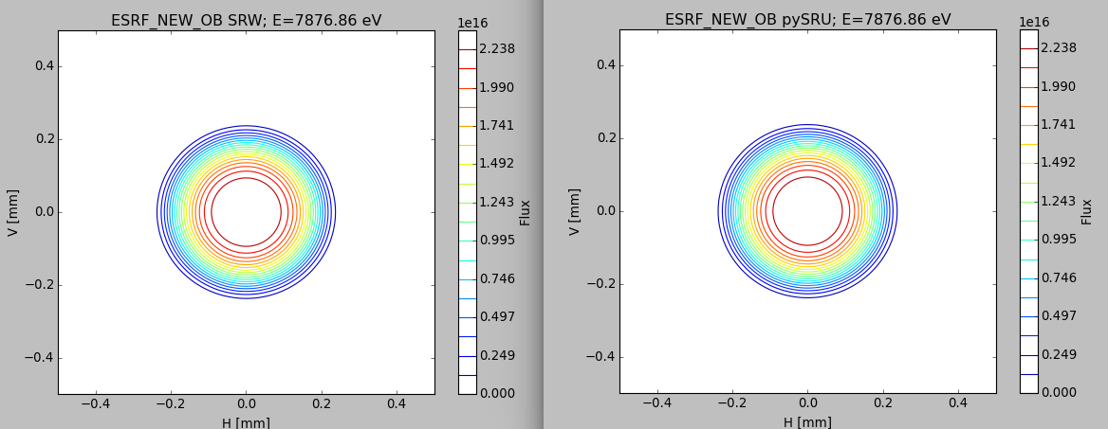

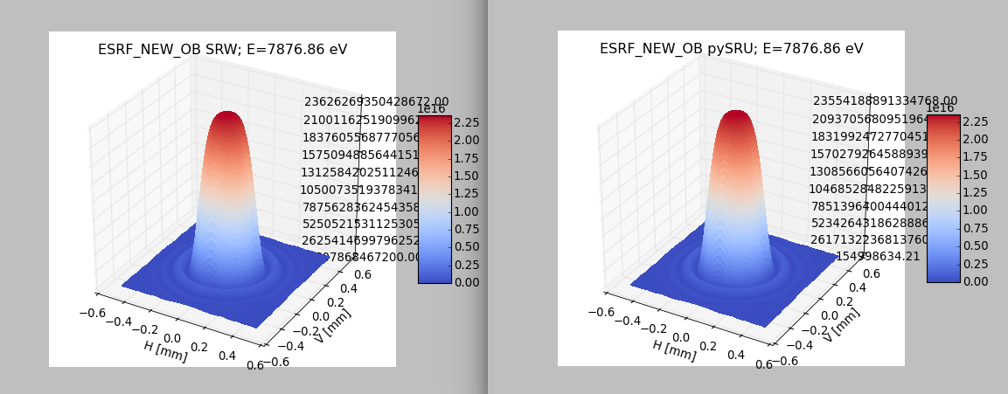

SHADOW_DEFAULT
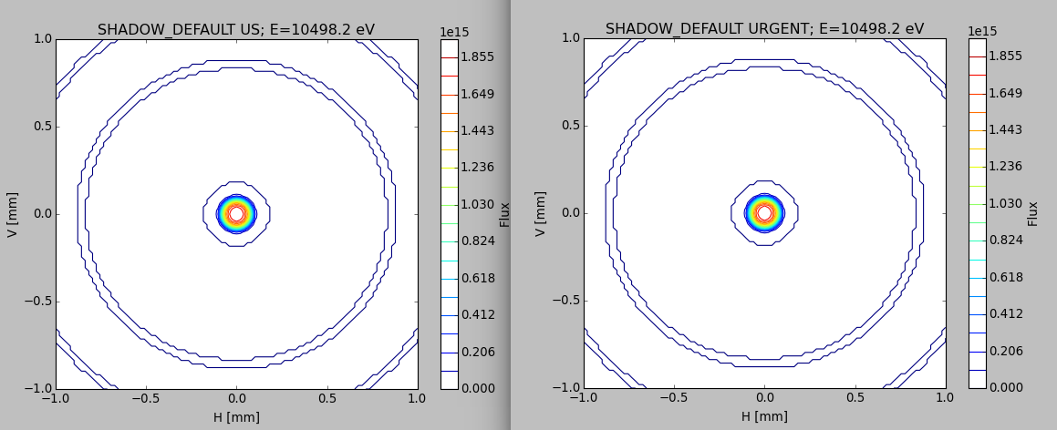
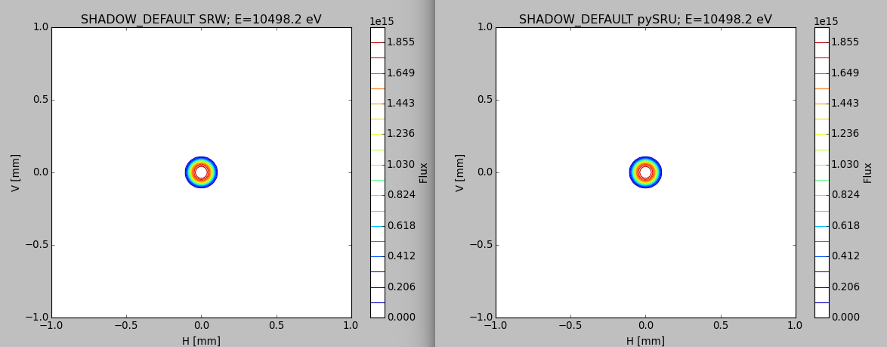

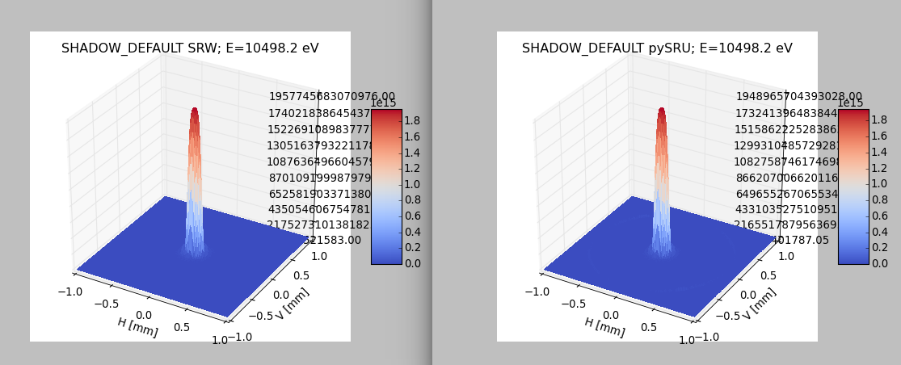

Energy spectrum
XRAY_BOOKLET

200 energy points. pySRU default (ODE+NEAR F)
(the pySRU flux is a bit higher because it used the full magnetic field with edges added -ODE- and SRW uses the theoretical trajectory for flux calculations)
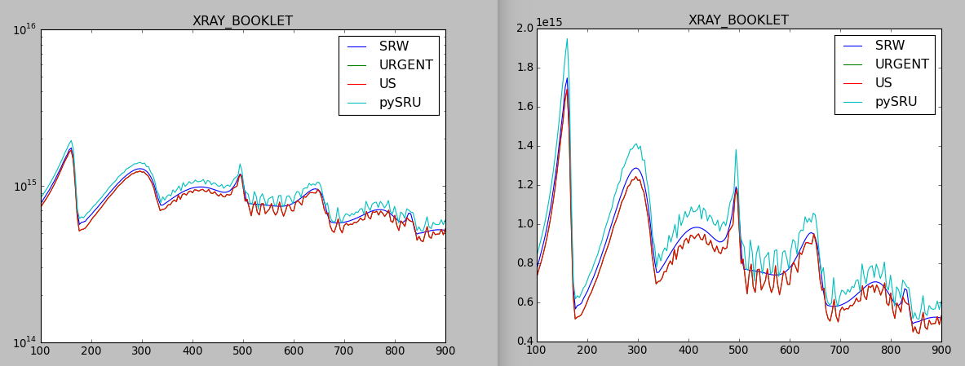
pySRU default (ODE+NEAR F) with more (20000) trajectory points: no major improvement
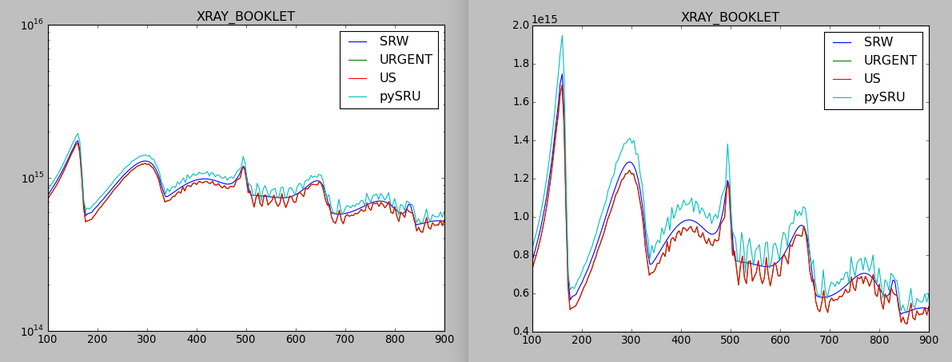

with more mesh points (101x101) we reduce the pySRU noise:
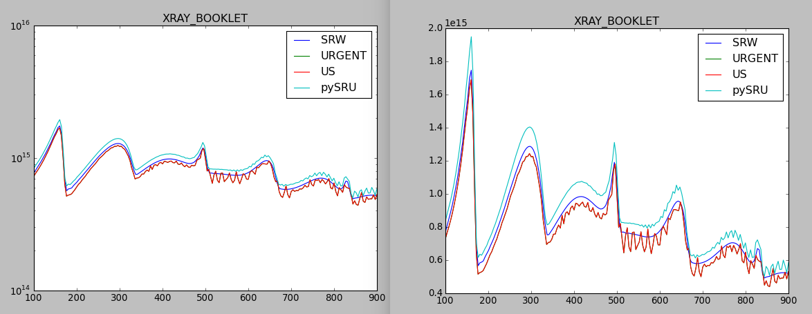

Using in pySRU analytical trajectory (N=14) and (101x101) we get a very good pySRU/SRW agreement:
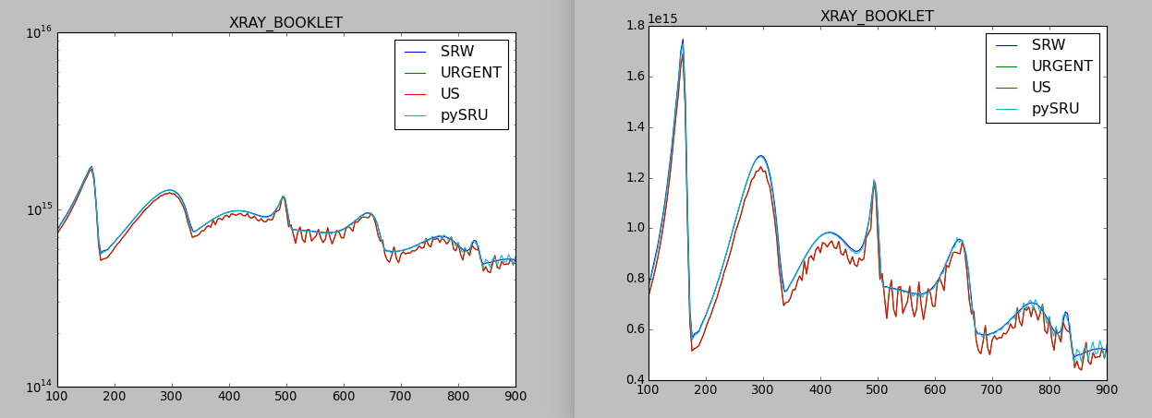
ID16_NA

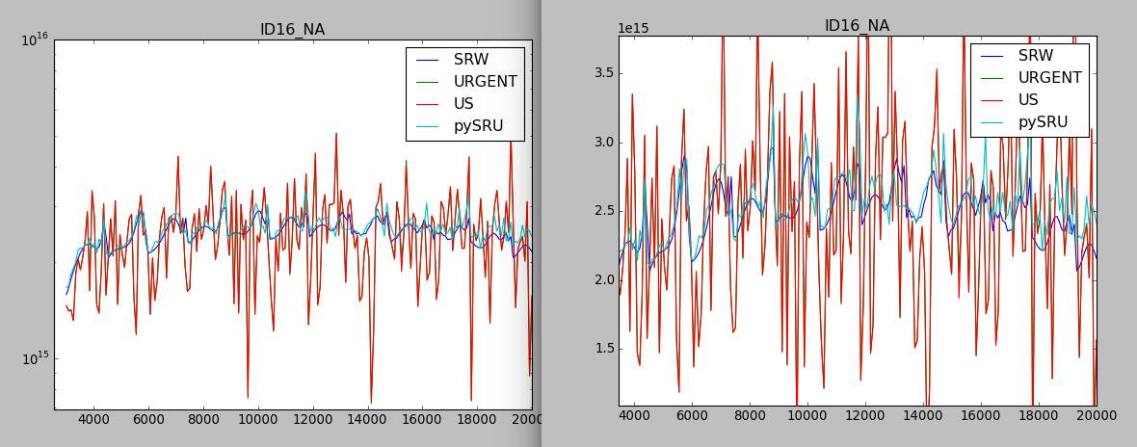

US and URGENT fail to get something reasonable, at least for the inputs I used. This is the comparison pySRU and SRW only. Certainly pySRU needs more grid points, and SRW needs to increase a bit more the max harmonic number (used 31 here, before we used 21).
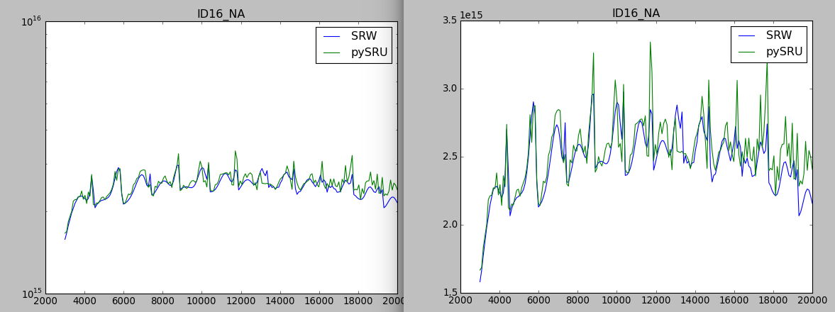

using up to 41 harmonics in SRW and 101x101 grid in pySRU we get:

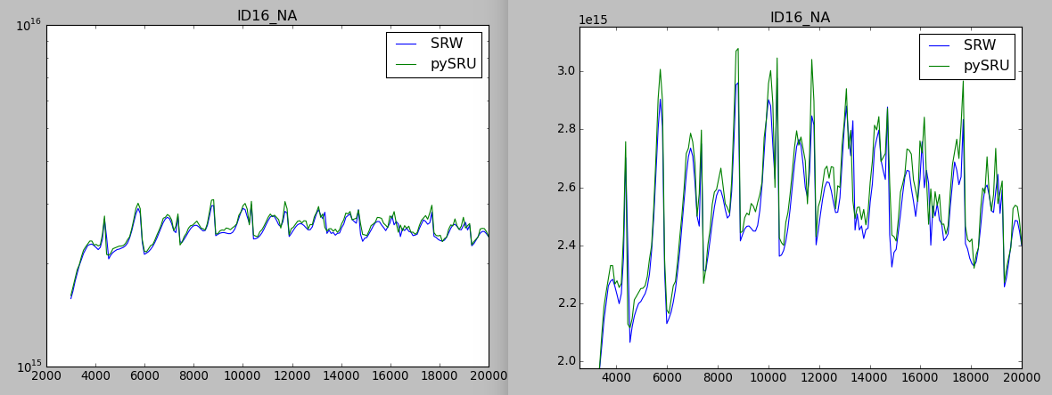

ESRF_NEW_OB

SRW Nmax=61; 101x101 mesh in pySRU:

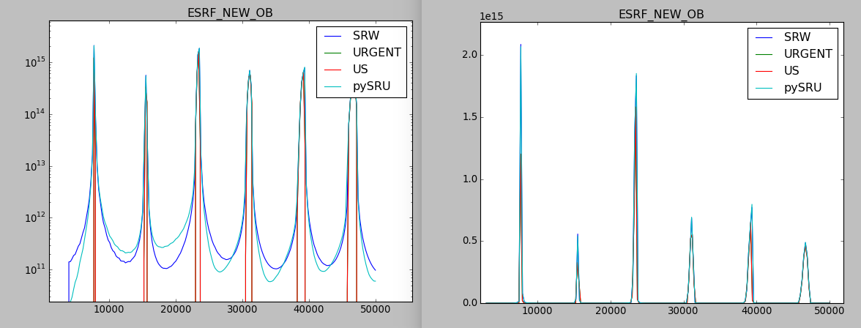
First peak:

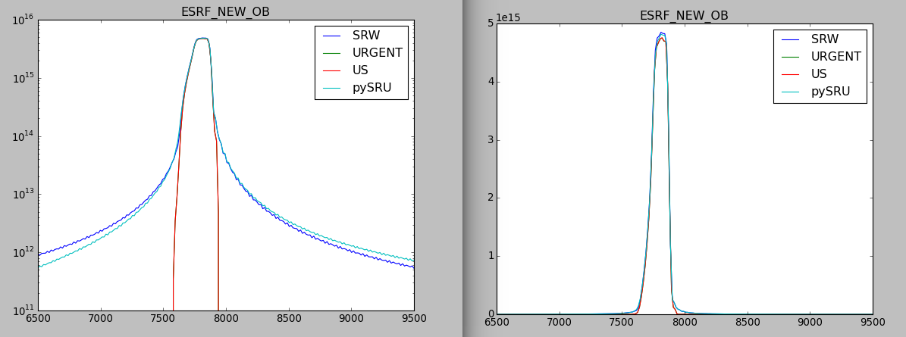
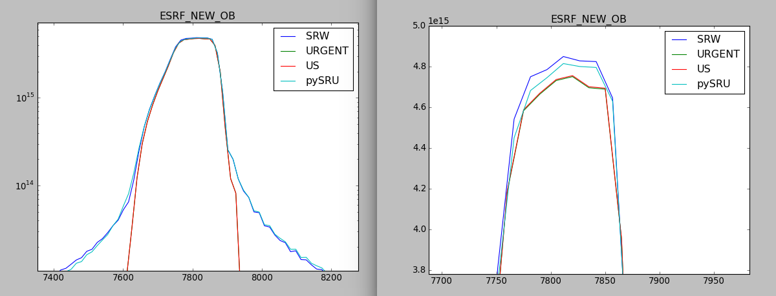

SHADOW_DEFAULT

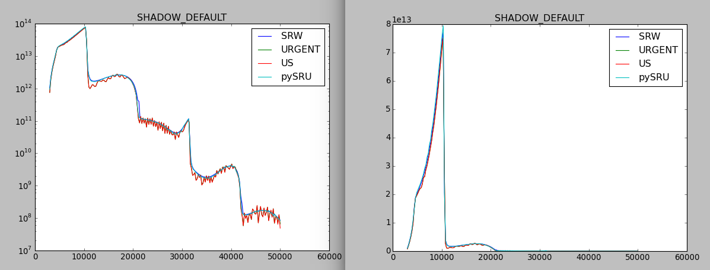

Power density
XRAY_BOOKLET

pySRU: Energy grid 90-2500eV one point per eV:
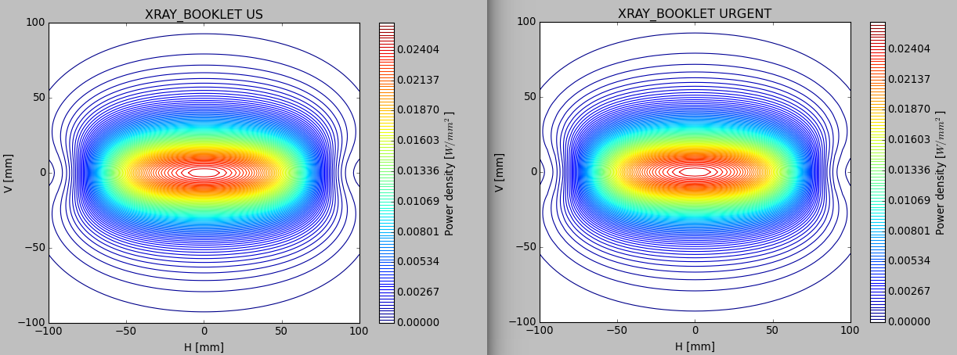
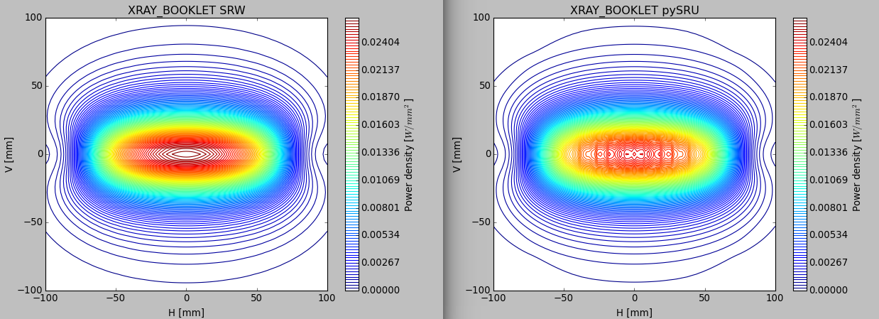

Spectrum by pySRU

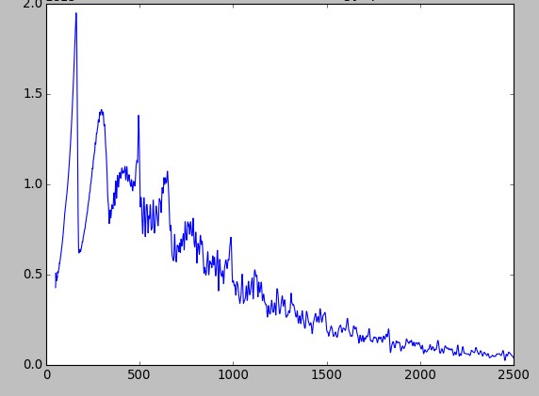

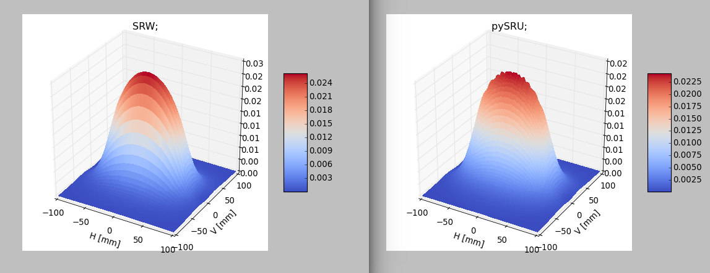

SHADOW_DEFAULT

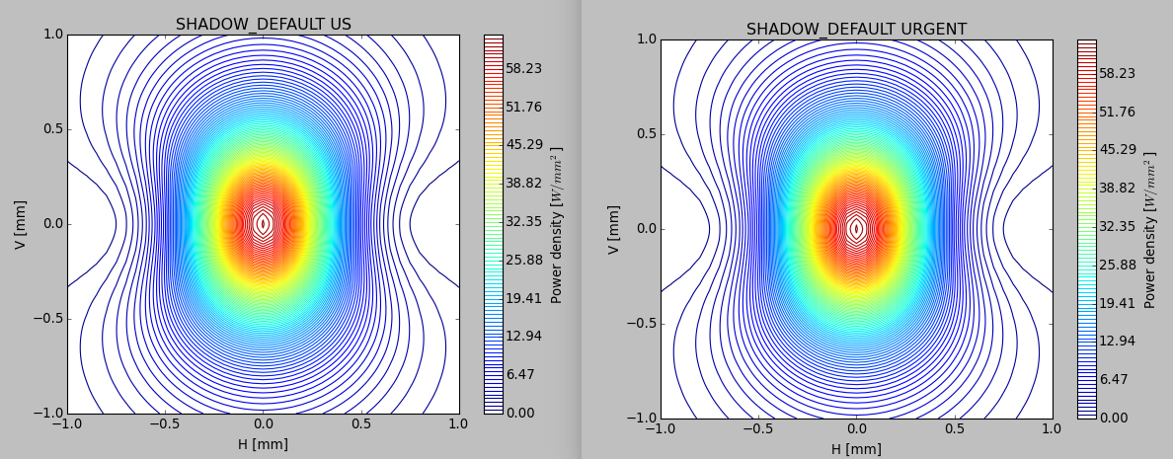

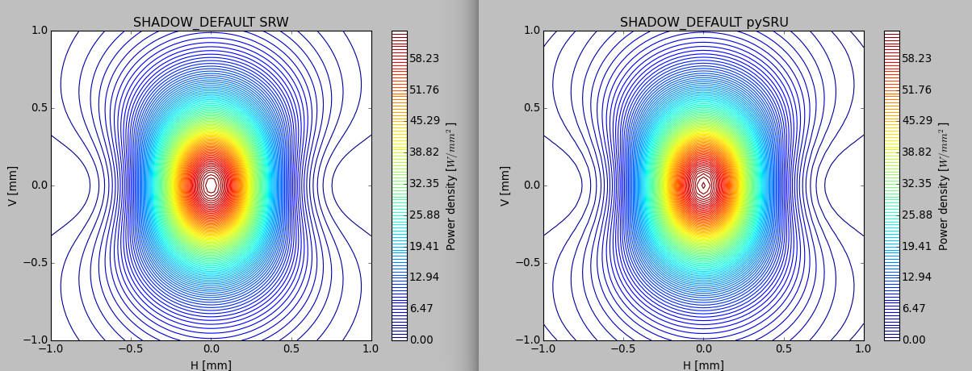
Spectrum by pySRU

